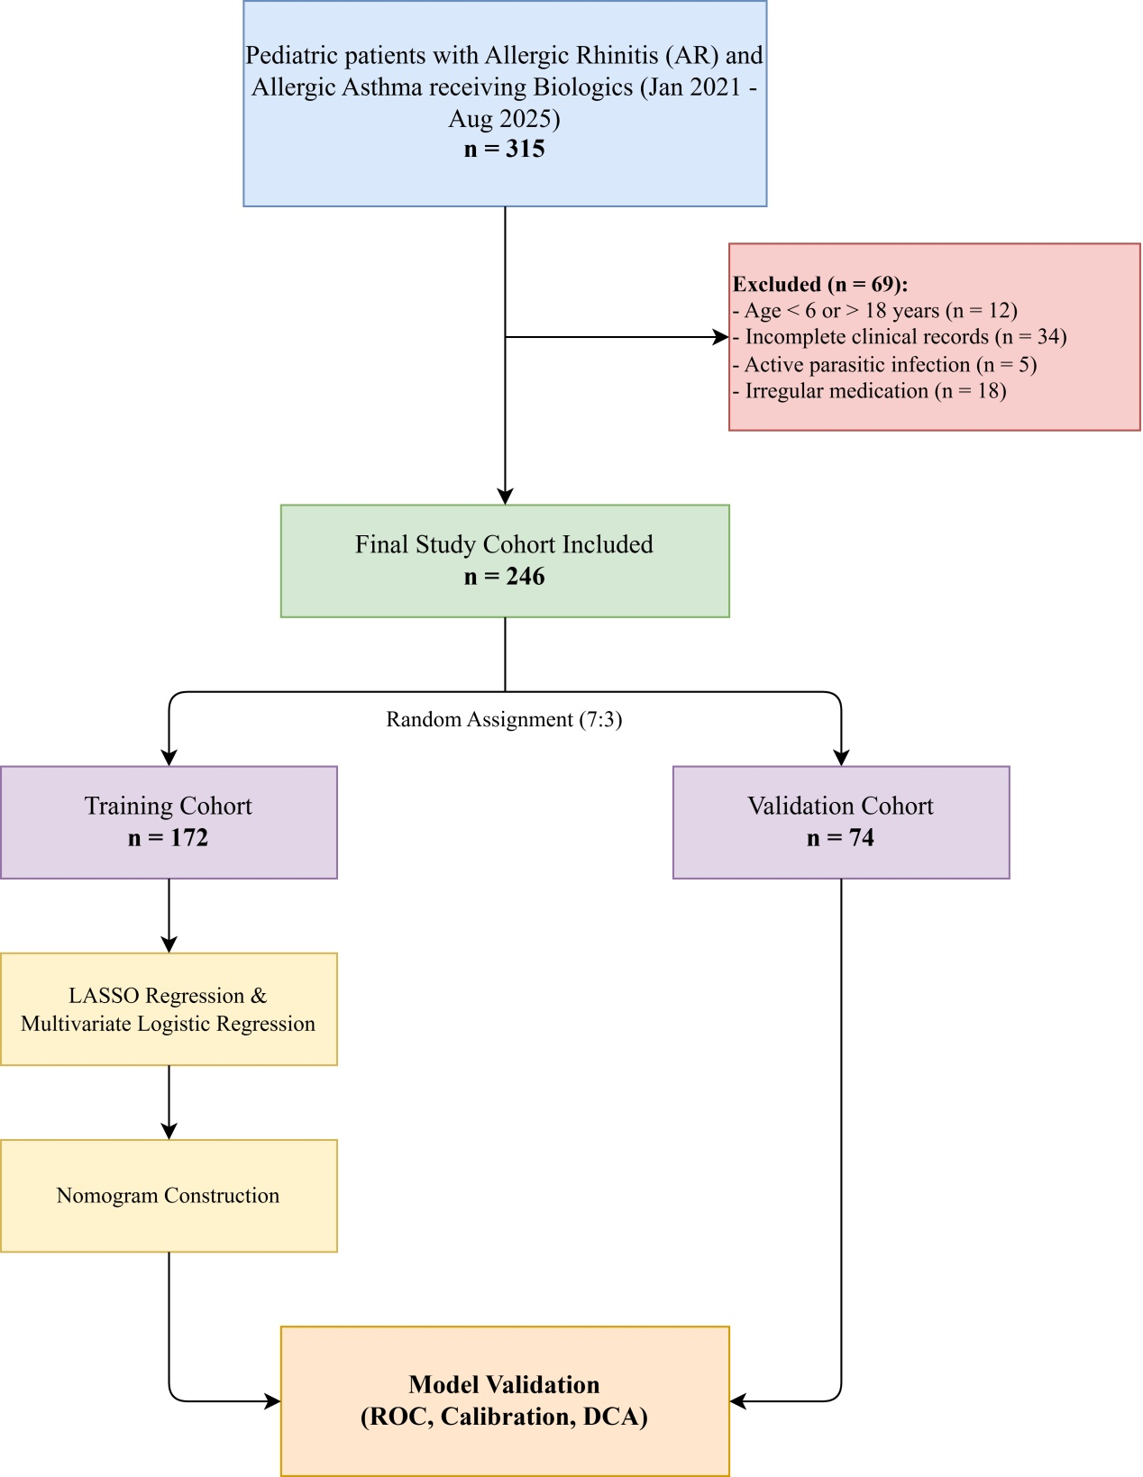
Supplementary Figure S1. Flowchart of patient recruitment, exclusion criteria, and the overall study design workflow. A total of 315 pediatric patients diagnosed with allergic rhinitis (AR) and comorbid allergic asthma receiving biologics between January 2021 and August 2025 were initially screened. Based on the exclusion criteria, 69 patients were excluded (12 due to age < 6 or > 18 years, 34 due to incomplete clinical records, 5 due to active parasitic infections, and 18 due to irregular medication). The final study cohort comprised 246 children, who were randomly assigned to either the training cohort (n = 172) or the validation cohort (n = 74) at a 7:3 ratio. Predictor selection was performed using LASSO regression and multivariate logistic regression to construct the nomogram, followed by validation through ROC, calibration curves, and Decision Curve Analysis (DCA).

