Supplementary Figure 1. Box plots of loneliness scores across three measurement tools. Each scale is shown in a separate panel because score ranges differ across instruments.
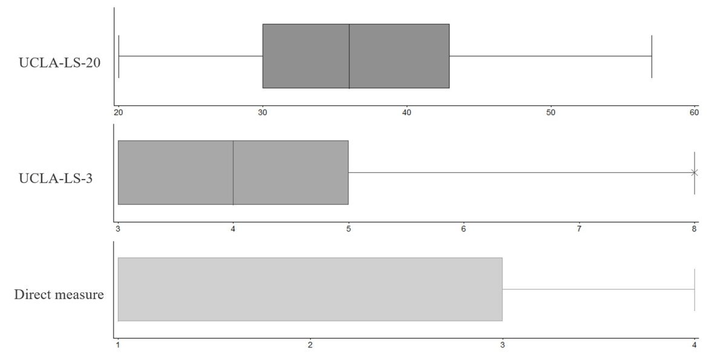

Supplementary Table 1. Block-wise analyses of factors associated with loneliness across three loneliness measures
 | Model 1 |  |  | Model 2
 | UCLALS-20 ≥ 43 | UCLA-LS-3 ≥ 6 | Direct measure | UCLALS-20 ≥ 43 | UCLA-LS-3 ≥ 6 | Direct measure
Variable | OR (95% CI) | OR (95% CI) | OR (95% CI) | OR (95% CI) | OR (95% CI) | OR (95% CI)
Gender
Male | Ref | Ref | Ref | Ref | Ref | Ref
Female | 0.84(0.36,1.93) | 1.70(0.61,4.77) | 2.15(0.85,5.46) | 0.72(0.27,1.89) | 2.21(0.63,7.73) | 2.61(0.80,8.52)
Age
<70 | Ref | Ref | Ref | Ref | Ref | Ref
≥70 | 1.90(0.78,4.63) | 2.71(0.90,8.17) | 1.78(0.69,4.59) | 2.31(0.83,6.44) | 1.42(0.39,5.23) | 0.92(0.29,2.91)
Religious beliefs
Yes | Ref | Ref | Ref | Ref | Ref | Ref
No | 2.27(0.70,7.33) | 0.83(0.18,3.87) | 1.81(0.552,6.25) | 3.75(1.01,13.92) | 1.93(0.31,12.18) | 3.74(0.85,16.52)
Education level
Elementary school or below | Ref | Ref | Ref | Ref | Ref | Ref
Junior high school | 1.30(0.46,3.66) | 2.56(0.75,8.72) | 2.02(0.67,6.10) | 1.05(0.31,3.56) | 1.26(0.26,6.22) | 1.11(0.25,5.00)
Senior high school | 0.69(0.24,1.97) | 1.53(0.43,5.42) | 0.99(0.32,3.13) | 0.54(0.16,1.77) | 2.00(0.46,8.82) | 0.99(0.27,3.73)
University or above | 0.83(0.24,2.88) | 3.50(0.80,15.33) | 2.98(0.81,10.95) | 0.66(0.15,2.93) | 2.43(0.34,17.36) | 2.01(0.35,11.51)
Marital status
Married | Ref | Ref | Ref | Ref | Ref | Ref
Separation, divorce, or widowhood | 1.05(0.29,3.71) | 0.20(0.04,1.01) | 0.47(0.12,1.82) | 0.77(0.16,3.76) | 0.09(0.01,0.67) | 0.32(0.06,1.83)
Living condition
Living alone | Ref | Ref | Ref | Ref | Ref | Ref
Living with a spouse or intimate partner | 2.42(0.43,13.60) | 0.41(0.05,3.43) | 0.45(0.08,2.51) | 3.71(0.42,32.62) | 0.44(0.03,6.66) | 0.26(0.03,2.40)
Living with a spouse and descendants | 0.97(0.18,5.22) | 0.13(0.02,1.09) | 0.13(0.02,0.71) | 1.25(0.15,10.32) | 0.11(0.01,1.60) | 0.06(0.01,0.59)
Living with other relatives or friends | 2.18(0.54,8.75) | 1.02(0.20,5.28) | 0.46(0.12,1.78) | 1.92(0.35,10.68) | 0.98(0.11,8.67) | 0.18(0.03,1.04)
Social media use: text messages
Texting/receiving messages daily or weekly | Ref | Ref | Ref | Ref | Ref | Ref
Texting/receiving messages occasionally or never | 0.59(0.24,1.48) | 0.76(0.27,2.14) | 1.38(0.56,3.41) | 0.64(0.23,1.78) | 1.14(0.30,4.28) | 2.43(0.74,7.98)
Social media use: video calls
Making video calls daily or weekly | Ref | Ref | Ref | Ref | Ref | Ref
Making video calls occasionally or never | 1.65(0.70,3.85) | 8.34(2.34,29.76) | 4.20(1.59,11.13) | 1.13(0.42,3.06) | 5.05(1.10,23.21) | 2.34(0.70,7.82)
Financial status
Well off | Ref | Ref | Ref | Ref | Ref | Ref
Hard up | 3.04(1.41,6.55) | 2.93(1.19,7.23) | 2.74(1.23,6.11) | 1.88(0.75,4.72) | 1.44(0.42,4.95) | 1.35(0.48,3.82)
Employment status
Currently employed | Ref | Ref | Ref | Ref | Ref | Ref
Unemployed | 0.91(0.42,1.99) | 2.06(0.76,5.56) | 1.86(0.80,4.32) | 0.67(0.27,1.68) | 1.42(0.42,4.81) | 1.63(0.57,4.63)
LSNS-6 |  |  |  | 0.90(0.83,0.97) | 1.04(0.94,1.15) | 1.00(0.91,1.09)
GDS-15 |  |  |  | 1.33(1.09,1.62) | 1.55(1.21,1.99) | 1.46(1.16,1.85)
GAD-7 |  |  |  | 1.15(1.00,1.32) | 1.00(0.85,1.19) | 1.27(1.07,1.51)
EQ-5D-5L |  |  |  | 0.74(0.59,0.92) | 1.05(0.79,1.40) | 0.86(0.65,1.14)
EQ-VAS |  |  |  | 0.99(0.95,1.03) | 0.95(0.91,1.00) | 0.94(0.90,0.99)

