Supplemental Information
Supplemental figure and table legends
Supplemental Table 1. Weighted adjacency matrix of depressive symptoms networks in CVD and Non-CVD groups after PSM.
Supplemental Figure 1. Bootstrapped confidence intervals of edge weights in CVD and Non-CVD groups after PSM.
Supplemental Figure 2. Estimation of edge weight difference by bootstrapped difference test in CVD and Non-CVD groups after PSM.
Supplemental Figure 3. Stability of node strength and expected influences in CVD and Non-CVD groups after PSM.
Supplemental Figure 4. Comparison of network properties between CVD and Non-CVD groups.
Supplemental Figure 5. Comparison of network properties among CVD patients with and without comorbidity.

Supplemental Table 1. Weighted adjacency matrix of depressive symptoms networks in CVD and Non-CVD groups after PSM
 | CVD | Non-CVD | CVD | Non-CVD | CVD | Non-CVD | CVD | Non-CVD | CVD | Non-CVD | CVD | Non-CVD | CVD | Non-CVD | CVD | Non-CVD | CVD | Non-CVD | CVD | Non-CVD
 | BOTHER |  | MIND |  | DEPRESS |  | EFFORT |  | HOPEFUL |  | FEARFUL |  | SLEEP |  | HAPPY |  | LONELY |  | GOING
BOTHER | 0.00 | 0.00 | 0.16 | 0.22 | 0.32 | 0.32 | 0.10 | 0.05 | 0.00 | 0.00 | 0.09 | 0.07 | 0.09 | 0.05 | 0.09 | 0.10 | 0.01 | 0.06 | 0.03 | 0.02
MIND | 0.16 | 0.22 | 0.00 | 0.00 | 0.20 | 0.25 | 0.17 | 0.11 | -0.02 | 0.00 | 0.05 | 0.02 | 0.04 | 0.07 | 0.02 | 0.03 | 0.03 | 0.01 | 0.04 | 0.04
DEPRESS | 0.32 | 0.32 | 0.20 | 0.25 | 0.00 | 0.00 | 0.24 | 0.24 | 0.00 | 0.00 | 0.06 | 0.09 | 0.08 | 0.06 | 0.08 | 0.08 | 0.11 | 0.06 | 0.05 | 0.04
EFFORT | 0.10 | 0.05 | 0.17 | 0.11 | 0.24 | 0.24 | 0.00 | 0.00 | 0.00 | 0.01 | 0.03 | 0.11 | 0.04 | 0.09 | 0.00 | 0.05 | 0.09 | 0.05 | 0.18 | 0.20
HOPEFUL | 0.00 | 0.00 | -0.02 | 0.00 | 0.00 | 0.00 | 0.00 | 0.01 | 0.00 | 0.00 | 0.00 | 0.00 | 0.00 | 0.00 | 0.35 | 0.28 | 0.00 | 0.01 | 0.04 | 0.00
FEARFUL | 0.09 | 0.07 | 0.05 | 0.02 | 0.06 | 0.09 | 0.03 | 0.11 | 0.00 | 0.00 | 0.00 | 0.00 | 0.04 | 0.09 | 0.00 | 0.01 | 0.10 | 0.17 | 0.21 | 0.19
SLEEP | 0.09 | 0.05 | 0.04 | 0.07 | 0.08 | 0.06 | 0.04 | 0.09 | 0.00 | 0.00 | 0.04 | 0.09 | 0.00 | 0.00 | 0.05 | 0.05 | 0.12 | 0.09 | 0.02 | 0.01
HAPPY | 0.09 | 0.10 | 0.02 | 0.03 | 0.08 | 0.08 | 0.00 | 0.05 | 0.35 | 0.28 | 0.00 | 0.01 | 0.05 | 0.05 | 0.00 | 0.00 | 0.09 | 0.09 | 0.08 | 0.06
LONELY | 0.01 | 0.06 | 0.03 | 0.01 | 0.11 | 0.06 | 0.09 | 0.05 | 0.00 | 0.01 | 0.10 | 0.17 | 0.12 | 0.09 | 0.09 | 0.09 | 0.00 | 0.00 | 0.31 | 0.24
GOING | 0.03 | 0.02 | 0.04 | 0.04 | 0.05 | 0.04 | 0.18 | 0.20 | 0.04 | 0.00 | 0.21 | 0.19 | 0.02 | 0.01 | 0.08 | 0.06 | 0.31 | 0.24 | 0.00 | 0.00
Note. PSM = propensity score matching, CVD = cardiovascular disease.
A. CVD group (N=1643) B. Non-CVD group (N=1643)
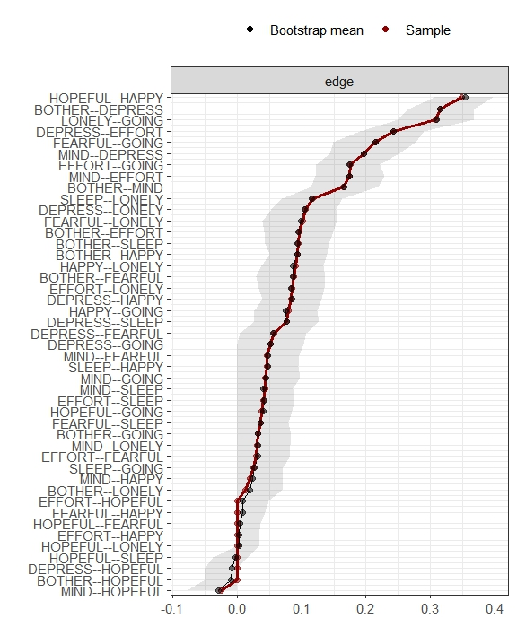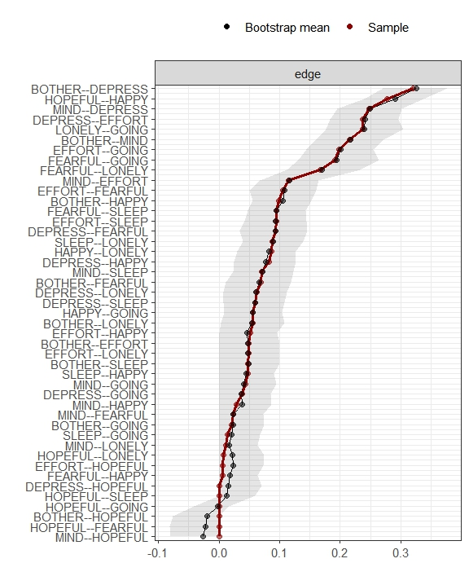
Supplemental Figure 1. Bootstrapped confidence intervals of edge weights in CVD and Non-CVD groups after PSM. The black dots indicate the values of each edge weight, ordered from the highest to the lowest value. The gray area represents the 95% Confidence Intervals of edge weights, estimated with the non-parametric bootstrap procedure (R package bootnet). Wide intervals indicate lower stability and narrow intervals indicate higher stability.

A. CVD group (N=1643) B. Non-CVD group (N=1643)
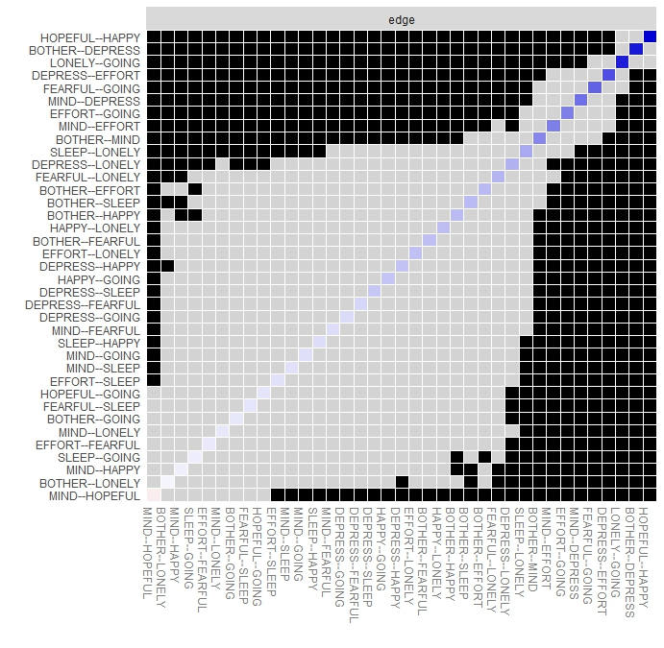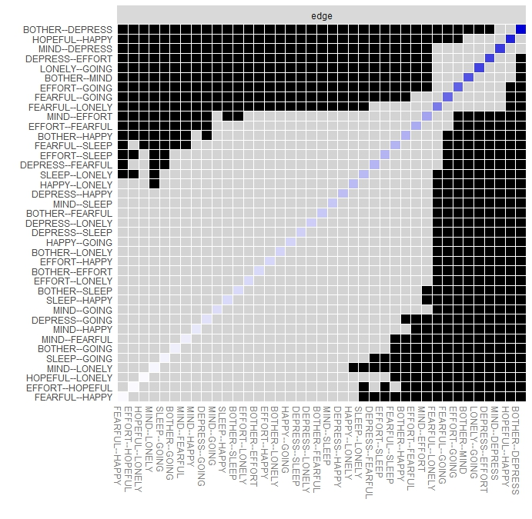
Supplemental Figure 2. Estimation of edge weight difference by bootstrapped difference test in CVD and Non-CVD groups after PSM. Gray boxes indicate edges that do not significantly differ from one-another. Black boxes represent edges with significant difference from one another (α= 0.05). Blue boxes in the edge-weight plot indicate positive correlations.
A. CVD group (N=1643) B. Non-CVD group (N=1643)
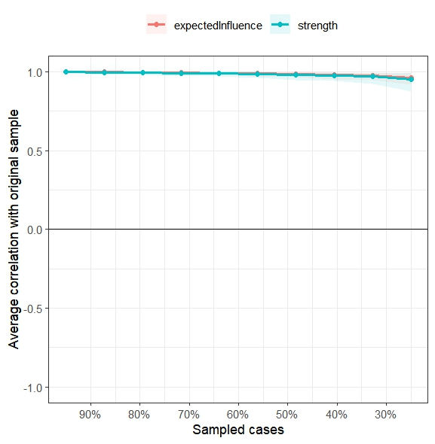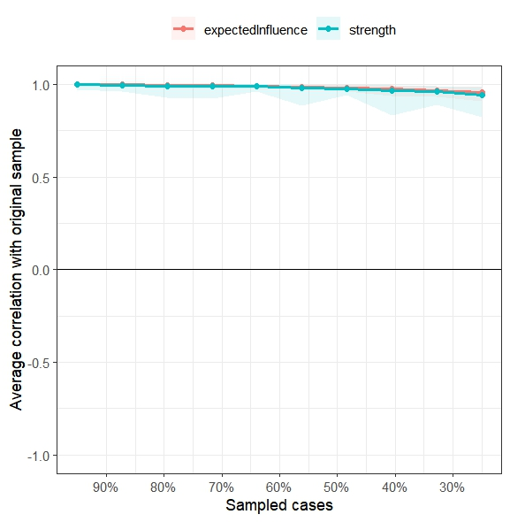
Supplemental Figure 3. Stability of node strength and expected influences in CVD and Non-CVD groups after PSM. The red bar represents the average correlation between expected influences in the full sample and subsample with the red area depicting the range from the 2.5th quantile to the 97.5th quantile. The blue bar represents the average correlation between strength in the full sample and subsample with the blue area depicting the range from the 2.5th quantile to the 97.5th quantile.
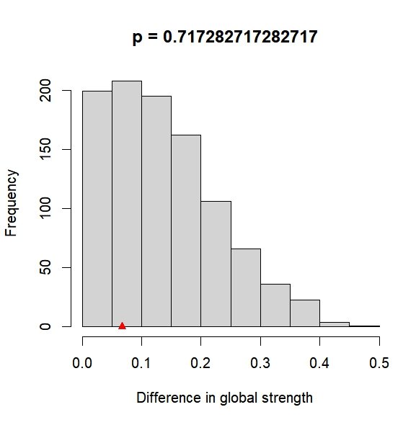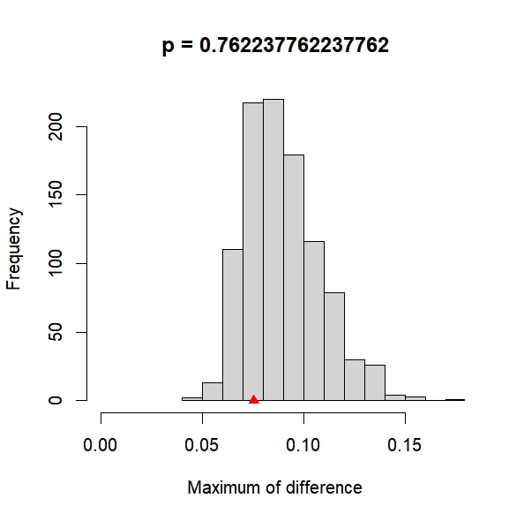
Supplemental Figure 4. Comparison of network properties between CVD and Non-CVD groups. Left Panel: Plot of bootstrap value of the difference in network global strength, with no significant difference (S=0.07, P=0.72). Right Panel: Plot of bootstrap value of the maximum difference in any of the edge weights (1000 permutations), with no significant difference (M=0.08, P=0.76). Invariance in edges weights was examined using the permutation test, generating sets of p values for each edge-edge comparison. Holm-Bonferroni corrected p values were all >0.05 indicating absence of significant differences.
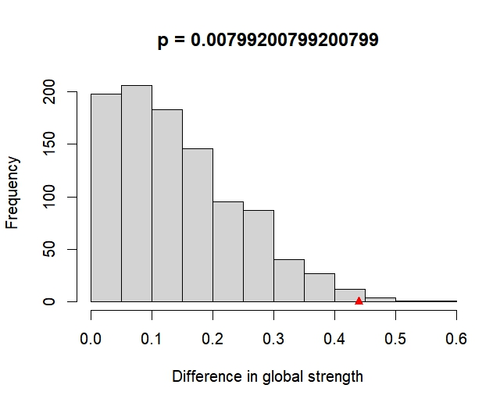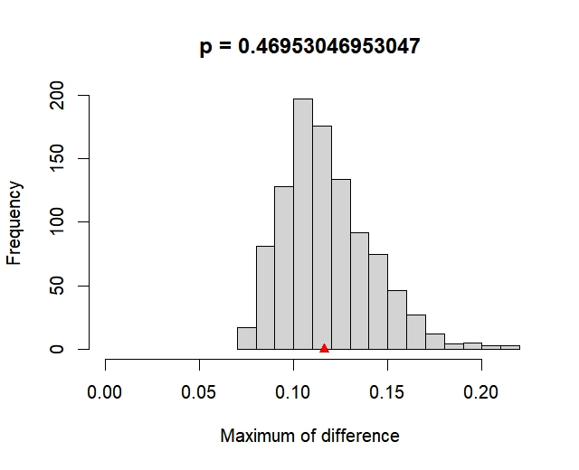
Supplemental Figure 5. Comparison of network properties among CVD patients with and without comorbidity. Left Panel: Plot of bootstrap value of the difference in network global strength, with significant difference (yes:4.13 vs no:3.69; S = 0.44, P = 0.008). Right Panel: Plot of bootstrap value of the maximum difference in any of the edge weights (1000 permutations), with no significant difference (M=0.12, P=0.47). Invariance in edges weights was examined using the permutation test, generating sets of p values for each edge-edge comparison. Holm-Bonferroni corrected p values were all >0.05 indicating absence of significant differences.

