Table S1. Calculation formulas of composite indicators
Composite indicator | Formula
TyG | Ln [TG (mg/dL) × FBG (mg/dL) / 2]
TG/HDL-C | TG (mg/dL) / HDL-C (mg/dL)
UHR (%) | Uric Acid (mg/dL) / HDL-C (mg/dL) × 100%
AIP | log10 [TG (mg/dL) / HDL-C (mg/dL)]
NHHR | non-HDL-C (mg/dL) / HDL-C (mg/dL)
GHR (% / mmol/L) | Glycated Hemoglobin (%) / HDL-C (mg/dL)
UA/Cr | Uric Acid (mg/dL) / Creatinine (mg/dL)
SHR | ABG (mmol/L) / [1.59 × HbA1c (%) − 2.59]
Abbreviations: TyG, triglyceride glucose; TG/HDL-C, total cholesterol to high-density lipoprotein cholesterol ratio; UHR, uric acid to high-density lipoprotein cholesterol ratio; AIP, atherogenic index of plasma; NHHR, non-high-density lipoprotein cholesterol to high-density lipoprotein cholesterol ratio; GHR, glycated hemoglobin to high-density lipoprotein cholesterol ratio; UA/Cr, uric acid to creatinine ratio; SHR, stress hyperglycemia ratio; FBG, fasting blood glucose; ABG, admission blood glucose.

Table S2. Comparison of missing variables in the training set before and after multiple imputation
Variables | Before interpolation | After interpolation | P value
SBP (mmHg) | 138.00 (126.00, 154.00) | 138.00 (126.00, 154.00) | 0.886
DBP (mmHg) | 80.00 (71.00, 88.00) | 80.00 (71.00, 88.00) | 0.770
Pulse (bpm) | 80.00 (73.00, 90.00) | 80.00 (73.00, 90.00) | 0.964
TC (mmol/l) | 4.12 (3.37, 4.94) | 4.10 (3.36, 4.91) | 0.108
TG (mmol/l) | 1.37 (0.98, 1.97) | 1.38 (0.98, 2.00) | 0.443
UA (umol/l) | 330.00 (262.00, 411.00) | 329.00 (262.00, 410.00) | 0.583
LDL-C (mmol/L) | 2.42 (1.75, 3.15) | 2.40 (1.73, 3.13) | 0.041
HDL-C (mmol/L) | 1.04 (0.86, 1.26) | 1.04 (0.86, 1.26) | 0.238
Hemoglobin (g/L) | 126.00 (113.00, 137.00) | 126.00 (113.00, 137.00) | 0.502
HbA1c (%) | 7.50 (6.60, 8.90) | 7.40 (6.60, 8.80) | 0.006
FG (mmol/l) | 7.40 (6.10, 9.60) | 7.50 (6.20, 9.90) | 0.025
WBC count (×10^9/L) | 6.90 (5.50, 8.80) | 6.90 (5.50, 8.80) | 0.800
Platelet (×10^9/L) | 183.00 (145.00, 227.00) | 183.00 (145.00, 228.00) | 0.707
Abbreviations: SBP, systolic blood pressure; DBP, diastolic blood pressure; TC, total cholesterol; TG, triglycerides; UA, uric acid; LDL-C, low-density lipoprotein cholesterol; HDL-C, high-density lipoprotein cholesterol; HbA1c, glycated hemoglobin; FG, fasting glucose; WBC, white blood cell.

Table S3. Comparison of missing variables in the validation set before and after multiple imputation
Variables | Before interpolation | After interpolation | P value
SBP (mmHg) | 137.00 (125.00, 152.00) | 137.00 (125.00, 152.00) | 0.954
DBP (mmHg) | 79.00 (71.00, 87.00) | 79.00 (71.00, 87.00) | 0.966
Pulse (bpm) | 81.00 (73.00, 92.00) | 81.00 (73.00, 92.00) | 0.992
TC (mmol/l) | 3.92 (3.18, 4.69) | 3.93 (3.21, 4.69) | 0.245
TG (mmol/l) | 1.34 (0.97, 1.95) | 1.35 (0.96, 1.97) | 0.750
UA (umol/l) | 326.00 (259.00, 407.00) | 326.00 (259.00, 407.00) | 0.842
LDL-C (mmol/L) | 2.34 (1.68, 3.10) | 2.33 (1.68, 3.06) | 0.480
HDL-C (mmol/L) | 0.98 (0.80, 1.18) | 0.99 (0.81, 1.19) | 0.061
Hemoglobin (g/L) | 126.00 (113.00, 138.00) | 126.00 (113.00, 138.00) | 0.690
HbA1c (%) | 7.50 (6.70, 8.90) | 7.50 (6.60, 8.80) | 0.032
FG (mmol/l) | 7.40 (6.10, 9.50) | 7.50 (6.20, 9.80) | 0.026
WBC count (10^9/L) | 7.00 (5.60, 9.00) | 7.00 (5.60, 9.00) | 0.710
Platelet (10^9/L) | 189.00 (151.00, 233.00) | 189.00 (151.00, 233.00) | 0.833
Abbreviations: SBP, systolic blood pressure; DBP, diastolic blood pressure; TC, total cholesterol; TG, triglycerides; UA, uric acid; LDL-C, low-density lipoprotein cholesterol; HDL-C, high-density lipoprotein cholesterol; HbA1c, glycated hemoglobin; FG, fasting glucose; WBC, white blood cell.

Table S4. Multicollinearity diagnosis of predictive variables
Variables | VIF | Tolerance
SBP (mmHg) | 1.018 | 0.982
UA (umol/l) | 1.148 | 0.871
Hemoglobin (g/L) | 1.108 | 0.903
HbA1c (%) | 1.243 | 0.805
WBC count (×10^9/L) | 1.031 | 0.970
TyG | 1.249 | 0.801
UA/Cr | 1.187 | 0.842
Abbreviations: SBP, systolic blood pressure; UA, uric acid; HbA1c, glycated hemoglobin; WBC, white blood cell; TyG, triglyceride glucose; UA/Cr, uric acid to creatinine ratio; VIF, variance inflation factor.

Table S5. Comparison of the present prediction model with previously published CKD prediction models in patients with T2DM
Feature | Cai et al.¹ | Zhang et al.² | Cheru et al.³ | Present study
Sample size | 210 | 5,730 | 520 | 28,443
Population | General T2DM | General T2DM | T2DM (age ≥60) | Older T2DM + CVD
Number of predictors | 5 | 5 | 2 | 7
Key predictors | FG, Cr, HbA1c, diabetic retinopathy, and duration of diabetes | Age, BMI, eGFR, diabetes and hypertension | Age (≥60) | SBP, UA, hemoglobin, HbA1c, WBC count, TyG, and UA/Cr
Model output | Risk score | Nomogram | Hazard ratio | Nomogram
AUC | 0.811 | 0.778 | Not reported | 0.845 (training), 0.853 (validation)
Clinical utility assessed | No | No | No | Yes (DCA and CIC)
Easy-to-use tool provided | No | Yes (nomogram) | No | Yes (nomogram)
Abbreviations: FG, fasting glucose; Cr, creatinine; SBP, systolic blood pressure; UA, uric acid; HbA1c, glycated hemoglobin; WBC, white blood cell; TyG, triglyceride glucose; UA/Cr, uric acid to creatinine ratio.

Figure S1. The ROC curve corresponding to each predictive variable
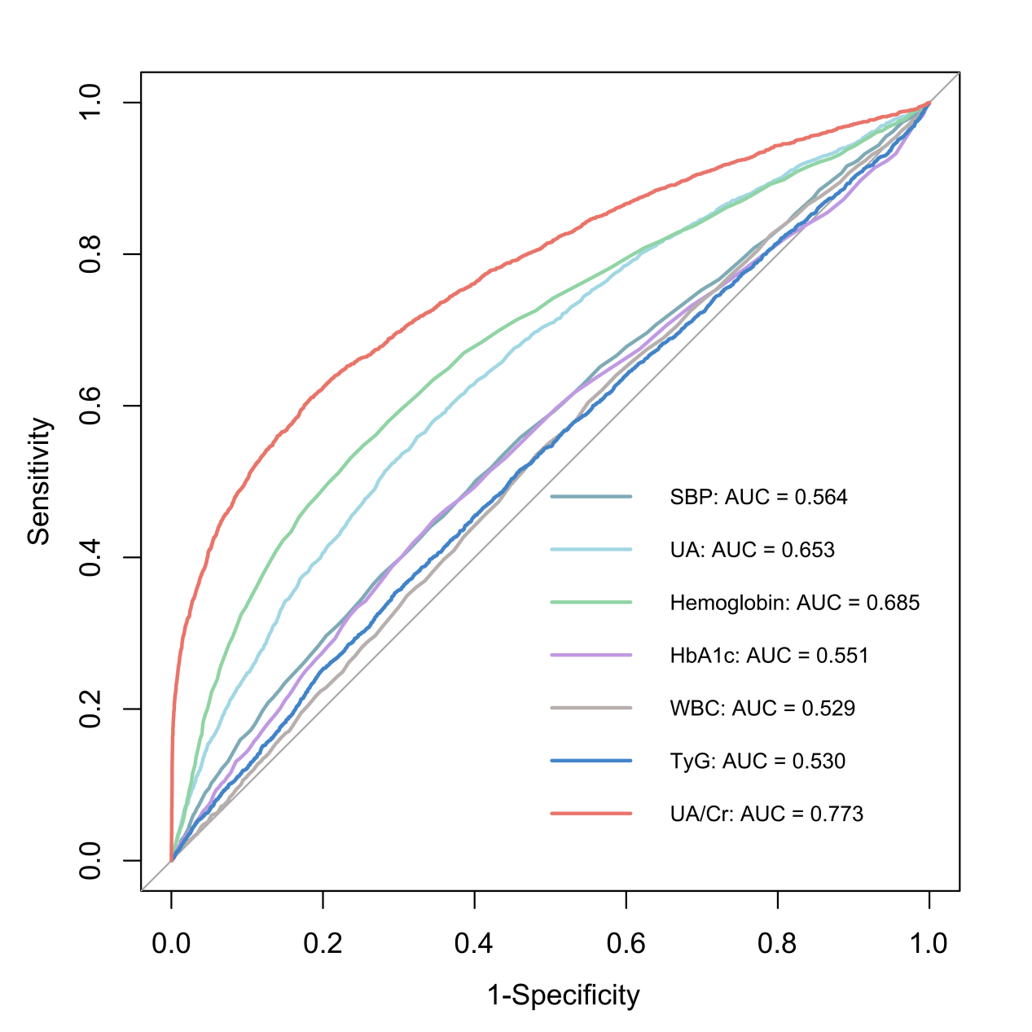

Figure S2. Prediction nomogram for the risk of CKD. To estimate an individual's risk, the corresponding point for each predictor is identified on the topmost point scale, and the total points are summed. The total points are then projected downward to the probability (Pr) scale, which shows the estimated CKD risk ranging from 0 to 1 (i.e., 0.0% to 100.0%). An example participant from this study is illustrated with values on each predictor axis, demonstrating how the total points and corresponding CKD risk are derived.
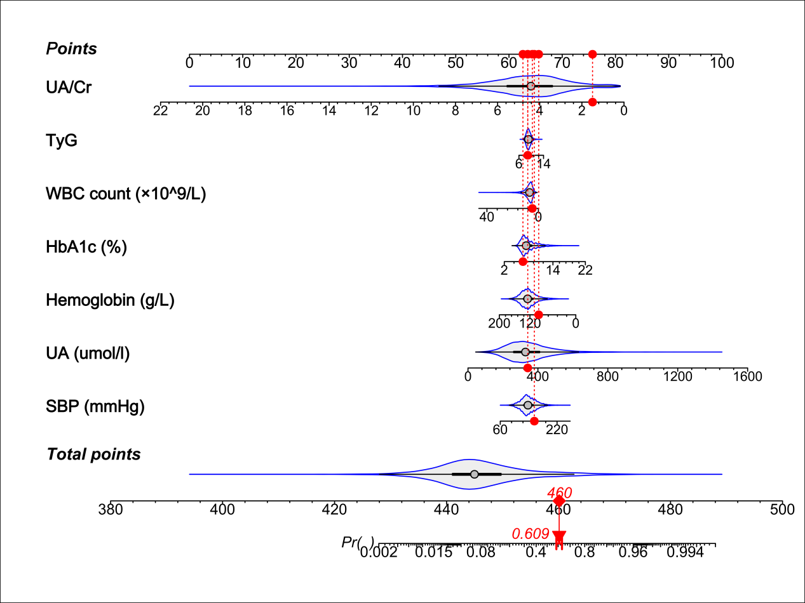

References:
- Cai SS, Zheng TY, Wang KY, et al. Clinical study of different prediction models in predicting diabetic nephropathy in patients with type 2 diabetes mellitus. World J Diabetes. 2024;15(1):43-52. doi: 10.4239/wjd.v15.i1.43.
- Zhang Q, Zhang J, Lei L, et al. Nomogram to predict risk of incident chronic kidney disease in high-risk population of cardiovascular disease in China: community-based cohort study. BMJ Open. 2021;11(11):e047774. doi: 10.1136/bmjopen-2020-047774.
- Cheru A, Edessa D, Regassa LD, et al. Incidence and predictors of chronic kidney disease among patients with diabetes treated at governmental hospitals of Harari Region, eastern Ethiopia, 2022. Front Public Health. 2024; 11:1290554. doi: 10.3389/fpubh.2023.1290554.

