Microenvironment-activated Fe-MOF nanoplatform enables controlled doxorubicin release and ferroptosis-associated oxidative damage in breast cancer cells

Miao Yuan^{a,#}, Yang Wu^{a,#}, Jing Zheng^{a,#}, Chaoran Wangª, Jiarong Wangª, Yifan Zhengª, Yunqi Wangª, Baiqi Wang^{a,b,*}

- Department of Occupational and Environmental Health, School of Public Health, Tianjin Medical University, Tianjin 300070, China;
- National Demonstration Center for Experimental Preventive Medicine Education (Tianjin Medical University), Tianjin 300070, China;

# These authors contributed equally to this work.
* Author to whom correspondence should be addressed.

Postal Address of Dr. Baiqi Wang:
Department of Occupational and Environmental Health
School of Public Health,
Tianjin Medical University,
No. 22, Qixiangtai Rd.,
Heping Dist., Tianjin 300070,
China

Telephone number: +86-22-83336630
Fax number: +86-22-83336603
Electronic mail: wbqpaper@126.com

S1. Chemical bonding and interfacial coupling
Fourier transform infrared (FTIR) spectroscopy was employed to investigate surface chemistry and interfacial bonding in UT, UTM, and NH₂-MIL-88B(Fe) (MFe) (Fig. S1). The MFe spectrum aligns with reported NH₂-MIL-88B(Fe) frameworks, featuring bands at 1603 cm⁻¹ and 1393 cm⁻¹ (asymmetric/symmetric carboxylate stretches), 1664 cm⁻¹ (C=O vibration), 751 cm⁻¹ (aromatic/C–H out-of-plane modes), and 672 cm⁻¹ (Fe–O vibrations).

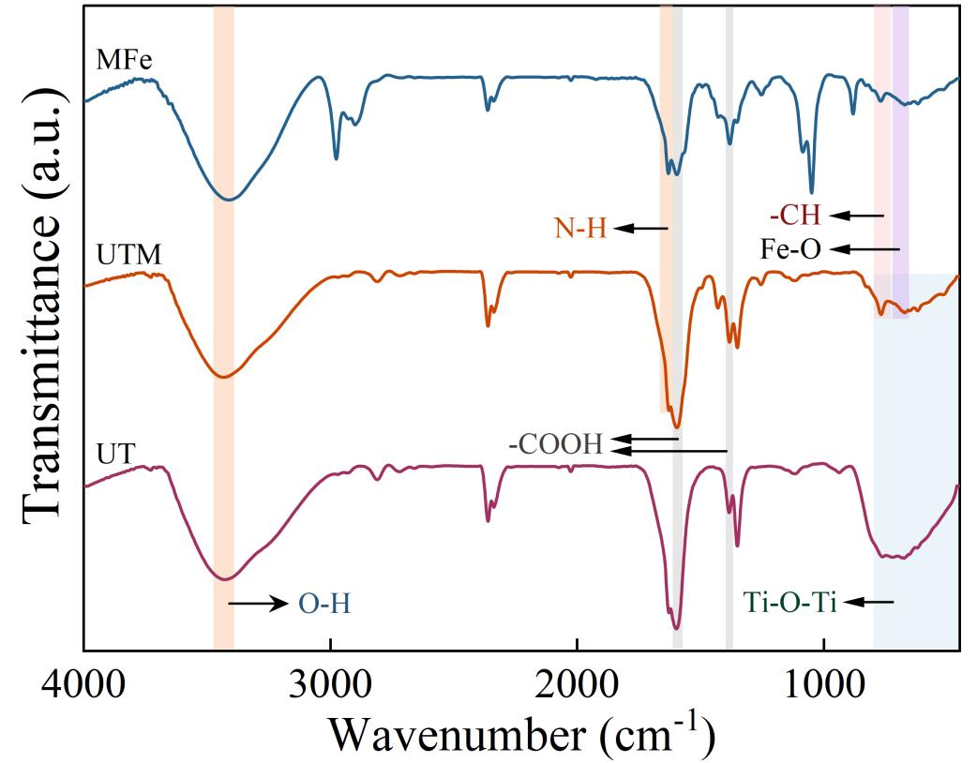
Fig. S1. FTIR spectra of UT, UTM, and NH₂-MIL-88B(Fe) (MFe). The spectra show the characteristic Ti–O–Ti vibrations of TiO₂ and the carboxylate linker bands of NH₂-MIL-88B(Fe); the reshaped low-wavenumber region in UTM suggests interfacial coupling (e.g., Ti–O–Fe linkages).

UT shows a broad peak at 3436 cm⁻¹ (O–H stretching from surface hydroxyls and adsorbed water) and strong bands at 400–880 cm⁻¹ (Ti–O–Ti lattice vibrations). UTM retains key features from both UT and MFe, confirming component integration. Reshaping and intensification of bands in the 400–800 cm⁻¹ region suggest formation of interfacial Ti–O–Fe linkages, indicating chemical bonding rather than physical mixing. This interfacial coupling enhances structural stability and supports coordinated DOX release with ferroptosis induction.

S2. Textural properties and porosity evolution
Nitrogen adsorption–desorption measurements were performed to evaluate the evolution of textural properties from UCNP to UT and UTM 9 (Fig. S2). UCNP displayed a type II/III isotherm with negligible hysteresis, indicating a largely nonporous structure with a low specific surface area (11.96 m²/g) and a large average pore diameter (44.75 nm). After TiO₂ coating, UT exhibited a type IV isotherm with an H3 hysteresis loop, consistent with the formation of mesopores (approximately 10–20 nm) associated with the TiO₂ shell; the specific surface area increased to 12.81 m²/g and the average pore diameter decreased to 41.34 nm. Following in situ growth of NH₂-MIL-88B(Fe), UTM maintained mesoporosity but showed reduced adsorption capacity, suggesting partial pore blocking by the MOF layer. The broadened pore size distribution (approximately 5–25 nm) indicates a hierarchical porous structure that can support molecular diffusion while providing adsorption sites for drug loading and microenvironment-responsive release.

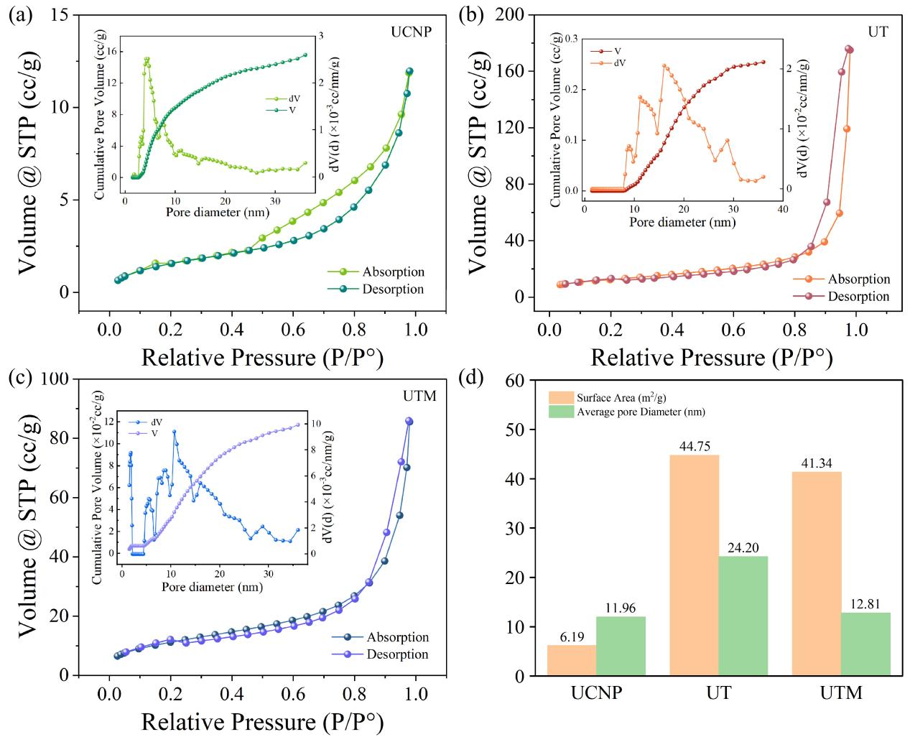
Fig. S2. Nitrogen adsorption–desorption isotherms and pore size distribution curves of (a) UCNP, (b) UT, and (c) UTM; (d) comparison of specific surface area and average pore diameter.

