Appendix 1. Item examples questionnaires
The items, initially formulated in Dutch for the participants, were revised to suit the objectives of this study and translated into English.

SIS-HCP
You need (therapy) goals. [name HCP] …
... explains why specific lifestyle changes are meaningful for me. (autonomy-support)
... provides an overview of possible goals for me and guides me in making a choice. (structure)
... determines which goal I will pursue. Ultimately, [name HCP] is the professional expert. (control)
... waits and lets me decide on my own goals. (chaos)
Example question from SIS-HCP.²⁴

BPNSFS
During the therapy with [name HCP], …
… I feel capable of achieving my therapy goals. (need satisfaction)
… most of the things I do feel like obligations. (need frustration)
Example question from BPNSFS.⁴⁹

BREQ-3
I go to therapy because...
… I enjoy my therapy sessions. (intrinsic motivation)
… I consider therapy a fundamental part of who I am. (integrated regulation)
… I find it important to attend my therapy regularly. (identified regulation)
… I feel guilty if I don’t go to my therapy. (introjected regulation)
… I go to therapy because others think I should. (external regulation)
… I don’t see why I should go to my therapy. (amotivation)
Example question from BREQ-3.⁵²

RAdMAT-NL
During therapy, ...
… I arrive on time for my therapy appointments. (participation/attendance)
… I communicate with [name HCP] if I have difficulties with an exercise. (communication)
… I put 100% effort into my therapeutic exercises. (attitude/effort)
Example question from RAdMAT-NL.⁵⁴

Supplementary Table 1: Descriptives study variables

 | McDonalds ω |  |  |  | Min.-Max. | M(SD) | Md (IQ1-IQ3) |  | Skewness | Kurtosis
(De)motivating interaction styles (range: 0-5; N = 346)
Motivating |  | .91 |  | .80 – 5.00 |  | 3.85 (.77) |  | 3.95 (3.35-4.45) | -.81 | .74
Demotivating |  | .84 |  | .00 – 4.75 |  | 1.73 (.82) |  | 1.70 (1.20-2.25) | .33 | .23
Autonomy-support |  | .82 |  | .90 – 5.00 |  | 3.87 (.77) |  | 4.00 (3.40-4.48) | -.73 | .60
Structure |  | .85 |  | .70 – 5.00 |  | 3.83 (.82) |  | 3.90 (3.30-4.50) | -.83 | .85
Control |  | .84 |  | .00 – 4.90 |  | 1.97 (1.05) |  | 2.00 (1.20-2.60) | .22 | -.44
Chaos |  | .80 |  | .00 – 4.60 |  | 1.49 (.90) |  | 1.40 (.80-2.08) | .41 | -.26
Basic Psychological Needs (range: 1-5; N = 330)
Need satisfaction |  | .91 |  | 1.25 – 5.00 |  | 3.75 (.81) |  | 3.83 (3.25-4.38) | -.53 | -.28
Need frustration |  | .75 |  | 1.00 – 3.33 |  | 1.55 (.47) |  | 1.42 (1.17-1.83) | .94 | .20
Autonomy satisfaction |  |  | .76 | 1.00 – 5.00 |  | 3.69 (.85) |  | 3.75 (3.25-4.25) | -.47 | -.09
Relatedness satisfaction |  |  | .90 | 1.00 – 5.00 |  | 3.57 (1.13) |  | 3.75 (2.75-4.50) | -.51 | -.71
Competence satisfaction |  |  | .74 | 1.00 – 5.00 |  | 4.00 (.76) |  | 4.00 (3.50-4.50) | -.85 | .53
Autonomy frustration |  |  | .67 | 1.00 – 4.25 |  | 1.78 (.75) |  | 1.50 (1.00-2.25) | .96 | .30
Relatedness frustration |  |  | .51 | 1.00 – 4.00 |  | 1.29 (.46) |  | 1.00 (1.00-1.50) | 2.08 | 5.65
Competence frustration |  |  | .67 | 1.00 – 4.00 |  | 1.58 (.64) |  | 1.25 (1.00-2.00) | 1.02 | .33
Motivation for therapy (range: 0-4; N = 335)
Autonomous motivation |  |  | .86 | .67 – 4.00 |  | 2.77 (.76) |  | 2.83 (2.25-3.33) | -.47 | -.32
Controlled motivation |  |  | .57 | .00 – 3.63 |  | 1.29 (.69) |  | 1.19 (.75-1.88) | .23 | -.37
Intrinsic motivation |  |  | .90 | .00 – 4.00 |  | 2.62 (1.07) |  | 2.75 (2.00-3.50) | -.51 | -.50
Integrated regulation |  |  | .79 | .00 – 4.00 |  | 2.59 (1.05) |  | 2.75 (1.75-3.50) | -.43 | -.71
Identified regulation |  |  | .60 | .50 – 4.00 |  | 3.09 (.68) |  | 3.00 (2.75-3.75) | -.87 | 1.17
Introjected regulation |  |  | .72 | .00 – 4.00 |  | 2.07 (1.08) |  | 2.00 (1.25-3.00) | .01 | -.73
External regulation |  |  | .82 | .00 – 3.75 |  | .51 (.79) |  | .00 (.00-.75) | 1.97 | 3.60
Amotivation |  |  | .68 | .00 – 3.50 |  | .23 (.53) |  | .00 (.00-.06) | 2.85 | 9.19
Therapy adherence (range: 1-4; N = 328)
Participation |  | .62 |  | 2.60 – 4.00 |  | 3.77 (.29) |  | 3.80 (3.60-4.00) | -1.42 | 1.78
Communication |  | .65 |  | 1.67 – 4.00 |  | 3.44 (.62) |  | 3.67 (3.00-4.00) | -1.02 | .34
Attitude |  | .89 |  | 2.13 – 4.00 |  | 3.74 (.39) |  | 3.88 (3.63-4.00) | -1.72 | 2.47
Note: N=Number, M=Mean, SD=Standard Deviation, Md=median, IQ=interquartile.

Supplementary Table 2: Correlation matrix with exact p-values

 | 1 | 2 | 3 | 4 | 5 | 6 | 7 | 8 | 9 | 10 | 11 | 12 | 13 | 14
(De)motivating interaction styles (range: 0-5; N = 346)
- Autonomy-support ª | -
- Structure ª | .87 (<.001) | -
- Control ª | .26 (<.001) | .39 (<.001) | -
- Chaos ª | -.14 (.011) | -.12 (.030) | .40 (<.001) | -
Basic psychological needs (range: 1-5; N = 330)
- Need satisfaction ª | .47 (<.001) | .52 (<.001) | .19 (<.001) | -.03 (.544) | -
- Need frustration ª | -.27 (<.001) | -.30 (<.001) | .17 (.002) | .24 (<.001) | -.20 (<.001) | -
Motivation for therapy (range: 0-4; N = 335)
- Intrinsic motivation ª | .32 (<.001) | .35 (<.001) | .15 (.005) | .04 (.478) | .58 (<.001) | -.25 (<.001) | -
- Integrated regulation ª | .29 (<.001) | .30 (<.001) | .10 (.060) | -.02 (.693) | .64 (<.001) | -.01 (.817) | .40 (<.001) | -
- Identified regulation ª | .32 (<.001) | .34 (<.001) | .09 (.095) | -.09 (.090) | .53 (<.001) | -.12 (.033) | .47 (<.001) | .66 (<.001) | -
- Introjected regulation ª | .20 (<.001) | .23 (<.001) | .16 (.003) | -.06 (.316) | .33 (<.001) | .13 (.017) | .21 (<.001) | .44 (<.001) | .52 (<.001) | -
- External regulation ^{b} | -.18 (<.001) | -.15 (.006) | .24 (<.001) | .30 (<.001) | -.13 (.024) | .36 (<.001) | -.12 (.033) | -.12 (.028) | -.06 (.302) | .09 (.085) | -
- Amotivation ^{b} | -.14 (.009) | -.14 (.014) | .21 (<.001) | .25 (<.001) | -.17 (.002) | .30 (<.001) | -.21 (<.001) | -.19 (<.001) | -.28 (<.001) | .03 (.614) | .41 (<.001) | -
Therapy adherence (range: 1-4; N = 328)
- Participationª | .14 (.011) | .25 (<.001) | .14 (.014) | -.05 (.352) | .37 (<.001) | -.16 (.004) | .22 (<.001) | .27 (<.001) | .26 (<.001) | .19 (<.001) | -.07 (.240) | -.05 (.412) | -
- Communicationª | .42 (<.001) | .40 (<.001) | -.05 (.418) | -.12 (.030) | .37 (<.001) | -.22 (<.001) | .23 (<.001) | .24 (<.001) | .24 (<.001) | .10 (.073) | -.19 (<.001) | -.20 (<.001) | .13 (.018) | -
- Attitude ^{b} | .34 (<.001) | .41 (<.001) | .12 (.038) | -.13 (.016) | .49 (<.001) | -.25 (<.001) | .39 (<.001) | .29 (<.001) | .37 (<.001) | .20 (<.001) | -.18 (.001) | -.17 (.002) | .43 (<.001) | .46 (<.001)
N=Number, ªnormal distribution, ^{b}non-normal distribution; values in bold=significant correlations (p<.05).

Supplementary Figure 1: Additional SEM analyses
A: Additional SEM analysis 1 (aggregated interaction styles to motivating and demotivating)
CFI=.91, RMSEA=.04, SRMR=.07
Note: Green arrow = positive relation, red arrow = negative relation.
B: Additional SEM analysis 2 (aggregated interaction styles and types of regulation)
CFI=.94, RMSEA=.04, SRMR=.06
Note: Green arrow = positive relation, red arrow = negative relation.
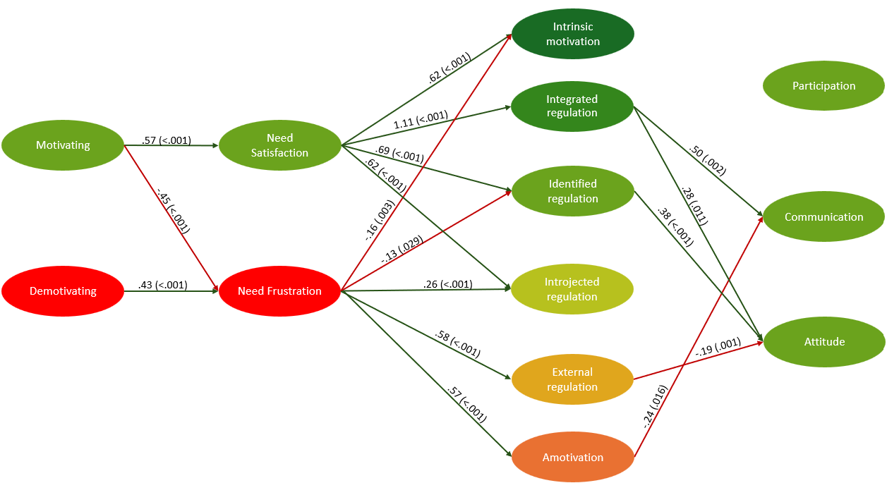
A
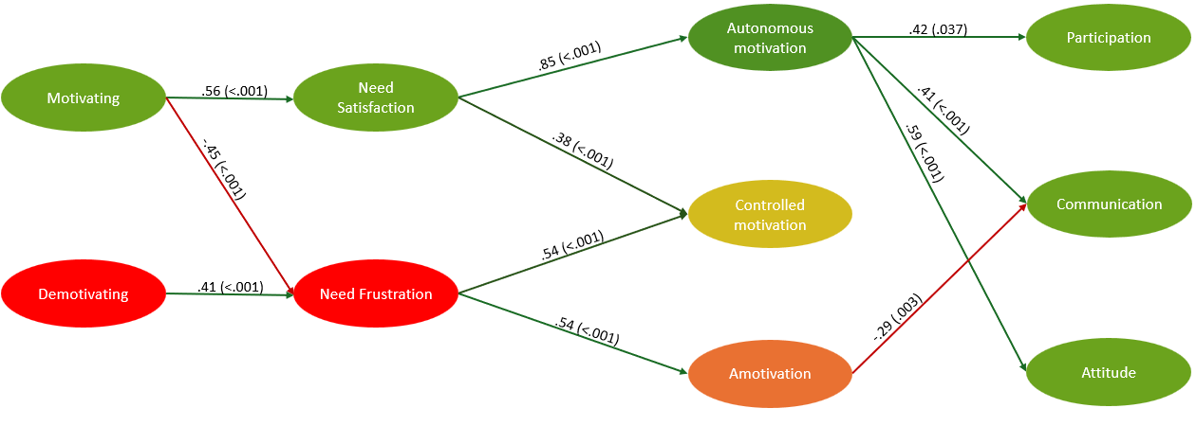
B

