Supplementary Table1 Different Expression Proteins（DEPs） of different groups analysis in plasma data
DEPs | DR vs T2DM |  | DME vs T2DM |  | DME vs DR |  | DR&DME vs T2DM
Upregulated | CCL19  IL4  STAMBP  IL5  MMP-10  SIRT2  4E-BP1  CD40  NRTN  CASP-8  CXCL10  IL17A | OPG  CCL28  CD5  CCL4  IL6  TSLP  β-NGF  GDNF  IL20  MCP-1 | CCL19  TSLP  IL4  IL7  IL24  CD40  IL33  IL10  SIRT2  CD8A  GDNF | STAMBP  4E-BP1  IL-1α  FGF-23  CXCL10  IL13  CCL25 | IL7  TWEAK  ADA  IL1α  LIF-R  IL10  CD8A  LIF  IL18  MMP-1  Flt3L  IL24  IL33  uPA | IL15RA  FGF-5  TSLP  IL22 RA1  TNFB  IL13  IL2RB  TRAIL  CXCL9  CCL25  SCF  IL18R1  IFN-γ  CSF-1 | CCL19  IL4  TSLP  CD40  SIRT2  STAMBP  4E-BP1  IL24  CXCL10  MMP-10 | IL7  GDNF  NRTN  IL33  OPG  FGF-23
Downregulated | OSM  uPA  MCP-4  CXCL6  TNFSF14  MMP-1  CXCL1  TWEAK  LIF-R  MCP-2  LIF  IL-15RA  DNER  EN-RAGE  CCL23  IL8  LAP TGF-β-1  Flt3L  IL18  IFN-γ | FGF-21  FGF-5  TNFB  TRANCE  ADA  CXCL9  FGF-19  TGF-α  IL10  CCL20  IL17C  TRAIL  IL-1α  CD244  IL10RB  HGF  ST1A1  ARTN | MCP-4  CXCL6  TNFSF14  OSM  CXCL1  uPA  EN-RAGE  CCL3  IL8  DNER  MCP-2  MCP-3  CCL23  IL20  MMP-1  TRANCE  IL5  MCP-1  CD6  IL10RB  CST5  LAP | TGF-β-1  FGF-21  NT-3  TWEAK  β-NGF  IL2  FGF-19  HGF  CCL20  CD244  ST1A1  AXIN1  IFN-γ | CXCL6  CXCL1  IL5  MCP-3  MCP-4  CCL3  MCP-1  TNFSF14  β-NGF  IL20  EN-RAGE  CASP-8  IL8  CST5  DNER  IL2  IL17A  CCL4  NRTN  CD5  CCL23  AXIN1  STAMBP | CCL28  CD6  NT-3  MMP-10  CDCP1  MCP-2  TNFRSF9  TRANCE  4E-BP1  IL6  IL10RA | OSM  MCP-4  CXCL6  TNFSF14  CXCL1  uPA  MMP-1  EN-RAGE  MCP-2  DNER  IL8  TWEAK  CCL23  CCL3  TRANCE  MCP-3  LAP TGF-β-1  FGF-21  IL-10RB  IFN-γ | LIF  LIF-R  FGF-19  CD6  IL15RA  HGF  CXCL9  Flt3L  CCL20  ST1A1  TGF-α  IL-20  FGF-5  NT-3  CD244  IL18
Number of DEPs | 60 |  | 52 |  | 62 |  | 52

Supplementary Table2 Different Expression Proteins（DEPs） of different groups analysis in tear data
DEPs | DR vs T2DM | DME vs T2DM |  | DME vs DR |  | DR&DME vs T2DM
Upregulated | PD-L1  TNFSF14  CXCL11  IL6  CCL19  DNER  IL12B  IL4  CXCL9  OPG  IL15RA  ADA  CCL4  CCL20  IL18  LIF  CST5  CD40  IL22RA1  CD6  SCF  TRANCE | IL6  CCL20  DNER  AXIN1  LIF-R  TNFSF14  IL24  CXCL11  LIF  ADA  IL17C  CCL19  OPG  uPA  CCL4  CCL3  CXCL10  TNFB  MCP-2  CXCL9  MCP-4  PD-L1  SIRT2  CASP-8  ST1A1  IL7  CST5  SCF  MMP-10  CCL28  TRAIL  Flt3L | CD40  VEGFA  FGF-23  IL18  CD6  IL20RA  IL8  HGF  CXCL5  STAMBP  CD5  TWEAK  TNF  MMP-1  IL10RB  CDCP1  TRANCE  CX3CL1  CSF-1  CXCL6  IL33  NT-3  IL18R1  OSM  TGF-α  IL-1α  4E-BP1  CCL23  CCL11  IL15RA | IL6  DNER  uPA  CCL20  IL17C  MCP-4  AXIN1  LIF-R  CCL3  IL24  LIF  CCL4  SIRT2  CASP-8  TNFB  ST1A1  MCP-2  TNFSF14  CXCL10  IL20RA  ADA  CCL19  TRAIL  CCL28  FGF-23  CST5  OPG  SCF  NT-3  CDCP1  IL10RB  IL8  CCL11  HGF | TWEAK  FGF-19  IFN-γ  CX3CL1  MMP-10  STAMBP  OSM  CXCL11  TNFRSF9  CXCL5  IL7  VEGFA  Flt3L  CD40  CCL23  TGF-α  CD5  IL2RB  EN-RAGE  TSLP  MMP-1  CXCL1  IL18R1  MCP-1  CD244  IL33  TNF  CXCL9  4E-BP1  CXCL6  CSF-1  CD6  IL18 | TNFSF14  CXCL11  CCL19  PD-L1  OPG  CXCL9  DNER  IL6  ADA  CCL4  LIF  CCL20  LIF-R  CST5  uPA  CCL3  AXIN1  IL17C  IL18  SCF  MCP-4  CD40  IL24  IL7  Flt3L  CD6  IL15RA  MMP-10  VEGFA  TNF  MCP-2  TRAIL | CXCL10  TRANCE  IL8  CXCL5  FGF-23  MMP-1  SIRT2  ST1A1  CD5  CSF-1  STAMBP  IL-1α  CASP-8  TNFB  CXCL6
Downregulated | TNFRSF9  TSLP  IL2  NT-3  IL13  IL2RB  SLAMF1  IFN-γ  IL20  IL17A  TNFB  FGF-19  CD244  CASP-8  IL5  CCL23  CCL11  CCL28 | IL12B  IL20  SLAMF1  IL5  IL17A  Beta-NGF  TSLP  IL2  CCL25  IL13  TNFRSF9  CD8A  MCP-3  IL10RA  FGF-21 |  | IL12B  IL4  β-NGF  SLAMF1  IL5  IL17A  IL15RA  IL22 RA1  ARTN  CCL25  MCP-3  IL20 |  | TSLP  TNFRSF9  IL2  IL20  SLAMF1  IL13  IL17A  IL5  β-NGF  IL2RB  CCL25  CD8A
Number of DEPs | 40 | 77 |  | 79 |  | 59

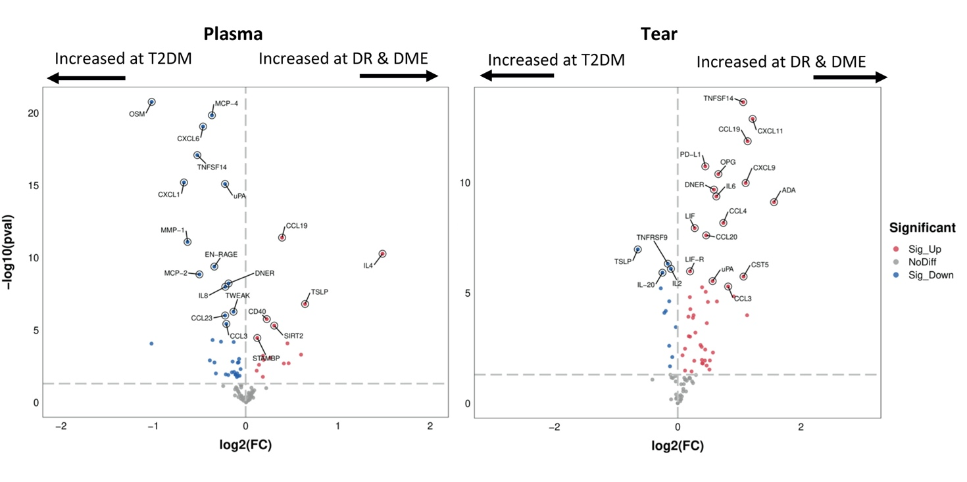
Supplementary Figure 1 Volcano plot of the DEPs compared between the DR & DME groups and the T2DM group.

