Supplementary Material: COREQ (COnsolidated criteria for REporting Qualitative research) Checklist

A checklist of items that should be included in reports of qualitative research. You must report the page number in your manuscript where you consider each of the items listed in this checklist. If you have not included this information, either revise your manuscript accordingly before submitting or note N/A.

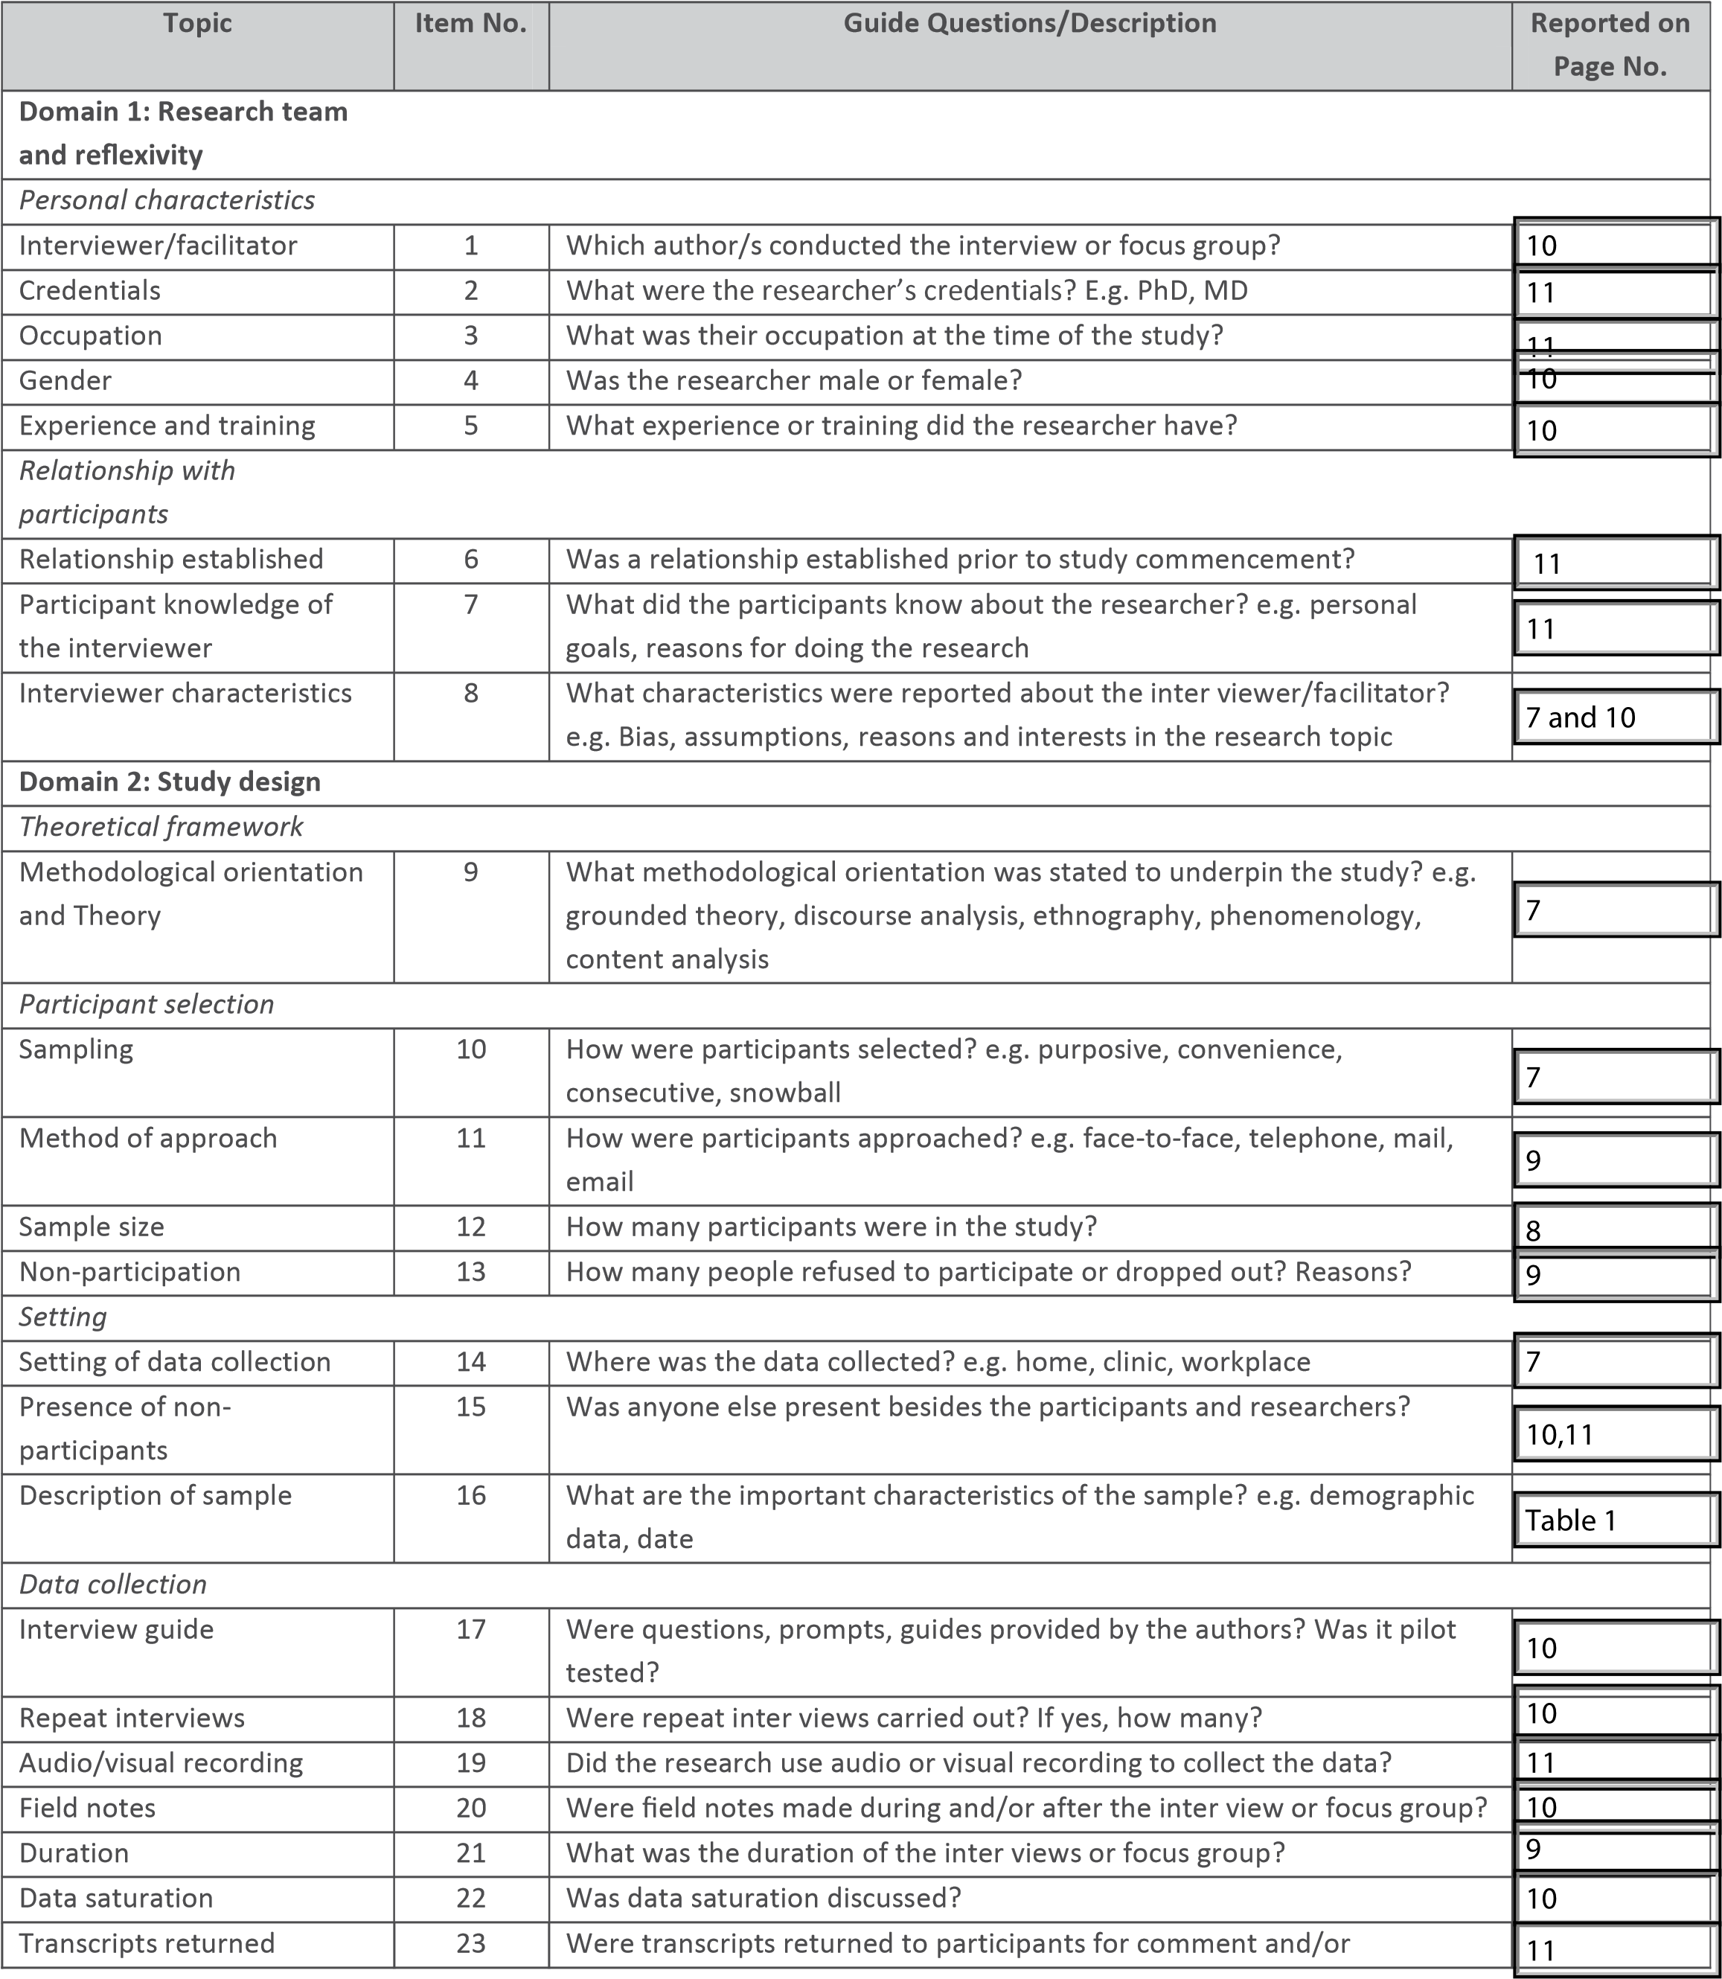
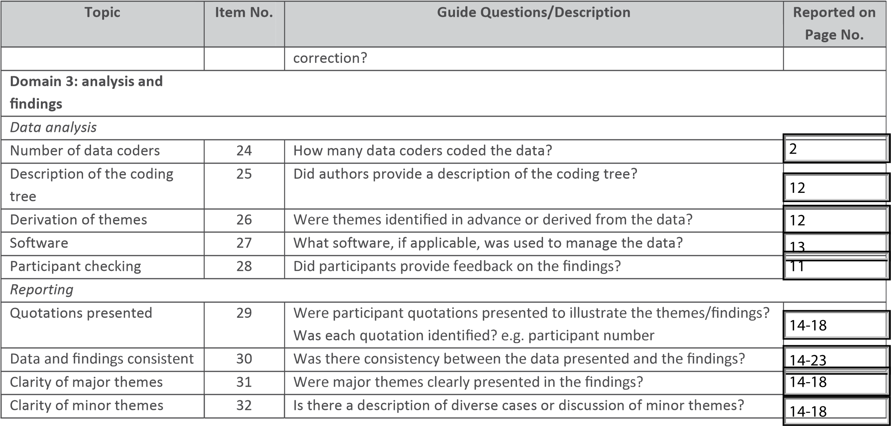
Developed from: Tong A, Sainsbury P, Craig J. Consolidated criteria for reporting qualitative research (COREQ): a 32-item checklist for interviews and focus groups. International Journal for Quality in Health Care. 2007. Volume 19, Number 6: pp. 349 357

Once you have completed this checklist, please save a copy and upload it as part of your submission. DO NOT include this checklist as part of the main manuscript document. It must be uploaded as a separate file.

