List of Supplementary Tables
Table | Title
Table S1 | Complete institutional distribution of participants in the final analytic sample
Table S2 | Chi-square analysis of format preference by age group
Table S3 | Chi-square analysis of format preference by sex
Table S4 | Welch ANOVA and Games-Howell post-hoc analysis of print-format preference score by study year
Table S5 | Welch ANOVA and Games-Howell post-hoc analysis of print-format preference score by medical specialty

Table S1. Complete institutional distribution of participants in the final analytic sample
University / institution | Frequency | Percent
Public universities | 1905 | 86.55
Idlib University | 41 | 1.86
Latakia University | 156 | 7.09
Aleppo University | 423 | 19.22
Hama University | 196 | 8.91
Homs University | 504 | 22.90
Damascus University | 428 | 19.45
Tartous University | 157 | 7.13
Private universities | 296 | 13.45
International University for Science and Renaissance | 5 | 0.23
Syrian Private University | 7 | 0.32
Sham Private University | 20 | 0.91
Arab Private University | 4 | 0.18
Qalamun Private University | 56 | 2.54
Al-Manara University | 7 | 0.32
Al-Wadi Private University | 32 | 1.45
National Private University | 53 | 2.41
Yarmouk Private University | 4 | 0.18
Al-Andalus Private University | 5 | 0.23
Al-Hawash University | 20 | 0.91
Qasioun Private University | 12 | 0.55
Cordoba University | 71 | 3.23
Total | 2201 | 100.0
Bold text indicates grouped university-type headings and the total row.

Table S2. Chi-square analysis of format preference by age group
Preference | Total | <21 n (%) | 21–24 n (%) | ≥25 n (%) | χ² | p-value | Cramér’s V
Neutral | 37 | 27 (73.0) | 8 (21.6) | 2 (5.4) | 17.484 | 0.002 | 0.063
Prefer print | 1784 | 786 (44.1) | 928 (52.0) | 70 (3.9)
Prefer electronic | 380 | 158 (41.6) | 199 (52.4) | 23 (6.1)
Total | 2201 | 971 (44.1) | 1135 (51.6) | 95 (4.3)
Percentages are calculated within each format-preference category. A statistically significant but very small association was observed between age group and overall format preference.

Table S3. Chi-square analysis of format preference by sex
Preference | Total | Male n (%) | Female n (%) | χ² | p-value | Cramér’s V
Neutral | 37 | 15 (40.5) | 22 (59.5) | 48.838 | <0.001 | 0.149
Prefer print | 1784 | 523 (29.3) | 1261 (70.7)
Prefer electronic | 380 | 181 (47.6) | 199 (52.4)
Total | 2201 | 719 (32.7) | 1482 (67.3)
Percentages are calculated within each format-preference category. Sex showed a small but statistically significant association with overall format preference

Table S4. Welch ANOVA and Games-Howell post-hoc analysis of print-format preference score by study year
A. Descriptive statistics by study year
Study year | N | Mean | SD | 95% CI
1st year | 387 | 3.69 | 0.58 | 3.64–3.75
2nd year | 485 | 3.66 | 0.63 | 3.61–3.72
3rd year | 398 | 3.67 | 0.74 | 3.60–3.75
4th year | 397 | 3.69 | 0.72 | 3.62–3.76
5th year | 390 | 3.66 | 0.65 | 3.59–3.72
6th year | 144 | 3.71 | 0.80 | 3.58–3.84
Total | 2201 | 3.68 | 0.68 | 3.65–3.71

B. Homogeneity of variance and Welch ANOVA results
Test | Statistic | df1 | df2 | p-value
Levene’s test | 8.288 | 5 | 2195 | <0.001
Welch ANOVA | 0.247 | 5 | 806.612 | 0.942

Table S5. Welch ANOVA and Games-Howell post-hoc analysis of print-format preference score by medical specialty
A. Descriptive statistics by medical specialty
Medical specialty | N | Mean | SD | 95% CI
Preparatory year | 250 | 3.79 | 0.49 | 3.73–3.85
Pharmacy | 429 | 3.81 | 0.61 | 3.76–3.87
Dentistry | 421 | 3.61 | 0.66 | 3.54–3.67
Medicine | 786 | 3.61 | 0.74 | 3.55–3.66
Health sciences | 315 | 3.68 | 0.70 | 3.60–3.76
Total | 2201 | 3.68 | 0.68 | 3.65–3.71

B. Homogeneity of variance and Welch ANOVA results
Test | Statistic | df1 | df2 | p-value
Levene’s test | 14.653 | 4 | 2196 | <0.001
Welch ANOVA | 11.152 | 4 | 918.658 | <0.001

C. Significant Games-Howell pairwise comparisons
Comparison | Mean difference | 95% CI | p-value
Preparatory year vs Dentistry | 0.181 | 0.058–0.303 | <0.001
Preparatory year vs Medicine | 0.182 | 0.071–0.294 | <0.001
Pharmacy vs Dentistry | 0.208 | 0.089–0.327 | <0.001
Pharmacy vs Medicine | 0.210 | 0.102–0.318 | <0.001

List of Supplementary Figures

Figure | Title
Figure S1 | Responses to the statement “I remember information from my course readings best when I read them from printed pages” reported by medical specialty
Figure S2 | Responses to the statement “I prefer to have all my course materials in print format” reported by medical specialty
Figure S3 | Responses to the statement “If an assigned reading is 7 pages or more, I prefer to read it in print” reported by medical specialty
Figure S4 | Responses to the statement “If an assigned reading is less than 7 pages, I prefer to read it electronically” reported by medical specialty
Figure S5 | Responses to the statement “I prefer electronic textbooks over print textbooks.“ reported by medical specialty
Figure S6 | Responses to the statement “I can focus on the material better when I read it in print.“ reported by medical specialty
Figure S7 | Responses to the statement “I prefer to read my course readings electronically.“ reported by medical specialty
Figure S8 | Responses to the statement “I usually highlight and annotate my printed course readings” reported by medical specialty
Figure S9 | Responses to the statement “I usually highlight and annotate my electronic readings.“ reported by medical specialty
Figure S10 | Responses to the statement “I am more likely to review my course readings (after I’ve read them at least once) when they are in print.“ reported by medical specialty
Figure S11 | Responses to the statement “I prefer to print out my course readings rather than read them electronically.“ reported by medical specialty
Figure S12 | Responses to the statement “I like to make digital copies of my printed course materials.“ reported by medical specialty
Figure S13 | Responses to the statement “I prefer to read course readings which are in my native language electronically rather than print.“ reported by medical specialty
Figure S14 | Responses to the statement “I prefer reading foreign language material in print rather than electronic format.“ reported by medical specialty
Figure S15 | Responses to the statement “My preferred reading format, electronic or print, depends on the language of the reading.“ reported by medical specialty

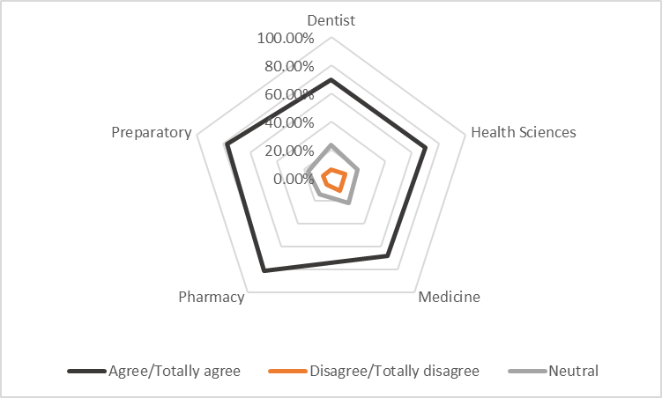
Fig S1. Responses to the statement “I remember information from my course readings best when I read them from printed pages,” reported by medical specialty. n = 2201; Agree/Totally agree n = 1587, 72.10%; Neutral n = 435, 19.76%; Disagree/Totally disagree n = 179, 8.13%.

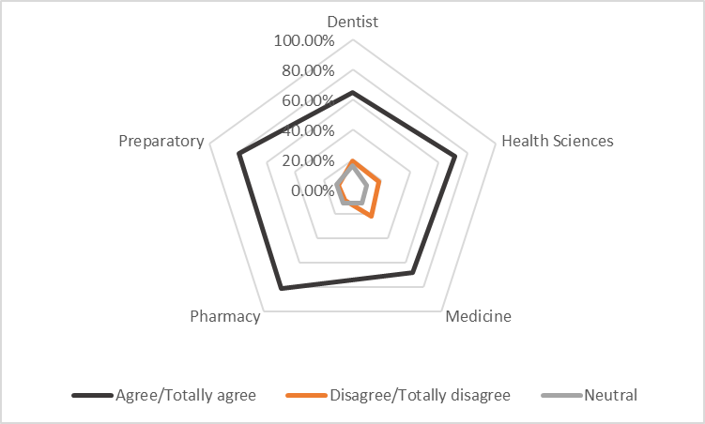
Fig S2. Responses to the statement “I prefer to have all my course materials in print format” reported by medical specialty n = 2201; Agree/Totally Agree n = 1578, 71.69%; Neutral n = 257, 11.68%; Disagree/Totally Disagree n = 366, 16.63%

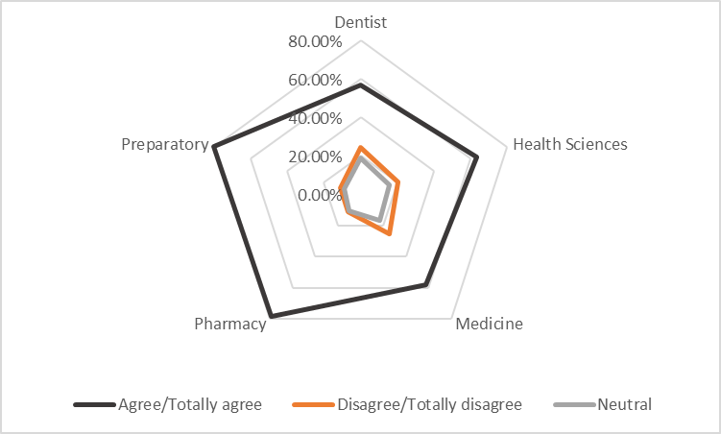
Fig S3. Responses to the statement “If an assigned reading is 7 pages or more, I prefer to read it in print” reported by medical specialty n = 2201; Agree/Totally Agree n = 1433, 65.11%; Neutral n = 328,14.90%; Disagree/Totally Disagree n = 440, 19.99%

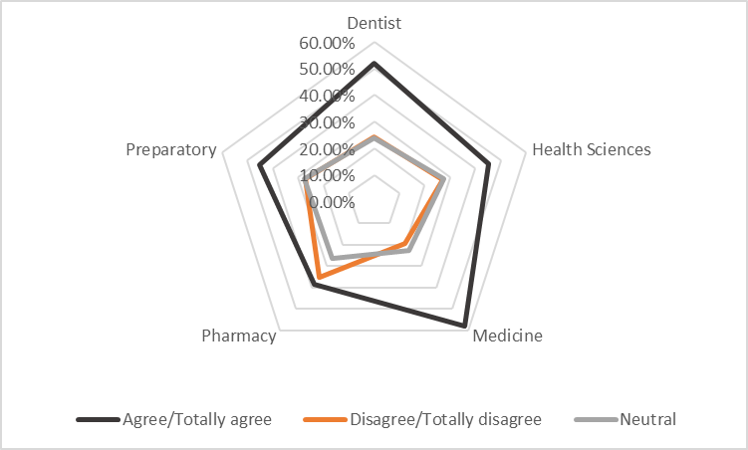
Fig S4. Responses to the statement “If an assigned reading is less than 7 pages, I prefer to read it electronically,” reported by medical specialty. n = 2201; Agree/Totally agree n = 1093, 49.66%; Neutral n = 547, 24.85%; Disagree/Totally disagree n = 561, 25.49%.

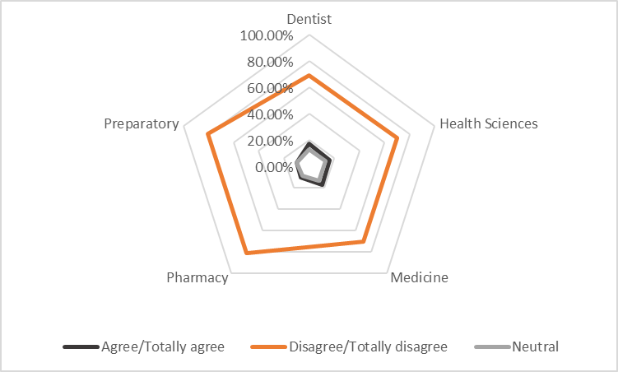
Fig S5. Responses to the statement “I prefer electronic textbooks over print textbooks.“ reported by medical specialty n = 2201; Agree/Totally Agree n = 330, 14.99%; Neutral n = 258, 11.72%; Disagree/Totally Disagree n = 1613, 73.28%

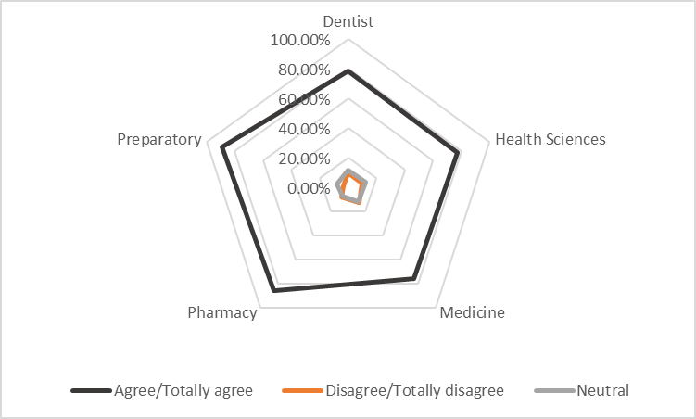
Fig S6. Responses to the statement “I can focus on the material better when I read it in print.“ reported by medical specialty n = 2201; Agree/Totally Agree n = 1758, 79.87%; Neutral n = 230, 10.45%; Disagree/Totally Disagree n = 213, 9.68%

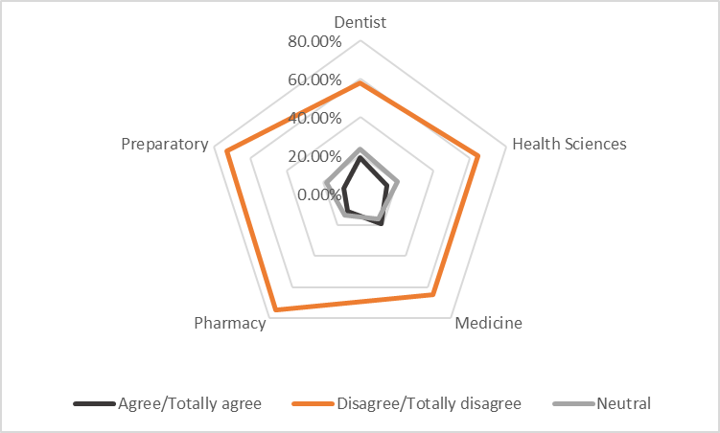
Fig S7. Responses to the statement “I prefer to read my course readings electronically.“ reported by medical specialty n = 2201; Agree/Totally Agree n = 346, 15.72%; Neutral n = 397, 18.04%; Disagree/Totally Disagree n = 1458, 66.24%

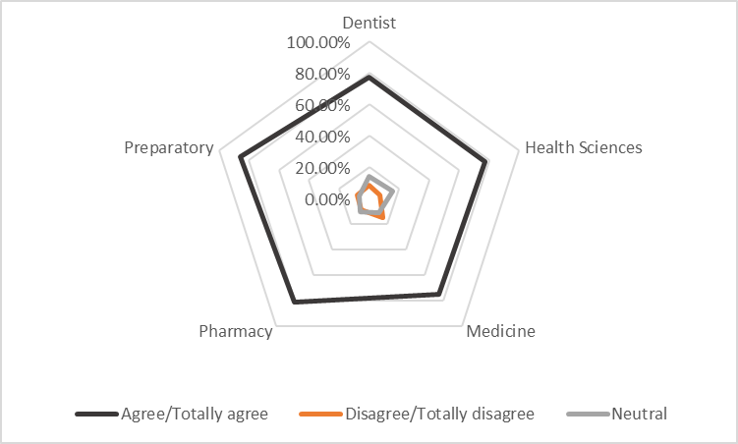
Fig S8. Responses to the statement “I usually highlight and annotate my printed course readings,” reported by medical specialty. n = 2201; Agree/Totally agree n = 1723, 78.28%; Neutral n = 250, 11.36%; Disagree/Totally disagree n = 228, 10.36%.

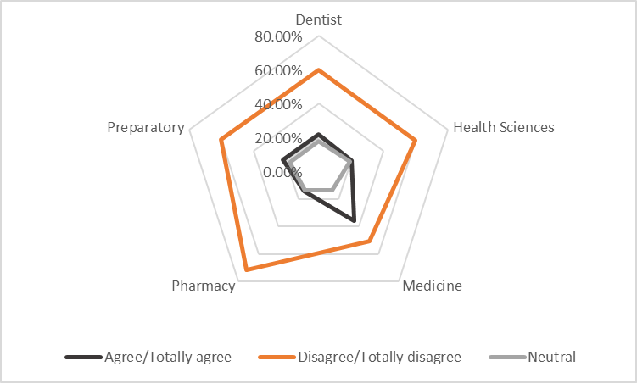
Fig S9. Responses to the statement “I usually highlight and annotate my electronic readings,” reported by medical specialty. n = 2201; Agree/Totally agree n = 557, 25.31%; Neutral n = 347, 15.77%; Disagree/Totally disagree n = 1297, 58.93%.

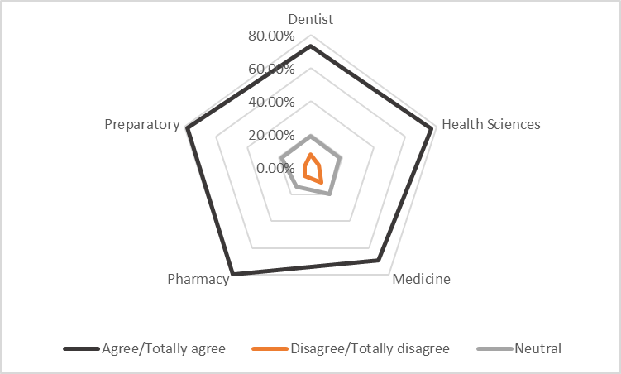
Fig S10. Responses to the statement “I am more likely to review my course readings (after I’ve read them at least once) when they are in print.“ reported by medical specialty n = 2201; Agree/Totally Agree n = 1631, 74.10%; Neutral n = 399 ,18.13%; Disagree/Totally Disagree n = 171, 7.77%

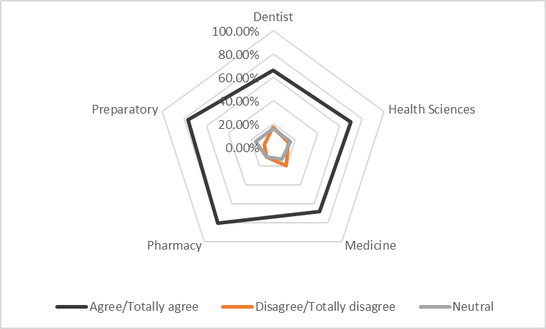
Fig S11. Responses to the statement “I prefer to print out my course readings rather than read them electronically.“ reported by medical specialty n = 2201; Agree/Totally Agree n = 1567, 71.19%; Neutral n = 300 ,13.63%; Disagree/Totally Disagree n = 334,15.17%

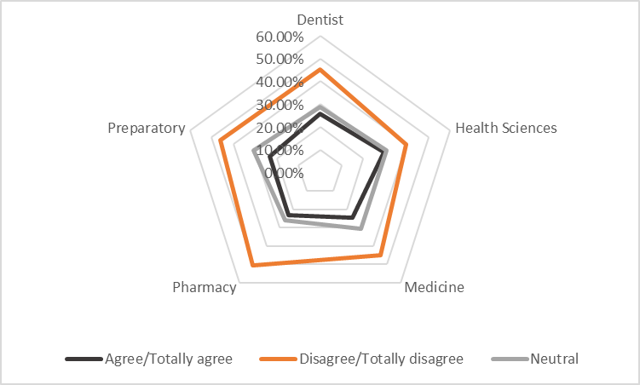
Fig S12. Responses to the statement “I like to make digital copies of my printed course materials.“ reported by medical specialty n = 2201; Agree/Totally Agree n = 552, 25.08%; Neutral n = 648 ,29.44%; Disagree/Totally Disagree n = 1001,45.48%

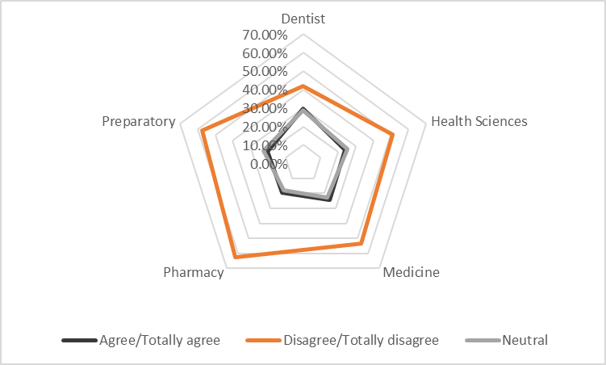
Fig S13. Responses to the statement “I prefer to read course readings in my native language electronically rather than in print,” reported by medical specialty. n = 2201; Agree/Totally agree n = 524, 23.81%; Neutral n = 510, 23.17%; Disagree/Totally disagree n = 1167, 53.02%.

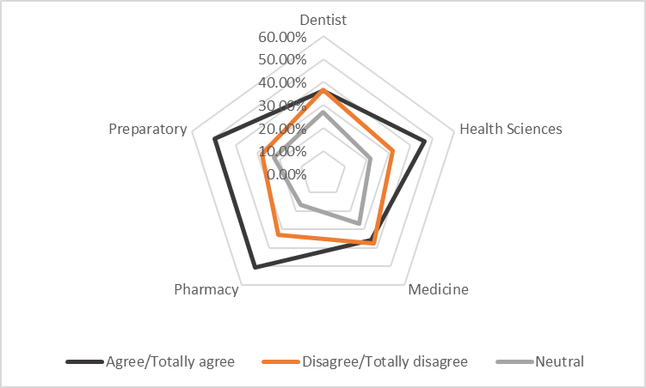
Fig S14. Responses to the statement “I prefer reading foreign language material in print rather than electronic format.“ reported by medical specialty n = 2201; Agree/Totally Agree n = 920, 41.80%; Neutral n = 521 ,23.67%; Disagree/Totally Disagree n = 760 ,34.53%

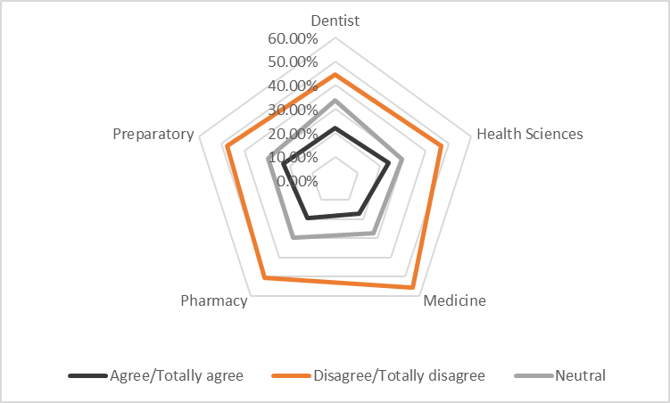
Fig S15. Responses to the statement “My preferred reading format, electronic or print, depends on the language of the reading.“ reported by medical specialty n = 2201; Agree/Totally Agree n = 442, 20.08%; Neutral n = 651 ,29.58%; Disagree/Totally Disagree n = 1108 ,50.34%

