Supplementary Information

Supplementary Table 1 Dose regimen for intervention treatment and comparators
Treatment | Administration  mode | Dosage | Reference
Upadacitinib
Upadacitinib 15 mg | Oral | 15 mg once daily | MEASURE UP-1, -2
Upadacitinib 30 mg | Oral | 30 mg once daily | MEASURE UP-1, -21
Upadacitinib 15 mg + TCS | Oral | 15 mg once daily along with TCS | AD UP
Upadacitinib 30 mg + TCS | Oral | 30 mg once daily along with TCS | AD UP2
Abrocitinib
Abrocitinib 100 mg | Oral | 100 mg once daily | JADE MONO-1, -2 ,
Abrocitinib 200 mg | Oral | 200 mg once daily | JADE MONO-1, -2 3,4
Baricitinib
Baricitinib 2 mg | Oral | 2 mg once daily | BREEZE AD-1, -2, -5
Baricitinib 4 mg | Oral | 4 mg once daily | BREEZE AD-1, -2 5
Baricitinib 2 mg + TCS | Oral | 2 mg once daily along with TCS | BREEZE AD-7
Baricitinib 4 mg + TCS | Oral | 4 mg once daily along with TCS | BREEZE AD-7 7
Dupilumab
Dupilumab | Subcutaneous | 300 mg Q2W, after a 600 mg loading dose on Day 0 | SOLO 1, 2; TA534
Dupilumab + TCS | Subcutaneous | 300 mg Q2W, after a 600 mg loading dose on Day 0 + TCS | CAFÉ; CHRONOS; TA534 9
Tralokinumab
Tralokinumab | Subcutaneous | 300 mg Q2W, after a 600 mg loading dose on Day 0 | ECZTRA 1, 2
Tralokinumab + TCS | Subcutaneous | 300 mg Q2W, after a 600 mg loading dose on Day 0 + TCS | ECZTRA 3
Q2W: every 2 weeks; TCS: topical corticosteroids

Supplementary Table 2 Direct Costs questionnaire
 |  | Non-responders |  |  | Responders year 1 |  |  | Responders year 2+
 | Outpatient/Inpatient visits
 |  | Proportion (%) | Frequency/ year |  | Proportion (%) | Frequency/ year |  | Proportion (%) | Frequency/ year |  |  |  | Unit cost
 | Visits to the GP
 | Dermatologist visits (outpatient)
 | Emergency admissions
 | Hospital admissions
 | Dermatology nurse visit (outpatient)
 | Day care
 | Full blood count
 | Total | 0 |  |  | 0 |  |  | 0
Medications/ treatments
Topical | Drug name | Proportion % |  | Number of months | Proportion % | Dose/number of boxes per month | Number of months | Proportion % | Dose/number of boxes per month | Number of months | Size of box | Unit | Price/Box.  unit
Topical | Emollients
Topical | Total | 0 |  |  | 0 |  |  | 0
Topical | Topical Corticosteroids (TCS)
Topical | Low potency TCS
Topical | Total | 0 |  |  | 0 |  |  | 0
Topical | Psychology visits/ support
Topical | Total | 0 |  |  | 0 |  |  | 0
Topical | Topical Calcineurin inhibitors (TCIs)
Topical | Total | 0 |  |  | 0 |  |  | 0
Topical | Topical PDE4 inhibitors
Topical | Total | 0 |  |  | 0 |  |  | 0
Systemic | Drug name | Proportion % | Dose/day (No. of tablets/ injections per day) | How long? (Days / year) | Proportion % | Dose/day (No. of tablets/ injections per day) | How long? (Days / year) | Proportion % | Dose/day (No. of tablets/ injections per day) | How long? (Days / year) | Size of box (no. of tablets/ no. of injections) | unit | Price/Box
Systemic | Systemic Antihistamines
Systemic | Total | 0 |  |  | 0 |  |  | 0
Systemic | Systemic Corticosteroids
Systemic | Total | 0 |  |  | 0 |  |  | 0
Systemic | Systemic immunosuppressants
Systemic | Total | 0 |  |  | 0 |  |  | 0
Systemic | Montelukast sodium
 | Total | 0 |  |  | 0 |  |  | 0
 | Antibiotics
 | Total | 0 |  |  | 0 |  |  | 0
Others | Phototherapy (ex. Narrow band UVB)
 | Total | 0 |  |  | 0 |  |  | 0
 | Total | 0 |  |  | 0 |  |  | 0
Final cost | Total annual cost | 0 |  |  | 0 |  |  | 0
 | Treatment of flares cost
 | Full blood count
 | Total | 0 |  |  | 0 |  |  | 0

Supplementary Table 3 Adverse Events Costs questionnaire
# | Adverse event | Treatment details and cost
1 | Injection site reaction
2 | Allergic conjunctivitis
3 | Infectious conjunctivitis
4 | Oral herpes
5 | Herpes zoster
6 | Adjudicated MACE (Major adverse cardiac events)
7 | Adjudicated venous thromboembolic events
8 | Malignancies excluding NMSC (Non-Melanoma Skin Cancer)
9 | Acne
10 | Nasopharyngitis
11 | Upper respiratory tract infections

Supplementary Table 4 Current Market shares questionnaire
 | Current market share
Upadacitinib 15 mg (without TCS)
Upadacitinib 15 mg + TCS
Upadacitinib 30 mg (without TCS)
Upadacitinib 30 mg + TCS
Dupilumab (without TCS)
Dupilumab + TCS
Abrocitinib 100 mg (without TCS)
Abrocitinib 100 mg + TCS
Abrocitinib 200 mg (without TCS)
Abrocitinib 200 mg + TCS
Tralokinumab (without TCS)
Tralokinumab + TCS
Baricitinib 2 mg (without TCS)
Baricitinib 2 mg + TCS
Baricitinib 4 mg (without TCS)
Baricitinib 4 mg + TCS
Best supportive care (BSC)
Total | 100%
BSC: Best supportive care; TCS: Topical corticosteroids

Supplementary Table 5 Estimated baseline prevalent cohort and annual incident eligible cohorts entering the budget impact model
Population | 2024 | 2025 | 2026 | 2027 | 2028
Total population | 32,175,224 | 32,635,330 | 33,102,015 | 33,575,374 | 34,055,502
Adolescents + adults | 24,288,334 | 24,635,657 | 24,987,947 | 25,345,275 | 25,707,712
Prevalent patients | 3,716,115
Incident patients |  | 332,581 | 337,337 | 342,161 | 347,054
Diagnosed patients | 1,486,446 | 133,033 | 134,935 | 136,864 | 138,822
Treated with advanced therapies (not BSC) | 297,289 | 26,607 | 26,987 | 27,373 | 27,764
Moderate-to-severe proportion | 104,051 | 9,312 | 9,445 | 9,581 | 9,718
Number of new patients treated each year* | 104,051 | 9,312 | 9,445 | 9,581 | 9,718
BSC: Best supportive care
* These values present the epidemiological derivation of the baseline prevalent cohort and annual incident eligible cohorts entering the BIA. Final modelled patient numbers were adjusted within the model cycles to account for mortality and treatment pathways.
Supplementary Table 6 Scenario 1 market shares (current upadacitinib market shares) and Scenario 2 market shares (increase upadacitinib market shares) over 5 years.
Market shares in scenario 1 (current market shares)
Treatment | Year 1 | Year 2 | Year 3 | Year 4 | Year 5
Upadacitinib 15 mg | 6.51% | 6.51% | 6.51% | 6.51% | 6.51%
Upadacitinib 30 mg | 1.47% | 1.47% | 1.47% | 1.47% | 1.47%
Upadacitinib 15 mg + TCS | 13.01% | 13.01% | 13.01% | 13.01% | 13.01%
Upadacitinib 30 mg + TCS | 8.56% | 8.56% | 8.56% | 8.56% | 8.56%
Dupilumab | 10.98% | 10.98% | 10.98% | 10.98% | 10.98%
Dupilumab + TCS | 58.55% | 58.55% | 58.55% | 58.55% | 58.55%
Baricitinib 2 mg + TCS | 0.23% | 0.23% | 0.23% | 0.23% | 0.23%
Baricitinib 4 mg + TCS | 0.69% | 0.69% | 0.69% | 0.69% | 0.69%
Market shares in scenario 2 (increased market shares)
Upadacitinib 15 mg | 8.33% | 9.67% | 11.00% | 12.00% | 12.67%
Upadacitinib 30 mg | 1.76% | 2.05% | 2.20% | 2.35% | 2.49%
Upadacitinib 15 mg + TCS | 16.67% | 19.33% | 22.00% | 24.00% | 25.33%
Upadacitinib 30 mg + TCS | 10.24% | 11.95% | 12.80% | 13.65% | 14.51%
Dupilumab | 9.80% | 8.85% | 8.06% | 7.43% | 6.96%
Dupilumab + TCS | 52.28% | 47.22% | 43.01% | 39.64% | 37.12%
Baricitinib 2 mg + TCS | 0.23% | 0.23% | 0.23% | 0.23% | 0.23%
Baricitinib 4 mg + TCS | 0.69% | 0.69% | 0.69% | 0.69% | 0.69%

TCS: Topical corticosteroids

Supplementary Table 7 Model default inputs and sensitivity analysis tested values
Model input | Base case | Lower value | Upper value | PSA distribution | Source
General characteristics
Discount rate, costs | 4.0% | 3.0% | 5.0% | NA | SFDA Guidelines
Discount rate, health effects | 4.0% | 3.0% | 5.0% | NA | SFDA Guidelines14
Starting age | 37.52 | 36.93 | 38.11 | Normal | Calculation from Maspero et al_2023
%male | 41.5% | 39.6% | 43.4% | Beta | Calculation from Maspero et al_202315
Utilities
Baseline health utility | 0.5766 | 0.5653 | 0.5879 | Beta | MEASURE UP-1, MEASURE UP-2, and AD UP trials, Low and high values based on 95% CI.
Average overall week-16 health utility | 0.8077 | 0.7994 | 0.8159 | Beta
EASI-50 utility | 0.7672 | 0.7484 | 0.7861 | Beta
EASI-75 utility | 0.8234 | 0.8100 | 0.8369 | Beta
EASI-90 utility | 0.8894 | 0.8811 | 0.8976 | Beta
Non-responders’ utility | 0.6756 | 0.6566 | 0.6946 | Beta
Costs
Non-responders’ annual direct cost | 10,528.29 | 5,264.15 | 15,792.44 | Gamma | Costs were calculated by multiplying resource utilization estimates, derived from aggregated local expert input, by unit costs obtained from local sources. These values were then aggregated to estimate the cost of each health state or cost component.
Responders year 1 annual cost | 6,229.25 | 3,114.63 | 9,343.88 | Gamma
Responders year 2+ annual cost | 2,681.71 | 1,340.85 | 4,022.56 | Gamma
Best supportive care annual cost for non-responders | 10,284.63 | 5,142.32 | 15,426.95 | Gamma
Best supportive care annual cost for responders in year 1 | 2,581.63 | 1,290.82 | 3,872.45 | Gamma
Best supportive care annual cost for responders in year 2+ | 2,581.63 | 1,290.82 | 3,872.45 | Gamma
Injection site reaction treatment cost | 3.74 | 1.87 | 5.61 | Gamma
Allergic conjunctivitis treatment cost | 318.28 | 159.14 | 477.42 | Gamma
Infectious conjunctivitis treatment cost | 291.50 | 145.75 | 437.25 | Gamma
Oral herpes treatment cost | 200.28 | 100.14 | 300.43 | Gamma
Herpes zoster treatment cost | 679.18 | 339.59 | 1,018.77 | Gamma
Adjudicated venous thromboembolic events treatment cost | 5,545.20 | 2,772.60 | 8,317.80 | Gamma
Malignancies excluding NMSC treatment cost | 36,790.65 | 18,395.32 | 55,185.97 | Gamma
Acne treatment cost | 32.54 | 16.27 | 48.81 | Gamma
Nasopharyngitis treatment cost | 20.14 | 10.07 | 30.21 | Gamma
Upper respiratory tract infections treatment cost | 25.74 | 12.87 | 38.61 | Gamma
Treatment efficacy – UPA 15mg
Response rate at week 16 – EASI 50 | 73.60% | 65.16% | 80.90% | CODA | Network meta-analyses,
Response rate at week 16 – EASI 75 | 58.60% | 49.01% | 67.75% | CODA | Network meta-analyses,
Response rate at week 16 – EASI 90 | 41.21% | 32.12% | 50.86% | CODA | Network meta-analyses,
Treatment efficacy – DUP
Response rate at week 16 – EASI 50 | 65.42% | 55.79% | 74.14% | CODA | Network meta-analyses16,17
Response rate at week 16 – EASI 75 | 49.31% | 39.40% | 59.28% | CODA | Network meta-analyses16,17
Response rate at week 16 – EASI 90 | 32.39% | 23.91% | 41.91% | CODA | Network meta-analyses16,17
Discontinuation and waning
Treatment discontinuation at year 2+ | 6.30% | 5.67% | 6.93% | BETA | NICE TA534 submission9
Waning effect at year 2 | 2.00% | 0.00% | 2.00% | BETA | NICE TA534 submission9
Waning effect at year 3 | 5.00% | 0.00% | 5.00% | BETA | NICE TA534 submission9
Waning effect at year 4 | 7.00% | 0.00% | 7.00% | BETA | NICE TA534 submission9
Waning effect at year 5 | 8.00% | 0.00% | 8.00% | BETA | NICE TA534 submission9
Waning effect at year 6 | 8.99% | 0.00% | 8.99% | BETA | NICE TA534 submission9
Waning effect at year 7 | 9.97% | 0.00% | 9.97% | BETA | NICE TA534 submission9
Waning effect at year 8 | 10.94% | 0.00% | 10.94% | BETA | NICE TA534 submission9
Waning effect at year 9 | 11.89% | 0.00% | 11.89% | BETA | NICE TA534 submission9
Waning effect at year 10 | 12.84% | 0.00% | 12.84% | BETA | NICE TA534 submission9
Adverse events rate- UPA 15mg
Injection site reaction | 0.00% | 0.00% | 0.00% | BETA | MEASURE UP-1, MEASURE UP-2 trials1
Allergic conjunctivitis | 0.36% | 0.00% | 0.86% | BETA | MEASURE UP-1, MEASURE UP-2 trials1
Infectious conjunctivitis | 0.54% | 0.00% | 1.15% | BETA | MEASURE UP-1, MEASURE UP-2 trials1
Oral herpes | 2.15% | 0.95% | 3.36% | BETA | MEASURE UP-1, MEASURE UP-2 trials1
Herpes zoster | 1.97% | 0.82% | 3.13% | BETA | MEASURE UP-1, MEASURE UP-2 trials1
Adjudicated MACE | 0.00% | 0.00% | 0.00% | BETA | MEASURE UP-1, MEASURE UP-2 trials1
Adjudicated venous thromboembolic events | 0.00% | 0.00% | 0.00% | BETA | MEASURE UP-1, MEASURE UP-2 trials1
Malignancies excluding NMSC | 0.00% | 0.00% | 0.00% | BETA | MEASURE UP-1, MEASURE UP-2 trials1
Acne | 9.69% | 7.24% | 12.15% | BETA | MEASURE UP-1, MEASURE UP-2 trials1
Nasopharyngitis | 6.82% | 4.73% | 8.92% | BETA | MEASURE UP-1, MEASURE UP-2 trials1
Upper respiratory tract infections | 7.90% | 5.66% | 10.14% | BETA | MEASURE UP-1, MEASURE UP-2 trials1
Adverse events rate- DUP
Injection site reaction | 10.97% | 8.13% | 13.81% | BETA | SOLO 1, SOLO 2 trials8
Allergic conjunctivitis | 3.01% | 1.46% | 4.56% | BETA | SOLO 1, SOLO 2 trials8
Infectious conjunctivitis | 4.30% | 2.46% | 6.15% | BETA | SOLO 1, SOLO 2 trials8
Oral herpes | 3.66% | 1.95% | 5.36% | BETA | SOLO 1, SOLO 2 trials8
Herpes zoster | 0.22% | 0.00% | 0.64% | BETA | SOLO 1, SOLO 2 trials8
Adjudicated MACE | 0.00% | 0.00% | 0.00% | BETA | SOLO 1, SOLO 2 trials8
Adjudicated venous thromboembolic events | 0.00% | 0.00% | 0.00% | BETA | SOLO 1, SOLO 2 trials8
Malignancies excluding NMSC | 0.00% | 0.00% | 0.00% | BETA | SOLO 1, SOLO 2 trials8
Acne | 0.00% | 0.00% | 0.00% | BETA | SOLO 1, SOLO 2 trials8
Nasopharyngitis | 9.03% | 6.43% | 11.64% | BETA | SOLO 1, SOLO 2 trials8
Upper respiratory tract infections | 2.80% | 1.30% | 4.29% | BETA | SOLO 1, SOLO 2 trials8
AD: Atopic dermatitis; CODA: Convergence Diagnosis and Output Analysis; DUP: Dupilumab; EASI: Eczema Area and Severity Index; MACE: Major adverse cardiovascular events; NA: Not applicable; NMSC: Non-melanoma skin cancer; PSA: Probabilistic sensitivity analysis; SFDA: Saudi Food and Drug Authority; UPA: Upadacitinib.
Supplementary Table 8 Model assumptions
Model component | Assumption | Rationale/ explanation of assumption | Tested in scenarios or in sensitivity analysis
Comparator | Main comparator is dupilumab | Based on experts in KSA, the main comparator for UPA 15mg is dupilumab | Different comparators are listed in supplementary files as scenarios
Drugs with or without TCS | Main comparison is DUP without TCs versus UPA without TCS | Patients might receive or not receive TCS with novel therapies. The outcomes are slightly different, but the comparison without TCS aims to isolate the effect comparison of the drug | A scenario with TCS is applied and all are listed in supplementary files as scenarios
Discount rate | Used 4% as default | Saudi guidelines set 3-5%. We used 4% as default | Yes, 3% and 5% are tested in sensitivity analysis
Starting age | Even patient age distribution over age groups | A study reported age group distribution of adult and adolescent AD patients in KSA. We needed 1 value for the average age, so we assumed even distribution among age groups and calculated the mean age | Yes, tested in sensitivity analysis
% male | Male-female distributions follow the same trend as Maspero et al.13 | Data from Maspero et al. showed Male-female distribution in KSA. We used this to calculate the male % in the population in KSA | Yes, tested in sensitivity analysis
Age-specific health utility weights applied | Utility is reduced by age | According to the equation by Ara ana Brazier, utility follows a trend to reduce as age increases | Yes, tested in sensitivity analysis, a scenario without age-specific utilities applied
Health state utilities | Utility in KSA would follow the global average used in the trials | Local data on health utilities for AD patients is not available in KSA. Trials were conducted in multiple locations, therefore we assumed no significant change in utilities and used those of the trial | Yes, tested in sensitivity analysis
Direct medical costs and health state costs | Resource utilization patterns were derived from aggregated local expert input. | No local registry or database provided exact resource utilization estimates; therefore, expert opinion was collected through questionnaires, and aggregated responses were used to inform the model. | Yes, in DSA, cost inputs were varied by 50% not 10% to mitigate the higher uncertainty compared to other inputs.
Adverse events costs | Adverse events treatment plan was derived from aggregated local expert input | No local registry or database provided exact resource utilization estimates; therefore, expert opinion was collected through questionnaires, and aggregated responses were used to inform the model. | Yes, in DSA, cost inputs were varied by 50% not 10% to mitigate the higher uncertainty compared to other inputs.
Indirect costs | Not included | Model is from the public payer perspective; therefore, only direct medical costs were included | No
Response rate and adverse event rates | Similar to trial/s | Response rate is assumed to be similar to the clinical trial/s of the interventions in KSA. No local data, and clinical data is not usually different between settings in such disease areas. | Yes, tested in sensitivity analysis
Treatment discontinuation | UPA similar to DUP in discontinuation at year2+ | UPA discontinuation was assumed to be equivalent to DUP because UPA-specific discontinuation data were unavailable. | Yes, tested in sensitivity analysis  This conservative assumption was considered appropriate given the lack of evidence suggesting differential discontinuation between the two treatments.
Wanning effect | UPA similar to DUP in waning | UPA waning (loss of effect) was assumed to be equivalent to DUP because UPA-specific waning data were unavailable. | Yes, tested in sensitivity analysis  Low value was set as no waning to test the impact of removing waning, while high value was set as maximum used in TA534 NICE report9
Time horizon | Lifetime | To capture all short- and long-term outcomes | No. Time horizon is excluded from the DSA/PSA analysis since the model uses a lifetime horizon which captures all outcomes. Shorter horizons would skip some cost and benefits
Market shares for BIA | Derived from local experts | No specific data was available for market shares; therefore, experts were asked about the market shares and the mean of the values they provided was used for calculations | Yes, tested in sensitivity analysis
Mortality | No disease specific mortality. Only background mortality was applied. | AD is not considered a fatal disease. Therefore, disease-specific mortality was assumed to be 0. However, because the model adopted a long-term time horizon, background mortality was included to reflect age-related mortality risks over time. | No.  No data for disease-specific mortality was identified, and this assumption was also confirmed by the experts, therefore, depending on background mortality was sufficient.
AD: Atopic dermatitis; BIA: Budget impact analysis; DSA: Deterministic sensitivity analysis; DUP: Dupilumab; KSA: Saudi Arabia; PSA: Probabilistic sensitivity analysis; UPA: Upadacitinib.

Supplementary Table 9 UPA 15mg +TCS vs dupilumab Base case cost-effectiveness model results
Treatment | Upadacitinib 15mg + TCS | Dupilumab + TCS | Difference
Discounted total costs/ SAR | 538,116 | 743,795 | -205,679
Discounted QALYs | 12.975 | 13.010 | -0.035
ICER | - | - | Cost saving per QALY forgone
Net Monetary Benefit/ SAR | - | - | 203,914

DUP: Dupilumab; ICER: Incremental cost-effectiveness ratio, QALY: Quality-adjusted Life Year, SAR: Saudi Riyal; UPA: Upadacitinib

Supplementary Table 10 Incremental analysis results comparing all interventions to best supportive care without TCS
Regimen | Total  Costs | Total  QALYs | Incremental  Costs | Incremental  QALYs | ICER | Status in full incremental analysis
Best supportive care (BSC) | 416,856 | 11.220 | NA | NA | NA | Included
Tralokinumab | 448,138 | 12.170 | 31,282 | 0.950 | 32,943 | Included
Baricitinib 2 mg | 504,382 | 12.124 | 87,526 | 0.904 | 96,815 | Dominated
UPA 15 mg | 516,317 | 12.754 | 99,461 | 1.533 | 64,870 | Included
Abrocitinib 100 mg | 532,131 | 12.483 | 115,275 | 1.262 | 91,326 | Dominated
Abrocitinib 200 mg | 557,404 | 12.846 | 140,548 | 1.625 | 86,472 | Extendedly dominated
BARI 4 mg | 571,653 | 12.258 | 154,797 | 1.037 | 149,248 | Dominated
Upadacitinib 30 mg | 623,311 | 13.018 | 206,455 | 1.798 | 114,857 | Included
Dupilumab | 664,385 | 12.542 | 247,529 | 1.321 | 187,311 | Dominated
ICER: Incremental cost-effectiveness ratio; NA: Not applicable; QALYs: Quality-adjusted life years
Ordered from the least costly ascendingly, the interventions were BSC, tralokinumab, baricitinib 2 mg, upadacitinib 15 mg, abrocitinib100 mg, abrocitinib 200 mg, baricitinib 4 mg, upadacitinib 30 mg, and dupilumab. In the conventional sequential incremental analysis, the cost-effectiveness frontier included BSC, tralokoinmab, upadacitinib 15 mg, and upadacitinib 30 mg. The incremental ICERs were 32,943 per QALY gained for tralokinumab versus BSC, 116,812 per QALY gained for upadacitinib 15 mg versus tralokinumab, and 404,876 per QALY gained for upadacitinib 30 mg versus upadacitinib 15 mg. The remaining alternatives were dominated or extendedly dominated and therefore did not represent efficient options in the incremental sequence.
From a real-world decision-making perspective, dupilumab is the practical reference treatment, as it currently accounts for approximately 70% of the market share (including dupilumab + TCS). Compared with dupilumab, abrocitinib 200 mg, upadacitinib 15 mg, and upadacitinib 30 mg are all dominant, as they provide greater QALYs at lower total costs. Among these options, upadacitinib 15 mg provides the lowest total cost, while upadacitinib 30 mg provides the highest health outcome and remains on the cost-effectiveness frontier. Although abrocitinib 200 mg is also more effective and less costly than dupilumab, it is extendedly dominated by upadacitinib 30 mg.

Supplementary Table 11 Cost utility analysis incremental results comparing all interventions +TCS to best supportive care
Regimen | Total  Costs | Total  QALYs | Incremental  Costs | Incremental  QALYs | ICER | Status in full incremental analysis
Best supportive care (BSC) | 424,903* | 11.259* | NA | NA | NA | Included
Tralokinumab + TCS | 464,475 | 12.469 | 39,572 | 1.210 | 32,704 | Included
Upadacitinib 15 mg + TCS | 538,116 | 12.975 | 113,213 | 1.715 | 65,996 | Included
Baricitinib 2 mg + TCS | 541,015 | 12.443 | 116,112 | 1.184 | 98,106 | Dominated
Baricitinib 4 mg + TCS | 627,079 | 12.612 | 202,175 | 1.352 | 149,489 | Dominated
Upadacitinib 30 mg + TCS | 656,860 | 13.291 | 231,957 | 2.032 | 114,149 | Included
Dupilumab + TCS | 743,795 | 13.010 | 318,892 | 1.751 | 182,146 | Dominated
* Costs and QALYs for BSC are slightly different than in supplementary table 10 since the data source (Network meta-analysis used) is different between the 2 scenarios.
BSC: Best supportive care; ICER: Incremental cost-effectiveness ratio; NA: Not applicable; QALYs: Quality-adjusted life years, TCS: Topical corticosteroids.
Ordered from the least costly ascendingly, the interventions were BSC, tralokinumab + TCS, upadacitinib 15 mg + TCS, baricitinib 2 mg + TCS, baricitinib 4 mg + TCS, upadacitinib 30 mg + TCS, and dupilumab + TCS. In the conventional sequential incremental analysis, the cost-effectiveness frontier included BSC, tralokinumab + TCS, upadacitinib 15 mg + TCS, and upadacitinib 30 mg + TCS. The incremental ICERs were 30,401 per QALY gained for tralokinumab + TCS versus BSC, 144,661 per QALY gained for upadacitinib 15 mg + TCS versus tralokinumab + TCS, and 370,504 per QALY gained for upadacitinib 30 mg + TCS versus upadacitinib 15 mg + TCS. The remaining alternatives were dominated and therefore did not represent efficient options in the incremental sequence.
From a real-world decision-making perspective, dupilumab + TCS is the practical reference treatment, given the current high market share of dupilumab. Compared with dupilumab + TCS, upadacitinib 30 mg + TCS is dominant, as it provides higher QALYs at a lower total cost. upadacitinib 15 mg + TCS is less costly than dupilumab + TCS but also slightly less effective, so it may be considered a cost-saving option but not a dominant alternative. Consequently, the most clinically relevant efficient alternative to dupilumab + TCS is upadacitinib 30 mg + TCS, as it remains on the cost-effectiveness frontier while offering greater health benefit and lower cost.
Supplementary Figure 1 UPA 15mg + TCS vs DUP +TCS tornado diagram showing the results of the deterministic sensitivity analysis (DSA)
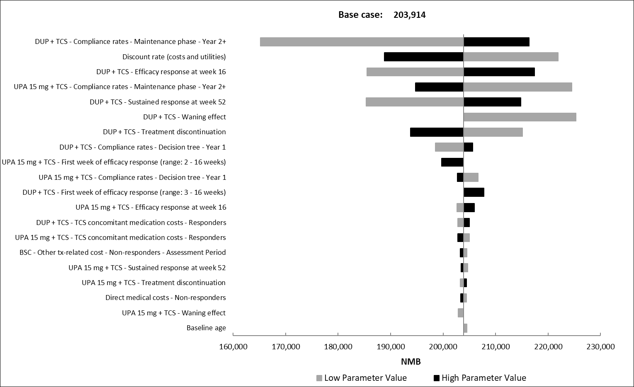
BSC: Best supportive care, DUP: Dupilumab, NMB: Net monetary benefit, TCS: Topical corticosteroid, UPA: Upadacitinib
Supplementary Figure 2 Scatter plot showing the probabilistic sensitivity analysis of upadacitinib 15 mg plus TCS versus dupilumab plus TCS

QALYs: Quality adjusted life years; SAR: Saudi Riyal; TCS: Topical corticosteroids
Supplementary Figure 3 Deterministic sensitivity analysis for moderate-severe atopic dermatitis budget impact analysis in the Kingdom of Saudi Arabia
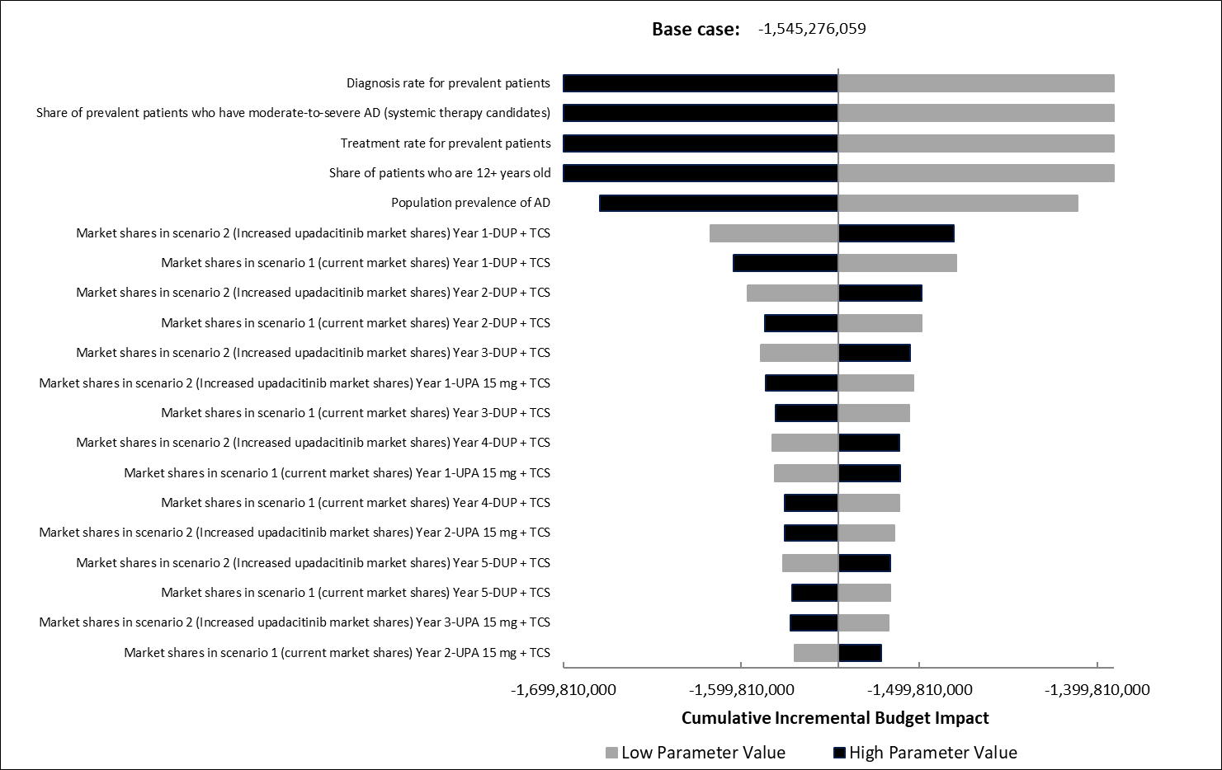
AD: Atopic dermatitis; DUP: Dupilumab; TCS: Topical corticosteroid; UPA: Upadacitinib

Supplementary Figure 4 Incremental analysis for moderate-severe atopic dermatitis without TCS

ABRO: Abrocitinib; BARI: Baricitinib; BSC: Best supportive care; DUP: Dupilumab; TRALO: Tralokinumab; UPA: Upadacitinib
Supplementary Figure 5 Incremental analysis for moderate-severe atopic dermatitis without TCS

BARI: Baricitinib; BSC: Best supportive care; DUP: Dupilumab; TRALO: Tralokinumab; TCS: Topical corticosteroid; UPA: Upadacitinib

Supplementary References

Guttman-Yassky E, Teixeira HD, Simpson EL, et al. Once-daily upadacitinib versus placebo in adolescents and adults with moderate-to-severe atopic dermatitis (Measure Up 1 and Measure Up 2): results from two replicate double-blind, randomised controlled phase 3 trials. Lancet. 2021; 397(10290):2151-2168. doi:10.1016/s0140-6736(21)00588-2
Reich K, Teixeira HD, de Bruin-Weller M, Bieber T, Soong W, Kabashima K, et al. Safety and efficacy of upadacitinib in combination with topical corticosteroids in adolescents and adults with moderate-to-severe atopic dermatitis (AD Up): results from a randomised, double-blind, placebo-controlled, phase 3 trial. Lancet. 2021;397(10290):2169-81.
Simpson EL, Sinclair R, Forman S, et al. Efficacy and safety of abrocitinib in adults and adolescents with moderate-to-severe atopic dermatitis (JADE MONO-1): a multicentre, double-blind, randomised, placebo-controlled, phase 3 trial. The Lancet. 2020;396(10246):255-66.
Silverberg JI, Simpson EL, Thyssen JP, et al. Efficacy and safety of abrocitinib in patients with moderate-to-severe atopic dermatitis: a randomized clinical trial. JAMA dermatology. 2020;156(8):863-73.
Simpson EL, Lacour JP, Spelman L, et al. Baricitinib in patients with moderate‐to‐severe atopic dermatitis and inadequate response to topical corticosteroids: results from two randomized monotherapy phase III trials. British Journal of Dermatology. 2020;183(2):242-55.
Simpson EL, Forman S, Silverberg JI, et al. Baricitinib in patients with moderate-to-severe atopic dermatitis: results from a randomized monotherapy phase 3 trial in the United States and Canada (BREEZE-AD5). Journal of the American Academy of Dermatology. 2021;85(1):62-70.
Reich K, Kabashima K, Peris K, et al. Efficacy and safety of baricitinib combined with topical corticosteroids for treatment of moderate to severe atopic dermatitis: a randomized clinical trial. JAMA dermatology. 2020;156(12):1333-43.
Simpson EL, Bieber T, Guttman-Yassky E, et al. Two phase 3 trials of dupilumab versus placebo in atopic dermatitis. New England Journal of Medicine. 2016;375(24):2335-48.
NICE. Single Technology Appraisal Dupilumab for treating moderate to severe atopic dermatitis after topical treatments [ID1048] .2018 https://www.nice.org.uk/guidance/ta534/documents/committee-papers. Accessed Mar 10, 2024.
de Bruin-Weller M, Thaçi D, Smith CH. Dupilumab with concomitant topical corticosteroid treatment in adults with atopic dermatitis with an inadequate response or intolerance to ciclosporin A or when this treatment is medically inadvisable: a placebo controlled, randomized phase III-clinical trial (LIBERTY AD CAFÉ). Br J Dermatol. 2018;178:992-3.
Blauvelt A, de Bruin-Weller M, Gooderham M, et al. Long-term management of moderate-to-severe atopic dermatitis with dupilumab and concomitant topical corticosteroids (LIBERTY AD CHRONOS): a 1-year, randomised, double-blinded, placebo-controlled, phase 3 trial. The Lancet. 2017;389(10086):2287-303.
Wollenberg A, Blauvelt A, Guttman‐Yassky E, et al. Tralokinumab for moderate‐to‐severe atopic dermatitis: results from two 52‐week, randomized, double‐blind, multicentre, placebo‐controlled phase III trials (ECZTRA 1 and ECZTRA 2). British Journal of Dermatology. 2021;184(3):437-49.
Silverberg JI, Toth D, Bieber T, et al. Tralokinumab plus topical corticosteroids for the treatment of moderate‐to‐severe atopic dermatitis: results from the double‐blind, randomized, multicentre, placebo‐controlled phase III ECZTRA 3 trial. British Journal of Dermatology. 2021;184(3):450-63.
SFDA. Economic Evaluation Studies Guidelines Saudi Food & Drug Authority Drug Sector2024 [03/7/2025]. Available from: https://sfda.gov.sa/sites/default/files/2024-07/EconomicEvaluationStudies.pdf.
Maspero J, De Paula Motta Rubini N, Zhang J, Sanclemente G, Amador JR, El Sayed MH, et al. Epidemiology of adult patients with atopic dermatitis in AWARE 1: A second international survey. World Allergy Organ J. 2023;16(3):100724.
Silverberg JI, Thyssen JP, Fahrbach K, et al. Comparative efficacy and safety of systemic therapies used in moderate‐to‐severe atopic dermatitis: a systematic literature review and network meta‐analysis. J Eur Acad Dermatol Venereol. 2021; 35(9):1797-1810. doi:10.1111/jdv.17351
Silverberg JI, Hong HC, Calimlim BM, et al. Comparative efficacy of targeted systemic therapies for moderate-to-severe atopic dermatitis without topical corticosteroids: an updated network meta-analysis. Dermatol Ther (Heidelb). 2023;13(10):2247-2264. doi:10.1007/s13555-023-01000-3
Ara R, Brazier JE. Populating an economic model with health state utility values: moving toward better practice. Value Health. 2010; 13(5):509-518. doi:10.1111/j.1524-4733.2010.00700.x

