Supplementary Figure 1. Cell annotation UMAP plot of single-cell sequencing data matched with spatial transcriptome data.

- UMAP of 6 major cell types corresponding to scRNA-seq of spatial transcriptome.
(B) UMAP of 8 major cell types after re labeling CD8+ T cells and SPP1+ macrophages corresponds to scRNA-seq of the spatial transcriptome.
(C) UMAP of T/NK cell subtypes.
(D) UMAP of Myeloid cell subtype.

Note: These two UMAPs are consistent with Figure 2A in the original text (Liu et al, 2023¹⁹).

Supplementary Figure 2. Visualization of annotated genes for seven types of immune cell types using bubble plots

Supplementary Figure 3. Stacked bar chart showing cell counts and cell proportions of each patient
(A) Stacked bar chart of cell counts for different cell types for each patient.
(B) Stacked bar chart of cell percentage for different cell types for each patient.

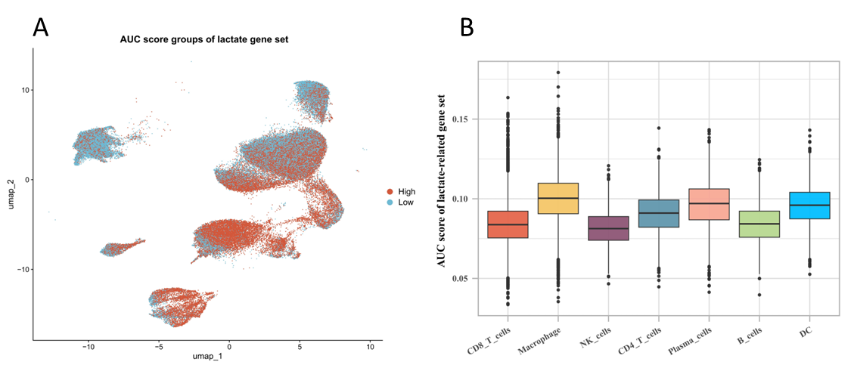

Supplementary Figure 4. Visualization of AUC score for lactate related gene set.
- High and low AUC score groups of lactate-related gene set in our single-cell sequencing data.
- AUC score of lactate related gene set in our different single-cell types.

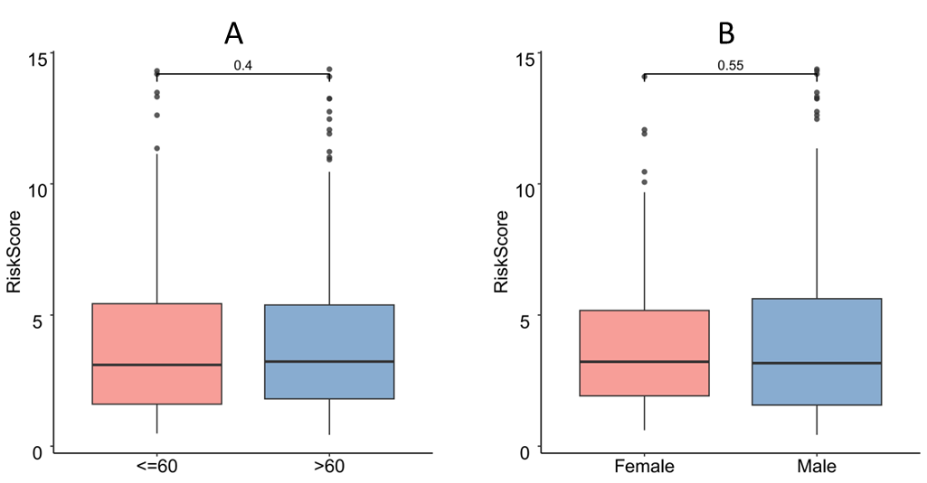

Supplementary Figure 5. Comparison of risk scores among different age and gender groups.
- Comparison of risk scores among different age groups (≤ 60 vs.＞60 years).
- Comparison of risk scores among different age groups (Female vs. Male).

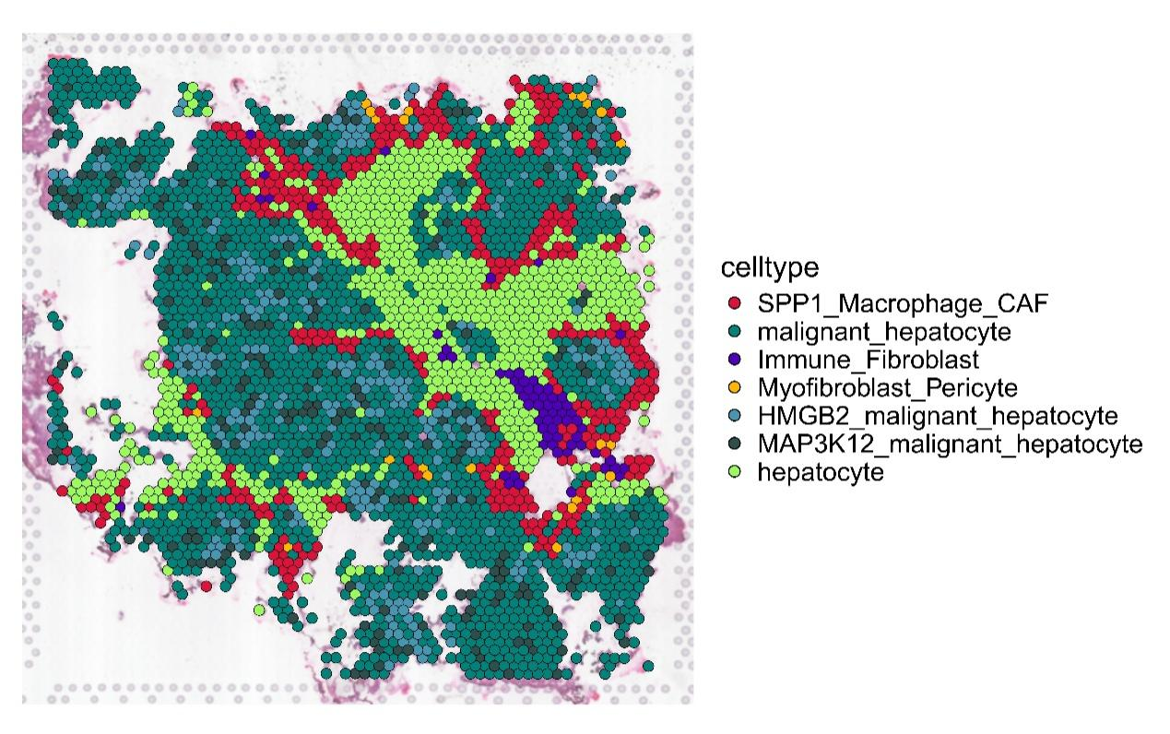

Supplementary Figure 6. The spatial distribution of different cell subtypes.
The immune barrier formed by SPP1 macrophage infiltration (Red) in the pathological section of patient # 1 is consistent with Figure 1C in the original text (Liu et al, 2023¹⁹).

Supplementary Box 1. List of 484 lactate-related genes
ABCG8 | LIPA | TPP1 | FASTKD2 | MT-ND3 | PDHX | TIMM50 | H4C6 | GPM6A | H2AC14 | NBN
ACAD9 | LMO1 | USB1 | FBXL4 | MT-ND4 | PDP1 | TK2 | H2BC3 | YTHDF2 | H2AC18 | TFEB
ACADM | LPIN1 | VPS13A | FDX2 | MT-ND5 | PDSS1 | TMEM126B | H4C11 | YTHDF1 | H2AC21 | H2AC17
AIFM1 | LYST | XK | GFM1 | MT-ND6 | PDSS2 | TMEM70 | H4C9 | RUBCNL | H2AC15 | H2AC8
AKR1D1 | MLIP | ZNFX1 | GFM2 | MT-TF | PET100 | TPK1 | H3C3 | NREP | H2AC7
ALDOA | MPL | AARS2 | GK | MT-TH | PET117 | TRMT10C | H4C8 | FASN | H2AC19
ALK | MT-CO1 | ACACA | GLRX5 | MT-TI | PHKG2 | TRMT5 | H2BC11 | AXIN1 | H2BC20P
B3GALNT2 | MT-CO3 | ACAT1 | GOT2 | MT-TK | PLPBP | TRMU | H2BC15 | SOX9 | H2BC19P
B4GAT1 | MTHFD1 | ACAT2 | GTPBP3 | MT-TL1 | PMPCB | TSFM | H3C10 | NCOA4 | CGAS
CALR | MVK | ADAMTS13 | GYS2 | MT-TL2 | PNPLA8 | TUFM | H3C11 | TRA-TGC7-1 | SIRT3
CAV3 | MYC | AGK | HADHB | MT-TN | PNPO | TWNK | H3C4 | PIK3C3 | HDAC2
CBLIF | MYCN | ALDH6A1 | HIBCH | MT-TP | PNPT1 | TXN2 | H3C6 | NMNAT1 | HDAC1
CD46 | NSUN2 | AMPD1 | HMGCL | MT-TQ | POLG | UPB1 | H3C8 | APOC2 | PAX6
CDAN1 | OBSCN | AMPD2 | HPDL | MT-TS1 | POLG2 | UQCC2 | H4C12 | ULK1 | IDH3B
CFH | OCRL | AMPD3 | HS6ST2 | MT-TS2 | POLRMT | UQCC3 | H4C2 | NR4A3 | CENPA
CFI | PEX2 | ATAD3A | HSD17B10 | MT-TV | PPCS | UQCRB | H2BC1 | HMGB1 | BDNF-AS
CHEK2 | PFKM | ATP5F1A | HSPD1 | MT-TW | PRORP | UQCRC2 | H2BC12 | RUNX2 | KRAS
CLN5 | PHOX2B | ATPAF2 | HTRA2 | MTFMT | PRSS12 | UQCRH | H2BC13 | SHMT2 | F2
COL4A1 | PIEZO1 | BCS1L | IFT56 | MTO1 | PUS1 | UQCRQ | H2BC4 | METTL3 | PCSK9
CPT2 | PIGA | C1QBP | ISCA1 | MTRFR | PYGL | WARS2 | H2BC9 | GCKR | MIF
CRPPA | PIK3CG | CA5A | ISCU | NADK2 | RARS1 | YARS1 | H3C14 | SP100 | ALDOB
CTSD | PITRM1 | CARS2 | KARS1 | NARS2 | RARS2 | YARS2 | H3C7 | FIS1 | FOXP3
DAG1 | PLA2G6 | CDK5 | LARS2 | NAXD | RMND1 | YME1L1 | H4C13 | SLC16A4 | SLC4A4
DHFR | PLEC | CHCHD10 | LETM1 | NAXE | RNASEH1 | ACACB | H4C4 | ALKBH3 | CRYAB
DNAJC5 | PNPLA2 | CLPB | LIAS | NDUFA1 | RRAGC | EMB | H2BC17 | YAP1 | AKR1B10
FKRP | POMGNT1 | COG3 | LIPT1 | NDUFA11 | RRM2B | SLC16A1 | H2BC10 | STK11 | ATXN7
FKTN | POMGNT2 | COQ4 | LIPT2 | NDUFA12 | SARS2 | SLC16A3 | H2BC18 | LRP1 | SST
FLI1 | POMK | COQ8A | LONP1 | NDUFA13 | SCO1 | SLC16A7 | H2BC26 | ARF1 | CEACAM6
GAA | POMT1 | COQ9 | LRPPRC | NDUFA6 | SCO2 | SLC16A8 | H2BC6 | NAT10 | CNMD
GATA1 | POMT2 | COX10 | LYRM7 | NDUFA8 | SDHA | SLC5A12 | H2BC8 | RARG | MIR125A
GATA2 | RB1 | COX11 | MDH2 | NDUFA9 | SDHB | SLC5A8 | H3C15 | GPR37 | MIR133B
GCLC | RHAG | COX14 | MECP2 | NDUFAF1 | SERAC1 | AARS1 | H4C15 | KCNK1 | MIR208B
GRN | RHCE | COX20 | MICOS13 | NDUFAF4 | SFXN4 | CREBBP | H2BC7 | TRAP1 | SOD2-OT1
HACE1 | RHD | COX4I1 | MIPEP | NDUFAF6 | SLC25A10 | EP300 | H2BC12L | NR6A1 | MAPK6P4
HBB | RPS14 | COX5A | MPC1 | NDUFB8 | SLC25A12 | MRE11 | ATM | OSBP2 | LDHB
HELLPAR | RXYLT1 | COX6A2 | MRPL12 | NDUFB9 | SLC25A26 | H3C1 | KAT2A | UNC119B | LIN28B
HLA-DRB1 | SAT1 | COX6B1 | MRPL3 | NDUFC2 | SLC25A3 | H4C14 | DCBLD1 | CYTOR | TOP2A
HMGCS2 | SIL1 | COX8A | MRPL39 | NDUFS1 | SLC25A4 | H3-3A | ACSF2 | SIRT1 | TP53
HMOX1 | SLC19A1 | CRAT | MRPL44 | NDUFS2 | SLC25A42 | H2AZ1 | CERNA3 | KPNA4 | ECHS1
INPP5K | SLC25A13 | CYC1 | MRPS14 | NDUFS3 | SLC31A1 | H2BC21 | HDAC3 | H2AC20 | FARS2
IRAK1 | SLC4A1 | CYP27A1 | MRPS16 | NDUFS8 | SOD1 | H3-3B | YY1 | H2AC4 | MT-ND1
JAK2 | SLC7A7 | DARS2 | MRPS2 | NDUFV1 | STAT2 | H4C3 | MLH1 | H2AC6 | MT-ND2
KCNN4 | SPP1 | DGUOK | MRPS22 | NFS1 | SUCLA2 | H4C16 | MYH6 | H2AC11 | PC
KIF23 | STAT4 | DLD | MRPS28 | NFU1 | SUCLG1 | H3C12 | CALML5 | H2AC13 | PDHA1
KLF1 | STIM1 | DNAJC19 | MRPS34 | NGLY1 | SURF1 | H4C1 | LUC7L2 | H2AC25 | TEFM
KY | TCIRG1 | DNM1L | MRPS7 | NSUN3 | SYNJ1 | H2BC14 | TEAD1 | H2AC1 | TIMM22
LARGE1 | TET2 | DTYMK | MT-ATP6 | OGDH | TANGO2 | H2BC5 | KAT5 | H2AC12 | H3C2
LDHA | TOMM7 | EARS2 | MT-CO2 | OPA1 | TARS2 | H3C13 | RAD50 | H2AC16 | H4C5

Supplementary Table 1. Distribution differences of seven immune cells between PT group and TT group
CellType | OR (95% CI) | P value | Sig.
CD8_T_cells | 0.44 (0.29-0.65) | <0.001 | ***
Macrophage | 26.51 (12.98-54.14) | <0.001 | ***
NK_cells | 0.29 (0.12-0.70) | 0.006 | **
CD4_T_cells | 0.85 (0.54-1.34) | 0.486 | ns
Plasma_cells | 0.54 (0.11-2.68) | 0.448 | ns
B_cells | 1.39 (0.66-2.90) | 0.383 | ns
DC | 5.85 (2.45-13.92) | <0.001 | ***
Note: P-values were calculated using generalized linear mixed models (GLMM). OR, odds ratio. CI, confidence interval. ** P < 0.01, *** P < 0.001，ns, not significant (P ≥ 0.05).

Supplementary Table 2. Comparison of IC50 values of different drugs in high-risk and low risk groups
Drug | IC50 | Drug | IC50 | Drug | IC50 | Drug | IC50
A.443654 | lower | Bicalutamide | higher | Docetaxel | lower | KIN001.135 | higher
A.770041 | NA | BIRB.0796 | lower | Axitinib | higher | KU.55933 | lower
ABT.263 | lower | Bleomycin | lower | EHT.1864 | NA | Lapatinib | higher
ABT.888 | lower | BMS.509744 | NA | Elesclomol | higher | Lenalidomide | higher
AG.014699 | higher | BMS.536924 | higher | Embelin | NA | LFM.A13 | higher
AICAR | NA | BMS.708163 | higher | Epothilone.B | lower | Metformin | NA
AKT.inhibitor.VIII | higher | BMS.754807 | higher | DMOG | higher | Methotrexate | lower
Camptothecin | lower | Bortezomib | lower | Etoposide | lower | MG.132 | NA
AP.24534 | NA | Bosutinib | NA | FH535 | NA | Midostaurin | NA
AS601245 | NA | Bryostatin.1 | higher | FTI.277 | lower | Mitomycin.C | lower
ATRA | lower | BX.795 | higher | GDC.0449 | NA | MK.2206 | NA
AUY922 | NA | Doxorubicin | lower | GDC0941 | higher | MS.275 | lower
Cisplatin | lower | CCT007093 | higher | Gefitinib | higher | Nilotinib | lower
AZ628 | NA | CCT018159 | lower | Gemcitabine | lower | NSC.87877 | lower
AZD.0530 | higher | CEP.701 | NA | GNF.2 | higher | NU.7441 | NA
AZD.2281 | lower | CGP.082996 | NA | GSK.650394 | lower | Nutlin.3a | higher
AZD6244 | higher | CGP.60474 | NA | GSK269962A | NA | NVP.BEZ235 | NA
AZD6482 | higher | CHIR.99021 | higher | GW.441756 | higher | NVP.TAE684 | NA
AZD7762 | NA | CI.1040 | higher | GW843682X | lower | Obatoclax.Mesylate | lower
AZD8055 | NA | Sorafenib | lower | Imatinib | higher | OSI.906 | higher
BAY.61.3606 | lower | CMK | lower | IPA.3 | lower | PAC.1 | NA
Bexarotene | higher | Cyclopamine | NA | JNJ.26854165 | higher | Paclitaxel | lower
BI.2536 | lower | Cytarabine | lower | JNK.9L | NA | Parthenolide | lower
BI.D1870 | lower | Dasatinib | higher | JNK.Inhibitor.VIII | lower | Pazopanib | NA
BIBW2992 | lower | AMG.706 | higher | JW.7.52.1 | lower | PD.0325901 | higher
PD.0332991 | higher | RDEA119 | higher | Sunitinib | NA | VX.702 | higher
PD.173074 | lower | RO.3306 | lower | TCGA | NA | WH.4.023 | NA
PF.02341066 | higher | Roscovitine | higher | Temsirolimus | higher | WO2009093972 | higher
PF.4708671 | lower | S.Trityl.L.cysteine | lower | Thapsigargin | NA | WZ.1.84 | NA
PF.562271 | higher | Salubrinal | lower | Tipifarnib | lower | X17.AAG | NA
PHA.665752 | NA | SB.216763 | higher | TW.37 | lower | X681640 | NA
PLX4720 | lower | SB590885 | NA | Vinblastine | lower | XMD8.85 | higher
Pyrimethamine | lower | Shikonin | lower | Vinorelbine | lower | Z.LLNle.CHO | NA
QS11 | lower | SL.0101.1 | lower | Vorinostat | lower | ZM.447439 | lower
Rapamycin | lower | Erlotinib | higher | VX.680 | lower

