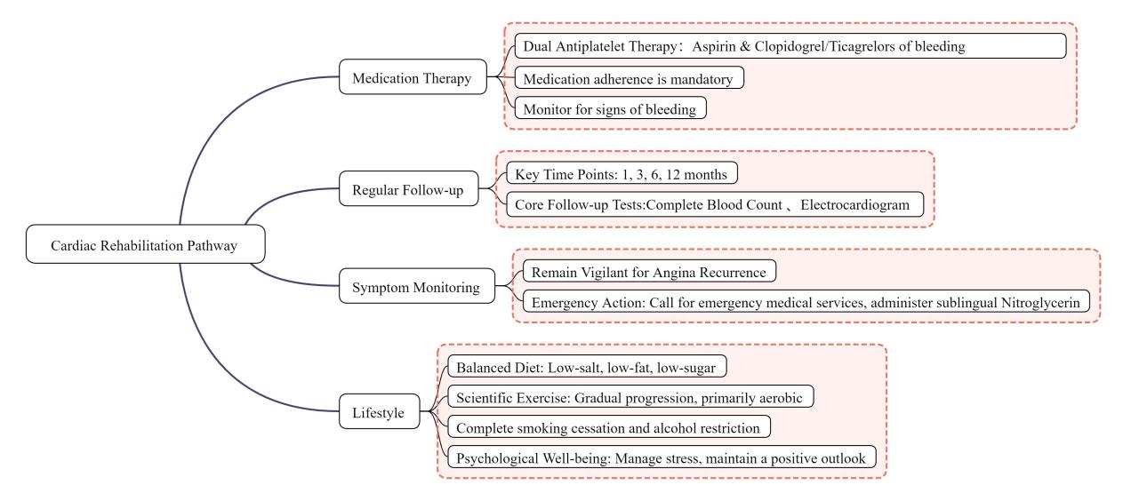
Figure S1 Visualized mind map for percutaneous coronary intervention (PCI) postoperative health education.

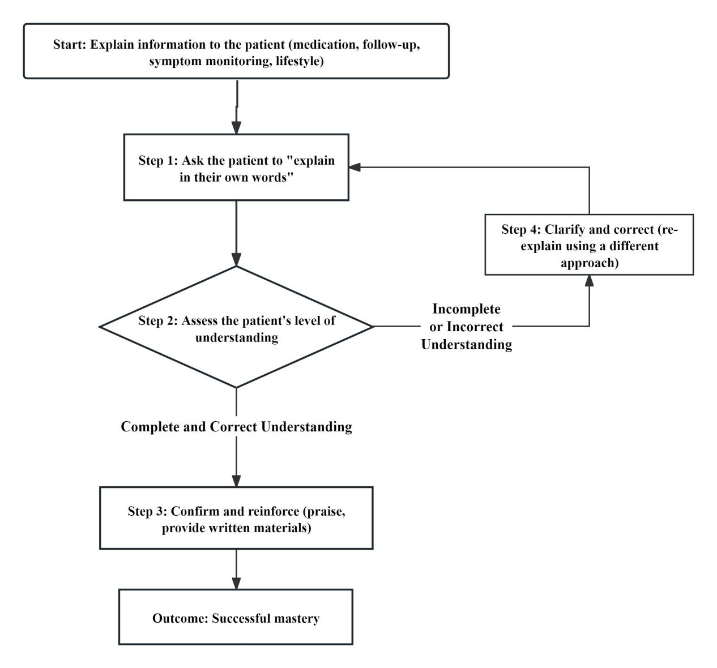
Figure S2. Implementation flowchart of the teach-back method in PCI postoperative health education.

