Table S1 Covariates and definitions included in the multi-state models
Category | Variable | Abbreviation | Definition
Hepatitis B (HBV) infection and antiviral therapy | HBV&Treatment | HBV&Treatment | Patients were categorized into four groups based on HBV infection and antiviral therapy status: HBV-positive receiving Tenofovir Disoproxil Fumarate (TDF), HBV-positive receiving other antiviral therapies (Other-AVT), HBV-positive without antiviral treatment (Untreated), and HBV-negative (Uninfected).
Demographics | Age | Age | Age (years)
 | Sex | Sex | Male or female, as recorded in medical records
Comorbidities | Non-alcoholic fatty liver disease | NAFLD | History of NAFLD documented in medical records
 | Alcoholic liver disease | ALD | History of ALD documented in medical records
 | Human immunodeficiency virus infection | HIV | HIV infection status
Hematology and inflammatory markers | Red blood cell count | RBC | Red blood cell count
 | White blood cell count | WBC | White blood cell count
 | Hemoglobin | HGB | Hemoglobin concentration
 | Platelet count | PLT | Platelet count
 | Lymphocyte count | LYM | Absolute lymphocyte count
 | Monocyte count | MONO | Absolute monocyte count
 | Neutrophil count | NEUT | Absolute neutrophil count
 | Eosinophil count | EOS | Absolute eosinophil count
 | Basophil count | BASO | Absolute basophil count
 | Albumin/globulin ratio | AG | Ratio of serum albumin to globulin
Liver and renal function | Alanine aminotransferase | ALT | Marker of hepatocellular injury
 | Aspartate aminotransferase | AST | Marker of hepatocellular injury
 | γ-glutamyl transferase | GGT | Marker of cholestasis and liver injury
 | Alpha-L-fucosidase | AFU | Enzyme associated with hepatobiliary disease
 | 5′-Nucleotidase | 5′-NT | Marker of cholestasis
 | Alkaline phosphatase | ALP | Marker of cholestasis
 | Cholinesterase | ChE | Indicator of hepatic synthetic function
 | Total bilirubin | TBIL | Total serum bilirubin
 | Direct bilirubin | DBIL | Conjugated bilirubin
 | Indirect bilirubin | IBIL | Unconjugated bilirubin
 | Total bile acid | TBA | Indicator of bile acid metabolism
 | Lactate | LAC | Serum lactate level
 | Estimated glomerular filtration rate | eGFR | Renal function indicator
 | Serum creatinine | SCr | Renal function indicator
 | Blood urea nitrogen | BUN | Renal function indicator
 | Uric acid | UA | Uric acid level
 | Prealbumin | PAB | Marker of nutritional and hepatic synthetic status
 | Total protein | TP | Total serum protein
 | Albumin | ALB | Serum albumin
 | Globulin | GLB | Serum globulin
 | C-reactive protein | CRP | Marker of systemic inflammation
Electrolytes | Sodium | Na | Serum sodium
 | Potassium | K | Serum potassium
 | Chloride | Cl | Serum chloride
 | Calcium | Ca | Serum calcium
 | Magnesium | Mg | Serum magnesium
 | Phosphorus | P | Serum phosphorus

Table S2 Observed transition matrix of AFP-defined disease states (S1–S4)
 | To
From | S1 | S2 | S3 | S4 | Total
S1 | 7303 (93.07%) | 453 (5.77%) | 50 (0.64%) | 41 (0.52%) | 7847
S2 | 568 (21.37%) | 1659 (62.42%) | 349 (13.13%) | 82 (3.09%) | 2658
S3 | 117 (7.94%) | 264 (17.91%) | 783 (53.12%) | 310 (21.03%) | 1474
S4 | 38 (1.62%) | 104 (4.43%) | 232 (9.88%) | 1973 (84.06%) | 2347
Note: Self-transitions (remaining in the same state) were permitted and observed. AFP: Alpha-fetoprotein. State 1 (S1): AFP < 20 ng/mL; State 2 (S2): 20 ≤ AFP < 200 ng/mL; State 3 (S3): 200 ≤ AFP < 1000 ng/mL; State 4 (S4): AFP ≥ 1000 ng/mL.

Table S3 Univariable associations of clinical covariates with transition hazards between AFP-defined disease states (S1–S4)
Covariate | Level | State 1 - State 2 | State 2 - State 3 | State 3 - State 4 | State 2 - State 1 | State 3 - State 2 | State 4 - State 3
Age | <65 | Reference | Reference | Reference | Reference | Reference | Reference
 | ≥65 | 0.948 (0.760-1.182) | 0.715 (0.544-0.939)* | 1.117 (0.827-1.509) | 0.883 (0.714-1.091) | 0.781 (0.591-1.033) | 1.209 (0.892-1.639)
Sex | Female | Reference | Reference | Reference | Reference | Reference | Reference
 | Male | 0.951 (0.721-1.256) | 0.909 (0.648-1.275) | 0.832 (0.587-1.179) | 0.834 (0.649-1.070) | 0.731 (0.534-1.000) | 1.013 (0.721-1.423)
HBV&Treatment | Other-AVT | Reference | Reference | Reference | Reference | Reference | Reference
 | TDF | 1.084 (0.820-1.435) | 1.027 (0.753-1.400) | 0.924 (0.664-1.286) | 1.386 (1.110-1.732)* | 0.999 (0.757-1.319) | 0.875 (0.641-1.195)
 | Untreated | 0.938 (0.766-1.148) | 0.877 (0.694-1.107) | 1.274 (0.989-1.642) | 0.884 (0.732-1.067) | 0.698 (0.551-0.884)* | 0.942 (0.736-1.206)
 | Uninfected | 0.527 (0.259-1.069) | 0.485 (0.194-1.216) | 2.362 (0.888-6.285) | 0.192 (0.075-0.492)* | 1.412 (0.574-3.476) | 0.934 (0.363-2.401)
NAFLD | No | Reference | Reference | Reference | Reference | Reference | Reference
 | Yes | 0.633 (0.394-1.019) | 0.856 (0.473-1.549) | 1.179 (0.556-2.500) | 0.630 (0.412-0.963)* | 1.922 (1.089-3.394)* | 1.759 (0.795-3.894)
ALD | No | Reference | Reference | Reference | Reference | Reference | Reference
 | Yes | 1.167 (0.578-2.353) | 1.035 (0.423-2.531) | 0.541 (0.205-1.426) | 1.186 (0.552-2.549) | 0.618 (0.252-1.515) | 0.752 (0.212-2.665)
HIV | No | Reference | Reference | Reference | Reference | Reference | Reference
 | Yes | 3.840 (1.095-13.463)* | 0.520 (0.153-1.767) | 0.889 (0.257-3.067) | 0.469 (0.112-1.955) | 0.089 (0.003-2.847) | 0.730 (0.091-5.865)
ALT | Normal | Reference | Reference | Reference | Reference | Reference | Reference
 | High | 1.539 (1.238-1.913)* | 1.079 (0.849-1.371) | 1.263 (0.986-1.616) | 1.360 (1.135-1.629)* | 1.443 (1.163-1.790)* | 1.120 (0.887-1.413)
AST | Normal | Reference | Reference | Reference | Reference | Reference | Reference
 | High | 1.484 (1.236-1.781)* | 0.954 (0.773-1.178) | 0.831 (0.653-1.056) | 1.047 (0.887-1.235) | 0.856 (0.691-1.058) | 0.603 (0.474-0.768)*
GGT | Normal | Reference | Reference | Reference | Reference | Reference | Reference
 | High | 1.598 (1.327-1.923)* | 1.047 (0.841-1.303) | 0.880 (0.684-1.132) | 0.902 (0.761-1.068) | 1.144 (0.916-1.431) | 0.610 (0.473-0.786)*
AFU | Normal | Reference | Reference | Reference | Reference | Reference | Reference
 | High | 1.440 (1.176-1.762)* | 0.860 (0.681-1.085) | 0.965 (0.754-1.235) | 1.012 (0.844-1.214) | 1.131 (0.911-1.403) | 0.783 (0.624-0.982)*
5′-NT | Normal | Reference | Reference | Reference | Reference | Reference | Reference
 | High | 1.098 (0.896-1.346) | 0.955 (0.769-1.187) | 0.789 (0.625-0.998)* | 0.660 (0.545-0.801)* | 0.775 (0.625-0.962)* | 0.603 (0.480-0.757)*
ALP | Normal | Reference | Reference | Reference | Reference | Reference | Reference
 | High | 1.509 (1.249-1.824)* | 0.861 (0.698-1.061) | 0.974 (0.776-1.224) | 0.767 (0.645-0.912)* | 0.796 (0.646-0.980)* | 0.715 (0.572-0.894)*
 | Low | 0.849 (0.394-1.831) | 0.392 (0.095-1.614) | 1.466 (0.337-6.387) | 0.340 (0.138-0.836)* | 0.991 (0.262-3.753) | 0.970 (0.130-7.223)
ChE | Normal | Reference | Reference | Reference | Reference | Reference | Reference
 | High | 2.906 (0.744-11.354) | 0.676 (0.079-5.804) | 1.250 (0.263-5.941) | 1.473 (0.449-4.827) | 2.213 (0.792-6.186) | 0.875 (0.131-5.835)
 | Low | 1.514 (1.258-1.823)* | 1.154 (0.937-1.420) | 0.935 (0.745-1.172) | 0.907 (0.765-1.075) | 0.751 (0.609-0.926)* | 0.724 (0.579-0.905)*
TBIL | Normal | Reference | Reference | Reference | Reference | Reference | Reference
 | High | 1.427 (1.104-1.845)* | 1.094 (0.837-1.429) | 0.959 (0.731-1.259) | 1.039 (0.820-1.316) | 0.672 (0.504-0.895)* | 0.621 (0.458-0.843)*
DBIL | Normal | Reference | Reference | Reference | Reference | Reference | Reference
 | High | 1.487 (1.191-1.857)* | 1.081 (0.856-1.366) | 0.942 (0.737-1.203) | 0.865 (0.698-1.071) | 0.633 (0.492-0.814)* | 0.627 (0.483-0.816)*
IBIL | Normal | Reference | Reference | Reference | Reference | Reference | Reference
 | High | 1.299 (0.972-1.735) | 1.031 (0.747-1.425) | 0.982 (0.705-1.368) | 0.952 (0.725-1.252) | 0.956 (0.686-1.332) | 0.609 (0.415-0.894)*
TBA | Normal | Reference | Reference | Reference | Reference | Reference | Reference
 | High | 1.115 (0.927-1.341) | 0.957 (0.774-1.183) | 1.123 (0.886-1.422) | 0.750 (0.635-0.885)* | 0.896 (0.728-1.103) | 0.854 (0.683-1.067)
LAC | Normal | Reference | Reference | Reference | Reference | Reference | Reference
 | High | 1.005 (0.826-1.223) | 1.126 (0.895-1.416) | 0.976 (0.752-1.269) | 1.216 (1.010-1.464)* | 1.011 (0.801-1.277) | 0.825 (0.643-1.058)
eGFR | Normal | Reference | Reference | Reference | Reference | Reference | Reference
 | Moderate | 0.971 (0.762-1.238) | 0.783 (0.578-1.063) | 0.942 (0.664-1.337) | 1.220 (0.982-1.517) | 0.976 (0.727-1.311) | 1.197 (0.845-1.695)
 | Severe | 1.306 (0.771-2.213) | 0.743 (0.388-1.422) | 0.867 (0.433-1.737) | 1.123 (0.652-1.935) | 0.486 (0.245-0.966)* | 1.300 (0.632-2.675)
SCr | Normal | Reference | Reference | Reference | Reference | Reference | Reference
 | High | 1.108 (0.767-1.601) | 0.792 (0.509-1.232) | 0.942 (0.577-1.537) | 1.225 (0.882-1.701) | 0.701 (0.446-1.100) | 0.987 (0.595-1.638)
 | Low | 0.972 (0.781-1.208) | 0.871 (0.686-1.107) | 1.043 (0.814-1.336) | 0.914 (0.754-1.109) | 0.759 (0.598-0.963)* | 0.719 (0.558-0.926)*
PAB | Normal | Reference | Reference | Reference | Reference | Reference | Reference
 | Low | 1.288 (1.071-1.548)* | 1.258 (1.015-1.559)* | 0.993 (0.783-1.258) | 0.798 (0.676-0.943)* | 0.877 (0.712-1.079) | 0.703 (0.559-0.885)*
TP | Normal | Reference | Reference | Reference | Reference | Reference | Reference
 | High | 0.961 (0.537-1.718) | 0.502 (0.241-1.045) | 1.541 (0.798-2.977) | 1.056 (0.683-1.632) | 0.841 (0.463-1.528) | 1.703 (0.988-2.935)
 | Low | 1.094 (0.880-1.361) | 1.196 (0.937-1.527) | 1.048 (0.802-1.370) | 0.846 (0.683-1.049) | 0.873 (0.670-1.138) | 0.847 (0.642-1.118)
ALB | Normal | Reference | Reference | Reference | Reference | Reference | Reference
 | Low | 1.458 (1.213-1.751)* | 1.132 (0.917-1.397) | 0.931 (0.738-1.173) | 0.891 (0.755-1.051) | 0.805 (0.655-0.989)* | 0.757 (0.605-0.947)*
GLB | Normal | Reference | Reference | Reference | Reference | Reference | Reference
 | High | 1.868 (1.385-2.520)* | 0.728 (0.504-1.050) | 0.925 (0.640-1.338) | 1.297 (1.000-1.683) | 0.891 (0.654-1.216) | 1.074 (0.801-1.440)
 | Low | 1.129 (0.547-2.327) | 1.137 (0.476-2.716) | 1.021 (0.414-2.515) | 1.685 (0.956-2.972) | 1.102 (0.454-2.676) | 0.808 (0.277-2.356)
UA | Normal | Reference | Reference | Reference | Reference | Reference | Reference
 | High | 0.902 (0.696-1.169) | 0.709 (0.515-0.975)* | 0.796 (0.556-1.140) | 0.881 (0.687-1.130) | 0.767 (0.556-1.058) | 0.859 (0.591-1.247)
 | Low | 1.170 (0.825-1.659) | 0.957 (0.656-1.398) | 0.861 (0.595-1.246) | 1.019 (0.746-1.390) | 0.771 (0.541-1.099) | 0.805 (0.549-1.182)
BUN | Normal | Reference | Reference | Reference | Reference | Reference | Reference
 | High | 1.143 (0.838-1.559) | 1.062 (0.740-1.526) | 1.333 (0.912-1.948) | 1.332 (1.001-1.772)* | 0.865 (0.590-1.269) | 0.957 (0.633-1.447)
 | Low | 1.565 (1.024-2.394)* | 0.993 (0.626-1.574) | 0.784 (0.485-1.269) | 0.872 (0.581-1.311) | 0.747 (0.472-1.182) | 0.827 (0.530-1.289)
CRP | Normal | Reference | Reference | Reference | Reference | Reference | Reference
 | High | 1.278 (0.725-2.254) | 0.745 (0.389-1.430) | 0.566 (0.296-1.085) | 0.853 (0.517-1.407) | 0.795 (0.458-1.380) | 0.498 (0.286-0.865)*
RBC | Normal | Reference | Reference | Reference | Reference | Reference | Reference
 | High | 0.987 (0.385-2.531) | 0.771 (0.335-1.775) | 0.346 (0.124-0.964)* | 1.310 (0.739-2.322) | 0.327 (0.134-0.801)* | 0.358 (0.168-0.763)*
 | Low | 1.400 (1.165-1.683)* | 1.009 (0.819-1.244) | 1.008 (0.803-1.266) | 0.895 (0.756-1.060) | 0.815 (0.663-1.004) | 0.793 (0.633-0.995)*
WBC | Normal | Reference | Reference | Reference | Reference | Reference | Reference
 | High | 0.712 (0.351-1.443) | 1.371 (0.745-2.523) | 0.951 (0.526-1.720) | 1.207 (0.756-1.926) | 0.956 (0.571-1.601) | 1.108 (0.665-1.844)
 | Low | 1.003 (0.823-1.222) | 1.071 (0.860-1.334) | 1.041 (0.820-1.323) | 0.885 (0.736-1.064) | 0.709 (0.564-0.892)* | 1.049 (0.817-1.347)
HGB | Normal | Reference | Reference | Reference | Reference | Reference | Reference
 | High | 1.152 (0.445-2.981) | 0.896 (0.249-3.221) | 2.308 (0.700-7.611) | 1.703 (0.733-3.960) | 1.043 (0.321-3.390) | 0.603 (0.215-1.695)
 | Low | 1.400 (1.160-1.690)* | 0.899 (0.727-1.111) | 0.932 (0.741-1.172) | 0.860 (0.723-1.023) | 0.836 (0.675-1.034) | 0.653 (0.519-0.823)*
PLT | Normal | Reference | Reference | Reference | Reference | Reference | Reference
 | High | 1.488 (0.711-3.114) | 0.912 (0.424-1.963) | 0.431 (0.173-1.071) | 0.830 (0.446-1.544) | 0.746 (0.383-1.453) | 0.480 (0.237-0.974)*
 | Low | 1.036 (0.862-1.246) | 0.907 (0.736-1.119) | 0.941 (0.748-1.183) | 0.695 (0.587-0.823)* | 0.728 (0.590-0.896)* | 0.901 (0.714-1.136)
LYM | Normal | Reference | Reference | Reference | Reference | Reference | Reference
 | High | 0.465 (0.060-3.623) | 0.566 (0.058-5.540) | 1.846 (0.279-12.214) | 0.946 (0.320-2.792) | 1.127 (0.290-4.387) | 5.333 (0.461-61.724)
 | Low | 1.144 (0.947-1.382) | 1.045 (0.839-1.302) | 0.818 (0.640-1.045) | 0.714 (0.603-0.844)* | 0.683 (0.552-0.843)* | 0.661 (0.526-0.829)*
MONO | Normal | Reference | Reference | Reference | Reference | Reference | Reference
 | High | 1.104 (0.802-1.520) | 0.881 (0.612-1.270) | 0.718 (0.489-1.055) | 1.258 (0.974-1.623) | 1.169 (0.859-1.591) | 0.627 (0.448-0.877)*
 | Low | 0.955 (0.475-1.921) | 1.155 (0.518-2.578) | 1.555 (0.621-3.892) | 0.571 (0.216-1.513) | 0.733 (0.271-1.985) | 1.368 (0.590-3.168)
NEUT | Normal | Reference | Reference | Reference | Reference | Reference | Reference
 | High | 1.000 (0.605-1.654) | 1.508 (0.903-2.520) | 0.879 (0.530-1.458) | 1.192 (0.805-1.765) | 1.284 (0.834-1.978) | 0.892 (0.586-1.359)
 | Low | 0.994 (0.792-1.248) | 1.185 (0.921-1.524) | 1.001 (0.760-1.318) | 0.985 (0.799-1.213) | 0.948 (0.732-1.229) | 0.954 (0.706-1.288)
EOS | Normal | Reference | Reference | Reference | Reference | Reference | Reference
 | High | 1.145 (0.753-1.742) | 0.832 (0.504-1.374) | 1.424 (0.790-2.567) | 1.118 (0.759-1.647) | 0.718 (0.407-1.267) | 1.603 (0.917-2.804)
 | Low | 1.777 (1.182-2.670)* | 1.178 (0.757-1.832) | 0.658 (0.401-1.080) | 1.276 (0.864-1.885) | 0.741 (0.455-1.206) | 0.547 (0.333-0.901)*
BASO | Normal | Reference | Reference | Reference | Reference | Reference | Reference
 | High | 0.994 (0.664-1.487) | 0.676 (0.403-1.134) | 1.034 (0.601-1.778) | 0.984 (0.703-1.379) | 1.455 (0.963-2.197) | 0.928 (0.585-1.473)
AG | Normal | Reference | Reference | Reference | Reference | Reference | Reference
 | High | 1.398 (0.740-2.640) | 1.109 (0.574-2.145) | 0.413 (0.159-1.073) | 0.589 (0.262-1.326) | 0.320 (0.126-0.816)* | 1.114 (0.500-2.484)
 | Low | 1.232 (0.923-1.643) | 0.693 (0.491-0.980)* | 0.905 (0.614-1.334) | 0.753 (0.558-1.016) | 0.547 (0.366-0.818)* | 0.932 (0.592-1.468)
K | Normal | Reference | Reference | Reference | Reference | Reference | Reference
 | High | 0.134 (0.001-14.724) | 0.743 (0.084-6.585) | 0.800 (0.115-5.556) | 0.072 (0.001-9.340) | 0.732 (0.073-7.341) | 0.084 (0.001-9.804)
 | Low | 0.893 (0.700-1.140) | 1.115 (0.845-1.470) | 0.976 (0.728-1.308) | 0.953 (0.759-1.196) | 0.958 (0.723-1.270) | 0.787 (0.577-1.072)
Cl | Normal | Reference | Reference | Reference | Reference | Reference | Reference
 | High | 0.780 (0.480-1.266) | 1.155 (0.686-1.943) | 1.076 (0.584-1.983) | 0.891 (0.564-1.406) | 0.969 (0.528-1.781) | 0.934 (0.414-2.109)
 | Low | 1.502 (1.021-2.210)* | 0.861 (0.565-1.313) | 1.107 (0.729-1.679) | 0.972 (0.697-1.356) | 0.891 (0.603-1.316) | 0.767 (0.545-1.078)
Ca | Normal | Reference | Reference | Reference | Reference | Reference | Reference
 | High | 0.893 (0.343-2.325) | 0.214 (0.035-1.296) | 1.261 (0.355-4.485) | 1.364 (0.730-2.548) | 0.890 (0.369-2.146) | 0.906 (0.327-2.504)
 | Low | 1.100 (0.844-1.434) | 1.151 (0.871-1.521) | 0.880 (0.654-1.183) | 0.932 (0.728-1.194) | 0.743 (0.556-0.993)* | 0.874 (0.645-1.184)
Mg | Normal | Reference | Reference | Reference | Reference | Reference | Reference
 | High | 1.033 (0.720-1.482) | 0.865 (0.553-1.355) | 1.314 (0.819-2.109) | 0.914 (0.646-1.294) | 1.038 (0.667-1.618) | 1.093 (0.661-1.806)
 | Low | 1.179 (0.902-1.539) | 1.260 (0.950-1.672) | 0.983 (0.732-1.320) | 0.884 (0.687-1.139) | 0.954 (0.711-1.281) | 0.590 (0.420-0.828)*
P | Normal | Reference | Reference | Reference | Reference | Reference | Reference
 | High | 0.702 (0.148-3.328) | 3.573 (0.875-14.593) | 1.551 (0.507-4.748) | 3.910 (1.165-13.120)* | 0.550 (0.142-2.134) | 1.784 (0.688-4.623)
 | Low | 1.150 (0.918-1.440) | 1.044 (0.809-1.347) | 1.124 (0.846-1.494) | 0.841 (0.673-1.051) | 0.801 (0.616-1.042) | 1.454 (1.088-1.944)*
Note: Values represent hazard ratios (HR) with 95% confidence intervals. State 1 (S1): AFP < 20 ng/mL; State 2 (S2): 20 ≤ AFP < 200 ng/mL; State 3 (S3): 200 ≤ AFP < 1000 ng/mL; State 4 (S4): AFP ≥ 1000 ng/mL. AFP: Alpha-fetoprotein; HBV, hepatitis B virus; TDF, tenofovir disoproxil fumarate; Other-AVT, antiviral therapies other than tenofovir; Untreated, HBV-positive without antiviral treatment; Uninfected, HBV-negative; NAFLD, non-alcoholic fatty liver disease; ALD, alcoholic liver disease; HIV, human immunodeficiency virus; RBC, red blood cell count; WBC, white blood cell count; HGB, hemoglobin; PLT, platelet count; LYM, lymphocyte count; MONO, monocyte count; NEUT, neutrophil count; EOS, eosinophil count; BASO, basophil count; AG, albumin/globulin ratio; ALT, alanine aminotransferase; AST, aspartate aminotransferase; GGT, γ-glutamyl transferase; AFU, alpha-L-fucosidase; 5′-NT, 5′-nucleotidase; ALP, alkaline phosphatase; ChE, cholinesterase; TBIL, total bilirubin; DBIL, direct bilirubin; IBIL, indirect bilirubin; TBA, total bile acid; LAC, lactate; eGFR, estimated glomerular filtration rate; SCr, serum creatinine; BUN, blood urea nitrogen; UA, uric acid; PAB, prealbumin; TP, total protein; ALB, albumin; GLB, globulin; CRP, C-reactive protein; Na, sodium; K, potassium; Cl, chloride; Ca, calcium; Mg, magnesium; P, phosphorus. *P-value <0.05

Table S4 Sensitivity analysis of transition hazards by replacing TBIL with DBIL and IBIL among AFP-defined disease states (S1–S4)
Covariate | Level | State 1 - State 2 | State 2 - State 3 | State 3 - State 4 | State 2 - State 1 | State 3 - State 2 | State 4 - State 3
Age | <65 | Reference | Reference | Reference | Reference | Reference | Reference
 | ≥65 | 0.907 (0.713-1.153) | 0.728 (0.541-0.981)* | 1.081 (0.767-1.523) | 0.907 (0.712-1.155) | 0.784 (0.572-1.074) | 1.117 (0.783-1.593)
HBV&Treatment | Other-AVT | Reference | Reference | Reference | Reference | Reference | Reference
 | TDF | 0.999 (0.751-1.330) | 1.039 (0.755-1.432) | 0.923 (0.649-1.313) | 1.358 (1.072-1.720)* | 1.004 (0.745-1.353) | 0.959 (0.688-1.336)
 | Untreated | 0.931 (0.758-1.145) | 0.947 (0.745-1.204) | 1.294 (0.990-1.692) | 0.873 (0.716-1.064) | 0.677 (0.528-0.867)* | 0.897 (0.687-1.170)
 | Uninfected | 0.362 (0.175-0.752)* | 0.550 (0.209-1.451) | 2.352 (0.841-6.577) | 0.151 (0.058-0.396)* | 1.338 (0.487-3.680) | 0.954 (0.345-2.635)
NAFLD | No | Reference | Reference | Reference | Reference | Reference | Reference
 | Yes | 0.759 (0.468-1.233) | 0.893 (0.490-1.625) | 1.138 (0.522-2.479) | 0.632 (0.398-1.004) | 1.653 (0.873-3.131) | 1.822 (0.778-4.264)
HIV | No | Reference | Reference | Reference | Reference | Reference | Reference
 | Yes | 8.825 (2.388-32.618)* | 0.746 (0.215-2.589) | 0.604 (0.145-2.513) | 0.722 (0.158-3.293) | 0.017 (0.000-158.259) | 0.370 (0.044-3.139)
ALT | Normal | Reference | Reference | Reference | Reference | Reference | Reference
 | High | 1.302 (1.005-1.687)* | 1.070 (0.809-1.415) | 1.529 (1.140-2.052)* | 1.497 (1.194-1.875)* | 1.688 (1.298-2.195)* | 1.528 (1.155-2.021)*
AST | Normal | Reference | Reference | Reference | Reference | Reference | Reference
 | High | 1.029 (0.809-1.308) | 0.933 (0.712-1.223) | 0.780 (0.572-1.065) | 1.046 (0.833-1.313) | 0.863 (0.649-1.149) | 0.664 (0.485-0.908)*
GGT | Normal | Reference | Reference | Reference | Reference | Reference | Reference
 | High | 1.503 (1.197-1.888)* | 1.173 (0.893-1.541) | 0.995 (0.729-1.360) | 0.947 (0.765-1.173) | 1.298 (0.978-1.722) | 0.854 (0.616-1.183)
AFU | Normal | Reference | Reference | Reference | Reference | Reference | Reference
 | High | 1.246 (0.998-1.557) | 0.836 (0.643-1.088) | 0.989 (0.752-1.301) | 1.041 (0.845-1.282) | 1.179 (0.920-1.512) | 0.916 (0.704-1.193)
5′-NT | Normal | Reference | Reference | Reference | Reference | Reference | Reference
 | High | 0.667 (0.518-0.858)* | 0.937 (0.714-1.228) | 0.700 (0.520-0.944)* | 0.674 (0.533-0.853)* | 0.715 (0.543-0.941)* | 0.678 (0.505-0.909)*
ALP | Normal | Reference | Reference | Reference | Reference | Reference | Reference
 | High | 1.191 (0.941-1.507) | 0.808 (0.622-1.049) | 1.137 (0.861-1.502) | 0.831 (0.670-1.031) | 0.788 (0.606-1.023) | 1.064 (0.795-1.424)
 | Low | 0.902 (0.409-1.989) | 0.591 (0.105-3.336) | 2.148 (0.398-11.582) | 0.369 (0.146-0.938)* | 1.621 (0.269-9.766) | 1.333 (0.207-8.571)
ChE | Normal | Reference | Reference | Reference | Reference | Reference | Reference
 | High | 3.089 (0.796-11.989) | 0.774 (0.081-7.387) | 2.791 (0.398-19.547) | 1.212 (0.363-4.051) | 3.872 (1.097-13.667)* | 3.139 (0.351-28.047)
 | Low | 1.162 (0.892-1.513) | 1.221 (0.907-1.643) | 1.018 (0.725-1.430) | 1.082 (0.844-1.388) | 0.889 (0.651-1.215) | 1.155 (0.827-1.614)
DBIL | Normal | Reference | Reference | Reference | Reference | Reference | Reference
 | High | 1.129 (0.841-1.515) | 1.063 (0.773-1.463) | 0.942 (0.673-1.320) | 0.923 (0.689-1.237) | 0.578 (0.406-0.823)* | 0.775 (0.539-1.113)
IBIL | Normal | Reference | Reference | Reference | Reference | Reference | Reference
 | High | 1.082 (0.762-1.536) | 0.907 (0.614-1.339) | 1.021 (0.680-1.535) | 1.002 (0.718-1.397) | 1.433 (0.950-2.162) | 0.775 (0.487-1.234)
TBA | Normal | Reference | Reference | Reference | Reference | Reference | Reference
 | High | 0.841 (0.677-1.044) | 0.945 (0.733-1.217) | 1.201 (0.902-1.597) | 0.807 (0.661-0.984)* | 1.167 (0.906-1.502) | 1.042 (0.794-1.366)
LAC | Normal | Reference | Reference | Reference | Reference | Reference | Reference
 | High | 0.972 (0.790-1.197) | 1.087 (0.854-1.385) | 0.966 (0.731-1.276) | 1.197 (0.981-1.461) | 1.066 (0.827-1.374) | 0.878 (0.668-1.153)
eGFR | Normal | Reference | Reference | Reference | Reference | Reference | Reference
 | Moderate | 1.035 (0.777-1.377) | 0.885 (0.615-1.273) | 0.899 (0.574-1.407) | 1.192 (0.911-1.558) | 0.998 (0.697-1.428) | 1.238 (0.790-1.940)
 | Severe | 1.398 (0.676-2.890) | 0.718 (0.298-1.728) | 0.768 (0.264-2.232) | 1.120 (0.537-2.333) | 0.588 (0.227-1.521) | 1.764 (0.601-5.174)
SCr | Normal | Reference | Reference | Reference | Reference | Reference | Reference
 | High | 1.036 (0.628-1.711) | 1.029 (0.553-1.913) | 1.107 (0.535-2.291) | 1.111 (0.707-1.744) | 1.149 (0.608-2.173) | 0.950 (0.450-2.005)
 | Low | 0.927 (0.741-1.161) | 0.886 (0.690-1.138) | 1.139 (0.873-1.488) | 0.922 (0.750-1.133) | 0.802 (0.620-1.037) | 0.794 (0.599-1.051)
PAB | Normal | Reference | Reference | Reference | Reference | Reference | Reference
 | Low | 0.991 (0.770-1.277) | 1.363 (1.012-1.835)* | 1.184 (0.861-1.628) | 0.903 (0.712-1.146) | 1.170 (0.880-1.557) | 1.089 (0.788-1.504)
ALB | Normal | Reference | Reference | Reference | Reference | Reference | Reference
 | Low | 1.229 (0.962-1.571) | 1.062 (0.792-1.424) | 0.886 (0.646-1.214) | 0.953 (0.757-1.200) | 0.873 (0.660-1.156) | 0.989 (0.720-1.358)
GLB | Normal | Reference | Reference | Reference | Reference | Reference | Reference
 | High | 1.459 (1.066-1.996)* | 0.796 (0.539-1.174) | 0.916 (0.609-1.378) | 1.365 (1.015-1.834)* | 1.118 (0.787-1.587) | 1.431 (1.028-1.992)*
 | Low | 1.204 (0.570-2.541) | 1.036 (0.443-2.423) | 0.940 (0.345-2.558) | 1.634 (0.884-3.019) | 0.878 (0.364-2.121) | 0.742 (0.222-2.476)
UA | Normal | Reference | Reference | Reference | Reference | Reference | Reference
 | High | 0.875 (0.663-1.153) | 0.805 (0.574-1.128) | 0.732 (0.481-1.115) | 0.765 (0.583-1.002) | 0.814 (0.567-1.169) | 0.811 (0.535-1.229)
 | Low | 0.879 (0.607-1.272) | 0.901 (0.603-1.346) | 0.894 (0.599-1.335) | 1.000 (0.717-1.395) | 0.958 (0.646-1.421) | 0.885 (0.573-1.365)
BUN | Normal | Reference | Reference | Reference | Reference | Reference | Reference
 | High | 1.087 (0.778-1.519) | 1.338 (0.894-2.004) | 1.543 (0.982-2.423) | 1.305 (0.942-1.807) | 1.112 (0.711-1.741) | 0.928 (0.564-1.528)
 | Low | 1.384 (0.901-2.128) | 0.866 (0.541-1.384) | 0.804 (0.492-1.315) | 0.869 (0.566-1.334) | 0.717 (0.448-1.148) | 0.964 (0.600-1.550)
CRP | Normal | Reference | Reference | Reference | Reference | Reference | Reference
 | High | 0.842 (0.462-1.534) | 0.633 (0.311-1.289) | 0.627 (0.297-1.323) | 0.773 (0.439-1.361) | 0.831 (0.439-1.575) | 0.789 (0.426-1.464)
RBC | Normal | Reference | Reference | Reference | Reference | Reference | Reference
 | High | 0.877 (0.319-2.407) | 0.836 (0.336-2.079) | 0.252 (0.079-0.802)* | 1.143 (0.601-2.174) | 0.230 (0.082-0.646)* | 0.421 (0.167-1.060)
 | Low | 1.241 (0.958-1.609) | 1.131 (0.848-1.510) | 1.145 (0.830-1.581) | 1.127 (0.895-1.421) | 1.055 (0.764-1.457) | 1.166 (0.834-1.630)
WBC | Normal | Reference | Reference | Reference | Reference | Reference | Reference
 | High | 0.487 (0.224-1.057) | 1.578 (0.772-3.224) | 1.607 (0.781-3.307) | 1.024 (0.585-1.792) | 1.258 (0.663-2.388) | 2.143 (1.130-4.066)*
 | Low | 0.901 (0.706-1.151) | 1.022 (0.780-1.340) | 1.101 (0.823-1.473) | 1.253 (0.994-1.580) | 0.783 (0.592-1.037) | 1.272 (0.922-1.755)
HGB | Normal | Reference | Reference | Reference | Reference | Reference | Reference
 | High | 1.067 (0.391-2.910) | 1.593 (0.353-7.184) | 6.254 (1.532-25.523)* | 1.479 (0.624-3.506) | 2.613 (0.611-11.163) | 1.498 (0.399-5.618)
 | Low | 1.066 (0.821-1.384) | 0.715 (0.536-0.954)* | 0.912 (0.661-1.257) | 0.896 (0.707-1.135) | 1.079 (0.785-1.483) | 0.642 (0.460-0.896)*
PLT | Normal | Reference | Reference | Reference | Reference | Reference | Reference
 | High | 1.454 (0.675-3.130) | 1.082 (0.486-2.413) | 0.482 (0.168-1.382) | 0.987 (0.502-1.943) | 0.661 (0.312-1.401) | 0.589 (0.253-1.369)
 | Low | 0.915 (0.726-1.152) | 0.736 (0.565-0.959)* | 0.949 (0.704-1.279) | 0.776 (0.625-0.964)* | 0.843 (0.642-1.107) | 0.947 (0.699-1.283)
LYM | Normal | Reference | Reference | Reference | Reference | Reference | Reference
 | High | 0.363 (0.038-3.422) | 0.585 (0.036-9.459) | 2.986 (0.313-28.462) | 1.023 (0.289-3.626) | 1.446 (0.236-8.864) | 7.358 (0.134-404.994)
 | Low | 1.043 (0.830-1.310) | 1.048 (0.806-1.362) | 0.728 (0.543-0.977)* | 0.854 (0.696-1.047) | 0.828 (0.643-1.067) | 0.669 (0.501-0.894)*
MONO | Normal | Reference | Reference | Reference | Reference | Reference | Reference
 | High | 0.993 (0.697-1.416) | 0.793 (0.523-1.201) | 0.578 (0.360-0.928)* | 1.203 (0.888-1.629) | 1.070 (0.730-1.570) | 0.517 (0.343-0.781)*
 | Low | 0.947 (0.459-1.951) | 1.126 (0.476-2.663) | 2.583 (0.940-7.101) | 0.643 (0.241-1.712) | 1.044 (0.377-2.890) | 2.226 (0.863-5.741)
EOS | Normal | Reference | Reference | Reference | Reference | Reference | Reference
 | High | 1.115 (0.727-1.712) | 0.971 (0.570-1.651) | 1.307 (0.689-2.479) | 1.138 (0.755-1.715) | 0.714 (0.394-1.293) | 1.546 (0.834-2.864)
 | Low | 1.561 (1.015-2.399)* | 1.152 (0.710-1.870) | 0.554 (0.324-0.948)* | 1.243 (0.813-1.901) | 0.904 (0.532-1.536) | 0.535 (0.311-0.921)*
AG | Normal | Reference | Reference | Reference | Reference | Reference | Reference
 | High | 1.431 (0.753-2.719) | 1.273 (0.636-2.545) | 0.344 (0.118-1.008) | 0.489 (0.207-1.152) | 0.269 (0.098-0.738)* | 1.129 (0.455-2.804)
 | Low | 1.220 (0.898-1.659) | 0.692 (0.480-0.997)* | 0.882 (0.578-1.345) | 0.836 (0.606-1.154) | 0.625 (0.404-0.967)* | 0.872 (0.521-1.460)
Cl | Normal | Reference | Reference | Reference | Reference | Reference | Reference
 | High | 0.760 (0.457-1.262) | 1.240 (0.722-2.131) | 1.081 (0.554-2.113) | 1.169 (0.721-1.897) | 1.454 (0.750-2.819) | 1.028 (0.422-2.505)
 | Low | 1.117 (0.745-1.674) | 0.765 (0.489-1.198) | 1.529 (0.950-2.460) | 0.857 (0.594-1.236) | 0.834 (0.538-1.292) | 1.033 (0.698-1.528)
Ca | Normal | Reference | Reference | Reference | Reference | Reference | Reference
 | High | 0.780 (0.288-2.112) | 0.168 (0.023-1.253) | 1.919 (0.529-6.956) | 1.064 (0.543-2.085) | 0.914 (0.358-2.334) | 1.284 (0.445-3.707)
 | Low | 0.806 (0.598-1.086) | 1.097 (0.799-1.508) | 0.967 (0.682-1.371) | 1.017 (0.763-1.356) | 0.907 (0.644-1.277) | 1.327 (0.915-1.926)
Mg | Normal | Reference | Reference | Reference | Reference | Reference | Reference
 | High | 1.322 (0.916-1.910) | 0.893 (0.563-1.415) | 1.286 (0.788-2.099) | 0.965 (0.670-1.389) | 1.029 (0.643-1.646) | 1.100 (0.641-1.889)
 | Low | 0.980 (0.739-1.299) | 1.280 (0.943-1.736) | 0.913 (0.660-1.262) | 0.954 (0.724-1.256) | 1.177 (0.850-1.631) | 0.578 (0.398-0.838)*
P | Normal | Reference | Reference | Reference | Reference | Reference | Reference
 | High | 0.520 (0.116-2.338) | 3.379 (0.775-14.737) | 1.325 (0.411-4.277) | 3.276 (0.975-11.005) | 0.406 (0.108-1.526) | 1.797 (0.669-4.823)
 | Low | 1.143 (0.904-1.445) | 1.040 (0.795-1.360) | 1.272 (0.938-1.725) | 0.856 (0.676-1.083) | 0.920 (0.690-1.226) | 1.555 (1.127-2.145)*
Note: Values represent hazard ratios (HR) with 95% confidence intervals. State 1 (S1): AFP < 20 ng/mL; State 2 (S2): 20 ≤ AFP < 200 ng/mL; State 3 (S3): 200 ≤ AFP < 1000 ng/mL; State 4 (S4): AFP ≥ 1000 ng/mL. AFP: Alpha-fetoprotein; HBV, hepatitis B virus; TDF, tenofovir disoproxil fumarate; Other-AVT, antiviral therapies other than tenofovir; Untreated, HBV-positive without antiviral treatment; Uninfected, HBV-negative; NAFLD, non-alcoholic fatty liver disease; ALD, alcoholic liver disease; HIV, human immunodeficiency virus; RBC, red blood cell count; WBC, white blood cell count; HGB, hemoglobin; PLT, platelet count; LYM, lymphocyte count; MONO, monocyte count; NEUT, neutrophil count; EOS, eosinophil count; BASO, basophil count; AG, albumin/globulin ratio; ALT, alanine aminotransferase; AST, aspartate aminotransferase; GGT, γ-glutamyl transferase; AFU, alpha-L-fucosidase; 5′-NT, 5′-nucleotidase; ALP, alkaline phosphatase; ChE, cholinesterase; TBIL, total bilirubin; DBIL, direct bilirubin; IBIL, indirect bilirubin; TBA, total bile acid; LAC, lactate; eGFR, estimated glomerular filtration rate; SCr, serum creatinine; BUN, blood urea nitrogen; UA, uric acid; PAB, prealbumin; TP, total protein; ALB, albumin; GLB, globulin; CRP, C-reactive protein; Na, sodium; K, potassium; Cl, chloride; Ca, calcium; Mg, magnesium; P, phosphorus. *P-value <0.05

Figure S1 Multi-state Markov model structure for AFP-defined disease states and allowed transitions
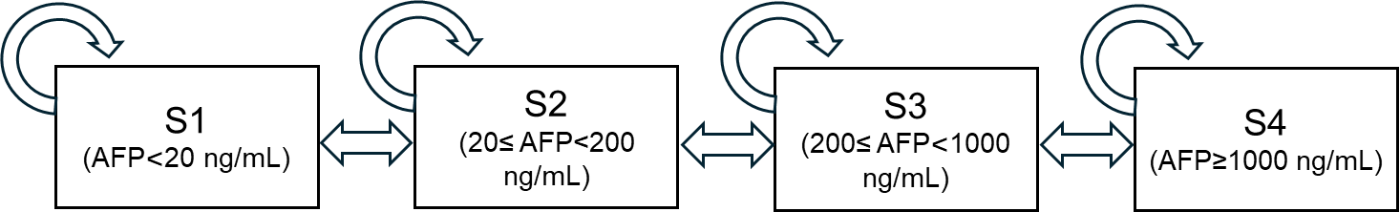
Note: AFP: Alpha-fetoprotein.

Figure S2 Estimated transition probabilities between AFP-defined disease states by age group
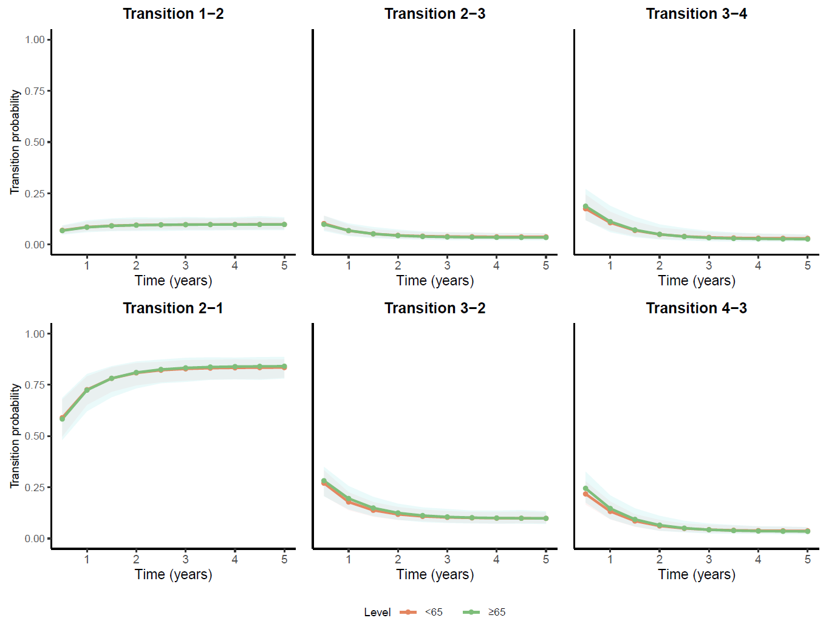
Note: AFP: Alpha-fetoprotein. State 1 (S1): AFP < 20 ng/mL; State 2 (S2): 20 ≤ AFP < 200 ng/mL; State 3 (S3): 200 ≤ AFP < 1000 ng/mL; State 4 (S4): AFP ≥ 1000 ng/mL.

Figure S3 Estimated transition probabilities between AFP-defined disease states by non-alcoholic fatty liver disease (NAFLD)
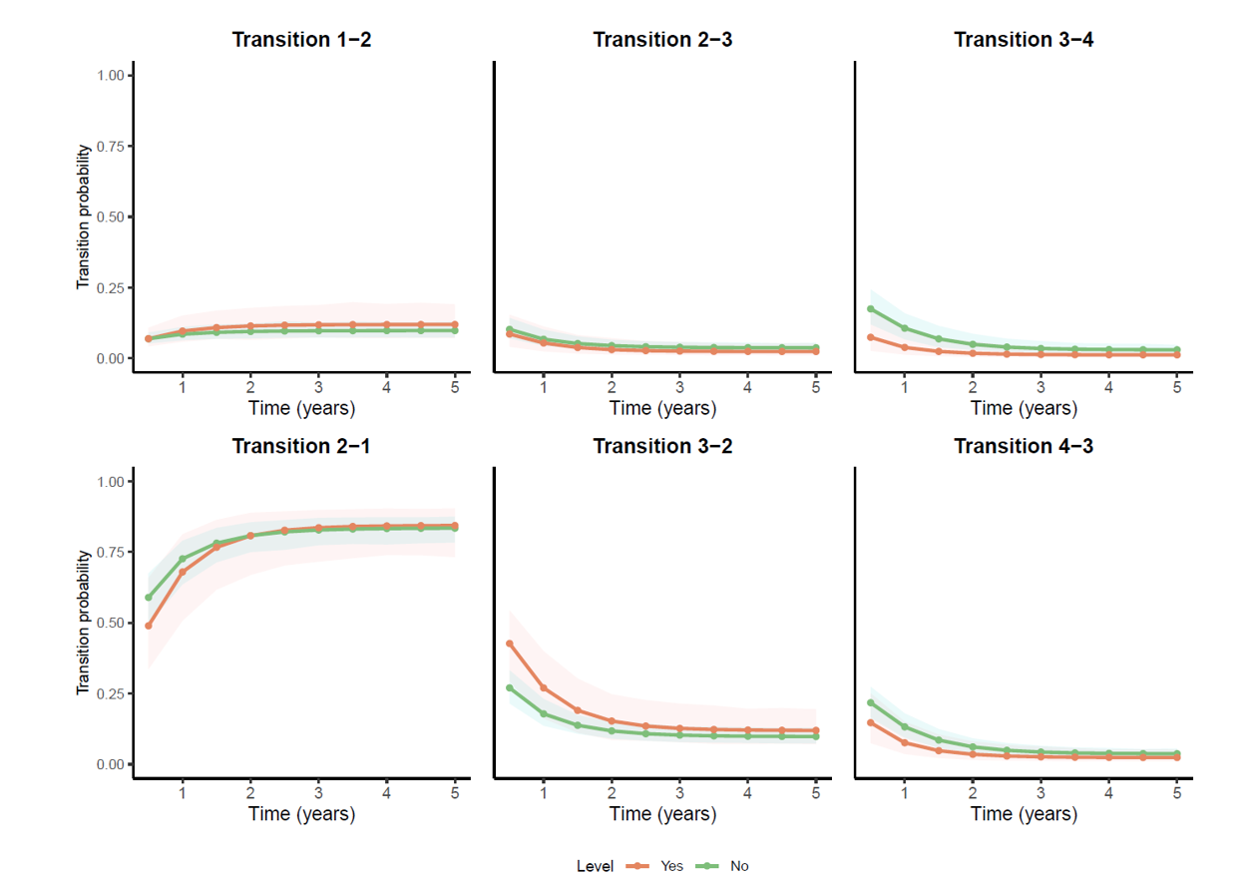
Note: AFP: Alpha-fetoprotein. State 1 (S1): AFP < 20 ng/mL; State 2 (S2): 20 ≤ AFP < 200 ng/mL; State 3 (S3): 200 ≤ AFP < 1000 ng/mL; State 4 (S4): AFP ≥ 1000 ng/mL.

Figure S4 Estimated transition probabilities between AFP-defined disease states by human immunodeficiency virus (HIV)
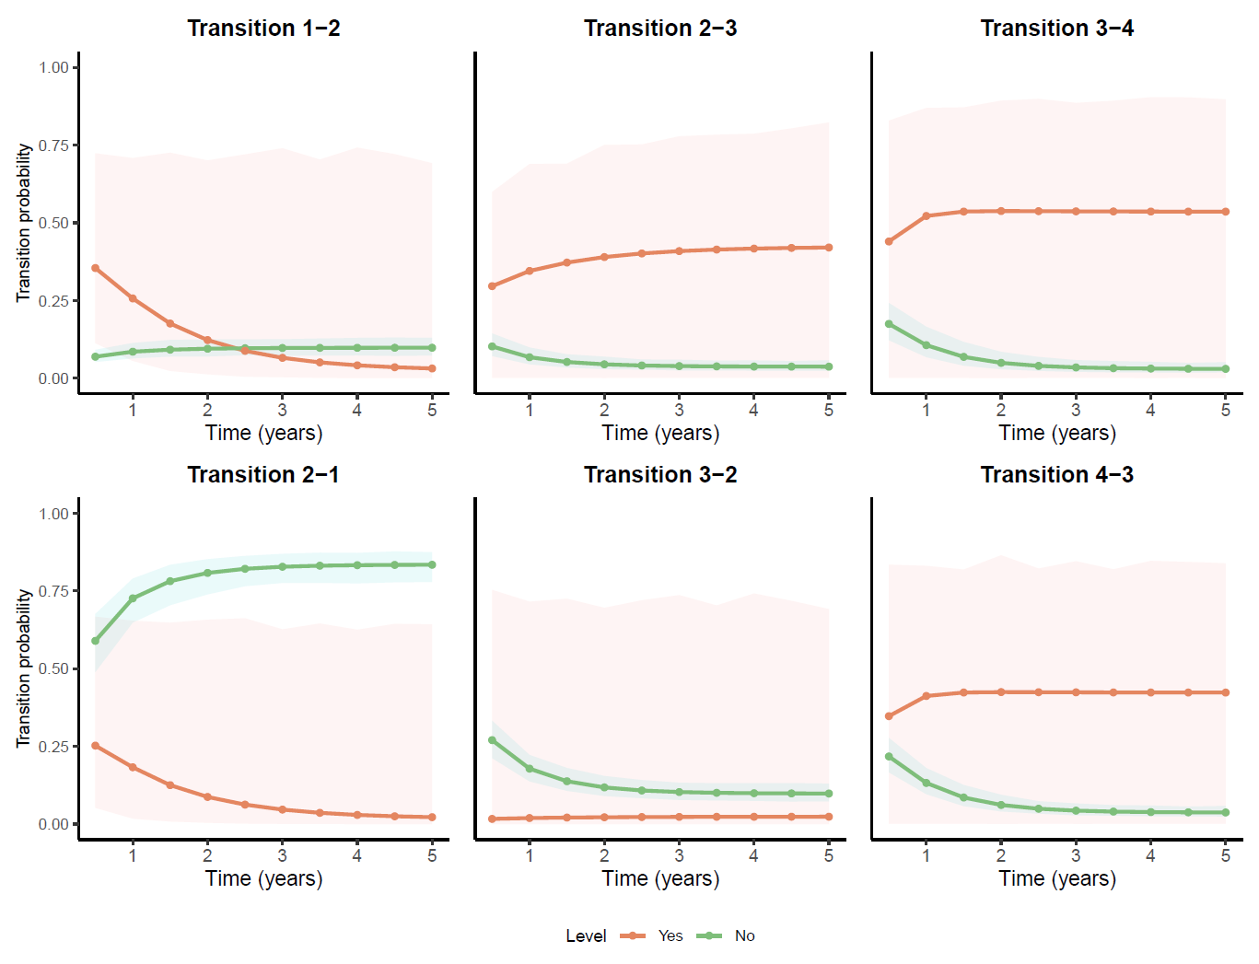
Note: AFP: Alpha-fetoprotein. State 1 (S1): AFP < 20 ng/mL; State 2 (S2): 20 ≤ AFP < 200 ng/mL; State 3 (S3): 200 ≤ AFP < 1000 ng/mL; State 4 (S4): AFP ≥ 1000 ng/mL.

Figure S5 Estimated transition probabilities between AFP-defined disease states by alanine aminotransferase (ALT)
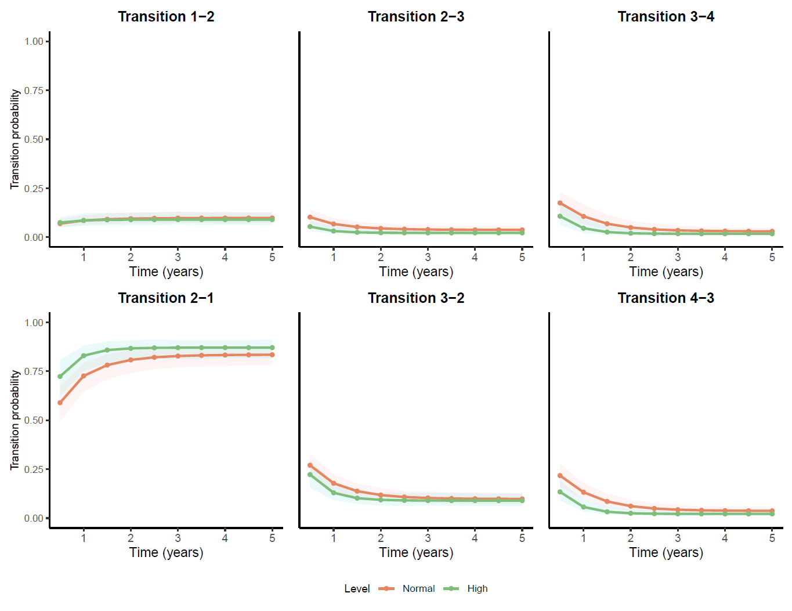
Note: AFP: Alpha-fetoprotein. State 1 (S1): AFP < 20 ng/mL; State 2 (S2): 20 ≤ AFP < 200 ng/mL; State 3 (S3): 200 ≤ AFP < 1000 ng/mL; State 4 (S4): AFP ≥ 1000 ng/mL.

Figure S6 Estimated transition probabilities between AFP-defined disease states by aspartate aminotransferase (AST)
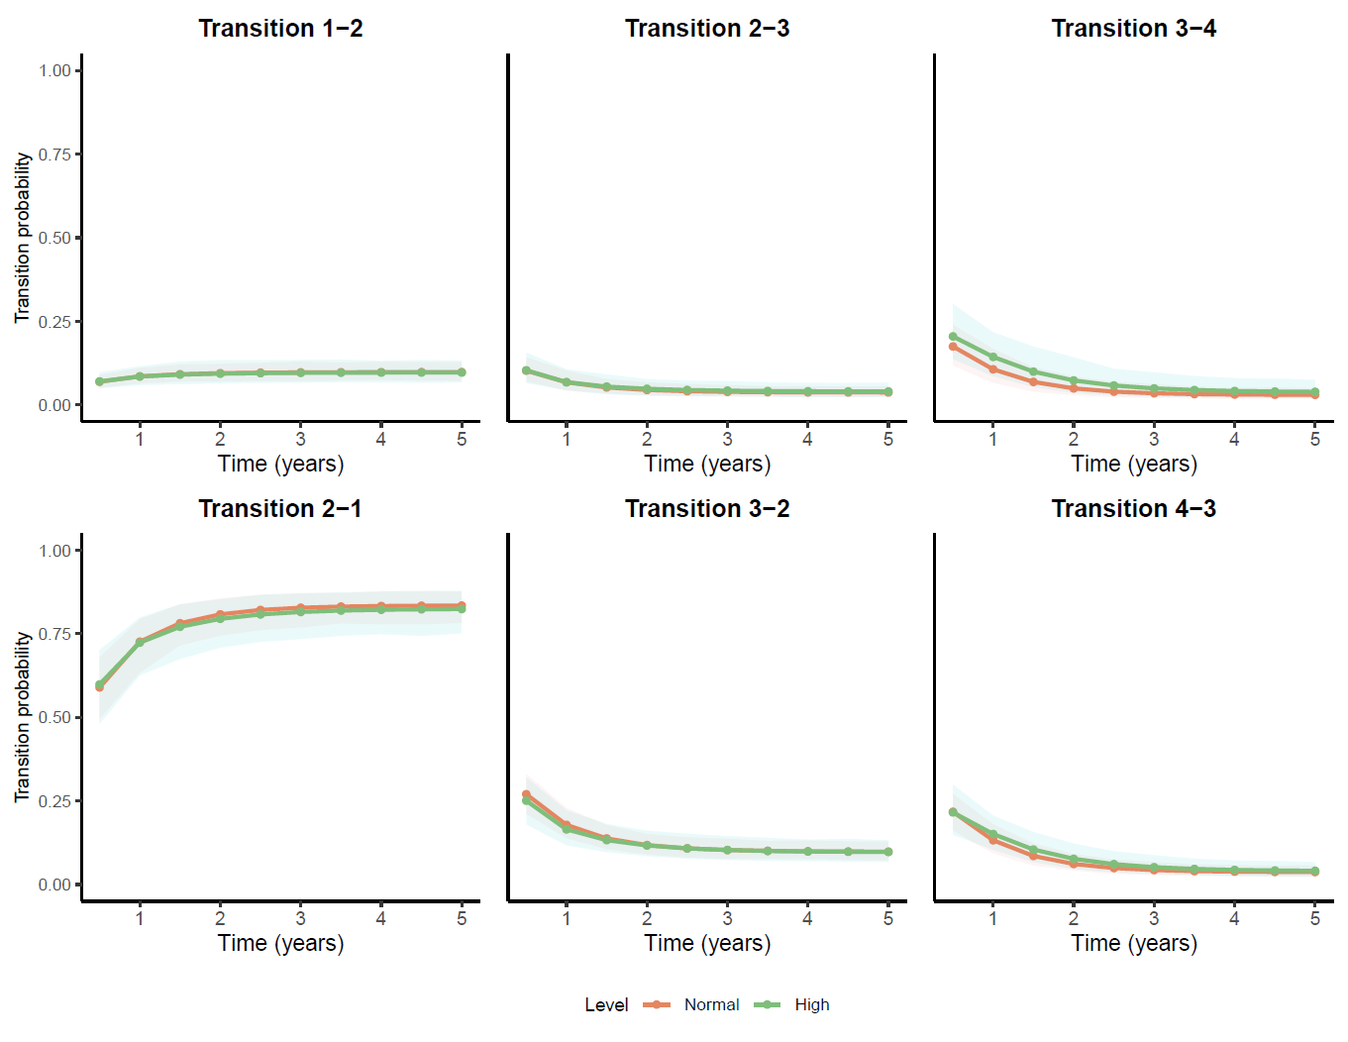
Note: AFP: Alpha-fetoprotein. State 1 (S1): AFP < 20 ng/mL; State 2 (S2): 20 ≤ AFP < 200 ng/mL; State 3 (S3): 200 ≤ AFP < 1000 ng/mL; State 4 (S4): AFP ≥ 1000 ng/mL.

Figure S7 Estimated transition probabilities between AFP-defined disease states by gamma-glutamyl transferase (GGT)
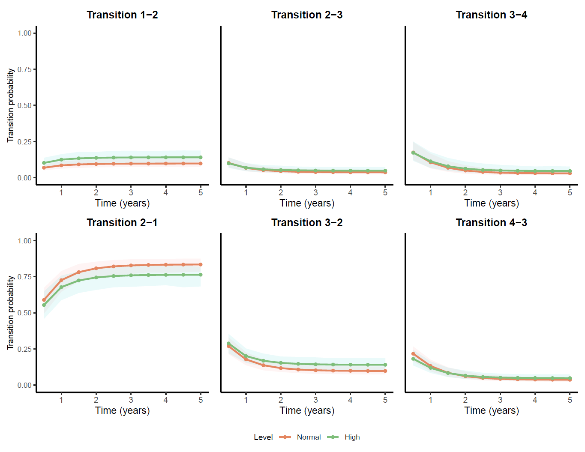
Note: AFP: Alpha-fetoprotein. State 1 (S1): AFP < 20 ng/mL; State 2 (S2): 20 ≤ AFP < 200 ng/mL; State 3 (S3): 200 ≤ AFP < 1000 ng/mL; State 4 (S4): AFP ≥ 1000 ng/mL.

Figure S8 Estimated transition probabilities between AFP-defined disease states by total bilirubin (TBIL)
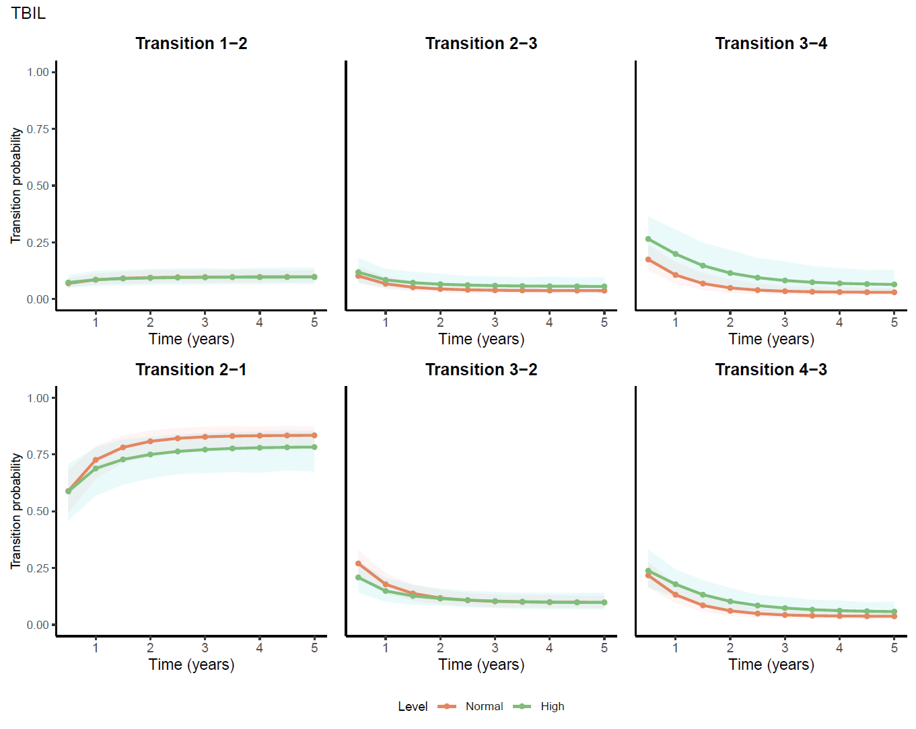
Note: AFP: Alpha-fetoprotein. State 1 (S1): AFP < 20 ng/mL; State 2 (S2): 20 ≤ AFP < 200 ng/mL; State 3 (S3): 200 ≤ AFP < 1000 ng/mL; State 4 (S4): AFP ≥ 1000 ng/mL.

Figure S9 Estimated transition probabilities between AFP-defined disease states by red blood cell count (RBC)
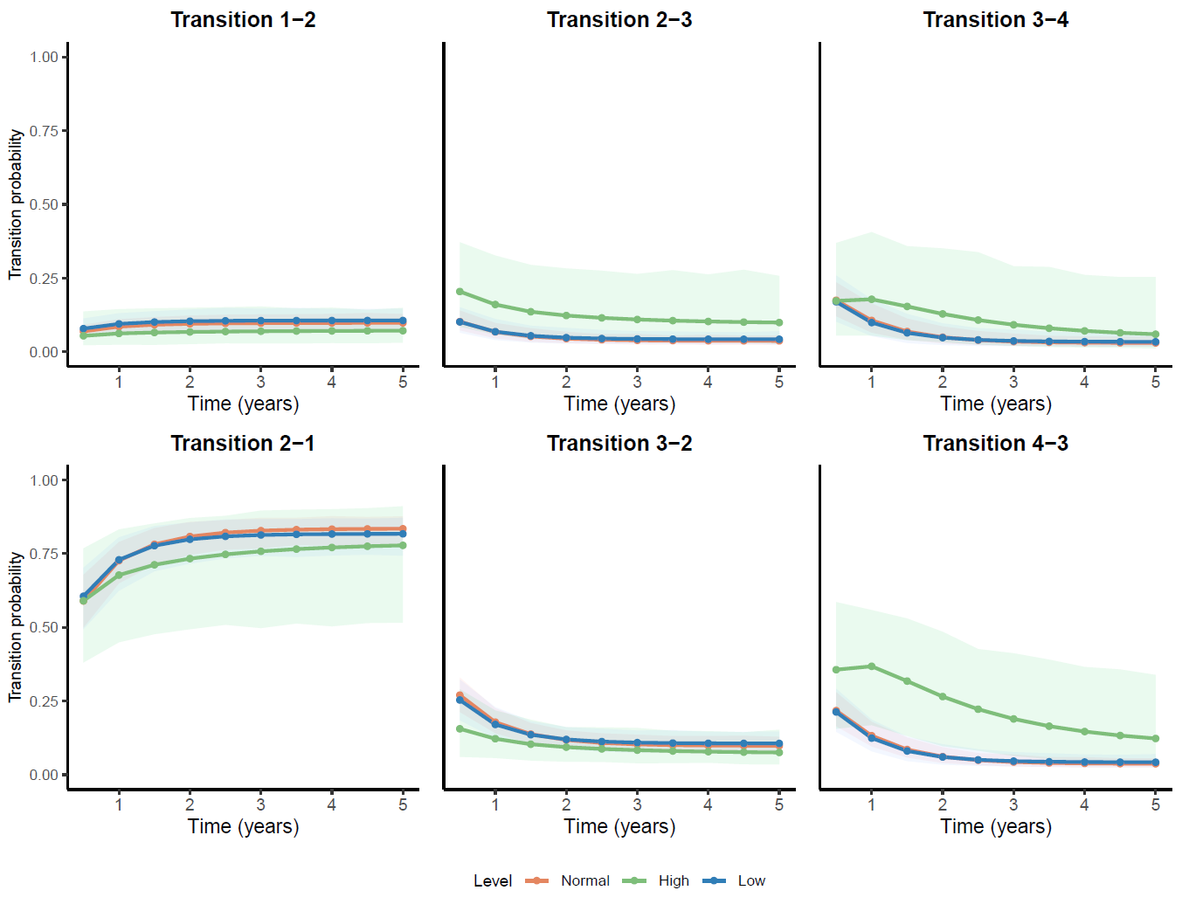
Note: AFP: Alpha-fetoprotein. State 1 (S1): AFP < 20 ng/mL; State 2 (S2): 20 ≤ AFP < 200 ng/mL; State 3 (S3): 200 ≤ AFP < 1000 ng/mL; State 4 (S4): AFP ≥ 1000 ng/mL.

Figure S10 Estimated transition probabilities between AFP-defined disease states by white blood cell count (WBC)
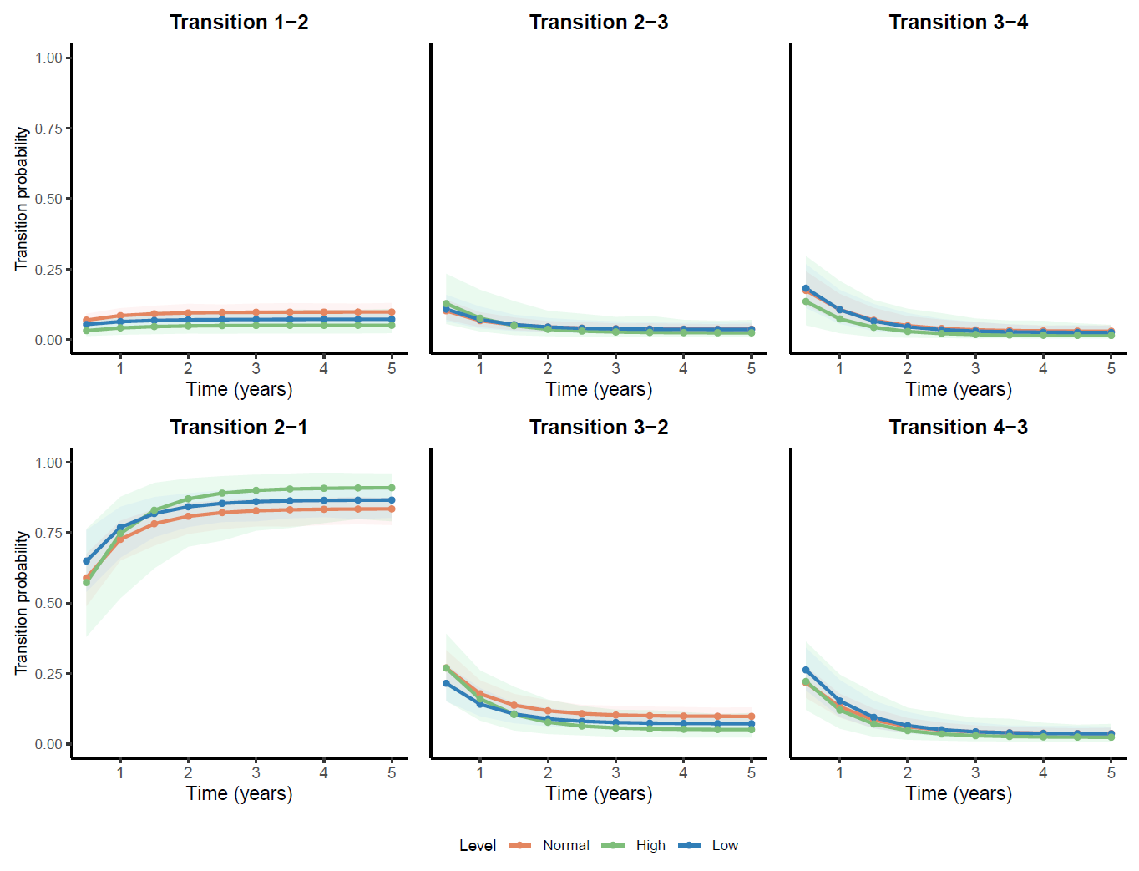
Note: AFP: Alpha-fetoprotein. State 1 (S1): AFP < 20 ng/mL; State 2 (S2): 20 ≤ AFP < 200 ng/mL; State 3 (S3): 200 ≤ AFP < 1000 ng/mL; State 4 (S4): AFP ≥ 1000 ng/mL.

Figure S11 Estimated transition probabilities between AFP-defined disease states by hemoglobin (HGB)
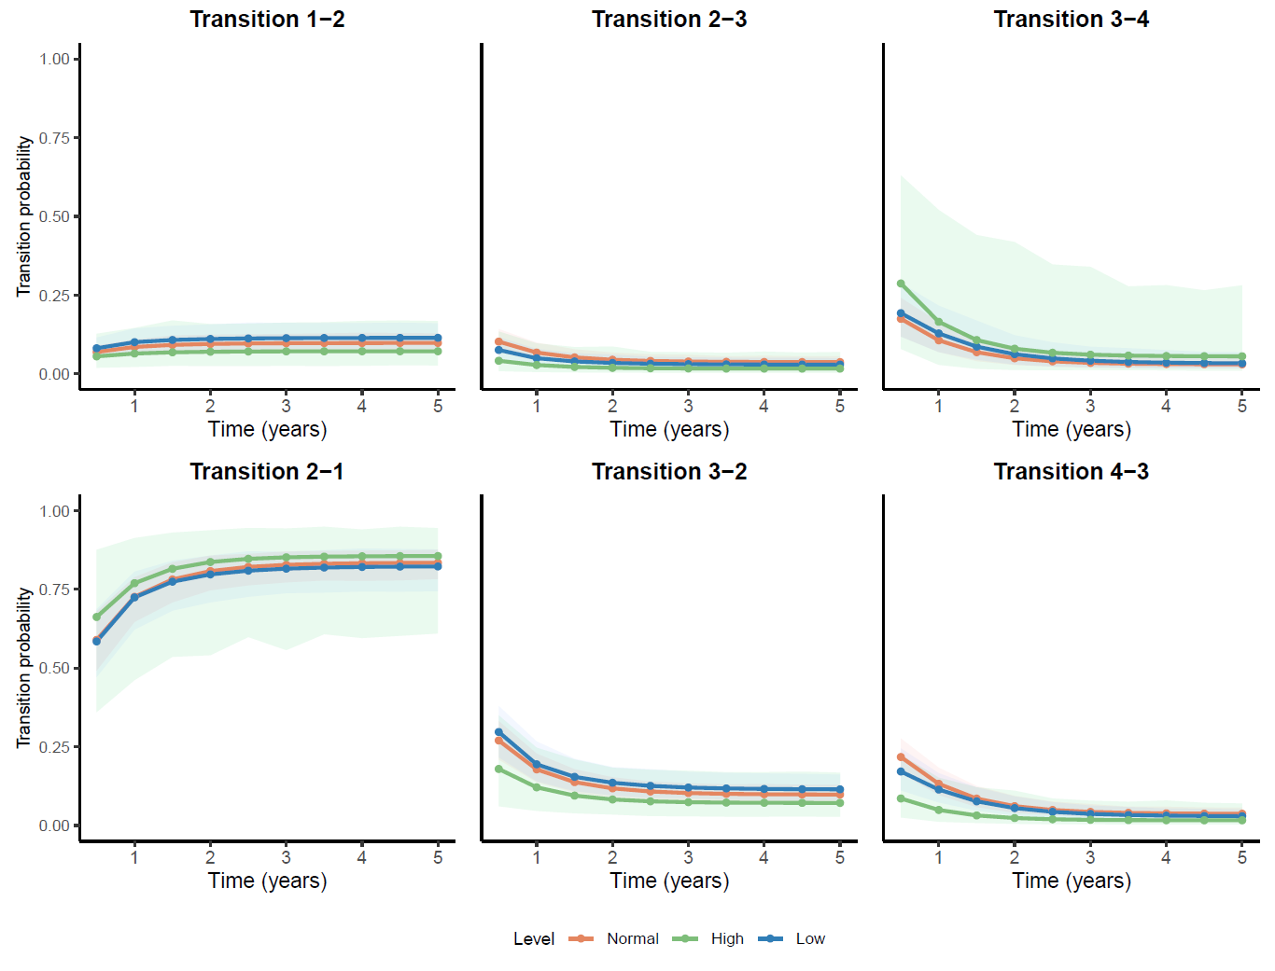
Note: AFP: Alpha-fetoprotein. State 1 (S1): AFP < 20 ng/mL; State 2 (S2): 20 ≤ AFP < 200 ng/mL; State 3 (S3): 200 ≤ AFP < 1000 ng/mL; State 4 (S4): AFP ≥ 1000 ng/mL.

Figure S12 Estimated transition probabilities between AFP-defined disease states by platelet count (PLT)
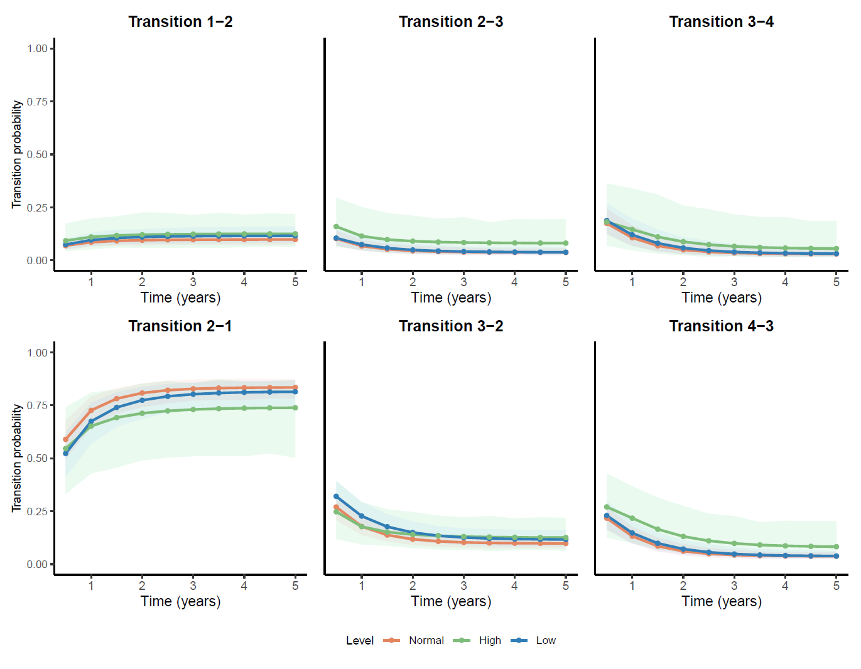
Note: AFP: Alpha-fetoprotein. State 1 (S1): AFP < 20 ng/mL; State 2 (S2): 20 ≤ AFP < 200 ng/mL; State 3 (S3): 200 ≤ AFP < 1000 ng/mL; State 4 (S4): AFP ≥ 1000 ng/mL.

