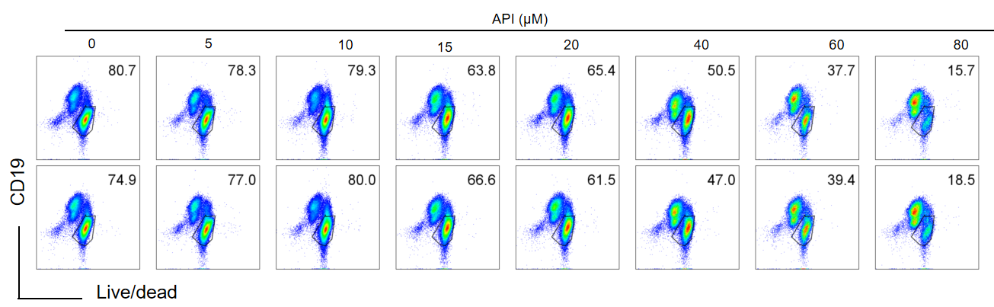
Figure S1 The cytotoxity of API on mouse splenic B cells. Splenic B cells from C57BL/6J mice were cultured with or without LPS (1 µg/mL) and using different concentrations of apigenin for 48 hours. Representative flow cytometry plots in CD19⁺ gated cells.

Figure S2 Apigenin ameliorates synovial inflammation in CIA mice. The changes in the weight of mice.

Table S1. Clinical scoring criteria for murine arthritis
Arthritis Score | Description of Joint Symptoms
0 | No signs of joint swelling or erythema
1 | Mild swelling/erythema of the wrist or ankle joint
2 | Mild swelling/erythema extending from the ankle to the metatarsal or metacarpal joints
3 | Moderate swelling/erythema extending from the ankle to the metatarsophalangeal or metacarpophalangeal joints
4 | Severe joint destruction with loss of integrity and widened joint space

Table S2. Histopathological scoring criteria for bone and joint destruction in mice
Bone Destruction Score | Description of Histopathological Features
0 | Normal bone and joint architecture without pathological changes.
1 | Mild synovial hyperplasia with inflammatory cell infiltration.
2 | Mild pannus formation with initial cartilage destruction.
3 | Extensive cartilage destruction.
4 | Loss of joint integrity, marked widening of the joint space, and severe structural damage.

Table S3. Histopathological scoring criteria for lung injury
Pathological Feature | Description of Severity | Score
Alveolar Epithelial Cell Necrosis | None | 0
Alveolar Epithelial Cell Necrosis | Mild (focal necrosis of a few alveolar epithelial cells) | 1
Alveolar Epithelial Cell Necrosis | Moderate (multifocal necrosis forming necrotic foci) | 2
Alveolar Epithelial Cell Necrosis | Severe (confluent or patchy necrosis of alveolar epithelial cells) | 3
Inflammatory Cell Infiltration | None | 0
Inflammatory Cell Infiltration | Mild (scattered infiltration of a few inflammatory cells) | 1
Inflammatory Cell Infiltration | Moderate (increased number of inflammatory cell aggregates) | 2
Inflammatory Cell Infiltration | Severe (extensive and diffuse inflammatory cell infiltration) | 3
Hemorrhage | None | 0
Hemorrhage | Mild | 1
Hemorrhage | Moderate | 2
Hemorrhage | Severe | 3
Interstitial Edema | None | 0
Interstitial Edema | Mild | 1
Interstitial Edema | Moderate | 2
Interstitial Edema | Severe | 3

