Supplementary table 1: Compartment model selection
Model | OFV | PK Parameter | Estimate | RSE (%) | Omega (CV%)
1 | 543.95 | V | 11.95 | 36.5 | 0.12 (12.25%)
1 | 543.95 | CL | 4.89 | 19.0 | 0.45 (47.15%)
2 | 533.77 | V1 | 0.01 | 1.54e+5 | 1.77 (471.09%)
2 | 533.77 | V2 | 4.95 | 21.7 | 0.20 (19.98%)
2 | 533.77 | CL | 3.22 | 14.1 | 0.44 (45.90%)
2 | 533.77 | Q | 6.36 | 103 | 0.70 (79.70%)
CL: clearance, CV: coefficient of variation, OFV: objective function value, PK: pharmacokinetic, RSE: relative standard error, V: volume of distribution

Supplementary table 2: Covariate Analysis
Step | Run Scenario | ΔOFV | nParm
1, forward inclusion
1, forward inclusion | CG-CL | -6.48 | 2
1, forward inclusion | CKD2012-CL | -10.50 | 2
1, forward inclusion | CKD2021-CL | -12.13 | 2
1, forward inclusion | WT-CL | -0.92 | 2
1, forward inclusion | Age-CL | -0.27 | 2
1, forward inclusion | BMI-CL | -0.40 | 2
1, forward inclusion | WT-V | -1.72 | 2
1, forward inclusion | Age-V | -0.31 | 2
1, forward inclusion | BMI-V | -2.16 | 2
2, forward inclusion
2, forward inclusion | WT, CKD2021-CL | +1.17 | 3
2, forward inclusion | Age, CKD2021-CL | -0.45 | 3
2, forward inclusion | BMI, CKD2021-CL | -0.16 | 3
2, forward inclusion | WT-V, CKD2021-CL | -2.29 | 3
2, forward inclusion | Age-V, CKD2021-CL | -3.29 | 3
2, forward inclusion | BMI-V, CKD2021-CL | -0.65 | 3
3, backward elimination
3, backward elimination | Base | +12.40 | 2
Note: Allometric scaling was applied for body weight with fixed exponents of 0.75 on CL and 1.0 on V, following standard allometric theory. Covariate selection based on change in OFV at least 3.84 (p < 0.05) during forward inclusion and an increase of more than 6.63 (p < 0.01) during backward elimination.
BMI: body mass index; CG: Cockcroft-Gault formula; CKD: Chronic Kidney Disease Epidemiology Collaboration formula; CL: clearance; OFV: objective function value; V: volume of distribution; WT: body weight.

Supplementary table 3: Parameter Uncertainty Propagation Analysis
fu=0.7, replicates = 100; value shown in PTA% (95%CI)
2250mgQ12H 1IF |  | MIC (mcg/mL) |  |  | Trough ≥361
 |  | ≥4 | ≥8 | ≥16 | Trough ≥361
eGFR | 20 | 100 (95.2 – 100) | 100 (82.5 – 100) | 99.8 (58.1 – 100) | 0.0 (0.0 – 1.3)
eGFR | 40 | 98.6 (68.0 – 100) | 93.3 (40.7 – 99.9) | 76.7 (14.0 – 99.5) | 0.0 (0.0 – 0.0)
eGFR | 60 | 79.8 (33.6 – 97.1) | 56.6 (13.2 – 89.3) | 28.7 (2.2 – 67.1) | 0.0 (0.0 – 0.0)
eGFR | 100 | 22.7 (4.7 – 39.2) | 8.6 (0.2 – 20.3) | 1.6 (0.0 – 7.0) | 0.0 (0.0 – 0.0)
eGFR | 130 | 4.5 (0.2 – 18.7) | 1.3 (0.0 – 7.5) | 0.1 (0.0 – 1.6) | 0.0 (0.0 – 0.0)
2250mgQ12H 4IF |  | MIC (mcg/mL) |  |  | Trough ≥361
 |  | ≥4 | ≥8 | ≥16 | Trough ≥361
eGFR | 20 | 100 (98.8 – 100) | 100 (93.4 – 100) | 100 (73.0 – 100) | 0.0 (0.0 – 2.0)
eGFR | 40 | 99.6 (86.4 – 100) | 97.4 (62.4 – 100) | 87.0 (27.4 – 99.7) | 0.0 (0.0 – 0.0)
eGFR | 60 | 90.4 (56.9 – 98.9) | 73.3 (27.9 – 94.7) | 41.8 (6.2 – 81.1) | 0.0 (0.0 – 0.0)
eGFR | 100 | 36.4 (13.7 – 52.6) | 17.2 (2.8 – 31.3) | 3.6 (0.0 – 11.8) | 0.0 (0.0 – 0.0)
eGFR | 130 | 10.9 (1.8 – 29.5) | 3.3 (0.1 – 14.2) | 0.5 (0.0 – 3.4) | 0.0 (0.0 – 0.0)
2250mgQ8H 1IF |  | MIC (mcg/mL) |  |  | Trough ≥361
 |  | ≥4 | ≥8 | ≥16 | Trough ≥361
eGFR | 20 | 100 (99.9 – 100) | 100 (99.2 – 100) | 100 (93.9 – 100) | 0.0 (0.0 – 20.9)
eGFR | 40 | 100 (96.1 – 100) | 99.8 (89.7 – 100) | 97.7 (64.6 – 100) | 0.0 (0.0 – 0.0)
eGFR | 60 | 97.9 (83.9 – 100) | 92.3 (66.3 – 99.2) | 74.1 (33.8 – 95.3) | 0.0 (0.0 – 0.0)
eGFR | 100 | 67.5 (45.3 – 78.7) | 41.5 (21.2 – 57.4) | 17.4 (4.1 – 30.9) | 0.0 (0.0 – 0.0)
eGFR | 130 | 32.9 (14.0 – 55.8) | 14.9 (3.1 – 32.9) | 3.7 (0.1 – 14.2) | 0.0 (0.0 – 0.0)
2250mgQ8H 4IF |  | MIC (mcg/mL) |  |  | Trough ≥361
 |  | ≥4 | ≥8 | ≥16 | Trough ≥361
eGFR | 20 | 100 (100 – 100) | 100 (99.9 – 100) | 100 (99.1 – 100) | 0.0 (0.0 – 27.4)
eGFR | 40 | 100 (99.5 – 100) | 100 (97.6 – 100) | 99.7 (88.5 – 100) | 0.0 (0.0 – 0.0)
eGFR | 60 | 99.8 (97.0 – 100) | 98.7 (88.8 – 100) | 91.5 (66.5 – 99.2) | 0.0 (0.0 – 0.0)
eGFR | 100 | 90 (78.9 – 97.5) | 71.9 (55.6 – 85.0) | 38.8 (21.7 – 52.1) | 0.0 (0.0 – 0.0)
eGFR | 130 | 65.7 (50.4 – 88.1) | 37.8 (21.1 – 59.2) | 13.6 (3.1 – 27.9) | 0.0 (0.0 – 0.0)
2250mgQ6H 1IF |  | MIC (mcg/mL) |  |  | Trough ≥361
 |  | ≥4 | ≥8 | ≥16 | Trough ≥361
eGFR | 20 | 100 (100 – 100) | 100 (100 – 100) | 100 (99.4 – 100) | 0.0 (0.0 – 54.1)
eGFR | 40 | 100 (99.6 – 100) | 100 (98.2 – 100) | 99.8 (91.8 – 100) | 0.0 (0.0 – 0.0)
eGFR | 60 | 99.9 (97.4 – 100) | 99.0 (91.1 – 100) | 94.1 (72.9 – 99.4) | 0.0 (0.0 – 0.0)
eGFR | 100 | 91.6 (80.9 – 98.0) | 76.6 (60.5 – 88.6) | 47.4 (29.2 – 60.0) | 0.0 (0.0 – 0.0)
eGFR | 130 | 68.9 (53.6 – 89.8) | 43.1 (26.6 – 65.0) | 17.6 (5.9 – 35.7) | 0.0 (0.0 – 0.0)
2250mgQ6H 4IF |  | MIC (mcg/mL) |  |  | Trough ≥361
 |  | ≥4 | ≥8 | ≥16 | Trough ≥361
eGFR | 20 | 100 (100 – 100) | 100 (100 – 100) | 100 (100 – 100) | 0.0 (0.1 – 68.3)
eGFR | 40 | 100 (100 – 100) | 100 (99.9 – 100) | 100 (99.3 – 100) | 0.0 (0.0 – 0.3)
eGFR | 60 | 100 (99.9 – 100) | 100 (99.4 – 100) | 99.6 (96.0 – 100) | 0.0 (0.0 – 0.0)
eGFR | 100 | 99.6 (98.4 – 100) | 97.3 (93.3 – 99.9) | 84.9 (73.9 – 97.0) | 0.0 (0.0 – 0.0)
eGFR | 130 | 96.9 (90.2 – 100) | 86.6 (72.0 – 99.1) | 57.5 (35.4 – 84.8) | 0.0 (0.0 – 0.0)
3375mgQ6H 1IF |  | MIC (mcg/mL) |  |  | Trough ≥361
 |  | ≥4 | ≥8 | ≥16 | Trough ≥361
eGFR | 20 | 100 (100 – 100) | 100 (100 – 100) | 100 (99.9 – 100) | 19.9 (0.2 – 99.2)
eGFR | 40 | 100 (99.8 – 100) | 100 (99.2 – 100) | 100 (96.4 – 100) | 0.3 (0.0 – 12.5)
eGFR | 60 | 100 (98.6 – 100) | 99.7 (95.8 – 100) | 97.7 (85.1 – 100) | 0.0 (0.0 – 0.3)
eGFR | 100 | 95.5 (87.5 – 99.6) | 87.3 (73.5 – 95.7) | 65.7 (47.6 – 79.5) | 0.0 (0.0 – 0.0)
eGFR | 130 | 79.5 (65.5 – 95.4) | 58.4 (43.6 – 83.3) | 31.8 (15.5 – 52.2) | 0.0 (0.0 – 0.0)
3375mgQ6H 4IF |  | MIC (mcg/mL) |  |  | Trough ≥361
 |  | ≥4 | ≥8 | ≥16 | Trough ≥361
eGFR | 20 | 100 (100 – 100) | 100 (100 – 100) | 100 (100 – 100) | 31.3 (0.6 – 99.7)
eGFR | 40 | 100 (100 – 100) | 100 (100 – 100) | 100 (99.8 – 100) | 0.5 (0.0 – 21.1)
eGFR | 60 | 100 (100 – 100) | 100 (99.9 – 100) | 99.9 (98.6 – 100) | 0.0 (0.0 – 0.7)
eGFR | 100 | 99.9 (99.2 – 100) | 99.1 (97.1 – 100) | 94.4 (87.5 – 99.8) | 0.0 (0.0 – 0.0)
eGFR | 130 | 98.8 (95.1 – 100) | 94.4 (84.4 – 99.9) | 77.9 (59.3 – 96.3) | 0.0 (0.0 – 0.0)
4500mgQ6H 1IF |  | MIC (mcg/mL) |  |  | Trough ≥361
 |  | ≥4 | ≥8 | ≥16 | Trough ≥361
eGFR | 20 | 100 (100 – 100) | 100 (100 – 100) | 100 (100 – 100) | 67.7 (1.8 – 100)
eGFR | 40 | 100 (99.9 – 100) | 100 (99.6 – 100) | 100 (98.2 – 100) | 3.5 (0.0 – 51.6)
eGFR | 60 | 100 (99.2 – 100) | 99.9 (97.4 – 100) | 99.0 (91.1 – 100) | 0.1 (0.0 – 2.3)
eGFR | 100 | 97.1 (91.2 – 99.8) | 91.5 (80.9 – 98.0) | 76.6 (60.5 – 88.6) | 0.0 (0.0 – 0.0)
eGFR | 130 | 84.7 (72.1 – 97.4) | 68.9 (53.6 – 89.8) | 43.1 (26.6 – 65.0) | 0.0 (0.0 – 0.0)
4500mgQ6H 4IF |  | MIC (mcg/mL) |  |  | Trough ≥361
 |  | ≥4 | ≥8 | ≥16 | Trough ≥361
eGFR | 20 | 100 (100 – 100) | 100 (100 – 100) | 100 (100 – 100) | 78.1 (6.5 – 100)
eGFR | 40 | 100 (100 – 100) | 100 (100 – 100) | 100 (99.9 – 100) | 6.9 (0.0 – 64.0)
eGFR | 60 | 100 (100 – 100) | 100 (99.9 – 100) | 100 (99.4 – 100) | 0.4 (0.0 – 4.8)
eGFR | 100 | 100 (99.6 – 100) | 99.6 (98.4 – 100) | 97.3 (93.3 – 99.9) | 0.0 (0.0 – 0.0)
eGFR | 130 | 99.4 (96.9 – 100) | 96.9 (90.2 – 100) | 86.6 (72.0 – 99.1) | 0.0 (0.0 – 0.0)

Supplementary Figure 1: Visual predictive check for the final population pharmacokinetic model
Outliers are highlighted using red markers and shaded regions, while the red vertical lines denote the bin boundaries
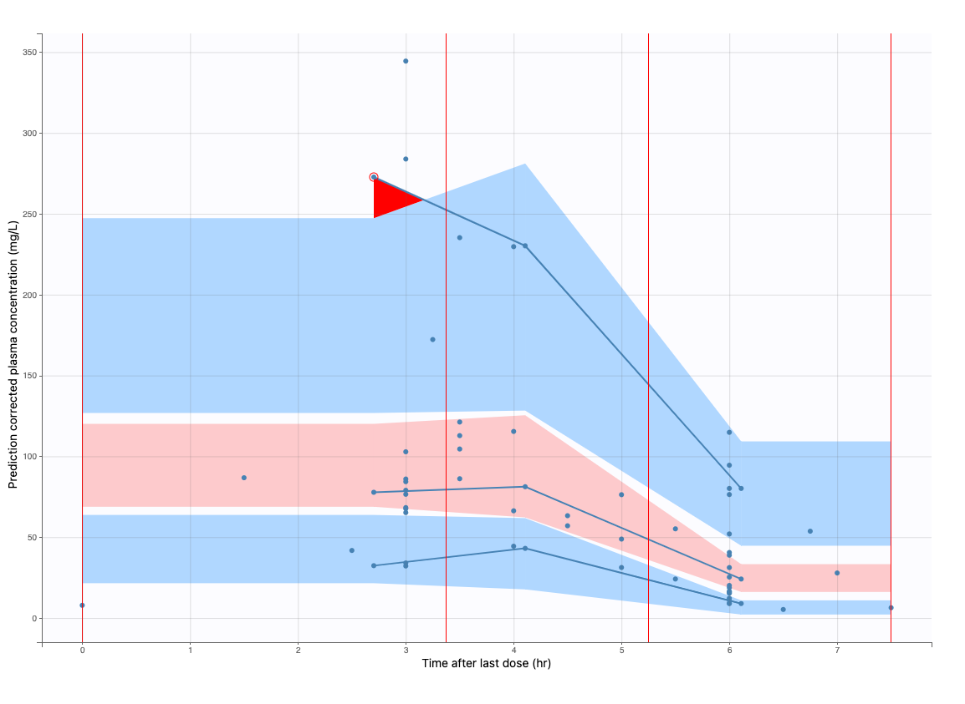

Supplementary Figure 2: Probability of target attainment under different dosing regimens and renal function

(a) 2250mg q12h IF 1hr (b) 2250mg q12h IF 4hr
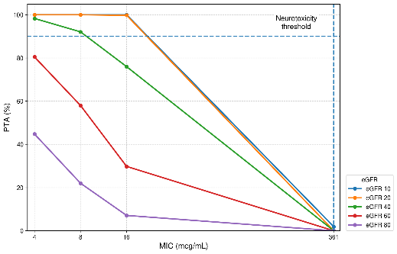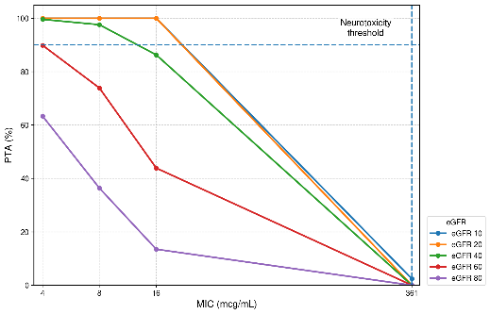
(c) 2250mg q8h IF 1hr (d) 2250mg q8h IF 4hr
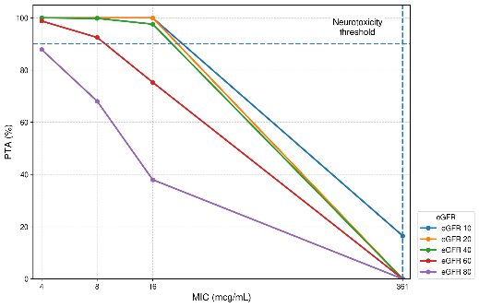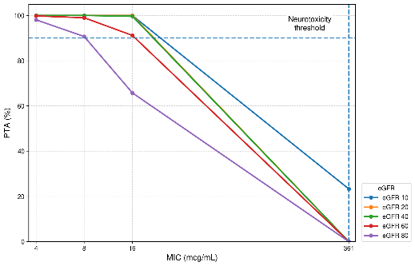
(e) 2250mg q6h IF 1hr (f) 2250mg q6h IF 4hr
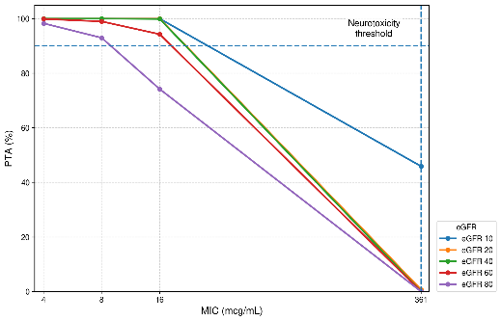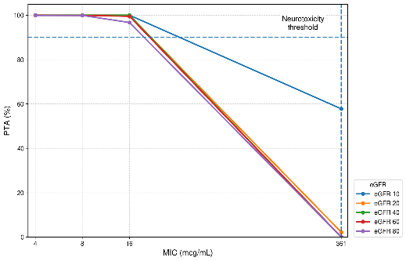
(g) 3375mg q6h IF 1hr (h) 3375mg q6h IF 4hr
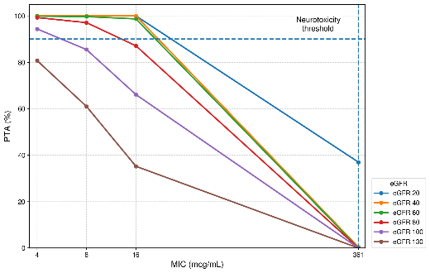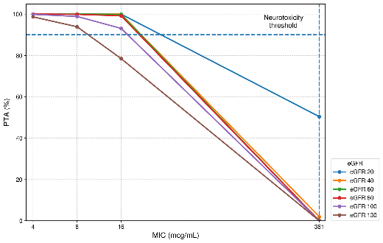
(i) 4500mg q6h IF 1hr (j) 4500mg q6h IF 4hr
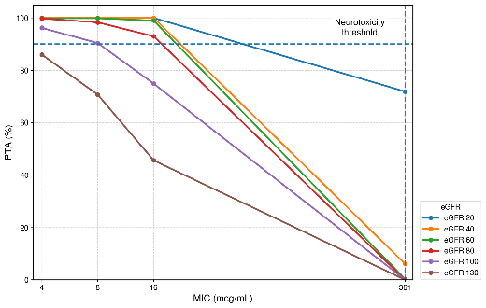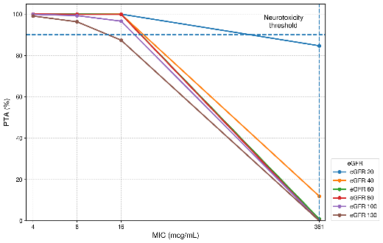
Supplementary Figure 3: Probability of target attainment (50% fT > MIC and 100% fT>4×MIC) at different MIC values and neurotoxicity risk for piperacillin under different dosing regimens and renal function strata.
* >10% probability of trough concentrations exceeding 361 mcg/mL
- 50% fT > MIC
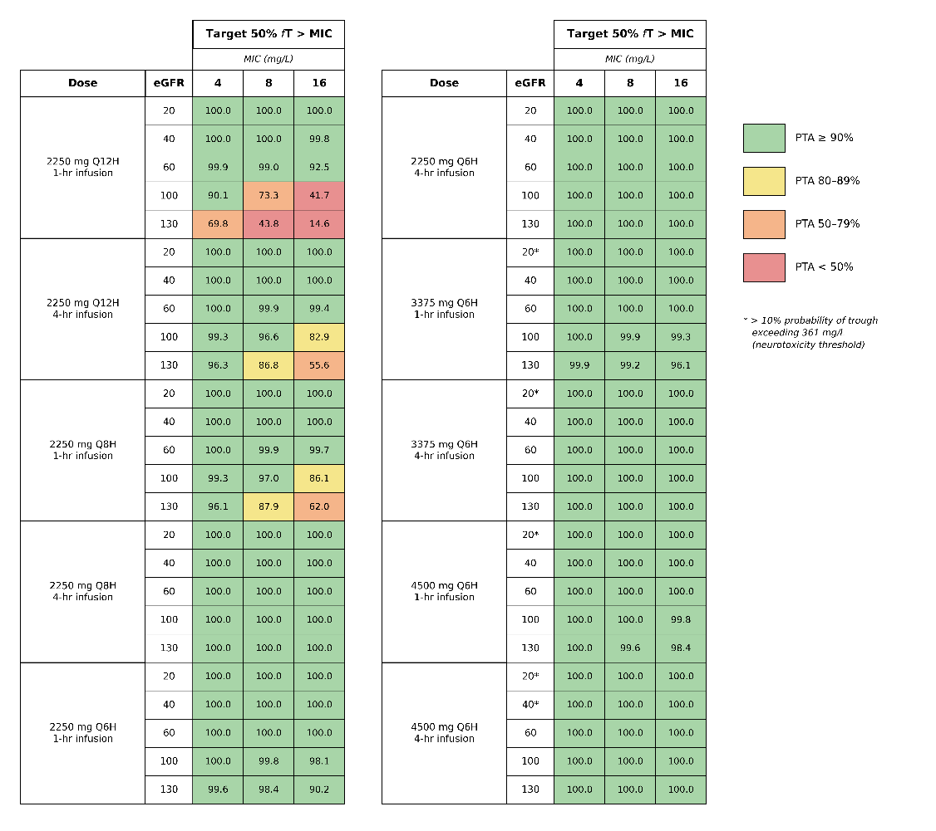
- 100% fT>4×MIC
