Supplementary Table 1 Outcome measures and timing of evaluation
Subjective ocular refraction was assessed using a computerized optotype system (YANG SMART, SIFI S.p.A., Catania, Italy), a computerized optotype system routinely used in our clinical setting during the study period.
Optical biometry was performed using the IOLMaster 700 (Carl Zeiss Meditec AG, Jena, Germany), a swept-source OCT–based device introduced in 2014 and progressively adopted in clinical practice during the study period.
Corneal topography, asphericity, and corneal aberrometry were assessed using a Scheimpflug–Placido topography system (Sirius, CSO, Florence, Italy).
Defocus curves were measured using ETDRS optotypes presented on a computerized visual acuity system (YANG SMART, SIFI S.p.A., Catania, Italy) at a testing distance of 4 meters
Outcome measures | Timing of evaluation
 | Preoperative | 1-2 months follow-up | 24 months follow-up
Subjective refraction (sphere, cylinder, sphere equivalent)
Defocus curve |  | Monocular | Binocular
Monocular and binocular Uncorrected Distance Visual Acuity (UDVA) and Corrected Distance Visual Acuity (CDVA)
Monocular and binocular Distance Corrected Near Visual Acuity (DCNVA)
Monocular and binocular Uncorrected Intermediate Visual Acuity (UIVA) at 100 cm and 63 cm
Monocular and binocular Distance Corrected Intermediate Visual Acuity (DCIVA) at 100 cm and 63 cm
Monocular and binocular Uncorrected Near Visual Acuity (UNVA) at 40 cm
Monocular and Binocular DCNVA at 40 cm
Distance-corrected contrast sensitivity (CS) |  | Monocular | Binocular
Binocular reading performance
Halo finding
Visual Function Questionnaire VF-11R
Postoperative Complications
Subjective Posterior Capsule Opacification (PCO)
Posterior Capsulotomy
Adverse Events (AEs) including Secondary Surgical Interventions (SSIs)
Device Deficiencies
Photic Phenomena Assessment
Notes:
: the outcome is measured in Monocular and Binocular;
Monocular: the outcome is measured in Monocular, only;
Binocular: the outcome is measured in Binocular, only.

Supplementary Table 2 Methods and available program for visual disturbances and distortions detection
Methods for visual disturbances and distortions detection | A specific software (Halo v1.0 software, Laboratory of Vision Sciences and Applications, University of Granada, Spain) was used by Investigator to test the presence of visual disturbances under low illumination. The test consists of discriminating peripheral luminous stimuli of 2 pixels around a more luminous central target of 24 pixels. The central stimulus causes intraocular scattering and retinal reflection in the patient’s eye, depending on the state of the retina and ocular media. The discrimination capacity of peripheral stimuli in the presence of visual disturbances is assessed by the disturbance index. The index is calculated as a ratio between non detected stimuli and all the peripheral stimuli presented to the observer.
Available program used to evaluate the halos | downloaded for free from http://www.ugr.es/~labvisgr/)

Supplementary Table 3 Percentage of answers for each item in the Visual Function Questionnaire VF-11R (VF-11R) at 2 years. The patients indicated whether they experienced difficulties, even with glasses, in performing the following 12 tasks
 | Question | Answer | %
Do you have difficulties, even with glasses… | 1. Reading small print, such as labels on medicine bottles, a telephone book, food | No | 56.52
Do you have difficulties, even with glasses… |  | A little | 26.09
Do you have difficulties, even with glasses… |  | A moderate amount | 17.39
Do you have difficulties, even with glasses… |  | A great deal | 0.00
Do you have difficulties, even with glasses… |  | Unable to do the activity | 0.00
Do you have difficulties, even with glasses… | 2. Reading a newspaper or a book | No | 69.57
Do you have difficulties, even with glasses… | 2. Reading a newspaper or a book | A little | 13.04
Do you have difficulties, even with glasses… | 2. Reading a newspaper or a book | A moderate amount | 17.39
Do you have difficulties, even with glasses… | 2. Reading a newspaper or a book | A great deal | 0.00
Do you have difficulties, even with glasses… | 2. Reading a newspaper or a book | Unable to do the activity | 0.00
Do you have difficulties, even with glasses… | 3. Reading a large-print book or a large-print newspaper or numbers on a telephone | No | 73.91
Do you have difficulties, even with glasses… |  | A little | 8.70
Do you have difficulties, even with glasses… |  | A moderate amount | 8.70
Do you have difficulties, even with glasses… |  | A great deal | 8.70
Do you have difficulties, even with glasses… |  | Unable to do the activity | 0.00
Do you have difficulties, even with glasses… | 4. Recognizing people when they are close to you | No | 73.91
Do you have difficulties, even with glasses… | 4. Recognizing people when they are close to you | A little | 8.70
Do you have difficulties, even with glasses… | 4. Recognizing people when they are close to you | A moderate amount | 4.35
Do you have difficulties, even with glasses… | 4. Recognizing people when they are close to you | A great deal | 13.04
Do you have difficulties, even with glasses… | 4. Recognizing people when they are close to you | Unable to do the activity | 0.00
Do you have difficulties, even with glasses… | 5. Seeing steps, stairs or curbs | No | 73.91
Do you have difficulties, even with glasses… | 5. Seeing steps, stairs or curbs | A little | 13.04
Do you have difficulties, even with glasses… | 5. Seeing steps, stairs or curbs | A moderate amount | 8.70
Do you have difficulties, even with glasses… | 5. Seeing steps, stairs or curbs | A great deal | 4.35
Do you have difficulties, even with glasses… | 5. Seeing steps, stairs or curbs | Unable to do the activity | 0.00
Do you have difficulties, even with glasses… | 6. Reading traffic signs, street signs, or store signs | No | 73.91
Do you have difficulties, even with glasses… | 6. Reading traffic signs, street signs, or store signs | A little | 8.70
Do you have difficulties, even with glasses… | 6. Reading traffic signs, street signs, or store signs | A moderate amount | 17.39
Do you have difficulties, even with glasses… | 6. Reading traffic signs, street signs, or store signs | A great deal | 0.00
Do you have difficulties, even with glasses… | 6. Reading traffic signs, street signs, or store signs | Unable to do the activity | 0.00
Do you have difficulties, even with glasses… | 7. Doing fine handwork like sewing, knitting, crocheting, carpentry | No | 56.52
Do you have difficulties, even with glasses… |  | A little | 30.43
Do you have difficulties, even with glasses… |  | A moderate amount | 8.70
Do you have difficulties, even with glasses… |  | A great deal | 4.35
Do you have difficulties, even with glasses… |  | Unable to do the activity | 0.00
Do you have difficulties, even with glasses… | 8. Writing checks or filling out forms | No | 65.22
Do you have difficulties, even with glasses… | 8. Writing checks or filling out forms | A little | 13.04
Do you have difficulties, even with glasses… | 8. Writing checks or filling out forms | A moderate amount | 13.04
Do you have difficulties, even with glasses… | 8. Writing checks or filling out forms | A great deal | 8.70
Do you have difficulties, even with glasses… | 8. Writing checks or filling out forms | Unable to do the activity | 0.00
Do you have difficulties, even with glasses… | 9. Playing games such as bingo, dominos, card games, mah-jong | No | 73.91
Do you have difficulties, even with glasses… |  | A little | 4.35
Do you have difficulties, even with glasses… |  | A moderate amount | 8.70
Do you have difficulties, even with glasses… |  | A great deal | 13.04
Do you have difficulties, even with glasses… |  | Unable to do the activity | 0.00
Do you have difficulties, even with glasses… | 10. Taking part in sports like bowling, handball, tennis, golf | No | 78.26
Do you have difficulties, even with glasses… |  | A little | 4.35
Do you have difficulties, even with glasses… |  | A moderate amount | 13.04
Do you have difficulties, even with glasses… |  | A great deal | 0.00
Do you have difficulties, even with glasses… |  | Unable to do the activity | 4.35
Do you have difficulties, even with glasses… | 11. Cooking | No | 69.57
Do you have difficulties, even with glasses… | 11. Cooking | A little | 8.70
Do you have difficulties, even with glasses… | 11. Cooking | A moderate amount | 17.39
Do you have difficulties, even with glasses… | 11. Cooking | A great deal | 4.35
Do you have difficulties, even with glasses… | 11. Cooking | Unable to do the activity | 0.00
Do you have difficulties, even with glasses… | 12. Watching television | No | 69.57
Do you have difficulties, even with glasses… | 12. Watching television | A little | 8.70
Do you have difficulties, even with glasses… | 12. Watching television | A moderate amount | 21.74
Do you have difficulties, even with glasses… | 12. Watching television | A great deal | 0.00
Do you have difficulties, even with glasses… | 12. Watching television | Unable to do the activity | 0.00

Supplementary Table 4 Percentage of answers for each item in the Visual Function Questionnaire VF-11R (VF-11R) at 2 years. The patients indicated whether they experienced difficulties, even with glasses, in performing the following 12 tasks
 | Question | Mean | SD
Do you have difficulties, even with glasses… | 1. Reading small print, such as labels on medicine bottles, a telephone book, food | 84.78 | 19.57
Do you have difficulties, even with glasses… | 2. Reading a newspaper or a book | 88.04 | 19.76
Do you have difficulties, even with glasses… | 3. Reading a large-print book or a large-print newspaper or numbers on a telephone | 86.96 | 24.85
Do you have difficulties, even with glasses… | 4. Recognizing people when they are close to you | 85.87 | 27.00
Do you have difficulties, even with glasses… | 5. Seeing steps, stairs or curbs | 89.13 | 21.09
Do you have difficulties, even with glasses… | 6. Reading traffic signs, street signs, or store signs | 89.13 | 19.69
Do you have difficulties, even with glasses… | 7. Doing fine handwork like sewing, knitting, crocheting, carpentry | 84.78 | 20.97
Do you have difficulties, even with glasses… | 8. Writing checks or filling out forms | 83.70 | 25.68
Do you have difficulties, even with glasses… | 9. Playing games such as bingo, dominos, card games, mah-jong | 84.78 | 27.94
Do you have difficulties, even with glasses… | 10. Taking part in sports like bowling, handball, tennis, golf | 88.04 | 25.97
Do you have difficulties, even with glasses… | 11. Cooking | 85.87 | 23.63
Do you have difficulties, even with glasses… | 12. Watching television | 86.96 | 21.15
Do you have difficulties, even with glasses… | Total Average Score | 86.50

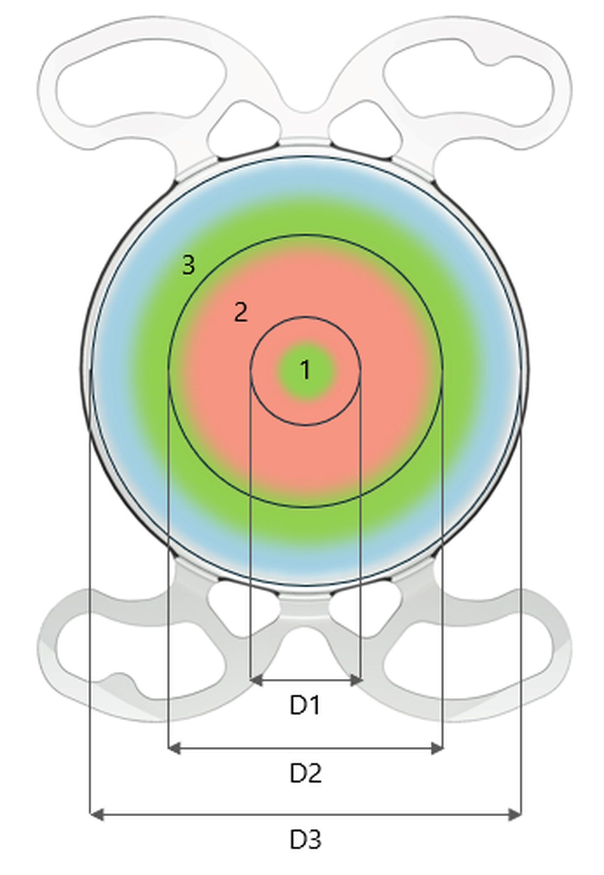
Supplementary Figure 1 Intraocular lens (IOL) Mini WELL (SIFI S.p.A., Catania, Italy), an aspheric progressive extended depth-of-focus (EDoF) IOL designed for continuous vision in the range of infinity to near (40 cm) distance.
Abbreviations: D1, central distance zone; D2, surrounding distance zone with spherical aberration of the opposite sign; D3, peripheral distance zone.

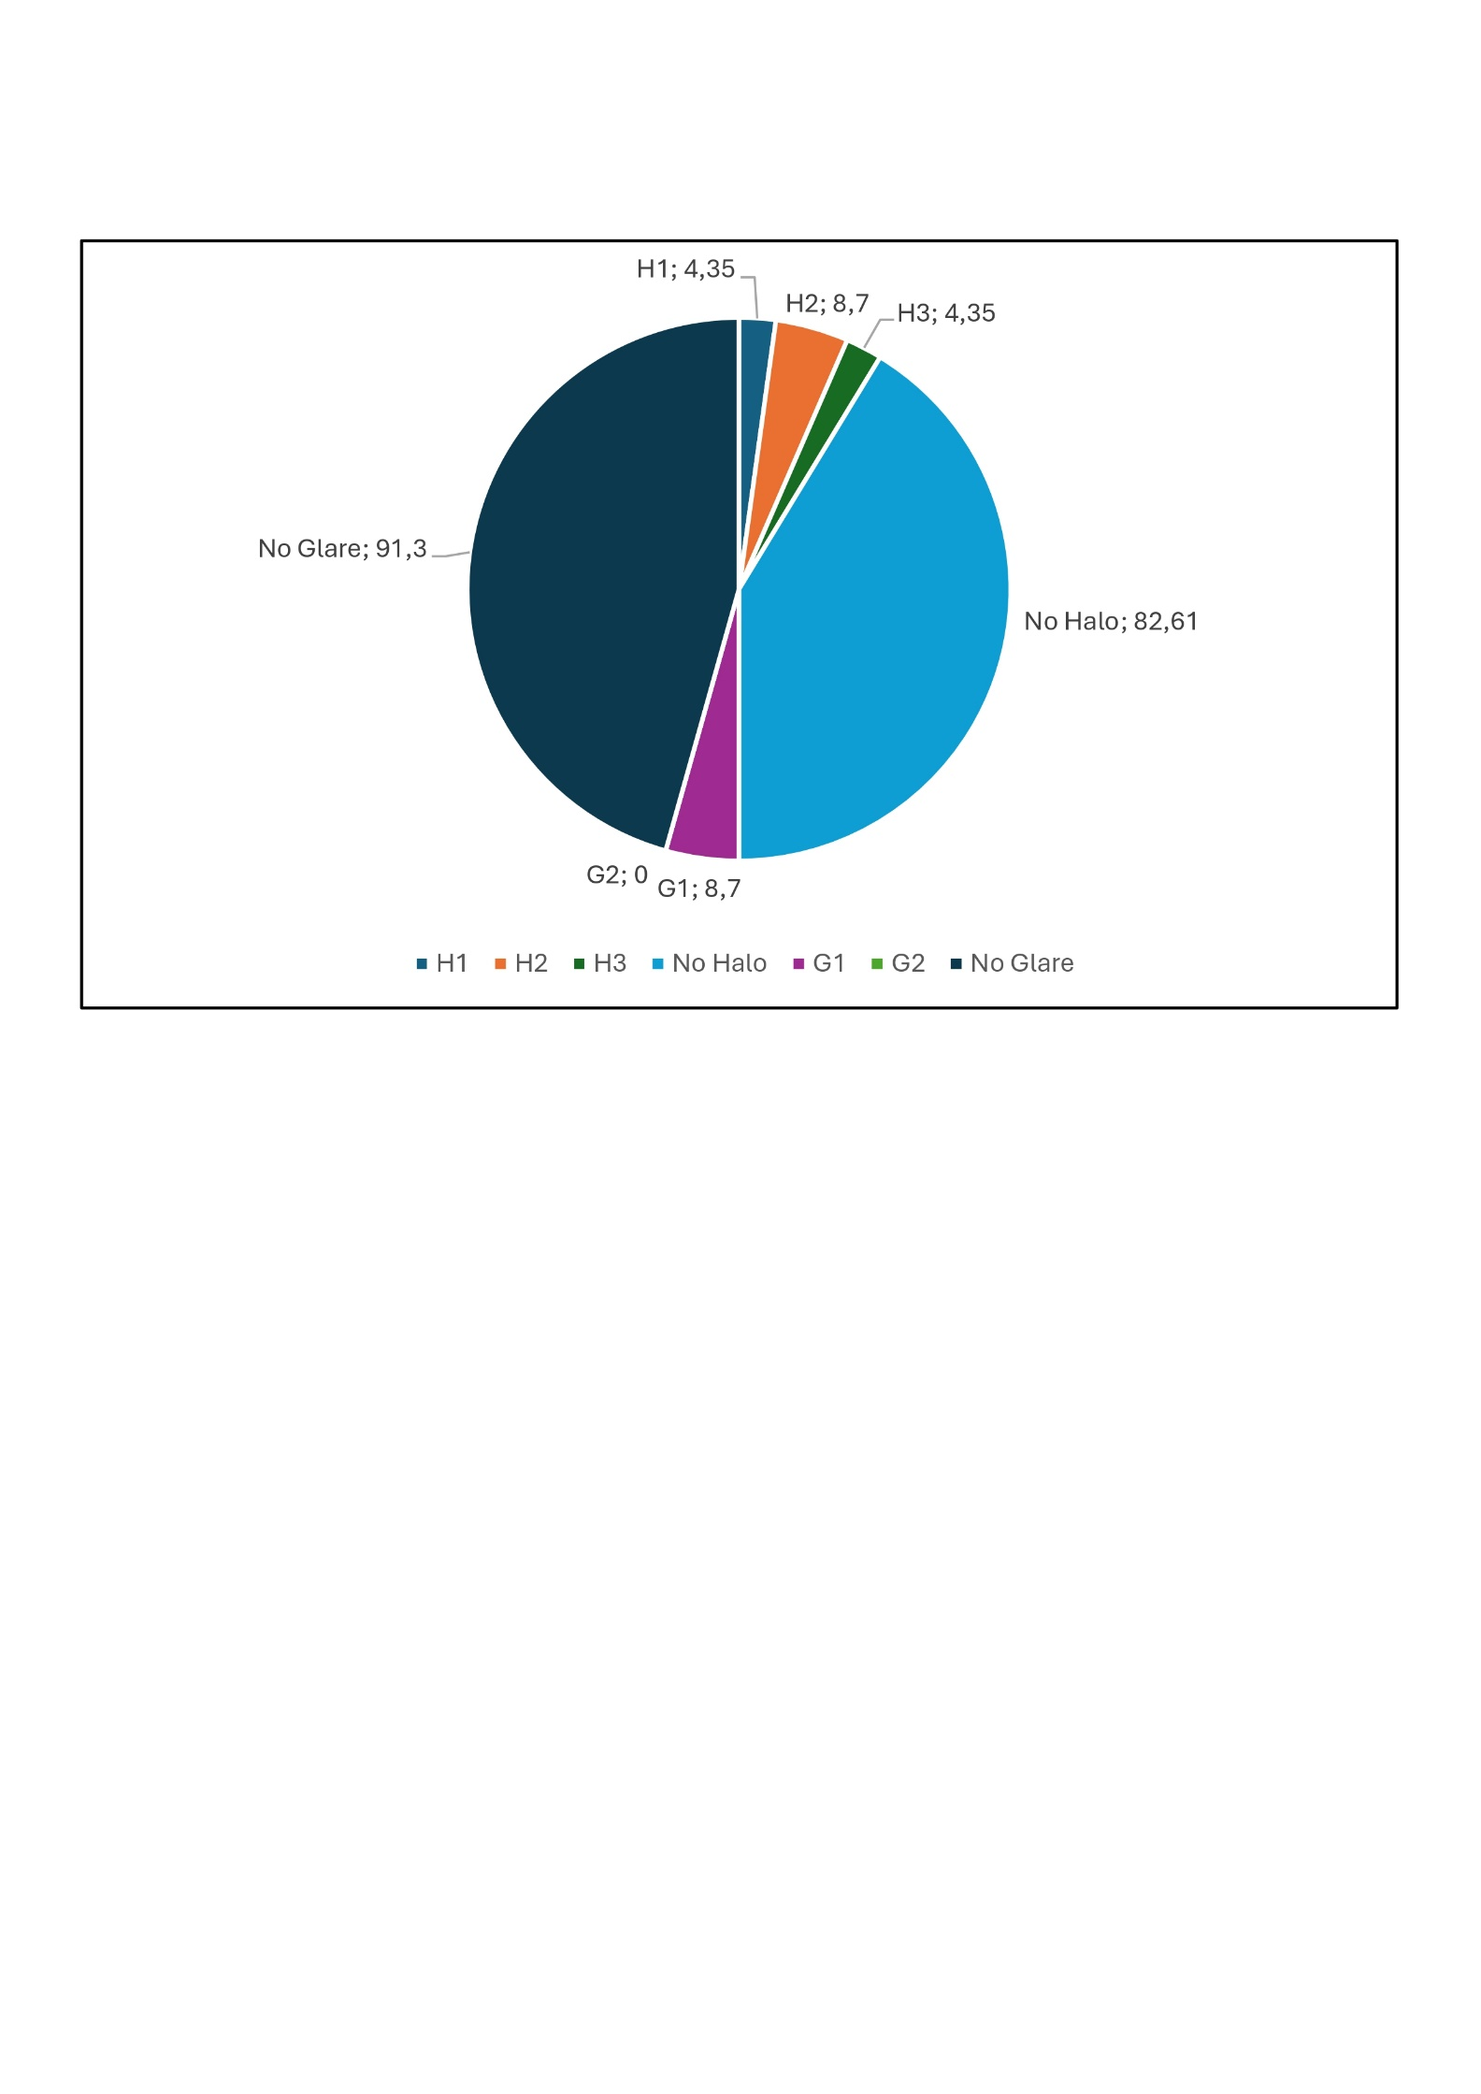

Supplementary Figure 2 Photic phenomenon assessment at the two-year follow-up.
Abbreviations: H1, diffuse halo ring; H2, starburst type; H3, distinct halo ring; G1, diffuse glare; G2, irregularly shaped glare.

