Supplemental Figure 1. Study design
Description: Schema illustrating key elements and timing of the study design
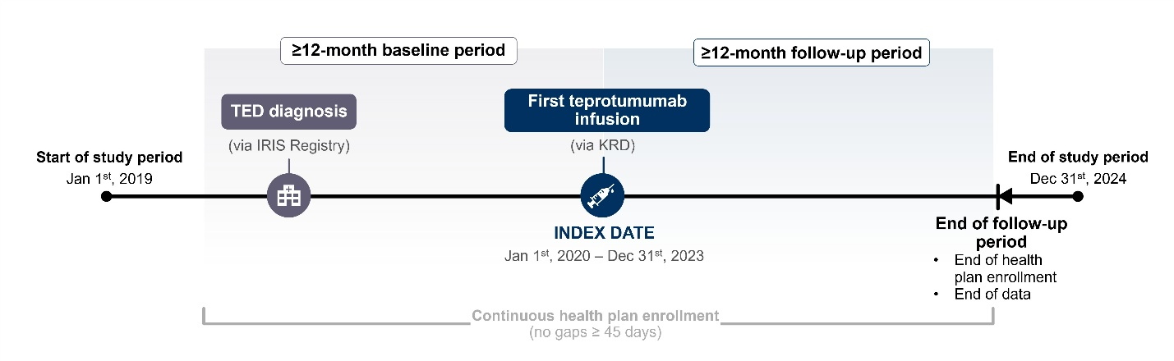
IRIS, Intelligent Research in Sight; KRD, Komodo Research Dataset; TED, thyroid eye disease.

Supplemental Figure 2. Study patient population
Description: Flowchart illustrating the selection criteria used to identify the eligible study population, including subgroups of interest
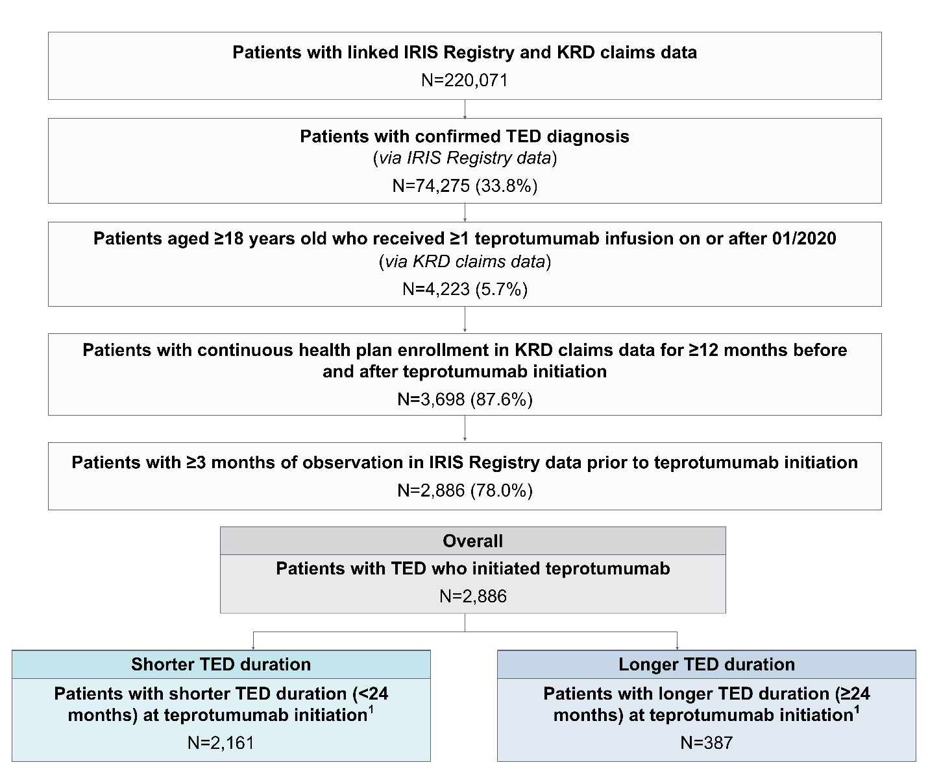
¹Some patients (N=338) could not be categorized into subgroups due to unknown TED duration at the index date and consequently were excluded from subgroup analyses.
IRIS, Intelligent Research in Sight; KRD, Komodo Research Dataset; TED, thyroid eye disease.
Supplemental Figure 3. Teprotumumab infusion patterns by TED duration
Description: Flowchart depicting infusion patterns across the first and second courses of teprotumumab treatment among subgroups of interest
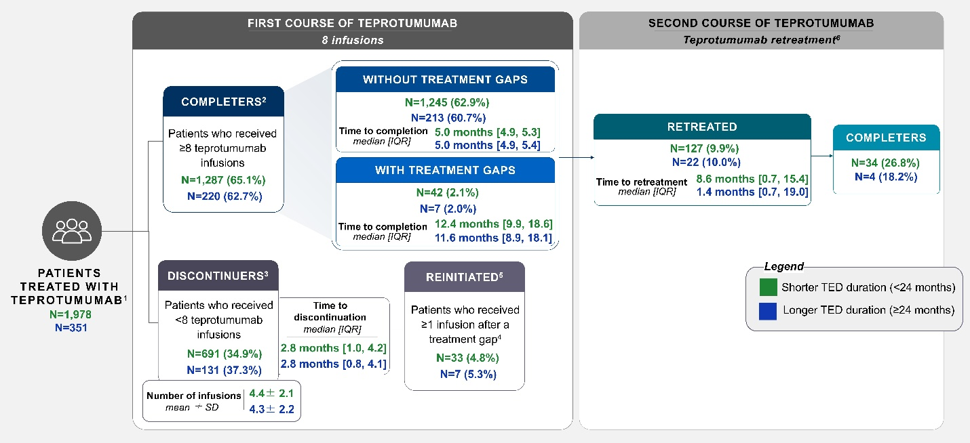
¹Infusion patterns were reported based on all teprotumumab claims (which were required to be ≥10 days apart to be considered separate claims) observed between the index date and the end of follow-up. Patients who were potentially impacted by the COVID-19 supply chain disruption (i.e., patients who initiated teprotumumab in the second half of 2020 and discontinued in the first half of 2021; n=249) and patients with unknown disease duration at index (N=338) were excluded from the infusion pattern analyses. ²First course completers were defined as patients who received ≥8 teprotumumab infusions. ³Discontinuers were defined as patients who received <8 teprotumumab infusions. ⁴Treatment gaps were defined as a period of ≥90 days between two consecutive teprotumumab infusions. ⁵Among discontinuers, reinitiation was defined as receiving a subsequent infusion after a treatment gap (≥90 days), while still receiving <8 overall. ⁶Among completers, retreatment was defined as receiving at least one subsequent infusion after completion of a course (i.e., ≥9 infusions), with second course completers defined as patients who received ≥16 teprotumumab infusions.
IQR: interquartile range; SD, standard deviation; TED, thyroid eye disease.

