Appendix 1: Patient Questionnaire

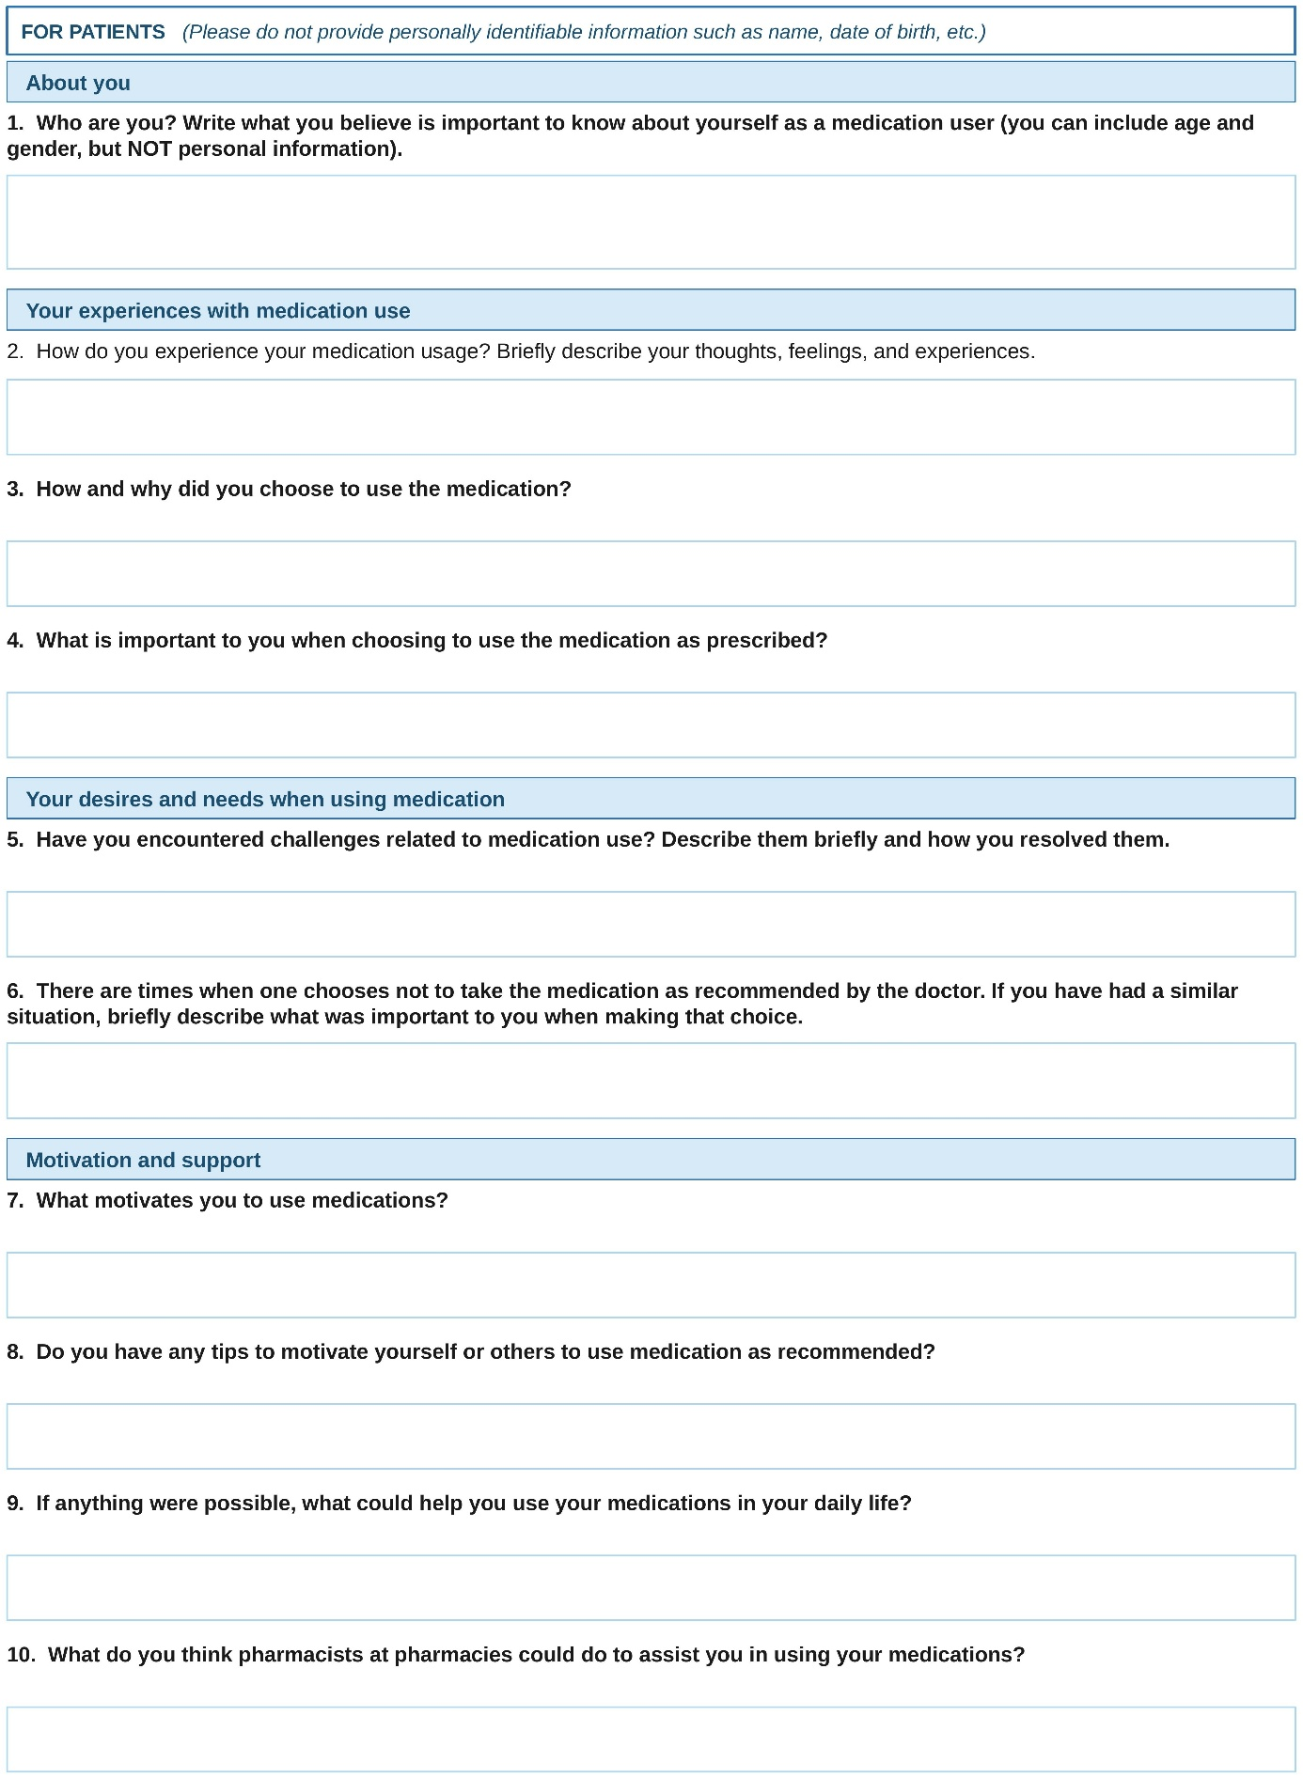
Figure S1. Patient questionnaire distributed to cardiovascular medication users at a hospital pharmacy.
Appendix 2: Interview Guide – Physicians and Nurses
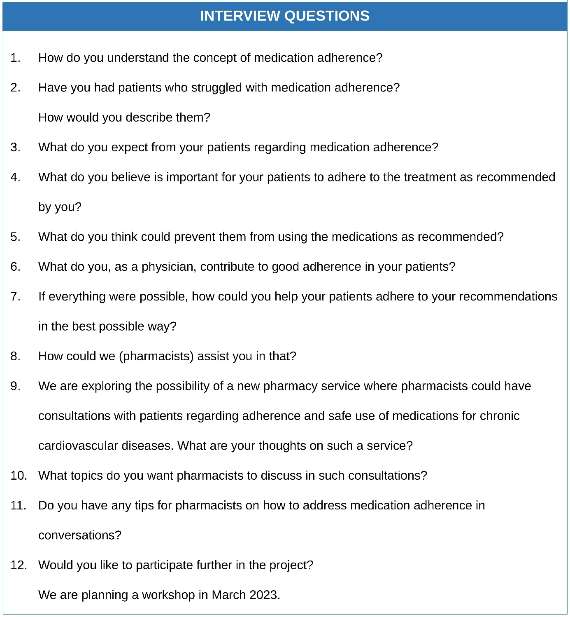
Figure S2. An interview guide used in semi-structured individual interviews with physicians and nurses.

Appendix 3: Interview Guide – Pharmacists
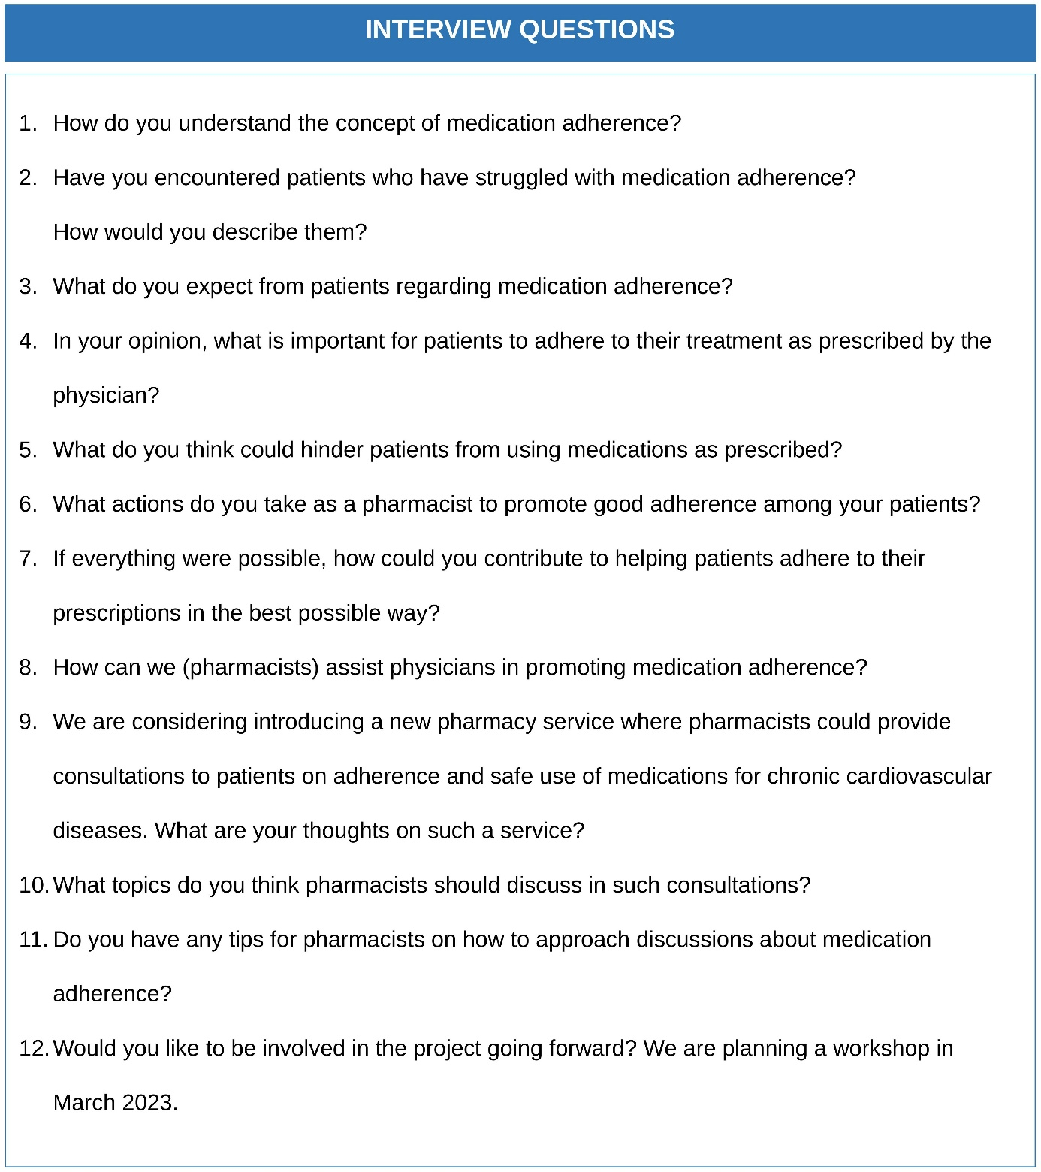
Figure S3. Interview guide for semi-structured individual interviews with pharmacists.

Appendix 4: Interview Guide – Patients and Next of Kin
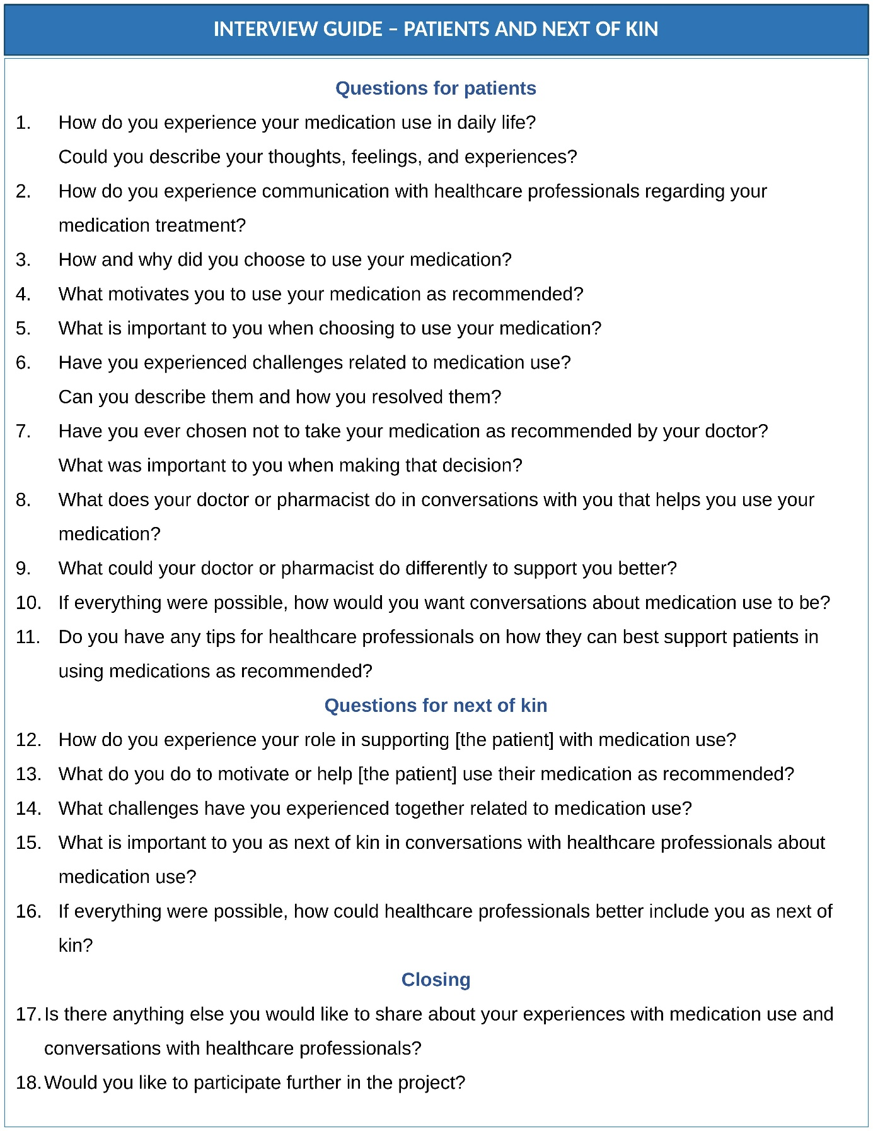
Figure S4. Interview guide for interviews with patients and next of kin.

Appendix 5: Workshop Materials
Two workshop sessions were conducted (March 23–24, 2023), comprising six and eight participants, respectively. Each workshop lasted approximately 180 minutes and was audio-recorded and transcribed verbatim.
Goals for the workshops
In-depth investigation of patients’, next of kin, and healthcare professionals’ (HCPs’) understanding and experiences related to medication adherence, as well as their perspectives on what is important and how HCPs can contribute to medication adherence.
Pre-workshop activities
The workshop was planned by a project group of six investigators comprising the authors, a nurse, and a pharmacist. The project group identified which topics to include in the workshop activities and helped recruit participants. Participants were recruited by distributing invitations to local GP offices, outpatient departments at Aalesund Hospital, pharmacies, and a patient organization.
NEL completed a course for user representatives at the University of Bergen, and TK participated in a Design Thinking course organized by Tekna and iCreative.
A brief review of the latest literature on adherence, as well as results from questionnaire surveys, was conducted in preparation for the workshops (HS, TK, NEL, and HMD)
Workshop
A two-day co-design workshop was conducted at Aalesund Hospital (Auditorium, main south entrance) on March 23rd (commencing 15:30) and March 24th (commencing 11:30), 2023.
The workshop comprised structured group discussions and plenary sessions addressing medication use, patient challenges, and person-centered communication.

Content of workshop
1. Introduction and welcome (5 min).
2. Presentation of the project (5 min).
3. Importance of user involvement (5–10 min).
4. What is safe medication management and adherence? (5 min).
5. Presentation of workshop activities (1–2 min).
6. Reflections and discussions (120 min).
7. Summary and conclusions in plenary (30 min).
Reflections and discussions
This session begins by presenting the following patient journey steps as a framework for discussion:
At the doctor's office (treatment choice or modification) → At the pharmacy (picking up medication) → At home (incorporation of medication use into daily life).
Participants were invited to think first as if they were patients, and then to reflect on their own role in supporting medication adherence. In addition, the group discussed how pharmacists could contribute to improving medication adherence. Key elements of the workshop discussions and reflections are described in the discussion guide (see Figure S5).
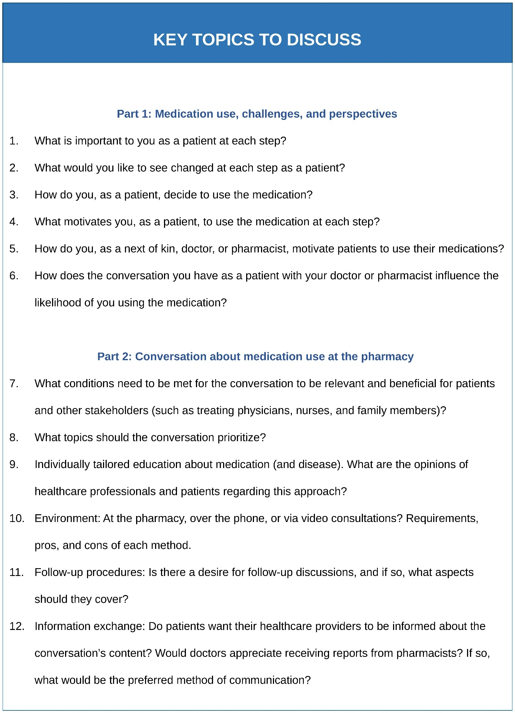
Figure S5. Workshop discussion guide used in the co-design workshop with patients, next of kin, and healthcare professionals.

