Figure S1 Study Flowchart with Participant Recruitment, Exclusions, and Split into Training/Evaluation Cohorts (January 2021–June 2023).

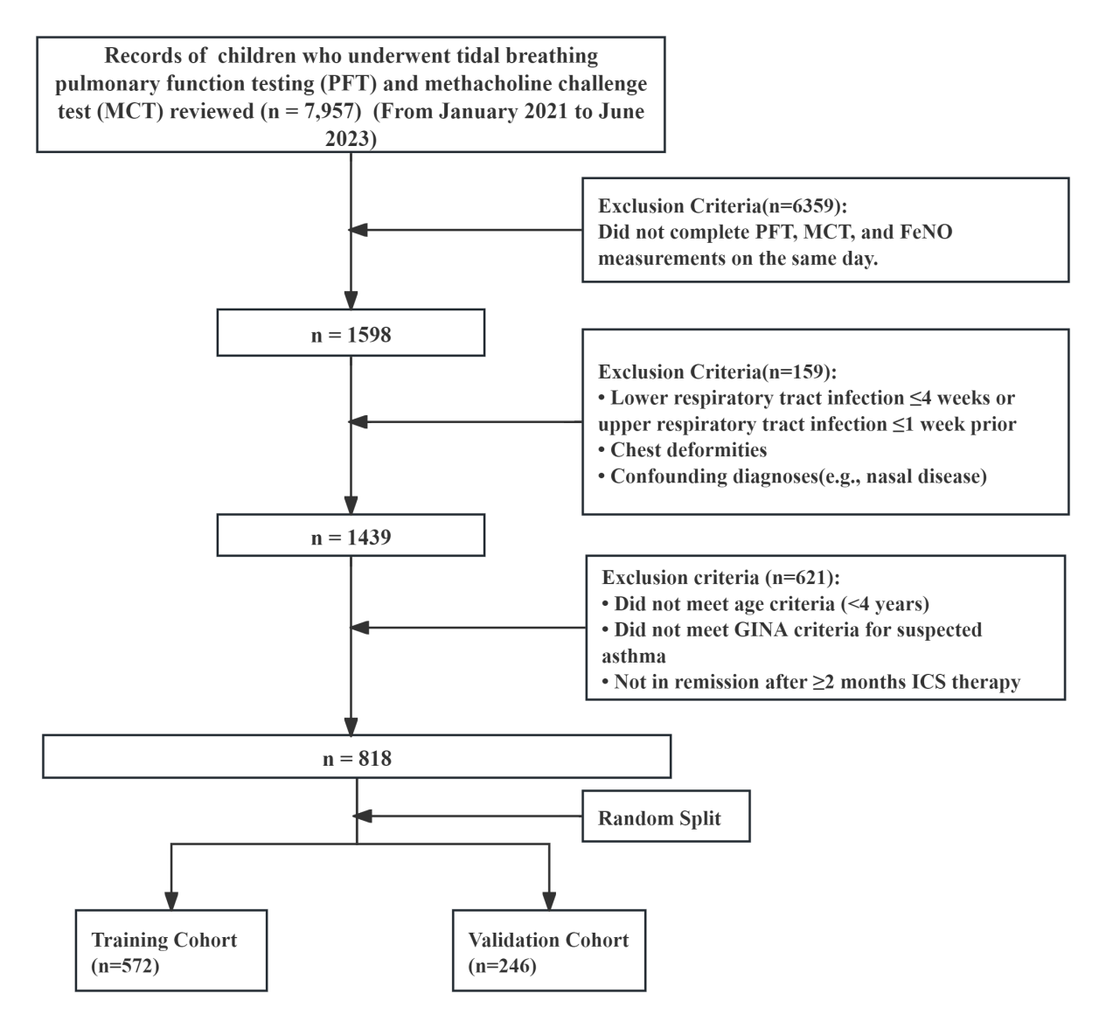
Figure S2 Feature importance ranking and SHAP (SHapley Additive exPlanations) visualization plots.
Note: (A) Feature importance plot: This plot displays the ranking of variables based on the mean absolute SHAP value [mean(|SHAP value|)], which quantifies the global contribution of each predictor to the airway hyperresponsiveness (AHR) prediction model. Higher values indicate a stronger overall impact on the model's output. Family history of asthma, wheeze, and FeNO were identified as the top three contributors to the prediction of AHR. (B) SHAP beeswarm plot: This plot illustrates the distribution of the impact that each feature has on the model's prediction for every individual participant. Each row represents a specific predictor, and each point represents an individual child. X-axis (SHAP value): A SHAP value greater than 0 indicates an increased risk of AHR, while a value less than 0 indicates a decreased risk.Color (Feature value): The color gradient from blue to red represents the feature value from low to high. For categorical variables (e.g., family history of asthma, wheeze, rhinitis, and allergy), red indicates "present/positive" and blue indicates "absent/negative."Interpretation: For instance, red points for family history of asthma, wheeze, and allergy are primarily distributed in the region where the SHAP value is greater than 0, indicating that the presence of these clinical histories significantly increases the predicted probability of AHR. Similarly, higher FeNO levels (red points) are associated with a higher risk of AHR.

Table S1 Missing Data Profile and Imputation Summary
Variable | Total (n) | Missing (n) | Missing (Rate)
Wheeze | 818 | 24 | 2.93%
Cough | 818 | 39 | 4.77%
History of Eczema | 818 | 67 | 8.19%
History Rhinitis | 818 | 97 | 11.86%
Family History Asthma | 818 | 46 | 5.62%
History Allergy | 818 | 174 | 21.27%
Note: MICE, Multivariate Imputation by Chained Equations. Missing values were assumed to be missing at random (MAR).

Table S2 Patient characteristics
Characteristic | Overall（n=818） | Training Cohort  (n=572) | evaluationCohort  （n=246） | Z/χ² | P
FeNO (ppb) | 27.00 (17.00, 39.00) | 27.00 (16.00, 39.00) | 28.00 (18.00, 40.00) | -1.07 | 0.282
Age (months) | 34.00 (26.25, 40.00) | 34.00 (26.00, 40.00) | 34.00 (27.00, 40.00) | -0.37 | 0.714
Height (cm) | 96.00 (90.00, 100.00) | 96.00 (90.00, 100.00) | 96.00 (90.00, 100.00) | -0.79 | 0.431
Weight (kg) | 14.00 (12.50, 15.00) | 14.00 (12.00, 15.00) | 14.00 (12.50, 15.00) | -0.01 | 0.994
RR (breaths/min) | 25.40 (22.90, 28.70) | 25.30 (22.80, 28.63) | 25.90 (23.30, 29.10) | -1.43 | 0.153
VT/kg (mL/kg) | 8.90 (7.80, 9.80) | 8.90 (7.70, 9.80) | 8.65 (7.80, 9.70) | -0.92 | 0.359
TPTEF/TE (%) | 23.20 (19.50, 28.17) | 23.10 (19.20, 28.13) | 23.40 (19.83, 28.40) | -0.91 | 0.364
VPTEF/VE (%) | 26.40 (23.90, 30.70) | 26.20 (23.70, 30.60) | 27.10 (24.20, 31.60) | -1.62 | 0.105
PEF/TEF25 (%) | 153.50 (136.53, 170.00) | 153.40 (136.70, 169.33) | 153.85 (135.12, 171.10) | -0.06 | 0.954
TEF50/TIF50 (%) | 71.80 (63.30, 80.50) | 70.90 (63.00, 80.00) | 72.85 (64.20, 81.80) | -1.14 | 0.253
TI/TE (%) | 63.00 (56.00, 70.00) | 63.00 (55.75, 70.00) | 63.00 (57.00, 69.00) | -0.57 | 0.567
Sex |  |  |  | 0.09 | 0.769
male | 505 (61.74) | 355 (62.06) | 150 (60.98)
female | 313 (38.26) | 217 (37.94) | 96 (39.02)
Wheeze |  |  |  | 0.22 | 0.637
No | 396 (48.41) | 280 (48.95) | 116 (47.15)
Yes | 422 (51.59) | 292 (51.05) | 130 (52.85)
Cough |  |  |  | 2.00 | 0.157
No | 340 (42.18) | 247 (43.79) | 93 (38.43)
Yes | 466 (57.82) | 317 (56.21) | 149 (61.57)
History of Eczema |  |  |  | 0.53 | 0.466
No | 644 (78.82) | 454 (79.51) | 190 (77.24)
Yes | 173 (21.18) | 117 (20.49) | 56 (22.76)
History Rhinitis |  |  |  | 0.06 | 0.806
No | 504 (61.61) | 354 (61.89) | 150 (60.98)
Yes | 314 (38.39) | 218 (38.11) | 96 (39.02)
Family History Asthma |  |  |  | 0.42 | 0.519
No | 486 (59.41) | 344 (60.14) | 142 (57.72)
Yes | 332 (40.59) | 228 (39.86) | 104 (42.28)
History Allergy |  |  |  | 0.02 | 0.897
No | 270 (33.01) | 188 (32.87) | 82 (33.33)
Yes | 548 (66.99) | 384 (67.13) | 164 (66.67)
Note: Data are presented as Number (%) and median (P25, P75). Z: Mann-Whitney test, χ²: Chi-square test.
Abbreviations: FeNO, fractional exhaled nitric oxide; TPTEF/TE, time to reach peak tidal expiratory flow over expiratory time; VPTEF/VE, volume to reach peak tidal expiratory flow over expiratory volume; RR, respiratory rate; VT/kg, tidal volume per kilogram of body weight; TI/TE, the ratio of inspiratory time to expiratory time; TEF50/TIF50, tidal expiratory flow at 50% of expiratory volume divided by tidal inspiratory flow at 50% of inspiratory volume; PTEF/TEF25, the ratio of peak expiratory flow rate to instantaneous expiratory flow rate with 25% tidal volume remaining.

Table S3 Univariable and multivariable logistic regression analyses of candidate predictors for methacholine-defined airway hyperresponsiveness in the training cohort
Variables | Univariable |  |  |  |  |  | Multivariable
Variables | β | S.E | Z | P | OR (95%CI) |  | β | S.E | Z | P | OR (95%CI)
Sex
Male |  |  |  |  | 1.00 (Reference)
Female | -0.02 | 0.20 | -0.09 | 0.926 | 0.98 (0.67 ~ 1.44)
Wheeze
No |  |  |  |  | 1.00 (Reference) |  |  |  |  |  | 1.00 (Reference)
Yes | 1.52 | 0.21 | 7.12 | <.001 | 4.59 (3.02 ~ 6.99) |  | 1.35 | 0.23 | 5.78 | <.001 | 3.85 (2.44 ~ 6.09)
Cough
No |  |  |  |  | 1.00 (Reference)
Yes | -0.88 | 0.21 | -4.20 | <.001 | 0.41 (0.27 ~ 0.62) |  | -
History of Eczema
No |  |  |  |  | 1.00 (Reference)
Yes | 0.44 | 0.26 | 1.72 | 0.085 | 1.55 (0.94 ~ 2.56)
History Rhinitis
No |  |  |  |  | 1.00 (Reference) |  |  |  |  |  | 1.00 (Reference)
Yes | 0.55 | 0.21 | 2.69 | 0.007 | 1.74 (1.16 ~ 2.60) |  | 0.53 | 0.24 | 2.18 | 0.029 | 1.69 (1.05 ~ 2.72)
Family History Asthma
No |  |  |  |  | 1.00 (Reference) |  |  |  |  |  | 1.00 (Reference)
Yes | 1.41 | 0.23 | 6.02 | <.001 | 4.09 (2.59 ~ 6.47) |  | 1.36 | 0.26 | 5.20 | <.001 | 3.90 (2.33 ~ 6.51)
History Allergy
No |  |  |  |  | 1.00 (Reference) |  |  |  |  |  | 1.00 (Reference)
Yes | 0.98 | 0.20 | 4.99 | <.001 | 2.67 (1.82 ~ 3.94) |  | 0.85 | 0.23 | 3.62 | <.001 | 2.34 (1.48 ~ 3.70)
FeNO (ppb) | 0.03 | 0.01 | 4.23 | <.001 | 1.03 (1.01 ~ 1.04) |  | 0.03 | 0.01 | 3.98 | <.001 | 1.03 (1.01 ~ 1.04)
Age (months) | -0.04 | 0.01 | -3.02 | 0.003 | 0.96 (0.94 ~ 0.99) |  | -0.04 | 0.01 | -2.76 | 0.006 | 0.96 (0.93 ~ 0.99)
Height (cm) | -0.03 | 0.01 | -2.12 | 0.034 | 0.97 (0.95 ~ 0.99)
Weight (kg) | -0.08 | 0.04 | -1.81 | 0.070 | 0.93 (0.85 ~ 1.01)
RR (breaths/min) | 0.02 | 0.02 | 1.05 | 0.291 | 1.02 (0.98 ~ 1.07)
VT/kg (mL/kg) | 0.00 | 0.03 | 0.02 | 0.980 | 1.00 (0.95 ~ 1.06)
TPTEF/TE (%) | -0.03 | 0.01 | -2.21 | 0.027 | 0.98 (0.95 ~ 0.99) |  | -0.03 | 0.01 | -2.20 | 0.028 | 0.97 (0.94 ~ 0.99)
VPTEF/VE (%) | -0.02 | 0.01 | -1.82 | 0.068 | 0.98 (0.95 ~ 1.00)
PEF/TEF25 (%) | 0.01 | 0.00 | 1.36 | 0.175 | 1.01 (1.00 ~ 1.01)
TEF50/TIF50 (%) | -0.00 | 0.01 | -0.68 | 0.497 | 1.00 (0.98 ~ 1.01)
TI/TE (%) | -0.02 | 0.01 | -2.55 | 0.011 | 0.98 (0.96 ~ 0.99)
Note: ORs for continuous variables represent the change in odds associated with a one-unit increase: 1 ppb for FeNO, 1 month for age, 1 cm for height, 1 kg for weight, 1 breath/min for RR, 1 mL/kg for VT/kg, and 1 percentage point for TPTEF/TE, VPTEF/VE, PEF/TEF25, TEF50/TIF50, and TI/TE. Adjusted ORs are reported only for variables retained in the final multivariable model; dashes indicate variables not retained after backward stepwise selection.

Table S4 Comparison of Predictive Performance Among Logistic Regression, LASSO, and Random Forest Models in the Evaluation Cohort
Model | AUC (95%CI) | Accuracy | Sensitivity | Specificity | PPV | NPV | P-values
Logistic Regression | 0.756 (0.685-0.827) | 0.684 | 0.685 | 0.683 | 0.869 | 0.414 | Reference
LASSO Regression | 0.754 (0.68-0.827) | 0.684 | 0.685 | 0.683 | 0.869 | 0.414 | 0.849
Random Forest | 0.792 (0.719-0.866) | 0.668 | 0.636 | 0.767 | 0.893 | 0.407 | 0.173
Note: AUC, area under the receiver operating characteristic curve; CI, confidence interval; LASSO, Least Absolute Shrinkage and Selection Operator. P-values were calculated using the DeLong test to compare the AUC of each machine learning model against the Logistic Regression model (Reference).

