Supplementary Table S1. Acoustic features most strongly associated with changes in peak expiratory flow (ΔPEF)
Feature | Spearman’s ρ (ΔPEF) | p-value | Spearman’s ρ (ΔFEV1) | p-value
Wheezing ratio | 0.2379 | 0.058 | 0.1033 | 0.417
Spectral bandwidth | 0.2074 | 0.100 | −0.0352 | 0.783
Wheezing power | −0.2049 | 0.104 | −0.0897 | 0.481
High-frequency sound (800–1200 Hz) | 0.1418 | 0.264 | −0.1017 | 0.424
Ultra-high-frequency sound (1600–2000 Hz) | 0.1386 | 0.275 | −0.0664 | 0.602
Statistical significance was defined as a p-value < 0.05.

Supplementary Table S2. Acoustic features most strongly associated with changes in forced expiratory volume in one second (ΔFEV1)
Feature | Spearman’s ρ (ΔPEF) | p-value | Spearman’s ρ (ΔFEV1) | p-value
Spectral centroid | 0.1118 | 0.379 | 0.1398 | 0.271
Mid-frequency sound (400–800 Hz) | 0.1087 | 0.392 | 0.1160 | 0.361
Wheezing ratio | 0.2379 | 0.058 | 0.1033 | 0.417
High-frequency sound (800–1200 Hz) | 0.1418 | 0.264 | −0.1017 | 0.424
Wheezing power | −0.2049 | 0.104 | −0.0897 | 0.481
Statistical significance was defined as a p-value < 0.05.

Figures:
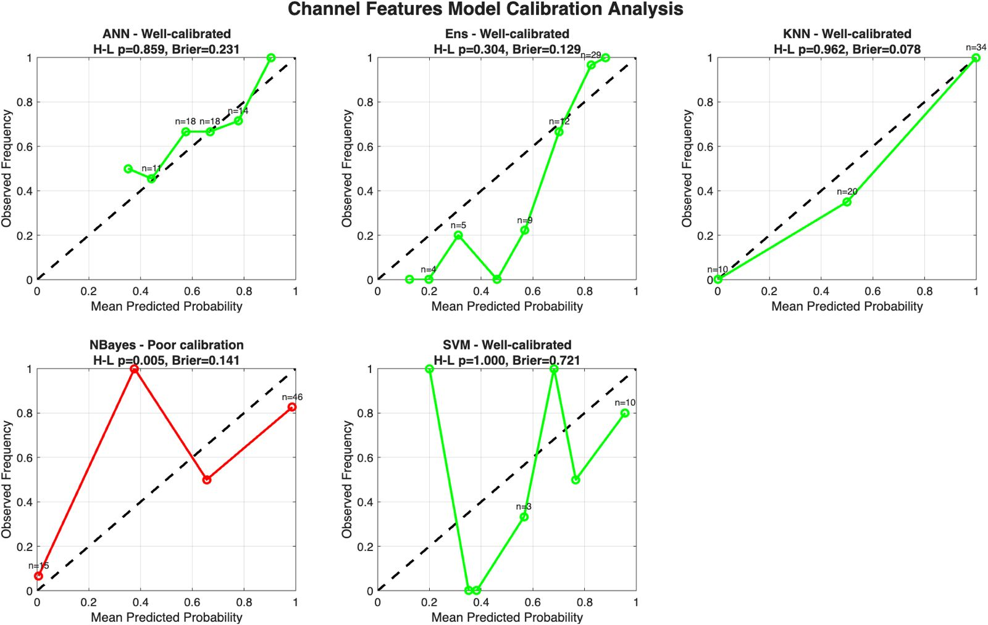

Supplementary Figure 1. Calibration curves of machine learning algorithms for the demographic+acoustic model (Model 1).

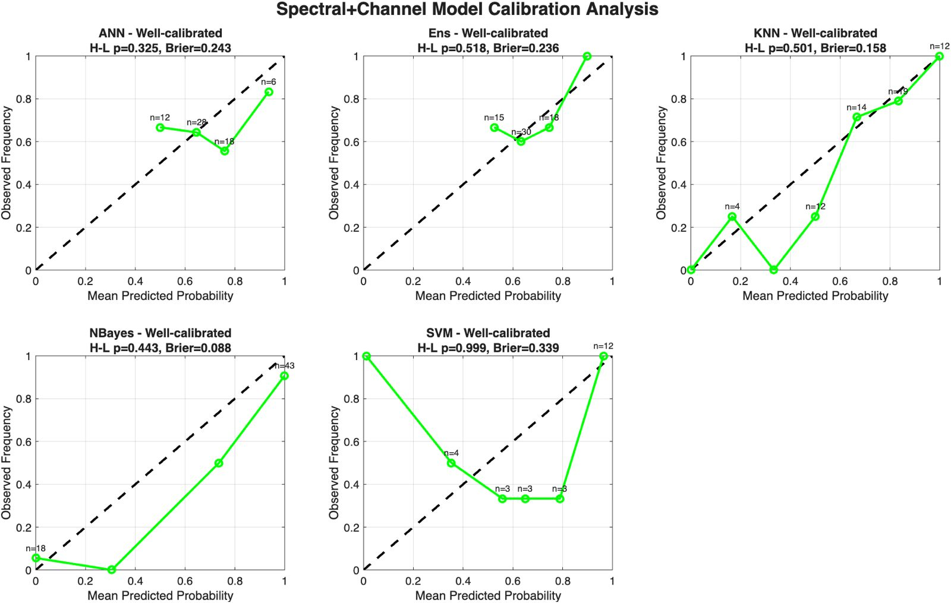

Supplementary Figure 2. Calibration curves of machine learning algorithms for the demographic+spectral+ acoustic model (Model 2).

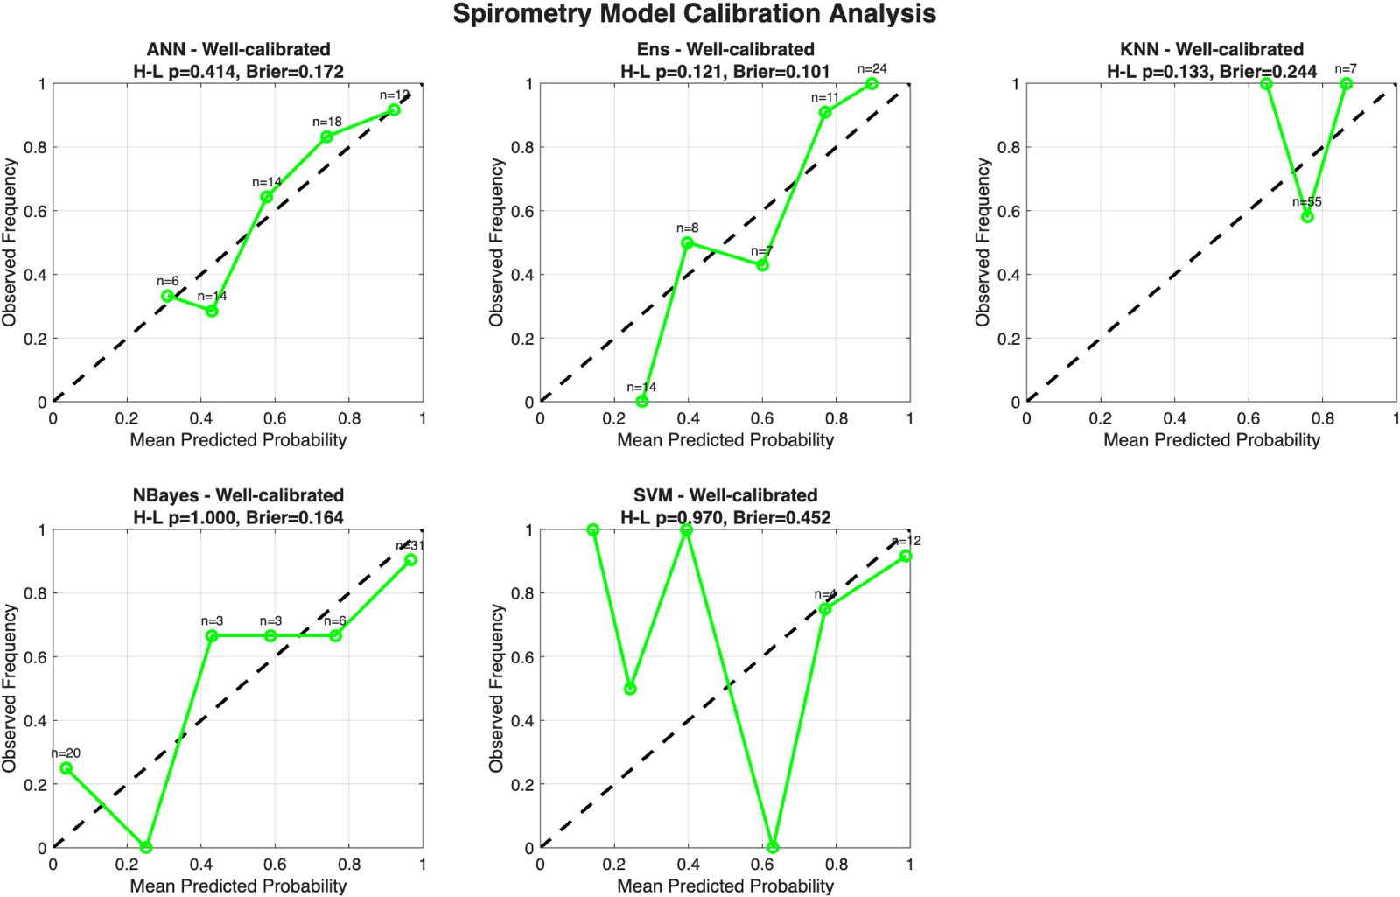

Supplementary Figure 3. Calibration curves of machine learning algorithms for the demographic+spirometric model (Model 3).

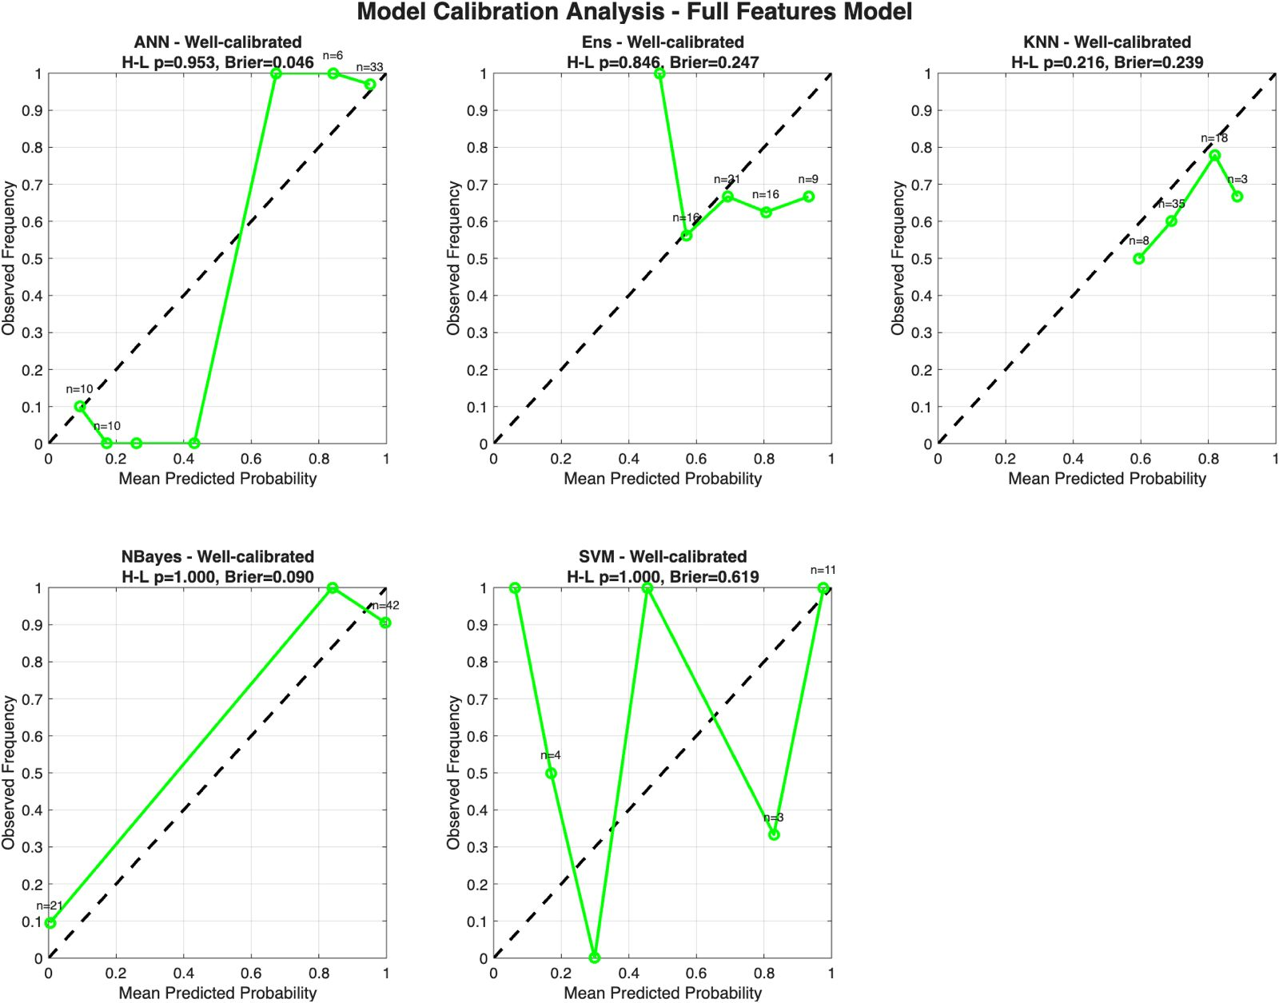

Supplementary Figure 4. Calibration curves of machine learning algorithms for the full-feature model (Model 4).

