Supplementary materials
Supplementary Material 1: Perceived boredom during the cognitive task
We expected a greater level of perceived boredom during the Stroop task than during the video task because the Stroop task is monotonous. An ANOVA was conducted on perceived boredom measured after the cognitive task in cLBP patients, with Task group (Stroop vs. Video) as a between-subjects factor. The effect of the task group did not reach significance: F (1, 58) = 2.172; p = .146. The mean score of perceived boredom in all cLBP patients was 10.25 (SD = 20.79). The same analysis was conducted in pain-free participants. For the cLBP patients, the effect of the task group did not reach significance: F (1, 58) = 0.112; p = .739. The mean score of perceived boredom in pain-free patients was 14.55 (SD = 21.80). Finally, the two cognitive tasks were perceived as weakly boring by the two populations.
Supplementary Material 2: Motivation to perform the TTE handgrip task
According to the motivational theory of mental fatigue, the motivation to perform the TTE handgrip should be lower after the Stroop task than after the video task in both groups. An ANOVA was conducted on motivation to perform the TTE handgrip task with Session time (before TTE handgrip task 1, before TTE handgrip task 2) as the repeated-measures factor and Task group (Stroop vs. Video) as the between-subjects factor in cLBP patients. The interaction between session time and task group, as well as the simple effects of session time and task group, did not reach significance. On average, the motivation to perform the TTE handgrip task was high: M = 88.44/100 (SD = 19.16). The same analysis was conducted in pain-free participants. Only the effect of session time reached significance: F (1, 56) = 21.921; p < .05; η² = .281. The motivation to perform the TTE handgrip task was greater before the first handgrip task (M = 93.05/100; SD = 8.98) than before the second handgrip task (M = 82.13/100; SD = 20.31) (i.e., after the cognitive task).
Supplementary Material 3: Effort perception during the TTE handgrip task
In TTE tasks, an increase in the perception of effort is generally observed from the beginning of the task to the dropout of the participant. In some cases, the perception of effort is greater in the presence of mental fatigue. A repeated-measures MANOVA was conducted on the perception of effort with TTE (0%, 33%, 67% and 100% of isotime) and Session time (before and after the cognitive task) as within-subject factors and Task group (Stroop vs. Video) as a between-subject factor in cLBP patients. The interactions among task group, session time and TTE did not reach significance. However, there was a significant interaction effect between TTE and session time: F (3, 56) = 15.418; p < .05; Wilks’ lambda = .548; η² = .452 (Figure S1A). The increase in perception of effort was sharper during the second TTE handgrip compared to the first TTE handgrip. The effect of the task group was not significant. The same results were observed for the pain-free participants: the interaction between TTE and session time reached significance: F (3, 56) = 11.073; p < .05; Wilks’ lambda = .628; η² = .372 (Figure S1B).
Supplementary Material 4: Pain perception during the TTE handgrip task
The same results as those for effort perception were expected for pain perception. Additionally, we expected a sharper increase in pain perception in cLBP patients. The same MANOVA design as that used for effort perception was applied to pain perception. The interactions among task group, session time and TTE did not reach significance. However, for effort perception, there was a significant interaction effect between TTE and Session time: F (3, 56) = 20.501; p < .05; Wilks’ lambda = .423; η² = .577. The perception of pain increased sharply during the second TTE handgrip task compared with the first TTE in cLBP patients. The effect of task group was not significant. The same analysis was conducted in pain-free participants and yielded the same results: interaction TTE and session time: F (3, 56) = 10.101; p < .05; Wilks’ lambda = .645; η² = .355. On average, contrary to our expectation, the perception of pain at 100% of the time after the cognitive task was quite the same in the cLBP patients (M = 7.667/10; SD = 2.685) and asymptomatic participants (M = 7.517/10; SD = 2.678).
Supplementary Material 5: Correlations between clinical variables and physical performance
Correlations between clinical variables (anxiety, depression, pain intensity, duration of low back pain, kinesiophobia, fear-avoidance beliefs, and self-control trait) and the two physical endurance measures (time to exhaustion during the first handgrip task and performance on the Shirado-Ito test) were assessed.
The results show expected correlations. Anxiety was strongly correlated with depression but also with pain intensity, kinesiophobia (Tampa), and fear-avoidance beliefs related to physical activity (FABQ-PA). Furthermore, Tampa was correlated with FABQ-PA scores. These results appear consistent and similar to those reported in the literature.
Regarding physical performance, a positive correlation was observed between performance on the Shirado-Ito test and time to exhaustion during the handgrip task, which seems coherent since both tests assess muscular endurance capacity.
A significant correlation was also observed between pain scores and self-control trait scores, indicating that higher pain intensity was associated with a higher perceived level of self-control. This more unexpected result remains difficult to interpret at this stage.
Supplementary Material 6: Inclusion and non-inclusion criteria
Pain-free control group
Inclusion criteria:
Native French speaker
Aged 18 years or older
Non-inclusion criteria:
Color vision deficiency
Engagement in muscle-strengthening activities for more than 6 months
Insufficient corrected vision to perform the experimental task
Language or learning disorders
History of severe neurological or metabolic disorders
Functional impairment involving the dominant hand
Presence of chronic pain (spine, upper limb, etc.)
Chronic low back pain (cLBP) group
Inclusion criteria:
Native French speaker
Aged 18 years or older
Diagnosis of chronic low back pain corresponding to secondary or tertiary levels (Duquesnoy, 2001)
Enrollment in a Functional Restoration of the Spine (FRS) program
Non-inclusion criteria:
Color vision deficiency
Engagement in muscle-strengthening activities for more than 6 months
Insufficient corrected vision to perform the experimental task
Language or learning disorders
History of severe neurological or metabolic disorders
Functional impairment involving the dominant hand
Serious or progressive low back pain due to tumor, infection, inflammation, severe trauma, or dystrophic conditions

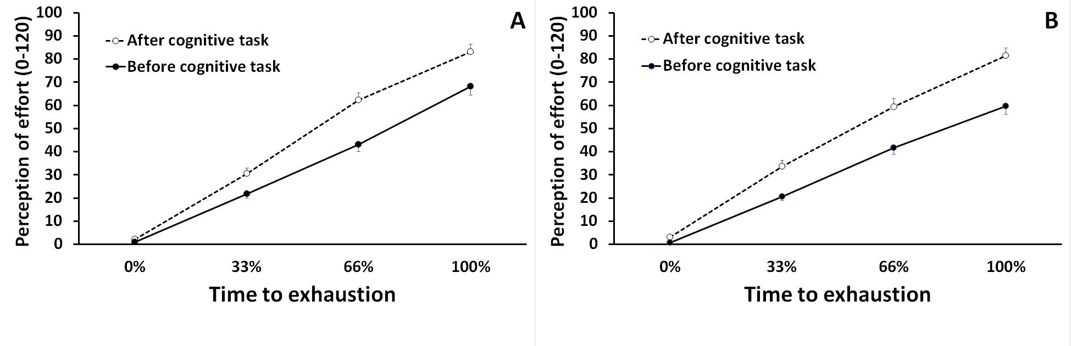
Figure S1: Perception of effort during the TTE handgrip task as a function of TTE (0%, 33%, 67%, 100%). Panel A: cLBP patients. Panel B: Pain-free participants. The error bars denote 95% confidence intervals.

Table S1: Correlations between Clinical Variables and Physical Endurance Measures in Chronic Low Back Pain Patients.
Variable
  M
  SD.
  Anxiety
  Depression
  Pain
  LBP-d
  SC trait
  Tampa
  FABQ-PA
  FABQ-W
  ITO
  HG1
 | 8.778 | 3.810
  Anxiety
  (0-21)
 | 5.315 | 3.638 | 0.613
  Depression
  (0-21)
 | 3.722 | 1.567 | 0.302 | 0.241
  Pain
  (0-10)
 | 12.426 | 11.524 | -0.235 | -0.238 | -0.110
  LBP-d
  (years)
 | 48.981 | 6.540 | -0.085 | 0.012 | 0.290 | 0.043
  SC trait
  (13-65)
 | 41.333 | 7.888 | 0.309 | 0.203 | -0.132 | -0.005 | -0.195
  Tampa
  (17-68)
 | 19.315 | 13.516 | 0.330 | 0.144 | 0.128 | -0.030 | -0.041 | 0.270
  FABQ-PA
  (0-24)
 | 12.352 | 7.117 | -0.066 | 0.066 | -0.131 | -0.078 | 0.133 | -0.010 | 0.036
  FABQ-W
  (0-42)
 | 79.704 | 58.680 | -0.248 | -0.028 | -0.147 | 0.262 | 0.046 | 0.092 | -0.010 | 0.030
  ITO
  (s)
 | 386.444 | 182.893 | -0.178 | -0.038 | -0.104 | 0.154 | 0.087 | 0.153 | -0.014 | -0.197 | 0.362
  HG1
  (s)
Notes: LBP-d = Low-back pain duration; SC trait = Self-control trait; FABQ-PA = Fear-Avoidance Beliefs Questionnaire, Physical activity subscale; FABQ-W = Fear-Avoidance Beliefs Questionnaire, Work subscale; HG1 = Time-to-exhaustion during the first handgrip task. The numbers written in red indicate that the correlation is significant.

Table S2: Detailed Performance Metrics for the Stroop Task
Variable | LS Group | AS Group
RT naming trials (ms) | 811.74 (86.48) | 807.25 (83.58)
RT reading trials (ms) | 653.05 (77.85) | 646.44 (81.30)
Error rate naming trials | 0.08 (0.06) | 0.07 (0.05)
Error rate reading trials | 0.02 (0.02) | 0.02 (0.02)
Table S2 provides a summary of the performance of the two groups of participants who completed the Stroop task. It reports reaction times and error rates, offering a detailed description of cognitive performance across groups.

