Supplementary Material

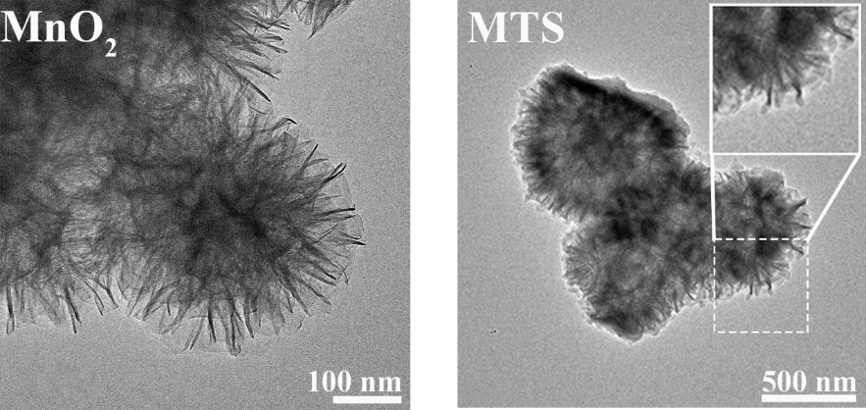
Figure S1. TEM image of MnO₂ and MTS.
Figure S2. The XPS detailed spectrum of MTS: (a) C 1s, (b) Sr 3d.

Figure S3. Standard curve of TA in deionized water.

Figure S4. Standard curve of BCA protein.

Figure S5. Standard curve of TA in a mixed solvent of 0.1 M ascorbic acid and 0.1 M HCl.

Figure S6. (a) The SEM image of MTS@QP-G@CO, as well as the distribution maps of C, N, O, and Mn elements and (b) EDS spectra.

Figure S7. The mass degradation ratios of MTS@QP-G@CO in PBS (pH 7.4) were measured over a period of 14 days.
Figure S8. Hemolysis ratios of CO and MTS@QP-G@CO hydrogels. Significance levels of ***p<0.001 were applied.

Gene | Forward (5’-3’) | Reverse (5’-3’)
Runx2 | AGTGATTTAGGGCGCATTCC | TCTGCCTGGGATCTGTAATCTG
OSX | GGATGGCGTCCTCTCTGCTTGAG | AGGGAGCTGGGTAGGCGTCC
OCN | CCTCACACTCCTCGCCCTAT | TTCACTACCTCGCTGCCCTC
GAPDH | TGCGATGGGTGTGAACCACGAGAA | GAGCCCTTCCACAATGCCAAAGTT
Table S1 List of primers

