Supplementary Table 1 The list of immunohistochemistry markers.
Antibody name | Clone/type | Dilution rate | Manufacturer
CD99 | Mouse monoclonal antibody | 1:100 | Dako
CD56 | Mouse monoclonal antibody | 1:100 | Dako
NKX2.2 | Mouse monoclonal antibody | 1:100 | Dako
WT1 | Mouse monoclonal antibody | 1:100 | Dako
P16 | Mouse monoclonal antibody | 1:100 | Dako
P53 | Mouse monoclonal antibody | 1:100 | Dako
β-caternin | Mouse monoclonal antibody | 1:100 | Dako
Desmin | Mouse monoclonal antibody | 1:100 | Dako
Ki67 | Mouse monoclonal antibody | 1:100 | Dako
PAX8 | Mouse monoclonal antibody | 1:100 | Dako
SALL4 | Mouse monoclonal antibody | 1:100 | Dako
ER | Mouse monoclonal antibody | 1:100 | Dako
PR | Mouse monoclonal antibody | 1:100 | Dako
MyoD1 | Mouse monoclonal antibody | 1:100 | Dako
CD10 | Mouse monoclonal antibody | 1:100 | Dako
CgA | Mouse monoclonal antibody | 1:100 | Dako
CK5 | Mouse monoclonal antibody | 1:100 | Dako
CK7 | Mouse monoclonal antibody | 1:100 | Dako
CK20 | Mouse monoclonal antibody | 1:100 | Dako
CKpan | Mouse monoclonal antibody | 1:100 | Dako
S-100 | Mouse monoclonal antibody | 1:100 | Dako
Syn | Mouse monoclonal antibody | 1:100 | Dako

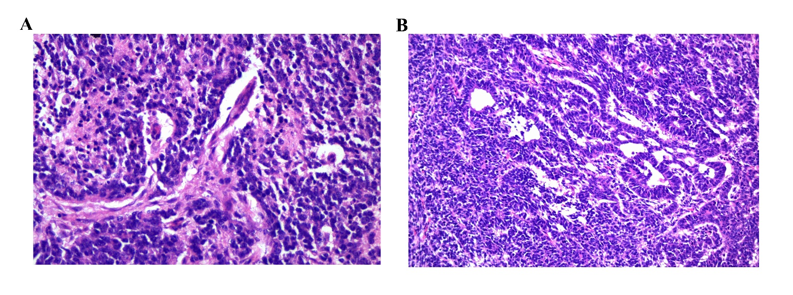
Supplementary Figure 1 The Hematoxylin and Eosin staining results from different regions of the tumor (×400), including region 1 (A) and region 2 (B).

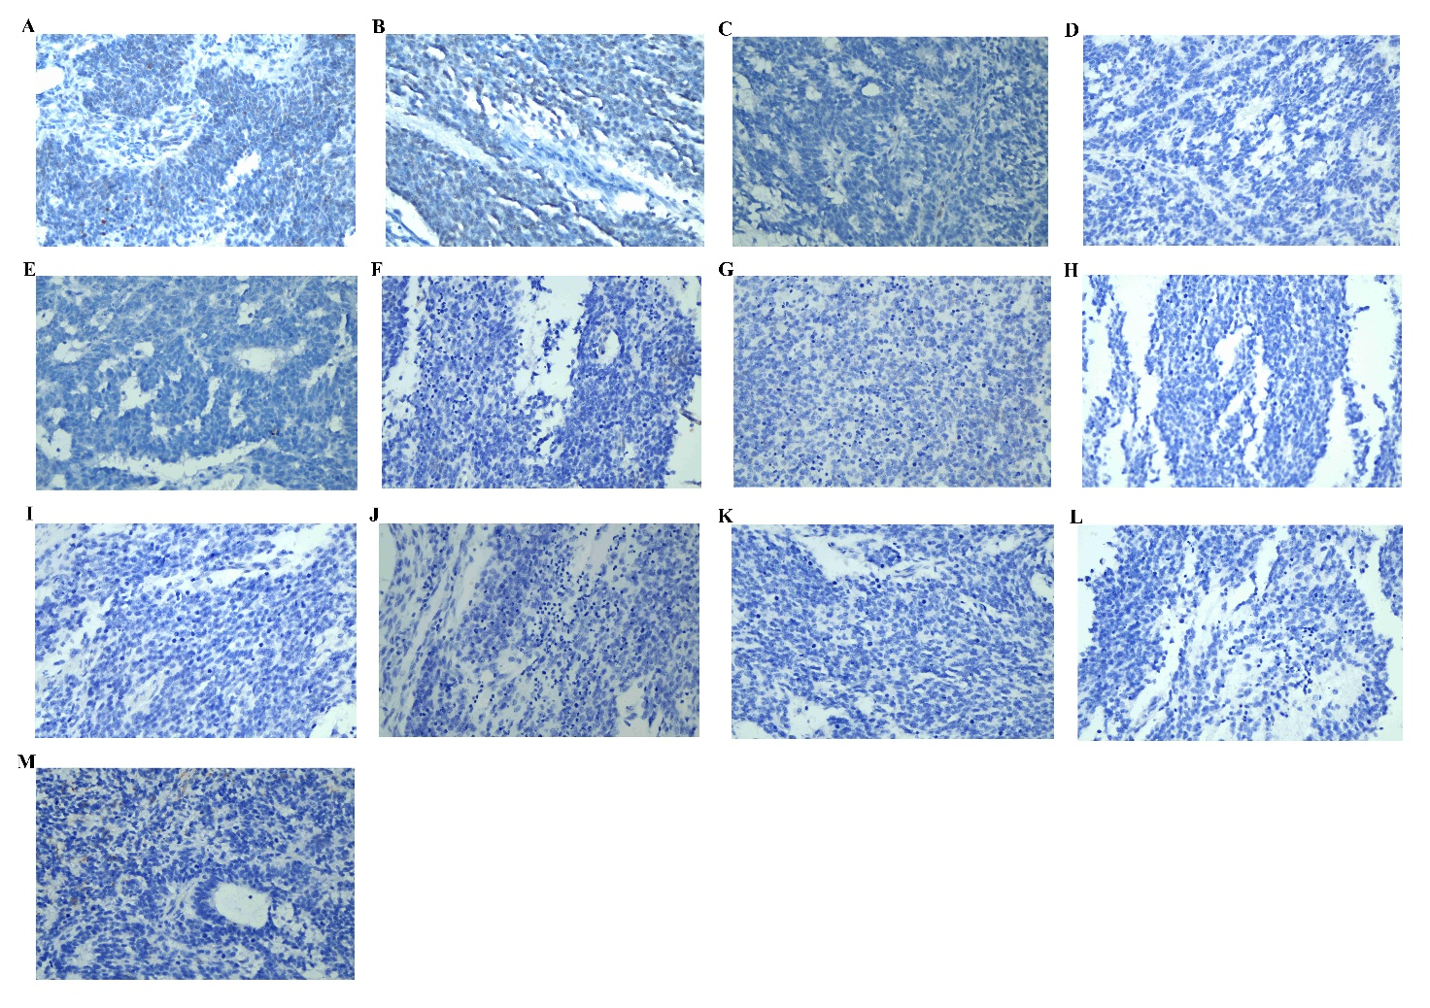
Supplementary Figure 2 Negative immunohistochemistry results (×400), including PAX8 (A), SALL4 (B), ER(C), PR (D), MyoD1 (E), CD10 (F), CgA (G), CK5 (H), CK7 (I), CK20 (J), CKpan (K), S-100 (L), and Syn (M).

