Supporting Information

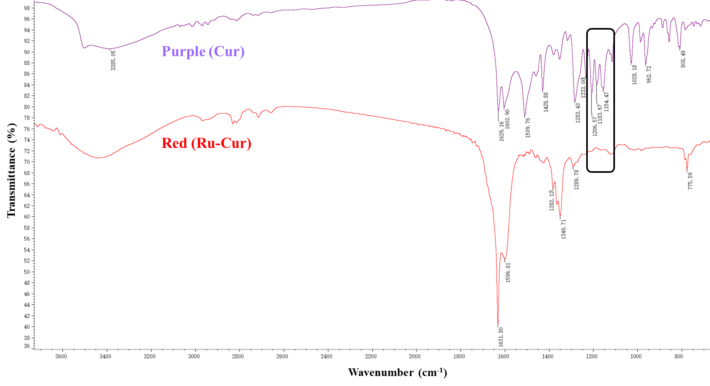
Figure S1. Fourier transform infrared spectroscopy of Cur and Ru-Cur. The black box highlights the wavenumber region of 1150-1200 cm⁻¹.

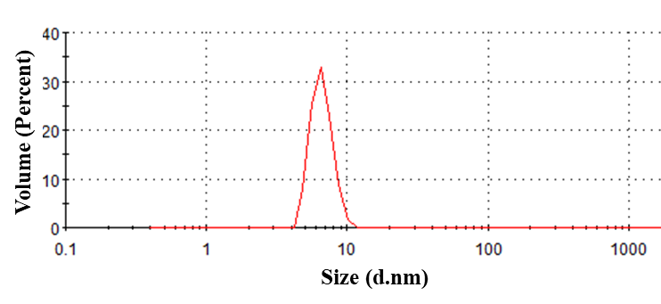
Figure S2. Particle size distribution of LMWC/Ru-Cur.

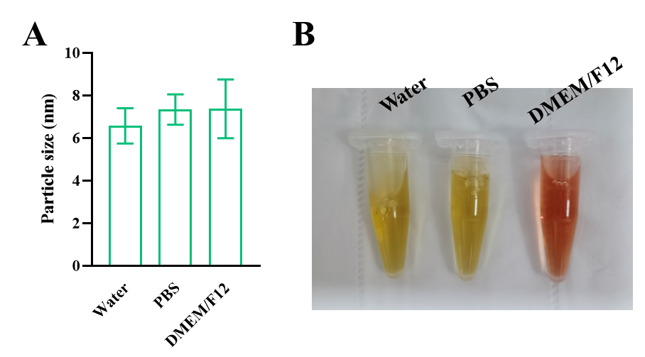
Figure S3. The size changes of LMWC/Ru-Cur in DD water, PBS, and DMEM/F12 culture medium after 2-day incubation (A), and their sample photographs (B). Data are presented as means ± SD with n = 3 replicates per group.

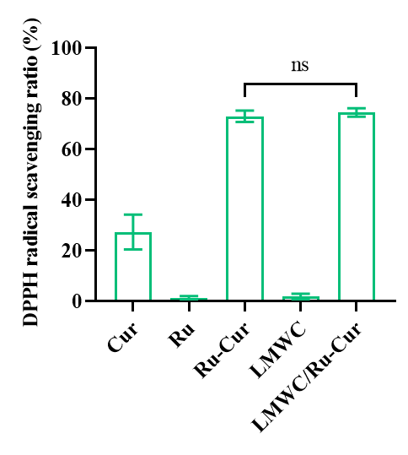
Figure S4. DPPH free radicals scavenging activity of Cur, Ru, Ru-Cur, LMWC, and LMWC/Ru-Cur. Data are presented as means ± SD with n = 3 replicates per group. ns = not significant.

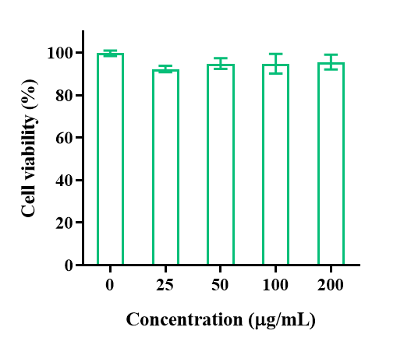
Figure S5. The cell viability of HK-2 cells after incubated with different concentrations of LMWC/Ru-Cur for 24 h. Data are presented as means ± SD with n = 3 replicates per group.

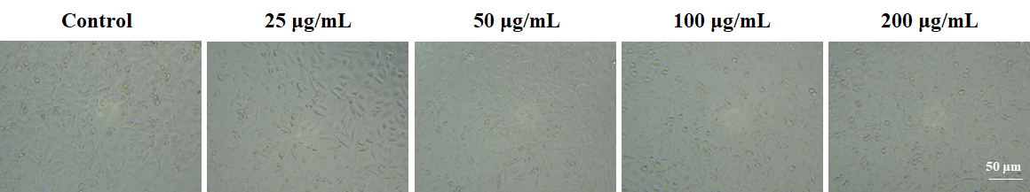
Figure S6. The cellular morphology of HK-2 cells. Scale bar 50 µm.

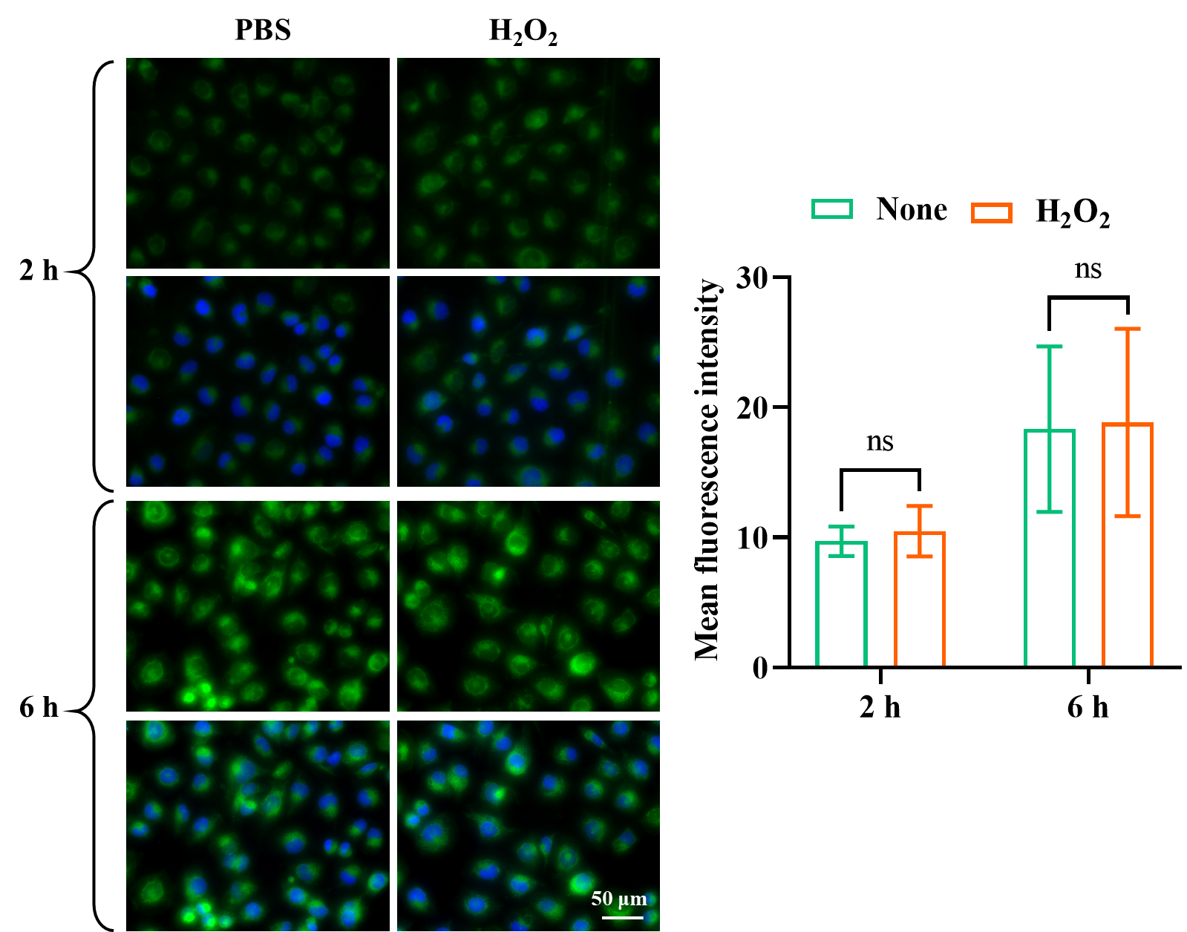
Figure S7. Fluorescence images of LMWC/Ru-Cur in PBS- or H₂O₂-induced HK-2 cells, and fluorescence quantitative analysis. Scale bar 50 µm. Data are presented as means ± SD with n = 6 replicates per group. ns = not significant.

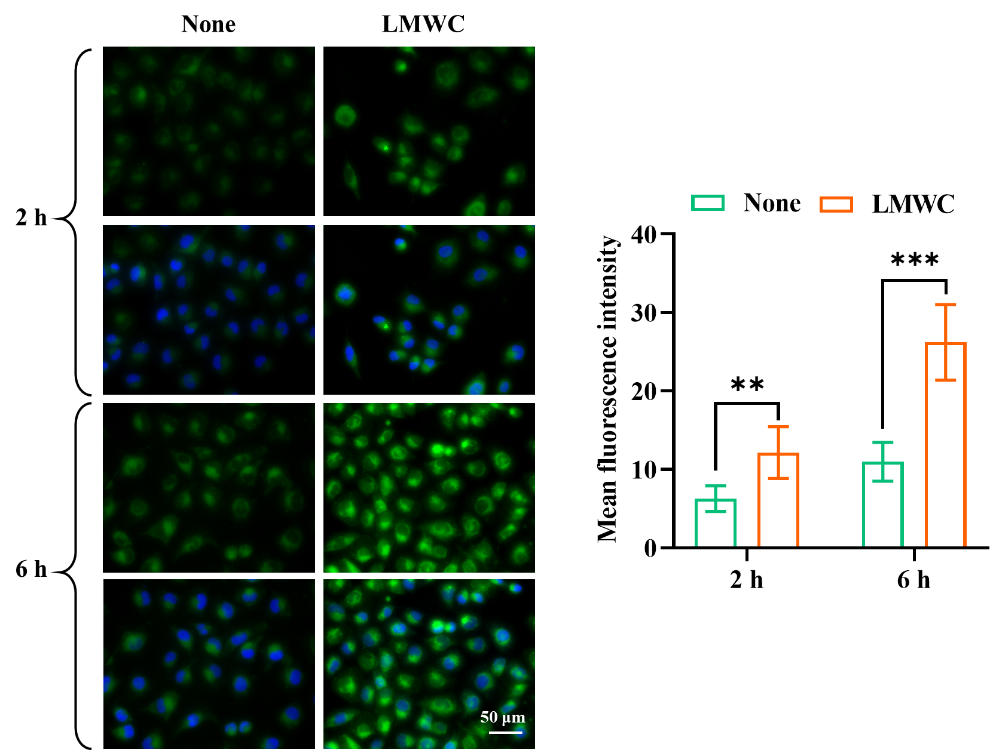
Figure S8. Fluorescence images of LMWC/Ru-Cur and LMWC+LMWC/Ru-Cur in H₂O₂-induced HK-2 cells, and fluorescence quantitative analysis. Scale bar 50 µm. Data are presented as means ± SD with n = 6 replicates per group. **p < 0.01, and ***p < 0.001.

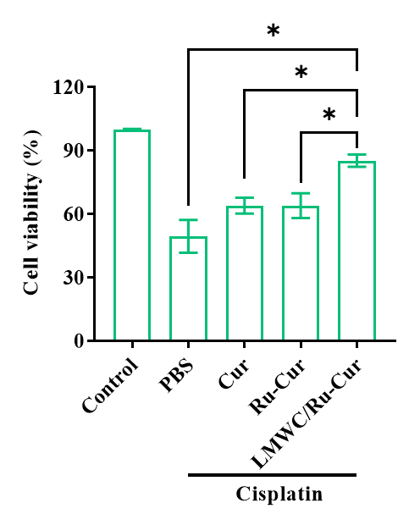
Figure S9. Cell viability of Cis-induced HK-2 cells after treated with Cur, Ru-Cur, and LMWC/Ru-Cur. Data are presented as means ± SD with n = 3 replicates per group. *p < 0.05.

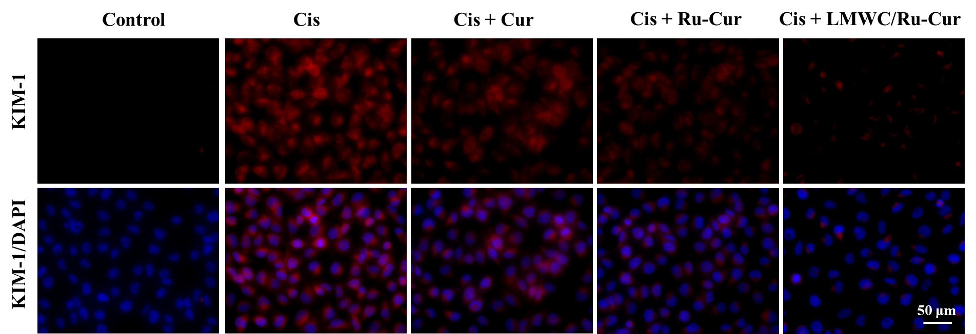
Figure S10. Immunofluorescence staining on the expression of KIM-1 in Cis-induced HK-2 cells. Scale bar 50 µm.

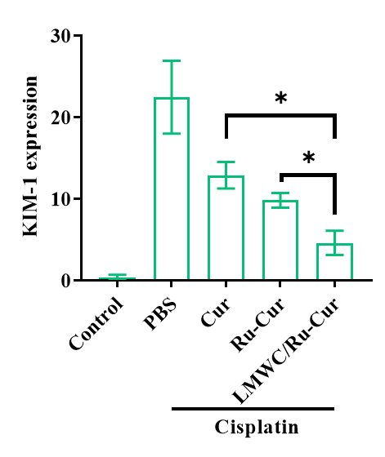
Figure S11. Fluorescence quantitative analysis on the expression of KIM-1 in Cis-induced HK-2 cells. Data are presented as means ± SD with n = 3 replicates per group. *p < 0.05.

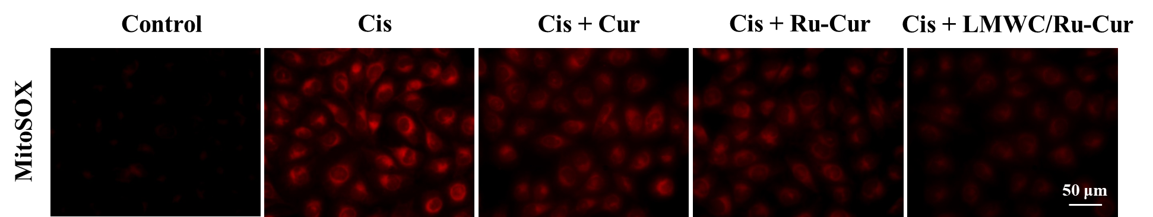
Figure S12. Fluorescence images of mitochondrial ROS levels in Cis-induced HK-2 cells detected by MitoSOX probe. Scale bar 50 µm.

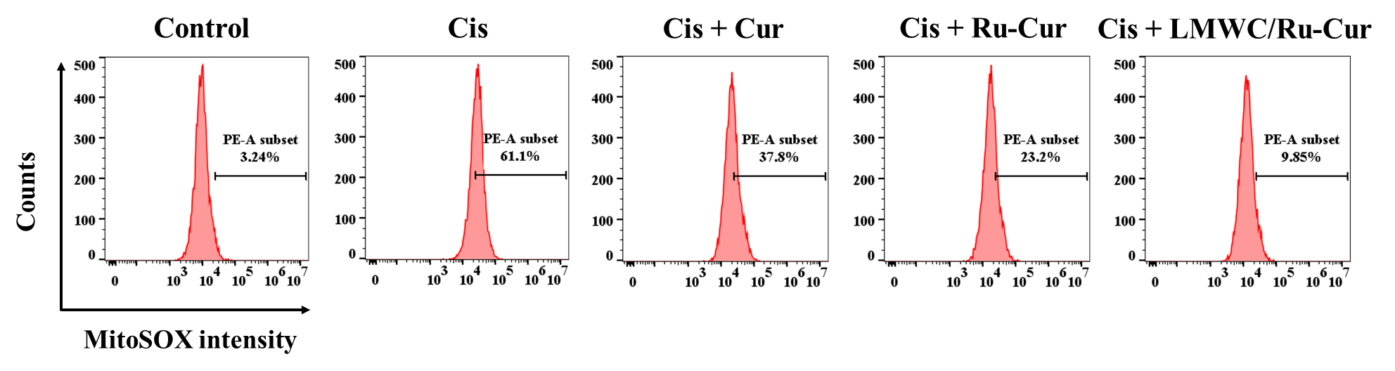
Figure S13. Flow cytometry results of mitochondrial ROS levels in Cis-induced HK-2 cells detected by MitoSOX probe.

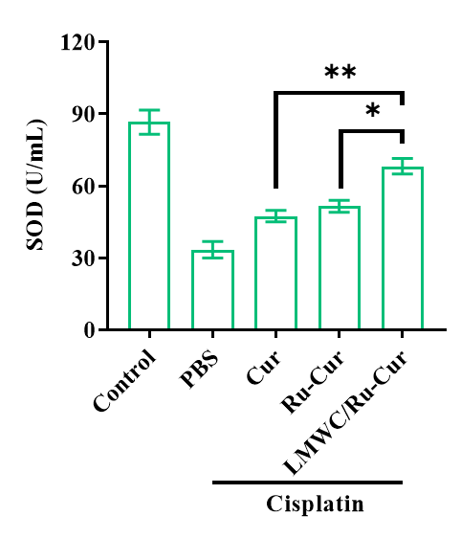
Figure S14. The changes of SOD concentrations. Data are presented as means ± SD with n = 3 replicates per group. *p < 0.05, and **p < 0.01.

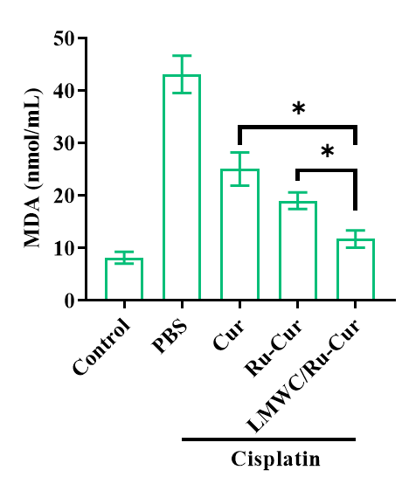
Figure S15. The changes of MDA concentrations. Data are presented as means ± SD with n = 3 replicates per group. *p < 0.05.

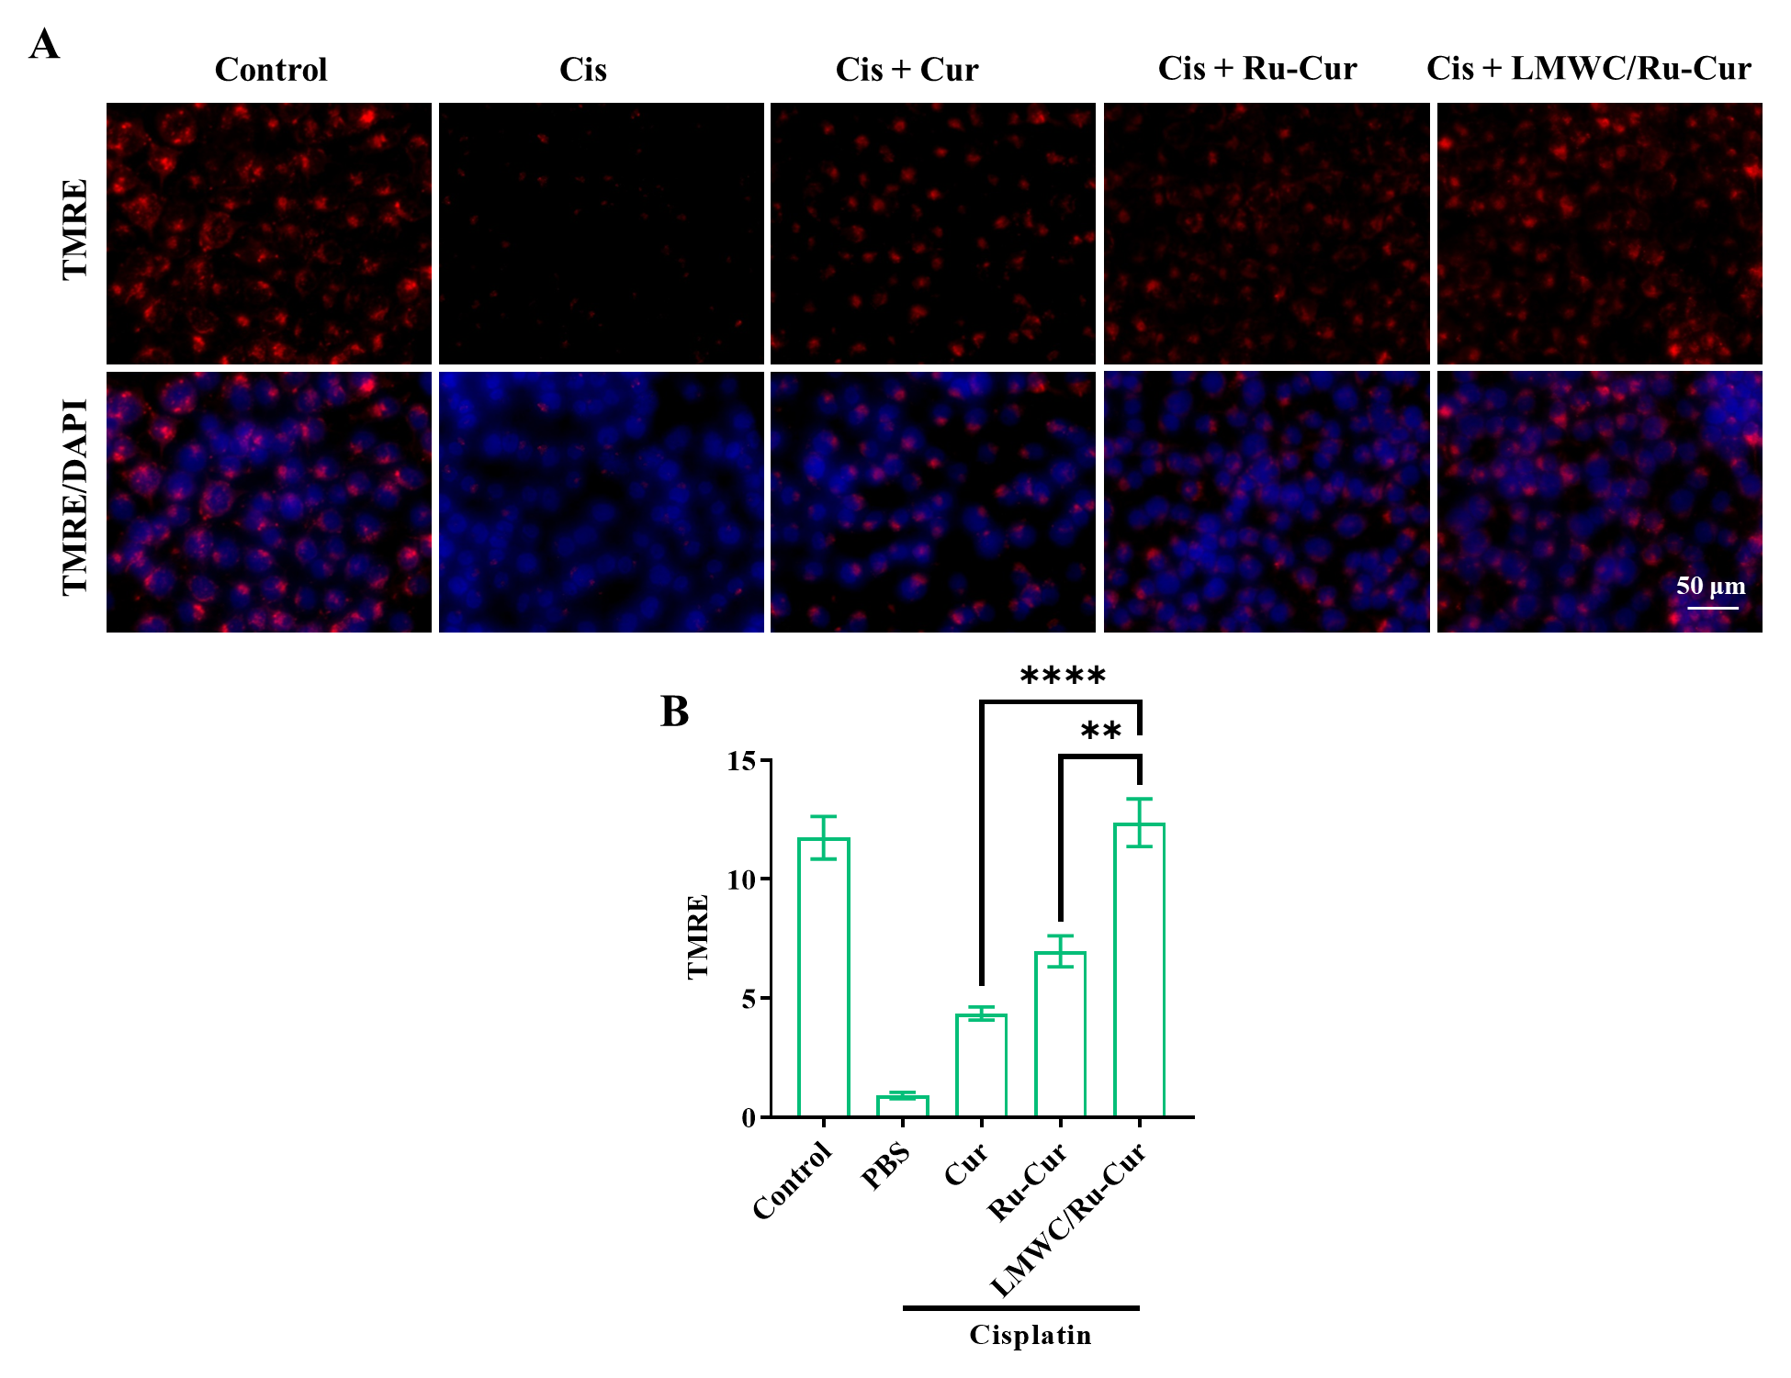
Figure S16. Fluorescence images of mitochondrial membrane potential in Cis-induced HK-2 cells detected by TMRE probe (A), and fluorescence quantitative analysis on TMRE fluorescence signals (B). Scale bar 50 µm. Data are presented as means ± SD with n = 6 replicates per group. **p < 0.01, and ****p < 0.0001.

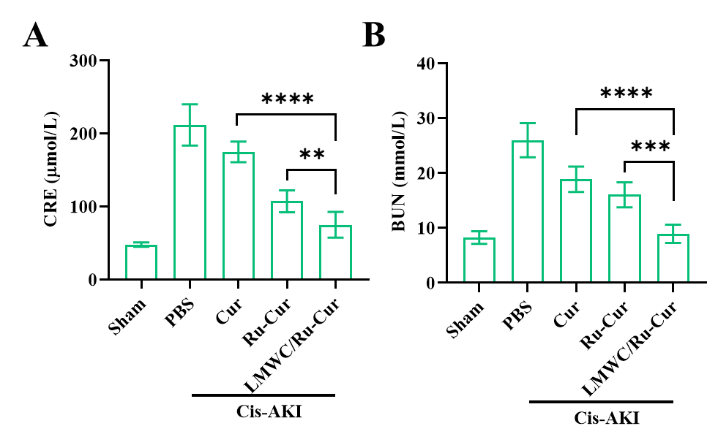
Figure S17. The changes of CRE (A) and BUN (B) in Cis-AKI mice. Data are presented as means ± SD with n = 6 replicates per group. **p < 0.01, ***p < 0.001, and ****p < 0.0001.

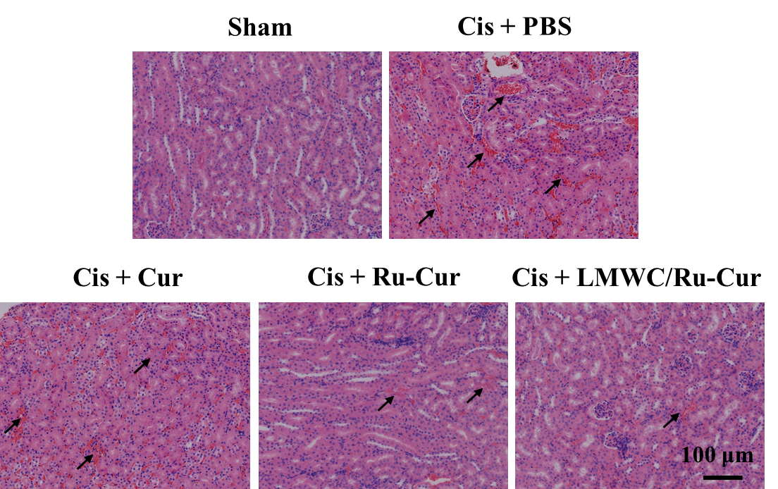
Figure S18. H&E staining sections of kidney tissues in Cis-AKI mice. Scale bar 100 µm.

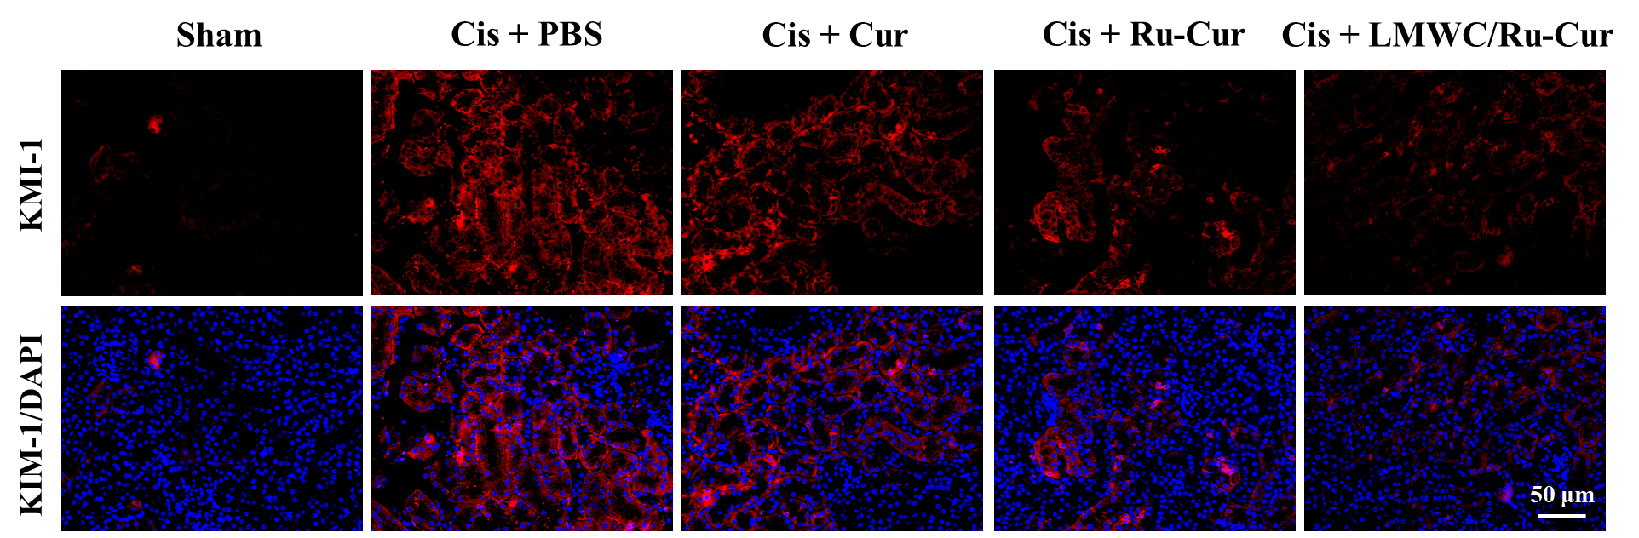
Figure S19. Fluorescence images of KIM-1 expression in kidney tissues of Cis-AKI mice. Scale bar 50 µm.

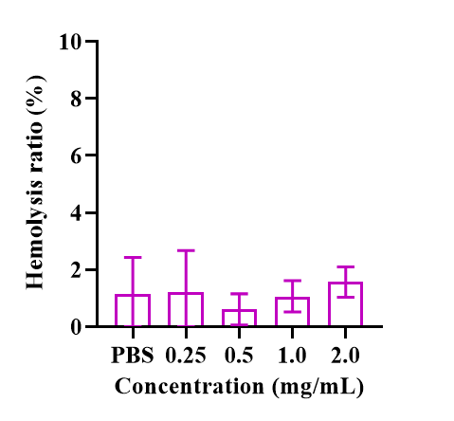
Figure S20. The hemolysis rate of LMWC/Ru-Cur nanodots. Data are presented as means ± SD with n = 3 replicates per group.

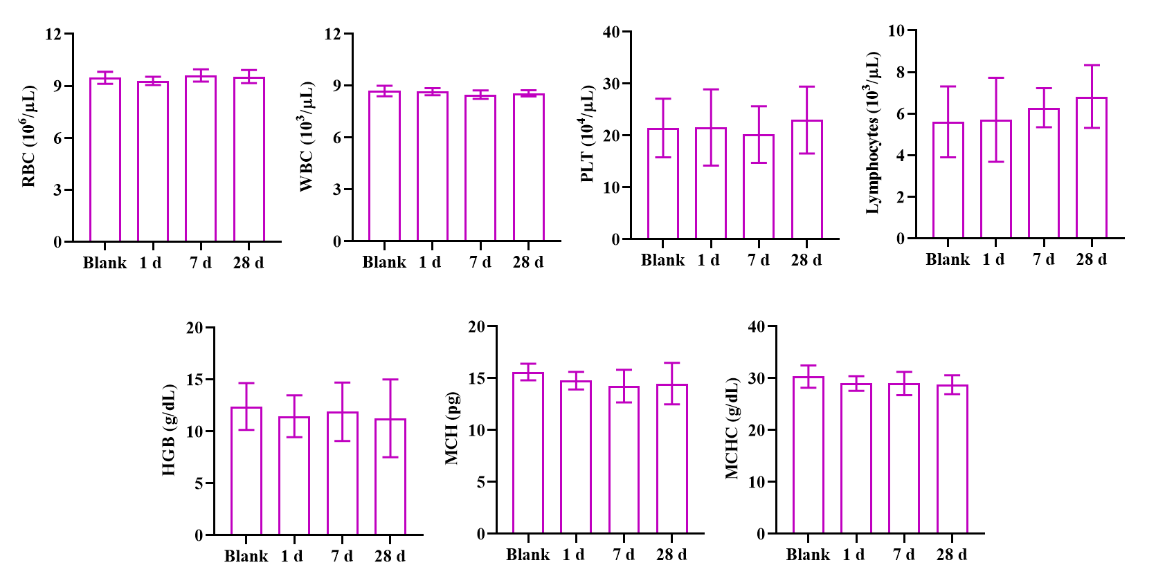
Figure S21. The changes in RBC, WBC, PLT, lymphocytes, HGB, MCH, and MCHC levels between the blank and LMWC/Ru-Cur-treated groups at all time points. Data are presented as means ± SD with n = 3 replicates per group.

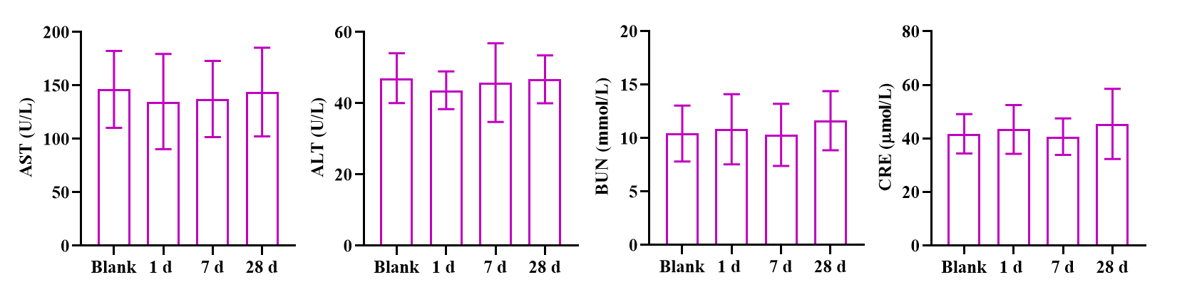
Figure S22. The changes in ALT, AST, BUN, and CRE levels between the blank and LMWC/Ru-Cur-treated groups at all time points. Data are presented as means ± SD with n = 3 replicates per group.

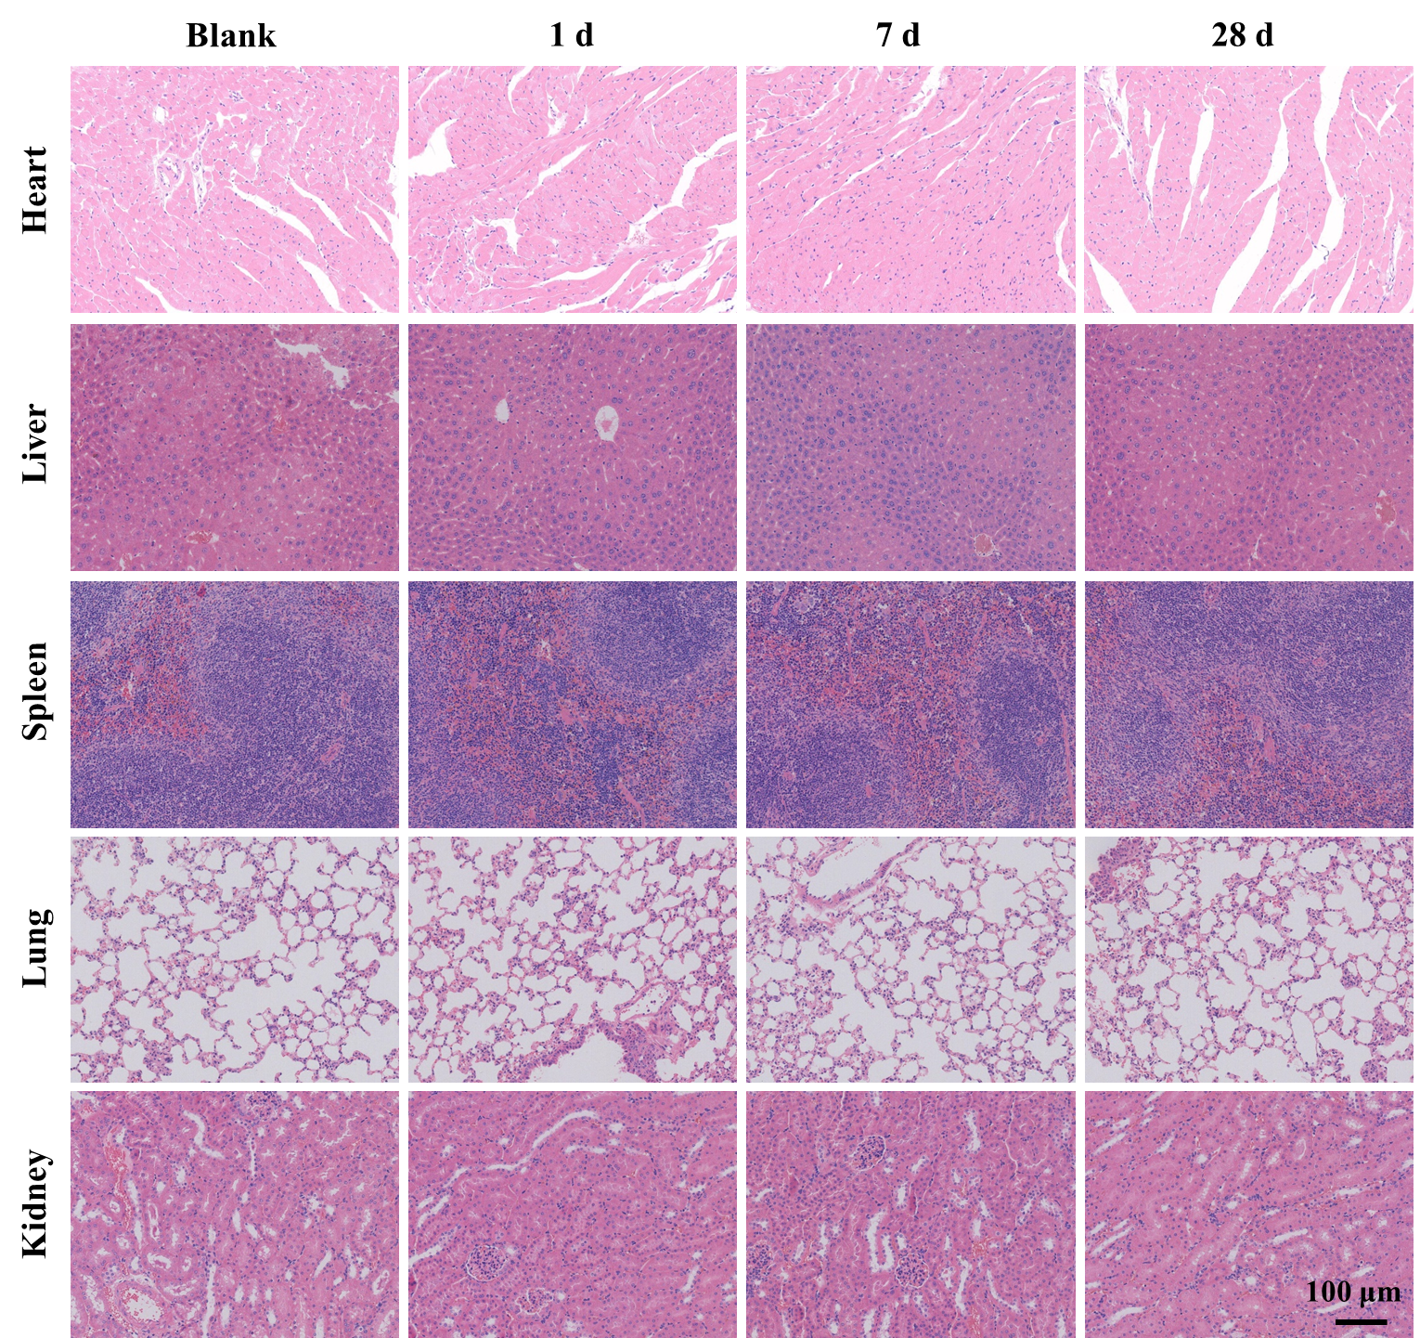
Figure S23. H&E staining sections of main tissues (heart, liver, spleen, lung, and kidney) in the blank and LMWC/Ru-Cur-treated groups at all time points. Scale bar 100 µm.

