Supplementary material
Supplementary Figure 1: Change in clinical indicators during follow-up in IMN patients with anti-PLA2R-antibody negative. (A) proteinuria and serum albumin in total population; (B) eGFR in total population; (C) proteinuria and serum albumin in SAb-/GAg+; (D) eGFR in SAb-/GAg+. Data are presented as mean ± standard deviation by assigned treatment. eGFR: estimated glomerular filtration rate; RTX: rituximab.

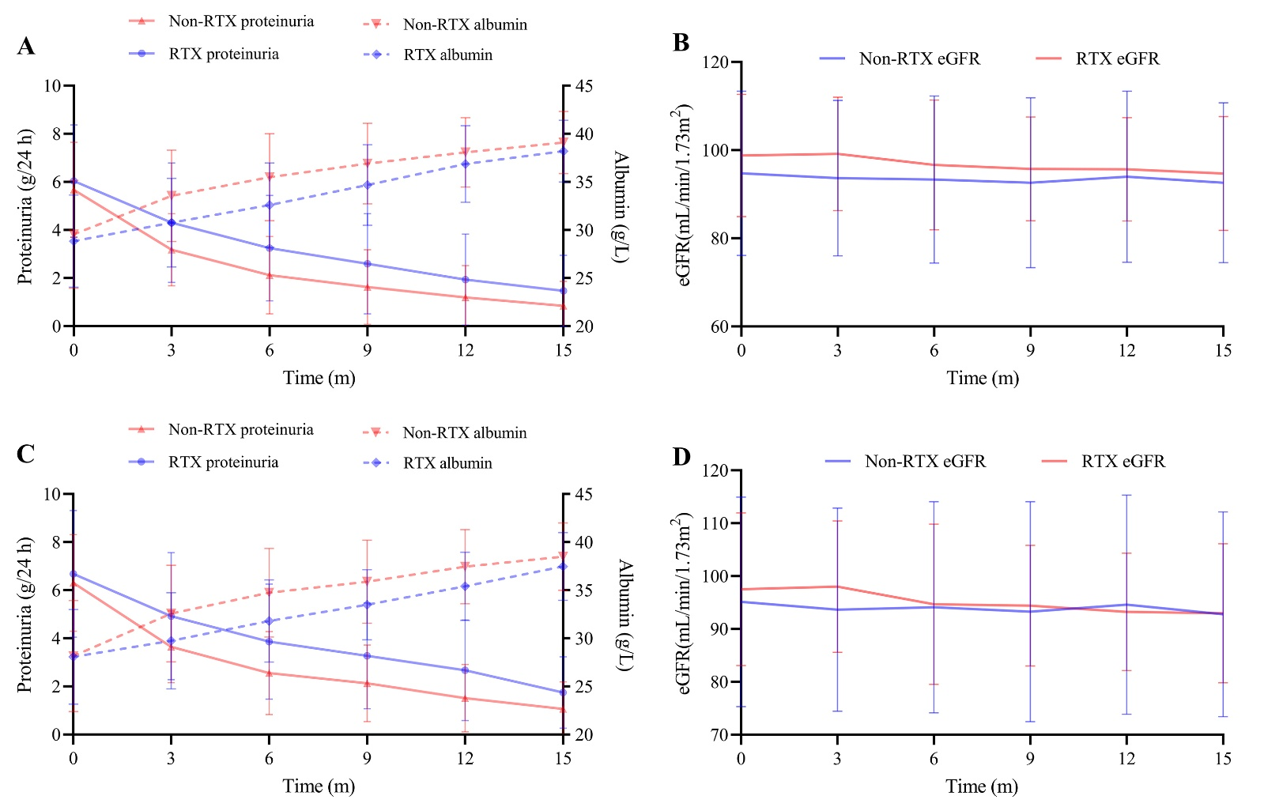

Supplementary Figure 2: Subgroup analyses of the association between treatment regimen and 15 months complete remission. (A) all population; (B) SAb-/GAg+ subgroup. Adjusted for age, sex, SBP, DBP, pathological, proteinuria, eGFR, and albumin.

