Supplementary Materials

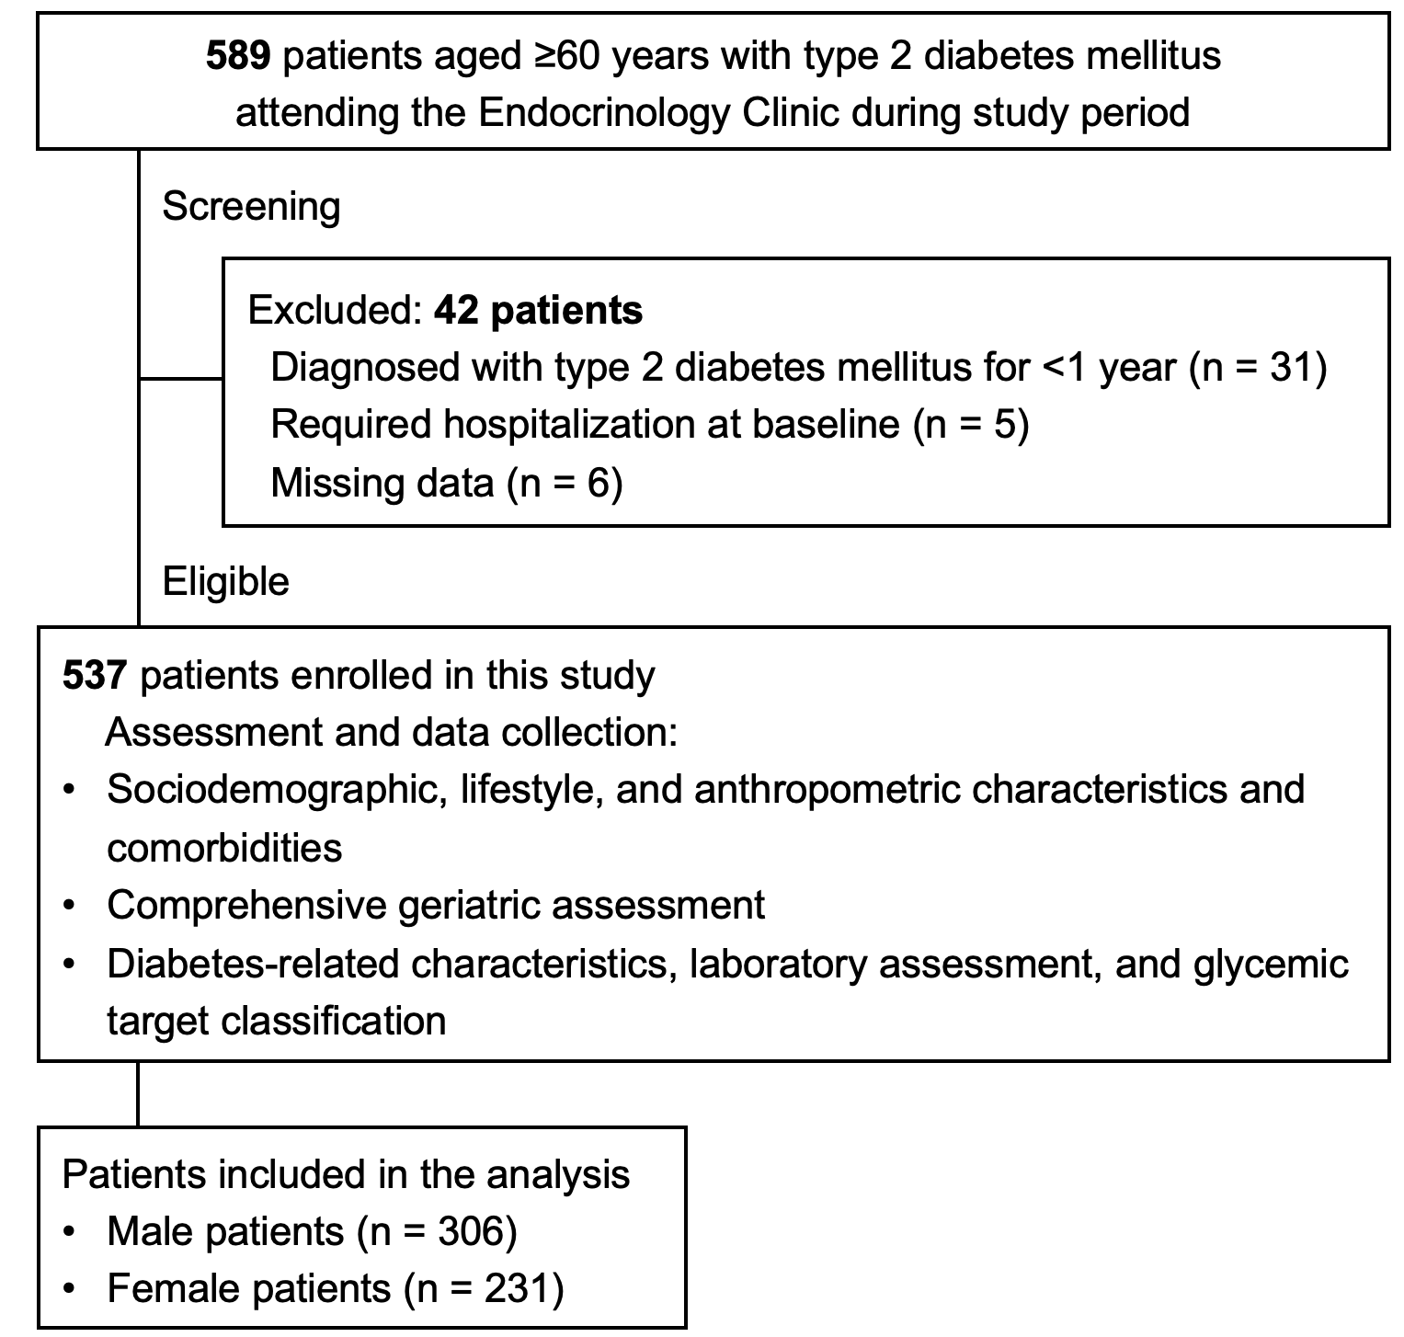

Supplementary Figure S1. Flow diagram of the study population.

Supplementary Table S1. Baseline characteristics of the study population by sex
Characteristics | Total  (n = 537) | Males  (n = 306) | Females  (n = 231) | P
Failure to achieve glycemic targets | 137 (25.5) | 76 (24.8) | 61 (26.4) | 0.690
Age ≥75 years | 155 (28.9) | 85 (27.8) | 70 (30.3) | 0.564
Dependent income | 472 (87.9) | 275 (89.9) | 197 (85.3) | 0.111
Senior high school and above | 451 (84.0) | 258 (84.3) | 193 (83.5) | 0.813
BMI groups |  |  |  | 0.028
Underweight | 12 (2.2) | 8 (2.6) | 4 (1.7)
Normal | 246 (45.8) | 123 (40.2) | 123 (53.2)
Overweight | 179 (33.3) | 112 (36.6) | 67 (29.0)
Obese | 100 (18.6) | 63 (20.6) | 37 (16.1)
Regular self-monitoring of blood glucose | 355 (66.1) | 197 (64.4) | 158 (68.4) | 0.358
Regular physical activity | 271 (50.5) | 172 (56.2) | 99 (42.9) | 0.002
Low-sodium diet | 203 (37.8) | 115 (37.6) | 88 (38.1) | 0.929
Alcohol consumption | 91 (17.0) | 85 (27.7) | 6 (2.6) | <0.001
Smoking | 43 (8.0) | 40 (13.1) | 3 (1.3) | <0.001
Currently sexually active | 28 (5.2) | 22 (7.2) | 6 (2.6) | 0.019
Multimorbidity | 533 (99.3) | 303 (99.0) | 230 (99.6) | 0.638
Polypharmacy | 426 (79.3) | 242 (79.1) | 184 (79.7) | 0.915
Physical frailty | 84 (15.6) | 50 (16.3) | 34 (14.7) | 0.633
Risk of falls | 108 (20.1) | 56 (18.3) | 52 (22.5) | 0.234
Risk of cognitive impairment | 80 (14.9) | 46 (15.0) | 34 (14.7) | 1.000
Depression | 75 (14.0) | 45 (14.7) | 30 (13.0) | 0.616
Limitations in IADL | 161 (30.0) | 80 (26.1) | 81 (35.1) | 0.029
Low social engagement | 129 (24.0) | 71 (23.2) | 58 (25.1) | 0.612
Poor health-related quality of life | 26 (4.8) | 13 (4.2) | 13 (5.6) | 0.544
Social frailty | 66 (12.3) | 43 (14.1) | 23 (10.0) | 0.184
Diabetes duration ≥5 years | 436 (81.2) | 247 (80.7) | 189 (81.8) | 0.824
Metformin | 519 (96.6) | 294 (96.1) | 225 (97.4) | 0.473
Sulfonylureas | 233 (43.4) | 137 (44.8) | 96 (41.6) | 0.482
DPP-4 inhibitors | 413 (76.9) | 236 (77.1) | 177 (76.6) | 0.918
SGLT2 inhibitors | 111 (20.7) | 71 (23.2) | 40 (17.3) | 0.107
Insulin | 48 (8.9) | 29 (9.5) | 19 (8.2) | 0.650
Dyslipidemia | 513 (95.5) | 290 (94.8) | 223 (96.5) | 0.401
Hypertension | 499 (92.9) | 286 (93.5) | 213 (92.2) | 0.612
Chronic coronary syndrome | 145 (27.0) | 83 (27.1) | 62 (26.8) | 1.000
Chronic kidney disease | 61 (11.4) | 35 (11.4) | 26 (11.3) | 1.000
Note: Categorical variables are presented as frequencies (n) and percentages (%). The chi-square test or Fisher’s exact test was used for comparisons. P values <0.05 are presented in bold. Abbreviations: BMI, body mass index; DPP-4, dipeptidyl peptidase-4; IADL, instrumental activities of daily living; SGLT2, sodium–glucose cotransporter-2.
Supplementary Table S2. Factors associated with failure to achieve glycemic targets (HbA1c <7%) in the overall population and by sex
 | All (n = 537) |  | Male (n = 306) |  | Female (n = 231)
 | Adjusted OR  (95% CI) | P | Adjusted OR  (95% CI) | P | Adjusted OR  (95% CI) | P
BMI groups
Underweight | 1 (reference) |  |  |  | 1 (reference)
Normal | 2.54  (0.68–9.54) | 0.165 |  |  | 1.63  (0.21–13.0) | 0.644
Overweight | 3.07  (0.80–11.7) | 0.101 |  |  | 1.52  (0.19–12.5) | 0.696
Obese | 4.97  (1.26–19.6) | 0.022 |  |  | 5.02  (0.56–45.0) | 0.149
Dependent income |  |  | 1.99  (0.75–3.97) | 0.199
Polypharmacy | 1.69  (1.09–2.64) | 0.020 | 2.13  (1.18–3.84) | 0.012
Frailty | 1.30  (0.71–2.38) | 0.394 | 1.29  (0.60–2.76) | 0.518 | 0.83  (0.32–2.15) | 0.700
Depression | 1.24  (0.71–2.17) | 0.456 | 1.18  (0.59–2.38) | 0.643
Dependence in IADL | 1.85  (1.18–2.88) | 0.007 | 1.38  (0.76–2.52) | 0.296 | 1.95  (1.01–3.76) | 0.047
Risk of cognitive impairment | 0.95  (0.54–1.69) | 0.868
Risk of falls | 1.20  (0.72–2.03) | 0.483 | 1.34  (0.680–2.65)
Low social engagement | 1.22  (0.76–1.94) | 0.412 |  |  | 2.26  (1.10–4.66) | 0.027
Social frailty | 0.88  (0.48–1.63) | 0.688 |  |  | 1.15  (0.41–3.32) | 0.791
Duration of diabetes ≥5 years | 1.77  (1.11–2.82) | 0.017 | 1.80  (0.98–3.31) | 0.058 | 1.34  (0.65–2.77) | 0.426
Note: P values <0.05 are presented in bold.
Abbreviations: CI, confidence interval; IADL, instrumental activities of daily living; OR, odds ratio.

Supplementary Table S3. Model performance and multicollinearity diagnostics
Model | c-statistic (AUC) | 95% CI | Hosmer–Lemeshow χ² | P | VIF (range)
Overall | 0.623 | 0.569–0.677 | 1.388 | 0.846 | 1.002–1.010
Male | 0.632 | 0.565–0.700 | 3.792 | 0.580 | 1.027–1.129
Female | 0.652 | 0.575–0.728 | 2.773 | 0.428 | 1.002–1.018
Note: AUC, area under the curve; CI, confidence interval; VIF, variance inflation factor.

