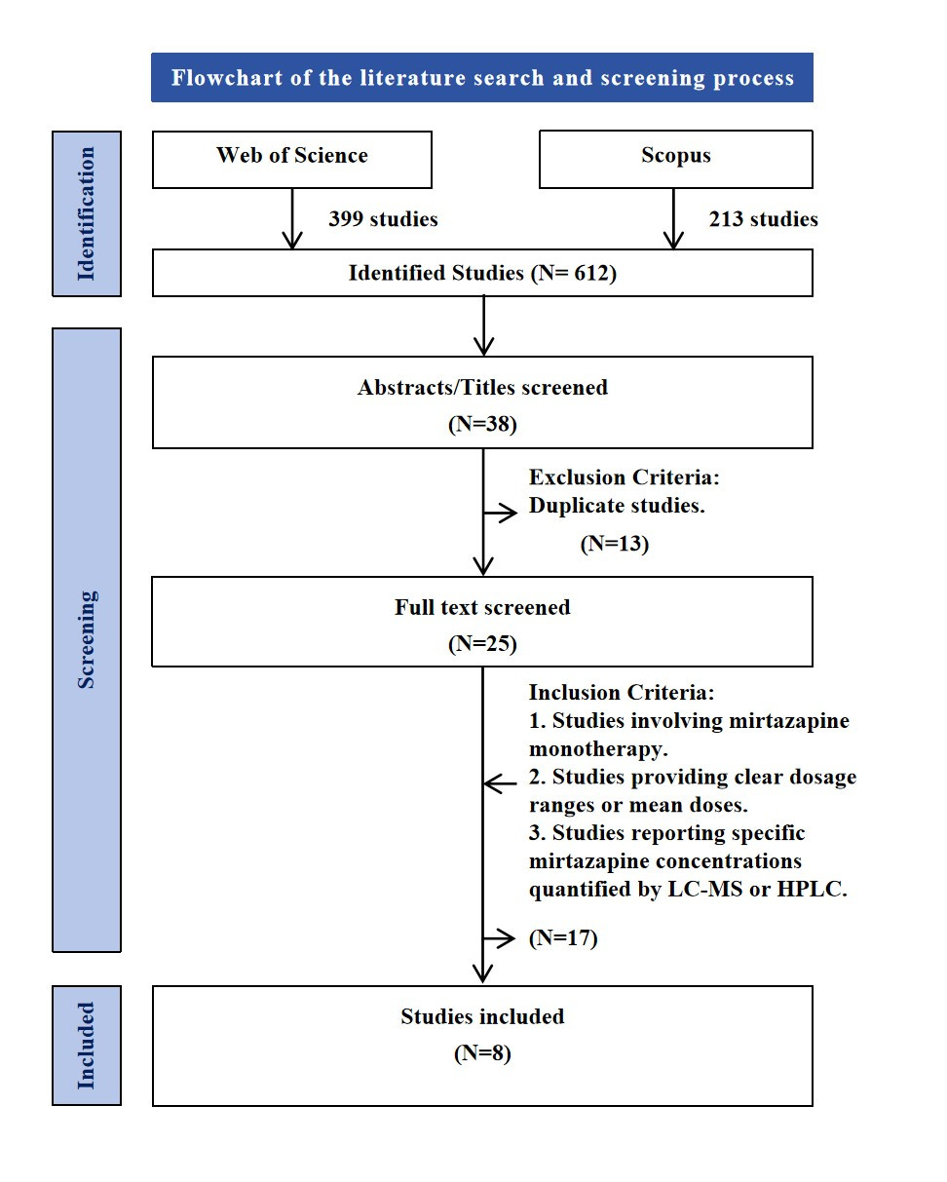
Suppl. Figure 1 Flowchart of the literature search and screening process.

Suppl. Table 1 The first round of forward inclusion in the covariate model for mirtazapine.
Model Type | Covariates affecting clearance rates | OFV | △OFV | *P < 0.01
Base model |  | 1362.194
 | BMI | 1350.051 | -12.143 | Yes
 | Sex | 1358.594 | -3.600 | No
 | Age | 1361.298 | -0.896 | No
 | Venlafaxine | 1358.602 | -3.592 | No
 | Fluvoxamine | 1350.205 | -11.989 | Yes
 | Fluoxetine | 1361.371 | -0.488 | No
 | Paroxetine | 1347.494 | -14.7 | Yes
 | Duloxetine | 1361.471 | -0.723 | No
 | Risperidone | 1358.161 | -4.033 | No
 | GFR | 1362.14 | -0.054 | No
 | CR | 1362.325 | 0.131 | No
 | AST | 1362.085 | -0.109 | No
 | ALT | 1362.474 | 0.28 | No
Notes: The “Base model” in the table refers to the model against which changes in the objective function values of other models in the table are compared; this should be distinguished from the concept of a base model mentioned in the main text; OFV: objective function value; △OFV: change in objective function value; GFR: Glomerular Filtration Rate; Cr: Creatinine; ALT: Alanine aminotransferase; AST: Aspartate aminotransferase; *P<0.01: △OFV<-6.63.

Suppl. Table 2 The second round of forward inclusion in the covariate model for mirtazapine.
Model Type | Covariates affecting clearance rates | OFV | △OFV | *P < 0.01
Base model | Paroxetine | 1347.494
 | Paroxetine and fluvoxamine | 1332.131 | -15.363 | Yes
 | Paroxetine and BMI | 1339.892 | -7.602 | Yes
Notes: The “Base model” in the table refers to the model against which changes in the objective function values of other models in the table are compared; this should be distinguished from the concept of a base model mentioned in the main text; OFV: objective function value; △OFV: change in objective function value; *P < 0.01: △OFV < -6.63.

Suppl. Table 3 Backward elimination in the covariate model for mirtazapine.
Model Type | Covariates affecting clearance rates | OFV | △OFV | *P < 0.001
Base model | Paroxetine, fluvoxamine and BMI | 1321.229
 | Paroxetine and fluvoxamine | 1332.131 | 10.902 | Yes
 | Paroxetine and BMI | 1339.892 | 18.663 | Yes
 | Fluvoxamine and BMI | 1333.24 | 12.011 | Yes
Notes: The “Base model” in the table refers to the model against which changes in the objective function values of other models in the table are compared; this should be distinguished from the concept of a base model mentioned in the main text; OFV: objective function value; △OFV: change in objective function value; *P < 0.01: △OFV > 10.83.

Suppl. Table 4 Characteristics of the included studies.
Numb | Site and Time | Subjects (Male) | Age | Diagnose  (Patients Type) | Plasma/Serum | Method | Prescribed dose mean ± SD (mg/d) | Concentration (ng/mL) | Study Design | Steady-State Concentration
1 | Japan, 2019 | 79 (32) | 54.4 ± 14.3 | Predominantly Major Depressive Disorder | Plasma | HPLC | 25.4 ± 13.1 | 24.6  (1.6–116.1) | Observational clinical pharmacokinetic study | Yes
2 | Germany, 2025 | 328 (189) | 54 ± 16 (18–90) | Major Depressive Disorder | Serum | LC-MS | 32.9 ± 10.5 | 42.2 ± 26.9  (4.5–153.0) | Retrospective single-center cohort study | Yes
3 | Norway, 2009 | 1767 (812) | 48 (16–96) | No restriction was made for psychiatric or somatic co-morbidity | Serum | LC-MS | 30  (7.5–90) | 32.37 | Retrospective study | Yes
4 | Germany, 2012 | 888 (393) | 53 ± 17 (18–92) | No restriction was made for psychiatric or somatic co-morbidity | Serum | HPLC | 36 ± 15  (7.5–90) | 52 ± 30  (3–193) | Retrospective study | Yes
5 | Germany, 2021 | 423 (179) | 54.1 ± 15.9 (18–92) | Psychiatric Disorders | Serum | HPLC | 7.0 ± 14.5  (7.5–75) | 48.5 ± 42.0  (0–357) | Retrospective study | Yes
6 | Germany, 2005 | 65 (28) | 49.2 ± 13.4 | Depressive Episode | Plasma | HPLC-UV | 37.3 ± 8.6 | 31.4 ± 16.3 | Prospective, naturalistic clinical study | Yes
7 | Germany, 2009 | 23 (4) | 52.26 ± 11.92 | Unipolar Depression | Serum | HPLC-UV | 45 | 78.90 ± 33.89 | Open-label study | Yes
8 | Germany, 2004 | 100 (48) | 52.5 (18–93） | Depressive Disorder | Serum | HPLC-UV | 35.3 ± 13.8（7.5–60） | 23.5 ± 13.1 | Retrospective study | Yes

