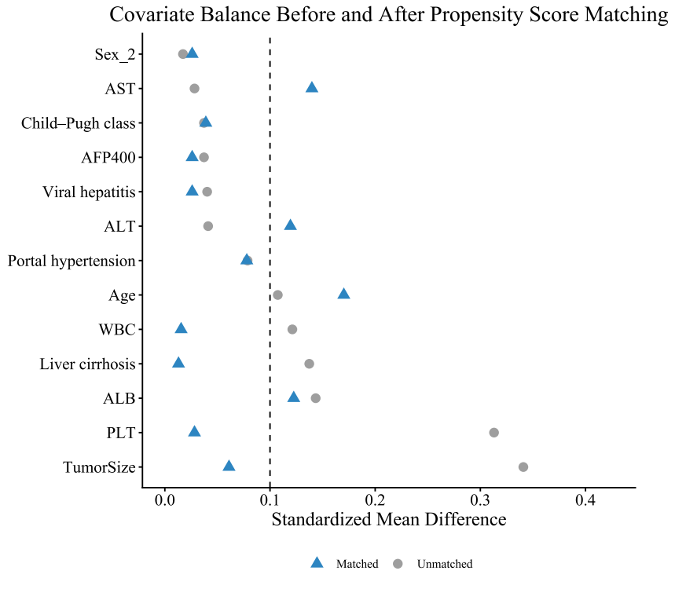
Supplementary Figure 1. Covariate balance before and after propensity score matching was assessed using standardized mean differences and visualized with a Love plot. After matching, all covariates achieved adequate balance (SMD < 0.1).

