Supplementary Table S1. Risk factors for refractory breathlessness
 | Unadjusted OR (95% CI) | P-value | Adjusted OR (95% CI) | P-value
Age | 1.004 (0.983-1.026) | 0.695 | 1.010 (0.984–1.037) | 0.463
Male | 1.151 (0.571-2.320) | 0.695 | 0.572 (0.208–1.574) | 0.279
BMI | 0.938 (0.884-0.994) | 0.031 | 0.994 (0.926–1.067) | 0.871
Smoking status (Ref: Never smoker)
Ex-smoker | 2.241 (1.229-4.089) | 0.009 | 2.153 (0.952–4.865) | 0.065
Current smoker | 2.525 (1.358-4.694) | 0.003 | 2.556 (1.098–5.946) | 0.029
Pack-years | 1.008 (1.000-1.016) | 0.052 | - | -
Charlson comorbidity index (Ref: 1)
2 | 2.071 (1.24-3.459) | 0.005 | 2.178 (1.229–3.860) | 0.008
≥3 | 1.597 (0.909-2.806) | 0.104 | 1.668 (0.891–3.124) | 0.110
mMRC (Ref: 1)
2 | 0.723 (0.383-1.366) | 0.318 | 0.617 (0.306–1.243) | 0.177
≥3 | 5.786 (2.172-15.415) | <0.001 | 4.028 (1.367–11.870) | 0.012
Prior history of moderate-to-severe exacerbation within 1 year | 1.808 (1.186-2.758) | 0.006 | 1.744 (1.078–2.821) | 0.023
Blood white blood cell count, 1000/uL | 1.072 (1.008-1.141) | 0.028 | - | -
Blood neutrophil, % | 1.021 (1.005-1.037) | 0.010 | - | -
Blood neutrophil count, 1000/uL | 1.079 (1.010-1.152) | 0.023 | 1.056 (0.990–1.127) | 0.099
Blood lymphocyte, % | 0.973 (0.955-0.992) | 0.005 | - | -
Blood lymphocyte count, 1000/uL | 0.929 (0.740-1.166) | 0.526 | 1.069 (0.811–1.410) | 0.634
Blood neutrophil/lymphocyte ratio | 1.026 (0.981-1.073) | 0.263 | - | -
Blood eosinophil, % | 0.967 (0.904-1.034) | 0.327 | - | -
Blood eosinophil count, 1000/uL | 0.823 (0.348-1.944) | 0.657 | - | -
Blood eosinophil count >300/uL | 0.999 (0.617-1.618) | 0.997 | - | -
FEV₁, L | 0.536 (0.357-0.806) | 0.003 | - | -
FEV₁, % of predicted value | 0.981 (0.969-0.993) | 0.002 | - | -
FEV₁, z-score | 0.710 (0.571-0.884) | 0.002 | 0.943 (0.680–1.307) | 0.724
FVC, L | 0.810 (0.632-1.039) | 0.097 | - | -
FVC, % of predicted value | 0.994 (0.983-1.004) | 0.248 | - | -
FVC, z-score | 0.900 (0.775-1.045) | 0.165 | - | -
FEV₁/FVC, % | 0.974 (0.956-0.991) | 0.004 | - | -
FEV₁/FVC, z-score | 0.756 (0.593-0.963) | 0.024 | 1.256 (0.849–1.860) | 0.254
FEF₂₅₋₇₅, L/s | 0.799 (0.397-1.610) | 0.531 | - | -
FEF₂₅₋₇₅, % of predicted value | 0.995 (0.975-1.015) | 0.616 | - | -
DL_{CO}, mL/min/mmHg | 0.878 (0.838-0.921) | <0.001 | - | -
DL_{CO}, % of predicted value | 0.974 (0.965-0.984) | <0.001 | 0.979 (0.967–0.991) | <0.001
LAA (-950 HU in inspiratory CT), % | 1.040 (1.015-1.065) | 0.001 | 1.024 (0.988–1.061) | 0.196
Pi10, mm | 1.147 (0.984-1.337) | 0.078 | 1.239 (1.032–1.487) | 0.021
BMI, body mass index; CT, computed tomography; DLCO, diffusing capacity for carbon monoxide; FEF25-75, forced expiratory flow at 25% to 75% of the forced vital capacity; FEV1, forced expiratory volume in 1 second; FVC, forced vital capacity; LAA, low-attenuation area; mMRC, modified Medical Research Council; NLR, neutrophil-to-lymphocyte ratio; Pi10, perimeter of the airway wall at 10 mm of internal diameter; SD, standard deviation; WBC, white blood cell

Supplementary Table S2. Comparison of factors potentially contributing to refractory breathlessness between groups
 | Refractory breathlessness group (n=244) | Improved breathlessness group (n=161) | P-value
COPD-related factors
Severe hyperinflation | 106 (43.4) | 66 (41.0) | 0.700
Severe emphysema | 118 (48.4) | 50 (31.1) | 0.001
Severe airflow limitation | 118 (48.4) | 45 (28.0) | <0.001
Current smoking | 69 (28.3) | 31 (19.3) | 0.052
Exacerbation event during treatment | 84 (34.4) | 10 (6.2) | <0.001
Occupational exposure | 4 (1.6) | 1 (0.6) | 0.654
Non-respiratory comorbidities
Advanced deconditioning | 92 (37.7) | 25 (15.5) | <0.001
Cardiovascular disease | 66 (27.0) | 19 (11.8) | <0.001
Obesity | 46 (18.9) | 38 (23.6) | 0.304
Pulmonary hypertension | 34 (13.9) | 7 (4.3) | 0.003
Depression or anxiety | 30 (12.3) | 7 (4.3) | 0.011
Arrhythmia | 24 (9.8) | 7 (4.3) | 0.065
Cognitive impairment | 19 (7.8) | 6 (3.7) | 0.147
Severe anemia | 13 (5.3) | 2 (1.2) | 0.063
Respiratory comorbidities
TB-destroyed lung | 57 (23.4) | 32 (19.9) | 0.480
Bronchiectasis | 35 (14.3) | 29 (18.0) | 0.395
Lung cancer | 24 (9.8) | 9 (5.6) | 0.179
Giant bulla | 19 (7.8) | 1 (0.6) | 0.003
Interstitial lung disease | 14 (5.7) | 4 (2.5) | 0.191
Endobronchial stenosis | 11 (4.5) | 2 (1.2) | 0.124
NTM pulmonary disease | 5 (2.0) | 4 (2.5) | 1.000
Fungal infection | 5 (2.0) | 3 (1.9) | 1.000
Thoracic wall abnormality | 1 (0.4) | 4 (2.5) | 0.164
Upper airway disease | 2 (0.8) | 2 (1.2) | 1.000
Pulmonary thromboembolism | 1 (0.4) | 1 (0.6) | 1.000
Device-related factors
Multiple device | 122 (50.0) | 42 (26.1) | <0.001
Poor adherence | 107 (43.9) | 26 (16.1) | <0.001
Poor technique | 97 (39.8) | 27 (16.8) | <0.001
Low inhalability | 73 (29.9) | 25 (15.5) | 0.001
COPD, chronic obstructive pulmonary disease; NTM, non-tuberculous mycobacteria; TB, tuberculosis
Supplementary Table S3. E-values for potential causes of refractory breathlessness
Potential causes of refractory breathlessness | Estimated E-value | Lower CI | Upper CI
Exacerbation event during treatment | 11.396 | 4.887 | 25.569
Pulmonary hypertension | 4.684 | 1.091 | 13.140
Cardiovascular disease | 5.288 | 2.497 | 10.397
Severe anemia | 8.991 | 1.033 | 44.822
Depression or anxiety | 5.136 | 1.545 | 13.659
Advanced deconditioning | 4.830 | 2.482 | 8.808
Giant bulla | 23.039 | 2.370 | 184.055
Endobronchial stenosis | 15.447 | 2.266 | 87.099
Poor adherence | 9.362 | 5.106 | 16.767
Low inhalability* | 3.108 | 1.255 | 6.035
Poor inhaler device technique | 5.534 | 2.946 | 9.907
Multiple device | 3.860 | 2.100 | 6.593
CI, confidence interval; ln, logarithmus Naturalis; OR, odds ratio; RB-Score, Refractory Breathlessness Score
*Apply to only DPI user

Supplementary Table S4. Risk stratification of refractory breathlessness based on RB-Score
RB-score | Risk group | Risk of refractory breathlessness
≤1.5 (n=146) | Low | 26% (19.6%–33.7%)
2.0–3.0 (=100) | Intermediate | 66% (56.3%–74.5%)
3.5–5.5 (=125) | High | 85% (77.5%–90.0%)
≥6.0 (=34) | Very high | 100% (89.8%–100.0%)

Supplementary Table S5. Sensitivity, Specificity, PPV, NPV for refractory breathlessness
 | AUROC  (95% CI) | Sensitivity  (95% CI) | Specificity  (95% CI) | PPV  (95% CI) | NPV  (95% CI)
RB-score | 0.85 (0.82-0.89) | 0.84 (0.79-0.88) | 0.70 (0.63-0.77) | 0.81 (0.76-0.86) | 0.75 (0.68-0.81)
Exacerbation event during treatment | 0.64 (0.61-0.68) | 0.34 (0.29-0.41) | 0.94 (0.89-0.97) | 0.89 (0.82-0.94) | 0.49 (0.43-0.54)
Pulmonary hypertension | 0.55 (0.52-0.57) | 0.14 (0.10-0.19) | 0.96 (0.91-0.98) | 0.83 (0.69-0.91) | 0.42 (0.37-0.47)
Cardiovascular disease | 0.58 (0.54-0.61) | 0.27 (0.22-0.33) | 0.88 (0.82-0.92) | 0.78 (0.68-0.85) | 0.44 (0.39-0.50)
Severe anemia | 0.52 (0.50-0.54) | 0.05 (0.03-0.09) | 0.99 (0.96-1.00) | 0.87 (0.62-0.96) | 0.41 (0.36-0.46)
Depression or anxiety | 0.54 (0.51-0.57) | 0.12 (0.09-0.17) | 0.96 (0.91-0.98) | 0.81 (0.66-0.91) | 0.42 (0.37-0.47)
Advanced deconditioning | 0.61 (0.57-0.65) | 0.38 (0.32-0.44) | 0.84 (0.78-0.89) | 0.79 (0.70-0.85) | 0.47 (0.42-0.53)
Giant bulla | 0.54 (0.52-0.55) | 0.08 (0.05-0.12) | 0.99 (0.97-1.00) | 0.95 (0.76-0.99) | 0.42 (0.37-0.47)
Endobronchial stenosis | 0.52 (0.50-0.53) | 0.05 (0.03-0.08) | 0.99 (0.96-1.00) | 0.85 (0.58-0.96) | 0.41 (0.36-0.45)
Poor adherence | 0.64 (0.60-0.68) | 0.44 (0.38-0.50) | 0.84 (0.77-0.89) | 0.80 (0.73-0.86) | 0.50 (0.44-0.56)
Low inhalability | 0.57 (0.53-0.61) | 0.30 (0.25-0.36) | 0.84 (0.78-0.89) | 0.74 (0.65-0.82) | 0.44 (0.39-0.50)
Poor inhaler device technique | 0.61 (0.57-0.66) | 0.40 (0.34-0.46) | 0.83 (0.77-0.88) | 0.78 (0.70-0.85) | 0.48 (0.42-0.54)
Multiple device | 0.62 (0.57-0.67) | 0.50 (0.44-0.56) | 0.74 (0.67-0.80) | 0.74 (0.67-0.80) | 0.49 (0.43-0.56)
CI, confidence interval; NPV, negative predictive value; PPV, positive predictive value

Supplementary Figure S1. Directed acyclic graph
AE, acute exacerbation; BMI, body mass index; CCI, Charlson comorbidity index; DL_{CO}, diffusing capacity for carbon monoxide; FEV₁, forced expiratory volume in 1 second; FEV₁/FVC, forced expiratory volume in 1 second to forced vital capacity ratio; FVC, forced vital capacity; LAA, low-attenuation area; Pi₁₀, square root of the wall area of a theoretical airway with an internal perimeter of 10 mm; WBC, white blood cell

Supplementary Figure S2. Prevalence of potential causes contributing to refractory breathlessness in refractory breathlessness group
Supplementary Figure S3. Unadjusted odds ratios of potential contributors to refractory breathlessness

Supplementary Figure S4. Comparison of RB-Scores between improved and refractory breathlessness groups

Supplementary Figure S5. Proportion of improved and refractory breathlessness groups by RB-Score

Supplementary Figure S6. Bootstrap-based calibration plot of RB-Score
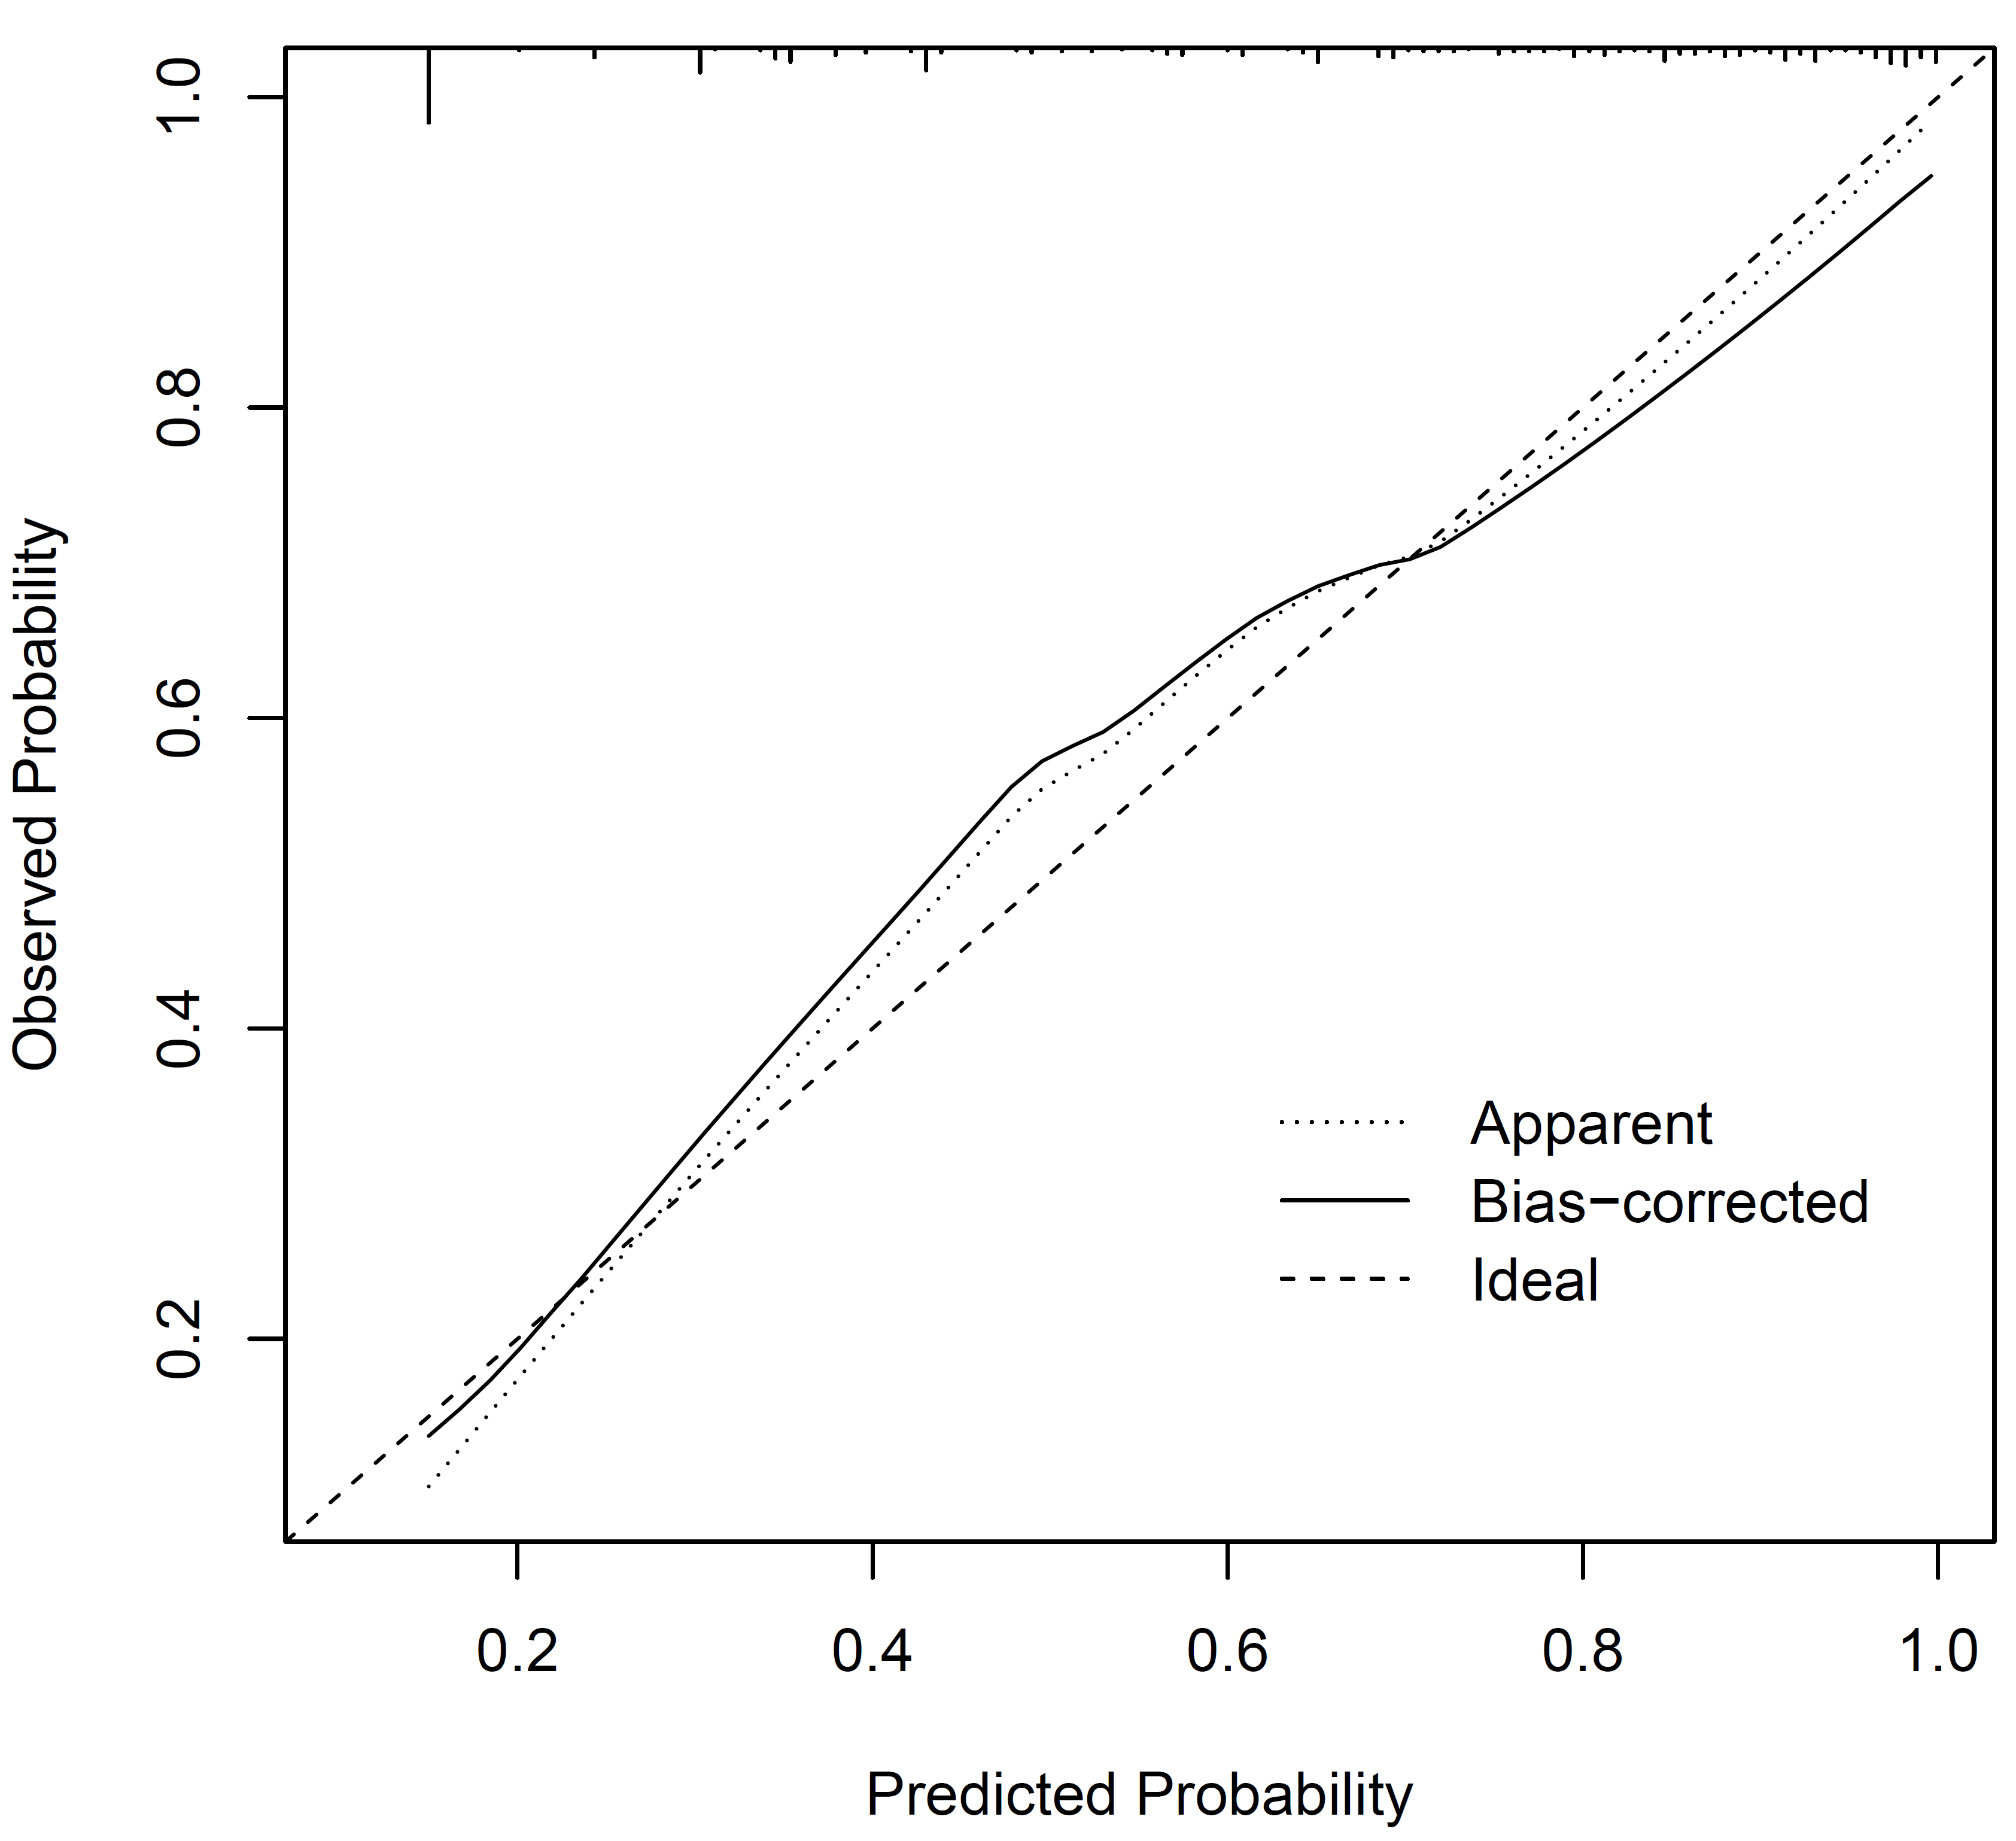
The dotted line represents apparent performance, the solid line represents bias-corrected performance, and the dashed line represents ideal calibration. Close agreement between the bias-corrected and ideal lines indicates adequate model calibration.

Supplementary Figure S7. Kaplan–Meier survival curves for all-cause mortality stratified by RB-Score risk groups
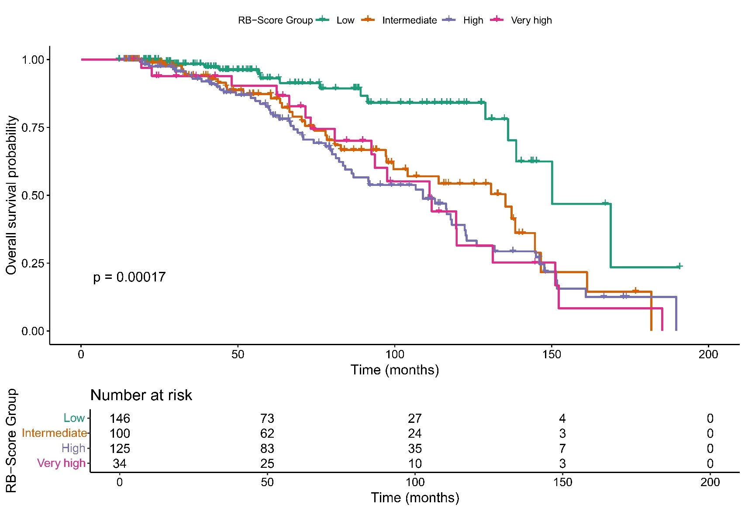
Kaplan–Meier survival estimates for time to all-cause mortality, stratified by RB-Score categories (Low [≤1.5], Intermediate [2.0–3.0], High [3.5–5.5], Very high [≥6.0]).

