Supplementary Table 1 Primer sequences in qRT-PCR
Gene | Sequence（5'-3'）
FKBP5-F | GAATGCTGTGACAAGGCCC
FKBP5-R | GTCACCCTTGGCTGACTCAA
HLA-DQA1-F | TGAAACACTGGGAGCCTGAG
HLA-DQA1-R | CATGAGGCCCACAGACAACC
GAPDH-F | AGGCCGGATGTGTTCGC
GAPDH-R | CAAATCCGTTGACTCCGACC

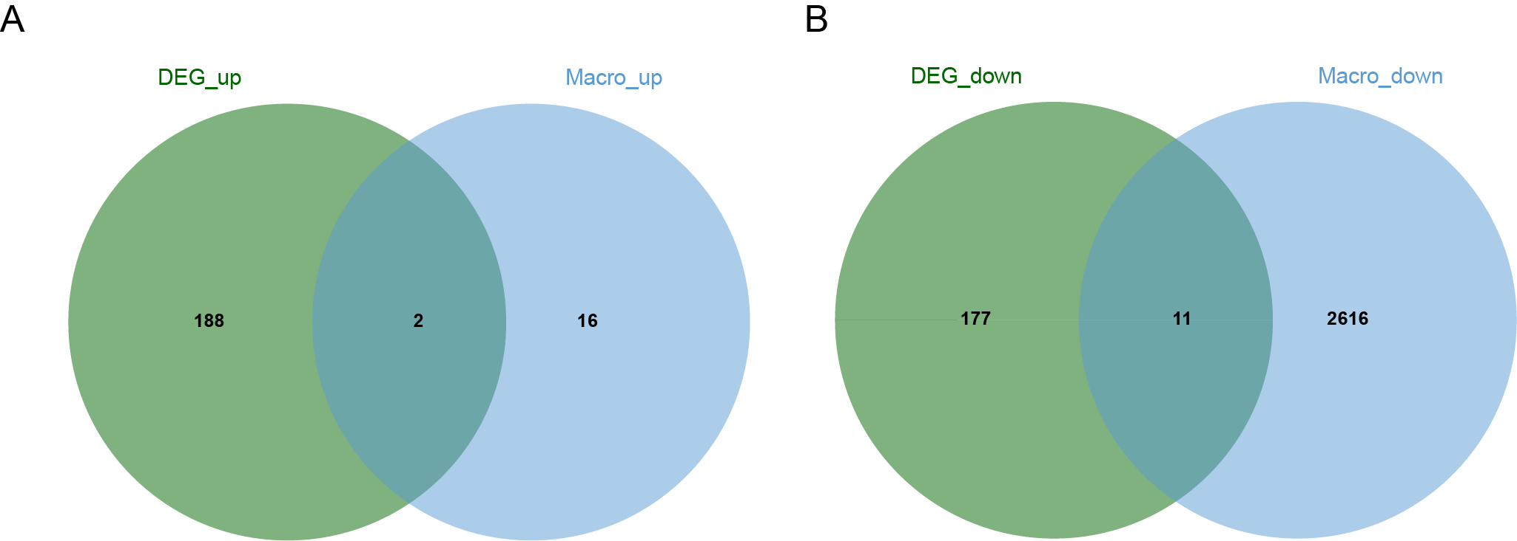
Supplementary Figure 1. Venn diagram

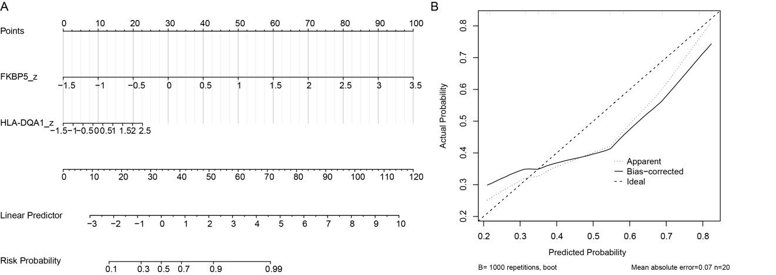
Supplementary Figure 2. Nomogram and evaluation results
- Nomogram construction; (B) Calibration curve evaluating nomogram accuracy.

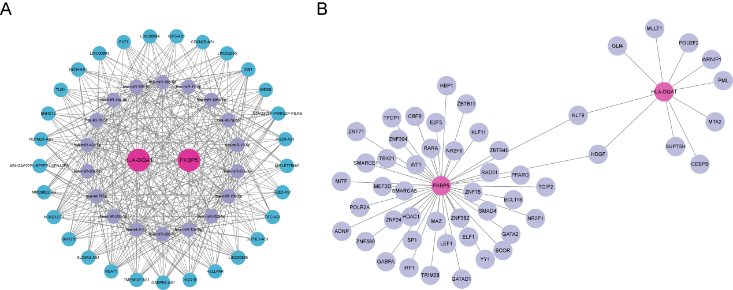
Supplementary Figure 3. Key gene network regulatory mechanisms
(A) ceRNA network construction. Blue nodes represent lncRNAs, purple nodes represent miRNAs, red nodes represent mRNAs. (B) Transcription factor prediction. Purple nodes represent transcription factors, red nodes represent key genes.

Supplementary Table 2. Binding free energies between key genes and small molecule drugs.
Drugs | targets | binding energy（kcal/mol）
saccharin | FKBP5 | -5.208
dacinostat | FKBP5 | -5.896
medrysone | FKBP5 | -7.164
salicin | FKBP5 | -5.788
senicapoc | FKBP5 | -6.877
budesonide | FKBP5 | -6.495
caffeine | FKBP5 | -4.804
timolol | FKBP5 | -5.217
zolpidem | FKBP5 | -6.329
betamethasone | FKBP5 | -7.213
saccharin | HLA-DQA1 | -5.545
dacinostat | HLA-DQA1 | -6.23
medrysone | HLA-DQA1 | -8.154
salicin | HLA-DQA1 | -5.468
senicapoc | HLA-DQA1 | -7.632
budesonide | HLA-DQA1 | -8.137
caffeine | HLA-DQA1 | -4.695
timolol | HLA-DQA1 | -5.152
zolpidem | HLA-DQA1 | -7.042
betamethasone | HLA-DQA1 | -7.773

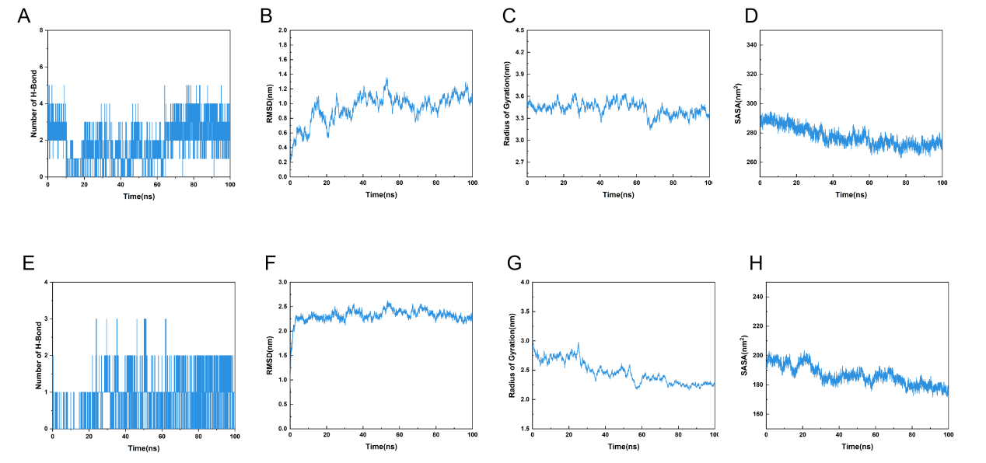
Supplementary Figure 4. System stability assessment during 100 ns molecular dynamics simulations.
(A-D) Betamethasone-FKBP5 complex: (A) Number of hydrogen bonds, (B) backbone RMSD, (C) radius of gyration (Rg), and (D) solvent-accessible surface area (SASA). (E-H) Medrysone-HLA-DQA1 complex: (E) Number of hydrogen bonds, (F) backbone RMSD, (G) radius of gyration (Rg), and (H) solvent-accessible surface area (SASA).

