Supplementary Material

1.Supplemental material and methods.

1.1. Baseline examination
Anthropometric indicators were measured by trained nurses. Body weight and height in accordance with a standardized procedure with an accuracy of 0.1 kg and 0.1 cm, respectively. The measurement of waist circumference is to be taken in a natural standing position, with the examinee wearing thin clothes. At the conclusion of the normal exhalation, the midpoint of the line connecting the lower edge of the 12th rib and the upper edge of the iliac bone is to be taken as the standard, and a tape measure is to be used to circle the abdomen horizontally. Waist circumference is the measurement in question, with a margin of error of 0.1 cm.
Abdominal obesity is defined as a waist circumference of ≥90 cm in men and ≥85 cm in women. Smoking is defined as current smoking or smoking cessation for less than 5 years. Drinking is defined as current drinking or abstinence for less than 1 year. Blood pressure was measured using a mercury sphygmomanometer after the patient had been seated quietly for a duration of at least 10 minutes, and the average of multiple measurements was taken as the systolic and diastolic blood pressure values. Blood samples were collected for biochemical analysis after an overnight fast.
1.2. Definitions
Hypertension was defined as SBP ≥140 mmHg and/or DBP ≥90 mmHg, or under antihypertensive therapy. Diabetes mellitus (DM) was defined if fasting glucose ≥7.0 mmol/L, if using any glucose-lowering medication, or if there was selfreported history of DM. The definition of dyslipidemia was based on the guideline of Chinese Prevention and Treatment of Dyslipidemia in adults: total cholesterol ≥6.22 mmol/L (240 mg/dL) and/or LDL-C ≥ 4.14 mmol/L (160 mg/dL) and/or HDL-C < 1.04mmol/L (40 mg/dL), and/or triglyceride ≥ 2.26 mmol/L (200 mg/dL) and/or they were taking a lipid lowering drug. The body mass index (BMI) was calculated using the following formula: Weight (kg)/Height² (metres).
1.3.Details of the statistical analyses.
To address the issue of missing data, we implemented non-parametric imputation using the missForest procedure in R. Additionally, we provide regression analysis results for both the pre- and post-interpolation data. The results before and after data interpolation are consistent, indicating the reliability of interpolation.
Continuous variables were expressed as mean ± standard deviation (SD) or median (interquartile range) based on normality testing, with between-group comparisons performed using ANOVA, Kruskal-Wallis as appropriate. Categorical variables were presented as frequencies (percentages) and compared using Pearson's χ² tests.
Furthermore, we used least absolute shrinkage and selection operator (LASSO) regression to derive the final set of variables (see supplementary figure S1A and S1B). This method, leveraging L1 regularization, facilitates high-dimensional variable screening by systematically eliminating variables with no association with MACCE or those exhibiting high multicollinearity with other predictors. Ultimately, we constructed two models to determine the independent predictive value of LDH (lactate dehydrogenase) for MACCE (major adverse cardiovascular and cerebrovascular events) events. Model 1 was adjusted for age, sex, smoke, Cr (creatinine), FPG (fasting plasma glucose), WBC (white blood cell), DM. Based on model 1, model 2 further adjusted duration of hypertension, ACEIs/ARBs (angiotensin-converting enzyme inhibitors/angiotensin receptor blockers), beta-blockers, hypoglycemic drugs, hypolipidemic drugs, antiplatelet medication, alcohol, BMI (body mass index), DBP (diastolic blood pressure), waist, BUN (blood urea nitrogen), HDL-C (high-density lipoprotein cholesterol), TC (total cholesterol), UA (uric acid), serum potassium, serum sodium, AST (aspartate transaminase).
To quantify cumulative exposure to LDH, we computed the trapezoidal rule-derived area under the curve (AUC) between chronological age and LDH levels (termed LDH_AUC). To account for interindividual variability in measurement frequency and timing, we further standardized this metric by annualizing LDH_AUC through division by total exposure duration (years). This methodological approach enabled robust comparison of LDH exposure effects. In the present study, annual LDH_AUC was analyzed as both continuous and categorical variables. Categorical variable analysis : stratified based on the third/fourth percentile of annual LDH_AUC, the subjects was categorized into three (Q1-Q3) or four (Q1-Q4) groups. Multivariate cox regression estimated hazard ratios (HRs) for MACCE risk across groups. Continuous variable analysis :Annual LDH_AUC was incorporated into a multivariable Cox model adjusted for confounders. The association between annual LDH_AUC increments and MACCE risk was quantified using HRs. Furthermore, to verify the robustness of the model and increase its credibility, multiple stratified analysis and sensitivity analysis were conducted separately. Furthermore, restricted cubic spline functions with 4 knots were incorporated into the Cox proportional hazards model to assess the nonlinear dose-response association between annual LDH_AUC levels and MACCE and its subtypes events.
Given the potential influence of participants' baseline characteristics on clinical outcomes, we performed stratified analyses according to sex (men, women), BMI (< 24, ≥ 24hg/m2), smoking status (yes, no), alcohol consumption status (yes, no), dyslipidemia (yes, no), DM (yes, no), duration of hypertensionand (<5 years, ≥ 5 years), No. of antihypertensive agents (<2, ≥ 2 ). This analytical approach enabled evaluation of whether the annual LDH_AUC-MACCE association exhibited consistency with the overall trends observed in the entire cohort. Finally, to assess the robustness of the findings, sensitivity analyses were performed by excluding patients with diabetes mellitus and those with follow-up duration <2 years.
Statistical analyses were conducted using IBM SPSS Statistics version 31.0 and R version 4.4.2. All statistical tests were two-tailed with a significance threshold set at p < 0.05.

2.Supplemental tables.

Supplementary table 1. Baseline characteristics of the study population based on LDH quartile.
 | Total | Q1 | Q2 | Q3 | Q4 | P
N | 13809 | 3263 | 3281 | 3273 | 3272
Age (years) | 52.34 ± 12.12 | 50.83 ± 11.34 | 52.07 ± 11.85 | 52.81 ± 12.32 | 53.65 ± 12.75 | <0.001
Men (n,%) | 7234 (55.27) | 1961 (60.10) | 1892 (57.67) | 1694 (51.76) | 1687 (51.56) | <0.001
Women (n,%) | 5855 (44.73) | 1302 (39.90) | 1389 (42.33) | 1579 (48.24) | 1585 (48.44) | <0.001
Smoke (n,%) | 4354 (33.26) | 1235 (37.85) | 1081 (32.95) | 1028 (31.41) | 1010 (30.87) | <0.001
Alcohol (n,%) | 3929 (30.02) | 1118 (34.26) | 1022 (31.15) | 899 (27.47) | 890 (27.20) | <0.001
Abdominal obesity (n,%) | 11151 (85.19) | 2701 (82.78) | 2762 (84.18) | 2816 (86.04) | 2872 (87.78) | <0.001
BMI (kg/m2) | 27.23 ± 3.91 | 26.67 ± 3.56 | 27.03 ± 3.80 | 27.34 ± 3.89 | 27.88 ± 4.26 | <0.001
DBP (mmHg) | 88.49 ± 14.52 | 87.81 ± 13.64 | 87.99 ± 13.77 | 88.67 ± 14.49 | 89.50 ± 16.01 | <0.001
SBP (mmHg) | 145.41 ± 20.11 | 141.73 ± 18.85 | 144.01 ± 19.46 | 146.59 ± 19.84 | 149.33 ± 21.39 | <0.001
Waist (cm) | 98.04 ± 11.59 | 96.75 ± 11.37 | 97.58 ± 11.21 | 98.17 ± 11.35 | 99.64 ± 12.21 | <0.001
BUN (mmol/L) | 5.27 ± 1.75 | 5.19 ± 1.47 | 5.25 ± 1.68 | 5.22 ± 1.72 | 5.43 ± 2.07 | <0.001
Cr (umol/L) | 69.78 ± 28.43 | 69.73 ± 21.15 | 69.41 ± 23.01 | 68.80 ± 31.93 | 71.16 ± 35.12 | 0.007
HDL-C (mmol/L) | 1.07 ± 0.28 | 1.03 ± 0.26 | 1.05 ± 0.27 | 1.08 ± 0.28 | 1.11 ± 0.29 | <0.001
LDL-C (mmol/L) | 2.72 ± 0.84 | 2.59 ± 0.78 | 2.68 ± 0.81 | 2.76 ± 0.83 | 2.87 ± 0.92 | <0.001
TG (mmol/L) | 1.89 ± 1.50 | 1.92 ± 1.41 | 1.90 ± 1.44 | 1.84 ± 1.41 | 1.90 ± 1.71 | 0.166
TC (mmol/L) | 4.51 ± 0.99 | 4.35 ± 0.92 | 4.47 ± 0.95 | 4.54 ± 0.98 | 4.68 ± 1.09 | <0.001
UA (umol/L) | 342.12 ± 93.99 | 339.11 ± 94.40 | 341.56 ± 93.74 | 341.22 ± 92.98 | 346.57 ± 94.73 | 0.011
Serum potassium (mmol/L) | 3.85 ± 0.37 | 3.87 ± 0.34 | 3.85 ± 0.36 | 3.83 ± 0.37 | 3.86 ± 0.42 | <0.001
Serum sodium (mmol/L) | 141.07 ± 2.53 | 140.99 ± 2.57 | 141.07 ± 2.51 | 141.12 ± 2.51 | 141.10 ± 2.52 | 0.175
FPG (mmol/L) | 5.16 ± 1.70 | 5.19 ± 1.82 | 5.13 ± 1.62 | 5.12 ± 1.67 | 5.18 ± 1.68 | 0.221
AST (U/l) | 20.93 ± 13.01 | 17.76 ± 5.93 | 19.65 ± 7.27 | 21.29 ± 8.58 | 25.03 ± 22.08 | <0.001
ALT (U/l) | 26.52 ± 22.56 | 22.39 ± 13.84 | 24.85 ± 16.19 | 27.21 ± 19.64 | 31.61 ± 33.91 | <0.001
WBC (*10⁹/L) | 6.34 ± 1.69 | 6.14 ± 1.52 | 6.20 ± 1.58 | 6.37 ± 1.67 | 6.66 ± 1.91 | <0.001
LDH (U/L) | 192.27 ± 43.71 | 147.21 ± 12.71 | 175.23 ± 6.53 | 198.57 ± 7.51 | 247.99 ± 43.86 | <0.001
Annual LDH_AUC (U/L×years) | 198.03 ± 50.19 | 170.83 ± 52.34 | 189.07 ± 43.16 | 203.30 ± 45.43 | 228.87 ± 40.19 | <0.001
Duration of hypertension (years) | 6.82+7.73 | 6.34+7.09 | 6.61+7.46 | 6.92+7.94 | 7.42+8.32 | <0.001
MACCE (n,%) | 879 (6.72) | 228 (6.99) | 219 (6.67) | 208 (6.36) | 224 (6.85) | 0.762
Dyslipidemia (n,%) | 7497 (57.28) | 1865 (57.16) | 1852 (56.45) | 1906 (58.23) | 1874 (57.27) | 0.538
DM (n,%) | 2401 (18.34) | 604 (18.51) | 583 (17.77) | 582 (17.78) | 632 (19.32) | 0.316
ACEIs/ARBs (n,%) | 5637 (43.07) | 1389 (42.57) | 1387 (42.27) | 1386 (42.35) | 1475 (45.08) | 0.064
Beta-blockers (n,%) | 2198 (16.79) | 454 (13.91) | 503 (15.33) | 570 (17.42) | 671 (20.51) | <0.001
Calcium channel  blockers (n,%) | 8527 (65.15) | 1957 (59.98) | 2084 (63.52) | 2192 (66.97) | 2294 (70.11) | <0.001
Diuretics (n,%) | 3358 (25.66) | 639 (19.58) | 815 (24.84) | 918 (28.05) | 986 (30.13) | <0.001
hypoglycemic  agents (n,%) | 1748 (13.35) | 408 (12.50) | 425 (12.95) | 426 (13.02) | 489 (14.94) | 0.019
Hypolipidemic drugs  (n,%) | 5060 (38.66) | 1018 (31.20) | 1134 (34.56) | 1327 (40.54) | 1581 (48.32) | <0.001
Antiplatelet medication (n,%) | 6662 (50.90) | 1627 (49.86) | 1690 (51.51) | 1647 (50.32) | 1698 (51.89) | 0.305
Abbreviations: BMI, body mass index, DBP, diastolic blood pressure, SBP, systolic blood pressure, BUN, blood urea nitrogen, Cr, creatinine, HDL-C, high-density lipoprotein cholesterol, LDL-C, low-density lipoprotein cholesterol, TG, triglyceride, TC, total cholesterol, UA, uric acid, FPG, fasting plasma glucose, AST, aspartate transaminase, ALT, alanine transaminase, WBC, white blood cell, LDH, lactate dehydrogenase, AUC, area under the curve, MACCE, major adverse cardiovascular and cerebrovascular events, DM, diabetes mellitus, ACEIs, angiotensin-converting enzyme inhibitors; ARBs, angiotensin receptor blockers.

Supplementary table 2. Comparison of discriminative performance (C-index) between models with and without annual LDH cumulative exposure.
 | Model1 | Model2
MACCE
C-index | 0.738 | 0.742
Cerebrovascular events
C-index | 0.738 | 0.740
Cardiac events
C-index | 0.756 | 0.760
All-cause death
C-index | 0.896 | 0.901
Model1: age, sex, smoke, Cr, FPG, WBC, DM, duration of hypertension, ACEIs/ARBs, beta-blockers, hypoglycemic drugs, hypolipidemic drugs, antiplatelet medication, alcohol, BMI, DBP, waist, BUN, HDL-C, TC, UA, potassium, sodium, AST.
Model 2: Model 1 plus LDH_AUC 10U
Abbreviations: MACCE, major adverse cardiovascular and cerebrovascular events; HR, hazard ratio; CI, Confidence Interval. Other abbreviations, see supplementary table 1.

Supplementary table 3. Analysis of the relationship between LDH, LDH_AUC and different end point events before data imputation.
 | Crude model |  | Model1 |  | Model2
 | HR (95%CI) | P | HR (95%CI) | P | HR (95%CI) | P
MACCE
LDH (per 10U/L increase) | 1.034 (1.022,1.047) | <0.001 | 1.034 (1.021,1.048) | <0.001 | 1.028 (1.013,1.043) | <0.001
Annual LDH_AUC (per 10-ng/dL×years increase) | 1.018 (1.013,1.022) | <0.001 | 1.013 (1.009,1.018) | <0.001 | 1.012 (1.007,1.017) | <0.001
Q1 | Reference |  | Reference |  | Reference
Q2 | 0.979 (0.825,1.160) | 0.804 | 1.015 (0.83,1.209) | 0.866 | 0.977 (0.820,1.165) | 0.798
Q3 | 1.417 (1.209,1.661) | <0.001 | 1.435 (1.216,1.694) | <0.001 | 1.350 (1.138,1.602) | <0.001
P for trend | 0.001 |  | 0.001 |  | 0.001
Q1 | Reference |  | Reference |  | Reference
Q2 | 0.890 (0.730,1.085) | 0.251 | 0.936 (0.764,1.147) | 0.523 | 0.919 (0.750,1.127) | 0.418
Q3 | 1.013 (0.834,1.230) | 0.895 | 1.090 (0.893,1.332) | 0.397 | 1.026 (0.838,1.257) | 0.803
Q4 | 1.523 (1.273,1.822) | <0.001 | 1.562 (1.295,1.883) | <0.001 | 1.470 (1.212,1.783) | <0.001
P for trend | <0.001 |  | <0.001 |  | <0.001
Cerebrovascular events
LDH (per 10U/L increase) | 1.039 (1.020,1.057) | <0.001 | 1.044 (1.025,1.063) | <0.001 | 1.037 (1.015,1.059) | 0.001
Annual LDH_AUC (per 10-ng/dL×years increase) | 1.016 (1.007,1.026) | <0.001 | 1.012 (1.003,1.021) | 0.01 | 1.007 (0.998,1.017) | 0.123
Q1 | Reference |  | Reference |  | Reference
Q2 | 0.956 (0.732,1.250) | 0.744 | 1.037 (0.789,1.364) | 0.794 | 0.983 (0.747,1.295) | 0.905
Q3 | 1.376 (1.071,1.769) | 0..013 | 1.451 (1.116,1.887) | 0.005 | 1.312 (1.001,1.719) | 0.049
P for trend | 0.09 |  | 0.09 |  | 0.09
Q1 | Reference |  | Reference |  | Reference
Q2 | 0.946 (0.695,1.287) | 0.723 | 1.027 (0.748,1.411) | 0.867 | 1.001 (0.728,1.376) | 0.995
Q3 | 1.009 (0.742,1.373) | 0.953 | 1.135 (0.825,1.562) | 0.436 | 1.032 (0.747,1.426) | 0.848
Q4 | 1.503 (1.129,2.002) | 0.005 | 1.616 (1.197,2.182) | 0.002 | 1.477 (1.084,2.011) | 0.013
P for trend | 0.044 |  | 0.044 |  | 0.044
Cardiac events
LDH (per 10U/L increase) | 1.032 (1.015,1.049) | <0.001 | 1.026 (1.007,1.045) | 0.006 | 1.019 (0.997,1.041) | 0.091
Annual LDH_AUC (per 10-ng/dL×years increase) | 1.019 (1.014,1.025) | <0.001 | 1.015 (1.009,1.020) | <0.001 | 1.014 (1.08,1.020) | <0.001
Q1 | Reference |  | Reference |  | Reference
Q2 | 0.957 (0.762,1.202) | 0.705 | 0.985 (0.780,1.244) | 0.899 | 0.957 (0.756,1.212) | 0.716
Q3 | 1.414 (1.144,1.748) | 0.001 | 1.428 (1.144,1.781) | 0.002 | 1.336 (1.062,1.680) | 0.013
P for trend | 0.017 |  | 0.017 |  | 0.017
Q1 | Reference |  | Reference |  | Reference
Q2 | 0.821 (0.629,1.070) | 0.144 | 0.853 (0.650,1.118) | 0.249 | 0.835 (0.635,1.097) | 0.195
Q3 | 0.989 (0.765,1.278) | 0.932 | 1.070 (0.822,1.393) | 0.613 | 1.027 (0.786,1.340) | 0.847
Q4 | 1.464 (1.154,1.856) | 0.002 | 1.491 (1.163,1.912) | 0.002 | 1.389 (1.074,1.797) | 0.012
P for trend | 0.009 |  | 0.009 |  | 0.009
All-cause death
LDH (per 10U/L increase) | 1.036 (0.981,1.095) | <0.001 | 1.026 (0.953,1.104) | 0.494 | 1.031 (0.952,1.117) | 0.454
Annual LDH_AUC (per 10-ng/dL×years increase) | 1.026 (1.011,1.042) | <0.001 | 1.018 (1.002,1.035) | 0.032 | 1.024 (1.005,1.043) | 0.013
Q1 | Reference |  | Reference |  | Reference
Q2 | 1.778 (0.699,4.523) | 0.227 | 1.581 (0.82,4.297) | 0.369 | 1.639 (0.585,4.591) | 0.347
Q3 | 2.923 (1.219,7.008) | 0.016 | 2.260 (0.885,5.767) | 0.088 | 2.482 (0.961,6.411) | 0.060
P for trend | 0.025 |  | 0.025 |  | 0.025
Q1 | Reference |  | Reference |  | Reference
Q2 | 1.659 (0.485,5.670) | 0.42 | 1.268 (0.355,4.531) | 0.714 | 1.206 (0.334,4.351) | 0.775
Q3 | 2.071 (0.623,6.877) | 0.235 | 1.433 (0.415,4.948) | 0.57 | 1.321 (0.368,4.749) | 0.669
Q4 | 5.057 (1.711,14.945) | 0.003 | 3.174 (1.052,9.577) | 0.04 | 3.408 (1.112,10.440) | 0.032
P for trend | 0.001 |  | 0.001 |  | 0.001
Model 1: age, sex, smoke, Cr, FPG, WBC, DM.
Model 2: Model 1 plus duration of hypertension, ACEIs/ARBs, beta-blockers, hypoglycemic drugs, hypolipidemic drugs, antiplatelet medication, alcohol, BMI, DBP, waist, BUN, HDL-C, TC, UA, potassium, sodium, AST.
Abbreviations: MACCE, major adverse cardiovascular and cerebrovascular events; HR, hazard ratio; CI, Confidence Interval. Other abbreviations, see supplementary table 1.

Supplementary table 4. The relationship between annual LDH cumulative exposure and MACCE and its subtypes using the RCS turning points.
 | HR (95% CI) | P
Turning point | 192.88 U/L×years
MACCE
Annual LDH_AUC <= 192.88 U/L×years | Reference
Annual LDH_AUC > 192.88 U/L×years | 1.286 (1.120,1.476) | <0.001
P for likelihood ratio test | <0.001
Cerebrovascular events
Annual LDH_AUC <= 192.88 U/L×years | Reference
Annual LDH_AUC > 192.88 U/L×years | 1.203 (0.968,1.497) | 0.096
P for likelihood ratio test | <0.001
Cardiac events
Annual LDH_AUC <= 192.88 U/L×years | Reference
Annual LDH_AUC > 192.88 U/L×years | 1.307 (1.086,1.572) | 0.005
P for likelihood ratio test | <0.001
All-cause death
Annual LDH_AUC <= 192.88 U/L×years | Reference
Annual LDH_AUC > 192.88 U/L×years | 2.220 (1.076,4.581) | 0.031
P for likelihood ratio test | <0.001
Age, sex, smoke, Cr, FPG, WBC, DM, duration of hypertension, ACEIs/ARBs, beta-blockers, hypoglycemic drugs, hypolipidemic drugs, antiplatelet medication, alcohol, BMI, DBP, waist, BUN, HDL-C, TC, UA, potassium, sodium, AST were adjusted.
Abbreviations: MACCE, major adverse cardiovascular and cerebrovascular events; HR, hazard ratio; CI, confidence interval. Other abbreviations, see supplementary table 1.

Supplementary table 5. Subgroup analysis of the relationship between annual LDH_AUC and CVD (Quartiles of annual LDH_AUC ).
 | Count | Groups | HR 95%CI | P value | P for interaction
Sex |  |  |  |  | 0.536
Men | 7234 | Q1 | Reference
 |  | Q2 | 0.871 (0.688,1.103) | 0.253
 |  | Q3 | 1.102 (0.875,1.387) | 0.410
 |  | Q4 | 1.455 (1.163,1.821) | 0.001
Women | 5855 | Q1 | Reference
 |  | Q2 | 0.984 (0.671, 1.444) | 0.934
 |  | Q3 | 0.801 (0.545,1.175) | 0.256
 |  | Q4 | 1.347 (0.942,1.925) | 0.103
BMI |  |  |  |  | 0.076
<24 | 2491 | Q1 | Reference
 |  | Q2 | 0.579 (0.347,0.965) | 0.036
 |  | Q3 | 0.982 (0.620,1.557) | 0.939
 |  | Q4 | 1.142 (0.732,1.783) | 0.559
>=24 | 10598 | Q1 | Reference
 |  | Q2 | 0.981 (0.789,1.221) | 0.866
 |  | Q3 | 1.018 (0.817,1.269) | 0.872
 |  | Q4 | 1.513 (1.228,1.864) | <0.001
Smoke |  |  |  |  | 0.273
No | 8735 | Q1 | Reference
 |  | Q2 | 0.989 (0.756,1.295) | 0.937
 |  | Q3 | 0.893 (0.676,1.181) | 0.429
 |  | Q4 | 1.389 (1.074,1.798) | 0.012
Yes | 4354 | Q1 | Reference
 |  | Q2 | 0.806 (0.595,1.092) | 0.163
 |  | Q3 | 1.159 (0.875,1.534) | 0.303
 |  | Q4 | 1.455 (1.100,1.925) | 0.009
Alcohol |  |  |  |  | 0.981
No | 9160 | Q1 | Reference
 |  | Q2 | 0.992 (0.776,1.269) | 0.949
 |  | Q3 | 0.970 (0.756,1.243) | 0.809
 |  | Q4 | 1.372 (1.084,1.736) | 0.008
Yes | 3929 | Q1 | Reference
 |  | Q2 | 0.735 (0.517,1.045) | 0.086
 |  | Q3 | 1.110 (0.798,1.544) | 0.536
 |  | Q4 | 1.531 (1.111,2.109) | 0.009
Dyslipidemia |  |  |  |  | 0.519
No | 5592 | Q1 | Reference
 |  | Q2 | 1.122 (0.803,1.568) | 0.500
 |  | Q3 | 1.116 (0.798,1.560) | 0.521
 |  | Q4 | 1.599 (1.163,2.198) | 0.004
Yes | 7497 | Q1 | Reference
 |  | Q2 | 0.809 (0.629,1.040) | 0.099
 |  | Q3 | 0.976 (0.763,1.250) | 0.850
 |  | Q4 | 1.348 (1.064,1.708) | 0.013
DM |  |  |  |  | 0.182
No | 10688 | Q1 | Reference
 |  | Q2 | 0.942 (0.737,1.198) | 0.615
 |  | Q3 | 0.966 (0.757,1.232) | 0.780
 |  | Q4 | 1.456 (1.159,1.830) | 0.001
Yes | 2401 | Q1 | Reference
 |  | Q2 | 0.840 (0.589,1.196) | 0.334
 |  | Q3 | 1.122 (0.797,1.578) | 0.509
 |  | Q4 | 1.369 (0.977,1.578) | 0.068
Duration of hypertension |  |  |  |  | 0.729
<5 years | 6762 | Q1 | Reference
 |  | Q2 | 0.965 (0.702,1.326) | 0.824
 |  | Q3 | 1.040 (0.760,1.423) | 0.808
 |  | Q4 | 1.641 (1.219,2.208) | 0.001
>= 5 years | 6327 | Q1 | Reference
 |  | Q2 | 0.872 (0.674,1.128) | 0.824
 |  | Q3 | 0.992 (0.768,1.282) | 0.808
 |  | Q4 | 1.301 (1.017,1.664) | 0.001
No. of antihypertensive agents |  |  |  |  | 0.907
<2 | 5807 | Q1 | Reference
 |  | Q2 | 0.649 (0.471,0.894) | 0.008
 |  | Q3 | 0.808 (0.594,1.100) | 0.176
 |  | Q4 | 1.399 (0.994,1.804) | 0.055
>=2 | 7282 | Q1 | Reference
 |  | Q2 | 1.117 (0.861,1.448) | 0.405
 |  | Q3 | 1.173 (0.903,1.522) | 0.232
 |  | Q4 | 1.497 (1.170,1.915) | 0.001
Age, sex, smoke, Cr, FPG, WBC, DM, duration of hypertension, ACEIs/ARBs, beta-blockers, hypoglycemic drugs, hypolipidemic drugs, antiplatelet medication, alcohol, BMI, DBP, waist, BUN, HDL-C, TC, UA, potassium, sodium, AST were adjusted.
Abbreviations: HR, hazard ratio; CI, confidence interval. Other abbreviations, see supplementary table 1.

Supplementary table 6. Sensitivity analysis by excluding patients with diabetes mellitus.
Variables | Crude model |  | Model1 |  | Model2
 | HR (95%CI) | P | HR (95%CI) | P | HR (95%CI) | P
MACCE
LDH (per 10U/L increase) | 1.036 (1.022,1.050) | <0.001 | 1.030 (1.015,1.045) | <0.001 | 1.025 (1.009,1.042) | 0.003
Annual LDH_AUC (per 10-ng/dL×years increase) | 1.018 (1.012,1.024) | <0.001 | 1.012 (1.006,1.018) | <0.001 | 1.010 (1.004,1.016) | 0.002
Q1 | Reference |  | Reference |  | Reference
Q2 | 0.912 (0.739,1.125) | 0.389 | 0.925 (0.749,1.143) | 0.47 | 0.902 (0.729,1.115) | 0.340
Q3 | 1.469 (1.214,1.778) | <0.001 | 1.149 (1.168,1.725) | <0.001 | 1.345 (1.102,1.642) | 0.004
P for trend | 0.001 |  | 0.001 |  | 0.001
Q1 | Reference |  | Reference |  | Reference
Q2 | 0.927 (0.728,1.180) | 0.538 | 0.957 (0.751,1.220) | 0.723 | 0.940 (0.737,1.198) | 0.615
Q3 | 0.993 (0.782,1.262) | 0.956 | 1.009 (0.793,1.285) | 0.941 | 0.966 (0.757,1.232) | 0.780
Q4 | 1.609 (1.294,2.001) | <0.001 | 1.544 (1.234,1.930) | <0.001 | 1.456 (1.159,1.830) | 0.001
P for trend | <0.001 |  | <0.001 |  | <0.001
Cerebrovascular events
LDH (per 10U/L increase) | 1.042 (1.022,1.062) | <0.001 | 1.038 (1.018,1.059) | <0.001 | 1.029 (1.006,1.052) | 0.013
Annual LDH_AUC (per 10-ng/dL×years increase) | 1.015 (1.005,1.026) | 0.005 | 1.009 (0.998,1.020) | 0.106 | 1.002 (0.991,1.014) | 0.688
Q1 | Reference |  | Reference |  | Reference
Q2 | 0.872 (0.630,1.205) | 0.406 | 0.882 (0.636,1.222) | 0.449 | 0.843 (0.607,1.169) | 0.306
Q3 | 1.413 (1.052,1.898) | 0.022 | 1.368 (1.012,1.850) | 0.042 | 1.229 (0.903,1.675) | 0.190
P for trend | 0.082 |  | 0.082 |  | 0.082
Q1 | Reference |  | Reference |  | Reference
Q2 | 0.964 (0.662,1.403) | 0.848 | 0.990 (0.678,1.444) | 0.958 | 0.968 (0.663,1.414) | 0.868
Q3 | 1.101 (0.962,1.590) | 0.608 | 1.123 (0.775,1.628) | 0.54 | 1.039 (0.715,1.511) | 0.841
Q4 | 1.609 (1.139,2.272) | 0.007 | 1.557 (1.093,1.628) | 0.014 | 1.405 (0.978,2.016) | 0.066
P for trend | 0.024 |  | 0.024 |  | 0.024
Cardiac events
LDH (per 10U/L increase) | 1.031 (1.011,1.051) | 0.003 | 1.022 (1.000,1.044) | 0.048 | 1.015 (1.007,1.023) | <0.001
Annual LDH_AUC (per 10-ng/dL×years increase) | 1.019 (1.012,1.027) | <0.001 | 1.014 (1.006,1.022) | <0.001 | 1.019 (0.995,1.044) | 0.123
Q1 | Reference |  | Reference |  | Reference
Q2 | 0.902 (0.679,1.198) | 0.475 | 0.930 (0.699,1.237) | 0.619 | 0.912 (0.685,1.216) | 0.531
Q3 | 1.446 (1.117,1.873) | 0.005 | 1.430 (1.098,1.864) | 0.008 | 1.365 (1.041,1.790) | 0.024
P for trend | 0.022 |  | 0.022 |  | 0.022
Q1 | Reference |  | Reference |  | Reference
Q2 | 0.860 (0.623,1.188) | 0.361 | 0.894 (0.647,1.237) | 0.5 | 0.876 (0.633,1.213) | 0.426
Q3 | 0.899 (0.651,1.241) | 0.516 | 0.941 (0.680,1.304) | 0.715 | 0.902 (0.650,1.253) | 0.539
Q4 | 1.495 (1.117,1.999) | 0.007 | 1.460 (1.083,1.969) | 0.013 | 1.383 (1.018,1.878) | 0.038
P for trend | 0.029 |  | 0.029 |  | 0.029
All-cause death
LDH (per 10U/L increase) | 1.034 (0.972,1.101) | 0.29 | 1.014 (0.932,1.104) | 0.746 | 1.021 (0.938,1.113) | 0.627
Annual LDH_AUC (per 10-ng/dL×years increase) | 1.027 (1.012,1.043) | <0.001 | 1.018 (1.001,1.036) | 0.039 | 1.022 (1.001,1.042) | 0.036
Q1 | Reference |  | Reference |  | Reference
Q2 | 1.803 (0.526,6.183) | 0.349 | 1.476 (0.429,5.085) | 0.537 | 1.712 (0.492,5.957) | 0.398
Q3 | 4.156 (1.378,12.537) | 0.011 | 2.636 (0.864,8.047) | 0.089 | 3.113 (1.009,9.604) | 0.048
P for trend | 0.009 |  | 0.009 |  | 0.009
Q1 | Reference |  | Reference |  | Reference
Q2 | 2.331 (0.452,12.022) | 0.312 | 1.883 (0.361,9.829) | 0.453 | 1.684 (0.317,8.965) | 0.541
Q3 | 2.013 (0.369,10.993) | 0.419 | 1.510 (0.274,8.311) | 0.636 | 1.609 (0.290,8.917) | 0.586
Q4 | 8.157 (1.865,35.675) | 0.005 | 4.704 (1.053,21.017) | 0.043 | 5.350 (1.185,24.147) | 0.029
P for trend | <0.001 |  | <0.001 |  | <0.001
Model 1: age, sex, smoke, Cr, FPG, WBC, DM.
Model 2: Model 1 plus duration of hypertension, ACEIs/ARBs, beta-blockers, hypoglycemic drugs, hypolipidemic drugs, antiplatelet medication, alcohol, BMI, DBP, waist, BUN, HDL-C, TC, UA, potassium, sodium, AST.
Abbreviations: MACCE, major adverse cardiovascular and cerebrovascular events; HR, hazard ratio; CI, Confidence Interval. Other abbreviations, see supplementary table 1.

Supplementary table 7. Sensitivity analysis by excluding participants with less than two years of follow-up.
Variables | Crude model |  | Model1 |  | Model2
 | HR (95%CI) | P | HR (95%CI) | P | HR (95%CI) | P
MACCE
LDH (per 10U/L increase) | 1.032 (1.018,1.046) | <0.001 | 1.030 (1.016,1.045) | <0.001 | 1.023 (1.007,1.040) | 0.005
Annual LDH_AUC (per 10-ng/dL×years increase) | 1.017 (1.011,1.022) | <0.001 | 1.013 (1.007,1.018) | <0.001 | 1.011 (1.006,1.017) | <0.001
Q1 | Reference |  | Reference |  | Reference
Q2 | 0.947 (0.780,1.150) | 0.582 | 0.986 (0.811,1.198) | 0.887 | 0.965 (0.793,1.174) | 0.724
Q3 | 1.429 (1.194,1.709) | <0.001 | 1.454 (1.209,1.748) | <0.001 | 1.395 (1.154,1.685) | <0.001
P for trend | 0.001 |  | 0.001 |  | 0.001
Q1 | Reference |  | Reference |  | Reference
Q2 | 0.807 (0.642,1.014) | 0.066 | 0.842 (0.670,1.060) | 0.143 | 0.828 (0.657,1.042) | 0.108
Q3 | 1.079 (0.869,1.338) | 0.492 | 1.147 (0.922,1.426) | 0.218 | 1.107 (0.888,1.379) | 0.366
Q4 | 1.504 (1.227,1.843) | <0.001 | 1.531 (1.243,1.886) | <0.001 | 1.457 (1.176,1.805) | <0.001
P for trend | <0.001 |  | <0.001 |  | <0.001
Cerebrovascular events
LDH (per 10U/L increase) | 1.039 (1.019,1.060) | <0.001 | 1.039 (1.019,1.060) | <0.001 | 1.031 (1.008,1.055) | 0.009
Annual LDH_AUC (per 10-ng/dL×years increase) | 1.017 (1.007,1.026) | <0.001 | 1.012 (1.002,1.022) | 0.016 | 1.007 (0.997,1.017) | 0.162
Q1 | Reference |  | Reference |  | Reference
Q2 | 1.055 (0.745,1.356) | 0.972 | 1.048 (0.776,1.416) | 0.761 | 0.999 (0.738,1.352) | 0.994
Q3 | 1.440 (1.086,1.909) | 0.011 | 1.455 (1.089,1.945) | 0.011 | 1.332 (0.989,1.794) | 0.059
P for trend | 0.042 |  | 0.042 |  | 0.042
Q1 | Reference |  | Reference |  | Reference
Q2 | 0.923 (0.650,1.311) | 0.654 | 0.951 (0.668,1.354) | 0.781 | 0.926 (0.649,1.320) | 0.670
Q3 | 1.193 (0.853,1.669) | 0.303 | 1.280 (0.911,1.797) | 0.155 | 1.193 (0.846,1.681) | 0.315
Q4 | 1.502 (1.084,2.081) | 0.014 | 1.507 (1.079,2.106) | 0.016 | 1.380 (0.979,1.945) | 0.066
P for trend | 0.021 |  | 0.021 |  | 0.021
Cardiac events
LDH (per 10U/L increase) | 1.026 (1.006,1.046) | 0.009 | 1.023 (1.002,1.044) | 0.033 | 1.015 (0.991,1.039) | 0.219
Annual LDH_AUC (per 10-ng/dL×years increase) | 1.017 (1.011,1.024) | <0.001 | 1.013 (1.007,1.020) | <0.001 | 1.013 (1.006,1.020) | <0.001
Q1 | Reference |  | Reference |  | Reference
Q2 | 0.899 (0.692,1.167) | 0.423 | 0.964 (0.741,1.254) | 0.784 | 0.949 (0.728,1.237) | 0.699
Q3 | 1.385 (1.089,1.762) | 0.008 | 1.461 (1.140,1.871) | 0.003 | 1.406 (1.090,1.237) | 0.009
P for trend | 0.033 |  | 0.033 |  | 0.033
Q1 | Reference |  | Reference |  | Reference
Q2 | 0.699 (0.513,0.954) | 0.024 | 0.740 (0.542,1.011) | 0.059 | 0.931 (0.534,0.999) | 0.049
Q3 | 1.002 (0.752,1.335) | 0.988 | 1.101 (0.823,1.471) | 0.517 | 1.071 (0.799,1.436) | 0.647
Q4 | 1.417 (1.082,1.855) | 0.011 | 1.494 (1.133,1.971) | 0.004 | 1.427 (1.074,1.897) | 0.014
P for trend | 0.010 |  | 0.010 |  | 0.010
All-cause death
LDH (per 10U/L increase) | 1.034 (0.969,1.103) | 0.312 | 1.020 (0.943,1.104) | 0.616 | 1.024 (0.946,1.108) | 0.560
Annual LDH_AUC (per 10-ng/dL×years increase) | 1.028 (1.012,1.043) | <0.001 | 1.018 (1.002,1.035) | 0.032 | 1.017 (0.998,1.037) | 0.079
Q1 | Reference |  | Reference |  | Reference
Q2 | 1.056 (0.340,3.282) | 0.925 | 0.908 (0.291,2.837) | 0.868 | 1.072 (0.340,3.375) | 0.906
Q3 | 2.926 (1.134,7.551) | 0.026 | 2.030 (0.774,5.323) | 0.15 | 2.311 (0.869,6.150) | 0.093
P for trend | 0.023 |  | 0.023 |  | 0.023
Q1 | Reference |  | Reference |  | Reference
Q2 | 1.576 (0.376,6.599) | 0.534 | 1.435 (0.340,6.054) | 0.623 | 1.383 (0.323,5.920) | 0.662
Q3 | 1.404 (0.314,6.274) | 0.657 | 1.154 (0.256,5.202) | 0.852 | 1.207 (0.266,5.470) | 0.807
Q4 | 5.767 (1.669,19.924) | 0.006 | 3.820 (1.081,13.494) | 0.037 | 4.412 (1.215,16.013) | 0.024
P for trend | 0.001 |  | 0.001 |  | 0.001
Model 1: age, sex, smoke, Cr, FPG, WBC, DM.
Model 2: Model 1 plus duration of hypertension, ACEIs/ARBs, beta-blockers, hypoglycemic drugs, hypolipidemic drugs, antiplatelet medication, alcohol, BMI, DBP, waist, BUN, HDL-C, TC, UA, potassium, sodium, AST.
Abbreviations: MACCE, major adverse cardiovascular and cerebrovascular events; HR, hazard ratio; CI, Confidence Interval. Other abbreviations, see supplementary table 1.

3.Supplemental figures.
Supplementary figure 1.

Supplementary figure 1A. Coefficient path diagram of risk variables.
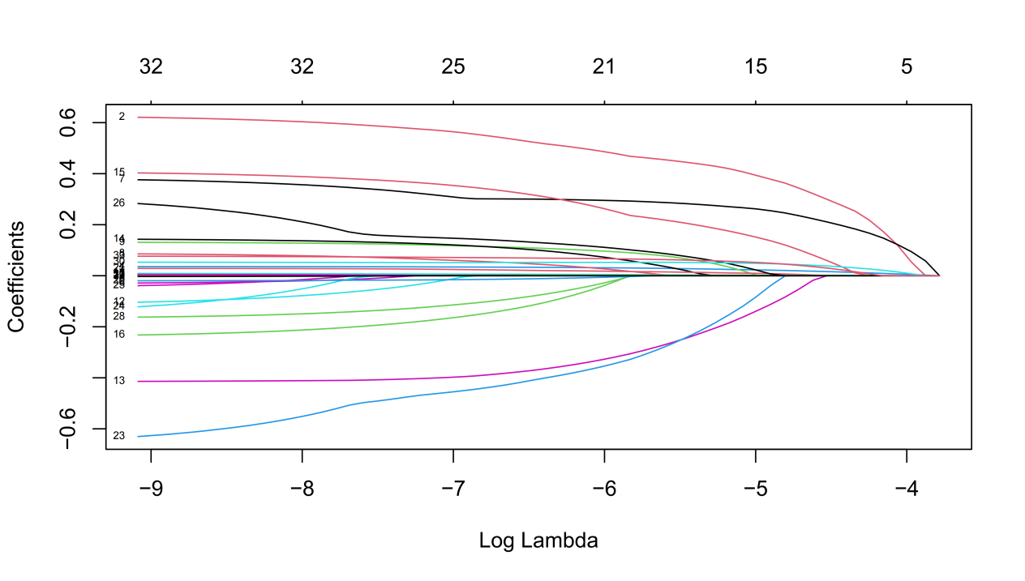
Supplementary figure 1B. Cross-validation curve of LASSO regression.
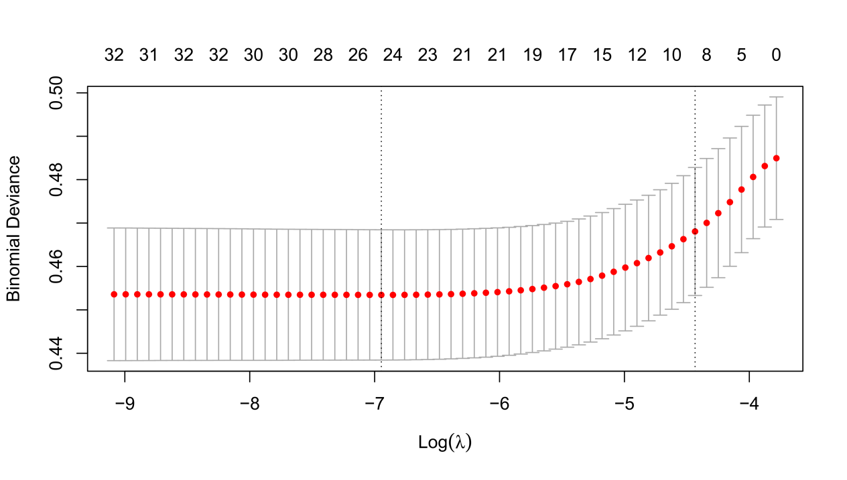

Supplementary figure 2. Kaplan-Meier cumulative morbidity risk curves for MACCE and its subtypes based on LDH quartiles.

Supplementary figure 2A. Kaplan-Meier cumulative morbidity risk curves for MACCE based on LDH quartiles.
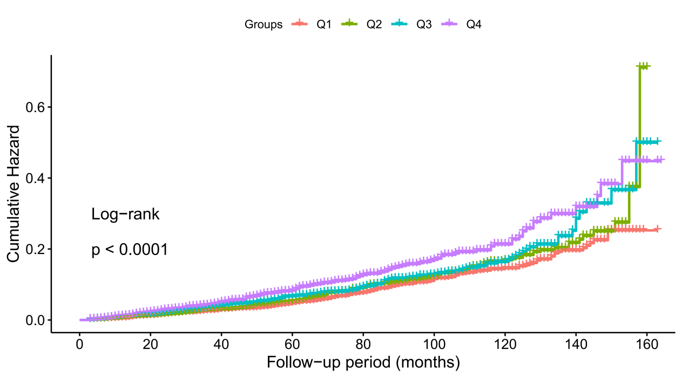

Supplementary figure 2B. Kaplan-Meier cumulative morbidity risk curves for cerebrovascular events based on LDH quartiles.
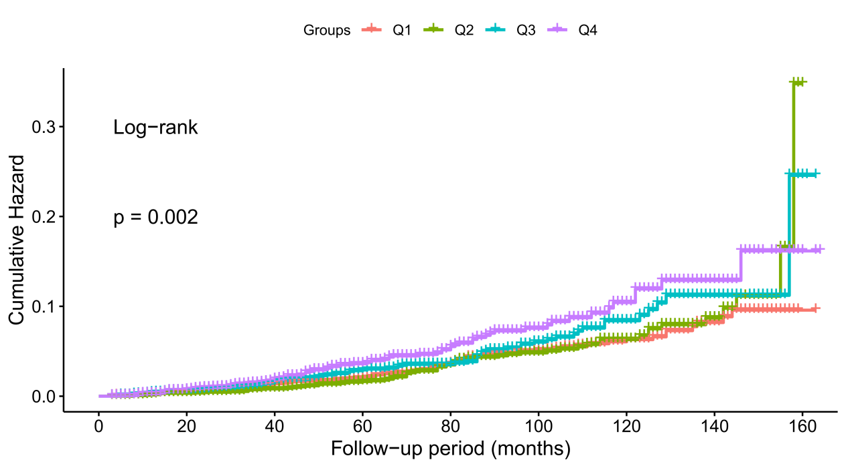

Supplementary figure 2C. Kaplan-Meier cumulative morbidity risk curves for cardiac events based on LDH quartiles.

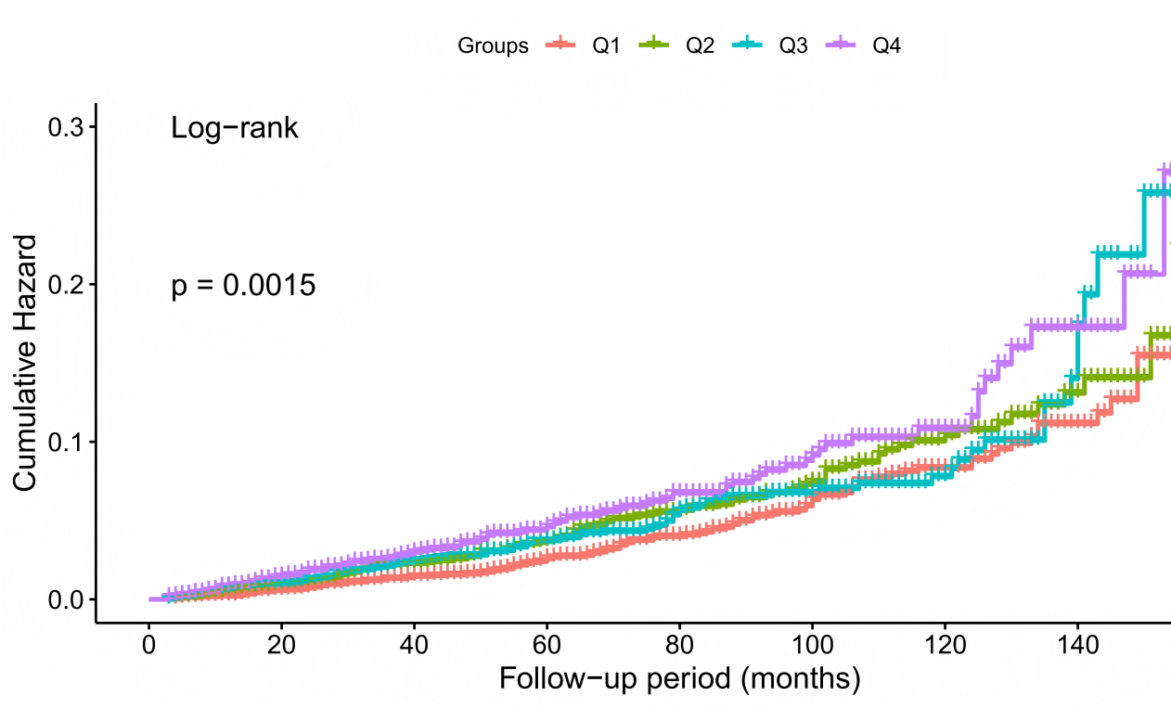

Supplementary figure 2D. Kaplan-Meier cumulative morbidity risk curves for all-causer death based on LDH quartiles.
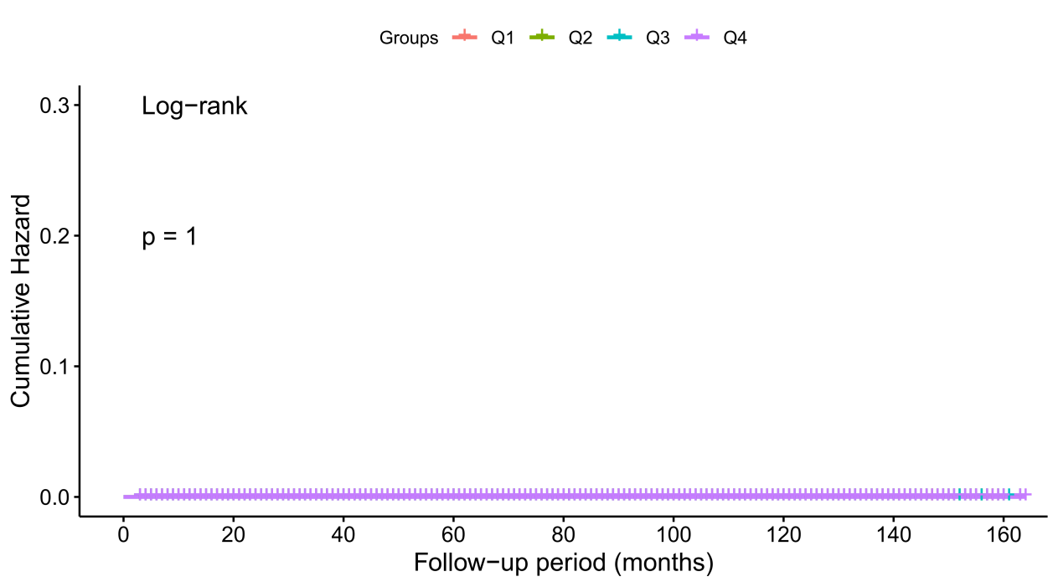

Supplementary figure 3. The nomogram for predicting MACCE.

Supplementary figure 3A. COX regression nomogram for MACCE: simplified model with 8 predictors.
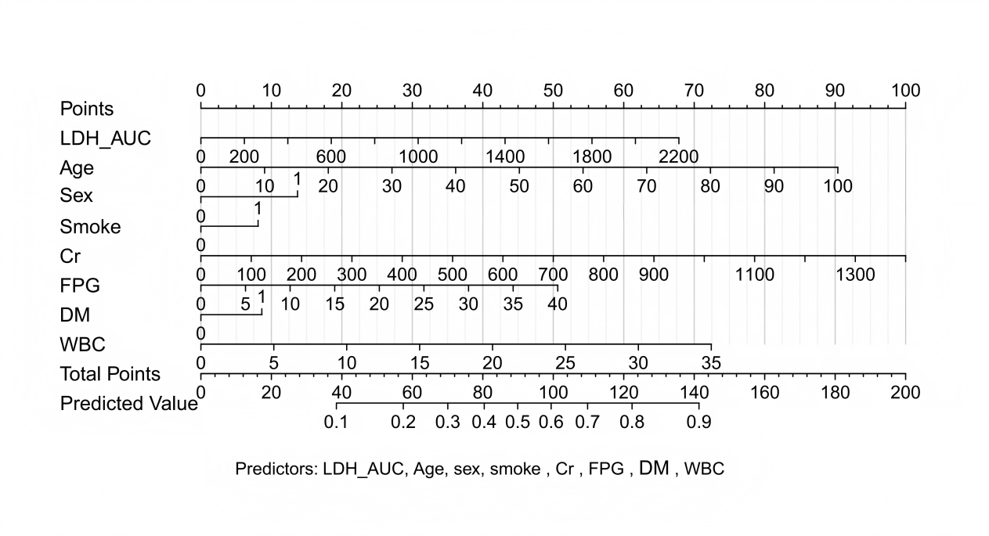
Supplementary figure 3B. COX regression nomogram for MACCE: comprehensive model with 25 predictors.
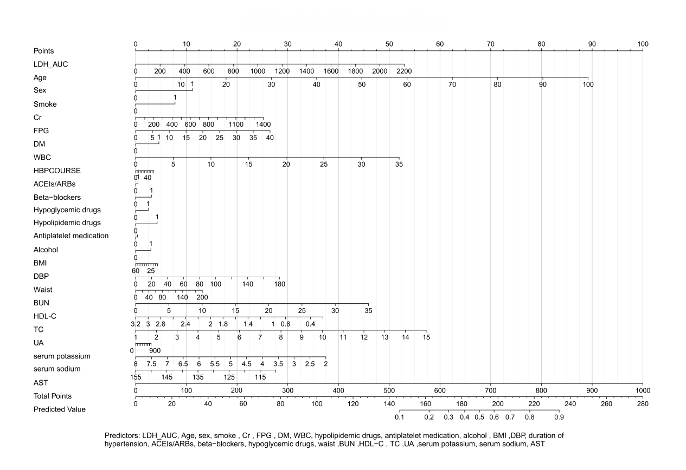

Supplementary figure Legends.

Supplementary figure 1.
(A) Coefficient path diagram of risk variables.
(B) Cross-validation curve of LASSO regression.

Supplementary figure 2. Kaplan-Meier cumulative morbidity risk curves for MACCE and its subtypes based on LDH quartiles.
(A) MACCE
(B) Cerebrovascular events
(C) Cardiac events
(D) All-causer death

Supplementary figure 3. The nomogram for predicting MACCE :
(A) COX regression nomogram for MACCE: simplified model with 8 predictors
(B) COX regression nomogram for MACCE: comprehensive model with 25 predictors.

The RECORD statement – checklist of items, extended from the STROBE statement, that should be reported in observational studies using routinely collected health data.

 | Item No. | STROBE items | Location in  manuscript where items are reported | RECORD items | Location in  manuscript  where items are reported
Title and abstract
 | 1 | (a) Indicate the study’s design with a commonly used term in the title or the abstract (b)  Provide in the abstract an  informative and balanced  summary of what was done and what was found | Title page and abstract section. Page 1-3. | RECORD 1.1: The type of data used should be specified in the title or  abstract. When possible, the name of the databases used should be included.  RECORD 1.2: If applicable, the geographic region and timeframe within which the study took place should be reported in the title or abstract.  RECORD 1.3: If linkage between  databases was conducted for the study, this should be clearly stated in the title or abstract. | Title page and abstract section. Page 1-3.
Introduction
Background rationale | 2 | Explain the scientific  background and rationale for the investigation being reported | Intriduction  section. Page 4-5.
Objectives | 3 | State specific objectives, including any prespecified hypotheses | Intriduction  section. Page 4-5.
Methods
Study Design | 4 | Present key elements of study design early in the paper | Material and methods section. Page 5-8.
Setting | 5 | Describe the setting, locations, and relevant dates, including  periods of recruitment, exposure, follow-up, and data collection | Material and methods section. Page 5-8.

Participants | 6 | (a) Cohort study - Give the  eligibility criteria, and the  sources and methods of selection of participants. Describe  methods of follow-up  Case-control study - Give the  eligibility criteria, and the  sources and methods of case  ascertainment and control  selection. Give the rationale for the choice of cases and controls Cross-sectional study - Give the eligibility criteria, and the  sources and methods of selection of participants  (b) Cohort study - For matched studies, give matching criteria and number of exposed and  unexposed  Case-control study - For  matched studies, give matching criteria and the number of  controls per case | Material and methods section. Page 5-8. | RECORD 6.1: The methods of study population selection (such as codes or algorithms used to identify subjects) should be listed in detail. If this is not possible, an explanation should be  provided.  RECORD 6.2: Any validation studies of the codes or algorithms used to  select the population should be  referenced. If validation was conducted for this study and not published  elsewhere, detailed methods and results should be provided.  RECORD 6.3: If the study involved  linkage of databases, consider use of a flow diagram or other graphical display to demonstrate the data linkage  process, including the number of individuals with linked data at each stage. | Material and  methods section. Page 5-8.
Variables | 7 | Clearly define all outcomes,  exposures, predictors, potential confounders, and effect  modifiers. Give diagnostic criteria, if applicable. | Material and methods section. Page 5-8. | RECORD 7.1: A complete list of codes and algorithms used to classify  exposures, outcomes, confounders, and effect modifiers should be provided. If these cannot be reported, an  explanation should be provided. | Material and  methods section. Page 5-8.
Data sources/  measurement | 8 | For each variable of interest, give sources of data and details of methods of assessment  (measurement).  Describe comparability of  assessment methods if there is more than one group | Material and methods section. Page 5-8.

Bias | 9 | Describe any efforts to address potential sources of bias | Material and methods section. Page 5-8.
Study size | 10 | Explain how the study size was arrived at | Material and methods section. Page 5-8.
Quantitative variables | 11 | Explain how quantitative  variables were handled in the analyses. If applicable, describe which groupings were chosen, and why | Material and methods section. Page 5-8.
Statistical  methods | 12 | (a) Describe all statistical  methods, including those used to control for confounding  (b) Describe any methods used to examine subgroups and  interactions  (c) Explain how missing data were addressed  (d) Cohort study - If applicable, explain how loss to follow-up was addressed  Case-control study - If  applicable, explain how  matching of cases and controls was addressed  Cross-sectional study - If  applicable, describe analytical methods taking account of  sampling strategy  (e) Describe any sensitivity analyses | Material and methods section. Page 5-8.
Data access and cleaning methods |  | .. |  | RECORD 12. 1: Authors should  describe the extent to which the  investigators had access to the database population used to create the study  population. | Material and  methods section. Page 5-8.

 |  |  |  | RECORD 12.2: Authors should  provide information on the data  cleaning methods used in the study. | Material and  methods section. Page 5-8.
Linkage |  | .. |  | RECORD 12.3: State whether the  study included person-level,  institutional-level, or other data linkage across two or more databases. The  methods of linkage and methods of linkage quality evaluation should be provided. | Material and  methods section. Page 5-8.
Results
Participants | 13 | (a) Report the numbers of  individuals at each stage of the study (e.g., numbers potentially eligible, examined for eligibility, confirmed eligible, included in the study, completing follow-up, and analysed)  (b) Give reasons for non- participation at each stage.  (c) Consider use of a flow diagram | Results section. Page 8- 12. | RECORD 13. 1: Describe in detail the selection of the persons included in the study (i.e., study population selection) including filtering based on data  quality, data availability and linkage. The selection of included persons can be described in the text and/or by  means of the study flow diagram. | Results section. Page 8- 12.
Descriptive data | 14 | (a) Give characteristics of study participants (e.g., demographic, clinical, social) and information on exposures and potential  confounders  (b) Indicate the number of  participants with missing data for each variable of interest  (c) Cohort study - summarise  follow-up time (e.g., average and total amount) | Results section. Page 8- 12.
Outcome data | 15 | Cohort study - Report numbers of outcome events or summary measures over time  Case-control study - Report numbers in each exposure | Results section. Page 8- 12.

 |  | category, or summary measures of exposure  Cross-sectional study - Report numbers of outcome events or summary measures | Results section. Page 8- 12.
Main results | 16 | (a) Give unadjusted estimates and, if applicable, confounder- adjusted estimates and their  precision (e.g., 95% confidence interval). Make clear which  confounders were adjusted for and why they were included  (b) Report category boundaries when continuous variables were categorized  (c) If relevant, consider  translating estimates of relative risk into absolute risk for a  meaningful time period | Results section. Page 8- 12.
Other analyses | 17 | Report other analyses done— e.g., analyses of subgroups and interactions, and sensitivity  analyses | Results section. Page 8- 12.
Discussion
Key results | 18 | Summarise key results with reference to study objectives | Discussion section. Page 12- 15.
Limitations | 19 | Discuss limitations of the study, taking into account sources of potential bias or imprecision.  Discuss both direction and  magnitude of any potential bias | Discussion section. Page 12- 15. | RECORD 19. 1: Discuss the  implications of using data that were not created or collected to answer the  specific research question(s). Include discussion of misclassification bias, unmeasured confounding, missing  data, and changing eligibility over  time, as they pertain to the study being reported. | Discussion  section. Page 12- 15.
Interpretation | 20 | Give a cautious overall interpretation of results considering objectives, | Discussion section. Page 12- 15.

limitations, multiplicity of analyses, results from similar studies, and other relevant
evidence
Generalisability | 21 | Discuss the generalisability (external validity) of the study results | Discussion section. Page 12- 15.
Other Information
Funding | 22 | Give the source of funding and the role of the funders for the present study and, if applicable, for the original study on which the present article is based | Page 16- 17.
Accessibility of protocol, raw data, and  programming code |  | .. | Page 16-17. | RECORD 22. 1: Authors should  provide information on how to access any supplemental information such as the study protocol, raw data, or  programming code. | Page 16-17.
*Reference: Benchimol EI, Smeeth L, Guttmann A, Harron K, Moher D, Petersen I, Sørensen HT, von Elm E, Langan SM, the RECORD Working Committee. The REporting of studies Conducted using Observational Routinely-collected health Data (RECORD) Statement. PLoS Medicine 2015; in press.
*Checklist is protected under Creative Commons Attribution (CC BY) license.

