Supplementary Material
Supplementary Figure S1. Exploratory biomarker comparisons by sleep quality and psychological distress categories. Panel A shows log1p-transformed IL-6 according to PSQI category. Panel B shows log1p-transformed IL-8 according to PSQI category. Panel C shows log1p-transformed IL-6 according to HADS-Anxiety category. Panel D shows log1p-transformed IL-8 according to HADS-Depression category. These analyses are exploratory and presented for hypothesis generation.
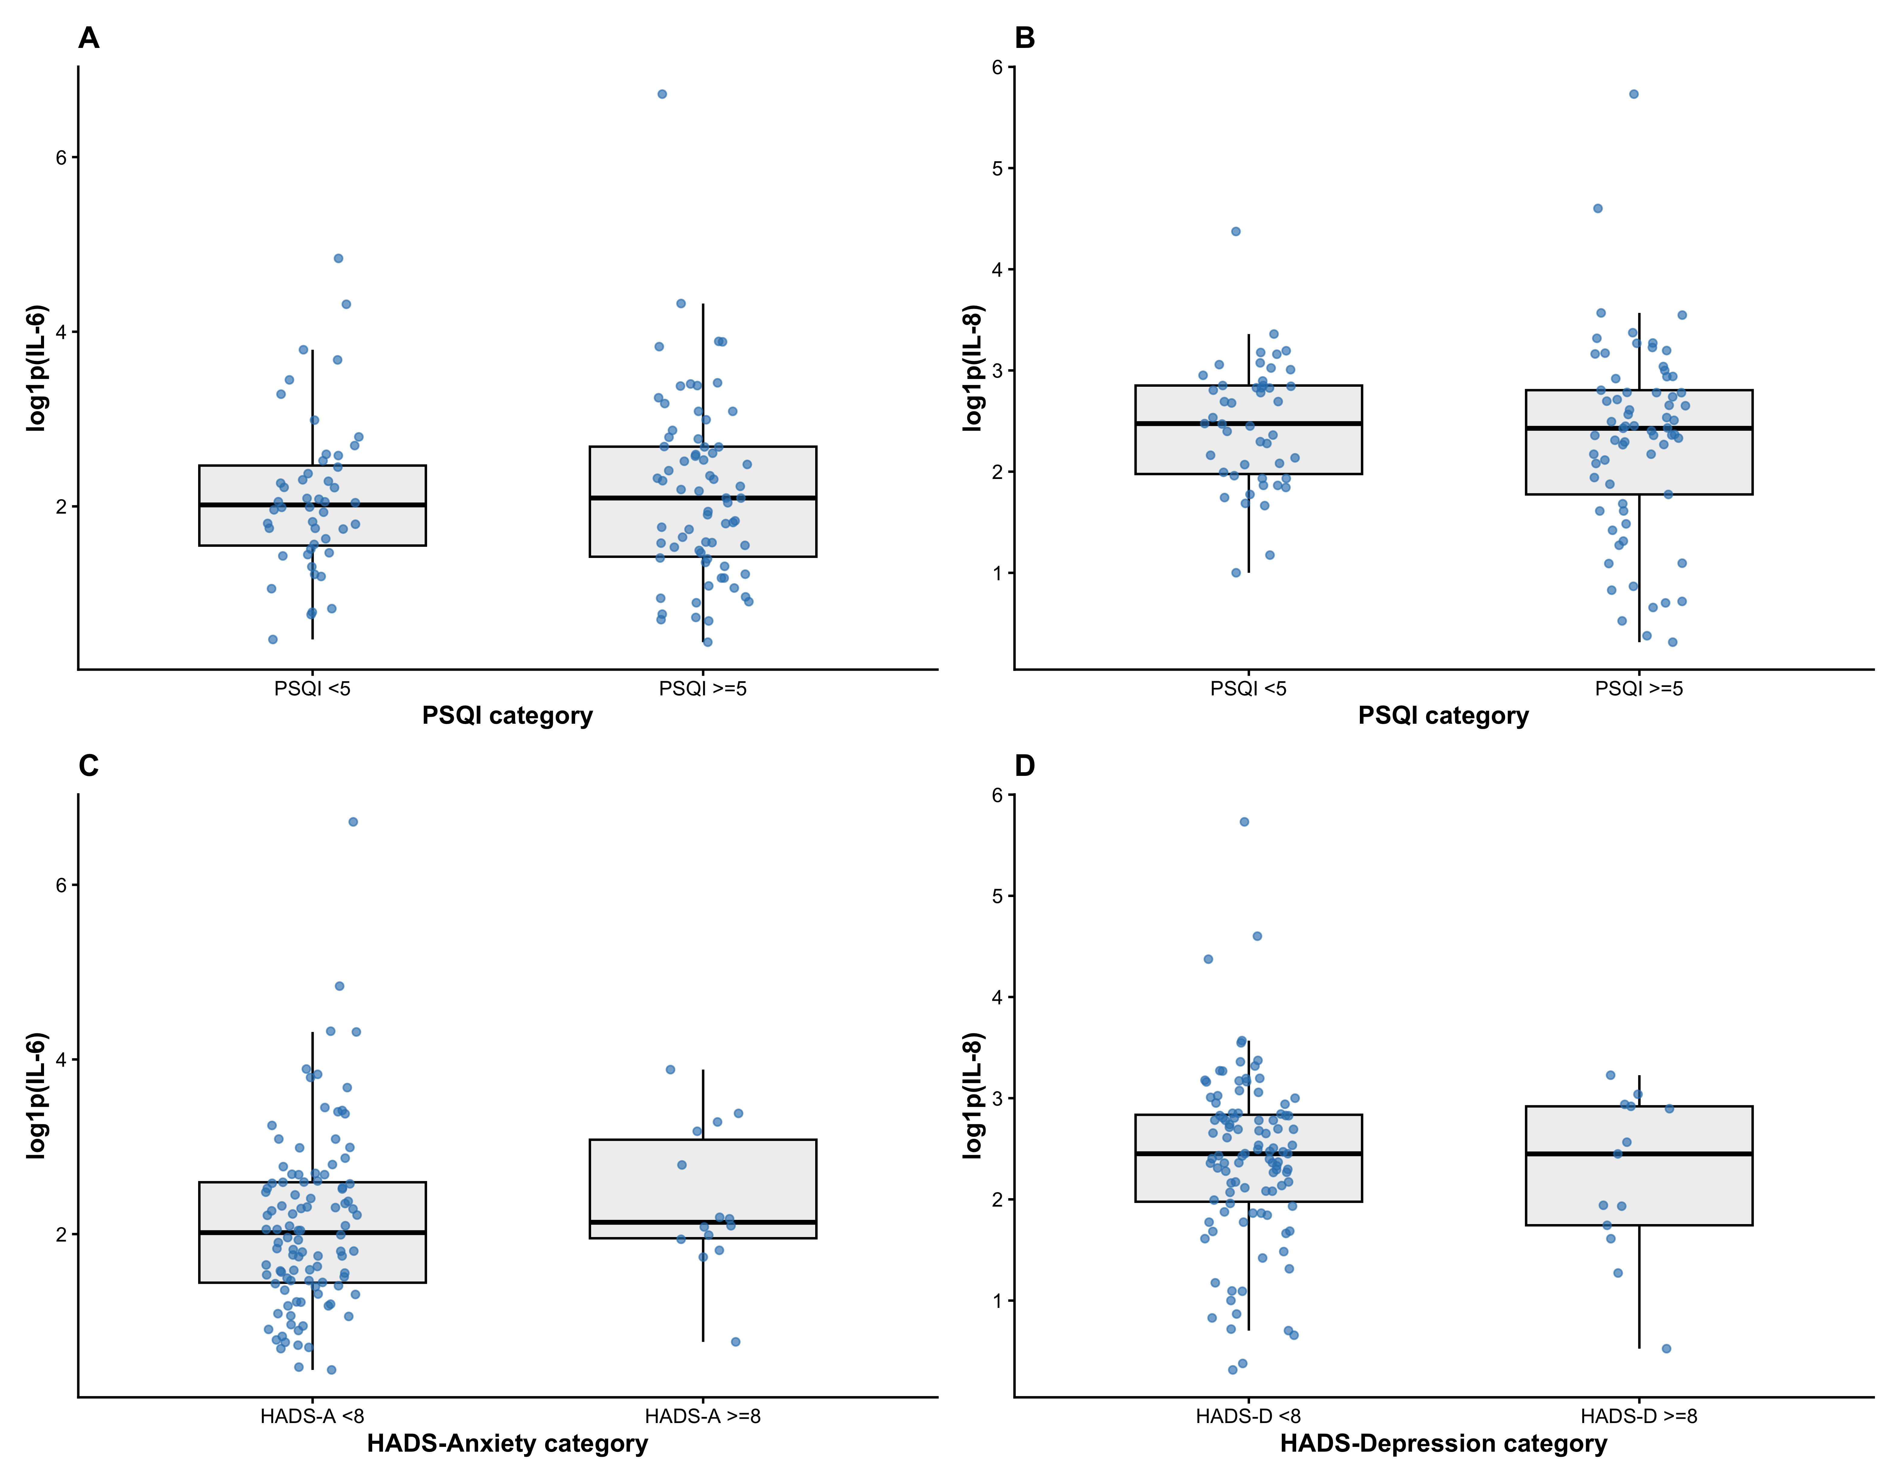
Supplementary Table S1. Multivariable-adjusted logistic regression model for ORR.
term | OR_CI | P_value
PSQI_total | 0.62 (0.48-0.75) | <0.001
HADS_A | 1.06 (0.87-1.30) | 0.536
HADS_D | 1.06 (0.89-1.27) | 0.537
Supplementary Table S2. Inverse-probability complete-case weighted logistic regression model for ORR.
term | OR_CI | P_value
PSQI_total | 0.63 (0.52-0.75) | <0.001
HADS_A | 1.10 (0.90-1.34) | 0.367
HADS_D | 1.01 (0.81-1.25) | 0.943
Supplementary Table S3. Complete-case weight model diagnostics, weight distribution, and balance diagnostics.
Item | Value
Total screened records | 223.0
Complete-case records | 129.0
Complete-case records with estimated weights | 124.0
Records used in complete-case probability model | 206.0
Raw weight minimum | 1.0
Raw weight median | 1.392
Raw weight maximum | 6.029
Complete-case model C statistic | 0.794
Complete-case model Brier score | 0.179
Complete-case model calibration intercept | -0.0
Complete-case model calibration slope | 1.0
Complete-case model Hosmer-Lemeshow statistic | 13.329
Complete-case model Hosmer-Lemeshow p value | 0.101
Truncation lower percentile | 1.005
Truncation upper percentile | 5.601
Truncated weight minimum | 1.005
Truncated weight median | 1.392
Truncated weight maximum | 5.601
Effective sample size after truncated weighting | 100.8
Balance diagnostics for complete-case weighting.
Variable | Level | Unweighted_SMD | Weighted_SMD
Age |  | 0.054 | 0.02
Sex | Male | 0.507 | 0.393
ECOG_PS |  | 0.08 | 0.054
ALBI_Grade | 2A | 0.106 | 0.031
ALBI_Grade | 2B | 0.07 | 0.097
ALBI_Grade | 3 | 0.212 | 0.155
Max_Tumor_Diam |  | 0.123 | 0.118
Tumor_Number | 1 | 0.341 | 0.231
Tumor_Number | 2 | 0.093 | 0.069
Tumor_Number | 3 | 0.155 | 0.133
PVTT | VP1 | 0.041 | 0.024
PVTT | VP2 | 0.231 | 0.098
PVTT | VP3 | 0.194 | 0.155
PVTT | VP4 | 0.216 | 0.124
Supplementary Table S4. Missing data distribution and multiple-imputation sensitivity results.
Variable | Missing_N | Total_N | Missing_Percent
ORR | 94 | 223 | 42.2
DCR | 94 | 223 | 42.2
PSQI_total | 94 | 223 | 42.2
HADS_A | 94 | 223 | 42.2
HADS_D | 94 | 223 | 42.2
Age | 0 | 223 | 0.0
Sex | 0 | 223 | 0.0
ECOG_PS | 0 | 223 | 0.0
ALBI_Grade | 8 | 223 | 3.6
Max_Tumor_Diam | 11 | 223 | 4.9
Tumor_Number | 6 | 223 | 2.7
PVTT | 0 | 223 | 0.0
c6_hypnotics | 94 | 223 | 42.2
term | OR_CI | P_value
PSQI_total | 0.66 (0.55-0.79) | <0.001
HADS_A | 1.05 (0.88-1.25) | 0.590
HADS_D | 1.04 (0.87-1.25) | 0.631
Supplementary Table S5. Multivariable-adjusted DCR sensitivity analysis using continuous PSQI and HADS scores.
Variable | OR_CI | P_value
PSQI total score | 0.60 (0.47-0.77) | <0.001
HADS-Anxiety score | 1.26 (0.93-1.71) | 0.130
HADS-Depression score | 0.95 (0.73-1.24) | 0.733
Supplementary Table S6. Multivariable-adjusted DCR sensitivity analysis using categorical PSQI and HADS thresholds.
Variable | OR_CI | P_value
PSQI >=5 | 0.13 (0.02-0.73) | 0.02
HADS-Anxiety >=8 | 1.00 (0.14-7.10) | 0.997
HADS-Depression >=8 | 0.74 (0.10-5.25) | 0.764

