Structural and Functional Brain Alterations in Postherpetic Neuralgia: A Systematic Review and Voxel-wise Coordinate-Based Meta-analysis via the SDM-PSI Method
Supplementary Documents
Contents
1.PRISMA 2020 Checklist 1
Supplementary Table 1. Checklists of PRISMA statement for reporting meta-analysis 1
2. Methods 7
2.1 Literature Search Strategy 7
Supplementary Table 2. Detail search strategy of five databases 7
2.2 Data Extraction 10
Supplementary Table 3. Demographic, clinical, and imaging characteristics of studies included in the functional rs-fMRI and structural VBM meta-analyses. 10
2.3 Neuroimaging data synthesis and coding 12
Supplementary Table 4. Data of the peak coordinates, effect size and their original studies 12
2.4 Quality Assessment 25
Supplementary Table 5. Quality Assessment of included studies in the rs-fMRI/VBM meta-analysis 25
3. Results 27
3.1 Glass-brain visualizations 27
Supplementary Figure 1. Glass-brain visualization of functional alterations in PHN versus HC (P_{TFCE} < 0.05). 27
Supplementary Figure 2. Glass-brain visualization of structural alterations in PHN versus HC (P_{TFCE} < 0.05). 27
Supplementary Figure 3. Glass-brain visualization of functional alterations in PHN versus HZ patients (P_{TFCE} < 0.05). 28
Supplementary Figure 4. Glass-brain visualization of longitudinal functional alterations in PHN pre- and post-treatment (P_{TFCE} < 0.05). 28
3.2. Jack-knife sensitivity analysis 29
Supplementary Table 6. Jack-knife Sensitivity Analysis for rs-fMRI Meta-Analysis (PHN vs HC, P_{uncorrected} < 0.005) 29
Supplementary Table 7. Jack-knife Sensitivity Analysis for rs-fMRI Meta-Analysis (PHN vs HC, P_{TFCE} < 0.05) 29
Supplementary Table 8. Jack-knife Sensitivity Analysis for VBM Structural MRI Meta-Analysis (PHN vs HC, P_{uncorrected} < 0.005) 30
Supplementary Table 9. Jack-knife Sensitivity Analysis for VBM Structural Meta-Analysis (PHN vs HC, P_{TFCE} < 0.05) 30
Supplementary Table 10. Jack-knife Sensitivity Analysis for comparisons PHN vs HC 31
Supplementary Table 11. Jack-knife Sensitivity Analysis for rs-fMRI Meta-Analysis (PHN vs HZ, P_{uncorrected} < 0.005) 31
Supplementary Table 12. Jack-knife Sensitivity Analysis for rs-fMRI Meta-Analysis (PHN vs HZ, P_{TFCE} < 0.05) 31
Supplementary Table 13. Jack-knife Sensitivity Analysis Results for PHN vs. HZ Comparison 32
Supplementary Table 14. Jack-knife Sensitivity Analysis for rs-fMRI Meta-Analysis (PHN Pre- and Post-Treatment, P_{uncorrected} < 0.005, P_{TFCE} < 0.05) 32
Supplementary Table 15. Jack-knife Sensitivity Analysis Results for PHN Pre- and Post-Treatment Comparison 32
3.3 Analysis of Heterogeneity and Publication Bias 33
Supplementary Table 16. Summary of Meta-Analytic Results: Effect Sizes, Heterogeneity, and Publication Bias for PHN Comparisons Across Functional and Structural Imaging Modalities 33
Supplementary Figures 5–15. Funnel plots for publication bias assessment in PHN versus HC and PHN versus HZ comparisons. 34
3.4 Meta-regression Analysis 37
Supplementary Table 17. Meta-regression results for demographic and clinical moderators in PHN 37
References： 38


1.PRISMA 2020 Checklist

Supplementary Table 1. Checklists of PRISMA statement for reporting meta-analysis
Section and Topic | Item # | Checklist item | Location where item is reported
TITLE
Title | 1 | Identify the report as a systematic review (Meta-analysis). | Cover
ABSTRACT
Abstract | 2 | Provide a structured summary including, as applicable: background; objectives; data sources; study eligibility criteria, participants, and interventions; study appraisal and synthesis methods; results; limitations; conclusions and implications of key findings; systematic review registration number. | Abstract
INTRODUCTION
Rationale | 3 | Describe the rationale for the review in the context of existing knowledge. | 1. Introduction
Objectives | 4 | Provide an explicit statement of the objective(s) or question(s) the review addresses. | 1. Introduction
METHODS |  |  | 2. Methods
Eligibility criteria | 5 | Specify the inclusion and exclusion criteria for the review and how studies were grouped for the syntheses. | 2.2 Eligibility and exclusion criteria
Information sources | 6 | Specify all databases, registers, websites, organisations, reference lists and other sources searched or consulted to identify studies. Specify the date when each source was last searched or consulted. | 2.1 Search strategy
Search strategy | 7 | Present the full search strategies for all databases, registers and websites, including any filters and limits used. | Supplementary Table 2
Selection process | 8 | Specify the methods used to decide whether a study met the inclusion criteria of the review, including how many reviewers screened each record and each report retrieved, whether they worked independently, and if applicable, details of automation tools used in the process. | 2.1 Search strategy;  2.3 Data extraction;  Supplementary Table 2
Data collection process | 9 | Specify the methods used to collect data from reports, including how many reviewers collected data from each report, whether they worked independently, any processes for obtaining or confirming data from study investigators, and if applicable, details of automation tools used in the process. | 2.1 Search strategy;  2.3 Data extraction;
Data items | 10a | List and define all outcomes for which data were sought. Specify whether all results that were compatible with each outcome domain in each study were sought (e.g. for all measures, time points, analyses), and if not, the methods used to decide which results to collect. | 2.3 Data extraction;  2.6 Voxel-wise meta-analysis of functional differences;  2.7 Voxel-wise meta-analysis of structural differences
 | 10b | List and define all other variables for which data were sought (e.g. participant and intervention characteristics, funding sources). Describe any assumptions made about any missing or unclear information. | 2.3 Data extraction;  2.4 Neuroimaging data synthesis and coding
Study risk of bias assessment | 11 | Specify the methods used to assess risk of bias in the included studies, including details of the tool(s) used, how many reviewers assessed each study and whether they worked independently, and if applicable, details of automation tools used in the process. | 2.5 Quality assessment
Effect measures | 12 | Specify for each outcome the effect measure(s) (e.g. risk ratio, mean difference) used in the synthesis or presentation of results. | 2.6 Voxel-wise meta-analysis of functional differences;  2.7 Voxel-wise meta-analysis of structural differences;  2.8 Robustness, heterogeneity, and publication bias analysis;  2.9 Meta-regression analyses
Synthesis methods | 13a | Describe the processes used to decide which studies were eligible for each synthesis (e.g. tabulating the study intervention characteristics and comparing against the planned groups for each synthesis (item #5)).
Synthesis methods | 13b | Describe any methods required to prepare the data for presentation or synthesis, such as handling of missing summary statistics, or data conversions.
Synthesis methods | 13c | Describe any methods used to tabulate or visually display results of individual studies and syntheses.
Synthesis methods | 13d | Describe any methods used to synthesize results and provide a rationale for the choice(s). If meta-analysis was performed, describe the model(s), method(s) to identify the presence and extent of statistical heterogeneity, and software package(s) used.
Synthesis methods | 13e | Describe any methods used to explore possible causes of heterogeneity among study results (e.g. subgroup analysis, meta-regression).
Synthesis methods | 13f | Describe any sensitivity analyses conducted to assess robustness of the synthesized results.
Reporting bias assessment | 14 | Describe any methods used to assess risk of bias due to missing results in a synthesis (arising from reporting biases). | 2.8 Robustness, heterogeneity, and publication bias analysis
Certainty assessment | 15 | Describe any methods used to assess certainty (or confidence) in the body of evidence for an outcome. | Not applicable
RESULTS |  |  | 3. Results
Study selection | 16a | Describe the results of the search and selection process, from the number of records identified in the search to the number of studies included in the review, ideally using a flow diagram. | Figure 1:PRISMA 2020 flow diagram.;  3.1 Included studies and sample characteristics: Table 1
Study selection | 16b | Cite studies that might appear to meet the inclusion criteria, but which were excluded, and explain why they were excluded. | 3.1 Included studies and sample characteristics: Table 1
Study characteristics | 17 | Cite each included study and present its characteristics. | Supplementary Table 3
Risk of bias in studies | 18 | Present assessments of risk of bias for each included study. | Supplementary Table 5
Results of individual studies | 19 | For all outcomes, present, for each study: (a) summary statistics for each group (where appropriate) and (b) an effect estimate and its precision (e.g. confidence/credible interval), ideally using structured tables or plots. | 3.2 Functional and structural abnormalities among included studies:Table 2, Figure 2a, Figure 2b, Figure 3, Figure 4, Supplementary Figures 1–4
Results of syntheses | 20a | For each synthesis, briefly summarise the characteristics and risk of bias among contributing studies. | 3.1 Included studies and sample characteristics: Table 1
Results of syntheses | 20b | Present results of all statistical syntheses conducted. If meta-analysis was done, present for each the summary estimate and its precision (e.g. confidence/credible interval) and measures of statistical heterogeneity. If comparing groups, describe the direction of the effect. | 3.2 Functional and structural abnormalities among included studies: Table 2
Results of syntheses | 20c | Present results of all investigations of possible causes of heterogeneity among study results. | Supplementary Table 16
Results of syntheses | 20d | Present results of all sensitivity analyses conducted to assess the robustness of the synthesized results. | Supplementary Tables 6–15
Reporting biases | 21 | Present assessments of risk of bias due to missing results (arising from reporting biases) for each synthesis assessed. | Supplementary Table 16;  Supplementary Figures 5–15
Certainty of evidence | 22 | Present assessments of certainty (or confidence) in the body of evidence for each outcome assessed. | Not assessed
DISCUSSION
Discussion | 23a | Provide a general interpretation of the results in the context of other evidence. | 4. Discussion
Discussion | 23b | Discuss any limitations of the evidence included in the review. | 6. Limitations
Discussion | 23c | Discuss any limitations of the review processes used. | 6. Limitations
Discussion | 23d | Discuss implications of the results for practice, policy, and future research. | 4. Discussion
OTHER INFORMATION
Registration and protocol | 24a | Provide registration information for the review, including register name and registration number, or state that the review was not registered. | PROSPERO registration  (CRD420251030103)
Registration and protocol | 24b | Indicate where the review protocol can be accessed, or state that a protocol was not prepared. | No protocol prepared
Registration and protocol | 24c | Describe and explain any amendments to information provided at registration or in the protocol. | No protocol prepared
Support | 25 | Describe sources of financial or non-financial support for the review, and the role of the funders or sponsors in the review. | Beijing Traditional Chinese Medicine Science and Technology Development Fund  (BJZZYB-2023-11);  National Natural Science Foundation of China  (Grant No. 82374555)
Competing interests | 26 | Declare any competing interests of review authors. | The authors declare no competing interests
Availability of data, code and other materials | 27 | Report which of the following are publicly available and where they can be found: template data collection forms; data extracted from included studies; data used for all analyses; analytic code; any other materials used in the review. | 2.4 Neuroimaging data synthesis and coding

From: Page MJ, McKenzie JE, Bossuyt PM, Boutron I, Hoffmann TC, Mulrow CD, et al. The PRISMA 2020 statement: an updated guideline for reporting systematic reviews. BMJ 2021;372:n71. doi: 10.1136/bmj.n71. This work is licensed under CC BY 4.0. To view a copy of this license, visit https://creativecommons.org/licenses/by/4.0/

2. Methods

2.1 Literature Search Strategy

Supplementary Table 2. Detail search strategy of five databases
Functional and Structural indicator
PubMed | https://pubmed.ncbi.nlm.nih.gov/
postherpetic neuralgia[Title/Abstract] OR PHN[Title/Abstract] OR herpes zoster neuralgia[Title/Abstract] OR zoster-associated pain[Title/Abstract] OR herpes zoster pain[Title/Abstract] OR post-shingles pain[Title/Abstract]）AND (fMRI OR functional magnetic resonance imaging OR MRI OR magnetic resonance imaging OR VBM OR voxel-based morphometry OR SBM OR surface-based morphometry OR source-based morphometry OR ASL OR arterial spin labeling OR rs-fMRI OR resting-state fMRI OR functional connectivity OR task-fMRI OR ALFF OR amplitude of low-frequency fluctuation OR fALFF OR fractional amplitude of low-frequency fluctuation OR ReHo OR regional homogeneity OR DTI OR diffusion tensor imaging OR neuroimaging OR brain morphometry OR structural connectivity OR WMV OR White matter OR GMV OR gray matter volume OR SPECT OR single-photon emission computed tomography OR PET OR positron emission tomography OR MRS OR magnetic resonance spectroscopy OR NIRS OR near-infrared spectroscopy)
Web of Science | https://www.webofscience.com/
#1. TS=(postherpetic neuralgia OR PHN OR herpes zoster neuralgia OR zoster-associated pain OR herpes zoster pain OR post-shingles pain)
#2. TI=(postherpetic neuralgia OR PHN OR herpes zoster neuralgia OR zoster-associated pain OR herpes zoster pain OR post-shingles pain)
#4. AB=(postherpetic neuralgia OR PHN OR herpes zoster neuralgia OR zoster-associated pain OR herpes zoster pain OR post-shingles pain)
#5. KP=(postherpetic neuralgia OR PHN OR herpes zoster neuralgia OR zoster-associated pain OR herpes zoster pain OR post-shingles pain)
#6. ALL=(fMRI OR functional magnetic resonance imaging OR MRI OR magnetic resonance imaging OR VBM OR voxel-based morphometry OR SBM OR surface-based morphometry OR source-based morphometry OR ASL OR arterial spin labeling OR rs-fMRI OR resting-state fMRI OR functional connectivity OR task-fMRI OR ALFF OR amplitude of low-frequency fluctuation OR fALFF OR fractional amplitude of low-frequency fluctuation OR ReHo OR regional homogeneity OR DTI OR diffusion tensor imaging OR neuroimaging OR GMV OR gray matter volume)
#7. ALL=(WMV OR White matter OR brain morphometry OR structural connectivity OR SPECT OR single-photon emission computed tomography OR PET OR positron emission tomography OR MRS OR magnetic resonance spectroscopy OR NIRS OR near-infrared spectroscopy)
#1 AND #6 OR #1 AND #7
#2 AND #6 OR #2 AND #7
#4 AND #6 OR #4 AND #7
#5 AND #6 OR #5 AND #7
Embase | https://www.embase.com/
#2. （'postherpetic neuralgia':ti,ab,kw OR 'phn':ti,ab,kw OR 'herpes zoster neuralgia':ti,ab,kw OR 'zoster-associated pain':ti,ab,kw OR 'herpes zoster pain':ti,ab,kw）
#3 .（'postherpetic neuralgia':ab,ti OR 'phn':ab,ti OR 'herpes zoster neuralgia':ab,ti OR 'zoster-associated pain':ab,ti OR 'herpes zoster pain':ab,ti）
#4. ('fmri' OR 'functional magnetic resonance imaging' OR 'mri' OR 'magnetic resonance imaging' OR 'vbm' OR 'voxel-based morphometry' OR 'sbm' OR 'surface-based morphometry' OR 'source-based morphometry' OR 'asl' OR 'arterial spin labeling' OR 'rs-fmri' OR 'resting-state fmri' OR 'functional connectivity' OR 'task-fmri' OR 'alff' OR 'amplitude of low-frequency fluctuation' OR 'falff' OR 'fractional amplitude of low-frequency fluctuation' OR 'reho' OR 'regional homogeneity' OR 'dti' OR 'diffusion tensor imaging' OR 'neuroimaging' OR 'brain morphometry' OR 'structural connectivity' OR 'wmv' OR 'white matter' OR 'gmv' OR 'gray matter volume' OR 'spect' OR 'single-photon emission computed tomography' OR 'pet' OR 'positron emission tomography' OR 'mrs' OR 'magnetic resonance spectroscopy' OR 'nirs' OR 'near-infrared spectroscopy')
#2 AND #4
#3 AND #4
CNKI | https://www.cnki.net/
1. TKA=(postherpetic neuralgia OR PHN OR herpes zoster neuralgia OR zoster-associated pain OR herpes zoster pain OR post-shingles pain) AND FT=(fMRI OR functional magnetic resonance imaging OR MRI OR magnetic resonance imaging OR VBM OR voxel-based morphometry OR SBM OR surface-based morphometry OR source-based morphometry OR ASL OR arterial spin labeling OR rs-fMRI OR resting-state fMRI OR functional connectivity OR task-fMRI OR ALFF OR amplitude of low-frequency fluctuation OR fALFF OR fractional amplitude of low-frequency fluctuation OR ReHo OR regional homogeneity OR DTI OR diffusion tensor imaging OR neuroimaging OR brain morphometry OR structural connectivity OR WMV OR white matter OR GMV OR gray matter volume OR SPECT OR single-photon emission computed tomography OR PET OR positron emission tomography OR MRS OR magnetic resonance spectroscopy OR NIRS OR near-infrared spectroscopy)
2. SU=(postherpetic neuralgia OR PHN OR herpes zoster neuralgia OR zoster-associated pain OR herpes zoster pain OR post-shingles pain) AND FT=(fMRI OR functional magnetic resonance imaging OR MRI OR magnetic resonance imaging OR VBM OR voxel-based morphometry OR SBM OR surface-based morphometry OR source-based morphometry OR ASL OR arterial spin labeling OR rs-fMRI OR resting-state fMRI OR functional connectivity OR task-fMRI OR ALFF OR amplitude of low-frequency fluctuation OR fALFF OR fractional amplitude of low-frequency fluctuation OR ReHo OR regional homogeneity OR DTI OR diffusion tensor imaging OR neuroimaging OR brain morphometry OR structural connectivity OR WMV OR white matter OR GMV OR gray matter volume OR SPECT OR single-photon emission computed tomography OR PET OR positron emission tomography OR MRS OR magnetic resonance spectroscopy OR NIRS OR near-infrared spectroscopy)
3. TI=(postherpetic neuralgia OR PHN OR herpes zoster neuralgia OR zoster-associated pain OR herpes zoster pain OR post-shingles pain) AND FT=(fMRI OR functional magnetic resonance imaging OR MRI OR magnetic resonance imaging OR VBM OR voxel-based morphometry OR SBM OR surface-based morphometry OR source-based morphometry OR ASL OR arterial spin labeling OR rs-fMRI OR resting-state fMRI OR functional connectivity OR task-fMRI OR ALFF OR amplitude of low-frequency fluctuation OR fALFF OR fractional amplitude of low-frequency fluctuation OR ReHo OR regional homogeneity OR DTI OR diffusion tensor imaging OR neuroimaging OR brain morphometry OR structural connectivity OR WMV OR white matter OR GMV OR gray matter volume OR SPECT OR single-photon emission computed tomography OR PET OR positron emission tomography OR MRS OR magnetic resonance spectroscopy OR NIRS OR near-infrared spectroscopy)
4. AB=(postherpetic neuralgia OR PHN OR herpes zoster neuralgia OR zoster-associated pain OR herpes zoster pain OR post-shingles pain) AND FT=(fMRI OR functional magnetic resonance imaging OR MRI OR magnetic resonance imaging OR VBM OR voxel-based morphometry OR SBM OR surface-based morphometry OR source-based morphometry OR ASL OR arterial spin labeling OR rs-fMRI OR resting-state fMRI OR functional connectivity OR task-fMRI OR ALFF OR amplitude of low-frequency fluctuation OR fALFF OR fractional amplitude of low-frequency fluctuation OR ReHo OR regional homogeneity OR DTI OR diffusion tensor imaging OR neuroimaging OR brain morphometry OR structural connectivity OR WMV OR white matter OR GMV OR gray matter volume OR SPECT OR single-photon emission computed tomography OR PET OR positron emission tomography OR MRS OR magnetic resonance spectroscopy OR NIRS OR near-infrared spectroscopy)
Wanfang Data | https://www.wanfangdata.com.cn/
#1. Topic:(postherpetic neuralgia OR PHN OR herpes zoster neuralgia OR zoster-associated pain OR herpes zoster pain OR post-shingles pain) and All:(fMRI OR functional magnetic resonance imaging OR MRI OR magnetic resonance imaging OR VBM OR voxel-based morphometry OR SBM OR surface-based morphometry OR source-based morphometry OR ASL OR arterial spin labeling OR rs-fMRI OR resting-state fMRI OR functional connectivity OR task-fMRI OR ALFF OR amplitude of low-frequency fluctuation OR fALFF OR fractional amplitude of low-frequency fluctuation OR ReHo OR regional homogeneity OR DTI OR diffusion tensor imaging OR neuroimaging OR brain morphometry OR structural connectivity OR GMV OR gray matter volume OR SPECT OR single-photon emission computed tomography OR PET OR positron emission tomography OR MRS)
#2.Topic:(postherpetic neuralgia OR PHN OR herpes zoster neuralgia OR zoster-associated pain OR herpes zoster pain OR post-shingles pain) and All:(WMV OR White matter OR magnetic resonance spectroscopy OR NIRS OR near-infrared spectroscopy)
#3. Title or Keywords:(postherpetic neuralgia OR PHN OR herpes zoster neuralgia OR zoster-associated pain OR herpes zoster pain OR post-shingles pain) and All:(fMRI OR functional magnetic resonance imaging OR MRI OR magnetic resonance imaging OR VBM OR voxel-based morphometry OR SBM OR surface-based morphometry OR source-based morphometry OR ASL OR arterial spin labeling OR rs-fMRI OR resting-state fMRI OR functional connectivity OR task-fMRI OR ALFF OR amplitude of low-frequency fluctuation OR fALFF OR fractional amplitude of low-frequency fluctuation OR ReHo OR regional homogeneity OR DTI OR diffusion tensor imaging OR neuroimaging OR brain morphometry OR structural connectivity OR GMV OR gray matter volume OR SPECT OR single-photon emission computed tomography OR PET OR positron emission tomography)
#4. Title or Keywords:(postherpetic neuralgia OR PHN OR herpes zoster neuralgia OR zoster-associated pain OR herpes zoster pain OR post-shingles pain) and All:(MRS OR WMV OR White matter OR magnetic resonance spectroscopy OR NIRS OR near-infrared spectroscopy)

2.2 Data Extraction

Supplementary Table 3. Demographic, clinical, and imaging characteristics of studies included in the functional rs-fMRI and structural VBM meta-analyses.
Study | Year | PHN (female),n | Mean age ±SD,year | Education years | Pain Duration | VAS Scores | Healthy (female),n | Mean age ±SD,year | Education year | Hand | Scanner | Time (s) | Software | Slice Thickness (mm) | FWHM (mm) | Coordinate | Methodology | Threshold | P-value
PHN vs HC
Functional
ALFF/fALFF/ReHo
Cao ⁹ | 2019 | 23(12) | 71.26±8.43 | 8.39±3.62 | 3.83±7.26 | 6.83±0.98 | 23(15) | 69.78±9.05 | 9.78±3.45 | Right | 3.0T | 420s | SPM8 | 3.5 | 4 | MNI | ALFF | GRF corrected | P＜0.01
Zhang ¹⁰ | 2016 | 17(8) | 64.82±7.03 | 5.53±4.17 | 5.12±6.17 | 6.53±1.46 | 17(10) | 60.88±6.47 | 5.94±3.53 | Right | 3.0T | 824s | DPARSF | 4 | 8 | MNI | fALFF, ReHo | AlphaSim corrected | P＜0.05
Yin ¹¹ | 2017 | 15(5) | 61.53±13.25 | 9.12±3.0 | 6.60±NA | NA | 15(5) | 55.73±8.31 | 11.48±2.30 | Right | 3.0T | 486s | DPARSF,SPM12 | 4 | 6 | MNI | fALFF, ReHo | AlphaSim corrected | P＜0.001
Liao et al ¹² | 2015 | 8(4) | 60.00 ±7.01 | NA | 10.75±5.52 | 5.88±0.99 | 8(4) | 61.15±6.54 | NA | Right | 3.0T | 480s | SPM8 | 3.5 | 6 | MNI | ALFF | AlphaSim corrected | Pvoxel＜0.001, Pcluster＜0.05
Jiang ¹³ | 2017 | 12(5) | 60.92±9.29 | 8.87±3.45 | NA | NA | 12(5) | 61.75±8.82 | 9.26±5.53 | Right | 3.0T | 480s | DPARSF,SPM8 | 4 | 4 | MNI | ALFF, fALFF | AlphaSim corrected | Pvoxel＜0.001, Pcluster＜0.05
Bai et al ¹⁴ | 2022 | 34(NA) | 65.61±5.49 | NA | NA | NA | 40(NA) | 64.45±3.48 | NA | Right | 3.0T | 480s | SPM8 | 4 | NA | MNI | ALFF | AlphaSim corrected | Pvoxel＜0.001,Pcluster＜0.05
Cao ¹⁵ | 2017 | 18(9) | 64.30±6.40 | NA | 13.60±19.60 | 6.30±1.10 | 20(12) | 60.30±5.80 | NA | Right | 3.0T | 420s | DPARSF,REST | 5 | 4 | MNI | fALFF, ReHo | AlphaSim corrected | Pcluster＜0.05
Huang et al¹⁶ | 2020 | 24(9) | 67.00±14.10 | NA | 7.57 ± 2.40 | 6.70±1.60 | 20(13) | 63.10±12.20 | NA | Right | 3.0T | 438s | DPARSF | 3.6 | 6 | MNI | ALFF | FDR corrected | P＜0.05
Cao et al ¹⁷ | 2017 | 19(8) | 64.40±2.10 | NA | 5.40±1.30 | 6.30±0.40 | 19(11) | 61.40±1.10 | NA | Right | 3.0T | 420s | DPARSF | 4 | 4 | MNI | fALFF, ReHo | AlphaSim corrected | Pvoxel＜0.05
Gu et al ¹⁸ | 2019 | 18(7) | 59.67±8.41 | NA | 3.89±0.87 | 6.61±1.47 | 18(7) | 59.27±7.74 | NA | Right | 3.0T | 480s | DPABI | 4 | 4 | MNI | ALFF | GRF corrected | Pvoxel＜0.025, Pcluster＜0.05
Hui et al ¹⁹ | 2020 | 12(5) | 60.92 ± 9.29 | 8.87±3.45 | NA | NA | 12(5) | 61.75± 8.82 | 9.26±5.53 | Right | 3.0T | 480s | DPABI, SPM8 | 4 | 6 | MNI | ALFF, fALFF | AlphaSim corrected | P＜0.05
Cao et al ²⁰ | 2017 | 23(13) | 65.90 ± 2.30 | NA | 12.20 ± 3.70 | 6.70±0.30 | 55(24) | 63.1 ± 0.79 | NA | Right | 3.0T | 420s | DPARSF | 4 | 4 | MNI | fALFF,ReHo | AlphaSim corrected | Pvoxel＜0.05
Structural
VBM
Zhang ¹⁰ | 2016 | 17(8) | 64.82±7.03 | 5.53±4.17 | 5.12±6.17 | 6.53±1.46 | 17(10) | 60.88±6.47 | 5.94±3.53 | Right | 3.0T | 824s | SPM8 | 1 | 8 | MNI | VBM | uncorrected | P＜0.001
Jiang ¹³ | 2017 | 12(5) | 60.92±9.29 | 8.87±3.45 | NA | NA | 12(5) | 61.75±8.82 | 9.26±5.53 | Right | 3.0T | 312s | SPM8 | 1 | 4 | MNI | VBM | AlphaSim corrected | Pvoxel＜0.001, Pcluster＜0.05
Wang et al ²¹ | 2017 | 17(6) | 62.53± 12.79 | 6.53±1.81 | 4.15± 2.64 | 6.74±0.59 | 17(8) | 54.65±11.96 | 6.82± 1.42 | Right | 3.0T | 696s | DPARSF | 1 | 8 | MNI | VBM | FDR corrected | P＜0.05
Yu et al ²² | 2021 | 28(11) | 63.07±7.90 | NA | 2.50±1.35 | 6.68±1.63 | 21(9) | 58.48±10.34 | NA | Right | 3.0T | 546s | SPM8 | 1 | 8 | MNI | VBM | AlphaSim corrected | Pvoxel＜0.01, Pcluster＜0.05
Liu et al ²³ | 2019 | 22(13) | 65.50±11.25 | NA | 2.00±2.25 | 6.50±1.00 | 28(19) | 54.00±9.75 | NA | Right | 3.0T | 480s | DPARSF | 1 | 8 | MNI | VBM | GRF corrected | Pvoxel＜0.01, Pcluster＜0.05
Li et al ²⁴ | 2022 | 25(12) | 63.00 ± 7.51 | 4.88±2.18 | 5.12 ± 6.17 | 6.53±1.46 | 25(15) | 61.68± 8.09 | 5.72± 2.01 | Right | 3.0T | NA | SPM8 | NA | NA | MNI | VBM | uncorrected | P＜0.001
Continues……
Study | Year | PHN (female),n | Mean age ±SD,year | Education years | Pain Duration | VAS Scores | HZ (female),n | Mean age ±SD,year | Education year | Pain Duration | VAS Scores | Hand | Scanner | Time | Software | Slice Thickness（mm） | FWHM (mm) | Coordinate | Methodology | Threshold | P-value
PHN vs HZ
Functional
ALFF/fALFF/ReHo
Cao ¹⁵ | 2017 | 18(9) | 64.30±6.40 | NA | 13.60±19.60 | 6.30±1.10 | 32(13) | 60.80±6.00 | NA | 0.90±0.60 | 6.94±1.40 | Right | 3.0T | 420s | DPARSF,REST | 5 | 4 | MNI | fALFF, ReHo | AlphaSim corrected | Pcluster＜0.05
Liang ²⁵ | 2013 | 6(3) | 58.33±4.03 | NA | 4.00±1.67 | 6.33±1.32 | 6(4) | 59.17±3.12 | NA | 0.38±0.04 | 7.41±1.88 | Right | 3.0T | 420s | SPM 8, REST | 4 | 4 | MNI | ALFF, fALFF | uncorrected | Puncorrected＜0.05
Cao et al ²⁰ | 2017 | 23(13) | 65.90±2.30 | NA | 12.20±3.70 | 6.70±0.30 | 50(21) | 60.50±1.80 | NA | 0.98±0.10 | 6.80±0.20 | Right | 3.0T | 420s | DPARSF,SPM8, REST | 4 | 4 | MNI | fALFF、ReHo | AlphaSim corrected | Pvoxel＜0.05
Liang et al ²⁶ | 2014 | 6(3) | 58.33±4.03 | NA | 4.00±1.67 | 6.33±1.32 | 6(4) | 59.17±3.12 | NA | 0.38±0.04 | 7.41±1.88 | Right | 3.0T | 420s | SPM8, REST | 4 | 4 | MNI | ReHo | uncorrected | P＜0.05
Structural
VBM
Cao ¹⁵ | 2017 | 18(9) | 64.30±6.40 | NA | 13.6±19.6 | 6.30±1.10 | 32(13) | 60.80±6.00 | NA | 0.90±0.60 | 6.94±1.40 | Right | 3.0T | 628s | DPARSF,SPM 8 | 1 | 8 | MNI | fALFF, ReHo | AlphaSim corrected | Pcluster＜0.05
Yu et al ²² | 2021 | 28(11) | 63.07±7.90 | NA | 2.50±1.35 | 6.68±1.63 | 25(11) | 59.00±9.84 | NA | 0.44±0.25 | 6.98±1.43 | Right | 3.0T | 546s | SPM 8 | 1 | 8 | MNI | VBM | AlphaSim corrected | Pvoxel＜0.01, Pcluster＜0.05
Liu et al ²³ | 2019 | 22(13) | 65.50±11.25 | NA | 2.00±2.25 | 6.50±1.00 | 33(20) | 57.00±12.50 | NA | 0.30±0.38 | 6.00±2.00 | Right | 3.0T | 480s | DPARSF | 1 | 8 | MNI | VBM | GRF corrected | Pvoxel＜0.01, Pcluster＜0.05

Continues……
Study | Year | PHN (female),n | Mean Age ±SD,year | Education years | Pain Duration | Treatment Duration | Treatment | Clinical Assessment Scales | Hand | Scanner | Time | Software | Slice Thickness (mm) | FWHM (mm) | Coordinate | Methodology | Threshold | P-value
PHN Pre- and Post-Treatment
Functional
ALFF/fALFF/ReHo
Jiang ¹³ | 2017 | 12(5) | 60.92±9.29 | 8.87±3.45 | NA | NA | NA | NA | Right | 3.0T | 480s | DPARSF, SPM 8 | 4 | 4 | MNI | ALFF, fALFF | AlphaSim corrected | Pvoxel＜0.001, Pcluster＜0.05
Chun et al ²⁷ | 2023 | 10(5) | 69.50±13.80 | NA | 3.25±2.35 | 0.5 | stSCS | NA | Right | 3.0T | 412s | DPARSF, SPM 8 | 2.2 | 6 | MNI | ALFF | GRF corrected | Pvoxel＜0.001, Pcluster＜0.05
Zhang et al ²⁸ | 2020 | 15(8) | 64.13±7.33 | NA | 3.57±2.27 | 6 | NA | Pre:7.1±1.2; Post:0.7±0.8 | Right | 3.0T | 420s | DPARSF, SPM 8 | 4 | 4 | MNI | fALFF,ReHo | AlphaSim corrected | Pvoxel＜0.05
Fan et al ²⁹ | 2022 | 10(5) | 69.50±13.80 | NA | 3.25±2.35 | 0.5 | stSCS | NA | Right | 3.0T | 412s | DPARSF, SPM 8 | 2.2 | 4 | MNI | ReHo | GRF corrected | Pvoxel＜0.005, Pcluster＜0.05
Abbreviation: ALFF: amplitude of low-frequency fluctuations; AlphaSim corrected: Monte Carlo simulation-based multiple comparison correction method; DPARSF: Data Processing Assistant for Resting-State fMRI; DPABI: Data Processing and Analysis for Brain Imaging; fALFF: Fractional Amplitude of Low-Frequency Fluctuations; FDR corrected: False Discovery Rate corrected; FWHM: full width at half maximum; GRF corrected: Gaussian Random Field corrected; ReHo: regional homogeneity; REST: Resting-State fMRI Data Analysis Toolkit; VBM: Voxel-Based Morphometry; SPM: Statistical Parametric Mapping.

2.3 Neuroimaging data synthesis and coding

Supplementary Table 4. Data of the peak coordinates, effect size and their original studies
PHN vs HC
Functional(ALFF/fALFF)
Record Number | Study | File name | Coordinate information (x,y,z,t-value)
*2 | Cao⁹ | ACaoWanYu.spm_mni | 25,-22,-7,3.96  -27,-11,-30,2.74  16,-17,4,3.29  -8,-7,4,3.83  20,7,10,4.4  -30,-18,4,2.79  -25,-10,-35,3.93  -38,-12-38,2.96
CaoWanYu.Postherpetic neuralgia in chest and back patients with emotion disorders:A resting state low frequency amplitude study [D].Chinese Medical Sciences University,2019.DOI:10.27652/d.cnki.gzyku.2019.001021.
*12 | Zhang¹⁰ | BZhangYi.spm_mni | 15,-45,-21,3.78  13,-74,20,4.46  -33,-12,-5,3.73  -27,48,11,-4.29  36,54,15,-5.31  -15,63,18,-4.82  -42,44,6,-4.05  -38,41,-13,-3.58
ZhangYi.Multimodal MRI-based study on patients with postherpetic neuralgia[D].Shanghai Jiao Tong University,2016. DOI:10.27307/d.cnki.gsjtu.2016.003364.
*13 | Yin¹¹ | CYinRuJiao.spm_mni | -6,-33,-33,5.13  -6,-33,-33,5.34  -14,-16,31,5.54  -11,18,31,5.14  -21,0,29,5.2  -30,12,-9,5.17  -21,-27,1,5.21  21,-4,-1,5.16  -1,-32,-19,5.24  6,-33,-57,4.94  31,-11,-17,5.22  -51,0,-12,5.32  -19,-1,6,5.24  -21,-31,52,5.12  33,-31,-2,5.29  -21,-31,35,5.24  -27,-21,-7,5.21  -9,41,28,5.23  -25,-11,41,5.12  -21,-30,-51,6.54  -21,-30,51,6.34  -12,-11,28,6.69  13,-12,11,6.54  -42,-6,-24,6.13  -9,-12,-15,6.11  21,21,-29,6.14  26,21,-5,6.15  21,-15,6,6.31  -9,48,39,-4.79  -22,-15,34,-4.16  -5,12,-32,-4.32  8,-22,-17,-4.45  33,48,-15,-4.06  45,23,0,-4.31  48,-39,-9,-4.17  -36,0,61,-4.49  60,-3,24,-4.2
YinRuJiao,Resting-state functional Magnetic Resonance Imaging study of the Brain in Patients with postherpetic neuralgia [D],Kunming Medical University,2017.
*17 | Liao et al¹² | DLiaoXiang.spm_mni | 27,-69,-18,7.39  24,36,-15,6.87  45,27,-9,14.02  -48,36,12,6.7  -30,-45,45,9.79  21,-93,-12,10.7  63,-27,-18,-8.64  -9,-99,-15,-8.13  6,-39,-9,-6.6  -15,-54,3,-7.66  54,-9,51,-10.82  24,-81,-39,5.62  15,27,-3,13.6  -54,12,-12,8.94  18,-93,33,9.79  6,-81,-12,8.33  -18,-27,-9,-6.68  6,-54,-33,-6.14  -6,3,48,-7.3  57,-6,6,-10.23  -57,6,3,-8.38  57,-42,24,-8.27
LiaoXiang, ChenFuYong, TaoWei,et al. Functional magnetic resonance imaging study on the changes of basic brain activity in patients with postherpetic neuralgia [J]. Advances in Biochemistry and Biophysics,2015,42(10):947-954.DOI:10.16476/j.pibb.2015.0095.
*22 | Jiang¹³ | EJiangChengCheng.spm_mni | -9,-30,-45,4.0465  42,-18,3,3.4013  -48,9,-6,3.5269  12,15,33,4.6225  12,-57,51,5.7298  -39,-27,15,4.1316  42,-39,-21,-4.622  21,-15,42,-4.4647  9,51,-24,-5.8557  -42,-36,-9,-3.8514  -15,-9,60,-3.9412  9,-66,-18,3.7405  12,24,-30,4.4287  24,-66,51,3.0217  -12,24,-17,3.7658  -27,-57,66,3.9027  15,45,-6,-4.3253  33,18,42,-4.7832  6,-60,48,-4.1152  -15,18,60,-4.4107
Jiang ChengCheng,The research of postherpetic neuralgia patients with resting state functional MRI and voxel based morphometry [D]. Suzhou University,2017.
*24 | Bai et al¹⁴ | FBoLaLa.spm_mni | -10,-33,-42,4.091  43,-8,7,3.882  -48,13,9,3.906  13,16,36,4.116  12,18,34,4.382  10,20,35,3.736  13,-48,45,3.362  -16,-21,18,-4.401  37,-18,21,-4.918  44,33,28,-4.709  -51,32,28,-3.902  49,21,18,-4.72  42,-39,-20,-3.118  40,-37,-23,-4.264
BoLaLa, YangWei, ZhouMiao, et al ,Magnetic Resonance Imaging Study of Brain Function and Structure Changes in Patients with Post-herpetic Neuralgia[J]. Imaging Science and Photochemistry,2022,40(02):286-290.
*32 | Cao¹⁵ | GCaoSong.spm_mni | 18,-78,-39,4.39  -15,-54,-54,4.25  -42,-21,-42,4.24  21,-9,9,4.62  -21,-9,0,3.64  66,-42,6,4.7  -30,-93,27,4.34  42,-78,30,4.88  -24,-21,45,3.99  9,-21,66,3.95  69,-27,18,-4.37  -24,-57,12,-38  3,45,15,-3.81  27,-39,24,-4.17  33,-63,45,-4.93
CaoSong,Multimodal MRI study on the herpes zoster pain and postherpetic neuralgia [D]. Shanghai Jiao Tong University,2017. DOI:10.27307/d.cnki.gsjtu.2017.000849.
5 | Huang et al¹⁶ | HJiabinHuang.spm_mni | 9,-57,24,4.92  -3,-63,27,4.89  -6,-48,27,5.46  66,-6,-27,5.38  69,-36,-12,4.67  54,-51,36,4.62  9,-48,24,5.8  -6,-48,27,5.76  0,-63,27,4.83  42,48,27,4.66  63,-6,-27,4.53
Huang J, Li Y, Xie H, Yang S, Jiang C, Sun W, Li D, Liao Y, Ba X, Xiao L. Abnormal Intrinsic Brain Activity and Neuroimaging-Based fMRI Classification in Patients With Herpes Zoster and Postherpetic Neuralgia. Front Neurol. 2020 Oct 22;11:532110.
6 | Cao et al¹⁷ | ISongCao.spm_mni | 21,-66,-60,3.56  12,-9,-30,3.54  15,-45,-21,3.78  30,-18,3,4.2  -33,-12,-6,3.73  21,-72,18,5.35  36,-12,54,3.78  36,54,15,-5.31  -30,-69,42,-3.55  30,36,39,-4.15  -24,36,54,-3.68
Cao S, Song G, Zhang Y, Xie P, Tu Y, Li Y, Yu T, Yu B. Abnormal Local Brain Activity Beyond the Pain Matrix in Postherpetic Neuralgia Patients: A Resting-State Functional MRI Study. Pain Physician. 2017 Feb;20(2):E303-E314.
16 | Gu et al¹⁸ | JLiLiGu.spm_mni | 30,57,0,–3.426  21,33,39,3.492  –6,24,–33,5.744  –15,60,27,5.35  18,63,42,4.781  42,33,33,–4.840  3,93,9,–4.809  –27,9,69,–4.455  –27,57,15,–5.222
Gu L, Hong S, Jiang J, Liu J, Cao X, Huang Q, Zeng X, Zhou F, Zhang D. Bidirectional alterations in ALFF across slow-5 and slow-4 frequencies in the brains of postherpetic neuralgia patients. J Pain Res. 2018 Dec 18;12:39-47. doi: 10.2147/JPR.S179077.
22 | Hui et al¹⁹ | KHuiDai.spm_mni | 9,-30,-45,-4.0111  42,0,9,-4.8418  -48,-21,-3,-3.3541  -12,45,-6,-3.6621  21,-45,18,-4.0819  -12,15,33,-4.1658  -12,-57,51,-5.62  -42,-39,-21,4.2719  63,-3,-30,4.3931  -9,51,-24,5.7819  -45,-72,-21,3.8813  24,-63,69,4.57  -15,-30,75,3.7825  -15,45,-6,-4.7132  15,18,60,-4.4553  -6,-69,-15,3.8436  -12,24,-30,4.7796  21,-63,51,4.1911
Dai H, Jiang C, Wu G, Huang R, Jin X, Zhang Z, Wang L, Li Y. A combined DTI and resting state functional MRI study in patients with postherpetic neuralgia. Jpn J Radiol. 2020 May;38(5):440-450.
35 | Cao et al²⁰ | LSongCao.spm_mni | -27,-57,-48,5.26  30,-9,-42,4.81  -51,-9,-33,4.91  -33,-18,3,5.55  21,-15,3,6.39  -48,-75,21,3.86  3,-72,39,4.35  -18,-9,42,4.81  24,-48,12,-4.76  3,-81,-6,-3.58  -21,-60,6,-5.22  -45,18,-12,-4.12  3,57,15,-5.07  3,-18,27,-4.05  15,27,66,-4.83
Cao S, Li Y, Deng W, Qin B, Zhang Y, Xie P, Yuan J, Yu B, Yu T. Local Brain Activity Differences Between Herpes Zoster and Postherpetic Neuralgia Patients: A Resting-State Functional MRI Study. Pain Physician. 2017 Jul;20(5):E687-E699.
Functional(ReHo)
*12 | Zhang¹⁰ | MZhangYi.spm_mni | -13,-8,5,3.000  15,-5,7,3.780  12,-75,21,4.100  -30,24,39,4.250  -33,-12,69,3.380  15,-17,-30,3.710  -36,-60,-45,-3.844  54,-3,-24,-3.688  -63,-21,-9,-5.323
ZhangYi. Multimodal MRI-based study on patients with postherpetic neuralgia [D]. Shanghai Jiao Tong University,2016.DOI:10.27307/d.cnki.gsjtu.2016.003364.
*13 | Yin¹¹ | NYinRuJiao.spm_mni | -30,12,-9,6.97  32,-3,27,5.15  23,-41,0,5.22  -21,30,7,5.65  30,-9,42,5.87  -42,-42,6,6.69  -9,-3,48,5.4  -30,-9,42,6.65  20,-12,18,4.16  21,23,-16,4.11  22,-41,24,5.17  -10,-12,31,5.12  54,33,9,5.24  -10,-12,31,5.12  34,7,-16,5.75  -42,-42,6,5.29  -4,-11,-52,6.69  12,0,48,5.31  -31,-33,12,5.57  -31,-33,12,5.57  -14,19,23,4.43  -37,-12,33,5.23  23,16,-12,4.1  13,31,-19,-5.89  3,-26,0,-5.89  3,36,-9,-5.89  3,36,-9,-5.89  24,-45,6,-4.65  45,-42,15,-5.95  -18,-69,21,-5.69  -31,42,-41,-5.89  51,6,30,-5.28
YinRuJiao,Resting-state functional Magnetic Resonance Imaging study of the Brain in Patients with postherpetic neuralgia [D],Kunming Medical University,2017.
*32 | Cao¹⁵ | OCaoSong.spm_mni | -12,-54,-54,4.88  -15,-93,-42,3.15  -18,-21,9,2.87  15,-3,6,3.73  63,-45,6,3.19  9,12,39,3.7  -21,36,36,3.35  -33,-9,54,2.96  3,-27,13,3.08  36,-9,-33,-4.02  48,-33,-27,-5.17  -57,-48,-6,-5.89  3,27,-18,-2.71  21,-93,12,-4.23  42,-42,39,-3.94  -57,-30,45,-3.93
CaoSong,Multimodal MRI study on the herpes zoster pain and postherpetic neuralgia [D]. Shanghai Jiao Tong University,2017. DOI:10.27307/d.cnki.gsjtu.2017.000849.
6 | Cao et al¹⁷ | PSongCao.spm_mni | 18,-63,-51,2.86  12,-21,-30,3.9  -21,-12,6,3.4  12,-51,-15,3.51  15,-6,6,3.78  27,36,-3,2.93  -36,-87,21,2.92  12,-75,21,4.1  15,3,45,3.37  -30,24,39,4.25  -36,-60,-45,-3.84  51,-33,-30,-4.68  54,-3,24,-3.69  -39,-42,-9,-3.11  -21,-36,-9,-3.58  -63,-21,-9,-5.32  -51,-21,21,-3.6  57,-15,18,-3.1  54,-6,42,-4.22  -36,-57,60,-3.2
Cao S, Song G, Zhang Y, Xie P, Tu Y, Li Y, Yu T, Yu B. Abnormal Local Brain Activity Beyond the Pain Matrix in Postherpetic Neuralgia Patients: A Resting-State Functional MRI Study. Pain Physician. 2017 Feb;20(2):E303-E314.
35 | Cao et al²⁰ | QSongCao.spm_mni | -12,-39,-33,5.15  -42,-78,-48,2.83  39,12,-33,3.49  21,27,-15,3.27  -12,30,39,6.09  3,-69,33,3.31  -42,-87,27,3.4  -24,-48,18,-5.22  -48,-39,-33,-6.73  -57,-33,48,-5.54  0,-9,48,-3.41
Cao S, Li Y, Deng W, Qin B, Zhang Y, Xie P, Yuan J, Yu B, Yu T. Local Brain Activity Differences Between Herpes Zoster and Postherpetic Neuralgia Patients: A Resting-State Functional MRI Study. Pain Physician. 2017 Jul;20(5):E687-E699.
Structural(VBM)
*12 | Zhang¹⁰ | RZhangYi.spm_mni | -27,-36,-27,-4.34  15,-3,-18,-4.24  25,4,10,-4.2  10,17,5,-4.23  -39,-24,12,-4.22  39,10,42,-4.49  54,-6,45,-4.6  0,-39,33,-4.25  -39,-24,42,-5.082  40,-29,42,-4.56
ZhangYi. Multimodal MRI-based study on patients with postherpetic neuralgia [D]. Shanghai Jiao Tong University,2016. DOI:10.27307/d.cnki.gsjtu.2016.003364.
*22 | Jiang¹³ | SJiangChengCheng.spm_mni | -25,-43,-45,3.9986  -29,-3,-45,3.3849  -29,-3,-45,3.3849  37,-81,-32,2.4633  36,2,-47,3.6017  36,2,-47,3.6017  -3,-38,-46,-2.581  2,-29,-29,-2.426  -3,-38,-46,-2.581  2,-29,-29,-2.426  -47,-11,-3,-2.2902  -37,-10,45,-2.4563  -37,-10,45,-2.4563  33,20,44,-2.2299  33,20,44,-2.2299
Jiang ChengCheng,The research of postherpetic neuralgia patients with resting state functional MRI and voxel based morphometry [D]. Suzhou University,2017.
*37 | Wang et al²¹ | TWangSiDan.spm_mni | 0,21,-27,-11.111  -42,18,-9,-7.1246  -30,6,9,-4.719  22,-7,-11,-7.124  3,-24,27,-7.925  -6,-87,42,-5.597  -6,12,9,-8.988  15,-3,-48,-8.348  -12,-93,-36,-7.823  33,-90,-36,-12.687  -48,-42,-45,-7.329  -27,-12,42,10.0424  24,27,30,8.7437  -27,-12 42,9.375  3,-46,-6,6.6842  15,-39,-39,12.9612
Wang S, LU Y, Zhao W, et al. Observation of morphological changes of brain gray matter volume in patients with postherpetic neuralgia using VBM-DARTEL method[J]. Journal of Practical Radiology, 2017: 1337-1340, 1356.
12 | Yu et al²² | UYuTang.spm_mni | -9,9,-9,-4.8363  21,9,-9,-3.4183
Tang Y, Ren C, Wang M, Dai G, Xiao Y, Wang S, Han F, Chen G. Altered gray matter volume and functional connectivity in patients with herpes zoster and postherpetic neuralgia. Brain Res. 2021 Oct 15;1769:147608. doi: 10.1016/j.brainres.2021.147608. Epub 2021 Jul 31.
13 | Liu et al²³ | VJiaQiLiu.spm_mni | –46.5,–25.5,13.5,–4.599  36,51,20.5,–4.034  36,–19.5,18,–6.278  –55.5,-6,27,–4.835  46.5,–13.5,40.5,–4.385  –37.5,–33,40.5,–4.080  –22.5,–33,–46.5,4.106  16.5,-6,–28.5,5.005  24,1.5,–1.5,5.587
Liu J, Gu L, Huang Q, Hong S, Zeng X, Zhang D, Zhou F, Jiang J. Altered gray matter volume in patients with herpes zoster and postherpetic neuralgia. J Pain Res. 2019 Feb 7;12:605-616. doi: 10.2147/JPR.S183561.
20 | Li et al²⁴ | WLiNiu.spm_mni | -27,-36,-27,-4.34  15,-3,-18,-4.24  25,4,10,-4.2  10,17,5,-4.23  -39,-24,12,-4.22  39,10,42,-4.49  54,-6,45,-4.6  0,-39,33,-4.25  -39,-24,42,-5.082  40,-29,42,-4.56
Niu L, Hu Y, Yuan C D, et al. Cerebral structural alterations in the patients undergoing postherpetic neuralgia: A VBM–MRI study[J]. ibrain, 2022, 8(2): 119-126.
PHN vs HZ
Functional（ALFF/fALFF/ReHo）
*32 | Cao¹⁵ | GGCaoSong.spm_mni | -36,-81,-42,4.93  33,-72,-39,4.84  60,-12,-27,4.3  -27,-15,-42,4.53  -48,-45,-21,4.42  -18,-12,42,3.7  18,-21,63,3.46  -21,-27,69,3.5  -42,9,-30,-3.02  -36,21,0,-3.95  3,42,6,-2.92  12,-24,24,-3.32  6,12,24,-3.35  33,-63,45,-3.72
*32 | Cao¹⁵ | IISongCao.spm_mni | 42,-84,-39,3.59  -24,-84,-30,3.4  -54,-9,-9,3.59  -36,3,0,2.79  36,6,15,3.68  -36,15,30,3.55  33,-12,-30,-4.34  51,-45,-6,-3.16  21,-93,24,-3.41  -21,-81,0,-3.36  33,-60,48,-4.42  -27,-54,57,-3.28
CaoSong,Multimodal MRI study on the herpes zoster pain and postherpetic neuralgia [D]. Shanghai Jiao Tong University,2017. DOI:10.27307/d.cnki.gsjtu.2017.000849.
*18 | Liang²⁵ | HHLiangHaoWen.spm_mni | -27,-26,-6,4.16  37,-12,13,2.65  24,-75,-27,5.25  -42,-69,-36,7.06  -24,-3,-33,5.22  29,-1,-27,3.75  6,15,4,3.29  21,-45,-11,3.82  -41,-32,-18,2.76  -4,27,21,3.28  -20,19,-25,3.93  -36,-4,-6,2.85  36,12,15,2.94  13,-72,-48,3.7  -33,-45,-9,4.75  -30,-62,57,3.59  -4,-1,47,3.56  -33,-40,-48,3.97
Liang Haowen,The study of cerebral function in postherpetic neuralgia pain by rest state fMRI [D]. Guangdong: Guangdong Medical University,2013.
35 | Cao et al²⁰ | JJCaoSong.spm_mni | -39,-72,-48,4.56  15,-27,75,3.16  -9,9,33,-3.84  51,-33,54,-3.53  21,-63,51,-3.53
35 | Cao et al²⁰ | LLSongCao.spm_mni | -9,-51,-54,4.42  36,-66,-48,4.19  -39,-81,-42,3.47  -24,-42,-18,3.95  -9,51,-18,3.92  51,-45,-6,-4.23  36,-78,6,-3.35  -36,-81,3,-3.51  -3,-36,24,-2.76  30,-60,51,-4.67  -33,-48,63,-3.85  45,-39,-33,-4.32
Cao S, Li Y, Deng W, Qin B, Zhang Y, Xie P, Yuan J, Yu B, Yu T. Local Brain Activity Differences Between Herpes Zoster and Postherpetic Neuralgia Patients: A Resting-State Functional MRI Study. Pain Physician. 2017 Jul;20(5):E687-E699.
*33 | Liang et al²⁶ | KKLiangHaoWen.spm_mni | 3,-12,6,3.11  7,-78,-18,2.91  30,-35,0,2.95  -9,-9,16,2.78  24,-51,-13,2.91  28,-36,3,3.36
Liang Haowen, XiaoLizu, QiuYunhai, et al.THE COMPARATIVE STUDY OF CEREBRAL FUNCTION IN DIFFERENT PHASES OF HERPES ZOSTER BY REHO fMRI [J]. Chinese Journal of Pain Medicine,2014,20(10):717-721.
Structural(VBM)
*32 | Cao¹⁵ | MMCaoSong.spm_mni | -36,-90,-9,-3.89  -3,-60,6,-2.63  0,-93,24,-2.62  54,-54,45,-3.03  -30,-48,63,-2.9  36,-39,60,-2.82  27,-33,-51,4.19  -21,-42,-42,3.27  -3,-30,-36,3.58  -3,9,9,3.07
CaoSong,Multimodal MRI study on the herpes zoster pain and postherpetic neuralgia [D]. Shanghai Jiao Tong University,2017. DOI:10.27307/d.cnki.gsjtu.2017.000849.
12 | Yu et al²² | NNYuTang.spm_mni | -15,-30,-12,-4.8013  -18,9,-6,-3.3369  3,-6,6,4.5786  6,21,6,-3.9766  -12,30,27,-3.4788
Tang Y, Ren C, Wang M, Dai G, Xiao Y, Wang S, Han F, Chen G. Altered gray matter volume and functional connectivity in patients with herpes zoster and postherpetic neuralgia. Brain Res. 2021 Oct 15;1769:147608. doi: 10.1016/j.brainres.2021.147608. Epub 2021 Jul 31. PMID: 34343527.
13 | Liu et al²³ | OOJiaqiLiu.spm_mni | 54,-12,48,–4.596  -3,-57,-10.5,4.467  -28.5,-39,-46.5,4.381  -28.5,-7.5,12,4.725
Liu J, Gu L, Huang Q, Hong S, Zeng X, Zhang D, Zhou F, Jiang J. Altered gray matter volume in patients with herpes zoster and postherpetic neuralgia. J Pain Res. 2019 Feb 7;12:605-616. doi: 10.2147/JPR.S183561.
PHN Pre- and Post-Treatment
Functional(ALFF/fALFF/ReHo)
Record Number | Study | File name | Coordinate information (x,y,z,t-value)
*22 | Jiang¹³ | CCJiangChengCheng.spm_mni | -39,18,-6,3.8087  -9,18,57,9.3805  -27,-39,42,5.8124  -45,-51,30,4.8025  45,-60,45,4.0927  -18,-48,39,6.8258  -48,-63,-21,-5.0075  -36,-72,-21,-4.7851  -60,-48,18,-4.3106  0,-84,-3,-5.5369  -6,45,24,4.1099  -6,30,39,6.2954  -60,-18,15,-6.8784  -42,-45,57,-6.4679
Jiang ChengCheng,The research of postherpetic neuralgia patients with resting state functional MRI and voxel based morphometry [D]. Suzhou University,2017.
8 | Chun et al²⁷ | DDChunXiaoBu.spm_mni | 51,-72,-12,8.6165  15,-90,-12,-11.1194  -27,-72,57,-7.5537  18,-54,69,-10.1811  -15,-57,63,-16.5591
Bu C, Ren H, Lv Q, et al. Alteration of static and dynamic intrinsic brain activity induced by short-term spinal cord stimulation in postherpetic neuralgia patients[J]. Frontiers in Neuroscience, 2023, 17: 1254514.
31 | Zhang et al²⁸ | EEYiZhang.spm_mni | 35,51,3,12.5  -39,35,20,8.9  -36,27,18,10.2  -36,36,-9,6.4  21,27,0,9.1  -18,18,9,21.5  48,-42,27,-25.2  6,-69,6,-10.7  -11,-93,-30,10.8  -30,-45,15,15.1  51,-27,3,12.8  -6,-18,39,11.7  -3,-54,39,12.2  45,-18,-36,-22.1  -55,-32,-20,-14.7  -3,46,-2,-10.8  0,24,42,-36.6  3,30,57,-7.9
Zhang Y, Cao S, Yuan J, et al. Functional and structural changes in postherpetic neuralgia brain before and six months after pain relieving[J]. Journal of pain research, 2020: 909-918.
10 | Fan et al²⁹ | FFXiaoChongFan.spm_mni | -54,-63,9,8.184  18,63,6,7.2821  -3,-60,39,8.7368  -48,-45,33,9.8058  -36,-60,48,7.6008  24,-51,60,6.6291  39,-30,18,-6.5298  27,-72,30,-6.5043
Fan X, Ren H, Bu C, et al. Alterations in local activity and functional connectivity in patients with postherpetic neuralgia after short-term spinal cord stimulation[J]. Frontiers in molecular neuroscience, 2022, 15: 938280.

Note: * indicates clinical research articles published in Chinese.

2.4 Quality Assessment

Supplementary Table 5. Quality Assessment of included studies in the rs-fMRI/VBM meta-analysis
Record Number | study | standardised diagnostic criteria（1） | Important demographic data were reported with mean and standard deviations（2） | exclude psychiatric and medical illnesses and demographic data was reported（1） | Important clinical variables were reported with mean and standard deviations（4） | Sample size per group > 10（2） | Whole brain analysis was automated（3） | Magnet strength at least 1.5T（1） | At least 5 minutes of resting state acquisition（1） | Whole brain coverage of resting scans（1） | The acquisition and preprocessing techniques were clearly described （1） | Coordinates reported in a standard space（1） | multiple comparison correction（1） | consistent and limitations（1） | Qulity scores (out of 20)
PHN vs HC
Functional | ALFF/fALFF/ReHo
2 | Cao⁹ | 1 | 2 | 1 | 4 | 2 | 3 | 1 | 1 | 1 | 1 | 1 | 1 | 1 | 20
12 | ZhangYi¹⁰ | 1 | 2 | 1 | 4 | 2 | 3 | 1 | 1 | 1 | 1 | 1 | 1 | 1 | 20
13 | YinRuJiao¹¹ | 1 | 2 | 1 | 3 | 2 | 3 | 1 | 1 | 1 | 1 | 1 | 1 | 1 | 19
17 | Liao et al¹² | 1 | 2 | 1 | 4 | 0 | 3 | 1 | 1 | 1 | 1 | 1 | 1 | 1 | 18
22 | Jiang¹³ | 1 | 2 | 1 | 2 | 2 | 3 | 1 | 1 | 1 | 1 | 1 | 1 | 1 | 18
24 | Bai et al¹⁴ | 1 | 1 | 1 | 2 | 2 | 3 | 1 | 1 | 1 | 1 | 1 | 1 | 1 | 17
32 | Cao¹⁵ | 1 | 2 | 1 | 4 | 2 | 3 | 1 | 1 | 1 | 1 | 1 | 1 | 1 | 20
5 | Huang et al ¹⁶ | 1 | 2 | 1 | 4 | 2 | 3 | 1 | 1 | 1 | 1 | 1 | 1 | 1 | 20
6 | Cao et al¹⁷ | 1 | 2 | 1 | 4 | 2 | 3 | 1 | 1 | 1 | 1 | 1 | 1 | 1 | 20
16 | Gu et al¹⁸ | 1 | 2 | 1 | 4 | 2 | 3 | 1 | 1 | 1 | 1 | 1 | 1 | 1 | 20
22 | Hui et al¹⁹ | 1 | 2 | 1 | 2 | 2 | 3 | 1 | 1 | 1 | 1 | 1 | 1 | 1 | 18
35 | Cao et al²⁰ | 1 | 2 | 1 | 4 | 2 | 3 | 1 | 1 | 1 | 1 | 1 | 1 | 1 | 20
Structural | VBM
12 | Zhang¹⁰ | 1 | 2 | 1 | 4 | 2 | 3 | 1 | 1 | 1 | 1 | 1 | 0 | 1 | 19
22 | Jiang¹³ | 1 | 2 | 1 | 2 | 2 | 3 | 1 | 1 | 1 | 1 | 1 | 1 | 1 | 18
37 | Wang et al²¹ | 1 | 2 | 1 | 4 | 2 | 3 | 1 | 1 | 1 | 1 | 1 | 1 | 1 | 20
12 | Yu et al²² | 1 | 2 | 1 | 4 | 2 | 3 | 1 | 1 | 1 | 1 | 1 | 1 | 1 | 20
13 | Liu et al²³ | 1 | 2 | 1 | 4 | 2 | 3 | 1 | 1 | 1 | 1 | 1 | 1 | 1 | 20
20 | Li et al²⁴ | 1 | 2 | 1 | 4 | 2 | 3 | 1 | 0 | 1 | 0.5 | 1 | 0 | 0.5 | 17
PHN vs HZ
Functional | ALFF/fALFF/ReHo
32 | Cao¹⁵ | 1 | 2 | 1 | 4 | 2 | 3 | 1 | 1 | 1 | 1 | 1 | 1 | 1 | 20
18 | Liang²⁵ | 1 | 2 | 1 | 4 | 0 | 3 | 1 | 1 | 1 | 1 | 1 | 0 | 1 | 17
35 | Cao et al²⁰ | 1 | 2 | 1 | 4 | 2 | 3 | 1 | 1 | 1 | 1 | 1 | 1 | 1 | 20
33 | Liang et al²⁶ | 1 | 2 | 1 | 4 | 2 | 3 | 1 | 1 | 1 | 1 | 1 | 1 | 1 | 20
Structural | VBM
32 | Cao¹⁵ | 1 | 2 | 1 | 4 | 2 | 3 | 1 | 1 | 1 | 1 | 1 | 1 | 1 | 20
12 | Yu at al²² | 1 | 2 | 1 | 4 | 2 | 3 | 1 | 1 | 1 | 1 | 1 | 1 | 1 | 20
13 | Liu et al²³ | 1 | 2 | 1 | 4 | 2 | 3 | 1 | 1 | 1 | 1 | 1 | 1 | 1 | 20
PHN Pre- and Post-Treatment
Functional | ALFF/fALFF/ReHo
22 | Jiang¹³ | 1 | 2 | 1 | 2 | 2 | 3 | 1 | 1 | 1 | 1 | 1 | 1 | 1 | 18
8 | Chun et al²⁷ | 1 | 2 | 1 | 2 | 2 | 3 | 1 | 1 | 1 | 1 | 1 | 1 | 1 | 18
31 | Zhang et al²⁸ | 1 | 2 | 1 | 4 | 2 | 3 | 1 | 1 | 1 | 1 | 1 | 1 | 1 | 20
10 | Fan et al²⁹ | 1 | 2 | 1 | 2 | 2 | 3 | 1 | 1 | 1 | 1 | 1 | 1 | 1 | 18
** 0.5 for partially satisfied, 0 for otherwise.

3. Results

3.1 Glass-brain visualizations

Supplementary Figure 1. Glass-brain visualization of functional alterations in PHN versus HC (P_{TFCE} < 0.05).
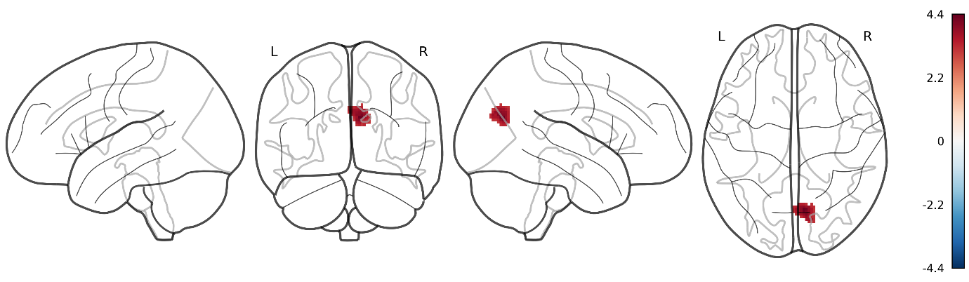
Red indicates increased functional activity in PHN patients relative to HC, whereas blue indicates decreased functional activity. The color bar represents SDM-Z values.

Supplementary Figure 2. Glass-brain visualization of structural alterations in PHN versus HC (P_{TFCE} < 0.05).
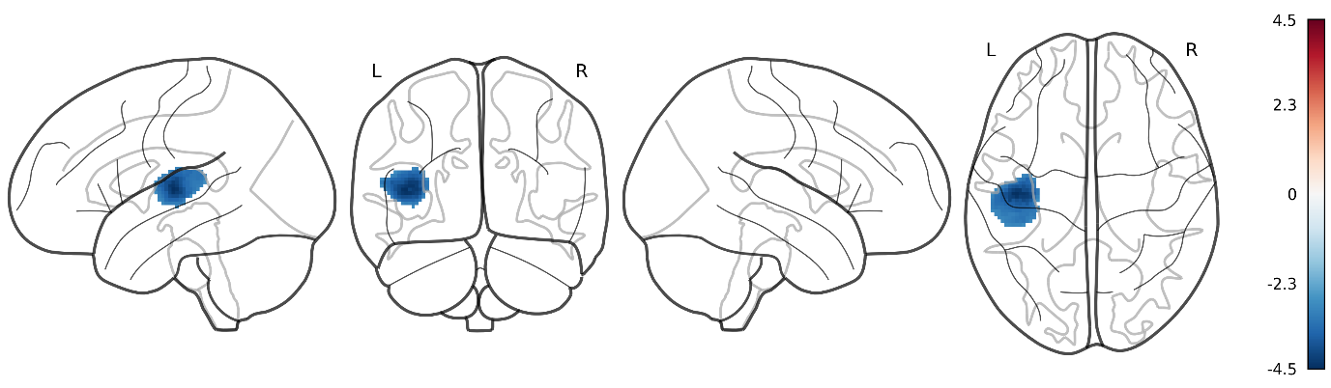
Blue indicates reduced gray matter volume in PHN patients relative to HC, whereas red indicates increased gray matter volume when present. The color bar represents SDM-Z values.

Supplementary Figure 3. Glass-brain visualization of functional alterations in PHN versus HZ patients (P_{TFCE} < 0.05).
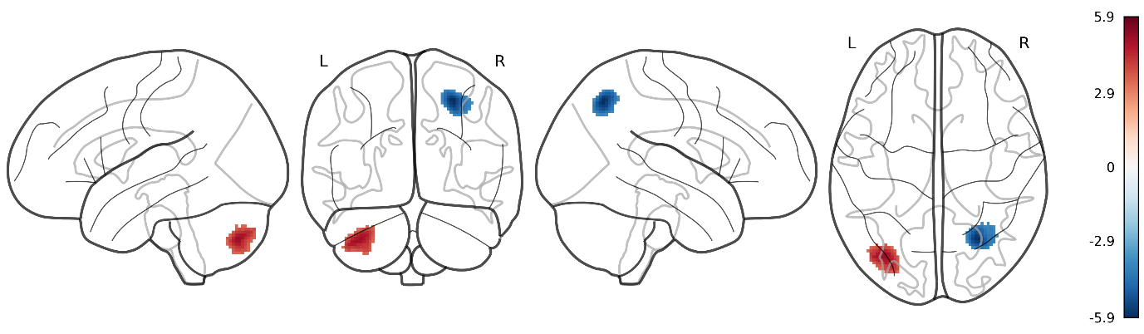
Red indicates increased functional activity in PHN patients relative to HZ patients, whereas blue indicates decreased functional activity. The color bar represents SDM-Z values.

Supplementary Figure 4. Glass-brain visualization of longitudinal functional alterations in PHN pre- and post-treatment (P_{TFCE} < 0.05).
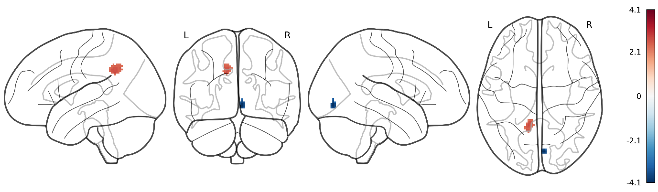 Red indicates increased functional activity after treatment, whereas blue indicates decreased functional activity after treatment. The color bar represents SDM-Z values.

3.2. Jack-knife sensitivity analysis

Supplementary Table 6. Jack-knife Sensitivity Analysis for rs-fMRI Meta-Analysis (PHN vs HC, P_{uncorrected} < 0.005)
All studies（n-1） | Brain Region of All Studies Overlapping Findings |  |  |  | Brain Region of Multiple Studies Overlapping Findings
All studies（n-1） | Right cuneus cortex | Left lenticular nucleus, putamen, BA 48 | Right anterior thalamic projections | Right fusiform gyrus, BA 20 | Right cerebellum, hemispheric lobule VIII | Right cerebellum, hemispheric lobule IV / V, BA 19
Cao ⁹ | ✔ | ✔ | ✔ | ✔ | ✔ | ✔
ZhangYi¹⁰ | ✔ |  | ✔ | ✔ | ✔
YinRuJiao¹¹ | ✔ | ✔ |  | ✔ | ✔
Liao et al¹² | ✔ | ✔ | ✔ | ✔
Jiang¹³ | ✔ | ✔ | ✔ |  | ✔
Bai et al¹⁴ |  |  | ✔ |  | ✔ | ✔
Cao¹⁵ | ✔ | ✔ | ✔ | ✔ |  | ✔
Huang et al¹⁶ | ✔ | ✔ | ✔ | ✔ | ✔ | ✔
Cao et al¹⁷ | ✔ | ✔ | ✔ | ✔
Gu et al¹⁸ | ✔ | ✔ | ✔ | ✔ | ✔ | ✔
Hui et al¹⁹ | ✔ | ✔ | ✔ |  | ✔
Cao et al²⁰ | ✔ | ✔ | ✔ | ✔ | ✔ | ✔
*Zhang¹⁰ | ✔ | ✔ |  | ✔ | ✔ | ✔
*Yin¹¹ | ✔ | ✔ |  | ✔ | ✔
*Cao¹⁵ | ✔ | ✔ |  |  | ✔ | ✔
*Cao et al¹⁷ | ✔ | ✔
*Cao et al²⁰ | ✔ | ✔ | ✔ | ✔ | ✔ | ✔
Total | 16 out of 17 | 15 out of 17 | 12 out of 17 | 12 out of 17 | 13 out of 17 | 9 out of 17
Note: * indicates datasets analyzed using ReHo (Regional Homogeneity).

Supplementary Table 7. Jack-knife Sensitivity Analysis for rs-fMRI Meta-Analysis (PHN vs HC, P_{TFCE} < 0.05)
All studies（n-1） | Brain Region of All Studies Overlapping Findings
All studies（n-1） | Right cuneus cortex
Cao ⁹ | ✔
ZhangYi¹⁰ | ✔
YinRuJiao¹¹ | ✔
Liao et al¹² | ✔
Jiang¹³ | ✔
Bai et al¹⁴
Cao¹⁵ | ✔
Huang et al¹⁶ | ✔
Cao et al¹⁷ | ✔
Gu et al¹⁸ | ✔
Hui et al¹⁹ | ✔
Cao et al²⁰ | ✔
*Zhang¹⁰ | ✔
*Yin¹¹ | ✔
*Cao¹⁵ | ✔
*Cao et al¹⁷
*Cao et al²⁰
Total | 14 out of 17
Note: * indicates datasets analyzed using ReHo (Regional Homogeneity).

Supplementary Table 8. Jack-knife Sensitivity Analysis for VBM Structural MRI Meta-Analysis (PHN vs HC, P_{uncorrected} < 0.005)
All studies（n-1） | Brain Region of All Studies Overlapping Findings |  |  | Brain Region of Multiple Studies Overlapping Findings
All studies（n-1） | Right Precentral Gyrus (BA 4) | Left Median Cingulate / Paracingulate | Left Postcentral Gyrus (BA 2) | Left Insula (BA 48)
Zhang¹⁰ |  |  |  | ✔
Jiang¹³ | ✔ |  | ✔ | ✔
Wang et al²¹ | ✔ |  | ✔
Yu et al²² | ✔ | ✔ | ✔
Liu et al²³ |  | ✔ |  | ✔
Li et al²⁴
Total | 3 out of 6 | 2 out of 6 | 3 out of 6 | 3 out of 6

Supplementary Table 9. Jack-knife Sensitivity Analysis for VBM Structural Meta-Analysis (PHN vs HC, P_{TFCE} < 0.05)
All studies（n-1） | Brain Region of All Studies Overlapping Findings | Brain Region of Multiple Studies Overlapping Findings
All studies（n-1） | Left Heschl’s Gyrus (BA 48) | Left Insula (BA 48)
Zhang¹⁰ |  | ✔
Jiang¹³ |  | ✔
Wang et al²¹ | ✔
Yu et al²² | ✔
Liu et al²³ |  | ✔
Li et al²⁴ | ✔
Total | 3 out of 6 | 3 out of 6

Supplementary Table 10. Jack-knife Sensitivity Analysis for comparisons PHN vs HC
Imaging Type | Jack-knife Sensitivity Analysis | Brain Region | Total of Subsamples (P_{uncorrected} < 0.005) | Replication Rate | Total of Subsamples (P_{TFCE} < 0.05) | Replication Rate
Functional changes | Brain Region of All Studies Overlapping Findings | Right cuneus cortex | 16 out of 17 | 0.941 | 14 out of 17 | 0.824
Functional changes | Brain Region of All Studies Overlapping Findings | Left lenticular nucleus, putamen, BA 48 | 15 out of 17 | 0.882 | – | –
Functional changes | Brain Region of All Studies Overlapping Findings | Right anterior thalamic projections | 12 out of 17 | 0.706 | – | –
Functional changes | Brain Region of All Studies Overlapping Findings | Right fusiform gyrus, BA 20 | 12 out of 17 | 0.706 | – | –
Functional changes | Brain Region of Multiple Studies Overlapping Findings | Right cerebellum, hemispheric lobule VIII | 13 out of 17 | 0.765 | – | –
Functional changes | Brain Region of Multiple Studies Overlapping Findings | Right cerebellum, hemispheric lobule IV / V, BA 19 | 9 out of 17 | 0.529 | – | –
Structural changes | Brain Region of All Studies Overlapping Findings | Left Heschl gyrus, BA 48 | 3 out of 6 | 0.500 | 3 out of 6 | 0.500
Structural changes | Brain Region of All Studies Overlapping Findings | Right Precentral gyrus, BA 4 | 3 out of 6 | 0.500 | – | –
Structural changes | Brain Region of All Studies Overlapping Findings | Left Median Cingulate/Paracingulate Gyri | 2 out of 6 | 0.333 | – | –
Structural changes | Brain Region of All Studies Overlapping Findings | Left Postcentral gyrus, BA 2 | 3 out of 6 | 0.500 | – | –
Structural changes | Brain Region of Multiple Studies Overlapping Findings | Left Insula, BA 48 | 3 out of 6 | 0.500 | 3 out of 6 | 0.500

Supplementary Table 11. Jack-knife Sensitivity Analysis for rs-fMRI Meta-Analysis (PHN vs HZ, P_{uncorrected} < 0.005)
All studies (n-1) | Brain Region of All Studies Overlapping Findings
All studies (n-1) | Left cerebellum, crus II | Right cerebellum, crus II | Right superior parietal gyrus, BA 7
Cao¹⁵ | ✔ | ✔ | ✔
Liang²⁵ | ✔ | ✔ | ✔
*Cao¹⁵ | ✔ | ✔ | ✔
Cao et al²⁰ | ✔ |  | ✔
*Liang et al²⁶ | ✔ | ✔ | ✔
*Cao et al²⁰ | ✔ |  | ✔
Total | 6 out of 6 | 4 out of 6 | 6 out of 6
Note: * indicates dataset analyzed using ReHo (Regional Homogeneity).

Supplementary Table 12. Jack-knife Sensitivity Analysis for rs-fMRI Meta-Analysis (PHN vs HZ, P_{TFCE} < 0.05)
All studies (n-1) | Brain Region of All Studies Overlapping Findings
All studies (n-1) | Left cerebellum, crus II | Right superior parietal gyrus, BA 7
Cao¹⁵ | ✔ | ✔
Liang²⁵ | ✔ | ✔
*Cao¹⁵
Cao et al²⁰ | ✔ | ✔
*Liang et al²⁶ | ✔ | ✔
*Cao et al²⁰ | ✔ | ✔
Total | 5 out of 6 | 5 out of 6
Note: * indicates datasets analyzed using ReHo (Regional Homogeneity).

Supplementary Table 13. Jack-knife Sensitivity Analysis Results for PHN vs. HZ Comparison
Imaging Type | Jack-knife Sensitivity Analysis | Brain Region | Total of Reproducible Studies (P uncorrected < 0.005) | Replication Rate | Total of Reproducible Studies(P TFCE < 0.05) | Replication Rate
Functional changes | Brain Region of All Studies Overlapping Findings | Right cerebellum, crus II | 6 out of 6 | 1.000 | 4 out of 6 | 0.667
Functional changes | Brain Region of All Studies Overlapping Findings | Left cerebellum, crus II | 4 out of 6 | 0.667 | 5 out of 6 | 0.833
Functional changes | Brain Region of All Studies Overlapping Findings | Right superior parietal gyrus, BA 7 | 6 out of 6 | 1.000 | 5 out of 6 | 0.833

Supplementary Table 14. Jack-knife Sensitivity Analysis for rs-fMRI Meta-Analysis (PHN Pre- and Post-Treatment, P_{uncorrected} < 0.005, P_{TFCE} < 0.05)
All studies (n-1) | Brain Region of All Studies Overlapping Findings
All studies (n-1) | Left median cingulate / paracingulate gyri | Right lingual gyrus, BA 17
Jiang¹³ | ✔
Chun et al²⁷
Zhang et al²⁸
*Fan et al²⁹ |  | ✔
Total | 1 out of 4 | 1 out of 4
Note: * indicates datasets analyzed using ReHo (Regional Homogeneity).

Supplementary Table 15. Jack-knife Sensitivity Analysis Results for PHN Pre- and Post-Treatment Comparison
Imaging Type | Jack-knife Sensitivity Analysis | Brain Region | Total of Subsamples (P_{uncorrected} < 0.005) | Replication Rate | Total of Subsamples (P_{TFCE} < 0.05) | Replication Rate
Functional changes | Brain Region of All Studies Overlapping Findings | Left median cingulate/paracingulate gyri | 1 out of 4 | 0.250 | 1 out of 4 | 0.250
Functional changes | Brain Region of All Studies Overlapping Findings | Right lingual gyrus, BA 17 | 1 out of 4 | 0.250 | 1 out of 4 | 0.250

3.3 Analysis of Heterogeneity and Publication Bias

Supplementary Table 16. Summary of Meta-Analytic Results: Effect Sizes, Heterogeneity, and Publication Bias for PHN Comparisons Across Functional and Structural Imaging Modalities
Comparison | Imaging Type | Threshold | Brain Region | Peak Coordinates | Extract test |  |  |  |  |  |  |  |  |  |  |  |  | Metabias Test  (Egger‘s Test) |  |  |  | Excess Significance test
 |  |  |  |  | Estimate（Hedges' g） | SDM-Z（Hedges' g） | uncorrp | uncorrp_neg | τ² | H² | I² | Q² | SDM-Z（Q2） | uncorrp_neg | corrp_voxel_neg | corrp_tfce | corrp_tfce_neg | Bias | z | P-value | df | P-value
PHN vs HC | Functional changes | P_{TFCE}<0.05 | Right cuneus cortex | 8,-70,24 | 0.403062 | 4.411559 | 0.999995 | 0.000005 | 0.003460 | 1.027771 | 2.702088 | 8.290720 | -1.552565 | 0.916 | 0.000 | 0.993 | 0.000 | 1.04 | 0.57 | 0.566 | 15 | 0.520
PHN vs HC | Functional changes | P_{uncorrected}<0.005 | Left lenticular nucleus, putamen | -30,-6,0 | 0.332378 | 3.769818 | 0.999918 | 0.000082 | 0.002605 | 1.022147 | 2.166723 | 11.774594 | -0.704198 | 0.208 | 0.000 | 0.888 | 0.000 | 0.65 | 0.35 | 0.728 | 15 | 0.552
PHN vs HC | Functional changes | P_{uncorrected}<0.005 | Right anterior thalamic projections | 14,-8,12 | 0.349195 | 3.05084 | 0.998859 | 0.001141 | 0.071753 | 1.630511 | 38.669537 | 18.483437 | 0.534906 | 0.000 | 0.000 | 0.000 | 0.000 | 3.80 | 1.93 | 0.054 | 15 | 0.199
PHN vs HC | Functional changes | P_{uncorrected}<0.005 | Right fusiform gyrus , BA 20 | 44,-36,-28 | -0.312016 | -2.962483 | 0.001526 | 0.998474 | 0.026432 | 1.221656 | 18.143925 | 13.454398 | -0.356558 | 0.000 | -0.001 | 0.000 | 0.194 | -1.45 | -0.75 | 0.452 | 15 | 0.000
PHN vs HC | Structural changes | P_{TFCE}<0.05 | Left heschl gyrus | -42,-16,8 | -0.690643 | -4.510931 | 0.000003 | 0.999997 | 0.004661 | 1.028755 | 2.795088 | 3.105832 | -0.477997 | 0.000 | -0.962 | 0.000 | 0.999 | -0.72 | -0.20 | 0.844 | 4 | 0.399
PHN vs HC | Structural changes | P_{uncorrected}<0.005 | Right precentral gyrus, BA 4 | 54,-6,38 | -0.578683 | -3.229142 | 0.000621 | 0.999379 | 0.032954 | 1.189401 | 15.924041 | 3.557299 | -0.291684 | 0.000 | 0.000 | 0.000 | 0.781 | 0.89 | 0.19 | 0.847 | 4 | 0.999
PHN vs HC | Structural changes | P_{uncorrected}<0.005 | Left median cingulate / paracingulate gyri | -2,-38,44 | -0.526787 | -2.921902 | 0.001740 | 0.998260 | 0.034447 | 1.214421 | 17.656252 | 4.339704 | -0.004042 | 0.000 | 0.000 | 0.000 | 0.610 | -2.19 | -0.52 | 0.600 | 4 | 0.907
PHN vs HC | Structural changes | P_{uncorrected}<0.005 | Left postcentral gyrus, BA 2 | -42,-32,44 | -0.529953 | -3.020737 | 0.001261 | 0.998739 | 0.022169 | 1.136569 | 12.015899 | 2.222310 | -0.906283 | 0.000 | 0.000 | 0.000 | 0.016 | 0.84 | 0.20 | 0.844 | 4 | 0.808
PHN vs HZ | Functional changes | P_{TFCE}<0.05 | Left cerebellum, crus II | -34,-76,-42 | 0.779260 | 5.074476 | 1.000000 | 0.000000 | 0.008855 | 1.061744 | 5.815318 | 3.837270 | -0.184209 | 0.997 | 0.000 | 0.999 | 0.000 | 0.47 | 0.31 | 0.759 | 4 | 0.000
PHN vs HZ | Functional changes | P_{uncorrected}<0.005 | Right cerebellum, crus II | 42,-72,-42 | 0.539110 | 3.414595 | 0.999681 | 0.000319 | 0.007154 | 1.043391 | 4.158621 | 2.925805 | -0.557548 | 0.009 | 0.000 | 0.927 | 0.000 | 0.36 | 0.23 | 0.820 | 4 | 0.384
PHN vs HZ | Functional changes | P_{TFCE}<0.05 | Right superior parietal gyrus, BA 7 | 28,-64,50 | -0.838942 | -5.878611 | 0.000000 | 1.000000 | 0.000941 | 1.006685 | 0.664024 | 1.406463 | -1.429746 | 0.000 | -0.999 | 0.000 | 0.999 | 1.11 | 0.70 | 0.481 | 4 | 0.933
PHN = Postherpetic Neuralgia; HC = Healthy Controls; HZ = Herpes Zoster.
Hedges' g = standardized mean difference effect size; SDM-Z = Z value from Seed-based d Mapping;
τ², H², I², Q² = heterogeneity metrics; TFCE = threshold-free cluster enhancement;
Bias and Egger's z, p = statistics from Egger’s test for publication bias;Excess significance test P-value refers to the likelihood of observed significant findings exceeding expectation.
“–” indicates insufficient number of studies (n < 10) to conduct bias or excess significance testing.
BA = Brodmann area; Peak coordinates are given in MNI space (x, y, z).

Supplementary Figures 5–15. Funnel plots for publication bias assessment in PHN versus HC and PHN versus HZ comparisons.
PHN vs HC
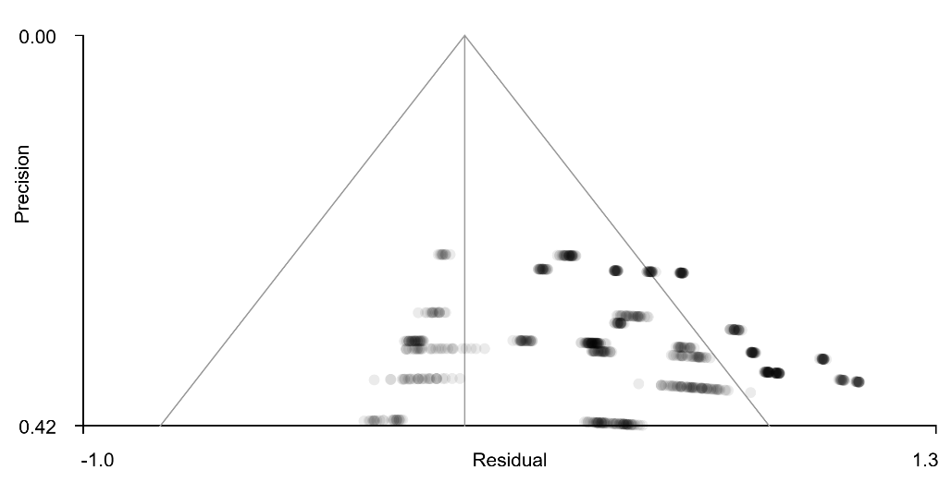 |  | 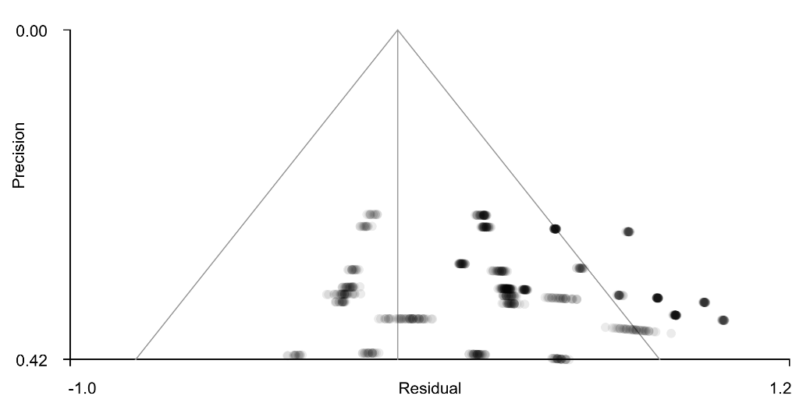
Figure 5. Bias test of funnel plot for Right cuneus cortex(P_{TFCE}<0.05) |  | Figure 6. Bias test of funnel plot for Left lenticular nucleus, putamen , BA 48(P_{uncorrected}<0.005)
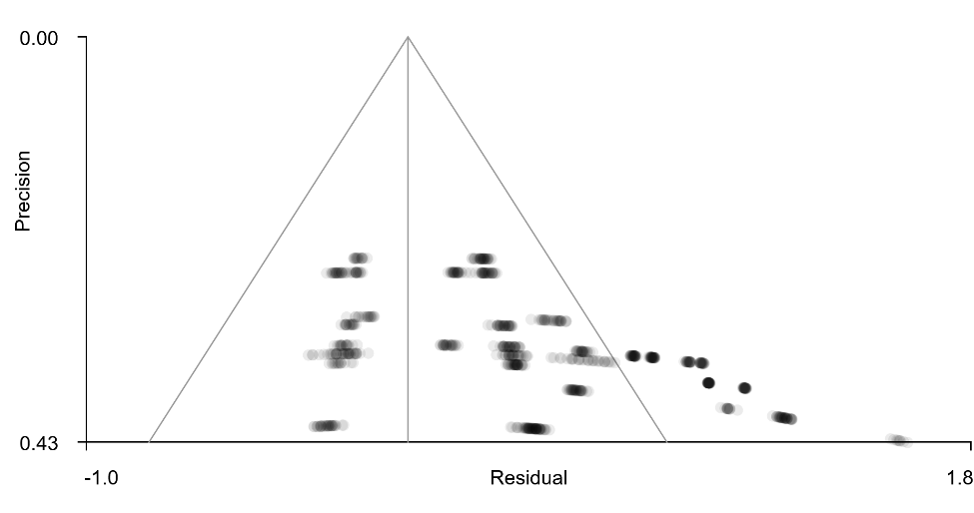 |  | 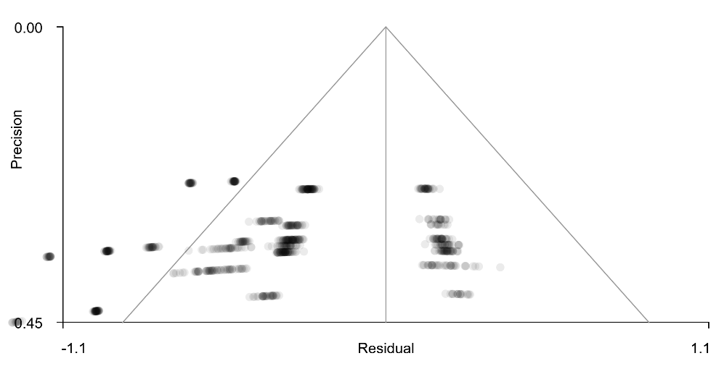
Figure 7. Bias test of funnel plot for Right anterior thalamic projections (P_{uncorrected}<0.005) |  | Figure 8. Bias test of funnel plot for Right fusiform gyrus , BA 20 (P_{uncorrected}<0.005)
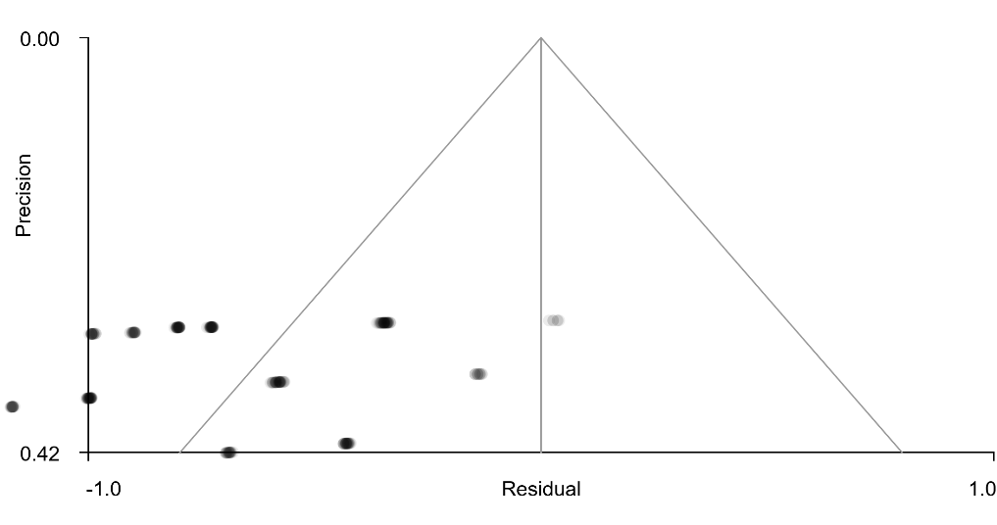 |  | 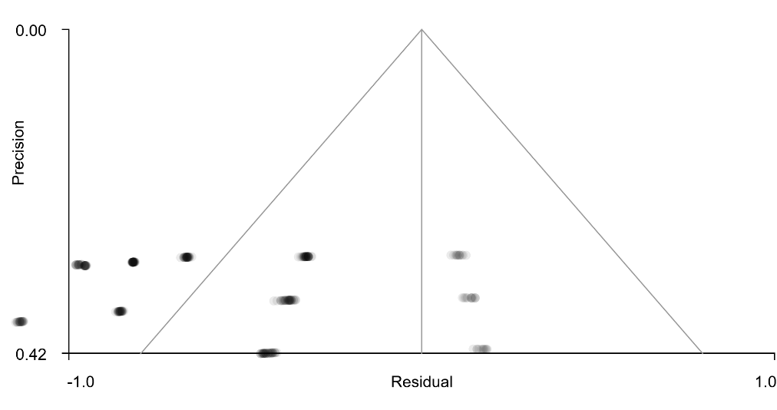
Figure 9. Bias test of funnel plot for Left heschl gyrus, BA 48 (P_{TFCE}<0.05) |  | Figure 10. Bias test of funnel plot for Right precentral gyrus, BA 4 (P_{uncorrected}<0.005)
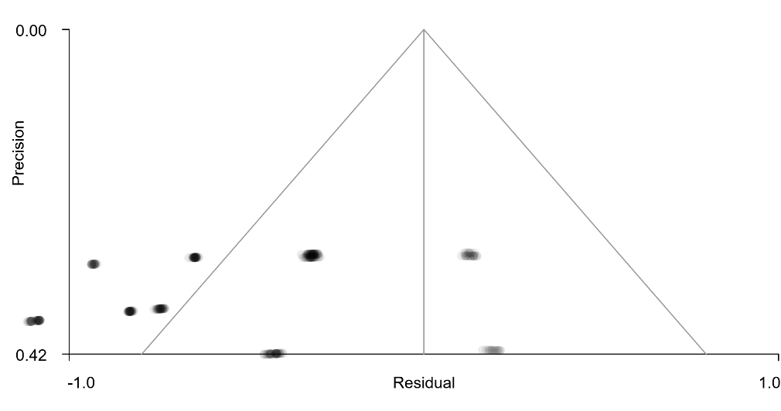 |  | 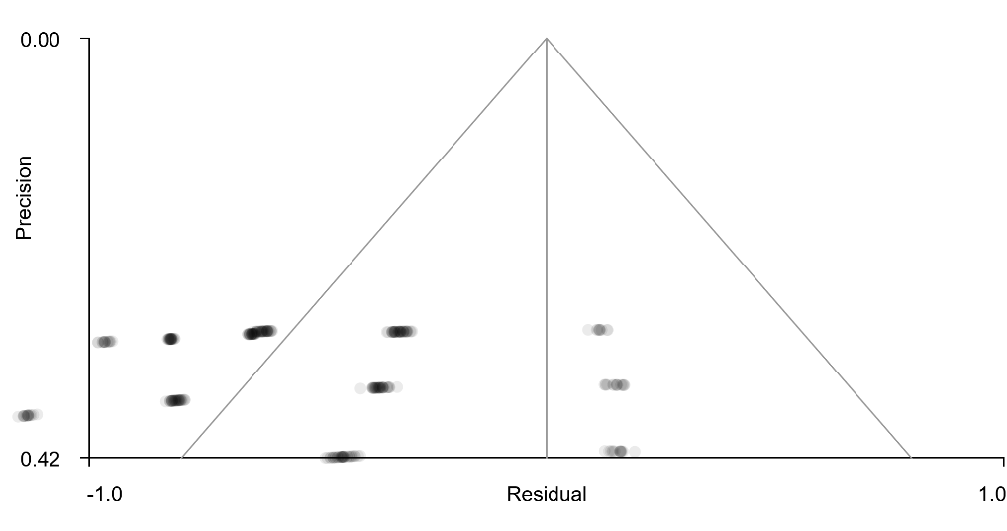
Figure 11. Bias test of funnel plot for Left median cingulate / paracingulate gyri (P_{uncorrected}<0.005) |  | Figure 12. Bias test of funnel plot for Left postcentral gyrus, BA 2 (P_{uncorrected}<0.005)
PHN vs HZ
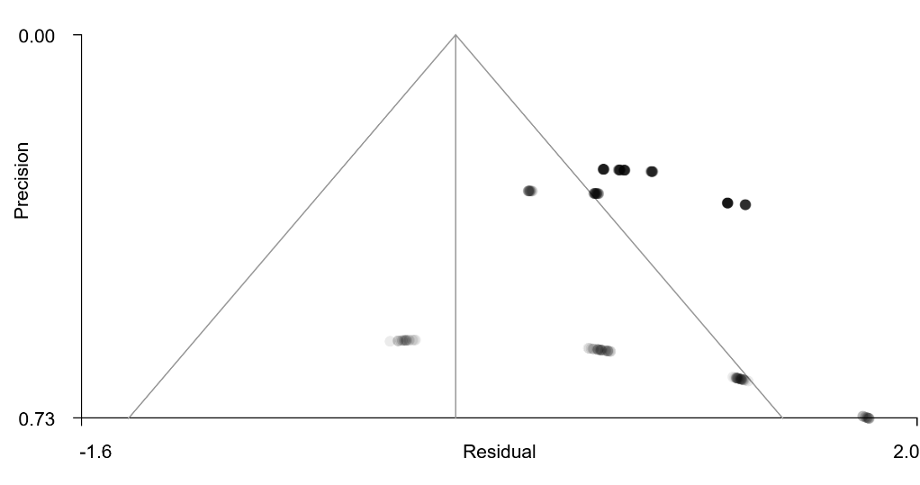 |  | 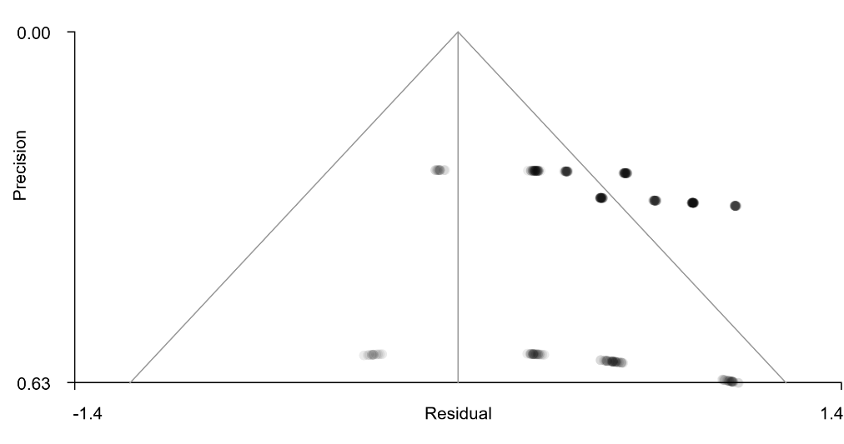
Figure 13. Bias test of funnel plot for Left cerebellum, crus II (P_{TFCE}<0.05) |  | Figure 14. Bias test of funnel plot for Right cerebellum, crus II (P_{uncorrected}<0.005)
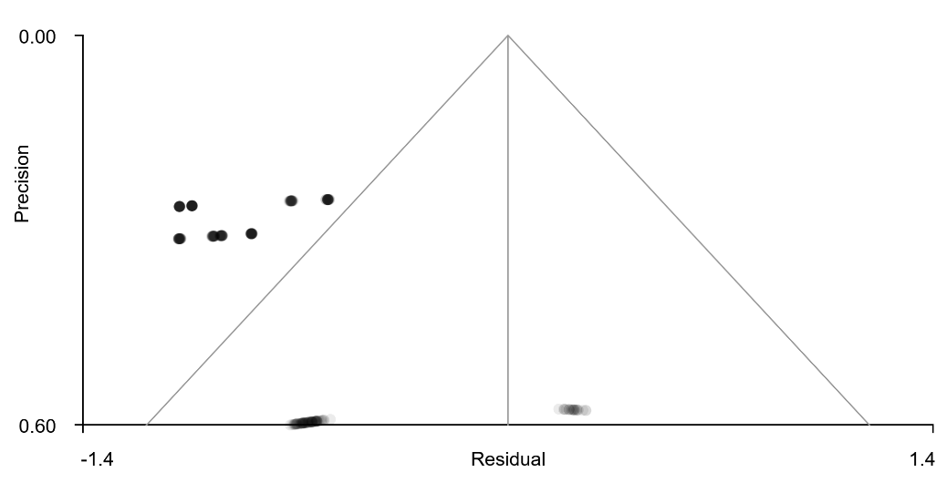
Figure 15. Bias test of funnel plot for Right superior parietal gyrus, BA 7 (P_{TFCE}<0.05)

3.4 Meta-regression Analysis

Supplementary Table 17. Meta-regression results for demographic and clinical moderators in PHN
Group | Change Type | Moderator | Direction | MNI Coordinate | SDM-Z value | P-value | Voxels | Brain region
PHN vs HC | Functional | Female | ↑ | -32,-72,-50 | 2.691 | 0.013999999 | 929 | Left cerebellum, hemispheric lobule VIIB
PHN vs HC | Functional | Female | ↓ | -4,-18,28 | -3.111 | 0.018999994 | 144 | Posterior anterior cingulate cortex
PHN vs HC | Functional | Female | ↓ | -32,16,-6 | -3.063 | 0.032000005 | 68 | Left insula, BA 48
PHN vs HC | Functional | Pain duration | ↑ | -20,-54,-52 | 4.249 | 0.000999987 | 1745 | Left cerebellum, hemispheric lobule VIII
PHN vs HC | Functional | VAS | ↑ | 56,-6,8 | 2.928 | 0.021000028 | 247 | Right rolandic operculum, BA 48
PHN vs HC | Functional | VAS | ↑ | 58,-30,-24 | 3.287 | 0.038999975 | 27 | Right inferior temporal gyrus, BA 20
PHN vs HC | Structural | Female | ↑ | 24,2,-4 | 4.716 | 0.012000024 | 135 | Right striatum
PHN vs HC | Structural | Education years | ↑ | -26,-40,-36 | 3.014 | 0.000999987 | 12 | Middle cerebellar peduncles
PHN vs HZ | Functional | Pain duration | ↓ | 22,-48,-12 | -3.036 | 0.012000024 | 27 | Right fusiform gyrus, BA 37
PHN vs HZ | Structural | Age | ↑ | -26,0,-2 | 2.496 | 0.000999987 | 484 | Left striatum
PHN vs HZ | Structural | Female | ↑ | -24,4,-4 | 2.516 | 0.000999987 | 370 | Left lenticular nucleus, putamen, BA 48

9. CaoWanYu, Postherpetic neuralgia in chest and back patients with emotion disorders: A resting state low frequency amplitude study. 2019, Chinese Medical Sciences University. p. 1-33 (in chinese).
10. ZhangYi, Multimodal MRI-based study on patients with postherpetic neuralgia. 2016, Shanghai Jiao Tong University p. 1-88 (in Chinese).
11. Rujiao, Y., Brain resting state-functional magnetic resonance study in postherpetic neuralgia. 2017, Kunming Medical University. p. 1-62 (in Chinese).
12. LiaoXiang, et al., Functional magnetic resonance imaging study on changes in basic brain activity in patients with postherpetic neuralgia. Progress in Biochemistry and Biophysics, 2015. 42(10): p. 947-954 (in Chinese).
13. JiangChengcheng, The research of postherpetic neuralgia patients with resting state functional MRI and voxel based morphometry 2017, Suzhou University. p. 1-49 (in Chinese).
14. Lala, B., et al., Magnetic Resonance Imaging Study of Brain Function and Structure Changes in Patients with Post-herpetic Neuralgia. Imaging Science & Photochemistry, 2022. 40(2).
15. Song, C., Multimodal MRI study on the herpes zoster pain and postherpetic neuralgia. 2017, Shanghai Jiao Tong University. p. 3-95 (in Chinese).
16. Huang, J., et al., Abnormal intrinsic brain activity and neuroimaging-based fMRI classification in patients with herpes zoster and postherpetic neuralgia. Frontiers in neurology, 2020. 11: p. 532110.
17. Cao, S., et al., Abnormal local brain activity beyond the pain matrix in postherpetic neuralgia patients: a resting-state functional MRI study. Pain Physician, 2017. 20(2): p. E303.
18. Gu, L., et al., Bidirectional alterations in ALFF across slow-5 and slow-4 frequencies in the brains of postherpetic neuralgia patients. Journal of pain research, 2018: p. 39-47.
19. Dai, H., et al., A combined DTI and resting state functional MRI study in patients with postherpetic neuralgia. Japanese journal of radiology, 2020. 38(5): p. 440-450.
20. Cao, S., et al., Local brain activity differences between herpes zoster and postherpetic neuralgia patients: a resting-state functional MRI study. Pain Physician, 2017. 20(5): p. E687.
21. WANG, S., et al., Observation of morphological changes of brain gray matter volume in patients with postherpetic neuralgia using VBM-DARTEL method. Journal of Practical Radiology, 2017: p. 1337-1340, 1356.
22. Tang, Y., et al., Altered gray matter volume and functional connectivity in patients with herpes zoster and postherpetic neuralgia. Brain research, 2021. 1769: p. 147608.
23. Liu, J., et al., Altered gray matter volume in patients with herpes zoster and postherpetic neuralgia. Journal of pain research, 2019: p. 605-616.
24. Niu, L., et al., Cerebral structural alterations in the patients undergoing postherpetic neuralgia: A VBM–MRI study. iBrain, 2022. 8(2): p. 119-126.
25. Haowen, L., The study of cerebral function in postherpetic neuralgia pain by rest state fMRI. 2013, Guangdong Medical College. p. 6-47 (in Chinese).
26. Haowen, L., et al., The comparative study of cerebral function in different phases of herpes zoster by ReHO fMRI. Chinese Journal of Pain Medicine, 2014. 20(10): p. 717-721 （in Chinese).
27. Bu, C., et al., Alteration of static and dynamic intrinsic brain activity induced by short-term spinal cord stimulation in postherpetic neuralgia patients. Frontiers in Neuroscience, 2023. 17: p. 1254514.
28. Zhang, Y., et al., Functional and structural changes in postherpetic neuralgia brain before and six months after pain relieving. Journal of pain research, 2020: p. 909-918.
29. Fan, X., et al., Alterations in local activity and functional connectivity in patients with postherpetic neuralgia after short-term spinal cord stimulation. Frontiers in molecular neuroscience, 2022. 15: p. 938280.

References：

