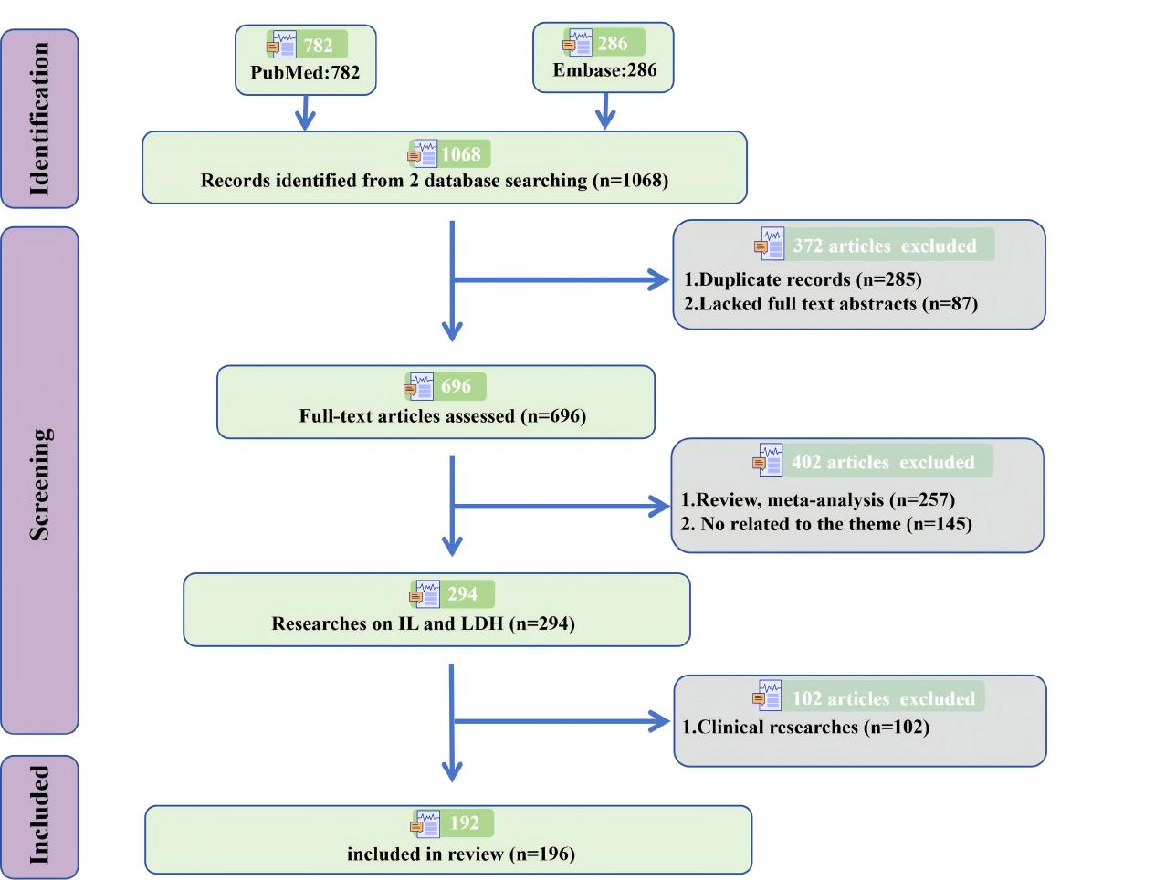 Supplementary Figure 1. Flow chart of the search strategy and process. We retrieved 1068 references from the Endonte and EMBase databases, of which 285 were duplicates, 87 did not have full-text abstracts, 145 were unrelated to lumbar disc herniation (LDH) and interleukin (IL), 257 were review articles or meta-analyses, and 102 were clinical studies. Finally, a total of 196 full-text original research papers related to the research topic were included in the analysis.

