- Supplementary Materials -

Cost-Effectiveness of Blinatumomab plus Chemotherapy vs Chemotherapy in Adults Newly Diagnosed with Philadelphia-Negative B-Cell Acute Lymphoblastic Leukemia in Italy

Supplementary Tables
Supplemental Table 1 Additional model input parameters
Parameter | Point estimate | Distribution used in the PSA | Value tested in the DSA | Source
Clinical Parameters
Overall survival (OS) – parametric distribution
Blinatumomab + SoC (Weibull) | Shape: 0.495  Scale: 3.217  Theta: 1.507 | Cholesky decomposition of the covariance matrix | - | ECOG-ACRIN E1910*
SoC (Weibull) | Shape: 0.370  Scale: 3.624  Theta: 0.131 | Cholesky decomposition of the covariance matrix | - | ECOG-ACRIN E1910*
Relapse-free survival (RFS) – parametric distribution
Blinatumomab + SoC (Lognormal) | Meanlog: 2.625  Sdlog: 0.181  Theta: 1.048 | Cholesky decomposition of the covariance matrix | - | ECOG-ACRIN E1910*
SoC (Lognormal) | Meanlog: 3.085  Sdlog: 0.282  Theta: -0.141 | Cholesky decomposition of the covariance matrix | - | ECOG-ACRIN E1910*
Survival of the general population
SMR | 1.09 | Gamma | 0.89 to 1.31 | ^{17,18,44}
% pre-relapse HSCT
Blinatumomab + SoC | 22.32% | Beta | 18.11% to 26.83% | ECOG-ACRIN E1910*
SoC | 25.00% | Beta | 20.27% to 30.04% | ECOG-ACRIN E1910*
Safety Parameters
Cost of AEs management
Alanine aminotransferase increased | €20.66 | Gamma | €16.81 to €24.90 | Specialist visit tariff³²
Anaemia | €3,061.86 | Gamma | €2,491.25 to €3,690.43 | ³⁰
Aphasia | €2,850.00 | Gamma | €2,318.87 to €3,435.08 | DRG 12²⁷
Aspartate aminotransferase increased | €20.66 | Gamma | €16.81 to €24.90 | Specialist visit tariff³²
Cytokine release syndrome | €1,272.00 | Gamma | €1,034.95 to €1,533.13 | DRG 450²⁷
Device related infection | €1,883.69 | Gamma | €1,532.65 to €2,270.00 | DRG 452 and 453²⁷ (weighed for SDO 2022)
Diarrhoea | €196.08 | Gamma | €159.54 to €236.33 | ³⁰
Fatigue | €133.26 | Gamma | €108.43 to €160.62 | ³⁰
Febrile neutropenia | €2,387.75 | Gamma | €1,942.77 to €2,877.93 | ³⁰
Headache | €20.66 | Gamma | €16.81 to €24.90 | Specialist visit tariff³²
Hyperglycaemia | €1,758.00 | Gamma | €1,430.38 to €2,118.90 | DRG 297²⁷
Hypertension | €1,773.00 | Gamma | €1,442.58 to €2,136.98 | ³¹
Hypertriglyceridaemia | €20.66 | Gamma | €16.81 to €24.90 | Specialist visit tariff³²
Hypotension | €2,097.00 | Gamma | €1,706.20 to €2,527.49 | DRG 145²⁷
Lymphocyte count decreased | €1,802.00 | Gamma | €1,466.18 to €2,171.93 | ³¹
Nausea | €52.17 | Gamma | €42.45 to €62.88 | ³⁰
Neutrophil count decreased | €1,245.89 | Gamma | €1,013.71 to €1,501.66 | ³⁰
Platelet count decreased | €1,323.00 | Gamma | €1,076.45 to €1,594.60 | ³¹
Sepsis | €5,943.00 | Gamma | €4,835.46 to €7,163.04 | DRG 576²⁷
White blood cell count decreased | €1,802.00 | Gamma | €1,466.18 to €2,171.93 | ³¹
AEs utility decrements
Alanine aminotransferase (ALT) increased | 0.00 | Constant | - | ¹⁸
Anaemia | 0.12 | Beta | 0.08 to 0.16 | ⁴⁵
Aphasia | 0.00 | Constant | - | Assumption
Aspartate aminotransferase increased | 0.00 | Constant | - | Assumed same as ALT increased
Cytokine release syndrome | 0.23 | Beta | 0.19 to 0.28 | ⁴⁶
Device related infection | 0.20 | Beta | 0.13 to 0.28 | Assumed same as sepsis
Diarrhoea | 0.05 | Beta | 0.04 to 0.06 | ⁴⁷
Fatigue | 0.12 | Beta | 0.09 to 0.14 | ⁴⁸
Febrile neutropenia | 0.09 | Beta | 0.05 to 0.13 | ⁴⁷
Headache | 0.03 | Beta | 0.02 to 0.03 | ⁴⁹
Hyperglycaemia | 0.06 | Beta | 0.04 to 0.08 | ⁴⁹
Hypertension | 0.07 | Beta | 0.05 to 0.09 | ¹⁸, assumed same as hypotension
Hypertriglyceridaemia | 0.00 | Constant | - | Assumed no disutility for abnormal lab tests
Hypotension | 0.07 | Beta | 0.05 to 0.09 | ⁵⁰
Lymphocyte count decreased | 0.07 | Beta | 0.05 to 0.09 | ⁵⁰
Nausea | 0.05 | Beta | 0.03 to 0.07 | Assumed same as diarrhoea
Neutrophil count decreased | 0.00 | Constant | - | ⁵¹
Platelet count decreased | 0.05 | Beta | 0.03 to 0.07 | ⁵²
Sepsis | 0.20 | Beta | 0.13 to 0.28 | ⁵³
White blood cell count decreased | 0.05 | Beta | 0.03 to 0.07 | ⁵¹
AEs duration
Alanine aminotransferase increased | 20.00 | Gamma | 16.27 to 24.11 | ¹⁸
Anaemia | 14.90 | Gamma | 12.12 to 17.96 | ⁴⁵
Aphasia | 0.00 | Constant | - | Assumption
Aspartate aminotransferase increased | 20.00 | Gamma | 16.27 to 24.11 | ¹⁸
Cytokine release syndrome | 4.30 | Gamma | 3.50 to 5.18 | ⁴⁶
Device related infection | 15.10 | Gamma | 12.29 to 18.20 | Assumed same as sepsis
Diarrhoea | 7.00 | Gamma | 5.70 to 8.44 | ⁴⁷
Fatigue | 7.00 | Gamma | 5.70 to 8.44 | ⁵⁴
Febrile neutropenia | 6.20 | Gamma | 5.04 to 7.47 | ⁴⁷
Headache | 2.00 | Gamma | 1.63 to 2.41 | ⁴⁹
Hyperglycaemia | 7.50 | Gamma | 6.10 to 9.04 | ⁴⁹
Hypertension | 4.00 | Gamma | 3.25 to 4.82 | ¹⁸
Hypertriglyceridaemia | 0.00 | Constant | - | Assumption
Hypotension | 2.30 | Gamma | 1.87 to 2.77 | ⁵⁰
Lymphocyte count decreased | 19.00 | Gamma | 15.46 to 22.90 | ⁵⁰
Nausea | 7.00 | Gamma | 5.70 to 8.44 | Assumed same as diarrhoea
Neutrophil count decreased | 9.80 | Gamma | 7.97 to 11.81 | ⁵¹
Platelet count decreased | 11.90 | Gamma | 9.68 to 14.34 | ⁵²
Sepsis | 15.10 | Gamma | 12.29 to 18.20 | ⁵³
White blood cell count decreased | 16.90 | Gamma | 13.75 to 20.37 | ⁵¹
Frequency of AEs (Blinatumomab + SoC) - Grade ≥3 treatment-emergent AEs that occurred in ≥ 5%
Alanine aminotransferase increased | 8.11% | Beta | 3.81% to 13.83% | ECOG-ACRIN E1910*
Anaemia | 31.53% | Beta | 23.26% to 40.43% | ECOG-ACRIN E1910*
Aphasia | 6.31% | Beta | 2.60% to 11.49% | ECOG-ACRIN E1910*
Aspartate aminotransferase increased | 5.41% | Beta | 2.03% to 10.29% | ECOG-ACRIN E1910*
Cytokine release syndrome | 3.60% | Beta | 1.00% to 7.76% | ECOG-ACRIN E1910*
Device related infection | 10.81% | Beta | 5.77% to 17.19% | ECOG-ACRIN E1910*
Diarrhoea | 3.60% | Beta | 1.00% to 7.76% | ECOG-ACRIN E1910*
Fatigue | 5.41% | Beta | 2.03% to 10.29% | ECOG-ACRIN E1910*
Febrile neutropenia | 20.72% | Beta | 13.74% to 28.70% | ECOG-ACRIN E1910*
Headache | 4.50% | Beta | 1.49% to 9.05% | ECOG-ACRIN E1910*
Hyperglycaemia | 10.81% | Beta | 5.77% to 17.19% | ECOG-ACRIN E1910*
Hypertension | 10.81% | Beta | 5.77% to 17.19% | ECOG-ACRIN E1910*
Hypertriglyceridaemia | 3.60% | Beta | 1.00% to 7.76% | ECOG-ACRIN E1910*
Hypotension | 5.41% | Beta | 2.03% to 10.29% | ECOG-ACRIN E1910*
Lymphocyte count decreased | 34.23% | Beta | 25.74% to 43.27% | ECOG-ACRIN E1910*
Nausea | 5.41% | Beta | 2.03% to 10.29% | ECOG-ACRIN E1910*
Neutrophil count decreased | 87.39% | Beta | 80.64% to 92.86% | ECOG-ACRIN E1910*
Platelet count decreased | 70.27% | Beta | 61.48% to 78.37% | ECOG-ACRIN E1910*
Sepsis | 13.51% | Beta | 7.84% to 20.43% | ECOG-ACRIN E1910*
White blood cell count decreased | 54.05% | Beta | 44.77% to 63.20% | ECOG-ACRIN E1910*
Frequency of AEs (SoC) - Grade ≥3 treatment-emergent AEs that occurred in ≥ 5%
Alanine aminotransferase increased | 7.14% | Beta | 3.16% to 12.56% | ECOG-ACRIN E1910*
Anaemia | 41.07% | Beta | 32.17% to 50.27% | ECOG-ACRIN E1910*
Aphasia | 0.00% | Constant | - | ECOG-ACRIN E1910*
Aspartate aminotransferase increased | 2.68% | Beta | 0.56% to 6.36% | ECOG-ACRIN E1910*
Cytokine release syndrome | 0.00% | Constant | - | ECOG-ACRIN E1910*
Device related infection | 5.36% | Beta | 2.01% to 10.20% | ECOG-ACRIN E1910*
Diarrhoea | 5.36% | Beta | 2.01% to 10.20% | ECOG-ACRIN E1910*
Fatigue | 3.57% | Beta | 0.99% to 7.70% | ECOG-ACRIN E1910*
Febrile neutropenia | 28.57% | Beta | 20.63% to 37.24% | ECOG-ACRIN E1910*
Headache | 6.25% | Beta | 2.57% to 11.39% | ECOG-ACRIN E1910*
Hyperglycaemia | 8.04% | Beta | 3.77% to 13.71% | ECOG-ACRIN E1910*
Hypertension | 2.68% | Beta | 0.56% to 6.36% | ECOG-ACRIN E1910*
Hypertriglyceridaemia | 5.36% | Beta | 2.01% to 10.20% | ECOG-ACRIN E1910*
Hypotension | 2.68% | Beta | 0.56% to 6.36% | ECOG-ACRIN E1910*
Lymphocyte count decreased | 27.68% | Beta | 19.83% to 36.28% | ECOG-ACRIN E1910*
Nausea | 0.89% | Beta | 0,02% 3,27% | ECOG-ACRIN E1910*
Neutrophil count decreased | 94.64% | Beta | 89.80% to 97.99% | ECOG-ACRIN E1910*
Platelet count decreased | 77.68% | Beta | 69.56% to 84.86% | ECOG-ACRIN E1910*
Sepsis | 9.82% | Beta | 5.05% to 15.94% | ECOG-ACRIN E1910*
White blood cell count decreased | 66.07% | Beta | 57.09% to 74.51% | ECOG-ACRIN E1910*
*Amgen, Clinical Study Report, unpublished data, 2023
Abbreviations: AEs, adverse events; HSCT, haematopoietic stem cell transplantation; OS, overall survival; RFS, relapse-free survival; SDO, hospital discharge records; SMR, standardized mortality ratio; SoC, standard of care.

Supplemental Table 2 Posology for drug administration
Cycle | Cycle length | Drug | Dose per admin | Administration route | Administration details
Blinatumomab + SoC
Cycle 1 - Blinatumomab | 42 days | Blinatumomab | 28 μg | cIV | Days 1 - 28
Cycle 2 - Blinatumomab | 42 days | Blinatumomab | 28 μg | cIV | Days 1 - 28
Consolidation Cycle 1 | 28 days | Cytarabine | 75mg/m² | IV or SC | Day 1 - 5
Consolidation Cycle 1 | 28 days | Etoposide | 100mg/m² | IV | Day 1 - 5
Consolidation Cycle 1 | 28 days | Methotrexate | 12.5mg | IT | Day 1
Consolidation Cycle 1 | 28 days | Pegaspargase | 2000IU/m² | IV | Day 5
Consolidation Cycle 2 | 28 days | Cytarabine | 75mg/m² | IV or SC | Day 1 - 5
Consolidation Cycle 2 | 28 days | Etoposide | 100mg/m² | IV | Day 1 - 5
Consolidation Cycle 2 | 28 days | Methotrexate | 12.5mg | IT | Day 1
Consolidation Cycle 3 | 42 days | Daunorubicin hydrochloride | 25mg/m² | IV | Days 1, 8, 15, 22
Consolidation Cycle 3 | 42 days | Vincristine sulfate | 1.4mg/m² | IV | Days 1, 8, 15, 22
Consolidation Cycle 3 | 42 days | Cyclophosphamide | 650mg/m² | IV | Day 29
Consolidation Cycle 3 | 42 days | Cytarabine | 75mg/m² | IV or SC | Days 30 - 33, 37 - 40
Consolidation Cycle 3 | 42 days | Mercaptopurine | 60mg/m² | PO | Days 29 - 42
Consolidation Cycle 3 | 42 days | Methotrexate | 12.5mg | IT | Day 2
Consolidation Cycle 3 | 42 days | Dexamethasone | 10mg/m² | PO | Days 1 - 7, 15 - 21
Consolidation Cycle 4 - Blinatumomab | 42 days | Blinatumomab | 28 μg | cIV | Days 1 - 28
Consolidation Cycle 5 | 28 days | Cytarabine | 75mg/m² | IV or SC | Day 1 - 5
Consolidation Cycle 5 | 28 days | Etoposide | 100mg/m² | IV | Day 1 - 5
Consolidation Cycle 5 | 28 days | Methotrexate | 12.5mg | IT | Day 1
Consolidation Cycle 6 – Blinatumomab | 42 days | Blinatumomab | 28 μg | cIV | Days 1 - 28
Chemotherapy (SoC)
Consolidation Cycle 1 | 28 days | Cytarabine | 75mg/m² | IV or SC | Day 1 - 5
Consolidation Cycle 1 | 28 days | Etoposide | 100mg/m² | IV | Day 1 - 5
Consolidation Cycle 1 | 28 days | Methotrexate | 12.5mg | IT | Day 1
Consolidation Cycle 1 | 28 days | Pegaspargase | 2000IU/m² | IV | Day 5
Consolidation Cycle 2 | 28 days | Cytarabine | 75mg/m² | IV or SC | Day 1 - 5
Consolidation Cycle 2 | 28 days | Etoposide | 100mg/m² | IV | Day 1 - 5
Consolidation Cycle 2 | 28 days | Methotrexate | 12.5mg | IT | Day 1
Consolidation Cycle 3 | 42 days | Daunorubicin hydrochloride | 25mg/m² | IV | Days 1, 8, 15, 22
Consolidation Cycle 3 | 42 days | Vincristine sulfate | 1.4mg/m² | IV | Days 1, 8, 15, 22
Consolidation Cycle 3 | 42 days | Cyclophosphamide | 650mg/m² | IV | Day 29
Consolidation Cycle 3 | 42 days | Cytarabine | 75mg/m² | IV or SC | Days 30 - 33, 37 - 40
Consolidation Cycle 3 | 42 days | Mercaptopurine | 60mg/m² | PO | Days 29 - 42
Consolidation Cycle 3 | 42 days | Methotrexate | 12.5mg | IT | Day 2
Consolidation Cycle 3 | 42 days | Dexamethasone | 10mg/m² | PO | Days 1 - 7, 15 - 21
Consolidation Cycle 4 | 28 days | Cytarabine | 75mg/m² | IV or SC | Day 1 - 5
Consolidation Cycle 4 | 28 days | Etoposide | 100mg/m² | IV | Day 1 - 5
Consolidation Cycle 4 | 28 days | Methotrexate | 12.5mg | IT | Day 1
Maintenance therapy
NA | NA | Mercaptopurine | 75.0 mg/m² | PO | Daily
NA | NA | Methotrexate | 20.0 mg/m² | PO | Weekly
NA | NA | Vincristine sulphate | 1.4 mg/m² | IV (Outpatient) | Day 1, every 3 months
NA | NA | Prednisolone | 60.0 mg/m² | PO | Days 1 - 5, every 3 months
NA | NA | Methotrexate | 12.5 mg | IT (chemotherapy into CNS) (Outpatient) | Day 1, every 3 months
Abbreviations: cIV, continuous intravenous; IT, intrathecal; IV, intravenous; NA, not applicable; NICE, National Institute for Health and Care Excellence; PO, oral administration; SC, subcutaneous; SoC, standard of care.
Supplemental Table 3 Subsequent therapies’ posology
Drug | Posology
Blinatumomab | The posology for 2L treatment assumed was a dose of 9 µg/day on days 1-7 of the first cycle, followed by a dose of 28 µg/day for the remaining days of the first cycle, and for all subsequent cycles, for a maximum of 9 cycles, according to the TOWER trial. Blinatumomab’s administration was similar to that of first-line treatment, with an initial hospitalization period followed by outpatient bag changes.
Inotuzumab ozogamicin | It was assumed that patients received, on average 9.49 vials during treatment. The acquisition cost was estimated by multiplying the number of vials by the cost per vial, which was administered in line with the NICE TA541⁵⁵ submission, assuming that the first two administrations took place in the hospital and the subsequent ones in outpatient settings.
CAR-T | Brexucabtagene autoleucel was the only CAR-T reimbursed in Italy for the treatment of adult patients aged 26 years or older with relapsed or refractory B-cell ALL. The analysis included the cost of the entire process: leukapheresis, bridging therapy (oral and IV), conditioning therapy, and CAR-T infusion. In line with 2021 NICE TA893¹⁸ submission, it was assumed that each patient received 1.27 leukapheresis to account for patients who did not receive CAR-T infusion.
FLAG-IDA | The administration of chemotherapy was assumed to happen entirely in the hospital setting for an average of 16.8 days per cycle.
Abbreviations: 2L, second-line; CAR-T, chimeric antigen receptor therapy; FLAG-IDA, combination of fludarabine, cytarabine, idarubicin, and granulocyte colony-stimulating factor (G-CSF); IV, intravenous; NICE, National Institute for Health and Care Excellence.

Supplemental Table 4 Scenario analysis variable inputs
Parameter | Base case | Assumed scenario | Rationale
Discount rate | 3.0% | 1.5% | These scenarios were investigated to explore the impact of varying the discount rate on the results of the cost-effectiveness analysis.
Discount rate | 3.0% | 5%
RFS curve extrapolation | Log-normal | Exponential and log-logistic | These scenarios were investigated to test the use of different parametric distributions.
Extrapolation of OS curves | Weibull | Gamma e Gompertz
Utility in "cured" patients | Same as the general population | 99.2% correction factor for the general population utility | This scenario is investigated to take into account the impact of ALL on patients' long-term quality of life. While no published literature on long-term utility decrements for ALL patients exists in the literature, in this scenario we applied a long-term disutility due to the residual effects of ALL of 99.2% to the age- and sex-matched general population utility. This correction factor was estimated by dividing the relapse-free utility by the age- and sex-matched general population utility for a 50-year-old person.
Standardized mortality ratio (SMR) | 1.09 | 1.8 | To address uncertainty around the SMR, the analysis investigated a scenario where an elevated SMR of 1.8 was applied. This was estimated as the weighted average of an SMR of 4.0, for patients that received HSCT⁵⁶, and the base case SMR of 1.09, for patients who did not receive HSCT.
Abbreviations: ALL, acute lymphoblastic leukaemia; HSCT, haematopoietic stem cell transplantation; OS, overall survival; SMR, standard mortality rate.

Supplemental Table 5 Goodness of fit statistics OS MCM for Blinatumomab + SoC.
Distribution | AIC | BIC | 10-year OS
Exponential | 253.673 | 259.110 | 76.2%
Gamma | 253.172 | 261.328 | 78.5%
Gompertz | 250.616 | 258.772 | 79.7%
Log-logistic | 253.961 | 262.116 | 77.0%
Log-normal | 255.141 | 263.296 | 75.8%
Weibull* | 252.309 | 260.465 | 79.2%
*Parametric distribution applied in the base case analysis.
Abbreviations: AIC, akaike information criterion; BIC, bayesian information criterion; OS, overall survival.

Supplemental Table 6 Goodness of fit statistics OS MCM for SoC.
Distribution | AIC | BIC | 10-year OS
Exponential | 464.910 | 470.347 | 41.6%
Gamma | 463.232 | 471.387 | 50.6%
Gompertz | 465.537 | 473.692 | 52.2%
Log-logistic | 463.095 | 471.251 | 48.9%
Log-normal | 464.168 | 472.323 | 44.5%
Weibull* | 463.431 | 471.586 | 51.8%
*Parametric distribution applied in the base case analysis.
Abbreviations: AIC, akaike information criterion; BIC, bayesian information criterion; OS, overall survival.

Supplemental Table 7 Goodness of fit statistics RFS MCM for Blinatumomab + SoC.
Distribution | AIC | BIC | 10-year RFS
Exponential | 306.892 | 312.329 | 73.5%
Gamma | 308.250 | 316.405 | 73.9%
Gompertz | 308.435 | 316.591 | 74.3%
Log-logistic | 308.496 | 316.651 | 72.6%
Log-normal* | 307.633 | 315.788 | 72.6%
Weibull | 308.359 | 316.514 | 74.0%
*Parametric distribution applied in the base case analysis.
Abbreviations: AIC, akaike information criterion; BIC, bayesian information criterion; RFS, relapse-free survival.

Supplemental Table 8 Goodness of fit statistics RFS MCM for SoC.
Distribution | AIC | BIC | 10-year RFS
Exponential | 477.952 | 483.389 | 51.7%
Gamma | 479.546 | 487.701 | 52.9%
Gompertz | 479.714 | 487.870 | 50.2%
Log-logistic | 478.085 | 486.241 | 51.5%
Log-normal* | 476.795 | 484.951 | 50.3%
Weibull | 479.809 | 487.965 | 52.6%
*Parametric distribution applied in the base case analysis.
AIC, akaike information criterion; BIC, bayesian information criterion; RFS, relapse-free survival.

Supplementary Figures
Supplemental Figure 1 Partitioned survival model.
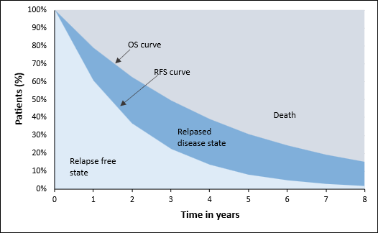
Abbreviations: OS, overall survival; RFS, relapse-free survival.

Supplemental Figure 2 Extrapolated OS MCM for Blinatumomab + SoC.
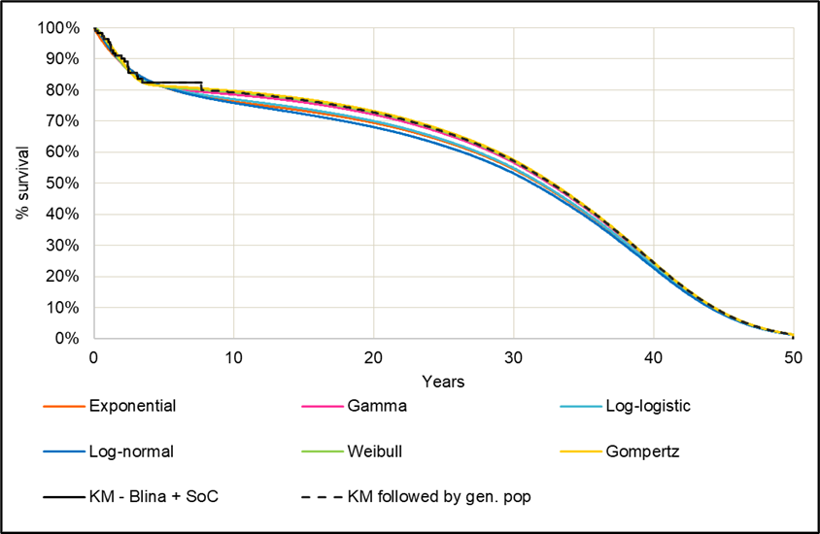

Supplemental Figure 3 Extrapolated OS MCM for SoC.
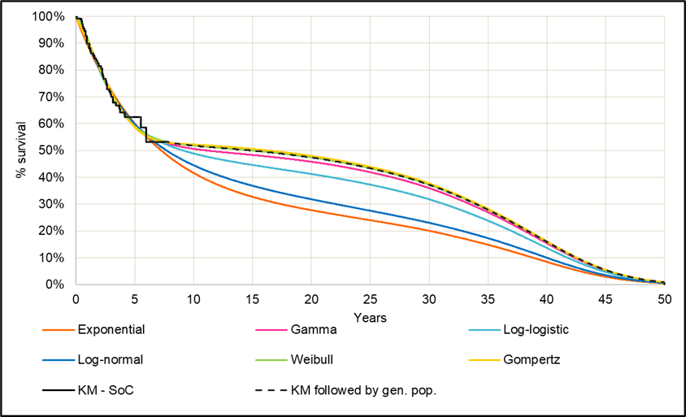

Supplemental Figure 4 Extrapolated RFS MCM for Blinatumomab + SoC.
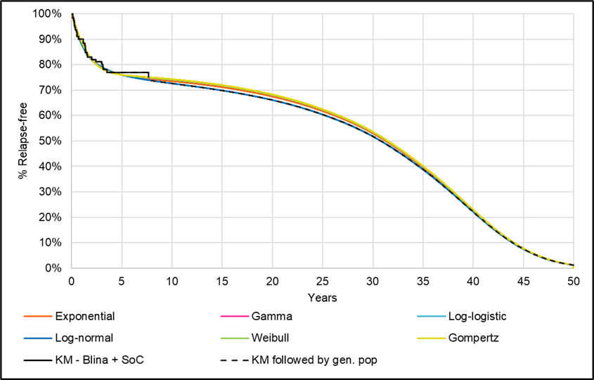

Supplemental Figure 5 Extrapolated RFS MCM for SoC.
