Supplemental Material
DNA Double-Strand Break (DSB) staining protocol:

Cells were grown on glass coverslips in 35 mm petri dishes at densities described in Section 2.4 and were incubated for 24 hrs for adherence. GNP-dosing procedures also followed, as described in Section 2.4. Post-irradiation to 200 cGy, the media in each well was removed and replaced with fresh media before cells were incubated. 24 hr after irradiation, cells were fixed with 4% PFA for 5 min at room temperature, followed by two PBS washes for 5 min each. Cells were blocked with 2%BSA/0.1% Triton-X in PBS for 20 min. The primary antibody 53BP1 was diluted to 1:200 in 0.5%BSA/0.1%Triton-X/PBS, while the second antibody (Alexa Fluor 488; excitation 490 nm, emission 525 nm) was diluted to 1:500 in 0.5% BSA/0.1% Triton-X/PBS. The coverslips were placed face down onto 50 uL of the primary antibody on parafilm and incubated in the dark for 60 minutes. The coverslips were returned to the Petri dishes and washed with PBS for five min and once with 0.5% BSA/0.1% Triton-X/PBS. On new parafilm, the coverslips were placed face down in 50 uL of the secondary antibody solution and incubated in the dark for 45 min. Coverslips were returned to the wells, washed with PBS, and mounted to glass microscope slides with ProLong™ (P36930; ThermoFisherScientific, Waltham, MA, USA) Glass Antifade Mountant for imaging. 53BP1 foci were imaged using a 60X oil immersion lens and a confocal laser scanning microscope (Zeiss LSM 980). Images were processed, and foci and nuclei were counted. GNP-induced DNA damage-enhancement was quantified via the relative increase in average foci-per-cell, representing sites of DNA DSB repair. Approximately 250-300 cells across 3-4 images per condition were counted for statistical analysis.

Table S1: Range of treatment delivery times (min) as a function of source activity (Ci) for the in vivo irradiation jig.
 | Dose [cGy]
Activity (Ci) | 300 | 350 | 400 | 500
Activity (Ci) | Treatment Delivery [min]
10 | 14 | 15 | 16 | 18
9 | 15 | 16 | 17 | 20
8 | 15 | 17 | 18 | 21
7 | 17 | 18 | 20 | 23
6 | 18 | 20 | 22 | 26
5 | 21 | 23 | 25 | 30

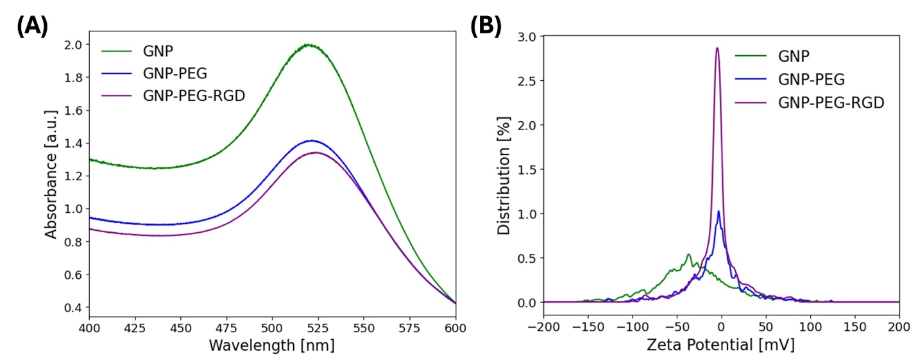
Figure S1: GNP Characterization. Ultra-violet visible spectra (A) and zeta potential (B) of bare and functionalized GNPs.

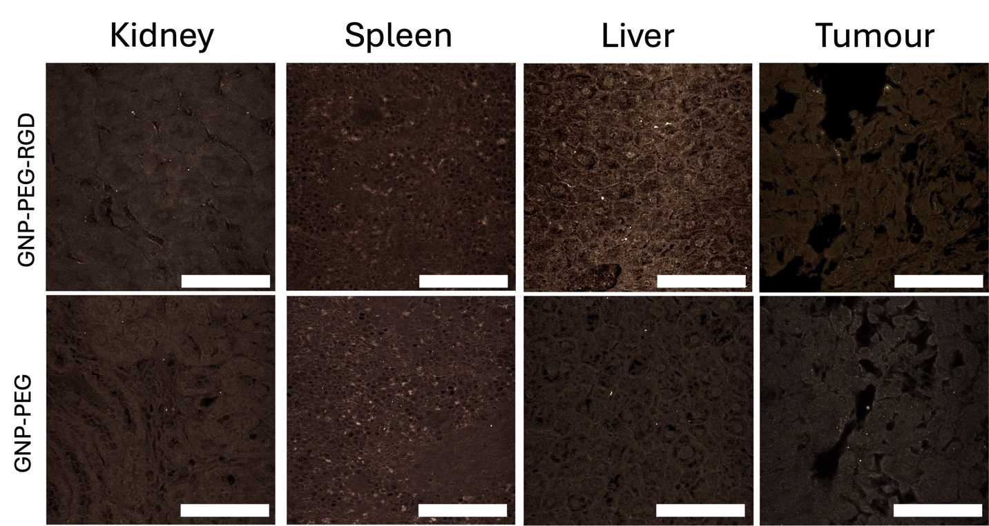
Figure S2: Tumour histology images depicting GNP-PEG and GNP-PEG-RGD distribution after intratumoural injections in the tumour, liver, spleen, and kidneys. Scale bar is 40 μm.

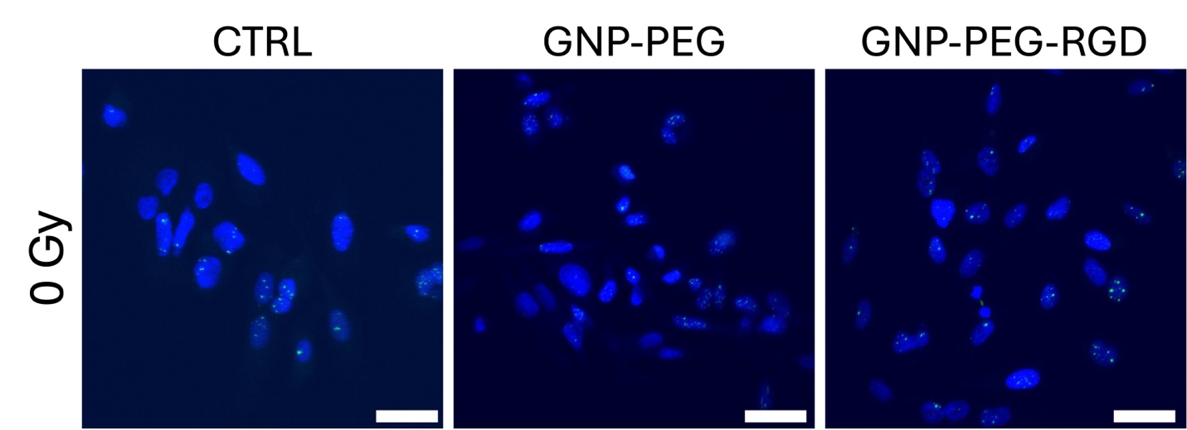
Figure S3: Confocal images of DNA DSBs in un-irradiated cell cultures. Scale bar is 20 μm.

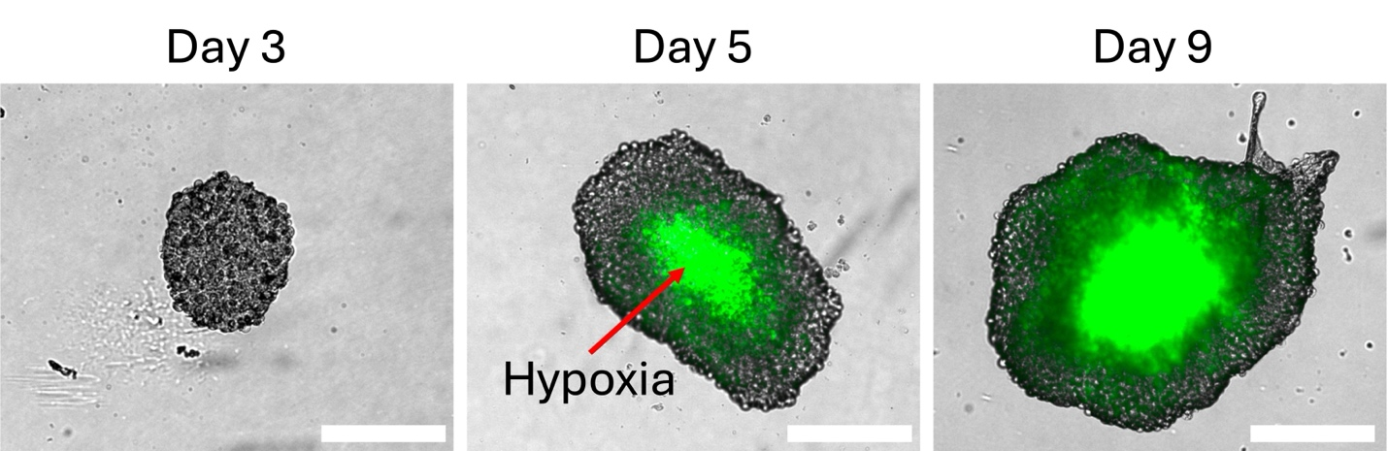
Figure S4: Hypoxic core in PC3 spheroids 3, 5, and 9 days post-seeding. The spheroids were incubated with 10 µM of Image-iT Hypoxia Reagent (Invitrogen) and then were incubated for 1 hour at 37 oC. The media was then exchanged with fresh medium. Brightfield images of the spheroids were then taken using a BioTek Cytation 1 Multimode Reader (Agilent Technologies, Santa Clara, CA, USA) using a 4X objective lens. Further, a GFP filter set (Excitation 469/35 nm, Emission 525/39 nm) was used to image the hypoxia reagent (Excitation 488 nm, Emission 520 nm). Scale bar is 300 μm.

Table S2: In vivo acute and physical toxicity assay investigating liver and kidney function, and total protein and electrolyte concentration.
Marker | GNP-PEG | GNP-PEG-RGD | Normal Range*
Liver Function
ALT | 15 U/L | 284 U/L | 29 ± 9 U/L
AST | 42 U/L | 396 U/L | 82 ± 47 U/L
Kidney Function
Urea (BUN) | 8.8 mmol/L | 9.9 mmol/L | 8.9 ± 1.1 mmol/L
Protein
Total Protein | 49 g/L | 51 g/L | 48 ± 3 g/L
Albumin | 29 g/L | 31 g/L | 28 ± 1 g/L
Globulin† | 20 g/L | 20 g/L | ~20 ± 3 g/L
Electrolytes and Carbohydrates
Sodium | 157 mmol/L | 158 mmol/L | 155 ± 1 mmol/L
Potassium | 7.0 mmol/L | 7.4 mmol/L | 5.2 ± 0.5 mmol/L
Calcium | 2.7 mmol/L | 2.7 mmol/L | 2.4 ± 0.1 mmol/L
Phosphorus | 3.0 mmol/L | 3.1 mmol/L | 3.4 ± 0.5 mmol/L
Glucose | 9.2 mmol/L | 13.7 mmol/L | 9.9 ± 1.6 mmol/L
*Ranges provided by The Jackson Laboratory. Physiological Data Summary -- NOD.CgRag1 ^{tm1Mom} Il2rg^{tm1Wjl}/SzJ (Stock No. 007799). Available from: https://www.jax.org/strain/007799. [Accessed April 22, 2026]. Values represent mean ± standard deviation of 9-10 male mice aged 8 weeks.

†: Globulin reference range derived from Total Protein minus Albumin
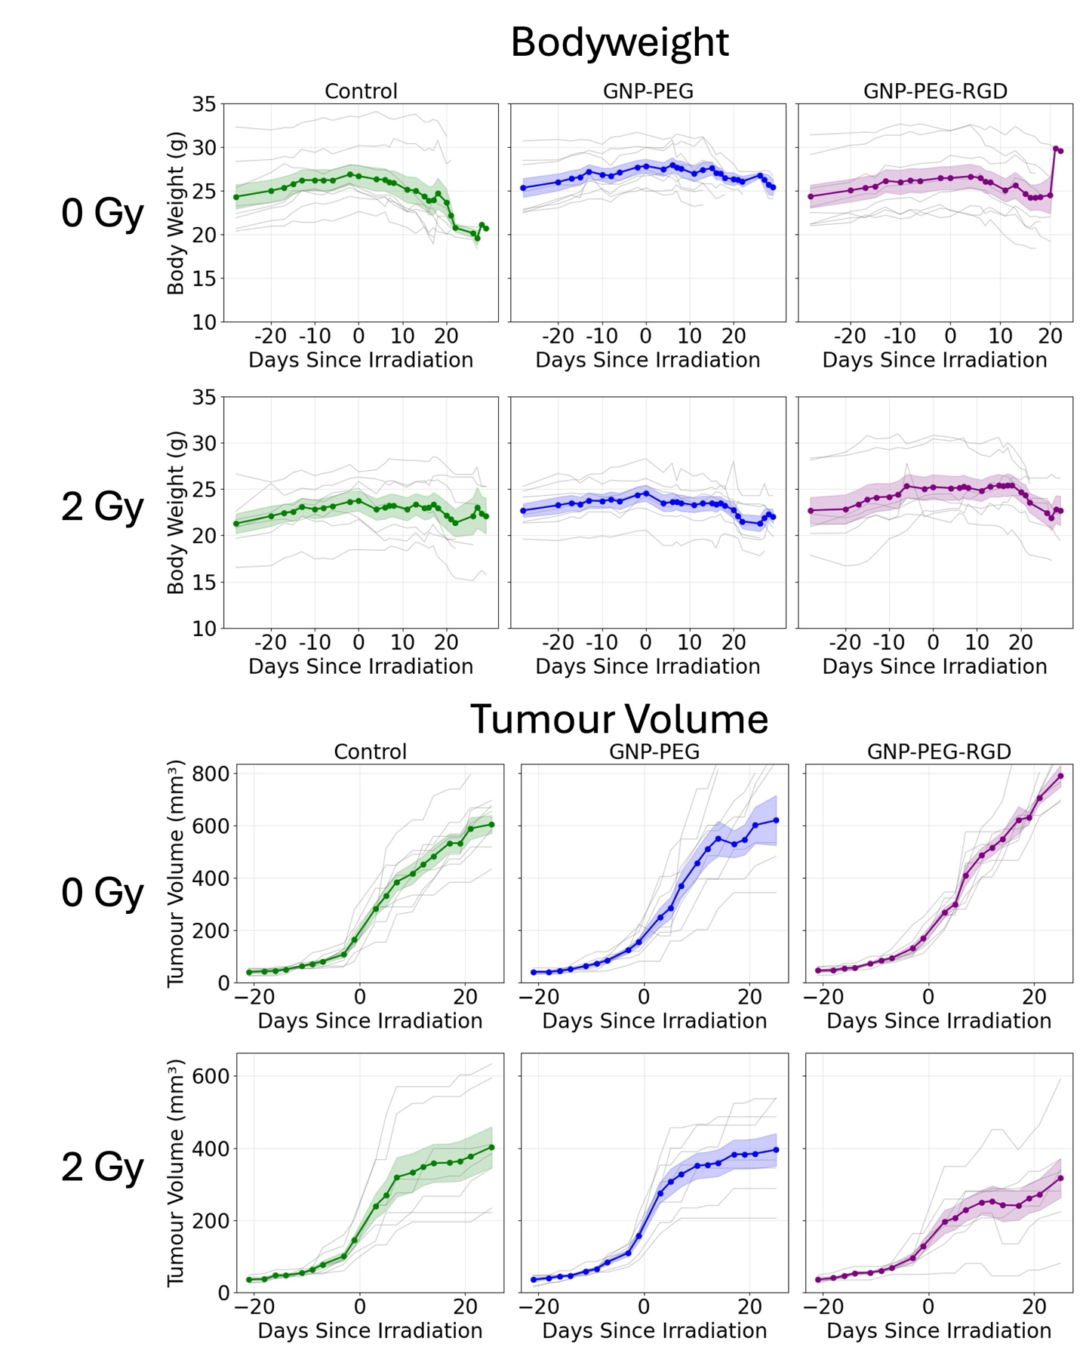
Figure S5: Individual (grey lines) bodyweight and tumour volumes of treatment groups over study period with group mean and ±SEM.

