Supplementary Online Content

Supplementary Figure 1. Flow chart of participants’ inclusion.
Supplementary Figure 2. Scree plot of eigenvalues within 15 sleep variables.
Supplementary Figure 3. Correlation matrix between sleep variables.
Supplementary Figure 4. Associations between sleep domains (rhythmicity, quality, duration, regularity, and timing) and risk of cognitive impairment were estimated using restricted cubic spline Cox proportional hazards models.
Supplementary Table 1. Factor loadings of 5 sleep domains within sleep variables.
Supplementary Table 2. Variable selection of elastic net regression.
Supplementary Table 3. Hyperparameters for the best-fitting XGBoost model.
Supplementary Table 4. Mean SHAP values for variables analysed in XGBoost model.
Supplementary Table 5. Subgroup analyses of associations between sleep domains and risk of cognitive impairment.
Supplementary Table 6. Sensitivity analyses of sleep domains and cognitive outcomes: cognitive impairment excluding early events and dementia diagnoses.
Supplementary Table 7. Sensitive analysis of factor loadings of 5 sleep domains within sleep variables using oblimin rotation.
Supplementary Table 8. Sensitive analysis of factor loadings of 5 sleep domains within sleep variables using promax rotation.
Supplementary Table 9. Cox regression analysis of sleep domains and cognitive impairment using oblimin rotation.
Supplementary Table 10. Cox regression analysis of sleep domains and cognitive impairment using proamx rotation.
Supplementary Table 11. Sensitive analysis for interval-censored Cox proportional hazards models.

Supplementary Figure 1. Flow chart of participants’ inclusion.
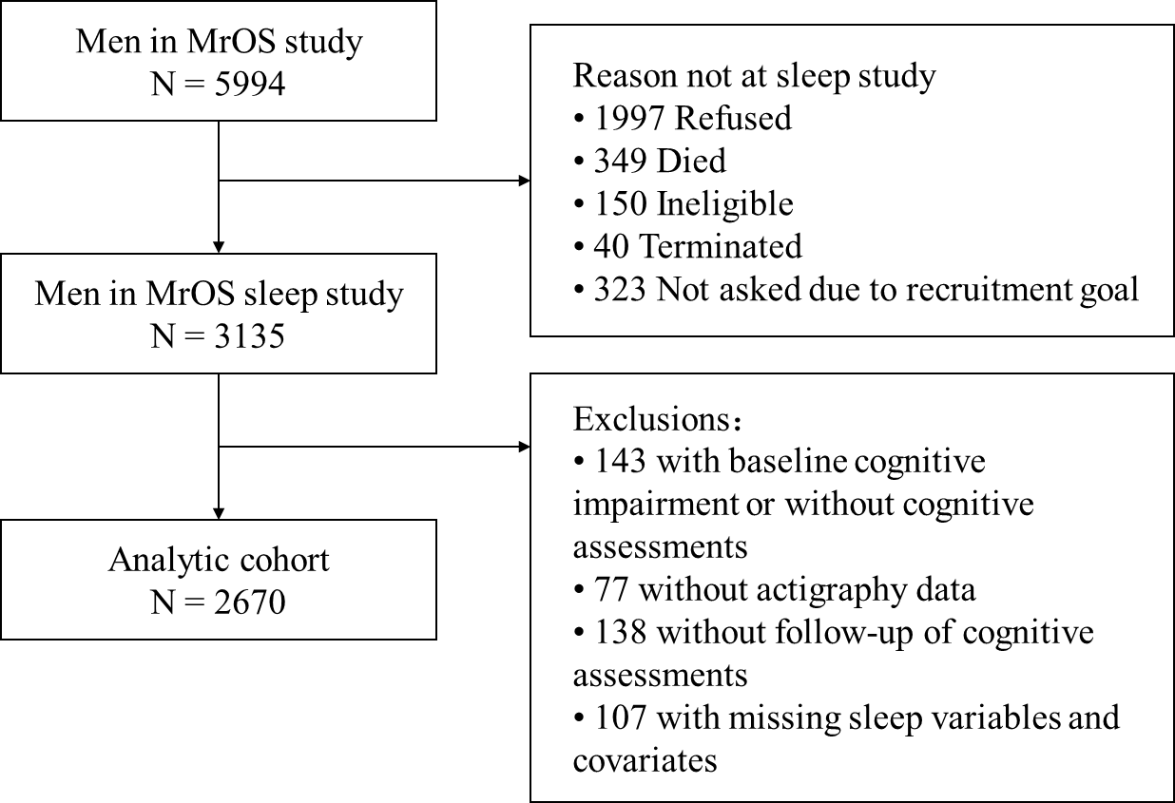

Supplementary Figure 2. Scree plot of eigenvalues within 15 sleep variables.
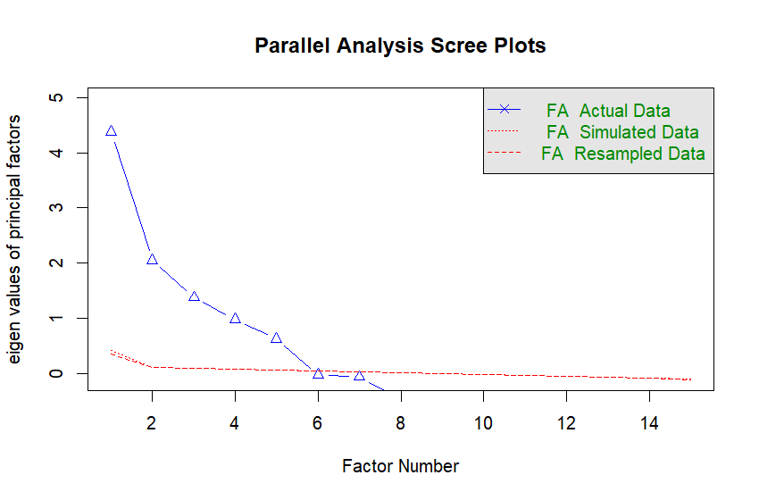
The x-axis represents the number of sleep variables, and the y-axis represents the eigenvalues. Parallel analysis was performed using both simulated and resampled data. The eigenvalues from the observed data exceeded those from the random data for the first five factors, supporting a five-factor solution.

Supplementary Figure 3. Correlation matrix between sleep variables.
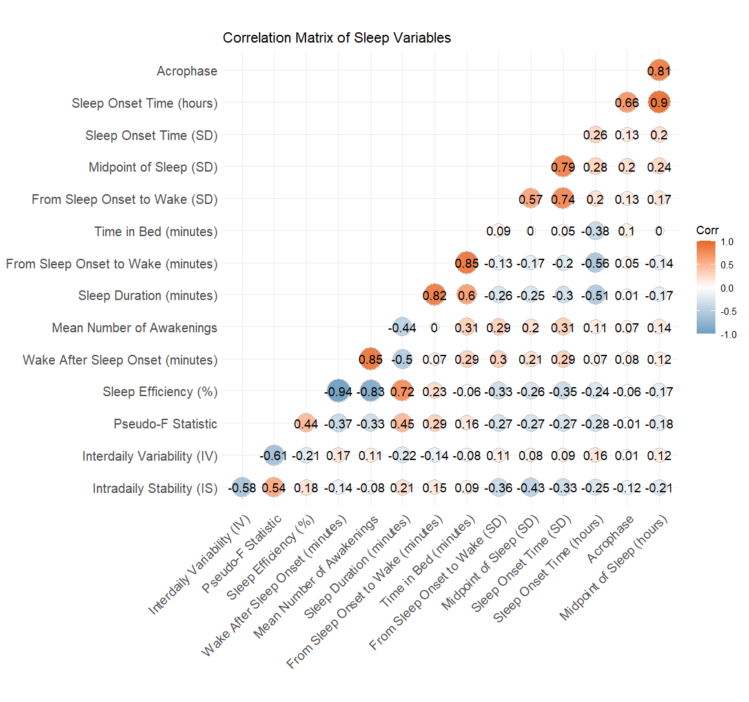

Supplementary Figure 4. Associations between sleep domains (rhythmicity, quality, duration, regularity, and timing) and risk of cognitive impairment were estimated using restricted cubic spline Cox proportional hazards models.
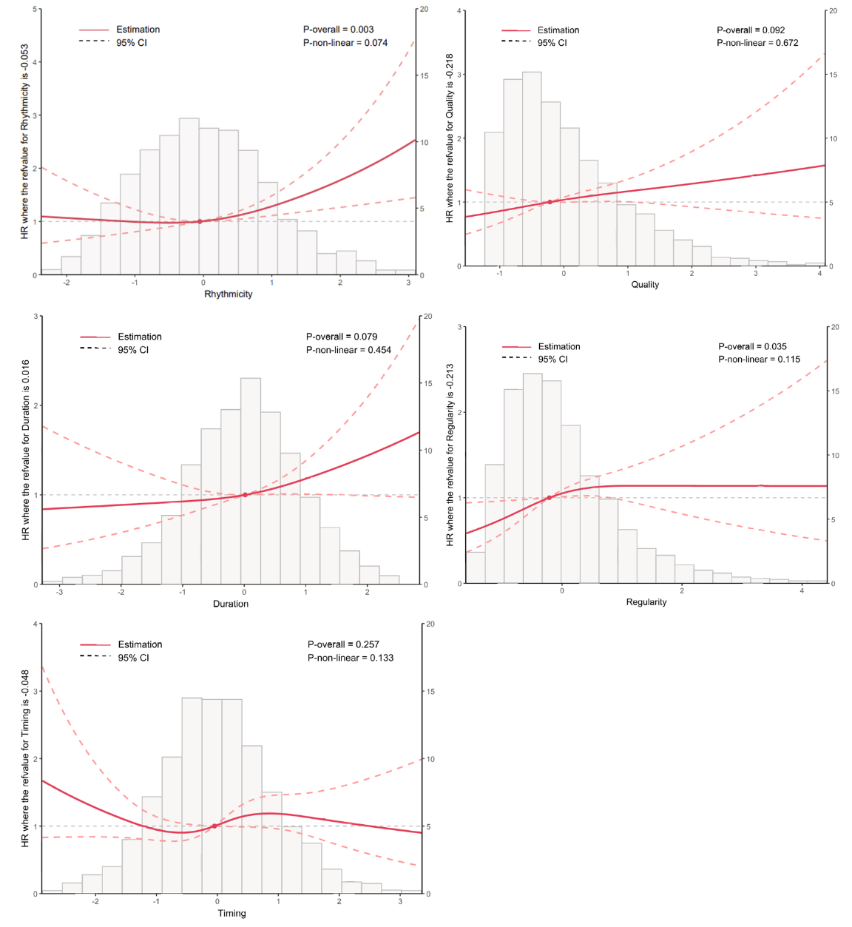
Restricted cubic spline under Cox proportional hazards models were used to examine the non-linear association between sleep domains and risk of cognitive impairment (3 knots). The red line represents the estimated hazard ratio (HR), and the shaded area indicates the 95% confidence interval. The histogram at the bottom illustrates the distribution of sleep domain values in the analytic sample. Models were fully adjusted for key demographics, lifestyle, health-related factors, self-reported medical comorbidities, and other sleep domains (Model 3). The reference value (HR = 1) corresponds to the median value of sleep domains. Overall and non-linear P-values are shown in the upper right corner of the plot.

Supplementary Table 1. Factor loadings of 5 sleep domains within sleep variables.
Variables | Rhythmicity | Quality | Timing | Regularity | Duration
Intradaily Stability (IS) | 0.704 | -0.063 | -0.137 | -0.293 | 0.077
Interdaily Variability (IV) | -0.779 | 0.117 | 0.055 | 0.017 | -0.098
Pseudo-F Statistic (PsF) | 0.667 | -0.334 | -0.097 | -0.154 | 0.23
Sleep Efficiency (%) | 0.074 | -0.948 | -0.077 | -0.134 | 0.192
Wake After Sleep Onset (minutes) | -0.076 | 0.985 | 0.026 | 0.089 | 0.102
Mean Number of Awakenings | 0.003 | 0.841 | 0.063 | 0.142 | 0.051
Sleep Onset Time (minutes) | -0.073 | 0.073 | 0.877 | 0.12 | -0.45
Acrophase (timing of peak activity) | 0.025 | 0.041 | 0.816 | 0.056 | 0.148
Midpoint of Sleep (minutes) | -0.067 | 0.081 | 0.989 | 0.083 | -0.015
From Sleep Onset to Wake (SD) | -0.11 | 0.232 | 0.086 | 0.707 | -0.038
Midpoint of Sleep (SD) | -0.129 | 0.134 | 0.158 | 0.777 | -0.065
Sleep Onset Time (SD) | -0.045 | 0.209 | 0.102 | 0.944 | -0.081
Sleep Duration (minutes) | 0.085 | -0.567 | -0.095 | -0.114 | 0.802
From Sleep Onset to Wake (mins) | 0.039 | -0.014 | -0.111 | -0.111 | 0.984
Time in Bed (minutes) | 0.065 | 0.202 | -0.01 | 0.089 | 0.88
Values in bold indicate factor loadings greater than 0.6.

Supplementary Table 2. Variable selection of elastic net regression.
Variables | Coefficient
Sleep Apnea | -0.30271
Cognitive Score at Baseline | -0.13331
Rhythmicity | 0.12056
Race | 0.10066
Frailty | 0.08314
Age | 0.04228
Depression Score | 0.03384
Duration | 0.03317
Self-Rated Health | 0.02863
Body Mass Index (kg/m²) | -0.02800
Quality | 0.01510
Regularity | 0.01020
Education | -0.00487
Sleep Medication | 0.00043
A total of 33 candidate variables, including multidimensional sleep measures (rhythmicity, regularity, duration, quality, and timing), demographic characteristics, lifestyle factors, clinical conditions, and baseline cognitive score, were entered into an elastic net model for variable selection. The optimal penalty parameter (λ) was determined using 10-fold cross-validation. Variables with non-zero coefficients at the optimal λ were retained for subsequent analyses.

Supplementary Table 3. Hyperparameters for the best-fitting XGBoost model.
Parameters | Value
Max Depth | 5.000
Learning Rate (eta) | 0.060
Loss Reduction (gamma) | 2.058
Subsample (sample size) | 0.675
Min Child Weight (min_n) | 8.000
Colsample Bytree (mtry) | 0.603

Supplementary Table 4. Mean SHAP values for variables analysed in XGBoost model.
Variables | Relative Importance
Cognitive Score at Baseline | 0.401
Frailty | 0.297
Rhythmicity | 0.216
Regularity | 0.172
Body Mass Index (kg/m²) | 0.157
Quality | 0.145
Age | 0.139
Duration | 0.115
Depression Score | 0.081
Education | 0.063
Race | 0.051
Sleep Medication | 0.036
Self-Rated Health | 0.014
Sleep Apnea | 0

Supplementary Table 5. Subgroup analyses of associations between sleep domains and risk of cognitive impairment.
 | Variable | Subgroups | HR (95% CI) | P value | P value for interaction
Duration
 | Age | <=80 | 1.14 (0.98-1.32) | 0.092 | 0.900
 |  | >80 | 1.14 (0.90-1.44) | 0.265
 | BMI | <=25 | 1.11 (0.90-1.35) | 0.329 | 0.763
 |  | >25 | 1.12 (0.95-1.31) | 0.166
 | Education | Under college | 1.17 (1.01-1.36) | 0.031* | 0.328
 |  | College | 1.10 (0.87-1.39) | 0.433
 | Smoke | Non-smoker | 1.09 (0.90-1.32) | 0.392 | 0.186
 |  | Smoker | 1.18 (1.01-1.39) | 0.042*
 | Alcohol | Non-drinker | 1.22 (1.01-1.48) | 0.040* | 0.700
 |  | Drinker | 1.08 (0.92-1.26) | 0.354
Quality
 | Age | <=80 | 1.14 (0.98-1.32) | 0.086 | 0.610
 |  | >80 | 1.08 (0.86-1.36) | 0.506
 | BMI | <=25 | 1.06 (0.85-1.32) | 0.611 | 0.865
 |  | >25 | 1.15 (0.99-1.33) | 0.063
 | Education | Under college | 1.13 (0.99-1.30) | 0.075 | 0.753
 |  | College | 1.21 (0.95-1.54) | 0.119
 | Smoke | Non-smoker | 1.08 (0.89-1.31) | 0.423 | 0.725
 |  | Smoker | 1.19 (1.01-1.40) | 0.035*
 | Alcohol | Non-drinker | 1.03 (0.84-1.27) | 0.76 | 0.269
 |  | Drinker | 1.20 (1.03-1.39) | 0.018*
Regularity
 | Age | <=80 | 1.09 (0.94-1.25) | 0.249 | 0.984
 |  | >80 | 1.14 (0.91-1.44) | 0.246
 | BMI | <=25 | 1.30 (1.05-1.61) | 0.014* | 0.127
 |  | >25 | 1.07 (0.92-1.24) | 0.365
 | Education | Under college | 1.15 (1.00-1.34) | 0.057 | 0.919
 |  | College | 1.04 (0.84-1.28) | 0.715
 | Smoke | Non-smoker | 1.16 (0.97-1.38) | 0.111 | 0.779
 |  | Smoker | 1.10 (0.93-1.30) | 0.28
 | Alcohol | Non-drinker | 1.33 (1.10-1.60) | 0.003** | 0.048*
 |  | Drinker | 1.02 (0.86-1.21) | 0.806
Rhythmicity
 | Age | <=80 | 1.19 (1.01-1.39) | 0.034* | 0.829
 |  | >80 | 1.44 (1.17-1.78) | <0.001***
 | BMI | <=25 | 1.21 (0.99-1.48) | 0.068 | 0.867
 |  | >25 | 1.21 (1.02-1.42) | 0.025*
 | Education | Under college | 1.22 (1.05-1.42) | 0.009** | 0.744
 |  | College | 1.33 (1.04-1.69) | 0.021*
 | Smoke | Non-smoker | 1.19 (0.99-1.44) | 0.057 | 0.889
 |  | Smoker | 1.22 (1.02-1.46) | 0.030*
 | Alcohol | Non-drinker | 1.27 (1.05-1.55) | 0.016* | 0.770
 |  | Drinker | 1.19 (1.01-1.41) | 0.034*
Timing
 | Age | <=80 | 0.97 (0.84-1.13) | 0.707 | 0.066
 |  | >80 | 1.19 (0.94-1.49) | 0.141
 | BMI | <=25 | 1.19 (0.96-1.48) | 0.103 | 0.097
 |  | >25 | 0.92 (0.79-1.08) | 0.326
 | Education | Under college | 0.99 (0.86-1.15) | 0.931 | 0.940
 |  | College | 0.97 (0.77-1.23) | 0.817
 | Smoke | Non-smoker | 0.96 (0.79-1.17) | 0.694 | 0.920
 |  | Smoker | 1.05 (0.89-1.23) | 0.564
 | Alcohol | Non-drinker | 0.87 (0.72-1.06) | 0.178 | 0.502
 |  | Drinker | 1.08 (0.91-1.27) | 0.393
* P value < 0.05, ** P value < 0.01, *** P value < 0.001
Abbreviations: HR, hazard ratio;
Adjusted for age at the sleep visit, race, body mass index, study site, marital status, living arrangement, education level, smoking status, alcohol use, self-rated health condition, depressive symptoms, physical activity, hypertension, congestive heart failure, stroke, myocardial infarction, transient ischemic attack, angina, coronary heart disease, cerebrovascular disease, diabetes, cancer, cataracts, hearing problems, frailty sleep medications within the past 30 days (nonbenzodiazepines and nonbarbiturate sedative-hypnotics), caffeine intake, and tea consumption, sleep apnea, as well as other sleep domains to account for their intercorrelations (Model 3).
Supplementary Table 6. Sensitivity analyses of sleep domains and cognitive outcomes: cognitive impairment excluding early events and dementia diagnoses.
 | Model 1ª |  | Model 2^{b} |  | Model 3^{c}
 | HR (95% CI) | P value | HR (95% CI) | P value | HR (95% CI) | P value
Excluding events in 2 years
Rhythmicity | 1.21 (1.06-1.39) | 0.006** | 1.20 (1.05-1.38) | 0.009** | 1.21 (1.05-1.39) | 0.008**
Regularity | 1.19 (1.05-1.34) | 0.008** | 1.17 (1.03-1.33) | 0.014* | 1.18 (1.04-1.33) | 0.013*
Quality | 1.13 (0.99-1.29) | 0.076 | 1.13 (0.98-1.30) | 0.083 | 1.16 (1.01-1.32) | 0.036*
Duration | 1.05 (0.91-1.20) | 0.495 | 1.05 (0.92-1.21) | 0.471 | 1.04 (0.91-1.19) | 0.538
Timing | 1.07 (0.93-1.24) | 0.324 | 1.05 (0.91-1.21) | 0.491 | 1.06 (0.92-1.21) | 0.435
Dementia
Rhythmicity | 1.26 (1.05-1.52) | 0.012* | 1.24 (1.03-1.50) | 0.020* | 1.27 (1.05-1.52) | 0.012*
Regularity | 1.21 (1.02-1.42) | 0.026* | 1.18 (1.00-1.40) | 0.048* | 1.17 (0.99-1.38) | 0.059
Quality | 1.23 (1.04-1.46) | 0.014* | 1.25 (1.05-1.48) | 0.012* | 1.26 (1.07-1.49) | 0.006**
Duration | 1.20 (1.00-1.44) | 0.053 | 1.21 (1.00-1.45) | 0.048* | 1.18 (0.99-1.41) | 0.066
Timing | 1.21 (1.01-1.44) | 0.037* | 1.18 (0.99-1.40) | 0.070 | 1.17 (0.99-1.39) | 0.073
* P value < 0.05, ** P value < 0.01
Abbreviations: HR, hazard ratio
ª Model 1: adjusted for key demographic, lifestyle, and health-related factors, including age at the sleep visit, race, body mass index, study site, marital status, living arrangement, education level, smoking status, alcohol use, self-rated health condition, depressive symptoms and physical activity.
^{b} Model 2: further adjusted for major medical comorbidities, including hypertension, congestive heart failure, stroke, myocardial infarction, transient ischemic attack, angina, coronary heart disease, cerebrovascular disease, diabetes, cancer, cataracts, hearing problems and frailty.
^{c} Model 3: further adjusted for sleep medications within the past 30 days (nonbenzodiazepines and nonbarbiturate sedative-hypnotics), caffeine intake, and tea consumption, sleep apnea, as well as other sleep domains to account for their intercorrelations.

Supplementary Table 7. Sensitive analysis of factor loadings of 5 sleep domains within sleep variables using oblimin rotation.
Variables | Rhythmicity | Quality | Timing | Regularity | Duration
Intradaily Stability (IS) | 0.726 | 0.112 | -0.043 | -0.2 | -0.059
Interdaily Variability (IV) | -0.83 | -0.007 | -0.015 | -0.11 | 0.03
Pseudo-F Statistic (PsF) | 0.687 | -0.2 | -0.007 | -0.03 | 0.104
Sleep Efficiency (%) | 0.037 | -0.932 | -0.022 | -0.039 | 0.144
Wake After Sleep Onset (minutes) | -0.051 | 0.991 | -0.009 | -0.007 | 0.149
Mean Number of Awakenings | 0.036 | 0.839 | 0.029 | 0.072 | 0.087
Sleep Onset Time (minutes) | -0.03 | -0.01 | 0.857 | 0.037 | -0.367
Acrophase (timing of peak activity) | 0.052 | 0.006 | 0.843 | -0.003 | 0.216
Midpoint of Sleep (minutes) | -0.034 | 0.015 | 1.001 | -0.006 | 0.081
From Sleep Onset to Wake (SD) | -0.051 | 0.069 | -0.015 | 0.724 | 0.029
Midpoint of Sleep (SD) | -0.066 | -0.053 | 0.05 | 0.8 | 0.011
Sleep Onset Time (SD) | 0.04 | 0.004 | -0.024 | 0.99 | -0.012
Sleep Duration (minutes) | 0.043 | -0.521 | -0.019 | -0.041 | 0.772
From Sleep Onset to Wake (mins) | 0.002 | 0.049 | -0.042 | -0.092 | 0.978
Time in Bed (minutes) | 0.058 | 0.228 | 0.028 | 0.099 | 0.893
Values in bold indicate factor loadings greater than 0.6.

Supplementary Table 8. Sensitive analysis of factor loadings of 5 sleep domains within sleep variables using promax rotation.
Variables | Rhythmicity | Quality | Timing | Regularity | Duration
Intradaily Stability (IS) | 0.738 | 0.128 | -0.034 | -0.182 | -0.057
Interdaily Variability (IV) | -0.854 | -0.02 | -0.024 | -0.14 | 0.037
Pseudo-F Statistic (PsF) | 0.691 | -0.191 | 0.01 | 0.002 | 0.096
Sleep Efficiency (%) | 0.008 | -0.952 | -0.003 | -0.001 | 0.115
Wake After Sleep Onset (minutes) | -0.039 | 1.02 | -0.014 | -0.047 | 0.189
Mean Number of Awakenings | 0.054 | 0.863 | 0.022 | 0.042 | 0.117
Sleep Onset Time (minutes) | -0.01 | -0.023 | 0.838 | 0.021 | -0.404
Acrophase (timing of peak activity) | 0.043 | 0.01 | 0.852 | -0.015 | 0.195
Midpoint of Sleep (minutes) | -0.039 | 0.014 | 1.003 | -0.024 | 0.052
From Sleep Onset to Wake (SD) | -0.021 | 0.067 | -0.027 | 0.733 | 0.024
Midpoint of Sleep (SD) | -0.034 | -0.06 | 0.037 | 0.814 | -0.002
Sleep Onset Time (SD) | 0.084 | -0.001 | -0.04 | 1.01 | -0.023
Sleep Duration (minutes) | -0.008 | -0.515 | 0.025 | -0.016 | 0.773
From Sleep Onset to Wake (mins) | -0.05 | 0.076 | 0.004 | -0.09 | 1.006
Time in Bed (minutes) | 0.023 | 0.257 | 0.066 | 0.098 | 0.92
Values in bold indicate factor loadings greater than 0.6.

Supplementary Table 9. Cox regression analysis of sleep domains and cognitive impairment using oblimin rotation.
 | Model 1ª |  | Model 2^{b} |  | Model 3^{c}
 | HR (95% CI) | P value | HR (95% CI) | P value | HR (95% CI) | P value
Rhythmicity | 1.23 (1.09-1.38) | <0.001*** | 1.21 (1.07-1.37) | 0.002** | 1.22 (1.07-1.40) | 0.004**
Quality | 1.13 (1.01-1.28) | 0.035* | 1.13 (1.00-1.28) | 0.046* | 1.08 (0.95-1.22) | 0.251
Duration | 1.12 (0.99-1.27) | 0.061 | 1.13 (1.00-1.28) | 0.053 | 1.19 (1.05-1.34) | 0.008**
Regularity | 1.16 (1.04-1.30) | 0.011* | 1.15 (1.03-1.29) | 0.017* | 1.09 (0.96-1.25) | 0.176
Timing | 1.03 (0.91-1.16) | 0.658 | 1.01 (0.89-1.15) | 0.851 | 0.98 (0.86-1.11) | 0.707
* P value < 0.05, ** P value < 0.01, *** P value < 0.001
Abbreviations: HR, hazard ratio
ª Model 1: adjusted for key demographic, lifestyle, and health-related factors, including age at the sleep visit, race, body mass index, study site, marital status, living arrangement, education level, smoking status, alcohol use, self-rated health condition, depressive symptoms and physical activity.
^{b} Model 2: further adjusted for major medical comorbidities, including hypertension, congestive heart failure, stroke, myocardial infarction, transient ischemic attack, angina, coronary heart disease, cerebrovascular disease, diabetes, cancer, cataracts, hearing problems and frailty.
^{c} Model 3: further adjusted for sleep medications within the past 30 days (nonbenzodiazepines and nonbarbiturate sedative-hypnotics), caffeine intake, and tea consumption, sleep apnea, as well as other sleep domains to account for their intercorrelations.

Supplementary Table 10. Cox regression analysis of sleep domains and cognitive impairment using promax rotation.
 | Model 1ª |  | Model 2^{b} |  | Model 3^{c}
 | HR (95% CI) | P value | HR (95% CI) | P value | HR (95% CI) | P value
Rhythmicity | 1.23 (1.09-1.39) | <0.001*** | 1.22 (1.07-1.37) | 0.002** | 1.23 (1.07-1.42) | 0.004**
Quality | 1.14 (1.01-1.28) | 0.03* | 1.13 (1.01-1.28) | 0.041* | 1.08 (0.95-1.23) | 0.252
Duration | 1.11 (0.98-1.25) | 0.111 | 1.11 (0.98-1.26) | 0.092 | 1.19 (1.05-1.36) | 0.007**
Regularity | 1.17 (1.04-1.31) | 0.007** | 1.16 (1.03-1.30) | 0.013* | 1.09 (0.95-1.24) | 0.232
Timing | 1.04 (0.91-1.17) | 0.584 | 1.02 (0.90-1.15) | 0.771 | 0.98 (0.86-1.11) | 0.738
* P value < 0.05, ** P value < 0.01, *** P value < 0.001
Abbreviations: HR, hazard ratio
ª Model 1: adjusted for key demographic, lifestyle, and health-related factors, including age at the sleep visit, race, body mass index, study site, marital status, living arrangement, education level, smoking status, alcohol use, self-rated health condition, depressive symptoms and physical activity.
^{b} Model 2: further adjusted for major medical comorbidities, including hypertension, congestive heart failure, stroke, myocardial infarction, transient ischemic attack, angina, coronary heart disease, cerebrovascular disease, diabetes, cancer, cataracts, hearing problems and frailty.
^{c} Model 3: further adjusted for sleep medications within the past 30 days (nonbenzodiazepines and nonbarbiturate sedative-hypnotics), caffeine intake, and tea consumption, sleep apnea, as well as other sleep domains to account for their intercorrelations.

Supplementary Table 11. Sensitive analysis for interval-censored Cox proportional hazards models.
 | Model 1ª |  | Model 2^{b} |  | Model 3^{c}
 | HR (95% CI) | P value | HR (95% CI) | P value | HR (95% CI) | P value
Rhythmicity | 1.22 (1.07-1.40) | 0.004** | 1.22 (1.06-1.40) | 0.005** | 1.22 (1.08-1.38) | 0.001**
Quality | 1.11 (0.99-1.25) | 0.084 | 1.11 (0.98-1.26) | 0.096 | 1.11 (1.00-1.24) | 0.052
Duration | 1.14 (1.00-1.30) | 0.055 | 1.14 (1.00-1.29) | 0.046* | 1.12 (0.97-1.29) | 0.120
Regularity | 1.12 (1.00-1.26) | 0.057 | 1.12 (0.99-1.27) | 0.065 | 1.12 (0.99-1.26) | 0.074
Timing | 1.02 (0.89-1.17) | 0.754 | 1.01 (0.90-1.14) | 0.827 | 1.00 (0.88-1.14) | 0.953
* P value < 0.05, ** P value < 0.01
Abbreviations: HR, hazard ratio
ª Model 1: adjusted for key demographic, lifestyle, and health-related factors, including age at the sleep visit, race, body mass index, study site, marital status, living arrangement, education level, smoking status, alcohol use, self-rated health condition, depressive symptoms and physical activity.
^{b} Model 2: further adjusted for major medical comorbidities, including hypertension, congestive heart failure, stroke, myocardial infarction, transient ischemic attack, angina, coronary heart disease, cerebrovascular disease, diabetes, cancer, cataracts, hearing problems and frailty.
^{c} Model 3: further adjusted for sleep medications within the past 30 days (nonbenzodiazepines and nonbarbiturate sedative-hypnotics), caffeine intake, and tea consumption, sleep apnea, as well as other sleep domains to account for their intercorrelations.

