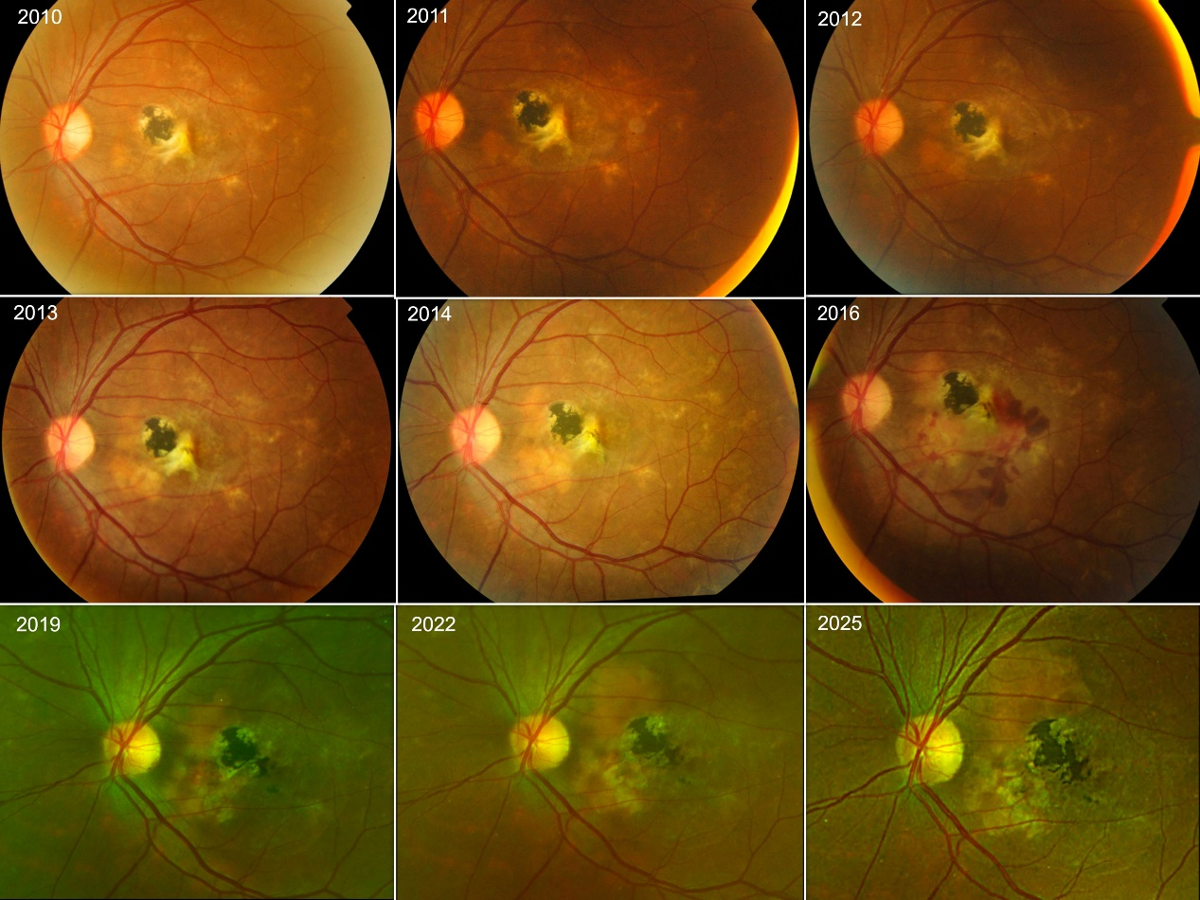
Supplemental figure 1: The serial examinations of the left eye throughout the follow-up duration from 2010 to 2025.

