Supplementary Figures and Tables
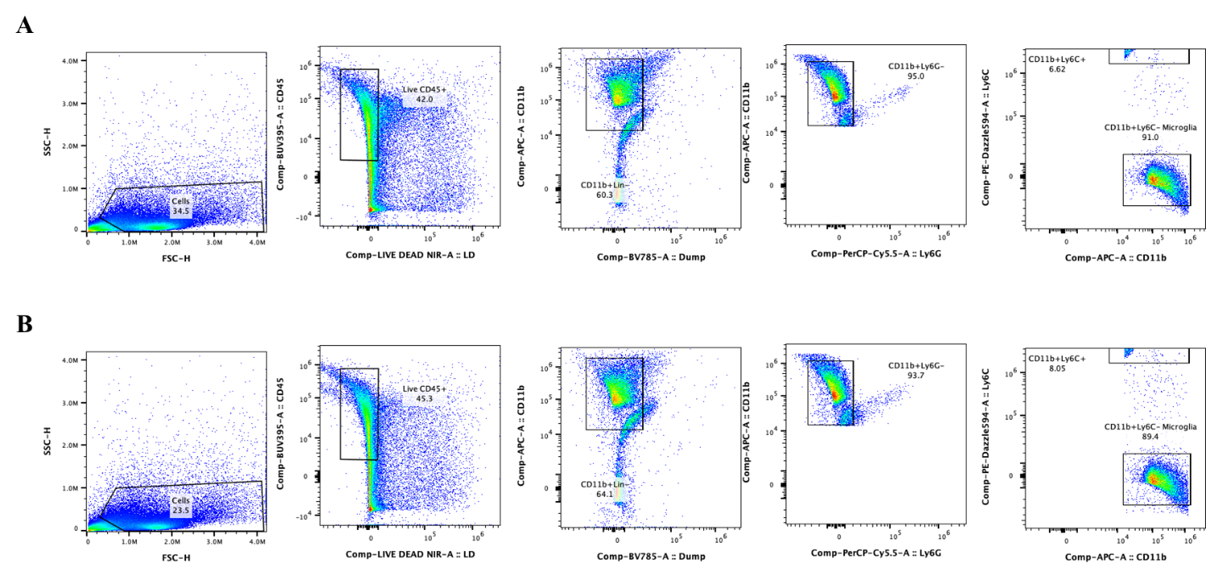

Supplementary Fig. 1 FACS gating strategy for microglia. A) Sorting strategy to identify and isolate microglia. Single cells were first identified by plotting side scatter-height against forward scatter-height. Selected live CD45⁺ cells were gated on the CD11b-positive population for microglia/macrophages while excluding T cells (CD3), B cells (CD19), and NK cells (NK1.1) in the dump channel. A purer microglial population was collected by removing cells that were positive for infiltrating macrophage maker Ly6C and neutrophil marker Ly6G. B) Post-sort analysis for the purity of the isolated CD45⁺CD11b⁺Ly6C⁻Ly6G⁻Dump⁻ microglia.

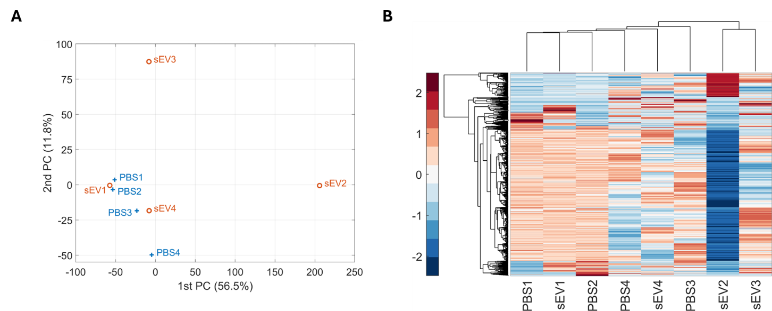

Supplementary Fig. 2 Correlation analysis of gene expression in spinal cord microglia from mice 14 days after intrathecal injection of sEVs or PBS. A) Principal component analysis (PCA). B) Hierarchical clustering of gene expression profiles. The gradient legend represents expression levels, with red indicating high expression and blue indicating low expression. Microglia were isolated from the whole spinal cord of mice 14 days post-sEV or PBS injection. Two samples were obtained by magnetic-activated cell sorting (MACS) and two by fluorescence-activated cell sorting (FACS). Each sample subjected to sequencing consisted of a pool of 6-8 mice.
Supplementary Table 1 List of differentially expressed genes in lumbar spinal cord tissue 7 days after sEV treatment. Genes were selected based on p-value < 0.01 and absolute fold change > 2. Signed fold change indicates direction and magnitude of expression change relative to PBS-treated controls.
Supplementary Table 2 Differentially expressed genes (excluding predicted or unannotated genes) in spinal cord microglia isolated 14 days after sEV treatment. Genes were selected based on p-value < 0.01 and absolute fold change > 2. Signed fold change indicates direction and magnitude of expression change relative to PBS-treated controls.
Supplementary Table 3 Alterations in H3K4me1 enrichment following sEV treatment, determined using ChIP-seq with an H3K4me1 antibody on spinal microglia collected 14 days after sEV injection. In the two biological samples per condition, each replicate consisted of a pool of 6-8 mice. Gene set enrichment analysis (GSEA) performed using the genes associated with peaks present only in the sEV-treated group.
Supplementary Table 4 Experimental design for studying effects of blocking H3Kme1 deposition by inhibiting SETD7 methyltransferase activity using PFI-2 in sEV-induced prophylaxis. DMSO at different concentrations were used as vehicle control. VEH, vehicle. sEVs, small extracellular vesicles.

Group | Day 1 | Day 2-4 (10 µL)
PBS/VEH | 5 µL 1% DMSO + 5 µL PBS | 0.1% DMSO
sEVs/VEH | 5 µL 1% DMSO + 5 µL sEVs (1 µg) | 0.1% DMSO
PBS/PFI-2 | 5 µL 20 µM PFI-2 + 5 µL PBS | 10 µM PFI-2
sEVs/PFI-2 | 5 µL 20 µM PFI-2 + 5 µL sEVs (1 µg) | 10 µM PFI-2

