Supplementary Materials
Table S1 Retrieval strategy
Pubmed: 846 records
#1 | "acute cerebrovascular lesion"[Title/Abstract] OR "acute focal cerebral vasculopathy"[Title/Abstract] OR "Apoplexia"[Title/Abstract] OR "Apoplexy"[Title/Abstract] OR "brain accident"[Title/Abstract] OR "brain attack"[Title/Abstract] OR "brain blood flow disturbance"[Title/Abstract] OR "brain insult*"[Title/Abstract] OR "Brain Vascular Accident*"[Title/Abstract] OR "cerebral bleeding"[Title/Abstract] OR "cerebral insult"[Title/Abstract] OR "Cerebrovascular Accident*"[Title/Abstract] OR "cerebrovascular insult"[Title/Abstract] OR "CVA"[Title/Abstract] OR "CVAs"[Title/Abstract] OR "Poststroke"[Title/Abstract] OR "intracerebral hemorrhage"[Title/Abstract] OR "cerebrovascular infarct*"[Title/Abstract] OR "brain infarct*" "Aphasia*"[Title/Abstract] OR "Word Deafness"[Title/Abstract] OR "Alogia*"[Title/Abstract] OR "Anepia*"[Title/Abstract] OR "Logagnosia*"[Title/Abstract] OR "Logamnesia*"[Title/Abstract] OR "Logasthenia*"[Title/Abstract] OR "Dysphasia*"[Title/Abstract] OR "Dejerine-Lichtheim Phenomenon"[Title/Abstract] OR "Dejerine Lichtheim Phenomenon"[Title/Abstract] OR "Lichtheim Sign"[Title/Abstract] OR "Lichtheims Sign"[Title/Abstract] OR "Speech"[Title/Abstract] OR "linguistic*"[Title/Abstract] OR "verbal communication"[Title/Abstract] OR "oral communication"[Title/Abstract] OR "word fluency"[Title/Abstract] OR "language disorder*"[Title/Abstract] OR "speech disorder*"[Title/Abstract] OR "anomia"[Title/Abstract]
#2 | Stroke[MeSH Terms]
#3 | Aphasia[MeSH Terms]
#4 | "Aphasia*"[Title/Abstract] OR "Word Deafness"[Title/Abstract] OR "Alogia*"[Title/Abstract] OR "Anepia*"[Title/Abstract] OR "Logagnosia*"[Title/Abstract] OR "Logamnesia*"[Title/Abstract] OR "Logasthenia*"[Title/Abstract] OR "Dysphasia*"[Title/Abstract] OR "Dejerine-Lichtheim Phenomenon"[Title/Abstract] OR "Dejerine Lichtheim Phenomenon"[Title/Abstract] OR "Lichtheim Sign"[Title/Abstract] OR "Lichtheims Sign"[Title/Abstract] OR "Speech"[Title/Abstract] OR "linguistic*"[Title/Abstract] OR "verbal communication"[Title/Abstract] OR "oral communication"[Title/Abstract] OR "word fluency"[Title/Abstract] OR "language disorder*"[Title/Abstract] OR "speech disorder*"[Title/Abstract] OR "anomia"[Title/Abstract]
#5 | Transcranial Magnetic Stimulation[MeSH Terms]
#6 | Transcranial Magnetic Stimulation*"[Title/Abstract] OR "repetitive transcranial magnetic stimulation"[Title/Abstract] OR "TMS"[Title/Abstract] OR "rTMS"[Title/Abstract] OR "magnetic stimulation"[Title/Abstract] OR "TBS"[Title/Abstract] OR "iTBS"[Title/Abstract] OR "cTBS"[Title/Abstract] OR "Theta burst stimulation"[Title/Abstract] OR "θ-brust stimulation"[Title/Abstract] OR "θ burst stimulation"[Title/Abstract] OR "intermittent theta burst stimulation"[Title/Abstract] OR "Continuous theta burst stimulation"[Title/Abstract] OR "non-invasive brain stimulation"[Title/Abstract]
#7 | (#1 OR #2) AND (#3 OR #4) AND (#5 OR #6)

Embase: 585 records
#1 | 'acute cerebrovascular lesion':ti,ab,kw OR 'acute focal cerebral vasculopathy':ti,ab,kw OR 'apoplexia':ti,ab,kw OR 'apoplexy':ti,ab,kw OR 'brain accident':ti,ab,kw OR 'brain attack':ti,ab,kw OR 'brain blood flow disturbance':ti,ab,kw OR 'brain insult*':ti,ab,kw OR 'brain vascular accident*':ti,ab,kw OR 'cerebral bleeding':ti,ab,kw OR 'cerebral insult':ti,ab,kw OR 'cerebrovascular accident*':ti,ab,kw OR 'cerebrovascular insult':ti,ab,kw OR 'cva':ti,ab,kw OR 'cvas':ti,ab,kw OR 'poststroke':ti,ab,kw OR 'intracerebral hemorrhage':ti,ab,kw OR 'cerebrovascular infarct*':ti,ab,kw OR 'brain infarct*':ti,ab,kw
#2 | 'cerebrovascular accident'/exp
#3 | 'aphasia*':ti,ab,kw OR 'word deafness':ti,ab,kw OR 'alogia*':ti,ab,kw OR 'anepia*':ti,ab,kw OR 'logagnosia*':ti,ab,kw OR 'logamnesia*':ti,ab,kw OR 'logasthenia*':ti,ab,kw OR 'dysphasia*':ti,ab,kw OR 'dejerine-lichtheim phenomenon':ti,ab,kw OR 'dejerine lichtheim phenomenon':ti,ab,kw OR 'lichtheim sign':ti,ab,kw OR 'lichtheims sign':ti,ab,kw OR 'speech':ti,ab,kw OR 'linguistic*':ti,ab,kw OR 'verbal communication':ti,ab,kw OR 'oral communication':ti,ab,kw OR 'word fluency':ti,ab,kw OR 'language disorder*':ti,ab,kw OR 'speech disorder*':ti,ab,kw OR 'anomia':ti,ab,kw
#4 | 'aphasia'/exp
#5 | 'transcranial magnetic stimulation*':ti,ab,kw OR 'repetitive transcranial magnetic stimulation':ti,ab,kw OR 'tms':ti,ab,kw OR 'rtms':ti,ab,kw OR 'magnetic stimulation':ti,ab,kw OR 'tbs':ti,ab,kw OR 'itbs':ti,ab,kw OR 'ctbs':ti,ab,kw OR 'theta burst stimulation':ti,ab,kw OR '胃-brust stimulation':ti,ab,kw OR '胃 burst stimulation':ti,ab,kw OR 'intermittent theta burst stimulation':ti,ab,kw OR 'continuous theta burst stimulation':ti,ab,kw OR 'non-invasive brain stimulation':ti,ab,kw
#6 | 'repetitive transcranial magnetic stimulation'/exp
#7 | (#1 OR #2) AND (#3 OR #4) AND (#5 OR #6)

Cochrane Library: 281 records
#1 | (‘acute cerebrovascular lesion‘ OR ‘acute focal cerebral vasculopathy‘ OR ‘Apoplexia‘ OR ‘Apoplexy‘ OR ‘brain accident‘ OR ‘brain attack‘ OR ‘brain blood flow disturbance‘ OR ‘brain insult*‘ OR ‘Brain Vascular Accident*‘ OR ‘cerebral bleeding‘ OR ‘cerebral insult‘ OR ‘Cerebrovascular Accident*‘ OR ‘cerebrovascular insult‘ OR ‘CVA‘ OR ‘CVAs‘ OR ‘Poststroke‘ OR ‘intracerebral hemorrhage‘ OR ‘cerebrovascular infarct*‘ OR ‘brain infarct*‘):ti,ab,kw
#2 | MeSH descriptor: [Stroke] explode all trees
#3 | ‘Aphasia*‘ OR ‘Word Deafness‘ OR ‘Alogia*‘ OR ‘Anepia*‘ OR ‘Logagnosia*‘ OR ‘Logamnesia*‘ OR ‘Logasthenia*‘ OR ‘Dysphasia*‘ OR ‘Dejerine-Lichtheim Phenomenon‘ OR ‘Dejerine Lichtheim Phenomenon‘ OR ‘Lichtheim Sign‘ OR ‘Lichtheims Sign‘ OR ‘Speech‘ OR ‘linguistic*‘ OR ‘verbal communication‘ OR ‘oral communication‘ OR ‘word fluency‘ OR ‘language disorder*‘ OR ‘speech disorder*‘ OR ‘anomia‘):ti,ab,kw
#4 | MeSH descriptor: [Aphasia] explode all trees
#5 | (‘Transcranial Magnetic Stimulation*‘ OR ‘repetitive transcranial magnetic stimulation‘ OR ‘TMS‘ OR ‘rTMS‘ OR ‘magnetic stimulation‘ OR ‘TBS‘ OR ‘iTBS‘ OR ‘cTBS‘ OR ‘Theta burst stimulation‘ OR ‘θ-brust stimulation‘ OR ‘θ burst stimulation‘ OR ‘intermittent theta burst stimulation‘ OR ‘Continuous theta burst stimulation‘ OR ‘non-invasive brain stimulation‘):ti,ab,kw
#6 | MeSH descriptor: [Transcranial Magnetic Stimulation] explode all trees
#7 | (#1 OR #2) AND (#3 OR #4) AND (#5 OR #6)

WOS: 188 records
#1 | TS=（“acute cerebrovascular lesion" OR "acute focal cerebral vasculopathy" OR "apoplexie" OR "Apoplexy" OR "brain accident" OR "brain attack" OR "brain blood flow disturbance" OR "brain insult*" OR "Brain Vascular Accident*" OR "cerebral bleeding" OR "cerebral insult" OR "Cerebrovascular Accident*" OR "cerebrovascular insult" OR "CVA" OR "CVAs" OR "Poststroke" OR "intracerebral hemorrhage" OR "cerebrovascular infarct*" OR "brain infarct*"）
#2 | TS=（“Aphasia*" OR "Word Deafness" OR "Alogia*" OR "Anepia*" OR "Logagnosia*" OR "Logamnesia*" OR "Logasthenia*" OR "Dysphasia*" OR "Dejerine-Lichtheim Phenomenon" OR "Dejerine Lichtheim Phenomenon" OR "Lichtheim Sign" OR "Lichtheims Sign" OR "Speech" OR "linguistic*" OR "verbal communication" OR "oral communication" OR "word fluency" OR "language disorder*" OR "speech disorder*" OR "anomia"）
#3 | TS=(“Transcranial Magnetic Stimulation*" OR "repetitive transcranial magnetic stimulation" OR "TMS" OR "rTMS" OR "magnetic stimulation" OR "TBS" OR "iTBS" OR "cTBS" OR "Theta burst stimulation" OR "θ-brust stimulation" OR "θ burst stimulation" OR "intermittent theta burst stimulation" OR "Continuous theta burst stimulation" OR "non-invasive brain stimulation"
#4 | #1 AND #2 AND #3

Table S2 Certainty of evidence (GRADE) for all network estimates across 11 outcomes
Outcome | Comparison | Network estimate SMD (95% CrI) | Certainty | τ² (95% CrI) | PSRF
Immediate Improvement in Aphasia Severity | LF-rTMS+music+SLT vs. SLT | 2.05 (0.84, 3.29) | Low b, d | 0.1728 (0.0057, 0.6349) | 1.02
Immediate Improvement in Aphasia Severity | LF-rTMS+music+SLT vs. SLT | 2.05 (0.84, 3.29) | ⨁⨁◯◯ | 0.1728 (0.0057, 0.6349) | 1.02
Immediate Improvement in Aphasia Severity | LF-rTMS+music+SLT vs. music+SLT | 1.77 (0.43, 3.14) | Low b, d | 0.1728 (0.0057, 0.6349) | 1.02
Immediate Improvement in Aphasia Severity | LF-rTMS+music+SLT vs. music+SLT | 1.77 (0.43, 3.14) | ⨁⨁◯◯ | 0.1728 (0.0057, 0.6349) | 1.02
Immediate Improvement in Aphasia Severity | LF-rTMS+music+SLT vs. LF-rTMS+SLT | 1.48 (0.21, 2.73) | Low b, d | 0.1728 (0.0057, 0.6349) | 1.02
Immediate Improvement in Aphasia Severity | LF-rTMS+music+SLT vs. LF-rTMS+SLT | 1.48 (0.21, 2.73) | ⨁⨁◯◯ | 0.1728 (0.0057, 0.6349) | 1.02
Immediate Improvement in Aphasia Severity | LF-rTMS+music+SLT vs. iTBS+SLT | 1.51 (0.18, 2.82) | Low b, d | 0.1728 (0.0057, 0.6349) | 1.02
Immediate Improvement in Aphasia Severity | LF-rTMS+music+SLT vs. iTBS+SLT | 1.51 (0.18, 2.82) | ⨁⨁◯◯ | 0.1728 (0.0057, 0.6349) | 1.02
Immediate Improvement in Aphasia Severity | LF-rTMS+music+SLT vs. cTBS+SLT | 1.31 (-0.11, 2.69) | Very Low b, f | 0.1728 (0.0057, 0.6349) | 1.02
Immediate Improvement in Aphasia Severity | LF-rTMS+music+SLT vs. cTBS+SLT | 1.31 (-0.11, 2.69) | ⨁◯◯◯ | 0.1728 (0.0057, 0.6349) | 1.02
Immediate Improvement in Aphasia Severity | LF-rTMS+music+SLT vs. Dual-rTMS+SLT | 0.99 (-0.74, 2.73) | Very Low b, f | 0.1728 (0.0057, 0.6349) | 1.02
Immediate Improvement in Aphasia Severity | LF-rTMS+music+SLT vs. Dual-rTMS+SLT | 0.99 (-0.74, 2.73) | ⨁◯◯◯ | 0.1728 (0.0057, 0.6349) | 1.02
Immediate Improvement in Aphasia Severity | Dual-rTMS+SLT vs. SLT | 0.17 (-0.56, 0.90) | Very Low b, d | 0.1728 (0.0057, 0.6349) | 1.02
Immediate Improvement in Aphasia Severity | Dual-rTMS+SLT vs. SLT | 0.17 (-0.56, 0.90) | ⨁◯◯◯ | 0.1728 (0.0057, 0.6349) | 1.02
Immediate Improvement in Aphasia Severity | Dual-rTMS+SLT vs. music+SLT | 0.79 (-0.86, 2.43) | Very Low b, f | 0.1728 (0.0057, 0.6349) | 1.02
Immediate Improvement in Aphasia Severity | Dual-rTMS+SLT vs. music+SLT | 0.79 (-0.86, 2.43) | ⨁◯◯◯ | 0.1728 (0.0057, 0.6349) | 1.02
Immediate Improvement in Aphasia Severity | Dual-rTMS+SLT vs. LF-rTMS+SLT | 0.49 (-0.79, 1.74) | Very Low b, f | 0.1728 (0.0057, 0.6349) | 1.02
Immediate Improvement in Aphasia Severity | Dual-rTMS+SLT vs. LF-rTMS+SLT | 0.49 (-0.79, 1.74) | ⨁◯◯◯ | 0.1728 (0.0057, 0.6349) | 1.02
Immediate Improvement in Aphasia Severity | Dual-rTMS+SLT vs. iTBS+SLT | 0.52 (-0.82, 1.83) | Very Low b, f | 0.1728 (0.0057, 0.6349) | 1.02
Immediate Improvement in Aphasia Severity | Dual-rTMS+SLT vs. iTBS+SLT | 0.52 (-0.82, 1.83) | ⨁◯◯◯ | 0.1728 (0.0057, 0.6349) | 1.02
Immediate Improvement in Aphasia Severity | Dual-rTMS+SLT vs. cTBS+SLT | 0.19 (-0.54, 0.94) | Very Low b, d | 0.1728 (0.0057, 0.6349) | 1.02
Immediate Improvement in Aphasia Severity | Dual-rTMS+SLT vs. cTBS+SLT | 0.19 (-0.54, 0.94) | ⨁◯◯◯ | 0.1728 (0.0057, 0.6349) | 1.02
Immediate Improvement in Aphasia Severity | iTBS+SLT vs. SLT | 0.54 (0.06, 1.06) | Low b, d | 0.1728 (0.0057, 0.6349) | 1.02
Immediate Improvement in Aphasia Severity | iTBS+SLT vs. SLT | 0.54 (0.06, 1.06) | ⨁⨁◯◯ | 0.1728 (0.0057, 0.6349) | 1.02
Immediate Improvement in Aphasia Severity | iTBS+SLT vs. music+SLT | 0.27 (-0.93, 1.49) | Very Low b, f | 0.1728 (0.0057, 0.6349) | 1.02
Immediate Improvement in Aphasia Severity | iTBS+SLT vs. music+SLT | 0.27 (-0.93, 1.49) | ⨁◯◯◯ | 0.1728 (0.0057, 0.6349) | 1.02
Immediate Improvement in Aphasia Severity | iTBS+SLT vs. LF-rTMS+SLT | -0.033 (-0.61, 0.54) | Very Low b, d | 0.1728 (0.0057, 0.6349) | 1.02
Immediate Improvement in Aphasia Severity | iTBS+SLT vs. LF-rTMS+SLT | -0.033 (-0.61, 0.54) | ⨁◯◯◯ | 0.1728 (0.0057, 0.6349) | 1.02
Immediate Improvement in Aphasia Severity | iTBS+SLT vs. cTBS+SLT | 0.32 (-1.09, 1.70) | Very Low b, f | 0.1728 (0.0057, 0.6349) | 1.02
Immediate Improvement in Aphasia Severity | iTBS+SLT vs. cTBS+SLT | 0.32 (-1.09, 1.70) | ⨁◯◯◯ | 0.1728 (0.0057, 0.6349) | 1.02
Immediate Improvement in Aphasia Severity | cTBS+SLT vs. SLT | 0.74 (0.09, 1.43) | Low b, d | 0.1728 (0.0057, 0.6349) | 1.02
Immediate Improvement in Aphasia Severity | cTBS+SLT vs. SLT | 0.74 (0.09, 1.43) | ⨁⨁◯◯ | 0.1728 (0.0057, 0.6349) | 1.02
Immediate Improvement in Aphasia Severity | cTBS+SLT vs. music+SLT | 0.47 (-0.80, 1.78) | Very Low b, f | 0.1728 (0.0057, 0.6349) | 1.02
Immediate Improvement in Aphasia Severity | cTBS+SLT vs. music+SLT | 0.47 (-0.80, 1.78) | ⨁◯◯◯ | 0.1728 (0.0057, 0.6349) | 1.02
Immediate Improvement in Aphasia Severity | cTBS+SLT vs. LF-rTMS+SLT | 0.17 (-0.56, 0.90) | Very Low b, d | 0.1728 (0.0057, 0.6349) | 1.02
Immediate Improvement in Aphasia Severity | cTBS+SLT vs. LF-rTMS+SLT | 0.17 (-0.56, 0.90) | ⨁◯◯◯ | 0.1728 (0.0057, 0.6349) | 1.02
Immediate Improvement in Aphasia Severity | LF-rTMS+SLT vs. SLT | 0.58 (0.29, 0.90) | Moderate b | 0.1728 (0.0057, 0.6349) | 1.02
Immediate Improvement in Aphasia Severity | LF-rTMS+SLT vs. SLT | 0.58 (0.29, 0.90) | ⨁⨁⨁◯ | 0.1728 (0.0057, 0.6349) | 1.02
Immediate Improvement in Aphasia Severity | LF-rTMS+SLT vs. music+SLT | 0.29 (-0.57, 1.15) | Very Low b, d | 0.1728 (0.0057, 0.6349) | 1.02
Immediate Improvement in Aphasia Severity | LF-rTMS+SLT vs. music+SLT | 0.29 (-0.57, 1.15) | ⨁◯◯◯ | 0.1728 (0.0057, 0.6349) | 1.02
Immediate Improvement in Aphasia Severity | music+SLT vs. SLT | 0.28 (-0.82, 1.38) | Very Low b, f | 0.1728 (0.0057, 0.6349) | 1.02
Immediate Improvement in Aphasia Severity | music+SLT vs. SLT | 0.28 (-0.82, 1.38) | ⨁◯◯◯ | 0.1728 (0.0057, 0.6349) | 1.02
Immediate Improvement in Repetition | LF-rTMS+music+SLT vs. SLT | 1.63 (0.86, 2.39) | Low c, d | 0.0072 (0.00001, 0.0890) | 1.01
Immediate Improvement in Repetition | LF-rTMS+music+SLT vs. SLT | 1.63 (0.86, 2.39) | ⨁⨁◯◯ | 0.0072 (0.00001, 0.0890)
Immediate Improvement in Repetition | LF-rTMS+music+SLT vs. music+SLT | 1.06 (0.05, 2.05) | Low c, d | 0.0072 (0.00001, 0.0890)
Immediate Improvement in Repetition | LF-rTMS+music+SLT vs. music+SLT | 1.06 (0.05, 2.05) | ⨁⨁◯◯ | 0.0072 (0.00001, 0.0890)
Immediate Improvement in Repetition | LF-rTMS+music+SLT vs. LF-rTMS+SLT | 1.29 (0.49, 2.08) | Low c, d | 0.0072 (0.00001, 0.0890)
Immediate Improvement in Repetition | LF-rTMS+music+SLT vs. LF-rTMS+SLT | 1.29 (0.49, 2.08) | ⨁⨁◯◯ | 0.0072 (0.00001, 0.0890)
Immediate Improvement in Repetition | LF-rTMS+music+SLT vs. iTBS+SLT | 1.38 (0.53, 2.21) | Low c, d | 0.0072 (0.00001, 0.0890)
Immediate Improvement in Repetition | LF-rTMS+music+SLT vs. iTBS+SLT | 1.38 (0.53, 2.21) | ⨁⨁◯◯ | 0.0072 (0.00001, 0.0890)
Immediate Improvement in Repetition | LF-rTMS+music+SLT vs. cTBS+SLT | 1.07 (0.12, 1.98) | Low c, d | 0.0072 (0.00001, 0.0890)
Immediate Improvement in Repetition | LF-rTMS+music+SLT vs. cTBS+SLT | 1.07 (0.12, 1.98) | ⨁⨁◯◯ | 0.0072 (0.00001, 0.0890)
Immediate Improvement in Repetition | LF-rTMS+music+SLT vs. LF-rTMS | 1.68 (0.49, 2.86) | Low c, d | 0.0072 (0.00001, 0.0890)
Immediate Improvement in Repetition | LF-rTMS+music+SLT vs. LF-rTMS | 1.68 (0.49, 2.86) | ⨁⨁◯◯ | 0.0072 (0.00001, 0.0890)
Immediate Improvement in Repetition | LF-rTMS+music+SLT vs. Dual-rTMS+SLT | 1.07 (0.12, 1.98) | Low c, d | 0.0072 (0.00001, 0.0890)
Immediate Improvement in Repetition | LF-rTMS+music+SLT vs. Dual-rTMS+SLT | 1.07 (0.12, 1.98) | ⨁⨁◯◯ | 0.0072 (0.00001, 0.0890)
Immediate Improvement in Repetition | Dual-rTMS+SLT vs. SLT | 0.61 (0.03, 1.09) | Moderate c | 0.0072 (0.00001, 0.0890)
Immediate Improvement in Repetition | Dual-rTMS+SLT vs. SLT | 0.61 (0.03, 1.09) | ⨁⨁⨁◯ | 0.0072 (0.00001, 0.0890)
Immediate Improvement in Repetition | Dual-rTMS+SLT vs. music+SLT | 0.60 (-0.12, 1.33) | Very Low c, d | 0.0072 (0.00001, 0.0890)
Immediate Improvement in Repetition | Dual-rTMS+SLT vs. music+SLT | 0.60 (-0.12, 1.33) | ⨁◯◯◯ | 0.0072 (0.00001, 0.0890)
Immediate Improvement in Repetition | Dual-rTMS+SLT vs. LF-rTMS+SLT | 0.31 (-0.11, 0.73) | Low c, d | 0.0072 (0.00001, 0.0890)
Immediate Improvement in Repetition | Dual-rTMS+SLT vs. LF-rTMS+SLT | 0.31 (-0.11, 0.73) | ⨁⨁◯◯ | 0.0072 (0.00001, 0.0890)
Immediate Improvement in Repetition | Dual-rTMS+SLT vs. iTBS+SLT | 0.42 (-0.08, 0.92) | Low c, d | 0.0072 (0.00001, 0.0890)
Immediate Improvement in Repetition | Dual-rTMS+SLT vs. iTBS+SLT | 0.42 (-0.08, 0.92) | ⨁⨁◯◯ | 0.0072 (0.00001, 0.0890)
Immediate Improvement in Repetition | Dual-rTMS+SLT vs. cTBS+SLT | 0.00 (-0.62, 0.62) | Low c, d | 0.0072 (0.00001, 0.0890)
Immediate Improvement in Repetition | Dual-rTMS+SLT vs. cTBS+SLT | 0.00 (-0.62, 0.62) | ⨁⨁◯◯ | 0.0072 (0.00001, 0.0890)
Immediate Improvement in Repetition | Dual-rTMS+SLT vs. LF-rTMS | 0.66 (-0.42, 1.74) | Very Low c, d | 0.0072 (0.00001, 0.0890)
Immediate Improvement in Repetition | Dual-rTMS+SLT vs. LF-rTMS | 0.66 (-0.42, 1.74) | ⨁◯◯◯ | 0.0072 (0.00001, 0.0890)
Immediate Improvement in Repetition | iTBS+SLT vs. SLT | 0.19 (-0.03, 0.41) | Moderate d | 0.0072 (0.00001, 0.0890)
Immediate Improvement in Repetition | iTBS+SLT vs. SLT | 0.19 (-0.03, 0.41) | ⨁⨁⨁◯ | 0.0072 (0.00001, 0.0890)
Immediate Improvement in Repetition | iTBS+SLT vs. LF-rTMS+SLT | -0.12 (-0.52, 0.28) | Low c, d | 0.0072 (0.00001, 0.0890)
Immediate Improvement in Repetition | iTBS+SLT vs. LF-rTMS+SLT | -0.12 (-0.52, 0.28) | ⨁⨁◯◯ | 0.0072 (0.00001, 0.0890)
Immediate Improvement in Repetition | iTBS+SLT vs. LF-rTMS | 0.24 (-0.84, 1.32) | Very Low c, d | 0.0072 (0.00001, 0.0890)
Immediate Improvement in Repetition | iTBS+SLT vs. LF-rTMS | 0.24 (-0.84, 1.32) | ⨁◯◯◯ | 0.0072 (0.00001, 0.0890)
Immediate Improvement in Repetition | iTBS+SLT vs. cTBS+SLT | -0.42 (-0.92, 0.08) | Low c, d | 0.0072 (0.00001, 0.0890)
Immediate Improvement in Repetition | iTBS+SLT vs. cTBS+SLT | -0.42 (-0.92, 0.08) | ⨁⨁◯◯ | 0.0072 (0.00001, 0.0890)
Immediate Improvement in Repetition | iTBS+SLT vs. music+SLT | 0.18 (-0.52, 0.88) | Low c, d | 0.0072 (0.00001, 0.0890)
Immediate Improvement in Repetition | iTBS+SLT vs. music+SLT | 0.18 (-0.52, 0.88) | ⨁⨁◯◯ | 0.0072 (0.00001, 0.0890)
Immediate Improvement in Repetition | cTBS+SLT vs. SLT | 0.19 (-0.03, 0.41) | Moderate d | 0.0072 (0.00001, 0.0890)
Immediate Improvement in Repetition | cTBS+SLT vs. SLT | 0.19 (-0.03, 0.41) | ⨁⨁⨁◯ | 0.0072 (0.00001, 0.0890)
Immediate Improvement in Repetition | cTBS+SLT vs. LF-rTMS+SLT | -0.12 (-0.52, 0.28) | Low c, d | 0.0072 (0.00001, 0.0890)
Immediate Improvement in Repetition | cTBS+SLT vs. LF-rTMS+SLT | -0.12 (-0.52, 0.28) | ⨁⨁◯◯ | 0.0072 (0.00001, 0.0890)
Immediate Improvement in Repetition | cTBS+SLT vs. LF-rTMS | 0.24 (-0.84, 1.32) | Very Low c, d | 0.0072 (0.00001, 0.0890)
Immediate Improvement in Repetition | cTBS+SLT vs. LF-rTMS | 0.24 (-0.84, 1.32) | ⨁◯◯◯ | 0.0072 (0.00001, 0.0890)
Immediate Improvement in Repetition | cTBS+SLT vs. music+SLT | 0.18 (-0.52, 0.88) | Low c, d | 0.0072 (0.00001, 0.0890)
Immediate Improvement in Repetition | cTBS+SLT vs. music+SLT | 0.18 (-0.52, 0.88) | ⨁⨁◯◯ | 0.0072 (0.00001, 0.0890)
Immediate Improvement in Repetition | LF-rTMS+SLT vs. SLT | 0.31 (0.11, 0.51) | High | 0.0072 (0.00001, 0.0890)
Immediate Improvement in Repetition | LF-rTMS+SLT vs. SLT | 0.31 (0.11, 0.51) | ⨁⨁⨁⨁ | 0.0072 (0.00001, 0.0890)
Immediate Improvement in Repetition | LF-rTMS+SLT vs. music+SLT | 0.30 (-0.34, 0.94) | Low c, d | 0.0072 (0.00001, 0.0890)
Immediate Improvement in Repetition | LF-rTMS+SLT vs. music+SLT | 0.30 (-0.34, 0.94) | ⨁⨁◯◯ | 0.0072 (0.00001, 0.0890)
Immediate Improvement in Repetition | LF-rTMS vs. SLT | -0.35 (-1.27, 0.57) | Very Low c, d | 0.0072 (0.00001, 0.0890)
Immediate Improvement in Repetition | LF-rTMS vs. SLT | -0.35 (-1.27, 0.57) | ⨁◯◯◯ | 0.0072 (0.00001, 0.0890)
Immediate Improvement in Repetition | music+SLT vs. SLT | 0.01 (-0.73, 0.75) | Low c, d | 0.0072 (0.00001, 0.0890)
Immediate Improvement in Repetition | music+SLT vs. SLT | 0.01 (-0.73, 0.75) | ⨁⨁◯◯ | 0.0072 (0.00001, 0.0890)
Immediate Improvement in Comprehension | Dual-rTMS+SLT vs. SLT | 1.18 (0.77, 1.57) | Moderate c | 0.0033 (0.00001, 0.0404) | 1.01
Immediate Improvement in Comprehension | Dual-rTMS+SLT vs. SLT | 1.18 (0.77, 1.57) | ⨁⨁⨁◯ | 0.0033 (0.00001, 0.0404) | 1.01
Immediate Improvement in Comprehension | Dual-rTMS+SLT vs. iTBS+SLT | 0.84 (0.35, 1.30) | Low c, d | 0.0033 (0.00001, 0.0404) | 1.01
Immediate Improvement in Comprehension | Dual-rTMS+SLT vs. iTBS+SLT | 0.84 (0.35, 1.30) | ⨁⨁◯◯ | 0.0033 (0.00001, 0.0404) | 1.01
Immediate Improvement in Comprehension | Dual-rTMS+SLT vs. LF-rTMS+SLT | 0.91 (0.48, 1.33) | Moderate c | 0.0033 (0.00001, 0.0404) | 1.01
Immediate Improvement in Comprehension | Dual-rTMS+SLT vs. LF-rTMS+SLT | 0.91 (0.48, 1.33) | ⨁⨁⨁◯ | 0.0033 (0.00001, 0.0404) | 1.01
Immediate Improvement in Comprehension | Dual-rTMS+SLT vs. cTBS+SLT | 0.72 (0.06, 1.37) | Low c, d | 0.0033 (0.00001, 0.0404) | 1.01
Immediate Improvement in Comprehension | Dual-rTMS+SLT vs. cTBS+SLT | 0.72 (0.06, 1.37) | ⨁⨁◯◯ | 0.0033 (0.00001, 0.0404) | 1.01
Immediate Improvement in Comprehension | Dual-rTMS+SLT vs. LF-rTMS | 1.38 (0.39, 2.37) | Low c, d | 0.0033 (0.00001, 0.0404) | 1.01
Immediate Improvement in Comprehension | Dual-rTMS+SLT vs. LF-rTMS | 1.38 (0.39, 2.37) | ⨁⨁◯◯ | 0.0033 (0.00001, 0.0404) | 1.01
Immediate Improvement in Comprehension | Dual-rTMS+SLT vs. music+SLT | 1.10 (0.34, 1.89) | Low c, d | 0.0033 (0.00001, 0.0404) | 1.01
Immediate Improvement in Comprehension | Dual-rTMS+SLT vs. music+SLT | 1.10 (0.34, 1.89) | ⨁⨁◯◯ | 0.0033 (0.00001, 0.0404) | 1.01
Immediate Improvement in Comprehension | iTBS+SLT vs. SLT | 0.33 (0.08, 0.58) | Moderate c | 0.0033 (0.00001, 0.0404) | 1.01
Immediate Improvement in Comprehension | iTBS+SLT vs. SLT | 0.33 (0.08, 0.58) | ⨁⨁⨁◯ | 0.0033 (0.00001, 0.0404) | 1.01
Immediate Improvement in Comprehension | iTBS+SLT vs. LF-rTMS+SLT | 0.071 (-0.21, 0.35) | Low c, d | 0.0033 (0.00001, 0.0404) | 1.01
Immediate Improvement in Comprehension | iTBS+SLT vs. LF-rTMS+SLT | 0.071 (-0.21, 0.35) | ⨁⨁◯◯ | 0.0033 (0.00001, 0.0404) | 1.01
Immediate Improvement in Comprehension | cTBS+SLT vs. SLT | 0.46 (-0.06, 0.97) | Low c, d | 0.0033 (0.00001, 0.0404) | 1.01
Immediate Improvement in Comprehension | cTBS+SLT vs. SLT | 0.46 (-0.06, 0.97) | ⨁⨁◯◯ | 0.0033 (0.00001, 0.0404) | 1.01
Immediate Improvement in Comprehension | LF-rTMS+SLT vs. SLT | 0.26 (0.14, 0.39) | High | 0.0033 (0.00001, 0.0404) | 1.01
Immediate Improvement in Comprehension | LF-rTMS+SLT vs. SLT | 0.26 (0.14, 0.39) | ⨁⨁⨁⨁ | 0.0033 (0.00001, 0.0404) | 1.01
Immediate Improvement in Comprehension | music+SLT vs. SLT | 0.07 (-0.59, 0.72) | Low c, d | 0.0033 (0.00001, 0.0404) | 1.01
Immediate Improvement in Comprehension | music+SLT vs. SLT | 0.07 (-0.59, 0.72) | ⨁⨁◯◯ | 0.0033 (0.00001, 0.0404) | 1.01
Immediate Improvement in Comprehension | LF-rTMS vs. SLT | 0.33 (0.08, 0.58) | Moderate c | 0.0033 (0.00001, 0.0404) | 1.01
Immediate Improvement in Comprehension | LF-rTMS vs. SLT | 0.33 (0.08, 0.58) | ⨁⨁⨁◯ | 0.0033 (0.00001, 0.0404) | 1.01
Immediate Improvement in Comprehension | LF-rTMS vs. LF-rTMS+SLT | 0.08 (-0.21, 0.34) | Low c, d | 0.0033 (0.00001, 0.0404) | 1.01
Immediate Improvement in Comprehension | LF-rTMS vs. LF-rTMS+SLT | 0.08 (-0.21, 0.34) | ⨁⨁◯◯ | 0.0033 (0.00001, 0.0404) | 1.01
Immediate Improvement in Comprehension | music+SLT vs. LF-rTMS+SLT | 0.19 (-0.48, 0.87) | Low c, d | 0.0033 (0.00001, 0.0404) | 1.01
Immediate Improvement in Comprehension | music+SLT vs. LF-rTMS+SLT | 0.19 (-0.48, 0.87) | ⨁⨁◯◯ | 0.0033 (0.00001, 0.0404) | 1.01
Immediate Improvement in Naming | LF-rTMS+music+SLT vs. SLT | 1.96 (1.15, 2.76) | Low c, d | 0.0052 (0.00001, 0.0656) | 1.01
Immediate Improvement in Naming | LF-rTMS+music+SLT vs. SLT | 1.96 (1.15, 2.76) | ⨁⨁◯◯ | 0.0052 (0.00001, 0.0656) | 1.01
Immediate Improvement in Naming | LF-rTMS+music+SLT vs. LF-rTMS+SLT | 1.55 (0.72, 2.36) | Low c, d | 0.0052 (0.00001, 0.0656) | 1.01
Immediate Improvement in Naming | LF-rTMS+music+SLT vs. LF-rTMS+SLT | 1.55 (0.72, 2.36) | ⨁⨁◯◯ | 0.0052 (0.00001, 0.0656) | 1.01
Immediate Improvement in Naming | LF-rTMS+music+SLT vs. iTBS+SLT | 1.56 (0.65, 2.47) | Low c, d | 0.0052 (0.00001, 0.0656) | 1.01
Immediate Improvement in Naming | LF-rTMS+music+SLT vs. iTBS+SLT | 1.56 (0.65, 2.47) | ⨁⨁◯◯ | 0.0052 (0.00001, 0.0656) | 1.01
Immediate Improvement in Naming | LF-rTMS+music+SLT vs. cTBS+SLT | 1.51 (0.53, 2.46) | Low c, d | 0.0052 (0.00001, 0.0656) | 1.01
Immediate Improvement in Naming | LF-rTMS+music+SLT vs. cTBS+SLT | 1.51 (0.53, 2.46) | ⨁⨁◯◯ | 0.0052 (0.00001, 0.0656) | 1.01
Immediate Improvement in Naming | LF-rTMS+music+SLT vs. Dual-rTMS+SLT | 1.21 (0.10, 2.41) | Low c, d | 0.0052 (0.00001, 0.0656) | 1.01
Immediate Improvement in Naming | LF-rTMS+music+SLT vs. Dual-rTMS+SLT | 1.21 (0.10, 2.41) | ⨁⨁◯◯ | 0.0052 (0.00001, 0.0656) | 1.01
Immediate Improvement in Naming | LF-rTMS+music+SLT vs. LF-rTMS | 2.59 (1.53, 3.61) | Low c, d | 0.0052 (0.00001, 0.0656) | 1.01
Immediate Improvement in Naming | LF-rTMS+music+SLT vs. LF-rTMS | 2.59 (1.53, 3.61) | ⨁⨁◯◯ | 0.0052 (0.00001, 0.0656) | 1.01
Immediate Improvement in Naming | LF-rTMS+music+SLT vs. music+SLT | 1.38 (0.36, 2.38) | Low c, d | 0.0052 (0.00001, 0.0656) | 1.01
Immediate Improvement in Naming | LF-rTMS+music+SLT vs. music+SLT | 1.38 (0.36, 2.38) | ⨁⨁◯◯ | 0.0052 (0.00001, 0.0656) | 1.01
Immediate Improvement in Naming | Dual-rTMS+SLT vs. SLT | 0.75 (-0.11, 1.61) | Very Low c, d | 0.0052 (0.00001, 0.0656) | 1.01
Immediate Improvement in Naming | Dual-rTMS+SLT vs. SLT | 0.75 (-0.11, 1.61) | ⨁◯◯◯ | 0.0052 (0.00001, 0.0656) | 1.01
Immediate Improvement in Naming | Dual-rTMS+SLT vs. LF-rTMS+SLT | 0.34 (-0.53, 1.17) | Very Low c, d | 0.0052 (0.00001, 0.0656) | 1.01
Immediate Improvement in Naming | Dual-rTMS+SLT vs. LF-rTMS+SLT | 0.34 (-0.53, 1.17) | ⨁◯◯◯ | 0.0052 (0.00001, 0.0656) | 1.01
Immediate Improvement in Naming | Dual-rTMS+SLT vs. iTBS+SLT | 0.34 (-0.62, 1.27) | Very Low c, d | 0.0052 (0.00001, 0.0656) | 1.01
Immediate Improvement in Naming | Dual-rTMS+SLT vs. iTBS+SLT | 0.34 (-0.62, 1.27) | ⨁◯◯◯ | 0.0052 (0.00001, 0.0656) | 1.01
Immediate Improvement in Naming | Dual-rTMS+SLT vs. cTBS+SLT | 0.29 (-0.70, 1.25) | Very Low c, d | 0.0052 (0.00001, 0.0656) | 1.01
Immediate Improvement in Naming | Dual-rTMS+SLT vs. cTBS+SLT | 0.29 (-0.70, 1.25) | ⨁◯◯◯ | 0.0052 (0.00001, 0.0656) | 1.01
Immediate Improvement in Naming | Dual-rTMS+SLT vs. LF-rTMS | 1.36 (0.28, 2.44) | Low c, d | 0.0052 (0.00001, 0.0656) | 1.01
Immediate Improvement in Naming | Dual-rTMS+SLT vs. LF-rTMS | 1.36 (0.28, 2.44) | ⨁⨁◯◯ | 0.0052 (0.00001, 0.0656) | 1.01
Immediate Improvement in Naming | Dual-rTMS+SLT vs. music+SLT | 0.16 (-0.91, 1.22) | Very Low c, d | 0.0052 (0.00001, 0.0656) | 1.01
Immediate Improvement in Naming | Dual-rTMS+SLT vs. music+SLT | 0.16 (-0.91, 1.22) | ⨁◯◯◯ | 0.0052 (0.00001, 0.0656) | 1.01
Immediate Improvement in Naming | iTBS+SLT vs. SLT | 0.40 (0.00, 0.81) | Moderate d | 0.0052 (0.00001, 0.0656) | 1.01
Immediate Improvement in Naming | iTBS+SLT vs. SLT | 0.40 (0.00, 0.81) | ⨁⨁⨁◯ | 0.0052 (0.00001, 0.0656) | 1.01
Immediate Improvement in Naming | iTBS+SLT vs. LF-rTMS+SLT | 0.01 (-0.43, 0.43) | Low c, d | 0.0052 (0.00001, 0.0656) | 1.01
Immediate Improvement in Naming | iTBS+SLT vs. LF-rTMS+SLT | 0.01 (-0.43, 0.43) | ⨁⨁◯◯ | 0.0052 (0.00001, 0.0656) | 1.01
Immediate Improvement in Naming | iTBS+SLT vs. cTBS+SLT | 0.06 (-0.59, 0.68) | Low c, d | 0.0052 (0.00001, 0.0656) | 1.01
Immediate Improvement in Naming | iTBS+SLT vs. cTBS+SLT | 0.06 (-0.59, 0.68) | ⨁⨁◯◯ | 0.0052 (0.00001, 0.0656) | 1.01
Immediate Improvement in Naming | iTBS+SLT vs. LF-rTMS | 1.02 (0.25, 1.80) | Low c, d | 0.0052 (0.00001, 0.0656) | 1.01
Immediate Improvement in Naming | iTBS+SLT vs. LF-rTMS | 1.02 (0.25, 1.80) | ⨁⨁◯◯ | 0.0052 (0.00001, 0.0656) | 1.01
Immediate Improvement in Naming | iTBS+SLT vs. music+SLT | -0.18 (-0.97, 0.59) | Low c, d | 0.0052 (0.00001, 0.0656) | 1.01
Immediate Improvement in Naming | iTBS+SLT vs. music+SLT | -0.18 (-0.97, 0.59) | ⨁⨁◯◯ | 0.0052 (0.00001, 0.0656) | 1.01
Immediate Improvement in Naming | cTBS+SLT vs. SLT | 0.46 (-0.08, 0.96) | Low c, d | 0.0052 (0.00001, 0.0656) | 1.01
Immediate Improvement in Naming | cTBS+SLT vs. SLT | 0.46 (-0.08, 0.96) | ⨁⨁◯◯ | 0.0052 (0.00001, 0.0656) | 1.01
Immediate Improvement in Naming | cTBS+SLT vs. LF-rTMS+SLT | 0.05 (-0.50, 0.57) | Low c, d | 0.0052 (0.00001, 0.0656) | 1.01
Immediate Improvement in Naming | cTBS+SLT vs. LF-rTMS+SLT | 0.05 (-0.50, 0.57) | ⨁⨁◯◯ | 0.0052 (0.00001, 0.0656) | 1.01
Immediate Improvement in Naming | cTBS+SLT vs. LF-rTMS | 1.09 (0.23, 1.88) | Low c, d | 0.0052 (0.00001, 0.0656) | 1.01
Immediate Improvement in Naming | cTBS+SLT vs. LF-rTMS | 1.09 (0.23, 1.88) | ⨁⨁◯◯ | 0.0052 (0.00001, 0.0656) | 1.01
Immediate Improvement in Naming | cTBS+SLT vs. music+SLT | -0.12 (-0.98, 0.71) | Low c, d | 0.0052 (0.00001, 0.0656) | 1.01
Immediate Improvement in Naming | cTBS+SLT vs. music+SLT | -0.12 (-0.98, 0.71) | ⨁⨁◯◯ | 0.0052 (0.00001, 0.0656) | 1.01
Immediate Improvement in Naming | LF-rTMS+SLT vs. SLT | 0.41 (0.27, 0.54) | High | 0.0052 (0.00001, 0.0656) | 1.01
Immediate Improvement in Naming | LF-rTMS+SLT vs. SLT | 0.41 (0.27, 0.54) | ⨁⨁⨁⨁ | 0.0052 (0.00001, 0.0656) | 1.01
Immediate Improvement in Naming | LF-rTMS+SLT vs. music+SLT | -0.18 (-0.86, 0.49) | Low c, d | 0.0052 (0.00001, 0.0656) | 1.01
Immediate Improvement in Naming | LF-rTMS+SLT vs. music+SLT | -0.18 (-0.86, 0.49) | ⨁⨁◯◯ | 0.0052 (0.00001, 0.0656) | 1.01
Immediate Improvement in Naming | LF-rTMS vs. SLT | -0.62 (-1.26, 0.05) | Very Low c, d | 0.0052 (0.00001, 0.0656) | 1.01
Immediate Improvement in Naming | LF-rTMS vs. SLT | -0.62 (-1.26, 0.05) | ⨁◯◯◯ | 0.0052 (0.00001, 0.0656) | 1.01
Immediate Improvement in Naming | LF-rTMS vs. music+SLT | -1.21 (-2.11, -0.26) | Low c, d | 0.0052 (0.00001, 0.0656) | 1.01
Immediate Improvement in Naming | LF-rTMS vs. music+SLT | -1.21 (-2.11, -0.26) | ⨁⨁◯◯ | 0.0052 (0.00001, 0.0656) | 1.01
Immediate Improvement in Naming | music+SLT vs. SLT | 0.58 (-0.07, 1.25) | Very Low c, d | 0.0052 (0.00001, 0.0656) | 1.01
Immediate Improvement in Naming | music+SLT vs. SLT | 0.58 (-0.07, 1.25) | ⨁◯◯◯ | 0.0052 (0.00001, 0.0656) | 1.01
Immediate Improvement in Spontaneous Speech | LF-rTMS+music+SLT vs. SLT | 1.48 (0.57, 2.40) | Low b, d | 0.0534 (0.00023, 0.3660) | 1.01
Immediate Improvement in Spontaneous Speech | LF-rTMS+music+SLT vs. SLT | 1.48 (0.57, 2.40) | ⨁⨁◯◯ | 0.0534 (0.00023, 0.3660) | 1.01
Immediate Improvement in Spontaneous Speech | LF-rTMS+music+SLT vs. LF-rTMS+SLT | 1.05 (0.10, 1.99) | Low b, d | 0.0534 (0.00023, 0.3660) | 1.01
Immediate Improvement in Spontaneous Speech | LF-rTMS+music+SLT vs. LF-rTMS+SLT | 1.05 (0.10, 1.99) | ⨁⨁◯◯ | 0.0534 (0.00023, 0.3660) | 1.01
Immediate Improvement in Spontaneous Speech | LF-rTMS+music+SLT vs. iTBS+SLT | 1.23 (0.24, 2.21) | Low b, d | 0.0534 (0.00023, 0.3660) | 1.01
Immediate Improvement in Spontaneous Speech | LF-rTMS+music+SLT vs. iTBS+SLT | 1.23 (0.24, 2.21) | ⨁⨁◯◯ | 0.0534 (0.00023, 0.3660) | 1.01
Immediate Improvement in Spontaneous Speech | LF-rTMS+music+SLT vs. cTBS+SLT | 2.53 (1.40, 3.70) | Low b, d | 0.0534 (0.00023, 0.3660) | 1.01
Immediate Improvement in Spontaneous Speech | LF-rTMS+music+SLT vs. cTBS+SLT | 2.53 (1.40, 3.70) | ⨁⨁◯◯ | 0.0534 (0.00023, 0.3660) | 1.01
Immediate Improvement in Spontaneous Speech | LF-rTMS+music+SLT vs. music+SLT | 1.27 (0.17, 2.36) | Low b, d | 0.0534 (0.00023, 0.3660) | 1.01
Immediate Improvement in Spontaneous Speech | LF-rTMS+music+SLT vs. music+SLT | 1.27 (0.17, 2.36) | ⨁⨁◯◯ | 0.0534 (0.00023, 0.3660) | 1.01
Immediate Improvement in Spontaneous Speech | Dual-rTMS+SLT vs. SLT | 1.06 (0.32, 1.80) | Moderate b | 0.0534 (0.00023, 0.3660) | 1.01
Immediate Improvement in Spontaneous Speech | Dual-rTMS+SLT vs. SLT | 1.06 (0.32, 1.80) | ⨁⨁⨁◯ | 0.0534 (0.00023, 0.3660) | 1.01
Immediate Improvement in Spontaneous Speech | Dual-rTMS+SLT vs. LF-rTMS+SLT | 0.63 (-0.16, 1.39) | Very Low b, d | 0.0534 (0.00023, 0.3660) | 1.01
Immediate Improvement in Spontaneous Speech | Dual-rTMS+SLT vs. LF-rTMS+SLT | 0.63 (-0.16, 1.39) | ⨁◯◯◯ | 0.0534 (0.00023, 0.3660) | 1.01
Immediate Improvement in Spontaneous Speech | Dual-rTMS+SLT vs. iTBS+SLT | 0.81 (-0.03, 1.62) | Very Low b, d | 0.0534 (0.00023, 0.3660) | 1.01
Immediate Improvement in Spontaneous Speech | Dual-rTMS+SLT vs. iTBS+SLT | 0.81 (-0.03, 1.62) | ⨁◯◯◯ | 0.0534 (0.00023, 0.3660) | 1.01
Immediate Improvement in Spontaneous Speech | Dual-rTMS+SLT vs. cTBS+SLT | 2.11 (1.13, 3.15) | Low b, d | 0.0534 (0.00023, 0.3660) | 1.01
Immediate Improvement in Spontaneous Speech | Dual-rTMS+SLT vs. cTBS+SLT | 2.11 (1.13, 3.15) | ⨁⨁◯◯ | 0.0534 (0.00023, 0.3660) | 1.01
Immediate Improvement in Spontaneous Speech | Dual-rTMS+SLT vs. music+SLT | 0.85 (-0.27, 1.98) | Very Low b, d | 0.0534 (0.00023, 0.3660) | 1.01
Immediate Improvement in Spontaneous Speech | Dual-rTMS+SLT vs. music+SLT | 0.85 (-0.27, 1.98) | ⨁◯◯◯ | 0.0534 (0.00023, 0.3660) | 1.01
Immediate Improvement in Spontaneous Speech | iTBS+SLT vs. SLT | 0.25 (-0.11, 0.63) | Low b, d | 0.0534 (0.00023, 0.3660) | 1.01
Immediate Improvement in Spontaneous Speech | iTBS+SLT vs. SLT | 0.25 (-0.11, 0.63) | ⨁⨁◯◯ | 0.0534 (0.00023, 0.3660) | 1.01
Immediate Improvement in Spontaneous Speech | iTBS+SLT vs. LF-rTMS+SLT | 0.18 (-0.23, 0.59) | Very Low b, d | 0.0534 (0.00023, 0.3660) | 1.01
Immediate Improvement in Spontaneous Speech | iTBS+SLT vs. LF-rTMS+SLT | 0.18 (-0.23, 0.59) | ⨁◯◯◯ | 0.0534 (0.00023, 0.3660) | 1.01
Immediate Improvement in Spontaneous Speech | iTBS+SLT vs. cTBS+SLT | 1.30 (0.58, 2.08) | Low b, d | 0.0534 (0.00023, 0.3660) | 1.01
Immediate Improvement in Spontaneous Speech | iTBS+SLT vs. cTBS+SLT | 1.30 (0.58, 2.08) | ⨁⨁◯◯ | 0.0534 (0.00023, 0.3660) | 1.01
Immediate Improvement in Spontaneous Speech | iTBS+SLT vs. music+SLT | 0.04 (-0.88, 0.98) | Very Low b, d | 0.0534 (0.00023, 0.3660) | 1.01
Immediate Improvement in Spontaneous Speech | iTBS+SLT vs. music+SLT | 0.04 (-0.88, 0.98) | ⨁◯◯◯ | 0.0534 (0.00023, 0.3660) | 1.01
Immediate Improvement in Spontaneous Speech | cTBS+SLT vs. SLT | -1.05 (-1.76, -0.38) | Low b, d | 0.0534 (0.00023, 0.3660) | 1.01
Immediate Improvement in Spontaneous Speech | cTBS+SLT vs. SLT | -1.05 (-1.76, -0.38) | ⨁⨁◯◯ | 0.0534 (0.00023, 0.3660) | 1.01
Immediate Improvement in Spontaneous Speech | cTBS+SLT vs. LF-rTMS+SLT | -1.48 (-2.23, -0.78) | Low b, d | 0.0534 (0.00023, 0.3660) | 1.01
Immediate Improvement in Spontaneous Speech | cTBS+SLT vs. LF-rTMS+SLT | -1.48 (-2.23, -0.78) | ⨁⨁◯◯ | 0.0534 (0.00023, 0.3660) | 1.01
Immediate Improvement in Spontaneous Speech | cTBS+SLT vs. music+SLT | -1.26 (-2.38, -0.18) | Low b, d | 0.0534 (0.00023, 0.3660) | 1.01
Immediate Improvement in Spontaneous Speech | cTBS+SLT vs. music+SLT | -1.26 (-2.38, -0.18) | ⨁⨁◯◯ | 0.0534 (0.00023, 0.3660) | 1.01
Immediate Improvement in Spontaneous Speech | LF-rTMS+SLT vs. SLT | 0.43 (0.23, 0.65) | Moderate b | 0.0534 (0.00023, 0.3660) | 1.01
Immediate Improvement in Spontaneous Speech | LF-rTMS+SLT vs. SLT | 0.43 (0.23, 0.65) | ⨁⨁⨁◯ | 0.0534 (0.00023, 0.3660) | 1.01
Immediate Improvement in Spontaneous Speech | LF-rTMS+SLT vs. music+SLT | 0.22 (-0.65, 1.11) | Very Low b, d | 0.0534 (0.00023, 0.3660) | 1.01
Immediate Improvement in Spontaneous Speech | LF-rTMS+SLT vs. music+SLT | 0.22 (-0.65, 1.11) | ⨁◯◯◯ | 0.0534 (0.00023, 0.3660) | 1.01
Immediate Improvement in Spontaneous Speech | music+SLT vs. SLT | 0.21 (-0.65, 1.06) | Very Low b, d | 0.0534 (0.00023, 0.3660) | 1.01
Immediate Improvement in Spontaneous Speech | music+SLT vs. SLT | 0.21 (-0.65, 1.06) | ⨁◯◯◯ | 0.0534 (0.00023, 0.3660) | 1.01
Immediate Improvement in Functional Comm. | Dual-rTMS+SLT vs. SLT | 0.62 (0.06, 1.17) | Low c, d | 0.0135 (0.00004, 0.1984) | 1.01
Immediate Improvement in Functional Comm. | Dual-rTMS+SLT vs. SLT | 0.62 (0.06, 1.17) | ⨁⨁◯◯ | 0.0135 (0.00004, 0.1984) | 1.01
Immediate Improvement in Functional Comm. | Dual-rTMS+SLT vs. iTBS+SLT | 0.73 (0.09, 1.37) | Low c, d | 0.0135 (0.00004, 0.1984) | 1.01
Immediate Improvement in Functional Comm. | Dual-rTMS+SLT vs. iTBS+SLT | 0.73 (0.09, 1.37) | ⨁⨁◯◯ | 0.0135 (0.00004, 0.1984) | 1.01
Immediate Improvement in Functional Comm. | Dual-rTMS+SLT vs. LF-rTMS+SLT | 0.46 (-0.16, 1.07) | Low c, d | 0.0135 (0.00004, 0.1984) | 1.01
Immediate Improvement in Functional Comm. | Dual-rTMS+SLT vs. LF-rTMS+SLT | 0.46 (-0.16, 1.07) | ⨁⨁◯◯ | 0.0135 (0.00004, 0.1984) | 1.01
Immediate Improvement in Functional Comm. | iTBS+SLT vs. SLT | -0.24 (-0.87, 0.38) | Very Low c, d | 0.0135 (0.00004, 0.1984) | 1.01
Immediate Improvement in Functional Comm. | iTBS+SLT vs. SLT | -0.24 (-0.87, 0.38) | ⨁◯◯◯ | 0.0135 (0.00004, 0.1984) | 1.01
Immediate Improvement in Functional Comm. | LF-rTMS+SLT vs. SLT | 0.16 (-0.11, 0.44) | Moderate d | 0.0135 (0.00004, 0.1984) | 1.01
Immediate Improvement in Functional Comm. | LF-rTMS+SLT vs. SLT | 0.16 (-0.11, 0.44) | ⨁⨁⨁◯ | 0.0135 (0.00004, 0.1984) | 1.01
Immediate Improvement in Functional Comm. | iTBS+SLT vs. LF-rTMS+SLT | -0.08 (-0.59, 0.75) | Low c, d | 0.0135 (0.00004, 0.1984) | 1.01
Immediate Improvement in Functional Comm. | iTBS+SLT vs. LF-rTMS+SLT | -0.08 (-0.59, 0.75) | ⨁⨁◯◯ | 0.0135 (0.00004, 0.1984) | 1.01
Immediate Improvement in Writing | LF-rTMS+SLT vs. SLT | 0.34 (0.10, 0.58) | Moderate c | 0.0109 (0.00002, 0.1497) | 1.01
Immediate Improvement in Writing | LF-rTMS+SLT vs. SLT | 0.34 (0.10, 0.58) | ⨁⨁⨁◯ | 0.0109 (0.00002, 0.1497) | 1.01
Immediate Improvement in Writing | iTBS+SLT vs. SLT | 0.17 (-0.24, 0.61) | Very Low c, d | 0.0109 (0.00002, 0.1497) | 1.01
Immediate Improvement in Writing | iTBS+SLT vs. SLT | 0.17 (-0.24, 0.61) | ⨁◯◯◯ | 0.0109 (0.00002, 0.1497) | 1.01
Immediate Improvement in Writing | LF-rTMS+SLT vs. iTBS+SLT | 0.16 (-0.31, 0.62) | Very Low c, d | 0.0109 (0.00002, 0.1497) | 1.01
Immediate Improvement in Writing | LF-rTMS+SLT vs. iTBS+SLT | 0.16 (-0.31, 0.62) | ⨁◯◯◯ | 0.0109 (0.00002, 0.1497) | 1.01
Long-Term Improvement in Aphasia Severity | Dual-rTMS+SLT vs. SLT | 1.23 (0.10, 2.36) | Low c, d | 0.0432 (0.00009, 0.9308) | 1.01
Long-Term Improvement in Aphasia Severity | Dual-rTMS+SLT vs. SLT | 1.23 (0.10, 2.36) | ⨁⨁◯◯ | 0.0432 (0.00009, 0.9308) | 1.01
Long-Term Improvement in Aphasia Severity | Dual-rTMS+SLT vs. LF-rTMS+SLT | 0.89 (-0.35, 2.12) | Very Low c, d | 0.0432 (0.00009, 0.9308) | 1.01
Long-Term Improvement in Aphasia Severity | Dual-rTMS+SLT vs. LF-rTMS+SLT | 0.89 (-0.35, 2.12) | ⨁◯◯◯ | 0.0432 (0.00009, 0.9308) | 1.01
Long-Term Improvement in Aphasia Severity | LF-rTMS+SLT vs. SLT | 0.34 (-0.17, 0.83) | Very Low c, d | 0.0432 (0.00009, 0.9308) | 1.01
Long-Term Improvement in Aphasia Severity | LF-rTMS+SLT vs. SLT | 0.34 (-0.17, 0.83) | ⨁◯◯◯ | 0.0432 (0.00009, 0.9308) | 1.01
Long-Term Improvement in Repetition | Dual-rTMS+SLT vs. SLT | 1.82 (0.44, 3.17) | Low c, d | 0.0673 (0.00013, 1.7868) | 1.01
Long-Term Improvement in Repetition | Dual-rTMS+SLT vs. SLT | 1.82 (0.44, 3.17) | ⨁⨁◯◯ | 0.0673 (0.00013, 1.7868) | 1.01
Long-Term Improvement in Repetition | Dual-rTMS+SLT vs. LF-rTMS+SLT | 1.51 (-0.03, 2.96) | Very Low c, f | 0.0673 (0.00013, 1.7868) | 1.01
Long-Term Improvement in Repetition | Dual-rTMS+SLT vs. LF-rTMS+SLT | 1.51 (-0.03, 2.96) | ⨁◯◯◯ | 0.0673 (0.00013, 1.7868) | 1.01
Long-Term Improvement in Repetition | Dual-rTMS+SLT vs. LF-rTMS | 1.78 (-0.02, 3.72) | Very Low c, f | 0.0673 (0.00013, 1.7868) | 1.01
Long-Term Improvement in Repetition | Dual-rTMS+SLT vs. LF-rTMS | 1.78 (-0.02, 3.72) | ⨁◯◯◯ | 0.0673 (0.00013, 1.7868) | 1.01
Long-Term Improvement in Repetition | LF-rTMS+SLT vs. SLT | 0.31 (-0.27, 0.97) | Very Low c, d | 0.0673 (0.00013, 1.7868) | 1.01
Long-Term Improvement in Repetition | LF-rTMS+SLT vs. SLT | 0.31 (-0.27, 0.97) | ⨁◯◯◯ | 0.0673 (0.00013, 1.7868) | 1.01
Long-Term Improvement in Repetition | LF-rTMS vs. SLT | 0.03 (-1.34, 1.25) | Very Low c, f | 0.0673 (0.00013, 1.7868) | 1.01
Long-Term Improvement in Repetition | LF-rTMS vs. SLT | 0.03 (-1.34, 1.25) | ⨁◯◯◯ | 0.0673 (0.00013, 1.7868) | 1.01
Long-Term Improvement in Repetition | LF-rTMS+SLT vs. LF-rTMS | -0.28 (-1.73, 0.98) | Very Low c, f | 0.0673 (0.00013, 1.7868) | 1.01
Long-Term Improvement in Repetition | LF-rTMS+SLT vs. LF-rTMS | -0.28 (-1.73, 0.98) | ⨁◯◯◯ | 0.0673 (0.00013, 1.7868) | 1.01
Long-Term Improvement in Comprehension | Dual-rTMS+SLT vs. SLT | 0.83 (-0.16, 1.83) | Very Low c, d | 0.0351 (0.00009, 0.4966) | 1.01
Long-Term Improvement in Comprehension | Dual-rTMS+SLT vs. SLT | 0.83 (-0.16, 1.83) | ⨁◯◯◯ | 0.0351 (0.00009, 0.4966) | 1.01
Long-Term Improvement in Comprehension | Dual-rTMS+SLT vs. LF-rTMS | 1.10 (-0.32, 2.59) | Very Low c, f | 0.0351 (0.00009, 0.4966) | 1.01
Long-Term Improvement in Comprehension | Dual-rTMS+SLT vs. LF-rTMS | 1.10 (-0.32, 2.59) | ⨁◯◯◯ | 0.0351 (0.00009, 0.4966) | 1.01
Long-Term Improvement in Comprehension | Dual-rTMS+SLT vs. LF-rTMS+SLT | 0.94 (-0.14, 2.02) | Very Low c, d | 0.0351 (0.00009, 0.4966) | 1.01
Long-Term Improvement in Comprehension | Dual-rTMS+SLT vs. LF-rTMS+SLT | 0.94 (-0.14, 2.02) | ⨁◯◯◯ | 0.0351 (0.00009, 0.4966) | 1.01
Long-Term Improvement in Comprehension | LF-rTMS+SLT vs. SLT | -0.11 (-0.51, 0.30) | Low c, d | 0.0351 (0.00009, 0.4966) | 1.01
Long-Term Improvement in Comprehension | LF-rTMS+SLT vs. SLT | -0.11 (-0.51, 0.30) | ⨁⨁◯◯ | 0.0351 (0.00009, 0.4966) | 1.01
Long-Term Improvement in Comprehension | LF-rTMS vs. SLT | -0.28 (-1.35, 0.74) | Very Low c, d | 0.0351 (0.00009, 0.4966) | 1.01
Long-Term Improvement in Comprehension | LF-rTMS vs. SLT | -0.28 (-1.35, 0.74) | ⨁◯◯◯ | 0.0351 (0.00009, 0.4966) | 1.01
Long-Term Improvement in Comprehension | LF-rTMS+SLT vs. LF-rTMS | 0.17 (-1.29, 0.90) | Very Low c, d | 0.0351 (0.00009, 0.4966) | 1.01
Long-Term Improvement in Comprehension | LF-rTMS+SLT vs. LF-rTMS | 0.17 (-1.29, 0.90) | ⨁◯◯◯ | 0.0351 (0.00009, 0.4966) | 1.01
Long-Term Improvement in Naming | Dual-rTMS+SLT vs. SLT | 1.47 (0.55, 2.37) | Low c, d | 0.0099 (0.00002, 0.1102) | 1.01
Long-Term Improvement in Naming | Dual-rTMS+SLT vs. SLT | 1.47 (0.55, 2.37) | ⨁⨁◯◯ | 0.0099 (0.00002, 0.1102) | 1.01
Long-Term Improvement in Naming | Dual-rTMS+SLT vs. LF-rTMS | 1.99 (0.82, 3.07) | Low c, d | 0.0099 (0.00002, 0.1102) | 1.01
Long-Term Improvement in Naming | Dual-rTMS+SLT vs. LF-rTMS | 1.99 (0.82, 3.07) | ⨁⨁◯◯ | 0.0099 (0.00002, 0.1102) | 1.01
Long-Term Improvement in Naming | Dual-rTMS+SLT vs. LF-rTMS+SLT | 1.23 (0.29, 2.15) | Low c, d | 0.0099 (0.00002, 0.1102) | 1.01
Long-Term Improvement in Naming | Dual-rTMS+SLT vs. LF-rTMS+SLT | 1.23 (0.29, 2.15) | ⨁⨁◯◯ | 0.0099 (0.00002, 0.1102) | 1.01
Long-Term Improvement in Naming | LF-rTMS+SLT vs. SLT | 0.24 (0.06, 0.41) | Moderate c | 0.0099 (0.00002, 0.1102) | 1.01
Long-Term Improvement in Naming | LF-rTMS+SLT vs. SLT | 0.24 (0.06, 0.41) | ⨁⨁⨁◯ | 0.0099 (0.00002, 0.1102) | 1.01
Long-Term Improvement in Naming | LF-rTMS vs. SLT | -0.51 (-1.17, 0.17) | Very Low c, d | 0.0099 (0.00002, 0.1102) | 1.01
Long-Term Improvement in Naming | LF-rTMS vs. SLT | -0.51 (-1.17, 0.17) | ⨁◯◯◯ | 0.0099 (0.00002, 0.1102) | 1.01
Long-Term Improvement in Naming | LF-rTMS+SLT vs. LF-rTMS | 0.75 (0.07, 1.43) | Low c, d | 0.0099 (0.00002, 0.1102) | 1.01
Long-Term Improvement in Naming | LF-rTMS+SLT vs. LF-rTMS | 0.75 (0.07, 1.43) | ⨁⨁◯◯ | 0.0099 (0.00002, 0.1102) | 1.01
CI, confidence interval; CrI, credible interval; PSRF, potential scale reduction factor; SMD, standardized mean difference; τ², between-study heterogeneity variance. Interpretation: Positive SMD values favor the first intervention in each comparison; 95% CrI not crossing 0 indicates statistical significance. GRADE: ⨁⨁⨁⨁ High; ⨁⨁⨁◯ Moderate; ⨁⨁◯◯ Low; ⨁◯◯◯ Very low. Model convergence: All PSRF < 1.05, indicating good convergence. Notes: a, Downgraded by 1 level due to risk of bias; b, Downgraded by 1 level due to inconsistency (high statistical heterogeneity, as indicated by a large upper bound of the Tau-squared value); c, Downgraded by 1 level due to indirectness (e.g., relying largely on indirect comparisons or sparse network connections); d, Downgraded by 1 level due to imprecision (the 95% CrI crosses zero or is wide); f, Downgraded by 2 levels due to very serious imprecision (the 95% CrI spans extremely widely across zero, causing high uncertainty). (Note: Downgrading for risk of bias was not generally applied, as approximately 70% of the included studies were assessed as having a low overall risk of bias according to the Cochrane RoB 2.0 tool.)

Table S3 Model diagnostics: consistency, heterogeneity, and convergence for all outcomes
Outcome | DIC (consistency) | ΔDIC | τ² (median) | τ² 95% CrI (2.5% to 97.5%) | PSRF
Immediate Improvement in Aphasia Severity | 49.62879 | 0.13422 | 0.1728 | 0.0057 to 0.6349 | 1.02
Immediate Improvement in Repetition | 29.69827 | -0.16184 | 0.0072 | 0.00001 to 0.0890 | 1.01
Immediate Improvement in Comprehension | 42.99506 | -0.31208 | 0.0033 | 0.00001 to 0.0404 | 1.01
Immediate Improvement in Naming | 43.22277 | 0.03217 | 0.0052 | 0.000007 to 0.0656 | 1.01
Immediate Improvement in Spontaneous Speech | 55.55522 | -0.03571 | 0.0534 | 0.00023 to 0.3660 | 1.01
Immediate Improvement in Functional Communication | 9.39788 | 0.02821 | 0.0135 | 0.00004 to 0.1984 | 1.01
Immediate Improvement in Writing | 10.95583 | 0.04647 | 0.0109 | 0.00002 to 0.1497 | 1.01
Long-Term Improvement in Aphasia Severity | 6.72172 | 0.01165 | 0.0432 | 0.00009 to 0.9308 | 1.01
Long-Term Improvement in Repetition | 9.60726 | 0.03319 | 0.0673 | 0.00013 to 1.7868 | 1.01
Long-Term Improvement in Comprehension | 9.43037 | -0.04952 | 0.0351 | 0.00009 to 0.4966 | 1.01
Long-Term Improvement in Naming | 20.81596 | -0.16015 | 0.0099 | 0.00002 to 0.1102 | 1.01
Notes:
DIC = deviance information criterion. Lower values indicate better model fit. The consistency model was used as the reference. ΔDIC = DIC(consistency) − DIC(inconsistency). Positive values favor the consistency model; negative values favor the inconsistency model. Absolute differences < 5 indicate acceptable consistency between direct and indirect evidence.
τ² = between-study heterogeneity variance. Values are posterior medians. Smaller values indicate lower heterogeneity.
τ² 95% CrI = 95% credible interval for τ², representing the uncertainty surrounding the heterogeneity estimate.
PSRF = potential scale reduction factor (Gelman-Rubin diagnostic). Values < 1.05 indicate adequate convergence of the Bayesian models. All outcomes except immediate aphasia severity (PSRF = 1.02) achieved PSRF = 1.01.

A
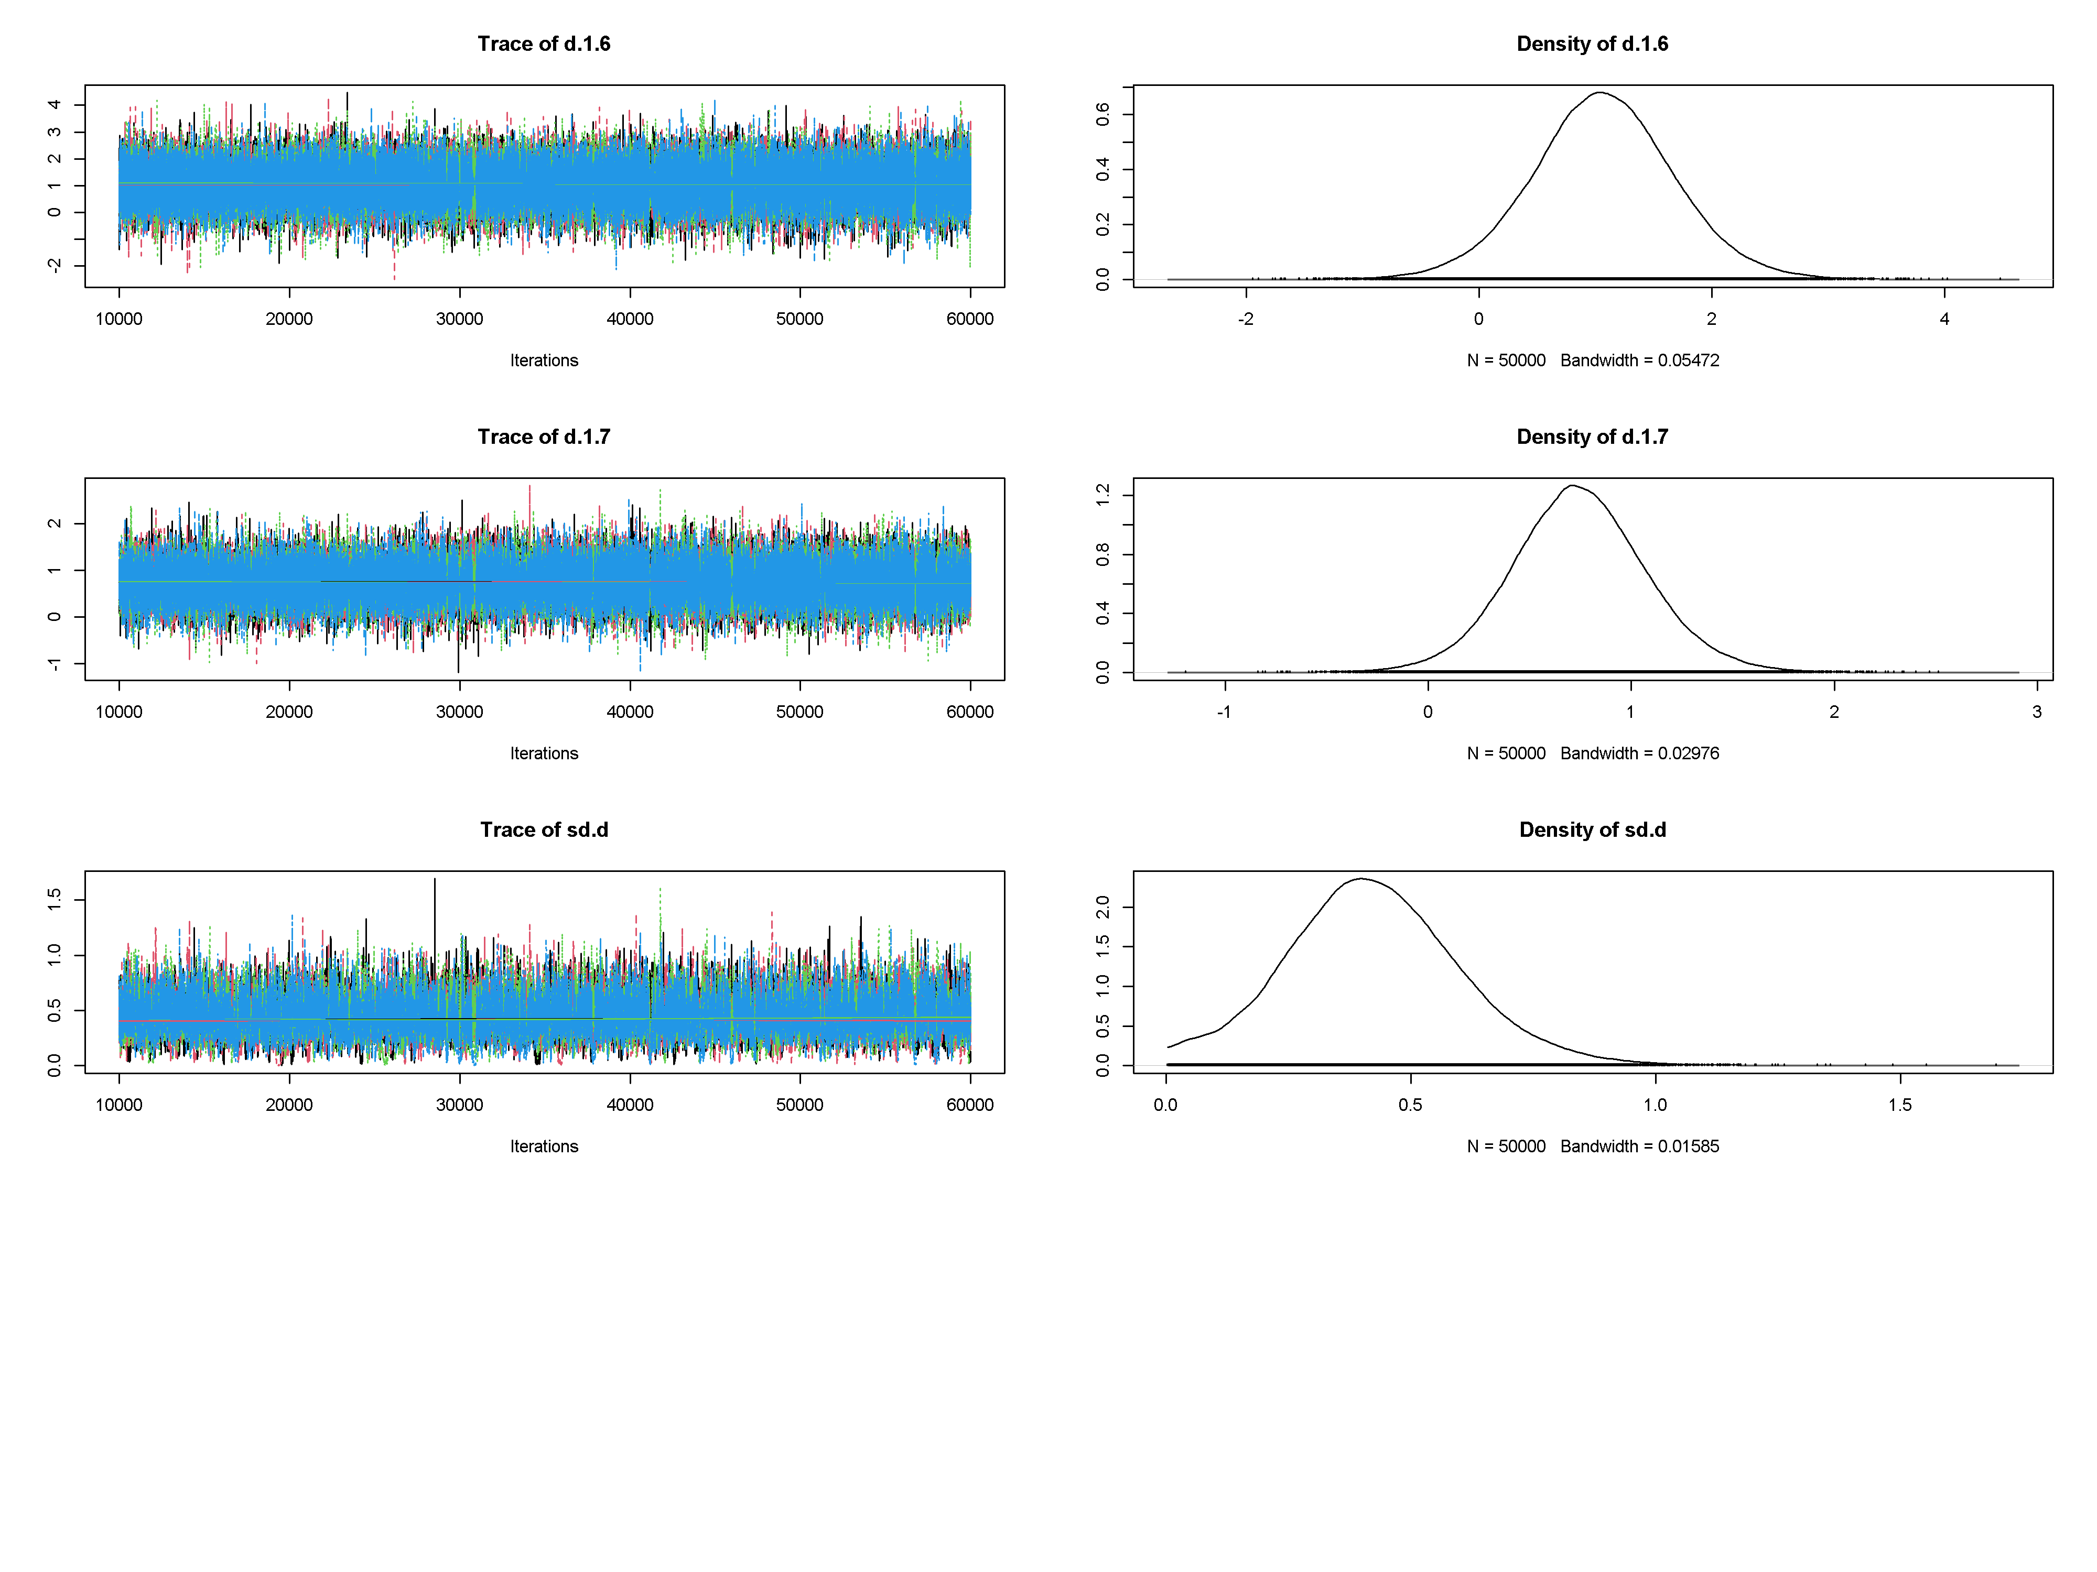

B
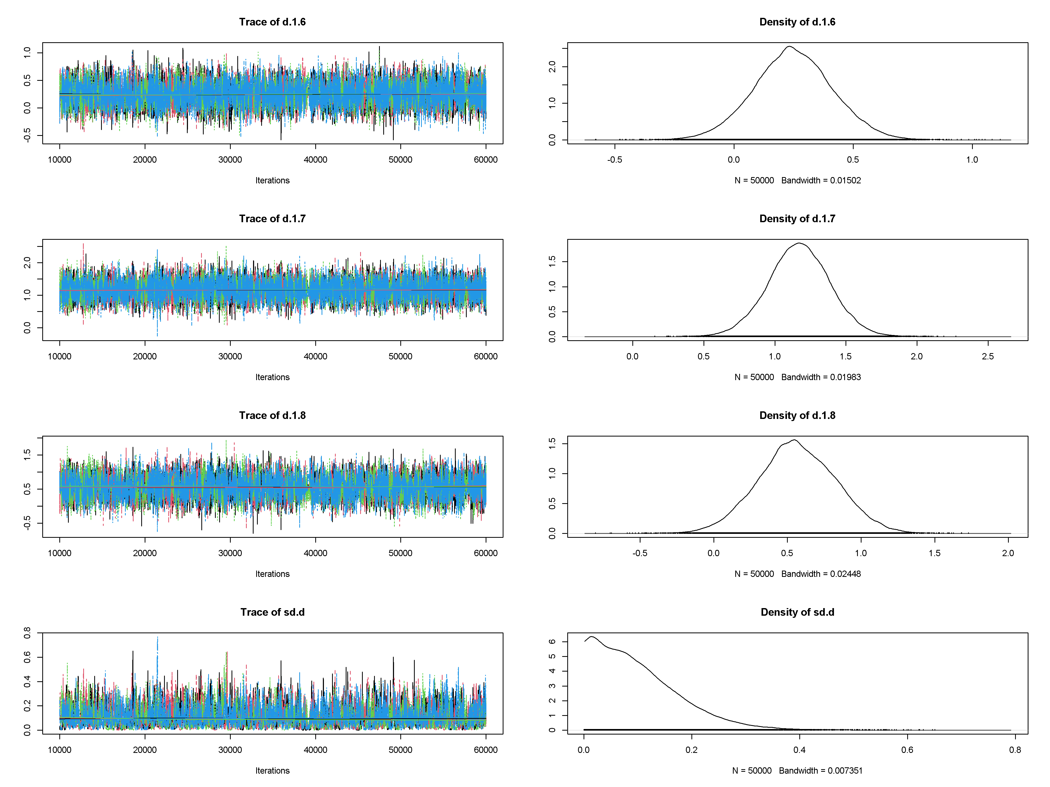

C
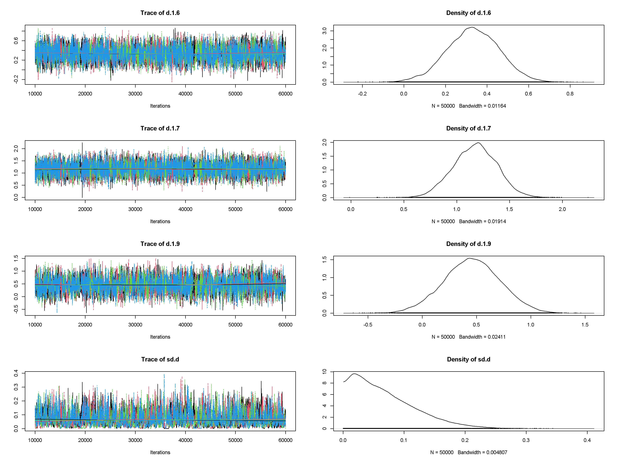

D
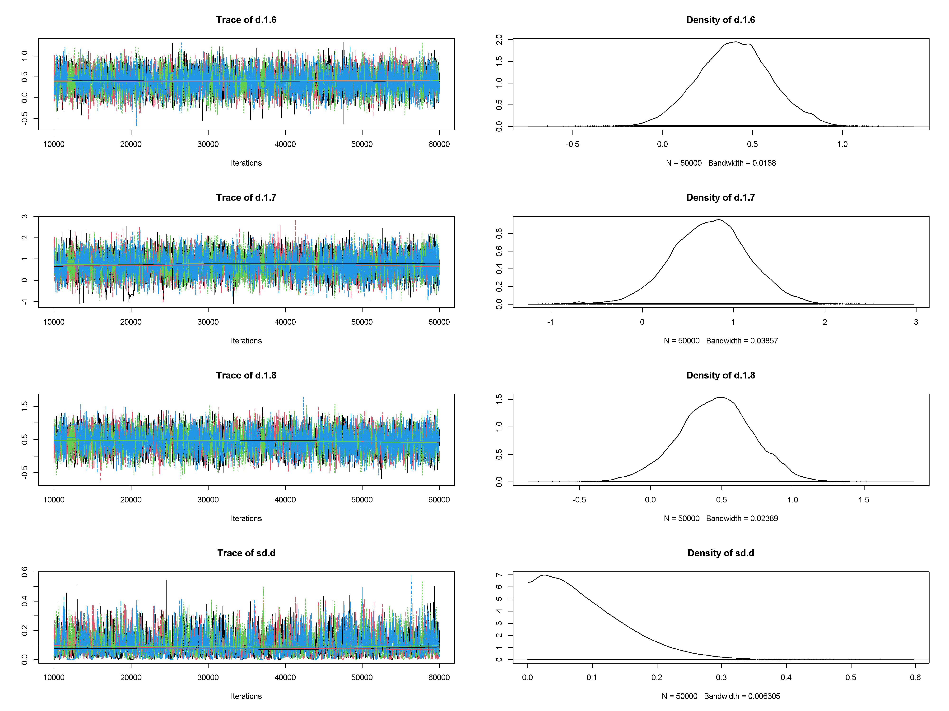

E
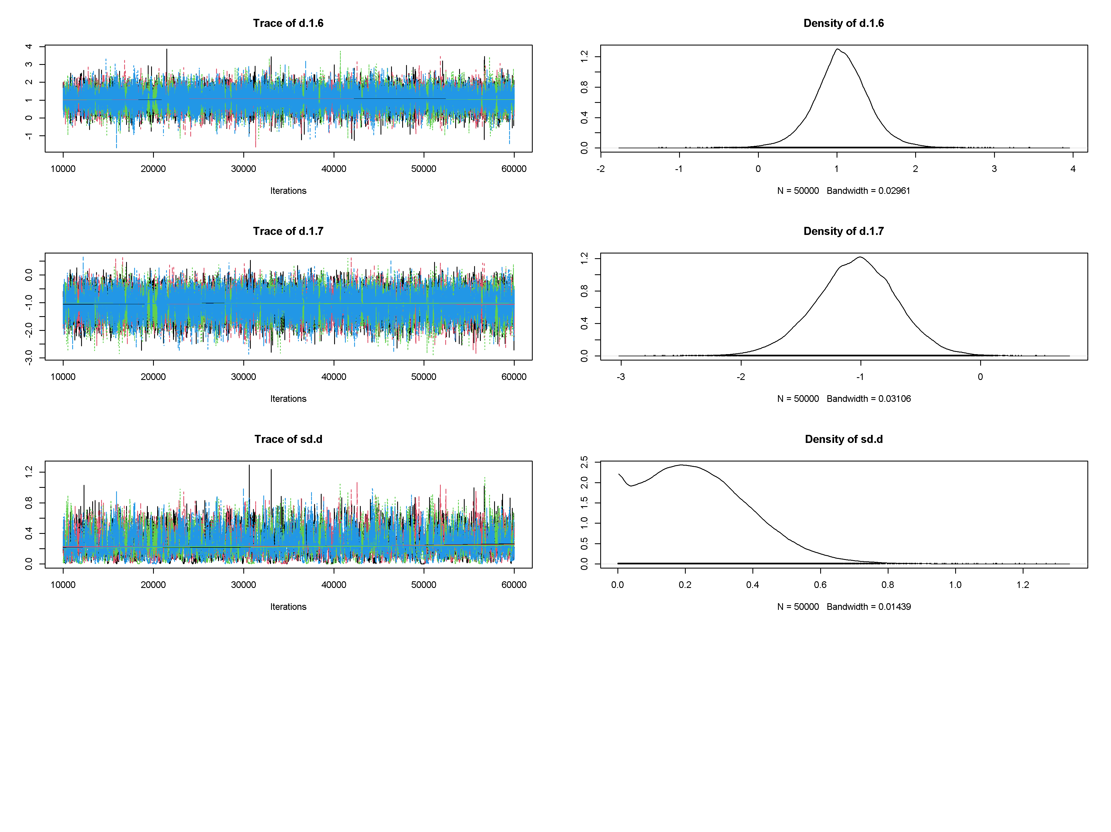

F
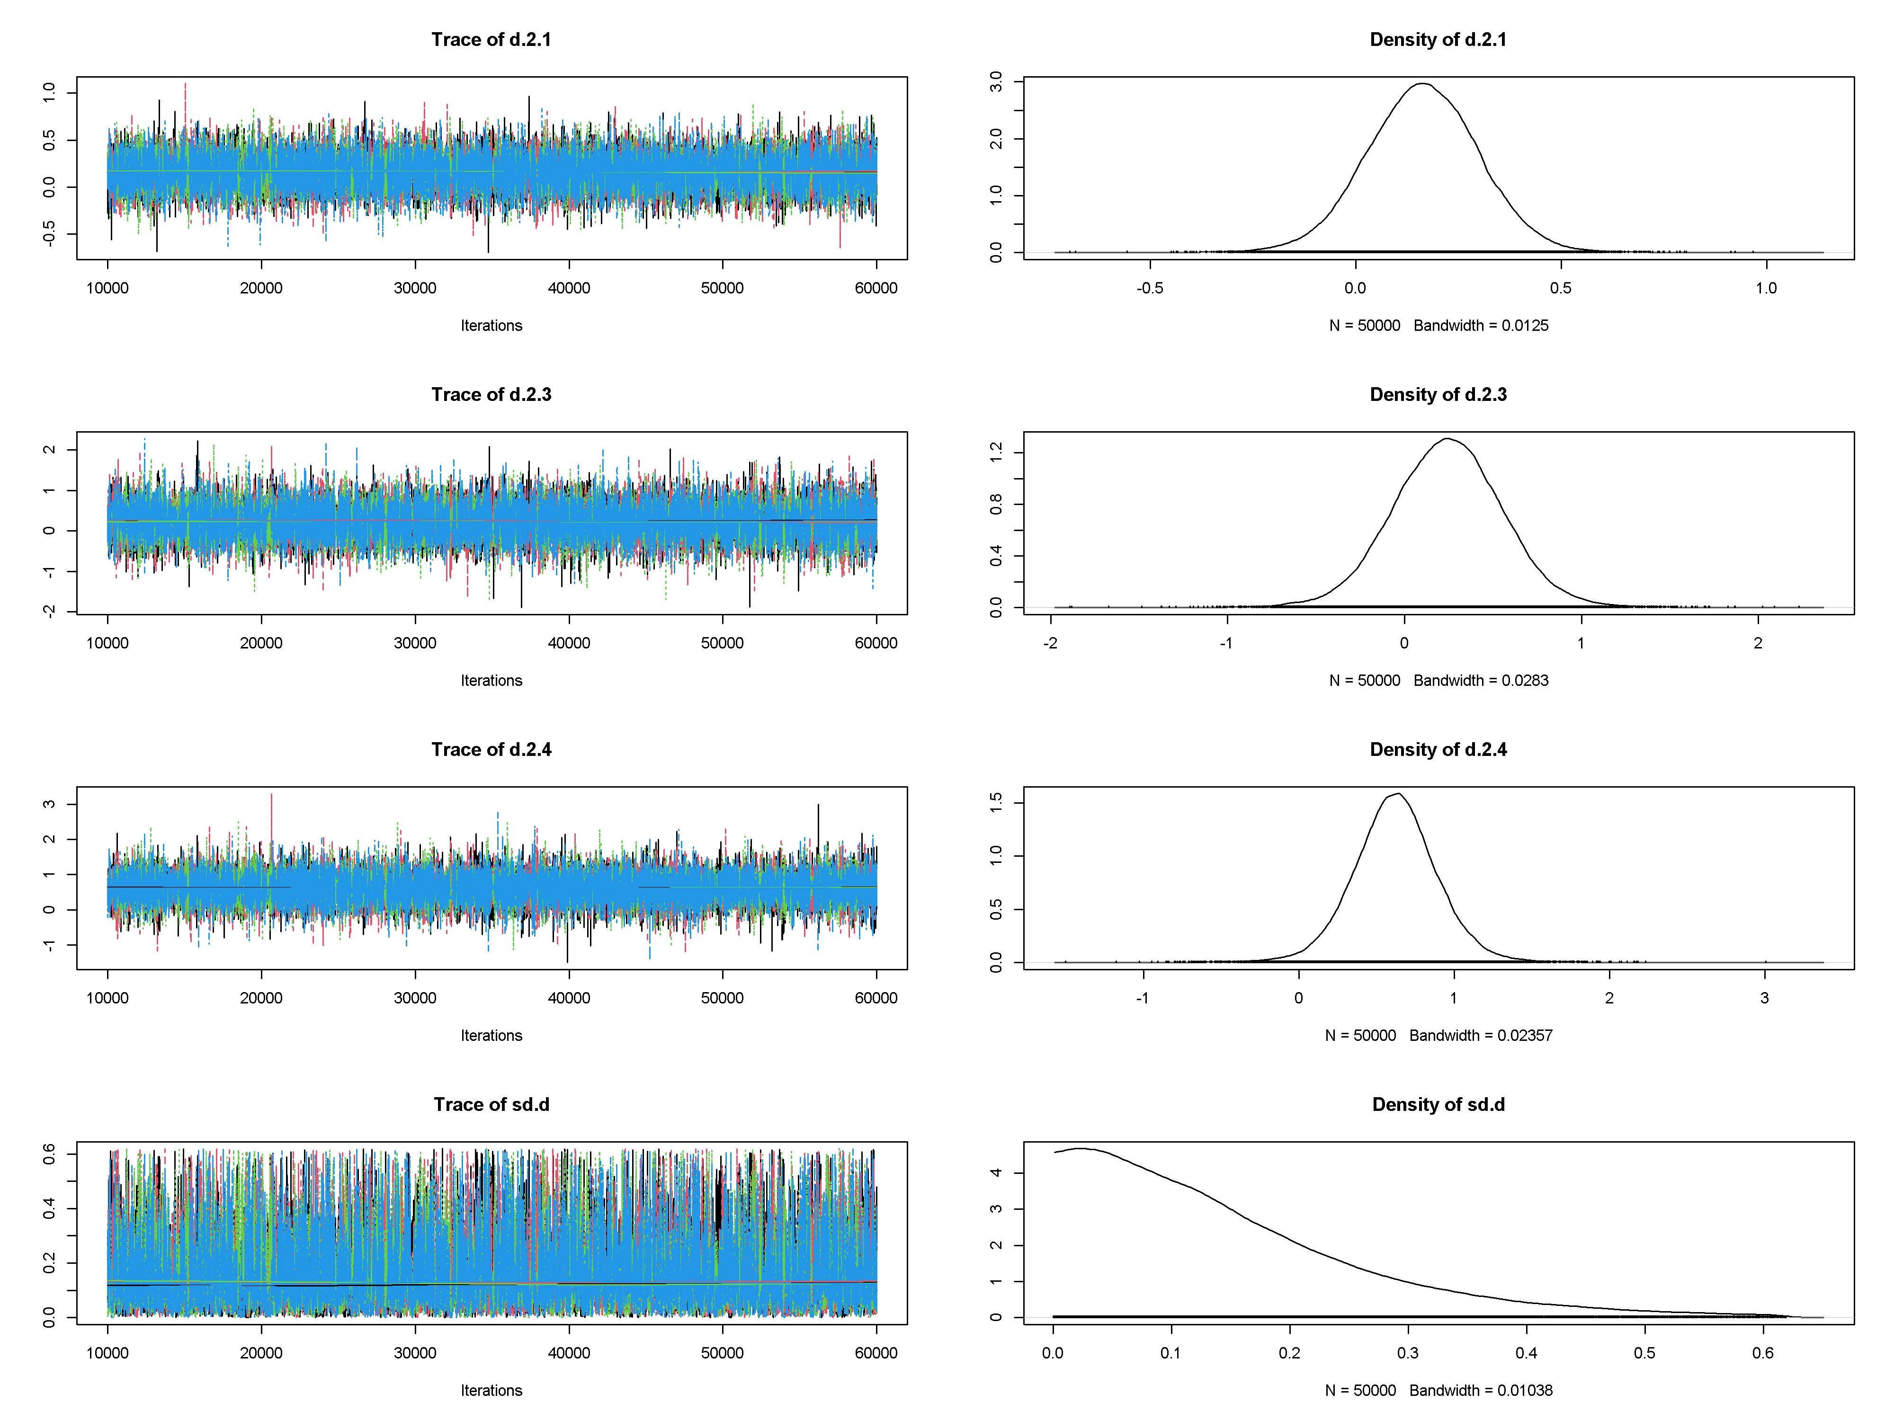

G
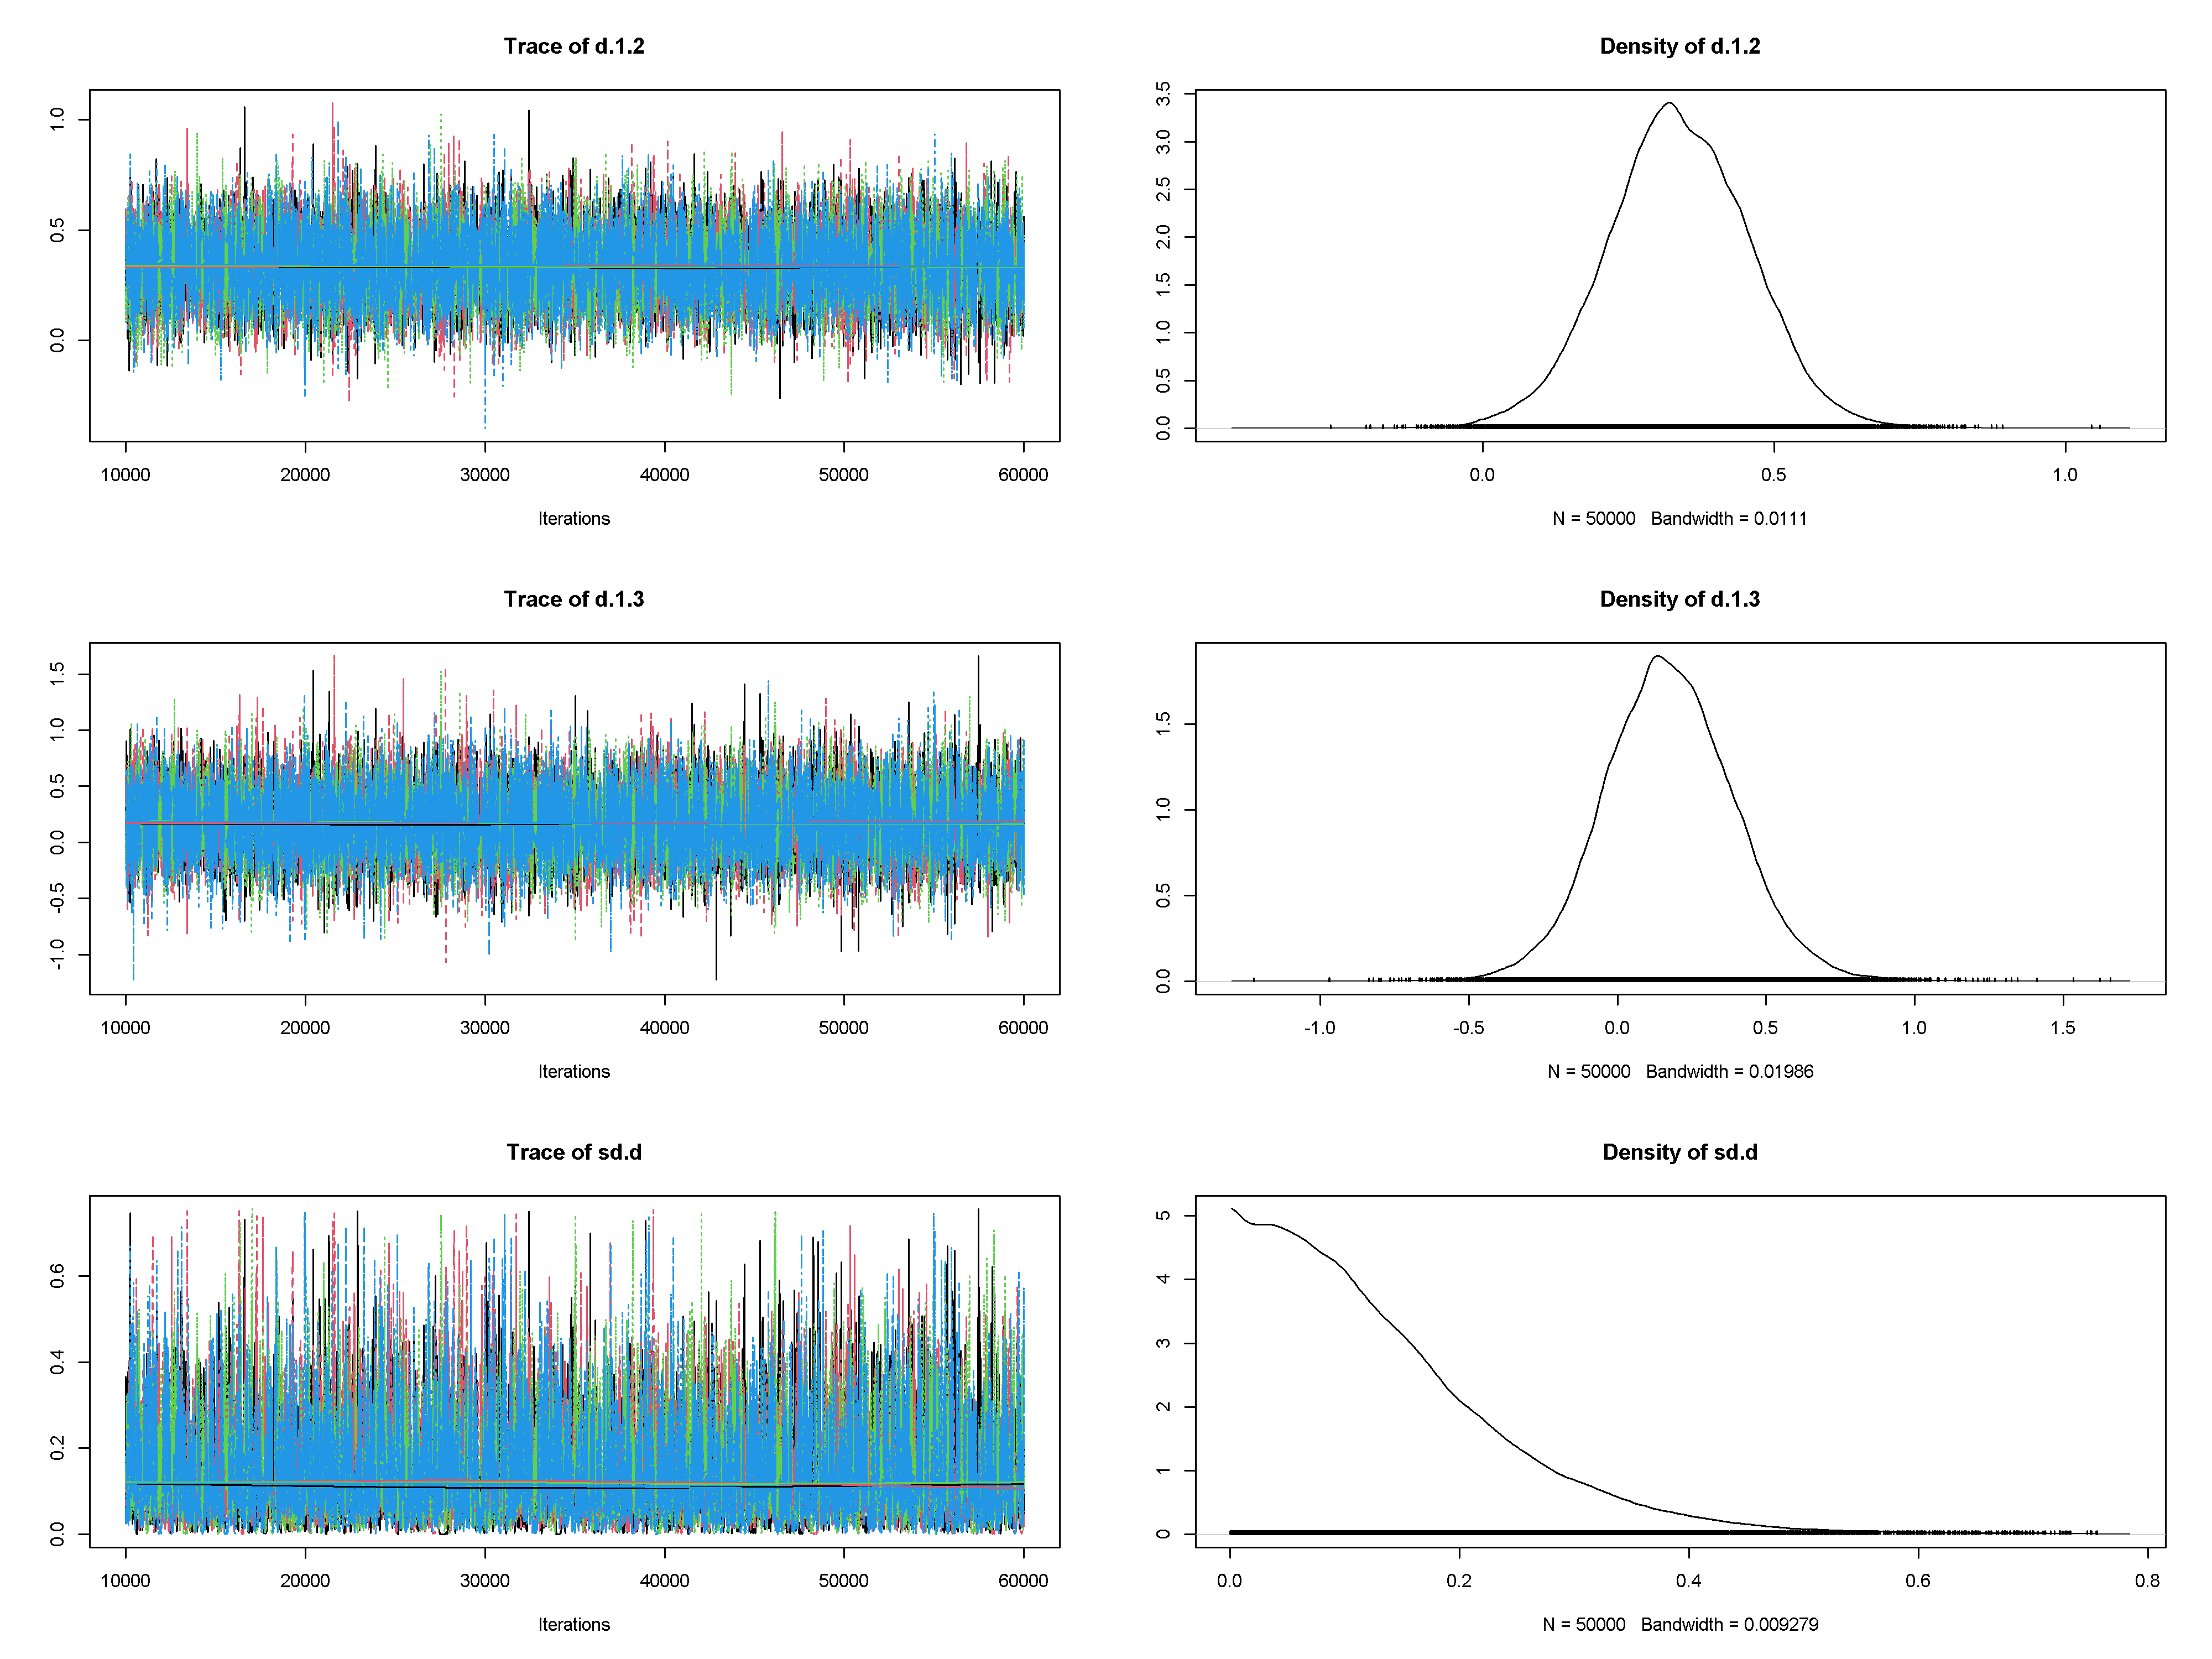

H
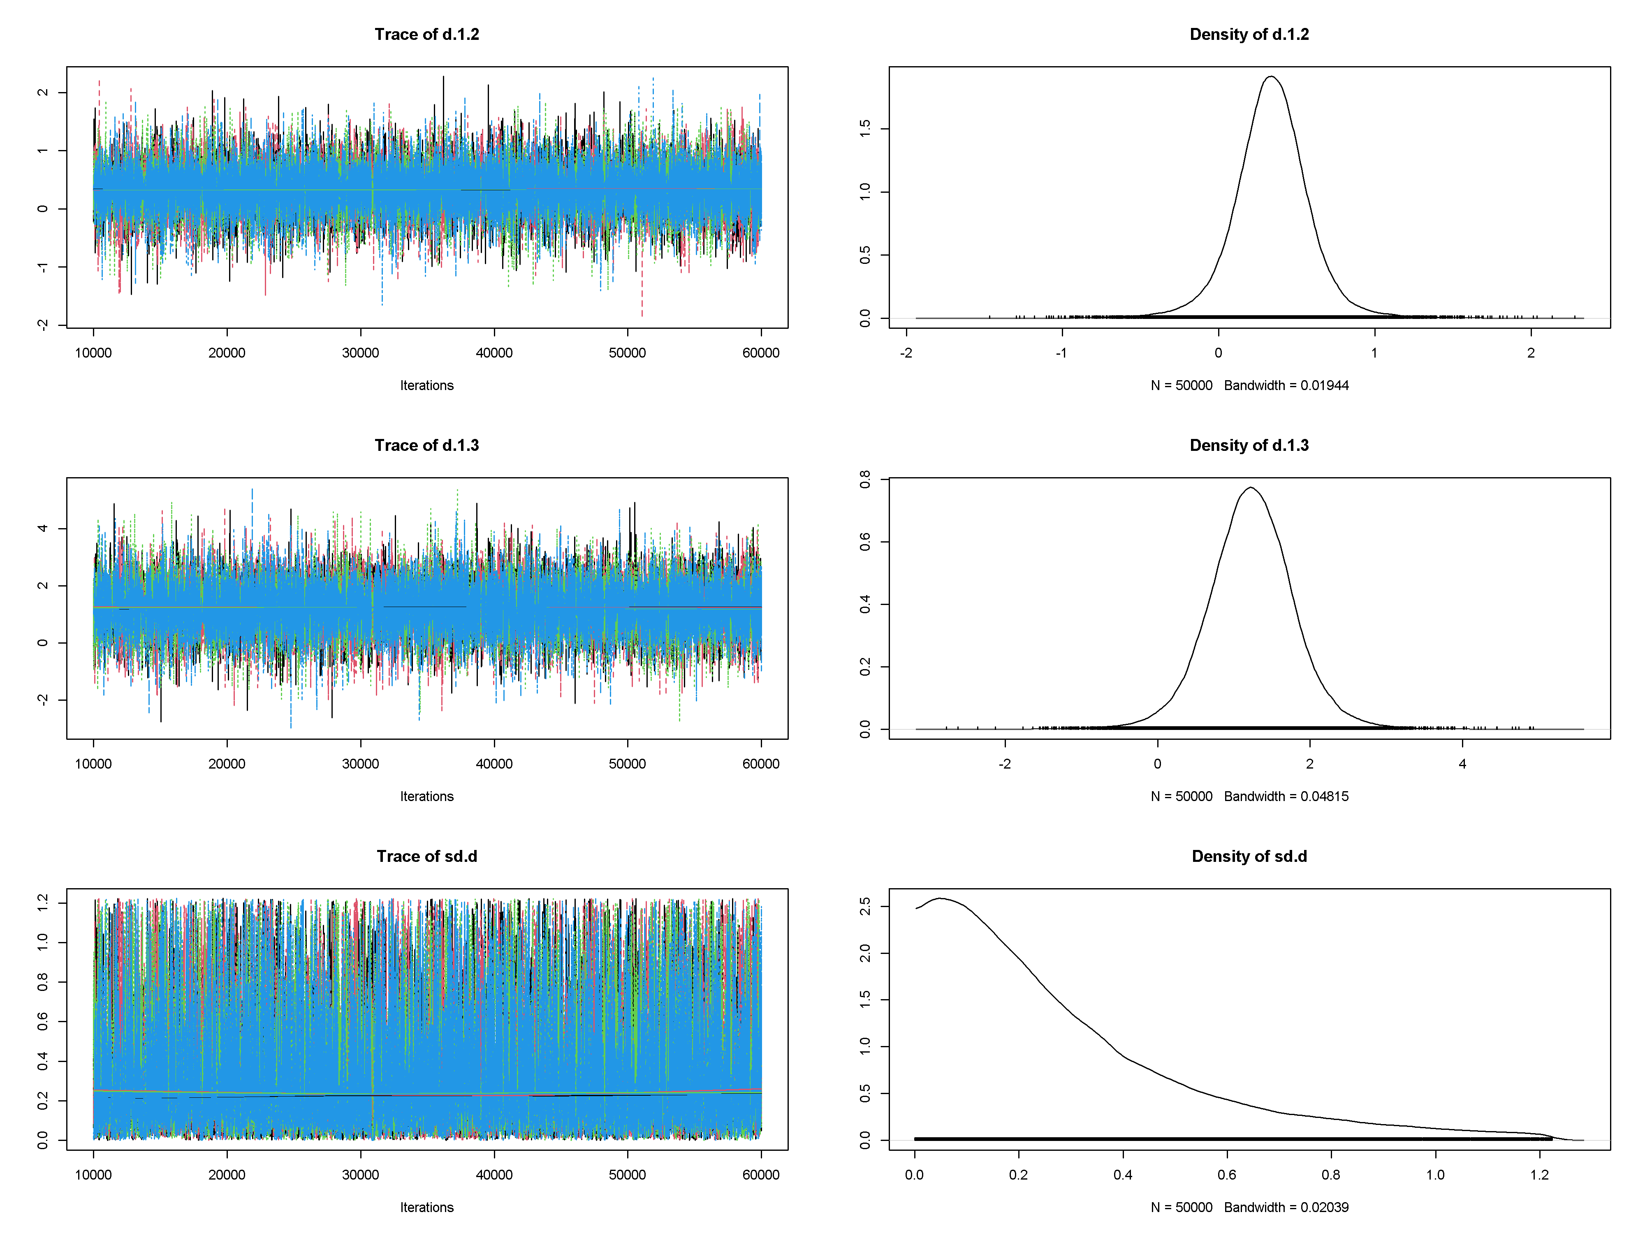

I
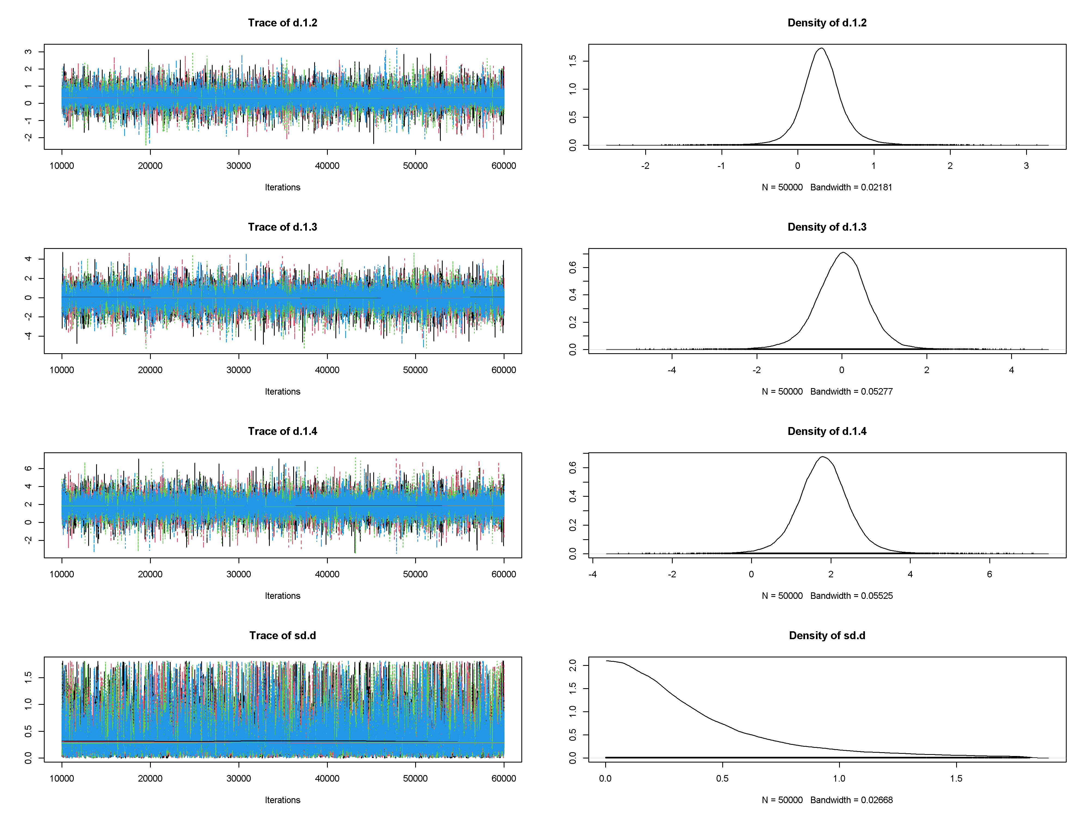

J
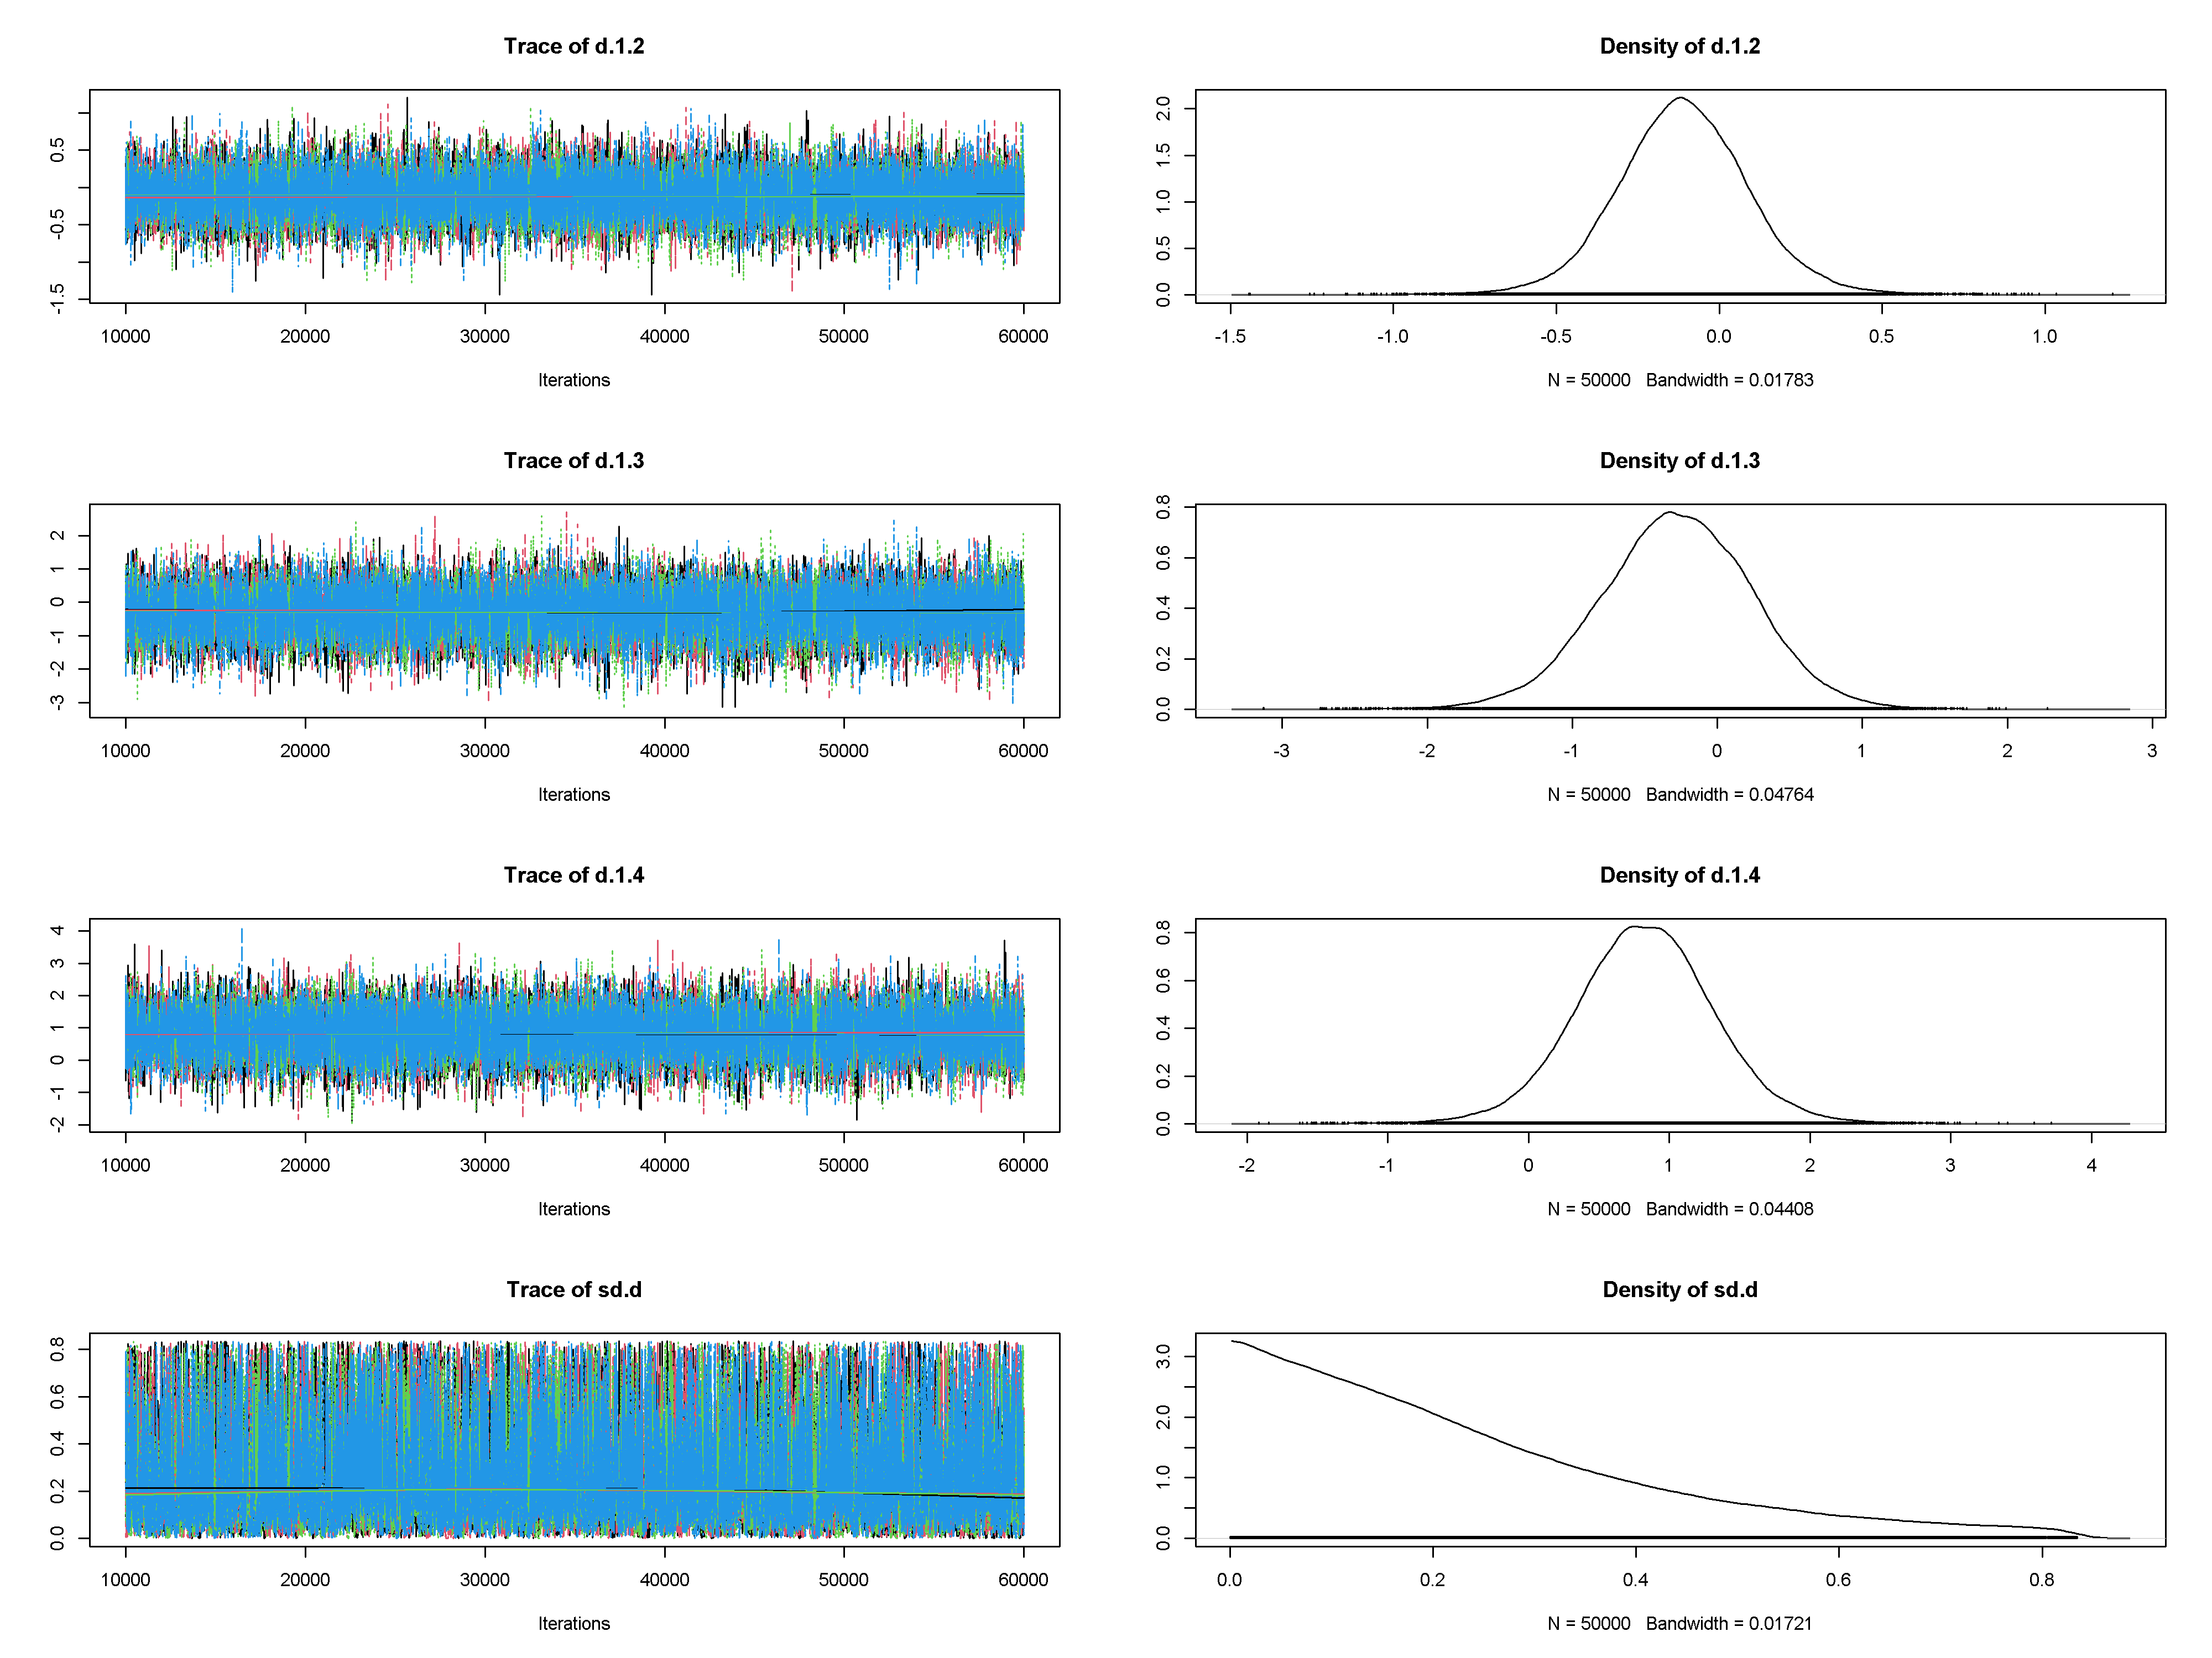

K
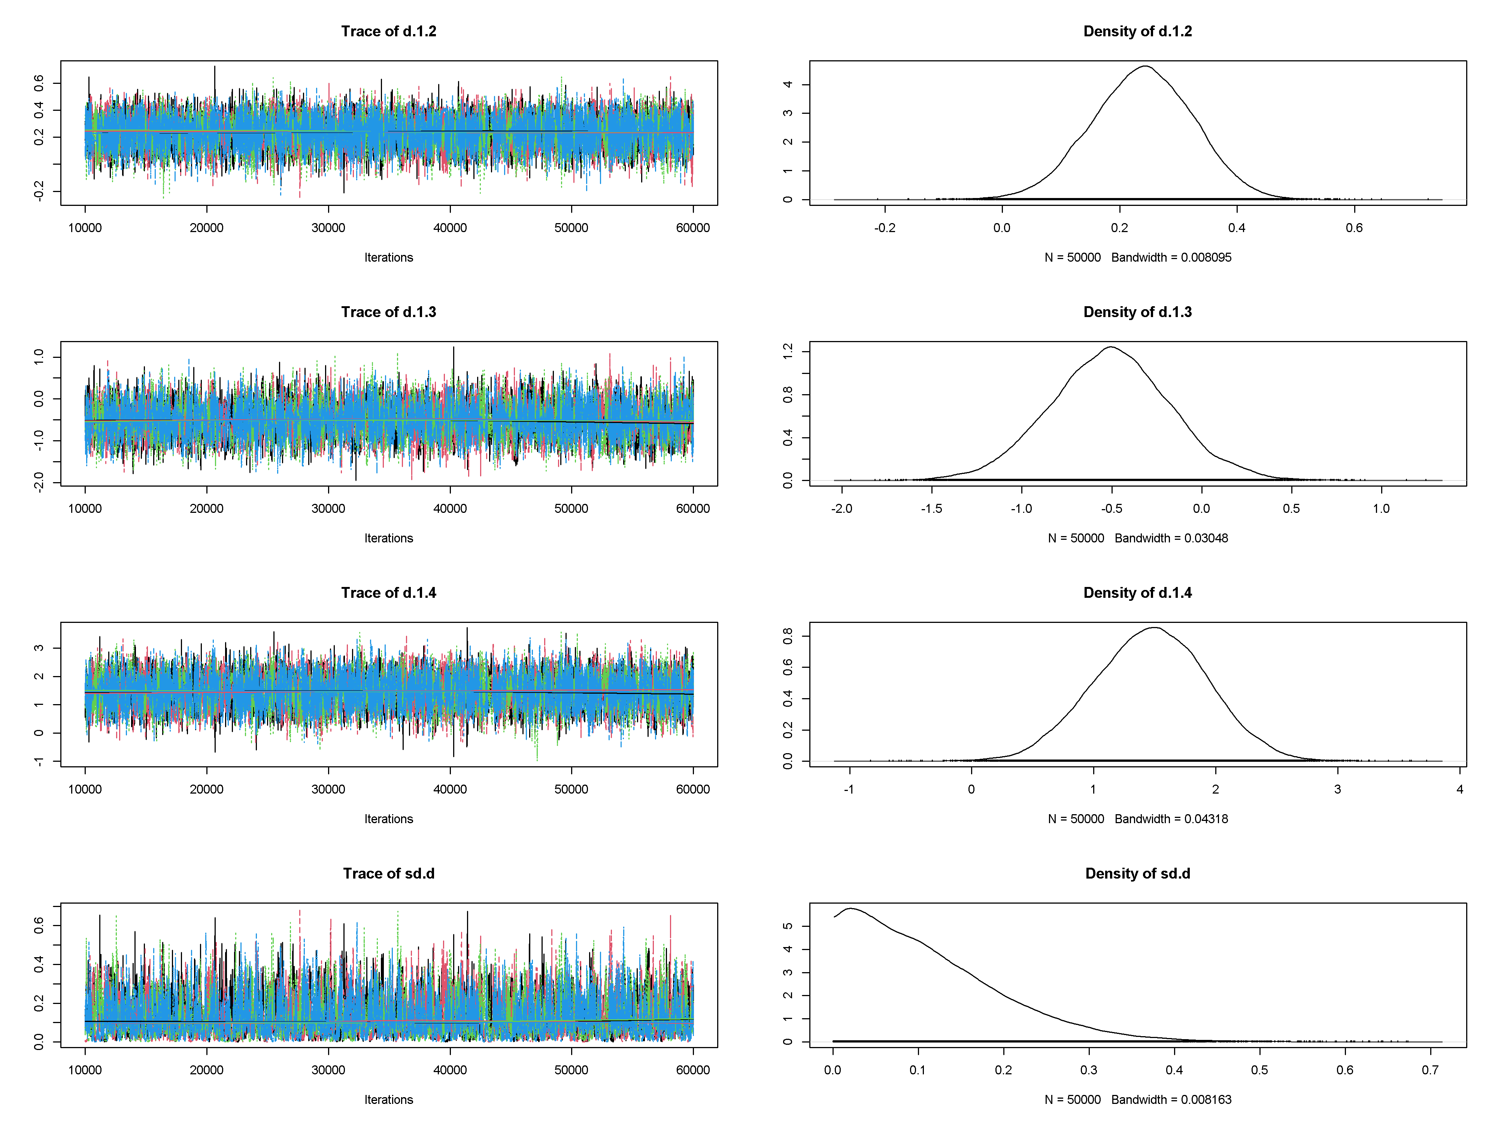

Figure S1 Trace and density plots. (A) Immediate Improvement in Aphasia Severity; (B) Immediate Repetition Improvement; (C) Immediate Improvement in Comprehension; (D) Immediate Improvement in Naming; (E) Immediate Improvement in Spontaneous Speech; (F) Immediate Improvement in Functional Communication; (G) Immediate Improvement in writing; (H) Long-Term Improvement in Aphasia Severity; (I) Long-Term Improvement in Repetition; (J) Long-Term Improvement in Comprehension; (K) Long-Term Improvement in Naming.

A
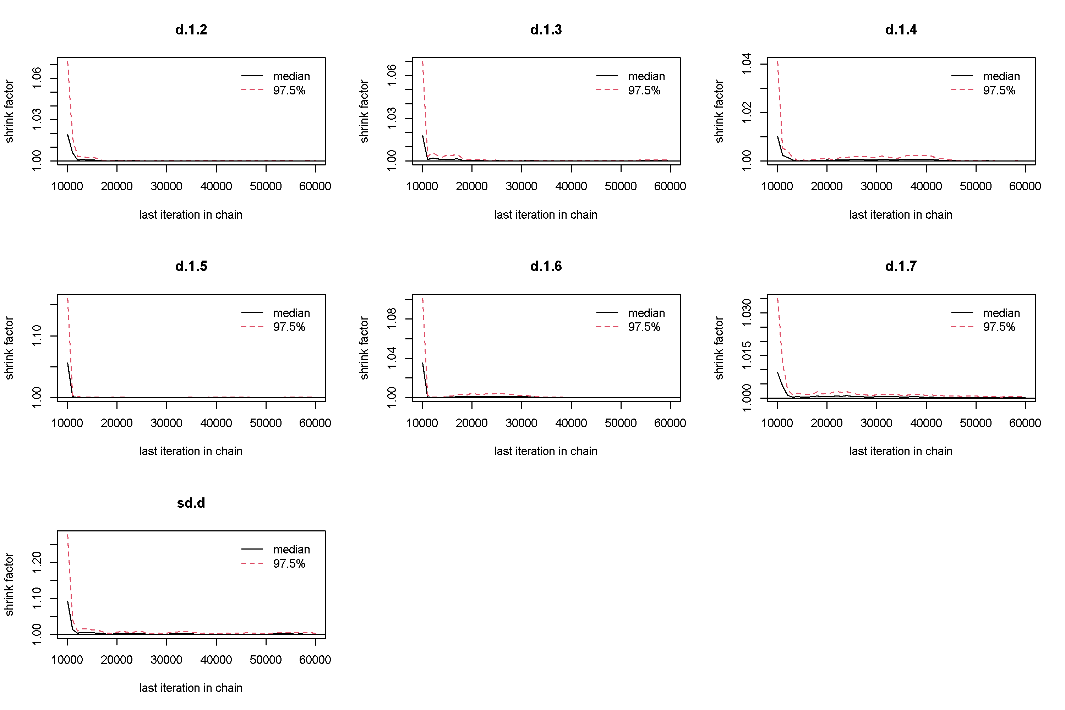

B
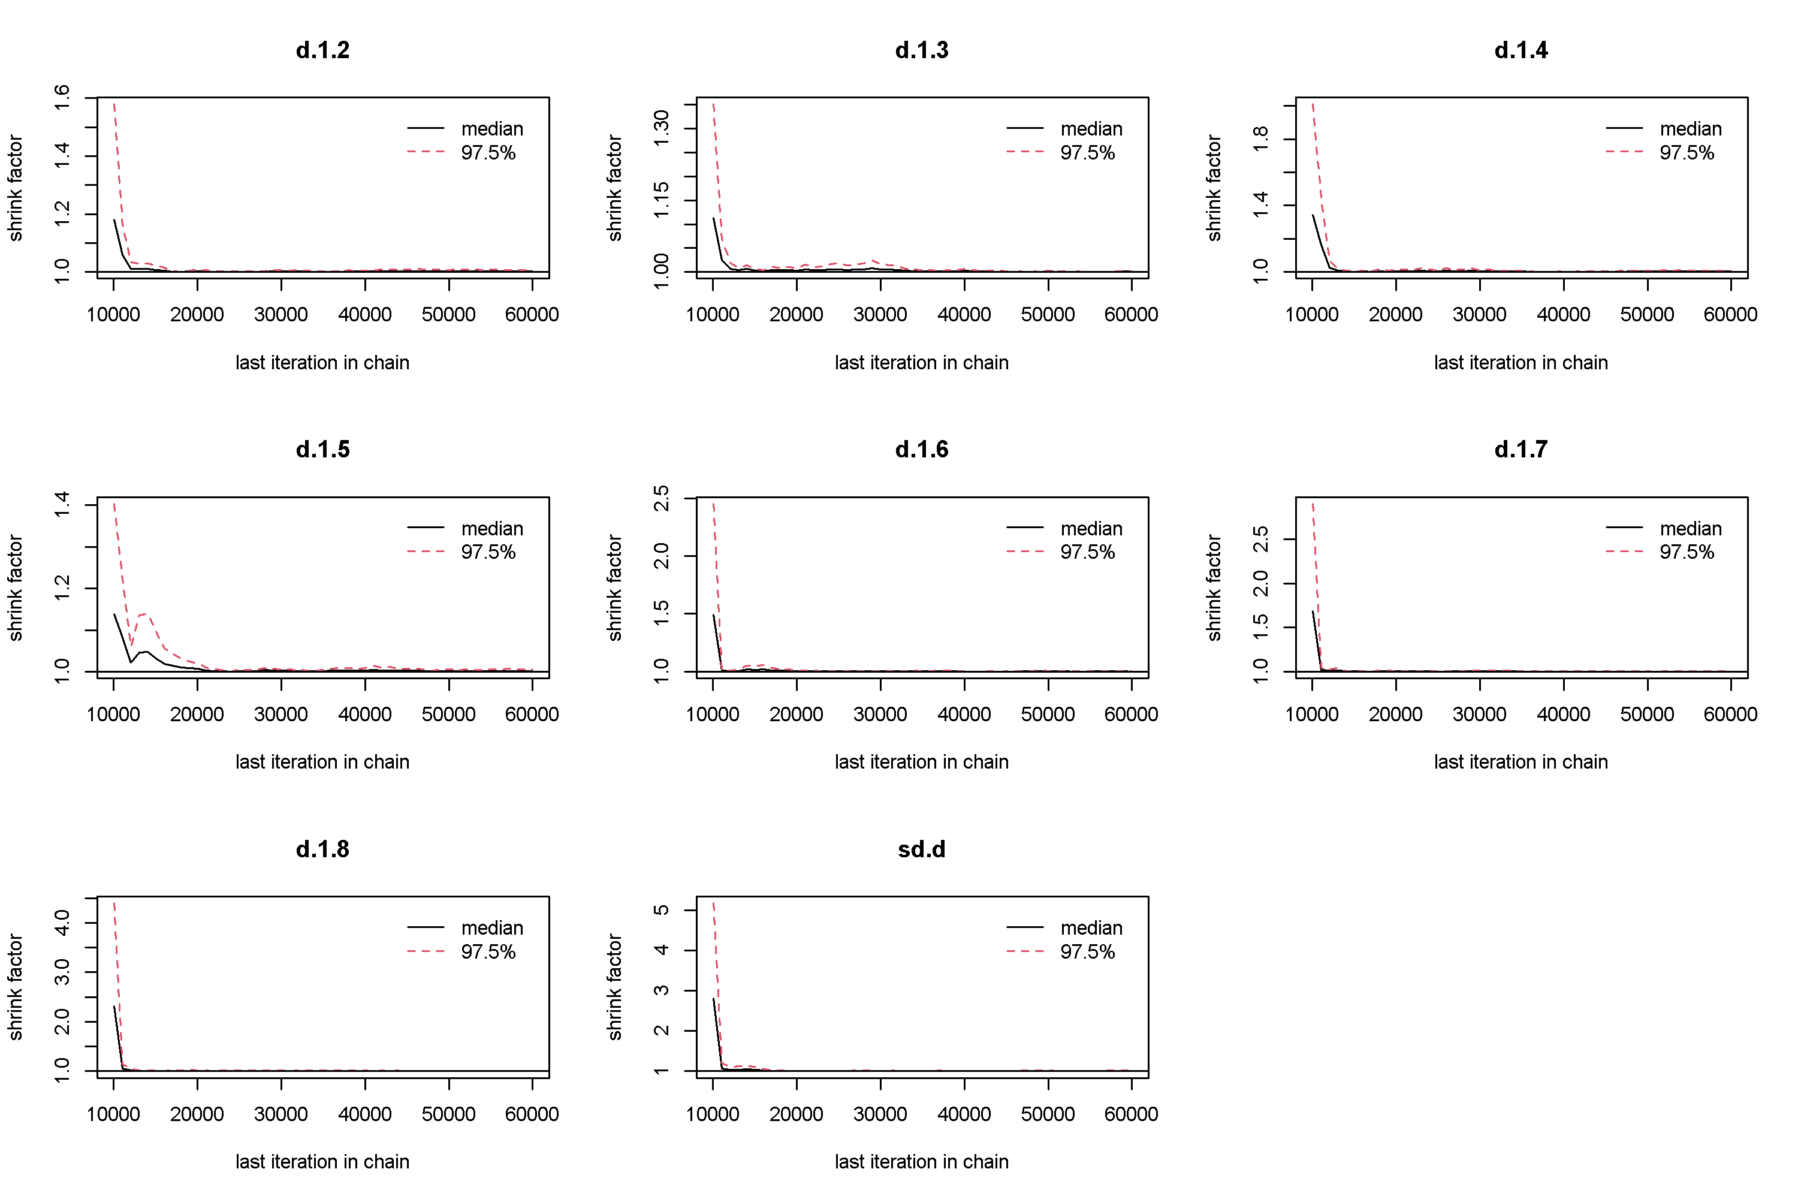

C
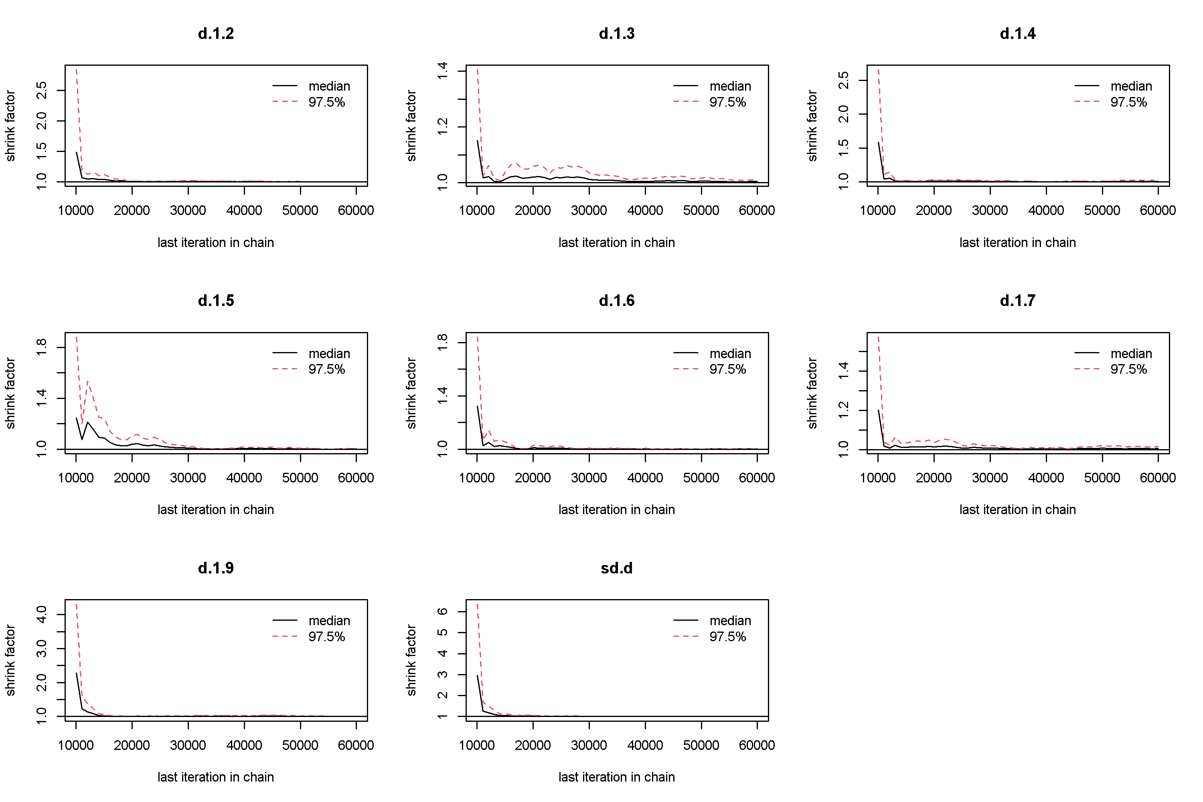

D
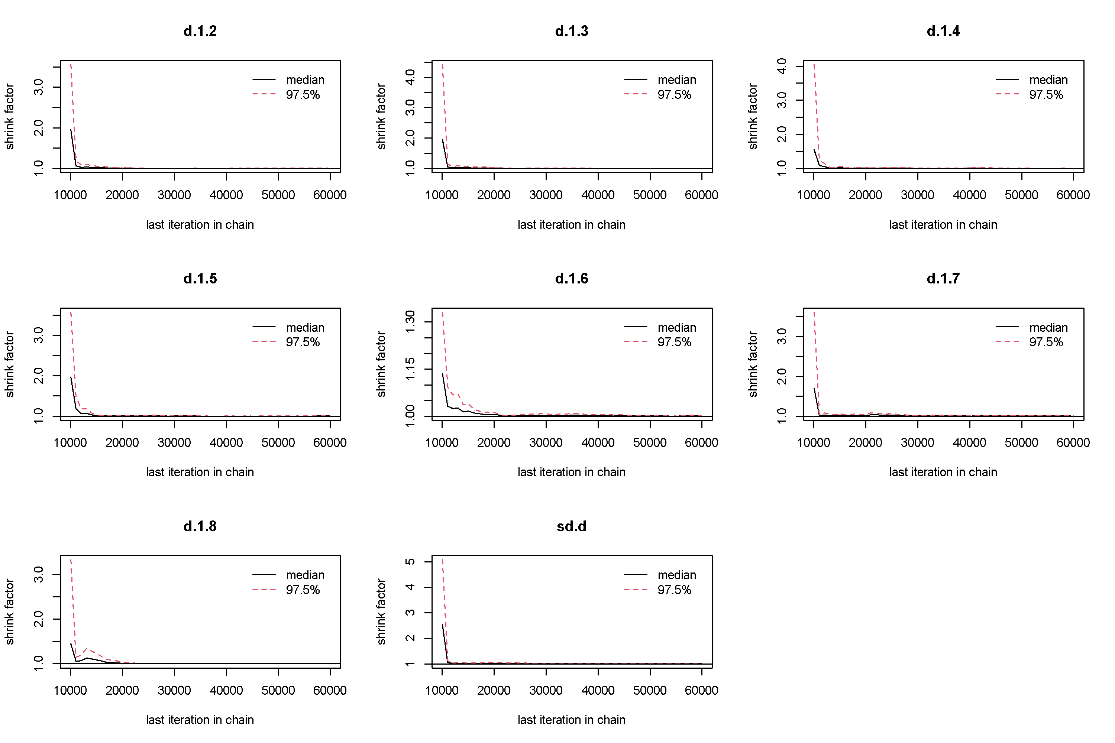

E
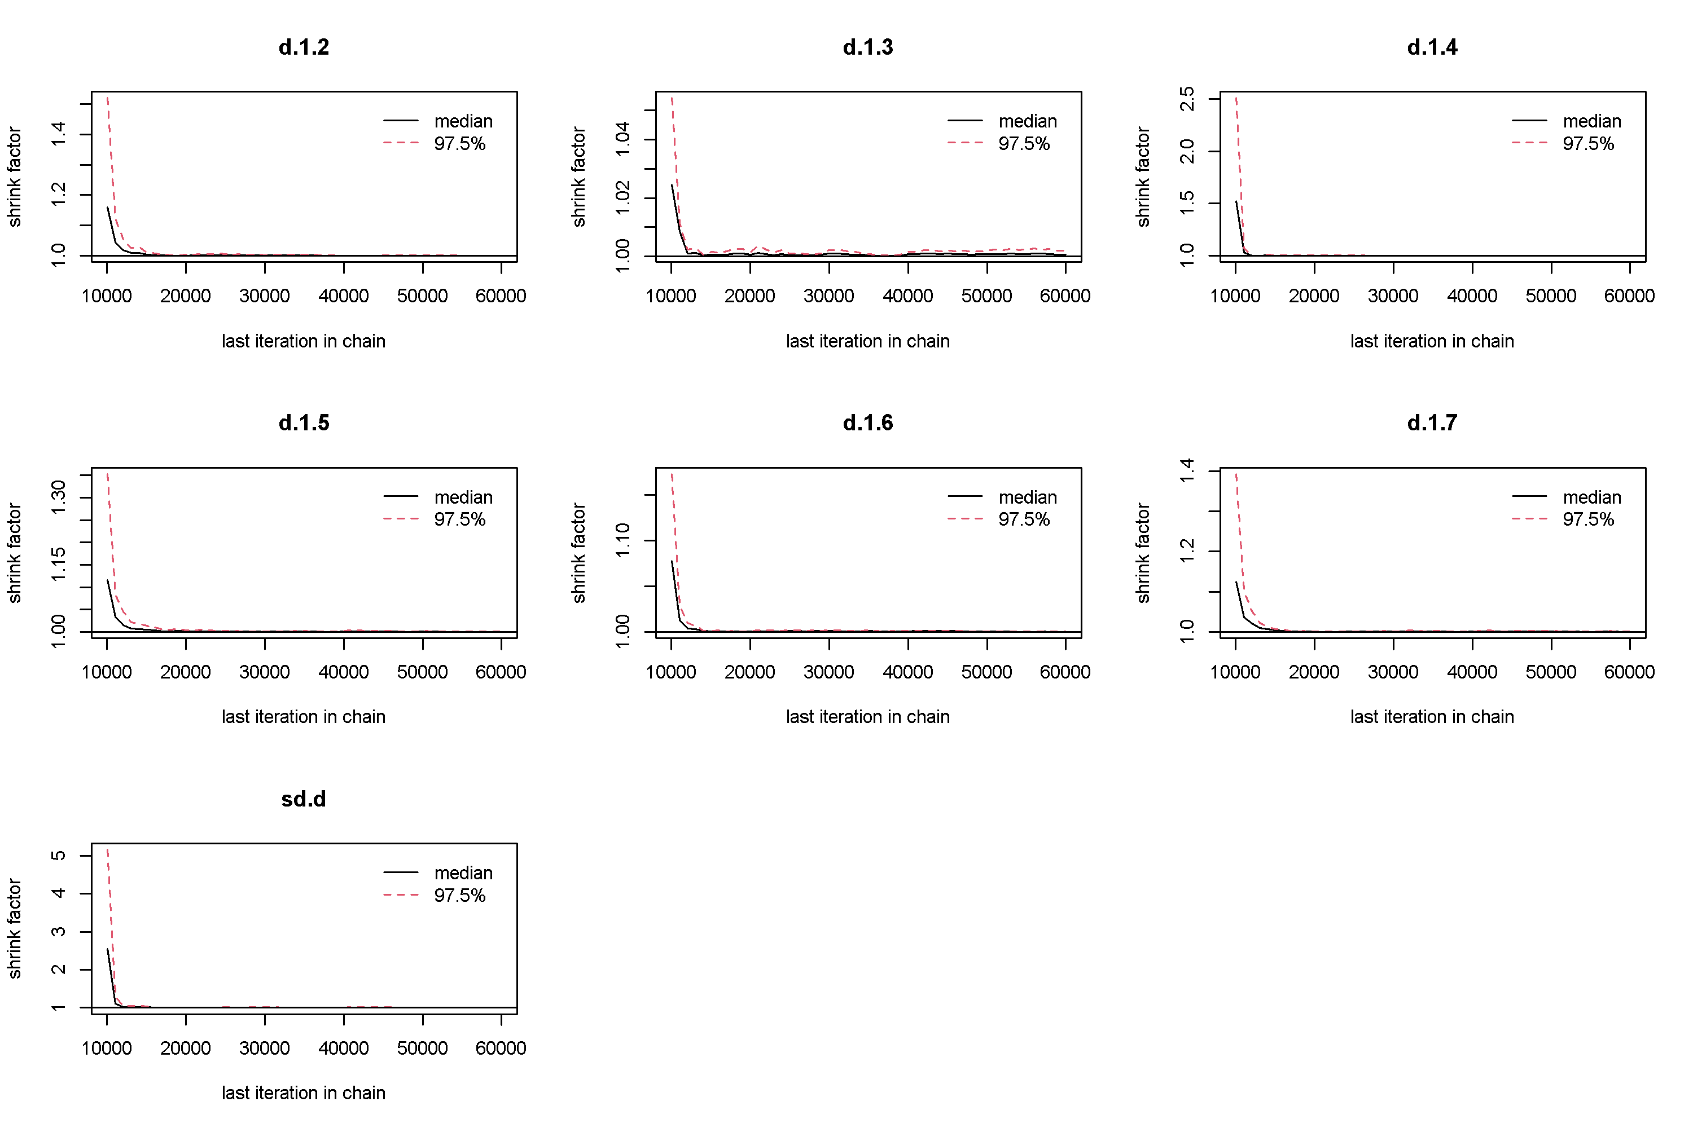

F
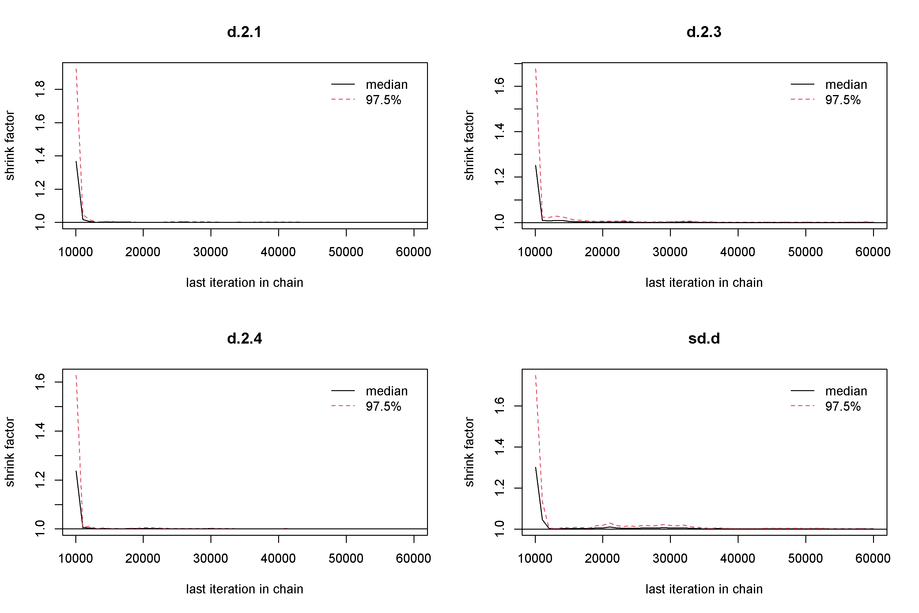

G
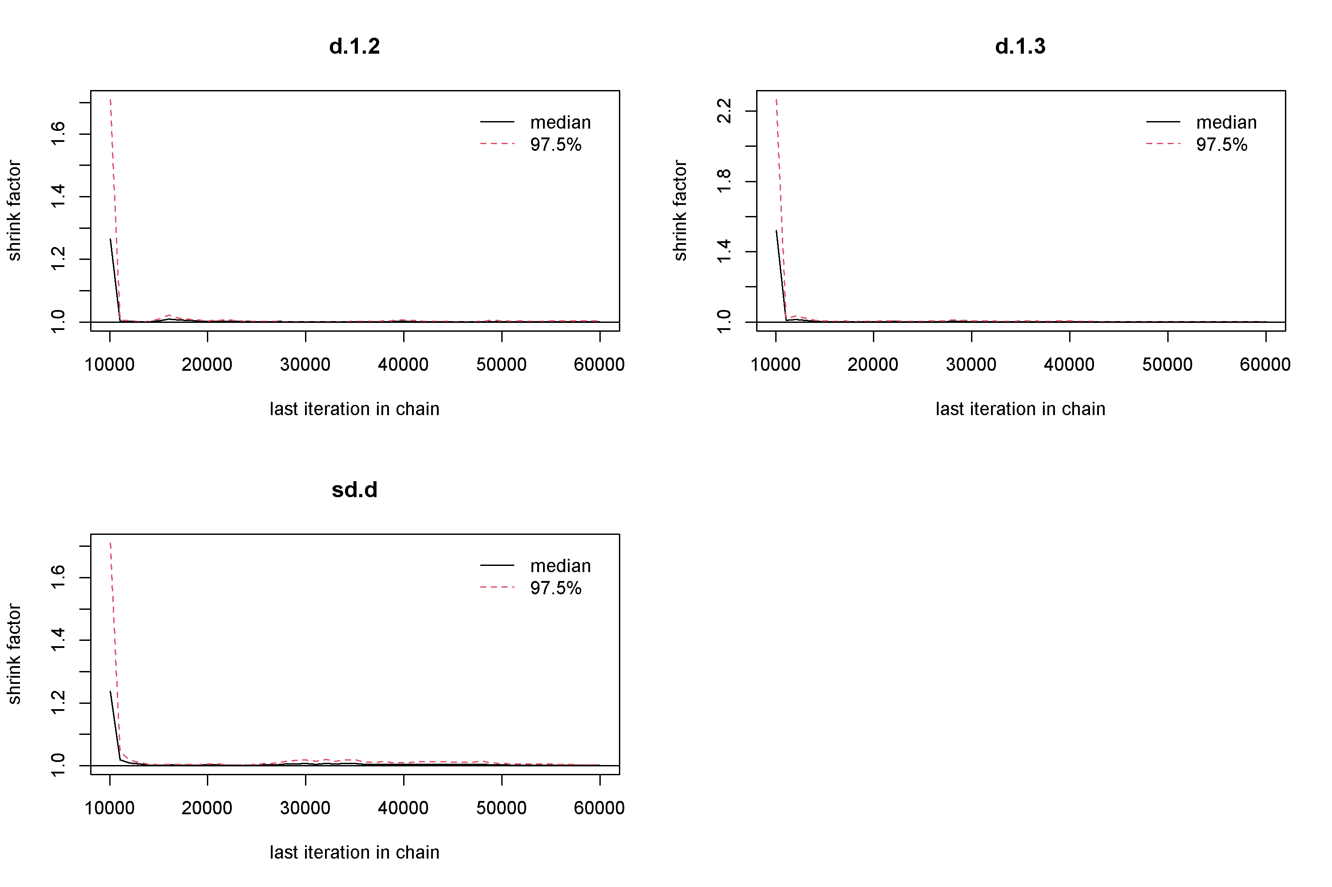

H
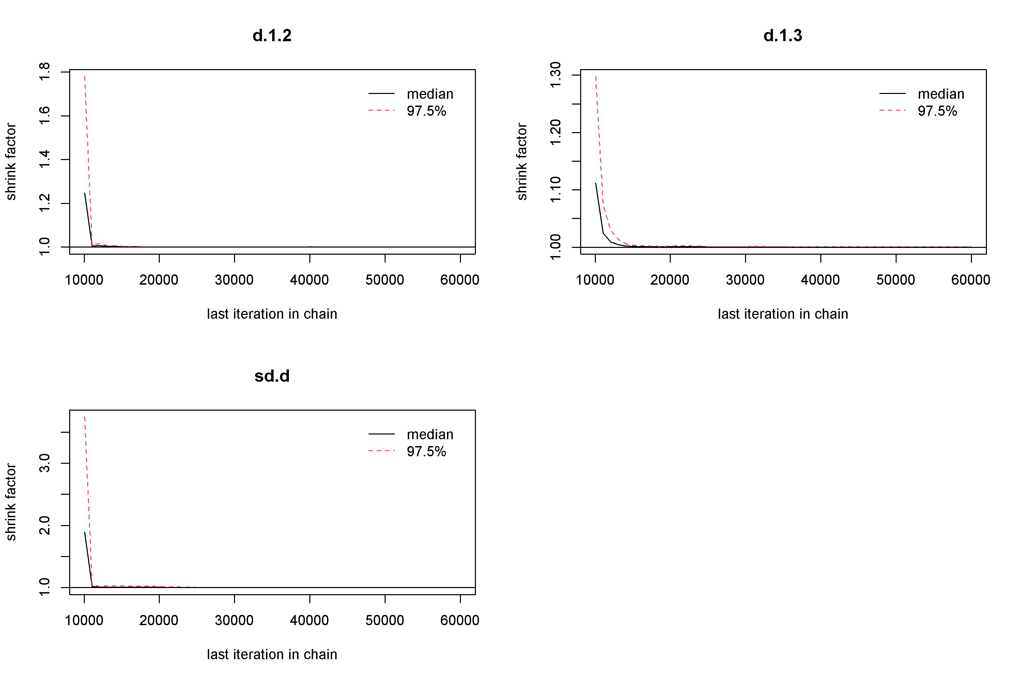

I
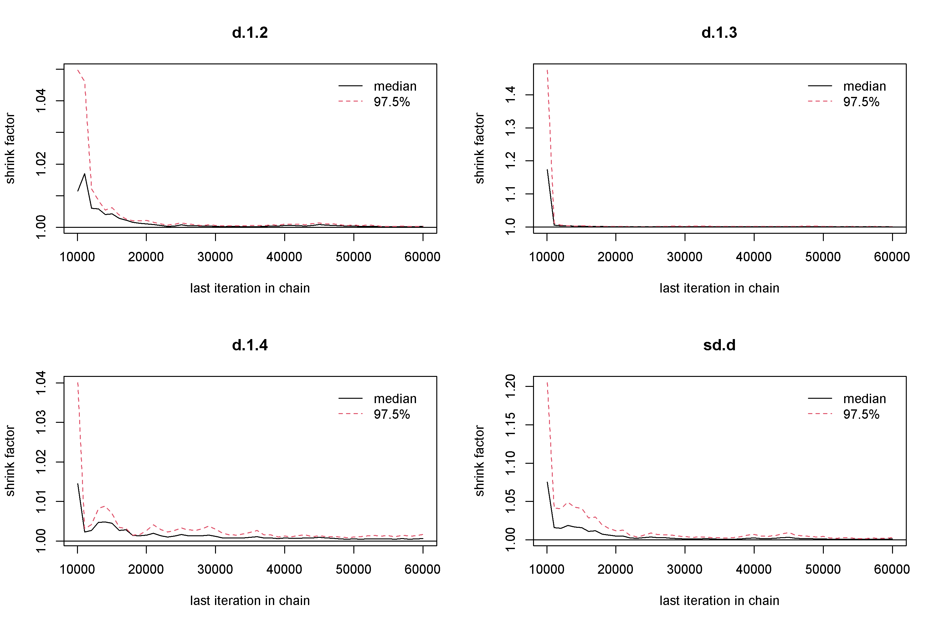

J
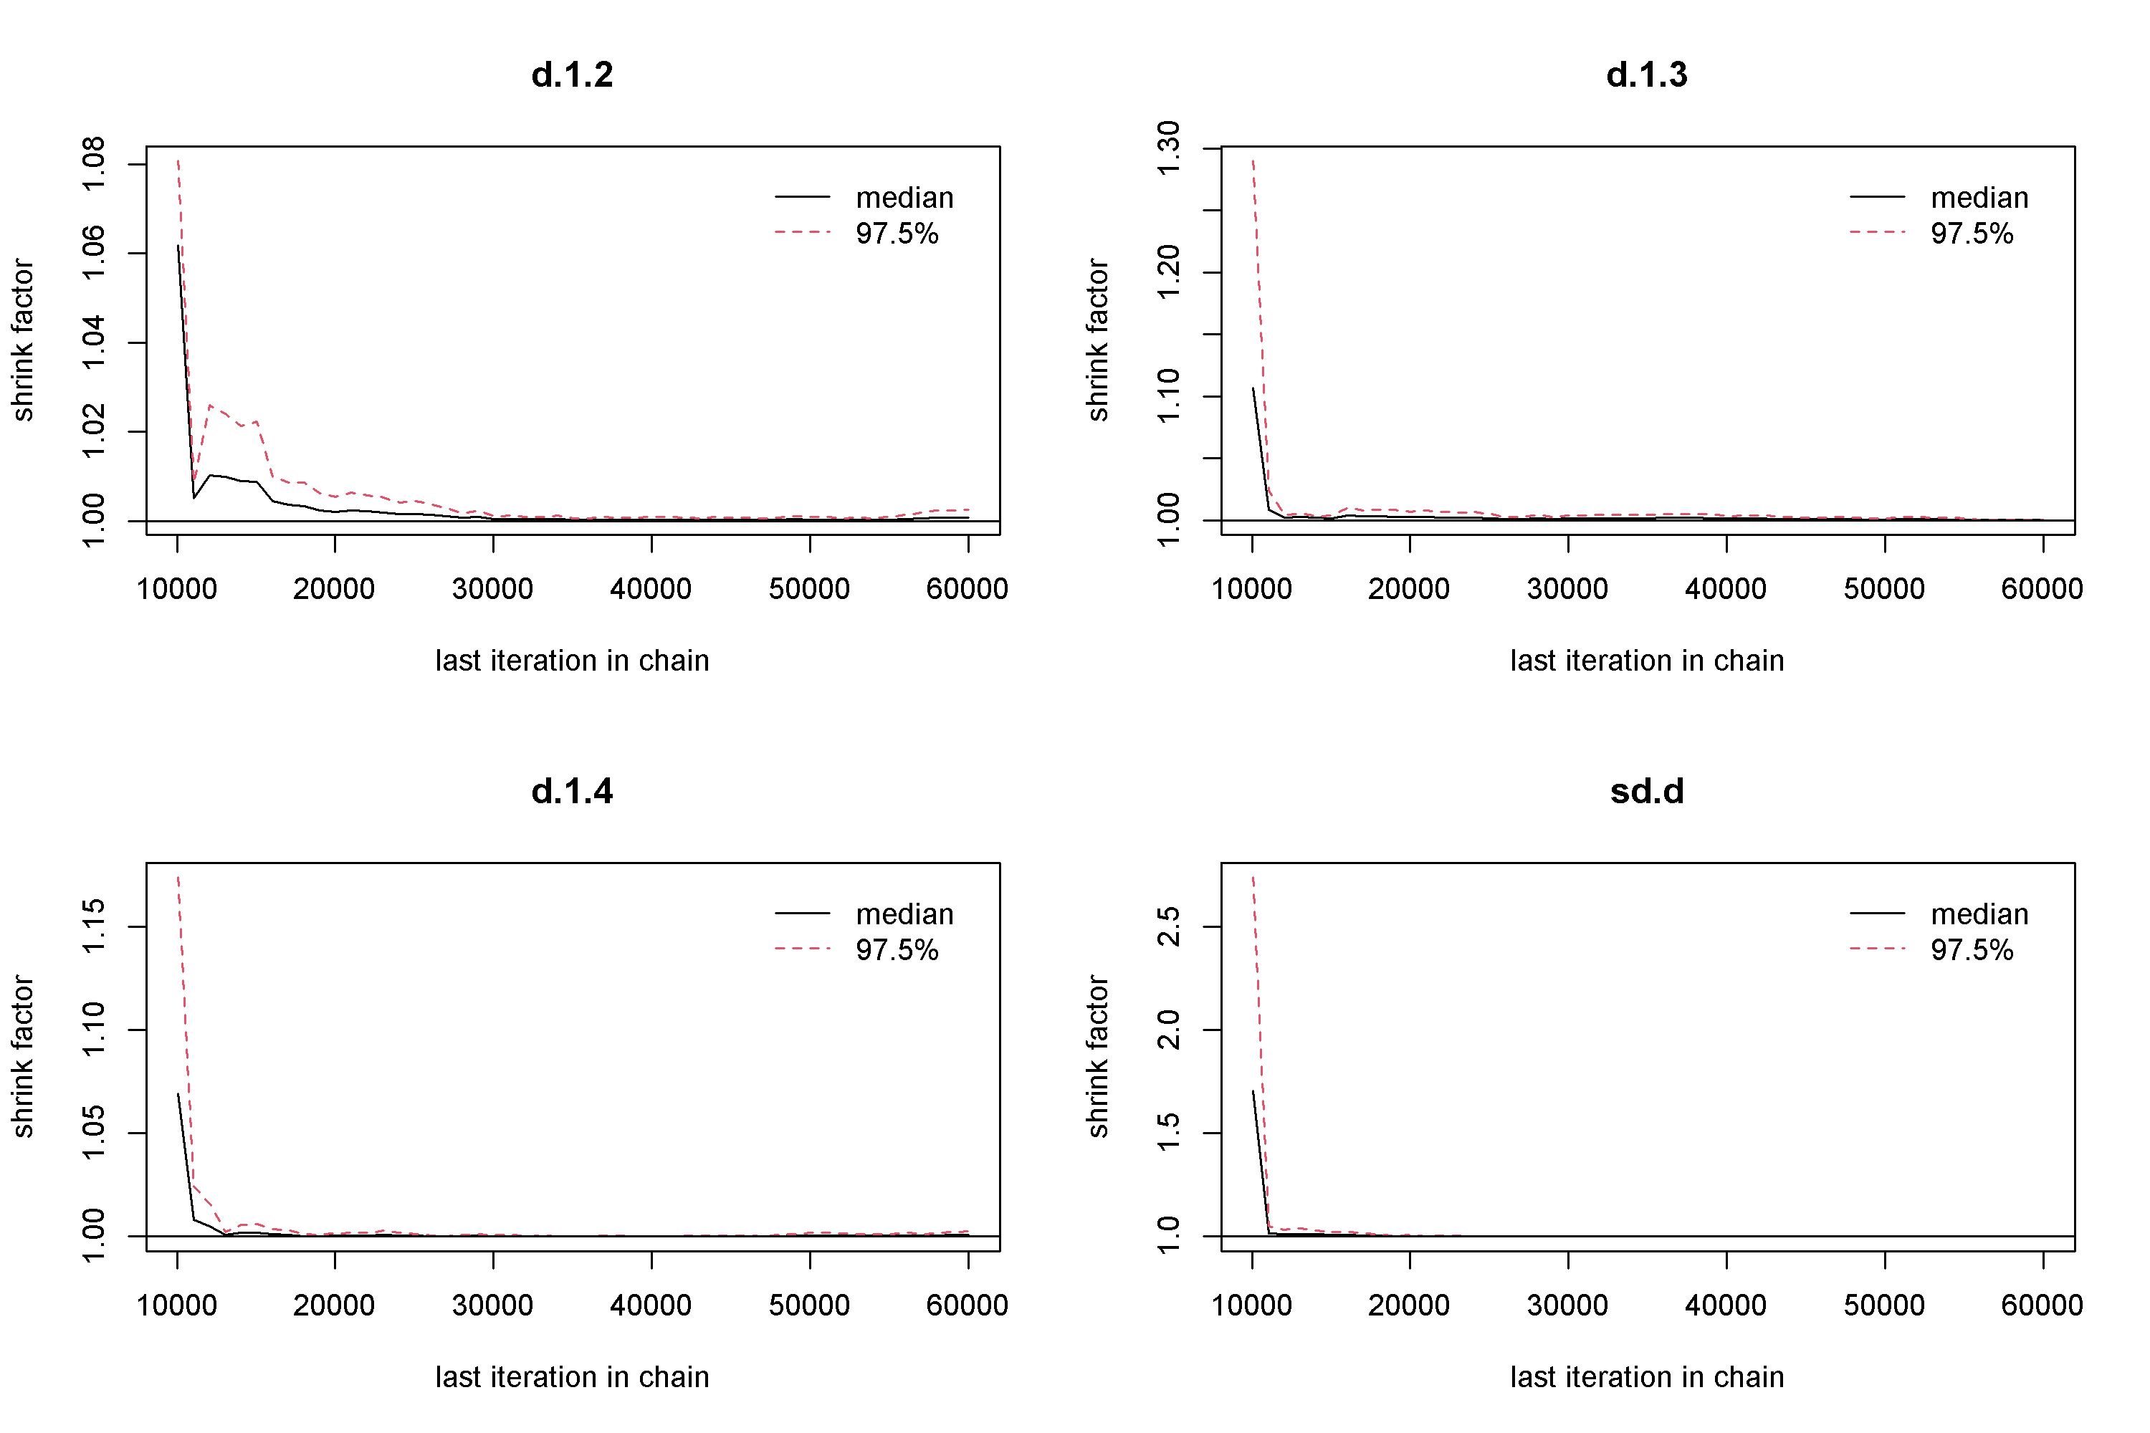

K
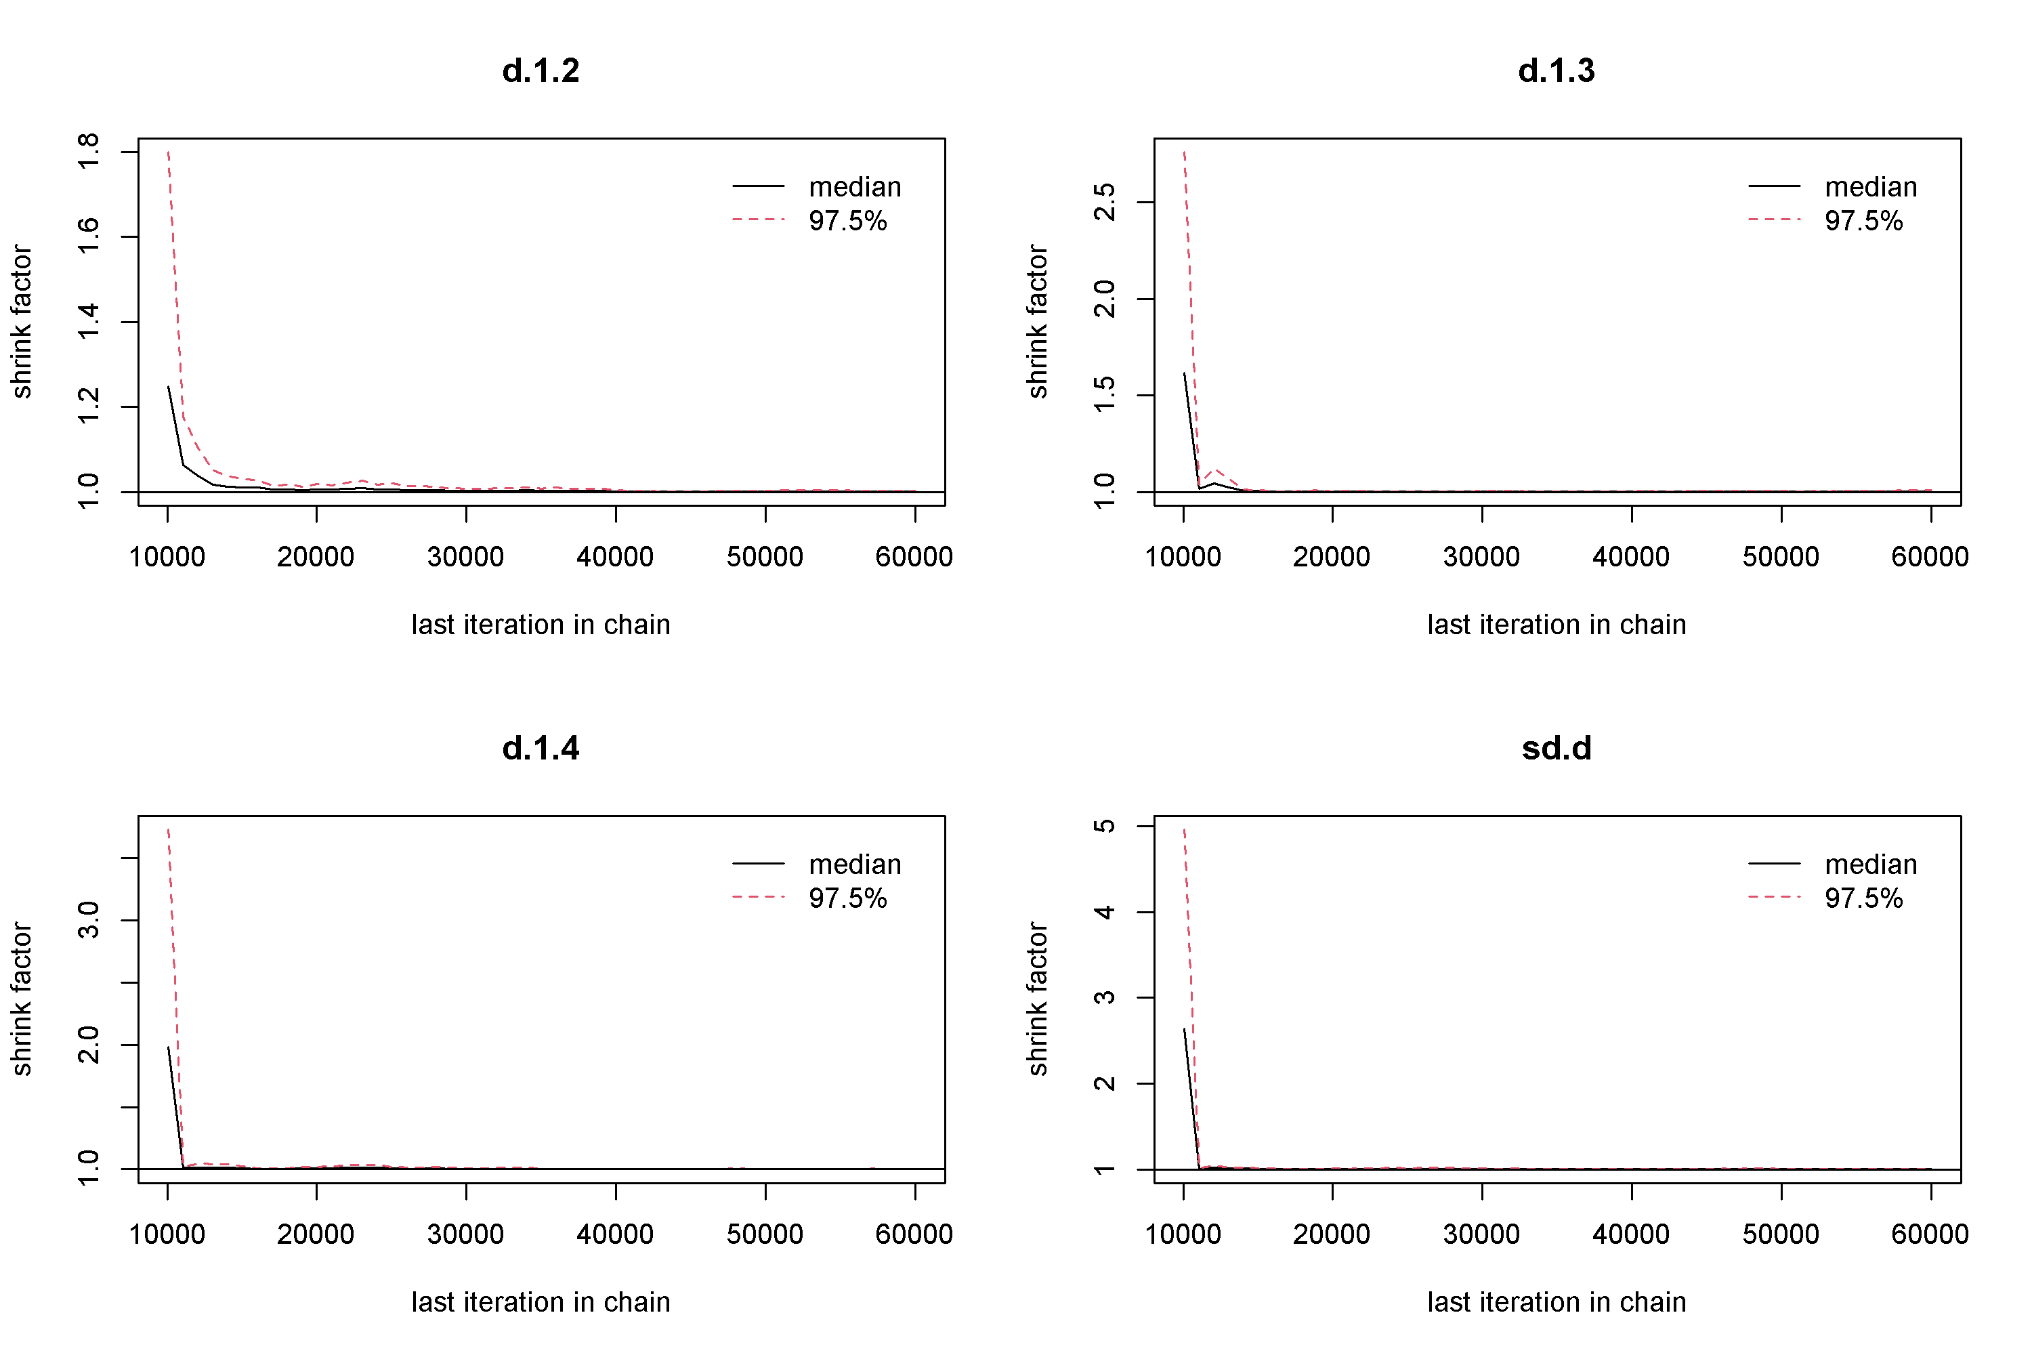

Figure S2 Brooks-Gelman-Rubin diagnostic plots (PSRF). (A) Immediate Improvement in Aphasia Severity; (B) Immediate Repetition Improvement; (C) Immediate Improvement in Comprehension; (D) Immediate Improvement in Naming; (E) Immediate Improvement in Spontaneous Speech; (F) Immediate Improvement in Functional Communication; (G) Immediate Improvement in writing; (H) Long-Term Improvement in Aphasia Severity; (I) Long-Term Improvement in Repetition; (J) Long-Term Improvement in Comprehension; (K) Long-Term Improvement in Naming.

Figure S3 (A) Severity of Immediate Aphasia Improvement; (B) Immediate Repetition Improvement; (C) Immediate Improvement in Comprehension; (D) Immediate Improvement in Naming; (E) Immediate Improvement in Spontaneous Speech; (F) Immediate Improvement in Functional Communication; (G) Immediate Improvement in wrting; (H) Immediate Improvement in Fluency; (I) Immediate Improvement in Writing; (J) Severity of Long-Term Aphasia Improvement; (K) Long-Term Improvement in Repetition; (L) Long-Term Improvement in Comprehension; (M) Long-Term Improvement in Naming; (N) Long-Term Improvement in Spontaneous Speech; (O) Long-Term Improvement in Functional Communication; (P) Long-Term Improvement in Fluency.

