Supplementary material

Table S1 Frequency, severity, and duration of URTIs as assessed by the WURSS-24 questionnaire over the 84-day supplementation period for the ITT population (n = 100)
Outcome | RJ | Placebo | P-value [95% CI]
Frequency of URTI (# of incidences)
Mean ± SD (n) | 1.30 ± 1.33 (46) | 1.41 ± 1.35 (44) | 0.670
Median (Q1 to Q3) | 1.00 (0.00 to 2.00) | 1.00 (0.00 to 2.25) | 1.08* [0.76 to 1.54]
(Min to Max) | (0.00 to 5.00) | (0.00 to 5.00)
AUC score (no units)
Mean ± SD (n) | 83.24 ± 100.66 (46) | 109.03 ± 170.06 (44) | 0.994
Median (Q1 to Q3) | 45.00 (2.25 to 110.00) | 48.75 (0.00 to 148.25) | 0.00** [-27.00 to 20.50]
(Min to Max) | (0.00 to 365.00) | (0.00 to 876.00)
Duration of URTI (days)
Mean ± SD (n) | 4.98 ± 4.19 (31) | 4.89 ± 4.92 (30) | 0.832
Median (Q1 to Q3) | 4.00 (2.00 to 7.00) | 3.00 (2.00 to 7.00) | 0.98* [0.72 to 1.34]
(Min to Max) | (1.00 to 19.00) | (1.00 to 22.00)
Notes: P-value for URTI frequency was calculated using a Poisson model. P-value for AUC was calculated using a Wilcoxon rank-sum test. P-value for duration days for URTI symptoms was calculated using a negative binomial model. *Estimated rate ratio; **estimated difference. AUC, aera under the curve; CI, confidence interval; min, minimum; max, maximum; n, number of participants; Q1, first quartile; Q3, third quartile; RJ, royal jelly; SD, standard deviation; URTI, upper respiratory tract infection.
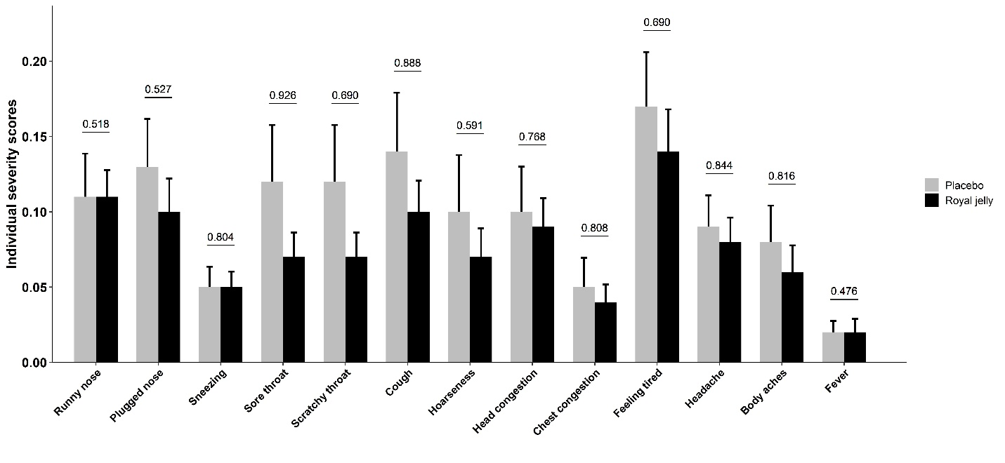
Figure S1 Individual severity scores of URTI symptoms for the ITT population (n = 100; 50 participants per group), as assessed by the WURSS-24 questionnaire. Data are presented as mean ± standard error

