Fig. S1. The uncropped images of original western blots in Fig. 1.

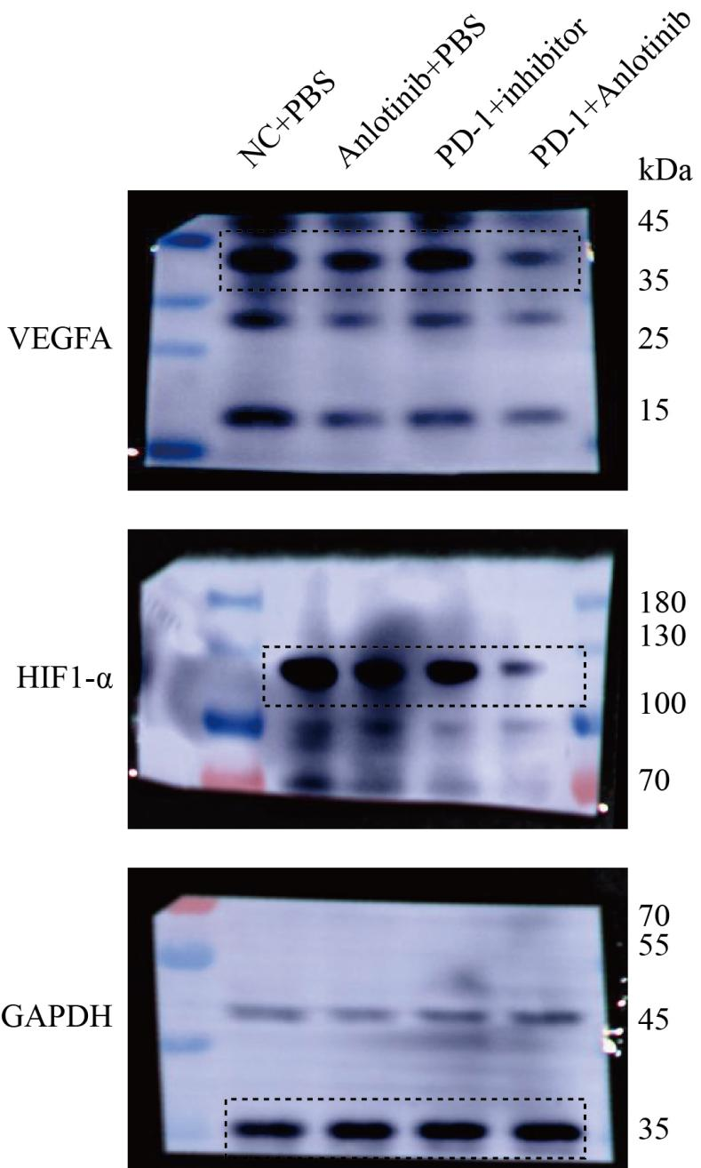
Fig. S2. The uncropped images of original western blots in Fig. 2.

Supplementary Western blot images
bcl2
Fig. S3. The uncropped images of original western blots for the bcl2 protein

caspase3
Fig. S4. The uncropped images of original western blots for the caspase3 protein

cleaved caspase3
Fig. S5. The uncropped images of original western blots for the cleaved caspase3 protein
HIF1-α
Fig. S6. The uncropped images of original western blots for the HIF1-α protein
VEGFA
Fig. S7. The uncropped images of original western blots for the VEGFA protein
Table S1 A
Western Blot Antibodies
Western Blot Antibodies
Antibody Name | Antibody Concentration Prepared | Catalog Number | Company
HIF1-α | 1:1,000 | BF8002 | Affinity Biosciences
Caspase-3 | 1:1,000 | HY-P80046 | MedChemExpress
Cleaved-Caspase 3 | 1:1,000 | HY-P80623 | MedChemExpress
VEGFA | 1:1,000 | AF5131 | Affinity Biosciences
BCL-2 | 1:1,000 | AF6139 | Affinity Biosciences
BAX | 1:1,000 | AF0120 | Affinity Biosciences
GAPDH | 1:1,0000 | AF7021 | Affinity Biosciences

Table S1 B
Flow cytometry Antibodies
Antibody Name | Catalog Number | Company
FITC anti-mouse CD45 | 103108 | BioLegend
Brilliant Violet 421™ anti-mouse CD4 | 100443 | BioLegend
APC anti-mouse CD25 | 102012 | BioLegend
FOXP3 Monoclonal Antibody (FJK-16s), PE | 12-5773-82 | ebioscience
PerCP/Cyanine5.5 anti-mouse/human CD11b | 101228 | BioLegend
APC/Fire™ 750 anti-mouse Ly-6C | 128046 | BioLegend
CD163 Monoclonal Antibody (TNKUPJ), PE | 12-1631-82 | ebioscience
APC anti-mouse F4/80 | 123116 | BioLegend
Brilliant Violet 421™ anti-mouse Ly-6G | 127627 | BioLegend
PE anti-mouse CD279 (PD-1) | 135206 | BioLegend
APC anti-mouse CD8a | 100712 | BioLegend

Section 2.2 revised and Supplementary Table S2 euthanasia/death time and endpoint.
Mouse ID | Group | Endpoint day | Endpoint criterion
NC-1 | Control | Day 16 | tumor necrosis
NC-2 | Control | Day 19 | tumor ulceration
NC-3 | Control | Day 23 | Severe distress
NC-4 | Control | Day 25 | Tumor volume ≥2000 mm³
NC-5 | Control | Day 28 | Tumor volume ≥2000 mm³
NC-6 | Control | Day 30 | Tumor volume ≥2000 mm³
Anl-1 | anlotinib-only treatment group | Day 8 | markedly reduced mobility
Anl-2 | anlotinib-only treatment group | Day 28 | tumor necrosis
Anl-3 | anlotinib-only treatment group | Day 33 | persistent hunching
Anl-4 | anlotinib-only treatment group | Day 35 | tumor ulceration
Anl-5 | anlotinib-only treatment group | Day 38 | Tumor volume ≥2000 mm³
Anl-6 | anlotinib-only treatment group | Day 39 | Tumor volume ≥2000 mm³
PD-1 1 | PD-1/PD-L1-IN-9 hydrochloride-only treatment group | Day 32 | tumor ulceration
PD-1 2 | PD-1/PD-L1-IN-9 hydrochloride-only treatment group | Day 36 | persistent hunching
PD-1 3 | PD-1/PD-L1-IN-9 hydrochloride-only treatment group | Day 43 | inability to access food
PD-1 4 | PD-1/PD-L1-IN-9 hydrochloride-only treatment group | Day 53 | tumor necrosis
PD-1 5 | PD-1/PD-L1-IN-9 hydrochloride-only treatment group | Day 58 | Severe distress
PD-1 6 | PD-1/PD-L1-IN-9 hydrochloride-only treatment group | Day 74 | Tumor volume ≥2000 mm³
Anl+PD-1 1 | combination of anlotinib and PD-1/PD-L1-IN-9 hydrochloride treatment group | Day 44 | inability to access water
Anl+PD-1 2 | combination of anlotinib and PD-1/PD-L1-IN-9 hydrochloride treatment group | Day 60 | tumor ulceration
Anl+PD-1 3 | combination of anlotinib and PD-1/PD-L1-IN-9 hydrochloride treatment group | Day 84 | Severe distress
Anl+PD-1 4 | combination of anlotinib and PD-1/PD-L1-IN-9 hydrochloride treatment group | Day 95 | Tumor volume ≥2000 mm³
Anl+PD-1 5 | combination of anlotinib and PD-1/PD-L1-IN-9 hydrochloride treatment group | Day 100 | euthanasia
Anl+PD-1 6 | combination of anlotinib and PD-1/PD-L1-IN-9 hydrochloride treatment group | Day 100 | euthanasia

