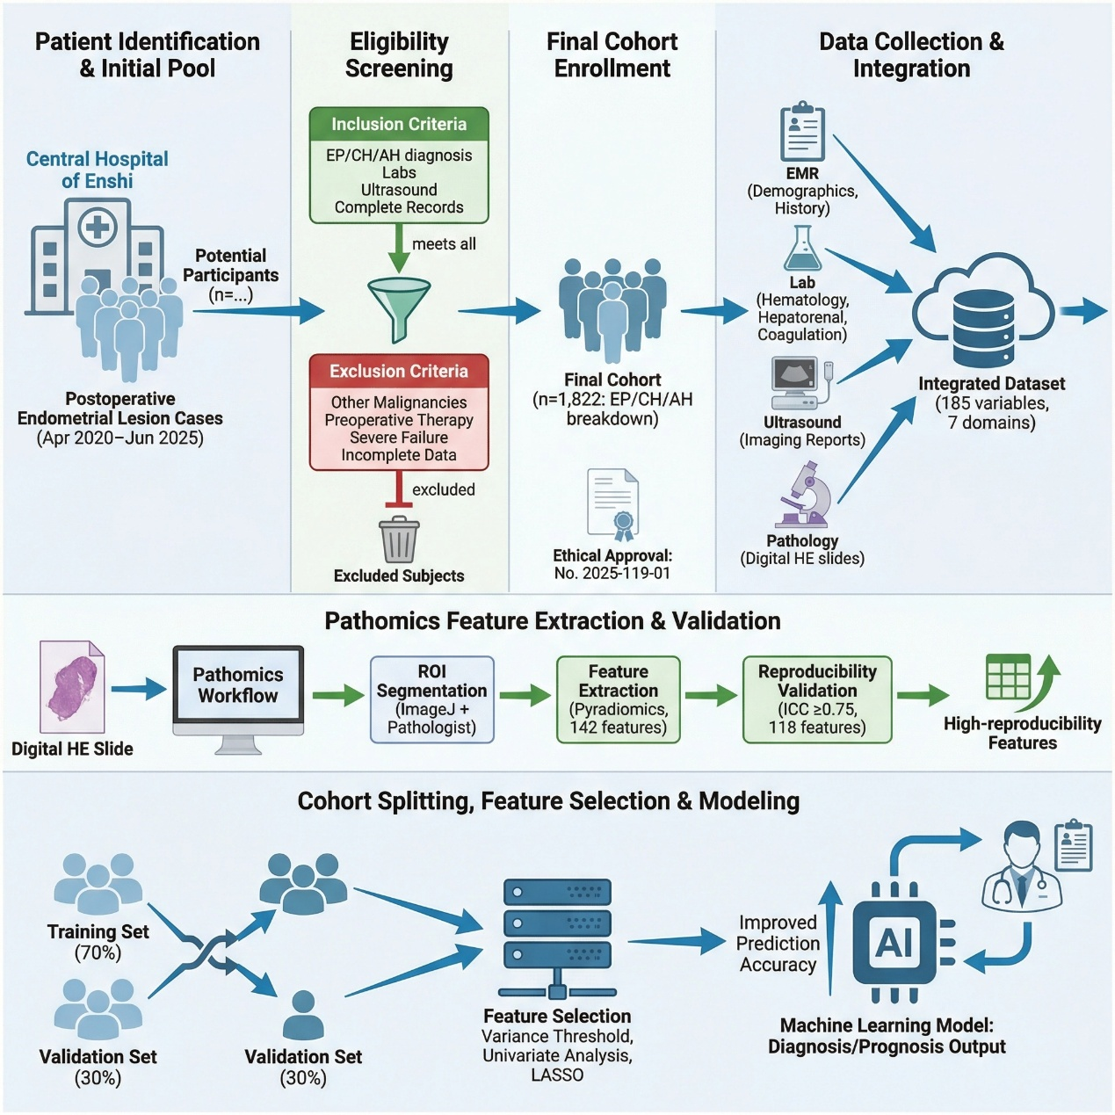
Supplementary figure 1. Flow Diagram of Retrospective Cohort Study for Participant Screening, Data Processing and Model Development

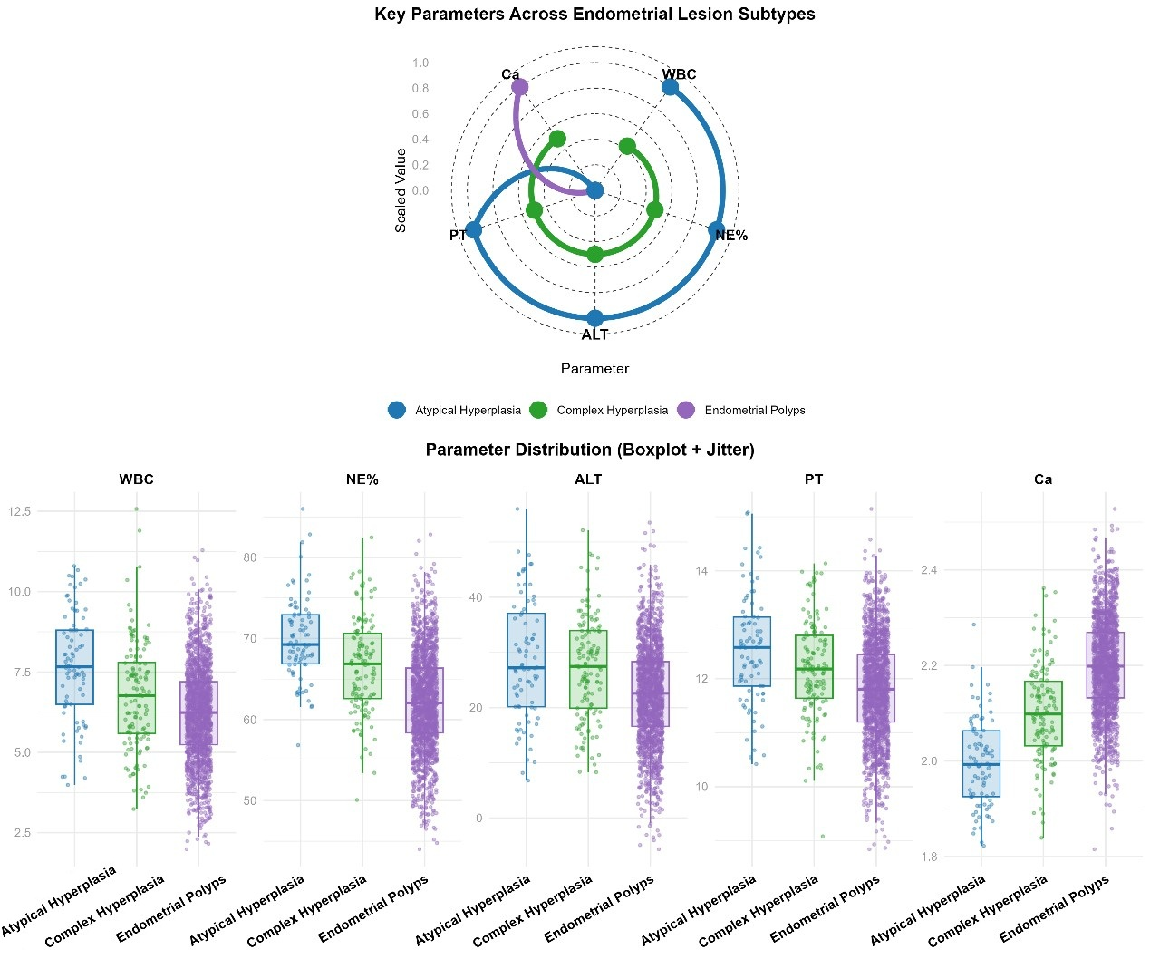
Supplementary Figure 2: Key Hematological, Coagulation, and Electrolyte Parameters Across Endometrial Lesion Subtypes.
Notes. This figure illustrates the distribution and gradient changes of 5 core preoperative parameters across three endometrial lesion subtypes: Endometrial Polyps (EP), Complex Hyperplasia (CH), and Atypical Hyperplasia (AH). (Top) Radar plot of scaled parameter values showing the overall trend: Atypical Hyperplasia (AH) exhibits the highest levels of white blood cell count (WBC), neutrophil percentage (NE%), alanine transaminase (ALT), and prothrombin time (PT), while calcium (Ca) is the lowest among the three subtypes. (Bottom) Boxplot with jitter displaying the distribution of individual patient data for each parameter, confirming significant inter-subtype differences (all P<0.001 for WBC, NE%, ALT, PT; P<0.01 for Ca). These parameters reflect systemic inflammatory, metabolic, and coagulation status, which are closely linked to the pathogenesis and severity of endometrial lesions. The gradient changes observed align with the progressive increase in malignant transformation risk from EP to AH, supporting the utility of these routine preoperative indicators for auxiliary subtype stratification.

Supplementary Figure 3: Scatter plots with regression lines showing the relationship between representative key features and lesion severity. Each subplot corresponds to a representative key feature, including (A) glandular circularity (pathomics feature), (B) gravidity (clinical reproductive feature), and (C) neutrophil percentage (NE%, inflammatory/hematological feature). The x-axis represents the feature value, and the y-axis represents lesion severity (encoded as 0=endometrial polyps, 1=complex hyperplasia, 2=atypical hyperplasia). The solid line indicates the linear regression fit, and the shaded area represents the 95% confidence interval. The correlation coefficient (r) and statistical significance (P<0.001) are labeled in each subplot, illustrating the positive or negative linear association between the feature and lesion severity.

