SUPPLEMENTARY MATERIAL
Plasma Lipidomic Signatures Across the Healthy–Pre-COPD–COPD Continuum Identified by Machine Learning
Supplementary Table S1. Differential lipid species (VIP, log₂FC, p-values) for each comparison. 2
Supplementary Table S2. Covariate-adjusted differentially expressed lipids identified from the overall comparison. 10
Supplementary Table S3. Pc14
Supplementary Figure S1. OPLS-DA score plot and permutation test 15
Supplementary Figure S2. Feature selection stability across 5-fold cross-validation for the combined model 22
Supplementary Figure S3. Training and test accuracy across the five outer folds of nested cross-validation for the combined model 25
Supplementary Figure S4. Confusion matrix of the combined model evaluated by nested cross-validation 27
Supplementary Figure S5. Calibration curves of the combined model (with Brier scores) 29

Supplementary Table S1. Differential lipid species (VIP, log₂FC, p-values) for each comparison.
Table S1-A. Differential lipid species for the comparison A vs B1.
Lipid ID | VIP | P-VALUE | FC | log₂FC
CerPE(d14:1(4E)/21:0) | 1.19966821 | 0.00438172 | 0.85906887 | -0.2191543
SM(d16:1/17:0) | 1.06057258 | 0.00580357 | 0.84746186 | -0.2387796
PC(16:0/22:4(7Z,10Z,13Z,16Z)) | 1.52537493 | 0.0085298 | 0.82716582 | -0.2737515
SM(d18:2/21:0) | 1.17610707 | 0.02236551 | 0.88966743 | -0.168662
PI(18:0/0:0) | 1.27320328 | 0.00098813 | 0.65395822 | -0.6127296
Cer(d18:1/22:0) | 1.55399884 | 0.00033076 | 0.61168519 | -0.7091388
PI(18:0/20:4(5Z,8Z,11Z,14Z)) | 1.80232886 | 9.16E-05 | 0.7985482 | -0.3245486
SM(d18:1/24:1(15Z)) | 1.48924502 | 0.00923743 | 0.91819208 | -0.1231321
PI(17:0/20:4(5Z,8Z,11Z,14Z)) | 1.38563762 | 0.00397843 | 0.76576576 | -0.3850249
GM3(d18:1/16:0) | 1.00955624 | 0.04145223 | 0.8730454 | -0.1958714
PS(17:0/22:0) | 1.48646527 | 0.01210872 | 0.8792554 | -0.1856458
PS(15:0/22:0) | 1.39359161 | 0.01184047 | 0.90941686 | -0.1369863
PA(14:0/12:0) | 1.11922219 | 0.03472735 | 0.93547347 | -0.0962314
PS(17:0/22:2(13Z,16Z)) | 1.53160352 | 0.00285284 | 0.89519894 | -0.1597198
PS(19:0/22:2(13Z,16Z)) | 1.47074287 | 0.00670809 | 0.84700759 | -0.2395532
PS(20:3(8Z,11Z,14Z)/21:0) | 1.33241113 | 0.03740995 | 0.89321539 | -0.16292
TG(14:0/16:0/17:0) | 1.84868814 | 0.00061825 | 1.81309428 | 0.85845395
TG(13:0/15:0/15:0) | 2.22108238 | 4.37E-05 | 1.74487383 | 0.80312272
PE(0:0/18:2(9Z,12Z)) | 1.47449273 | 0.00749049 | 1.37837468 | 0.46296811
DG(18:0/20:4(5Z,8Z,11Z,14Z)/0:0) | 1.41632002 | 0.00344158 | 0.83013426 | -0.2685834
TG(12:0/14:0/15:0) | 1.93329566 | 0.00099573 | 1.68850049 | 0.75574259
TG(12:0/14:0/14:0) | 1.32321931 | 0.04710642 | 3.17817438 | 1.66819828
SM(d18:2/23:0) | 1.24209274 | 0.03050439 | 0.90149907 | -0.1496021
PE(0:0/18:0) | 1.10600842 | 0.02792913 | 1.21062728 | 0.27575477
PA(18:1(9Z)/0:0) | 1.56433403 | 0.00931775 | 1.43154286 | 0.51757087
PE(0:0/20:4(8Z,11Z,14Z,17Z)) | 1.29456066 | 0.02584078 | 1.25391644 | 0.32644121
PE(18:1(11Z)/0:0) | 1.46723028 | 0.00538327 | 1.49773555 | 0.58278292
TG(13:0/15:0/16:0) | 1.62526932 | 0.0146704 | 2.4157504 | 1.2724714
TG(18:0/18:2(9Z,12Z)/18:3(9Z,12Z,15Z)) | 1.12363306 | 0.0485298 | 0.83854357 | -0.2540423
TG(13:0/16:0/16:1(9Z)) | 2.12907171 | 0.00010166 | 2.03123176 | 1.02235486
DG(14:0/16:0/0:0) | 1.43644054 | 0.00971447 | 1.80489096 | 0.85191168
TG(13:0/15:0/15:1(9Z)) | 1.83012502 | 0.00118834 | 1.79516232 | 0.8441143
TG(14:0/16:0/16:1(9Z)) | 1.41495277 | 0.04928258 | 2.07599073 | 1.0538
PE(P-18:0/18:3(9Z,12Z,15Z)) | 1.49175351 | 0.04466076 | 1.28196826 | 0.35836054
TG(12:0/14:0/16:0) | 1.47980731 | 0.02411232 | 2.87838076 | 1.52525745
TG(14:1(9Z)/15:0/15:0) | 1.5028183 | 0.02356211 | 2.49608305 | 1.31966594
SM(d18:1/20:0) | 1.25735226 | 0.00629176 | 0.85571756 | -0.2247934
PA(O-16:0/0:0) | 1.07649804 | 0.04227652 | 1.29454379 | 0.37244377
PE(16:0/0:0) | 1.15637559 | 0.04783537 | 1.21525211 | 0.28125564
CerPE(d14:1(4E)/24:0(2OH)) | 1.14308723 | 0.00758866 | 0.79698505 | -0.3273754
TG(12:0/14:0/16:1(9Z)) | 1.3781001 | 0.04123991 | 2.659559 | 1.41118704
TG(20:1(11Z)/22:1(13Z)/22:2(13Z,16Z)) | 1.33401339 | 0.00855597 | 1.49673438 | 0.58181821
TG(18:1(9Z)/18:1(9Z)/20:4(5Z,8Z,11Z,14Z)) | 1.28283499 | 0.01679613 | 0.83978929 | -0.2519007
PI(18:1(9Z)/18:3(6Z,9Z,12Z)) | 1.42923789 | 0.00278718 | 2.59762964 | 1.37719575
TG(14:0/15:0/16:0) | 2.29475106 | 1.08E-05 | 1.88722508 | 0.91626649
PA(O-16:0/20:3(8Z,11Z,14Z)) | 1.73180007 | 0.01839814 | 1.2845761 | 0.36129236
Cer(d18:1/26:0) | 1.3310974 | 0.00377461 | 0.76273429 | -0.3907475
SM(d18:1/26:0) | 1.0338537 | 0.014274 | 0.7575127 | -0.400658
TG(16:1(9Z)/18:0/20:1(11Z)) | 1.60666908 | 0.02213695 | 0.89053054 | -0.167263
PC(17:2(9Z,12Z)/20:1(11Z)) | 1.06069122 | 0.03097202 | 0.83629975 | -0.257908
GlcCer(d18:1/24:1(15Z)) | 1.76316141 | 0.00053073 | 0.58710437 | -0.7683111
SM(d18:1/17:0) | 1.33477069 | 0.00281219 | 0.78707788 | -0.3454217
SM(d18:1/26:1(17Z)) | 1.44815071 | 0.00196419 | 0.76109177 | -0.3938577
TG(13:0/14:0/14:1(9Z)) | 1.54308621 | 0.01075197 | 1.91224078 | 0.9352642
TG(18:0/18:3(6Z,9Z,12Z)/18:4(6Z,9Z,12Z,15Z)) | 1.41963821 | 0.02596325 | 0.79958701 | -0.3226731
18:2 Cholesterol ester | 1.20803492 | 0.02316875 | 1.86075976 | 0.8958918
PC(O-18:0/20:3(8Z,11Z,14Z)) | 1.10625854 | 0.0231805 | 0.85689776 | -0.222805
PC(20:0/22:5(7Z,10Z,13Z,16Z,19Z)) | 1.18719652 | 0.02067395 | 0.81131822 | -0.3016602
PC(17:0/22:6(4Z,7Z,10Z,13Z,16Z,19Z)) | 1.17242211 | 0.01917437 | 0.7003415 | -0.5138695
PA(20:5(5Z,8Z,11Z,14Z,17Z)/22:0) | 1.22795615 | 0.01305415 | 0.73189177 | -0.4502978
Cer(d18:2/24:0) | 1.00942825 | 0.04618133 | 0.87186872 | -0.1978172
Cer(t18:0/19:0) | 1.01591275 | 0.01965729 | 0.84981636 | -0.234777
PE(P-20:0/14:1(9Z)) | 1.64270572 | 0.00740874 | 1.36196165 | 0.44568608
TG(12:0/18:4(6Z,9Z,12Z,15Z)/22:3(10Z,13Z,16Z)) | 1.22072861 | 0.02684429 | 0.67767913 | -0.5613258
DG(14:0/14:0/0:0) | 1.37217824 | 0.03986645 | 6.81761256 | 2.76926661
GlcCer(d16:1/20:0) | 1.54100215 | 0.03033086 | 2.11465005 | 1.08041893
TG(14:1(9Z)/16:0/18:3(9Z,12Z,15Z)) | 1.76609302 | 0.0105879 | 2.27419117 | 1.18535353
PC(18:2(9Z,12Z)/19:1(9Z)) | 1.10921351 | 0.02424583 | 0.9018673 | -0.1490129
Dodecanoylcarnitine | 1.00930846 | 0.00394925 | 0.91354517 | -0.130452
PE(17:1(9Z)/22:2(13Z,16Z)) | 1.07831192 | 0.01794132 | 0.81345262 | -0.2978698
Table S1-B. Differential lipid species for the comparison A vs B2.
Lipid ID | VIP | P-VALUE | FC | log₂FC
CerPE(d14:1(4E)/21:0) | 1.04351828 | 0.02696278 | 0.84307305 | -0.2462705
CerPE(d14:1(4E)/24:1(15Z)) | 1.21121401 | 0.00402919 | 0.88264747 | -0.1800907
SM(d16:1/25:0) | 1.37714417 | 0.00925255 | 0.91809301 | -0.1232878
PC(15:0/0:0) | 1.04175406 | 0.0198094 | 0.91166445 | -0.1334252
PI(18:1(9Z)/18:0) | 1.03572584 | 0.03393038 | 0.83420645 | -0.2615236
SM(d18:2/21:0) | 1.12300825 | 0.00864209 | 0.86698408 | -0.2059226
PE(22:6(4Z,7Z,10Z,13Z,16Z,19Z)/0:0) | 1.04358905 | 0.0324399 | 0.84007607 | -0.2514081
PC(18:0/0:0) | 1.09209724 | 0.03683337 | 0.90088855 | -0.1505795
PI(18:2(9Z,12Z)/16:0) | 1.09951181 | 0.03325738 | 0.84356312 | -0.2454321
PI(18:0/20:4(5Z,8Z,11Z,14Z)) | 1.93955735 | 1.61E-05 | 0.81935724 | -0.2874355
PI(20:1(11Z)/18:0) | 1.46167991 | 0.00089044 | 0.81337747 | -0.2980031
PI(18:2(9Z,12Z)/18:0) | 1.06488801 | 0.03612583 | 0.8823565 | -0.1805664
SM(d18:1/24:1(15Z)) | 1.52154567 | 0.00310144 | 0.88796712 | -0.1714218
PI(16:0/22:6(4Z,7Z,10Z,13Z,16Z,19Z)) | 1.54716003 | 0.00381007 | 0.77351701 | -0.3704951
PI(17:0/20:4(5Z,8Z,11Z,14Z)) | 1.66898829 | 0.0003356 | 0.68193619 | -0.5522913
PI(16:0/18:1(9Z)) | 1.19513386 | 0.02917726 | 0.82495175 | -0.2776184
Cer(d18:1/24:0) | 1.11531596 | 0.00412196 | 0.79533952 | -0.3303572
PI(20:4(5Z,8Z,11Z,14Z)/16:0) | 1.53671182 | 0.00309307 | 0.80149338 | -0.3192375
GM3(d18:1/16:0) | 1.2958891 | 0.00273083 | 0.78699898 | -0.3455663
PA(12:0/14:1(9Z)) | 1.20491211 | 0.00541577 | 0.88632864 | -0.1740864
PS(15:0/22:0) | 1.18897671 | 0.01165598 | 0.91719639 | -0.1246974
PA(14:0/12:0) | 1.55495429 | 0.00315494 | 0.90817647 | -0.1389554
PS(17:0/22:2(13Z,16Z)) | 1.3746364 | 0.00305822 | 0.89444282 | -0.1609388
PS(19:0/22:2(13Z,16Z)) | 1.26958912 | 0.01064209 | 0.85412609 | -0.227479
PS(20:3(8Z,11Z,14Z)/21:0) | 1.1660986 | 0.02101264 | 0.88755161 | -0.1720971
TG(14:0/16:0/17:0) | 1.49661242 | 0.01831911 | 1.46462817 | 0.55053445
TG(13:0/15:0/15:0) | 1.6949598 | 0.03697763 | 1.34790032 | 0.43071381
DG(18:0/20:4(5Z,8Z,11Z,14Z)/0:0) | 1.22128364 | 0.02683905 | 0.86740563 | -0.2052213
TG(12:0/14:0/15:0) | 1.58645568 | 0.0172263 | 1.4367006 | 0.52275944
LacCer(d18:1/16:0) | 1.1227121 | 0.01440915 | 0.85332274 | -0.2288366
SM(d18:2/23:0) | 1.46871893 | 0.01390567 | 0.871327 | -0.1987139
TG(14:0/16:0/16:0) | 1.14115516 | 0.02966647 | 1.8985887 | 0.9249274
TG(13:0/15:0/16:0) | 1.39228717 | 0.02822758 | 2.08880017 | 1.06267448
DG(14:0/16:0/0:0) | 1.50863125 | 0.00436595 | 1.97061933 | 0.97864911
TG(13:0/15:0/15:1(9Z)) | 1.40325616 | 0.04171492 | 1.4355821 | 0.52163584
SM(d18:1/16:0(2OH)) | 1.11023936 | 0.01987068 | 0.85254071 | -0.2301594
GlcCer(d18:2(4E,8E)(9Me)/16:0) | 1.09072722 | 0.04653347 | 0.84277218 | -0.2467854
GlcCer(d15:2(4E,6E)/22:0) | 1.03127974 | 0.0164063 | 0.80739647 | -0.3086508
PI(18:0/18:3(9Z,12Z,15Z)) | 1.0895545 | 0.04780401 | 0.84969453 | -0.2349838
TG(12:0/14:0/16:0) | 1.34007078 | 0.04510445 | 2.38589538 | 1.25453078
PA(O-20:0/20:0) | 1.16320323 | 0.04831982 | 0.79095197 | -0.338338
SM(d18:1/20:0) | 1.27654997 | 0.01620987 | 0.87471984 | -0.1931071
DG(16:0/20:4(5Z,8Z,11Z,14Z)/0:0) | 1.31654229 | 0.02523294 | 0.79258648 | -0.3353597
SM(d18:2/18:1) | 1.41473363 | 0.00185727 | 0.78061703 | -0.3573132
Cer(d18:1/23:0) | 1.05650681 | 0.00766478 | 0.81524842 | -0.2946884
PE(P-16:0/16:1(9Z)) | 1.19712906 | 0.02403833 | 0.80786326 | -0.307817
CerPE(d14:1(4E)/24:0(2OH)) | 1.32813466 | 0.00188084 | 0.80313504 | -0.3162855
PC(22:6(4Z,7Z,10Z,13Z,16Z,19Z)/18:0) | 1.16560668 | 0.03977649 | 0.86648198 | -0.2067584
SM(d16:1/22:1) | 1.20634734 | 0.01417926 | 0.87764402 | -0.1882922
SM(d18:1/18:1(9Z)) | 1.20591157 | 0.00795699 | 0.84281752 | -0.2467078
PS(O-16:0/20:2(11Z,14Z)) | 1.00261633 | 0.03716563 | 0.84373751 | -0.2451339
PS(P-20:0/22:6(4Z,7Z,10Z,13Z,16Z,19Z)) | 1.14201874 | 0.03056231 | 0.77908422 | -0.3601488
PI(18:4(6Z,9Z,12Z,15Z)/18:0) | 1.36045324 | 0.02274079 | 0.82159429 | -0.2835019
PI(18:1(9Z)/18:3(6Z,9Z,12Z)) | 1.10509818 | 0.01146811 | 2.17335554 | 1.11992421
TG(14:0/15:0/16:0) | 1.68576913 | 0.03985257 | 1.37023219 | 0.45442038
PC(10:0/24:0) | 1.1947021 | 0.01791108 | 0.8761974 | -0.1906722
SM(d18:2/15:0) | 1.28246904 | 0.03845276 | 0.84243256 | -0.2473669
PC(18:4(6Z,9Z,12Z,15Z)/22:6(4Z,7Z,10Z,13Z,16Z,19Z)) | 1.21098856 | 0.04884391 | 0.80850376 | -0.3066736
PC(26:0/0:0) | 1.02188394 | 0.01926162 | 0.78792089 | -0.3438773
Cer(d18:1/26:0) | 1.08693323 | 0.01298801 | 0.81845708 | -0.2890213
SM(d18:1/26:0) | 1.26635818 | 0.01772995 | 0.83403594 | -0.2618185
GlcCer(d18:1/24:1(15Z)) | 1.34751057 | 0.02125676 | 0.68384327 | -0.5482624
SM(d18:1/17:0) | 1.14719051 | 0.01415029 | 0.83181395 | -0.2656672
SM(d18:1/26:1(17Z)) | 1.40397094 | 0.01416509 | 0.77721455 | -0.3636152
PA(18:3(9Z,12Z,15Z)/22:1(11Z)) | 1.1233676 | 0.01819828 | 0.82507273 | -0.2774068
GlcCer(d18:1/23:0) | 1.43565399 | 0.00556636 | 0.76390142 | -0.3885416
Cer(d18:2/24:0) | 1.00597252 | 0.02459424 | 0.86071163 | -0.2163981
PE(O-18:0/22:1(11Z)) | 1.17767405 | 0.02297197 | 0.82477059 | -0.2779352
Cer(t18:0/19:0) | 1.21196925 | 0.00523637 | 0.8220037 | -0.2827832
PI(18:4(6Z,9Z,12Z,15Z)/22:4(7Z,10Z,13Z,16Z)) | 1.06681759 | 0.04125392 | 1.22886821 | 0.2973302
PC(18:2(9Z,12Z)/19:1(9Z)) | 1.20180671 | 0.04385318 | 0.91415026 | -0.1294968
PC(18:2(9Z,12Z)/17:1(9Z)) | 1.04051552 | 0.03667302 | 0.92463024 | -0.1130516
PE(17:1(9Z)/22:2(13Z,16Z)) | 1.09943425 | 0.02618118 | 0.80719559 | -0.3090098
SM(d18:0/22:0) | 1.29216595 | 0.0078 | 0.80453622 | -0.3137707
SM(d18:2/25:0) | 1.43962747 | 0.0216659 | 0.82584946 | -0.2760493
SM(d16:1/24:1) | 1.21726995 | 0.03705535 | 0.81701344 | -0.2915683
PE(O-16:0/16:1(9Z)) | 1.33753061 | 0.00869231 | 0.80610149 | -0.3109666
Table S1-C. Differential lipid species for the comparison A vs B3.
Lipid ID | VIP | P-VALUE | FC | log₂FC
PI(18:0/0:0) | 1.33174272 | 0.00897286 | 0.68940722 | -0.5365717
PI(18:0/20:4(5Z,8Z,11Z,14Z)) | 1.45960355 | 0.00358971 | 0.8059353 | -0.3112641
SM(d18:1/24:1(15Z)) | 1.22203795 | 0.01304759 | 0.89866528 | -0.1541442
Cer(d18:1/24:0) | 1.32837919 | 0.00486696 | 0.78515816 | -0.3489448
GM3(d18:1/16:0) | 1.77307396 | 0.00021538 | 0.77108765 | -0.3750332
TG(14:0/16:0/17:0) | 1.41119524 | 0.0266493 | 1.4459031 | 0.53197088
DG(18:0/20:4(5Z,8Z,11Z,14Z)/0:0) | 1.58892402 | 0.0009598 | 0.78772025 | -0.3442447
TG(12:0/14:0/15:0) | 1.44177501 | 0.04451257 | 1.38209783 | 0.46685974
GlcCer(d16:1/18:0) | 1.08745017 | 0.03526928 | 0.73456468 | -0.4450386
GM3(d18:1/22:0) | 1.69585916 | 0.00082577 | 0.6930773 | -0.5289118
TG(12:0/14:0/14:0) | 1.66736094 | 0.04977873 | 3.08759338 | 1.62648277
SM(d18:2/23:0) | 1.52273597 | 0.00178626 | 0.83092587 | -0.2672083
Cer(m18:1(4E)/20:0) | 2.2424589 | 0.01879101 | 1.18281047 | 0.24221892
TG(14:0/16:0/16:0) | 1.50137832 | 0.02669454 | 1.91986242 | 0.94100293
TG(13:0/15:0/16:0) | 1.68726785 | 0.02170046 | 2.18237749 | 1.12590067
Gb3(d18:1/16:0) | 1.12766127 | 0.00307263 | 0.80693481 | -0.309476
PI(18:3(9Z,12Z,15Z)/20:0) | 1.2047316 | 0.03908807 | 0.75201673 | -0.4111633
DG(14:0/16:0/0:0) | 1.2838193 | 0.00571532 | 1.90667735 | 0.93106073
Cer(m18:0/18:0) | 1.67502114 | 0.00039025 | 0.85551952 | -0.2251273
TG(14:0/16:0/16:1(9Z)) | 1.63185751 | 0.03659875 | 2.16244454 | 1.11266313
CerPE(d14:1(4E)/20:0) | 1.04446894 | 0.02883616 | 0.8810046 | -0.1827785
SM(d18:1/16:0(2OH)) | 1.10945498 | 0.01059228 | 0.8618361 | -0.2145146
GlcCer(d18:2(4E,8E)(9Me)/16:0) | 1.21459564 | 0.02127039 | 0.81161466 | -0.3011332
GlcCer(d15:2(4E,6E)/22:0) | 1.1511942 | 0.01795863 | 0.82999652 | -0.2688228
TG(12:0/14:0/16:0) | 1.69804087 | 0.03396432 | 2.57191011 | 1.36284022
TG(14:1(9Z)/15:0/15:0) | 1.70989383 | 0.03301827 | 2.28645812 | 1.19311449
SM(d18:1/20:0) | 1.08656267 | 0.0276436 | 0.86458598 | -0.2099186
SM(d18:1/24:0) | 1.01915264 | 0.01982071 | 0.83485683 | -0.2603993
SM(d18:2/18:1) | 1.09489449 | 0.00382544 | 0.81443702 | -0.296125
Cer(d16:0/16:0) | 2.3033087 | 0.02873068 | 1.16350742 | 0.21848041
PE(16:0/0:0) | 1.45726119 | 0.03318458 | 1.22344261 | 0.29094643
CerPE(d14:1(4E)/24:0(2OH)) | 1.10973857 | 0.00556631 | 0.78171561 | -0.3552843
Cer(d18:1/34:0) | 1.40917068 | 0.00899995 | 1.59070992 | 0.66967077
TG(12:0/14:0/16:1(9Z)) | 1.67801201 | 0.04419531 | 2.57748509 | 1.36596408
SM(d16:1/22:1) | 1.20816533 | 0.01890628 | 0.88694712 | -0.17308
SM(d18:1/18:1(9Z)) | 1.20841381 | 0.00422293 | 0.82913479 | -0.2703214
PG(20:4(5Z,8Z,11Z,14Z)/0:0) | 1.90672116 | 0.02272299 | 1.19529199 | 0.25736308
SM(d16:1/23:0) | 1.11892697 | 0.04815052 | 0.82472328 | -0.278018
Cer(d18:1/26:0) | 1.38336422 | 0.00365231 | 0.79945005 | -0.3229202
Cer(d18:0/14:0) | 2.39689425 | 0.00067292 | 1.26775559 | 0.34227664
SM(d18:1/26:0) | 1.10374769 | 0.02108626 | 0.79617299 | -0.3288462
GlcCer(d18:1/24:1(15Z)) | 1.21320764 | 0.02797628 | 0.70416761 | -0.5060092
SM(d18:1/17:0) | 1.13887907 | 0.00650048 | 0.79052335 | -0.33912
SM(d18:1/26:1(17Z)) | 1.40970116 | 0.00827793 | 0.77445193 | -0.3687524
Cer(d18:0/15:0) | 2.22078025 | 0.03484241 | 1.15505073 | 0.20795621
TG(13:0/14:0/14:1(9Z)) | 1.24881988 | 0.04819683 | 1.6177023 | 0.69394614
Cer(m18:0/16:0) | 2.48484567 | 0.00129652 | 1.2445329 | 0.31560437
GlcCer(d18:1/22:0) | 1.21329583 | 0.03351021 | 0.86271418 | -0.2130454
GlcCer(d18:1/23:0) | 1.50276062 | 0.00254126 | 0.72491047 | -0.4641253
PC(P-20:0/22:4(7Z,10Z,13Z,16Z)) | 1.10335883 | 0.032739 | 1.45791195 | 0.54390359
PG(16:0/0:0) | 1.69208764 | 0.00546437 | 1.22153299 | 0.28869283
DG(14:0/14:0/0:0) | 1.61967012 | 0.03314435 | 8.48949047 | 3.08567797
GlcCer(d16:1/20:0) | 1.61320437 | 0.03673702 | 1.9915132 | 0.99386505
TG(14:1(9Z)/16:0/18:3(9Z,12Z,15Z)) | 1.5730396 | 0.04306182 | 1.75973136 | 0.8153552
PG(21:0/0:0) | 1.70957629 | 0.02377864 | 1.24748784 | 0.31902576
SM(d18:0/22:0) | 1.37950506 | 0.00330656 | 0.75995092 | -0.3960218
SM(d18:2/25:0) | 1.16294562 | 0.02142935 | 0.83622661 | -0.2580341
SM(d16:1/24:1) | 1.04126509 | 0.03397367 | 0.80886272 | -0.3060332
Table S1-D. Differential lipid species for the comparison B1 vs C.
Lipid ID | VIP | P-VALUE | FC | log₂FC
PE(16:0/22:6(4Z,7Z,10Z,13Z,16Z,19Z)) | 1.13164149 | 0.04869907 | 1.29131132 | 0.36883686
PE(O-18:0/20:3(8Z,11Z,14Z)) | 1.55577141 | 0.02647396 | 1.48536081 | 0.57081342
DG(17:2(9Z,12Z)/20:3(8Z,11Z,14Z)/0:0) | 1.46818337 | 0.03070045 | 1.39675416 | 0.48207812
TG(14:0/16:0/17:0) | 1.32673304 | 0.01380924 | 0.6652024 | -0.5881347
TG(13:0/15:0/15:0) | 1.50279661 | 0.0196859 | 0.71787201 | -0.4782014
PE(18:1(11Z)/0:0) | 1.30204868 | 0.01963214 | 0.83014185 | -0.2685702
TG(13:0/16:0/16:1(9Z)) | 1.4799258 | 0.01851634 | 0.63692633 | -0.6508016
Cer(m18:0/18:0) | 1.90265698 | 0.00029637 | 0.85977741 | -0.2179649
TG(13:0/15:0/15:1(9Z)) | 1.30954709 | 0.04868278 | 0.71919227 | -0.4755506
SM(d18:1/20:0) | 1.80522271 | 0.01888219 | 1.24416937 | 0.3151829
Cer(d18:1/23:0) | 1.20400695 | 0.04746394 | 1.23479062 | 0.30426643
Cer(d18:1/34:0) | 1.61839902 | 0.0491188 | 1.41020883 | 0.49590882
TG(14:0/15:0/16:0) | 1.79438644 | 0.00263231 | 0.63878065 | -0.6466075
PC(22:4(7Z,10Z,13Z,16Z)/0:0) | 1.16171871 | 0.00255029 | 0.77308816 | -0.3712952
CerPE(d14:1(4E)/23:0) | 1.5077696 | 0.00035233 | 0.79838106 | -0.3248506
Cer(d18:0/14:0) | 2.11277946 | 0.00598931 | 1.26487396 | 0.33899363
TG(16:0/17:1(9Z)/17:1(9Z)) | 1.43917299 | 0.01487535 | 0.84127338 | -0.2493534
PC(15:0/18:4(6Z,9Z,12Z,15Z)) | 1.25092106 | 0.02392544 | 1.27810566 | 0.35400711
PI(16:1(9Z)/18:0) | 1.7667622 | 0.01371068 | 0.74635964 | -0.4220571
TG(16:0/16:0/18:3(9Z,12Z,15Z)) | 1.31732185 | 0.01705841 | 0.82171668 | -0.283287
18:2 Cholesterol ester | 1.10321721 | 0.01929783 | 0.57823365 | -0.7902755
PC(20:0/22:5(7Z,10Z,13Z,16Z,19Z)) | 1.21547095 | 0.0400014 | 1.30564723 | 0.38476515
PS(O-20:0/20:3(8Z,11Z,14Z)) | 1.58290376 | 0.00224448 | 1.64216999 | 0.71560348
PC(P-20:0/22:4(7Z,10Z,13Z,16Z)) | 1.00884657 | 0.0119348 | 0.68137056 | -0.5534885
PC(14:1(9Z)/20:1(11Z)) | 1.1731235 | 0.0096556 | 0.76912207 | -0.3787155
TG(12:0/18:4(6Z,9Z,12Z,15Z)/22:3(10Z,13Z,16Z)) | 1.52446156 | 0.02780047 | 1.56728566 | 0.64826816
PG(20:5(5Z,8Z,11Z,14Z,17Z)/0:0) | 2.16892102 | 0.03363418 | 1.18400932 | 0.24368043
PE(20:5(5Z,8Z,11Z,14Z,17Z)/22:0) | 1.48080074 | 0.01884746 | 1.52040134 | 0.6044522
LacCer(d16:0/16:0) | 1.47182556 | 0.00346547 | 1.7029324 | 0.76802117
Table S1-E. Differential lipid species for the comparison B2 vs C.
Lipid ID | VIP | P-VALUE | FC | log₂FC
PE(18:2(9Z,12Z)/0:0) | 1.39476011 | 0.04185575 | 1.44742117 | 0.53348478
PC(O-16:1(11Z)/0:0) | 1.697391 | 0.04607185 | 1.26878817 | 0.34345122
PI(20:4(5Z,8Z,11Z,14Z)/0:0) | 1.29689579 | 0.00235801 | 0.74727631 | -0.4202863
PI(18:0/0:0) | 1.06825922 | 0.00328679 | 0.64948658 | -0.6226284
PE(20:4(5Z,8Z,11Z,14Z)/0:0) | 1.8103337 | 0.03187242 | 1.32409955 | 0.40501159
PE(P-16:0/0:0) | 1.72610002 | 0.03715732 | 1.29288776 | 0.37059703
PE(22:6(4Z,7Z,10Z,13Z,16Z,19Z)/0:0) | 2.25856638 | 0.00176431 | 1.48374296 | 0.56924118
PE(16:0/22:6(4Z,7Z,10Z,13Z,16Z,19Z)) | 1.03689052 | 0.04272707 | 1.40583244 | 0.49142465
PE(18:0/22:6(4Z,7Z,10Z,13Z,16Z,19Z)) | 1.06249315 | 0.04550105 | 1.30013124 | 0.37865726
22:6 Cholesterol ester | 1.36517215 | 0.0346817 | 1.35050505 | 0.43349903
PC(18:4(9E,11E,13E,15E)/18:2(9Z,12Z)) | 1.18872537 | 0.02662556 | 1.42793058 | 0.51392585
PE(0:0/18:0) | 1.65323087 | 0.02952278 | 1.28391503 | 0.36054972
PE(0:0/20:4(8Z,11Z,14Z,17Z)) | 1.63667924 | 0.04716663 | 1.35905155 | 0.44260017
SM(d18:1/16:0) | 1.21623178 | 0.00484544 | 0.86222055 | -0.2138712
DG(14:0/16:0/0:0) | 1.24182683 | 0.03065851 | 0.66510791 | -0.5883397
Cer(m18:0/18:0) | 1.64499656 | 0.00023268 | 0.84445458 | -0.2439083
GlcCer(d15:2(4E,6E)/22:0) | 1.53413007 | 0.02795791 | 1.33044554 | 0.41190946
PA(O-20:0/20:0) | 1.4411857 | 0.04946005 | 1.35872689 | 0.4422555
PE(P-16:0/22:6(4Z,7Z,10Z,13Z,16Z,19Z)) | 1.22177848 | 0.02737285 | 1.35662364 | 0.44002054
PE(16:0/0:0) | 1.80295667 | 0.01826218 | 1.3582892 | 0.44179069
PS(P-20:0/22:6(4Z,7Z,10Z,13Z,16Z,19Z)) | 1.53339751 | 0.04712773 | 1.39811922 | 0.48348739
PC(18:4(6Z,9Z,12Z,15Z)/22:6(4Z,7Z,10Z,13Z,16Z,19Z)) | 1.63441205 | 0.01537536 | 1.4058544 | 0.49144718
CerPE(d14:1(4E)/23:0) | 1.35011598 | 0.00090221 | 0.81272462 | -0.2991615
TG(16:0/17:1(9Z)/17:1(9Z)) | 1.0146691 | 0.02415166 | 0.84829781 | -0.2373573
PE(20:1(11Z)/20:5(5Z,8Z,11Z,14Z,17Z)) | 1.27835801 | 0.01751319 | 1.45802733 | 0.54401777
PC(P-20:0/22:4(7Z,10Z,13Z,16Z)) | 1.19128018 | 0.00509021 | 0.63874046 | -0.6466982
PI(18:4(6Z,9Z,12Z,15Z)/22:4(7Z,10Z,13Z,16Z)) | 1.30554349 | 0.00067453 | 0.74945193 | -0.4160921
PC(14:1(9Z)/20:1(11Z)) | 1.18514856 | 0.00536967 | 0.74327288 | -0.4280361
PI(P-18:0/22:6(4Z,7Z,10Z,13Z,16Z,19Z)) | 1.13750434 | 0.00320208 | 0.59493858 | -0.7491874
LacCer(d16:0/16:0) | 1.38515843 | 0.01240918 | 1.56622352 | 0.64729012
PS(22:6(4Z,7Z,10Z,13Z,16Z,19Z)/22:6(4Z,7Z,10Z,13Z,16Z,19Z)) | 1.221756 | 0.00166486 | 0.77209239 | -0.3731546
SM(d16:1/24:1) | 1.50835332 | 0.01972425 | 1.38550681 | 0.47041381
Table S1-F. Differential lipid species for the comparison B3 vs C.
Lipid ID | VIP | P-VALUE | FC | log₂FC
Cer(d18:1/22:0) | 1.27265033 | 0.04874782 | 0.81396775 | -0.2969565
PI(16:0/18:1(9Z)) | 1.057895 | 0.032615 | 0.85229843 | -0.2305694
GlcAbeta-Cer(d16:0/14:0) | 1.64504323 | 0.01764579 | 0.88204763 | -0.1810715
DG(14:0/16:0/0:0) | 1.29442569 | 0.04050284 | 0.68741284 | -0.5407513
PS(19:1(9Z)/22:2(13Z,16Z)) | 1.62239144 | 0.01111664 | 0.78684392 | -0.3458506
GlcCer(d15:2(4E,6E)/22:0) | 2.14021774 | 0.03494791 | 1.29421871 | 0.37208144
PE(P-16:0/22:6(4Z,7Z,10Z,13Z,16Z,19Z)) | 2.01939675 | 0.01088515 | 1.3968005 | 0.48212598
SM(d18:1/18:1(9Z)) | 1.90190934 | 0.0352145 | 1.25277846 | 0.32513131
PE(19:1(9Z)/22:2(13Z,16Z)) | 1.57146139 | 0.00698861 | 0.84787645 | -0.238074
PC(15:0/18:4(6Z,9Z,12Z,15Z)) | 1.5628789 | 0.04482572 | 1.26291867 | 0.33676173
PI(16:1(9Z)/18:0) | 1.1216611 | 0.03264443 | 0.79140752 | -0.3375073
Cer(m18:0/16:0) | 2.43354062 | 0.0013614 | 0.85586644 | -0.2245424
PE(20:1(11Z)/20:5(5Z,8Z,11Z,14Z,17Z)) | 2.09793855 | 0.0168396 | 1.41165932 | 0.49739196
PE(O-20:0/17:2(9Z,12Z)) | 1.75341561 | 0.04198192 | 1.46979461 | 0.55561457
PC(P-20:0/22:4(7Z,10Z,13Z,16Z)) | 1.69871555 | 0.00308554 | 0.61568234 | -0.6997419
PI(18:4(6Z,9Z,12Z,15Z)/22:4(7Z,10Z,13Z,16Z)) | 1.11447585 | 0.01800284 | 0.85088323 | -0.2329669
PI(P-18:0/22:6(4Z,7Z,10Z,13Z,16Z,19Z)) | 1.47356251 | 0.00435655 | 0.63171715 | -0.6626494
Dodecanoylcarnitine | 1.77335914 | 0.00436213 | 0.85784933 | -0.2212038
LacCer(d16:0/16:0) | 1.60723703 | 0.02531713 | 1.70651385 | 0.77105212
CerPE(d16:1(4E)/24:0(2OH)) | 1.945557 | 0.03145391 | 1.28666961 | 0.36364164
SM(d18:0/22:0) | 2.05202719 | 0.02780297 | 1.33352233 | 0.41524198
SM(d16:1/24:1) | 1.91120806 | 0.01812637 | 1.39946823 | 0.48487874
Table S1-G. Differential lipid species for the comparison A vs C.
Lipid ID | VIP | P-VALUE | FC | log₂FC
PI(20:4(5Z,8Z,11Z,14Z)/0:0) | 1.31877685 | 0.00384272 | 0.75958129 | -0.3967237
PC(16:0/22:4(7Z,10Z,13Z,16Z)) | 2.37689967 | 0.00722552 | 0.84678118 | -0.2399389
PI(18:0/0:0) | 1.60790471 | 0.00069227 | 0.60131384 | -0.7338099
PE(22:6(4Z,7Z,10Z,13Z,16Z,19Z)/0:0) | 1.43247905 | 0.02241678 | 1.24645695 | 0.31783305
Cer(d18:1/22:0) | 1.50158192 | 0.00266042 | 0.70656891 | -0.5010978
PI(18:0/20:4(5Z,8Z,11Z,14Z)) | 2.08857743 | 0.00119556 | 0.85918662 | -0.2189566
PI(20:1(11Z)/18:0) | 1.54356956 | 0.00829702 | 0.84952318 | -0.2352748
PI(17:0/20:4(5Z,8Z,11Z,14Z)) | 1.985275 | 0.00396673 | 0.77200939 | -0.3733097
GM3(d18:1/16:0) | 1.0904659 | 0.00453779 | 0.83648154 | -0.2575944
PS(17:0/22:0) | 1.80700928 | 0.03485512 | 0.90920288 | -0.1373258
PA(12:0/14:1(9Z)) | 1.66775081 | 0.01200328 | 0.91107101 | -0.1343646
PS(15:0/22:0) | 2.06000966 | 0.01171766 | 0.91136455 | -0.1338998
PE(0:0/18:2(9Z,12Z)) | 2.08573017 | 0.02531573 | 1.27834984 | 0.35428271
DG(18:0/20:4(5Z,8Z,11Z,14Z)/0:0) | 1.73473937 | 0.00111611 | 0.84913099 | -0.235941
PE(0:0/18:0) | 2.01608224 | 0.02232906 | 1.20478851 | 0.26877992
PA(18:1(9Z)/0:0) | 1.9195308 | 0.04654839 | 1.30318534 | 0.38204228
TG(13:0/15:0/16:0) | 1.97785058 | 0.02902239 | 2.0867369 | 1.06124872
PE(O-16:0/20:5(5Z,8Z,11Z,14Z,17Z)) | 1.97463068 | 0.01828368 | 1.33680537 | 0.41878943
Gb3(d18:1/16:0) | 1.0218591 | 0.01672057 | 0.84682719 | -0.2398605
Cer(m18:0/18:0) | 1.6295529 | 1.53E-05 | 0.84422252 | -0.2443048
PE(P-18:0/18:3(9Z,12Z,15Z)) | 2.31318807 | 0.04537741 | 1.28288003 | 0.35938626
TG(12:0/14:0/16:0) | 1.94236988 | 0.04632957 | 2.37352954 | 1.247034
PE(18:0/18:3(9Z,12Z,15Z)) | 1.14638759 | 0.04233212 | 1.31542662 | 0.39553077
PE(P-16:0/22:6(4Z,7Z,10Z,13Z,16Z,19Z)) | 2.07468517 | 0.01078531 | 1.30785652 | 0.38720428
Cer(d16:0/16:0) | 1.84437385 | 0.04459626 | 1.15622277 | 0.20941938
PA(O-16:0/0:0) | 1.86104616 | 0.03759988 | 1.27417835 | 0.34956723
Myristic acid | 1.37452552 | 0.02137666 | 0.92769403 | -0.108279
PC(17:1(9Z)/22:6(4Z,7Z,10Z,13Z,16Z,19Z)) | 1.98996714 | 0.01187809 | 0.61528915 | -0.7006635
SM(d18:0/24:0) | 1.05146936 | 0.02969516 | 0.8536149 | -0.2283427
Cer(d18:0/14:0) | 2.17466631 | 0.00022216 | 1.2785382 | 0.35449527
TG(16:1(9Z)/18:0/20:1(11Z)) | 1.44280252 | 0.0302531 | 0.8964101 | -0.1577692
GlcCer(d18:1/24:1(15Z)) | 1.58991251 | 0.04547877 | 0.78835847 | -0.3430763
PI(18:3(9Z,12Z,15Z)/20:2(11Z,14Z)) | 1.47077225 | 0.01964411 | 0.84385056 | -0.2449406
PE(20:1(11Z)/20:5(5Z,8Z,11Z,14Z,17Z)) | 2.01603878 | 0.01803543 | 1.32301888 | 0.40383365
DG(14:0/14:0/0:0) | 1.86309636 | 0.04767144 | 5.58713853 | 2.48210959
LacCer(d16:0/16:0) | 2.09699898 | 0.00666601 | 1.45347538 | 0.53950663
PG(21:0/0:0) | 1.65060732 | 0.04032097 | 1.20591367 | 0.27012663

Supplementary Table S2. Covariate-adjusted differentially expressed lipids identified from the overall comparison.
Table S2-A.Covariate-adjusted differentially expressed lipids for the B model
Lipid | p_raw | p_fdr
Cer.m18.0.18.0. | 5.35978358701286e-06 | 0.000916522993379199
PI.18.0.20.4.5Z.8Z.11Z.14Z.. | 1.32967680232099e-05 | 0.00113687366598444
SM.d18.1.20.0. | 4.21078564970261e-05 | 0.00240014782033049
Cer.d18.1.23.0. | 0.00010465371358264 | 0.00382387165736407
SM.d18.1.18.1.9Z.. | 0.000111809112788423 | 0.00382387165736407
SM.d18.2.21.0. | 0.00053846518334631 | 0.00990599028123425
PI.17.0.20.4.5Z.8Z.11Z.14Z.. | 0.000663267414059594 | 0.00990599028123425
SM.d18.2.23.0. | 0.000613555666353259 | 0.00990599028123425
PI.18.1.9Z..18.3.6Z.9Z.12Z.. | 0.000519377801023058 | 0.00990599028123425
TG.14.0.15.0.16.0. | 0.000629494871556451 | 0.00990599028123425
Cer.d18.0.14.0. | 0.000534453470666523 | 0.00990599028123425
SM.d18.0.22.0. | 0.000695157212718193 | 0.00990599028123425
SM.d18.1.24.1.15Z.. | 0.000958598622337942 | 0.0110103641540153
DG.14.0.16.0.0.0. | 0.000934538340048508 | 0.0110103641540153
Cer.t18.0.19.0. | 0.000965821417018887 | 0.0110103641540153
PS.17.0.22.2.13Z.16Z.. | 0.00117254943166898 | 0.0111392196008553
TG.13.0.15.0.16.0. | 0.00112692127653017 | 0.0111392196008553
CerPE.d14.1.4E..24.0.2OH.. | 0.00104940179618508 | 0.0111392196008553
DG.18.0.20.4.5Z.8Z.11Z.14Z..0.0. | 0.00140363502057413 | 0.0120010794259089
SM.d18.2.18.1. | 0.00136564643387005 | 0.0120010794259089
TG.14.0.16.0.17.0. | 0.00204001406022118 | 0.0166113571149202
SM.d16.1.22.1. | 0.00213713366390786 | 0.0166113571149202
TG.13.0.15.0.15.0. | 0.0030049656480157 | 0.0183517544932387
GlcCer.d15.2.4E.6E..22.0. | 0.00283273298367354 | 0.0183517544932387
TG.12.0.14.0.16.0. | 0.00273374511162318 | 0.0183517544932387
Cer.d18.1.26.0. | 0.00273919821368881 | 0.0183517544932387
GlcCer.d18.1.24.1.15Z.. | 0.00268437396159921 | 0.0183517544932387
SM.d18.1.17.0. | 0.00296174869009322 | 0.0183517544932387
SM.d18.1.26.1.17Z.. | 0.00341391462564466 | 0.0201303241719047
TG.12.0.14.0.15.0. | 0.00375424192293473 | 0.021399178960728
PC.P.20.0.22.4.7Z.10Z.13Z.16Z.. | 0.00393613323932611 | 0.0217122188362827
CerPE.d14.1.4E..23.0. | 0.00417693361696949 | 0.0223204890156807
SM.d16.1.17.0. | 0.00477766190218673 | 0.022693894035387
Cer.d18.1.22.0. | 0.00465926294947301 | 0.022693894035387
TG.14.1.9Z..15.0.15.0. | 0.00471002066911455 | 0.022693894035387
SM.d18.2.15.0. | 0.00470678041928786 | 0.022693894035387
CerPE.d14.1.4E..24.1.15Z.. | 0.0050080227645082 | 0.0227648831743842
SM.d16.1.25.0. | 0.0052094253133297 | 0.0227648831743842
PI.20.1.11Z..18.0. | 0.005458246842981 | 0.0227648831743842
PS.19.0.22.2.13Z.16Z.. | 0.00539368569247064 | 0.0227648831743842
DG.14.0.14.0.0.0. | 0.00506096837835666 | 0.0227648831743842
TG.14.1.9Z..16.0.18.3.9Z.12Z.15Z. | 0.00571528311196172 | 0.0232693669558441
TG.13.0.16.0.16.1.9Z. | 0.00663836210192739 | 0.0248121940828045
GlcCer.d18.1.23.0. | 0.00642495205206176 | 0.0248121940828045
PI.18.4.6Z.9Z.12Z.15Z..22.4.7Z.10Z.13Z.16Z.. | 0.0066746253088246 | 0.0248121940828045
SM.d16.1.24.1. | 0.00627146608278165 | 0.0248121940828045
TG.12.0.14.0.14.0. | 0.0074133449877641 | 0.0261641698975428
GlcCer.d16.1.20.0. | 0.00738029687507818 | 0.0261641698975428
CerPE.d16.1.4E..24.0.2OH.. | 0.0074973352337988 | 0.0261641698975428
TG.12.0.14.0.16.1.9Z. | 0.0082504740042935 | 0.0276633540143959
PG.16.0.0.0. | 0.00809977302747456 | 0.0276633540143959
TG.14.0.16.0.16.0. | 0.00934040455560251 | 0.0307155611347698
GM3.d18.1.16.0. | 0.0102031854471716 | 0.0329197115371009
TG.13.0.15.0.15.1.9Z. | 0.0108862408893624 | 0.0338463125832904
LacCer.d16.0.16.0. | 0.0108314561231178 | 0.0338463125832904
PE.22.6.4Z.7Z.10Z.13Z.16Z.19Z..0.0. | 0.0128896127577655 | 0.0393593532424626
TG.14.0.16.0.16.1.9Z. | 0.0158928079633246 | 0.0476784238899739
PE.17.1.9Z..22.2.13Z.16Z.. | 0.0165423994730448 | 0.0487715570670803

Table S2-B.Covariate-adjusted differentially expressed lipids for the B1 model
Cer.m18.0.18.0. | 6.52436697180485e-07 | 6.78534165067705e-05
PI.18.0.20.4.5Z.8Z.11Z.14Z.. | 0.000128155227729948 | 0.00666407184195732
SM.d18.1.20.0. | 0.000368569339283313 | 0.00958280282136613
Cer.d18.0.14.0. | 0.000287118397275848 | 0.00958280282136613
TG.14.0.15.0.16.0. | 0.000473855286489031 | 0.00985618995897184
PE.18.1.11Z..0.0. | 0.000746141648390608 | 0.011647611582908
GlcCer.d18.1.24.1.15Z.. | 0.000783973856541885 | 0.011647611582908
PG.20.5.5Z.8Z.11Z.14Z.17Z..0.0. | 0.0010592992358958 | 0.0137708900666454
PE.0.0.18.2.9Z.12Z.. | 0.00131464871660297 | 0.0151914962807455
Cer.d18.1.22.0. | 0.00150028747353793 | 0.0156029897247945
PI.18.1.9Z..18.3.6Z.9Z.12Z.. | 0.00203362178138361 | 0.0192269695694451
PS.17.0.22.2.13Z.16Z.. | 0.00304286121382243 | 0.0254162195666443
PS.19.0.22.2.13Z.16Z.. | 0.0035094055936136 | 0.0254162195666443
TG.13.0.15.0.15.0. | 0.00366580089903523 | 0.0254162195666443
CerPE.d14.1.4E..23.0. | 0.00360798403381532 | 0.0254162195666443
PA.18.1.9Z..0.0. | 0.00414421488197457 | 0.0259872337972745
PE.0.0.20.4.8Z.11Z.14Z.17Z.. | 0.00424791321686218 | 0.0259872337972745
LacCer.d16.0.16.0. | 0.00493315927425135 | 0.0285026980290078
SM.d16.1.17.0. | 0.00541861537132225 | 0.0296597894009218
Cer.d18.1.23.0. | 0.00575348208362135 | 0.029918106834831
CerPE.d14.1.4E..21.0. | 0.00610860305797134 | 0.0302521294299533
PE.0.0.18.0. | 0.00648583520823854 | 0.0306603118934913
TG.13.0.16.0.16.1.9Z. | 0.0070134111834928 | 0.0317128157862283
PS.O.20.0.20.3.8Z.11Z.14Z.. | 0.00769396148385101 | 0.0330041036761481
TG.12.0.18.4.6Z.9Z.12Z.15Z..22.3.10Z.13Z.16Z. | 0.00793367876830482 | 0.0330041036761481
SM.d18.1.17.0. | 0.00977570823330284 | 0.0388386620329661
Dodecanoylcarnitine | 0.0100831141816354 | 0.0388386620329661
Cer.d18.1.26.0. | 0.0114036856665776 | 0.0423565467615739
DG.18.0.20.4.5Z.8Z.11Z.14Z..0.0. | 0.0128026779087168 | 0.0459130518105704
PE.22.6.4Z.7Z.10Z.13Z.16Z.19Z..0.0. | 0.014031570179438 | 0.0486427766220518
TG.14.0.16.0.17.0. | 0.0151977197882646 | 0.0494652091631719
PC.20.0.22.5.7Z.10Z.13Z.16Z.19Z.. | 0.015220064357899 | 0.0494652091631719

Table S2-C.Covariate-adjusted differentially expressed lipids for the B2 model
Lipid | p_raw | p_fdr
Cer.m18.0.18.0. | 1.77059966612267e-06 | 0.000212471959934721
PI.18.0.20.4.5Z.8Z.11Z.14Z.. | 3.99490667925672e-05 | 0.00239694400755403
PI.17.0.20.4.5Z.8Z.11Z.14Z.. | 0.000177546353464652 | 0.00710185413858609
PA.14.0.12.0. | 0.000423515995530431 | 0.0127054798659129
Cer.d18.1.22.0. | 0.00146556995239229 | 0.0251240563267251
PI.20.1.11Z..18.0. | 0.00130763747776806 | 0.0251240563267251
Cer.d18.0.14.0. | 0.00145489753987432 | 0.0251240563267251
PE.22.6.4Z.7Z.10Z.13Z.16Z.19Z..0.0. | 0.00222662652017377 | 0.029688353602317
DG.18.0.20.4.5Z.8Z.11Z.14Z..0.0. | 0.00219429311025828 | 0.029688353602317
SM.d16.1.25.0. | 0.00361012900994986 | 0.0433215481193984
CerPE.d14.1.4E..24.1.15Z.. | 0.00603017358616696 | 0.0452263018962522
PI.18.0.0.0. | 0.00494228432489577 | 0.0452263018962522
SM.d18.1.24.1.15Z.. | 0.00459904861165707 | 0.0452263018962522
PS.17.0.22.2.13Z.16Z.. | 0.00578100051174656 | 0.0452263018962522
PI.18.1.9Z..18.3.6Z.9Z.12Z.. | 0.00446346359005662 | 0.0452263018962522
LacCer.d16.0.16.0. | 0.00560030425601683 | 0.0452263018962522
PI.20.4.5Z.8Z.11Z.14Z..0.0. | 0.00723020800372117 | 0.0465439377630124
SM.d18.2.21.0. | 0.00736945681247696 | 0.0465439377630124
PI.20.4.5Z.8Z.11Z.14Z..16.0. | 0.00676111423649393 | 0.0465439377630124

Table S2-D.Covariate-adjusted differentially expressed lipids for the B3 model
Lipid | p_raw | p_fdr
Cer.d18.0.14.0. | 5.355440022008e-06 | 0.000498055922046744
Cer.m18.0.18.0. | 2.22910795430806e-05 | 0.00103653519875325
Cer.m18.0.16.0. | 6.08583947071934e-05 | 0.00188661023592299
PG.16.0.0.0. | 9.1858278299921e-05 | 0.00213570497047316
DG.18.0.20.4.5Z.8Z.11Z.14Z..0.0. | 0.000422175401319137 | 0.00785246246453595
GM3.d18.1.22.0. | 0.000516333540377447 | 0.00800316987585043
SM.d18.2.23.0. | 0.000755702305281708 | 0.00891461515101822
SM.d18.1.18.1.9Z.. | 0.000766848615141352 | 0.00891461515101822
PI.18.0.20.4.5Z.8Z.11Z.14Z.. | 0.00157306659626457 | 0.0162550214947339
GlcCer.d18.1.23.0. | 0.00196144101338383 | 0.0182414014244696
PI.17.0.20.4.5Z.8Z.11Z.14Z.. | 0.00217065486824495 | 0.0183519002497073
GM3.d18.1.16.0. | 0.00292106409107568 | 0.0208968431130799
SM.d18.0.22.0. | 0.00285803750529411 | 0.0208968431130799
Cer.m18.1.4E..20.0. | 0.0033652691027461 | 0.0223550018968134
Dodecanoylcarnitine | 0.00394793019844764 | 0.0244771672303754
SM.d18.1.17.0. | 0.00447423393159883 | 0.0260064847274182
SM.d18.1.20.0. | 0.00554517261186077 | 0.0303353560531207
CerPE.d14.1.4E..24.0.2OH.. | 0.00708697122227937 | 0.0366160179817768
SM.d18.2.18.1. | 0.00901994650977062 | 0.044150264495193

Supplementary Table S3. Performance of the combined model across all classification tasks
Table S3-A. Detailed classification metrics of the Bcombined model.
Class | Precision | Recall | F1 | Specificity | TP | FP | TN | FN
A | 0.75 | 0.6 | 0.67 | 0.94 | 18 | 6 | 88 | 12
B | 0.68 | 0.83 | 0.75 | 0.61 | 52 | 24 | 37 | 11
C | 0.75 | 0.58 | 0.66 | 0.94 | 18 | 6 | 87 | 13

Table S3-B. Detailed classification metrics of the B1combined model.
Class | Precision | Recall | F1 | Specificity | TP | FP | TN | FN
A | 0.84 | 0.87 | 0.85 | 0.91 | 26 | 5 | 49 | 4
B1 | 0.67 | 0.70 | 0.68 | 0.87 | 16 | 8 | 53 | 7
C | 0.86 | 0.81 | 0.83 | 0.93 | 25 | 4 | 49 | 6

Table S3-C. Detailed classification metrics of the B2combined model.
Class | Precision | Recall | F1 | Specificity | TP | FP | TN | FN
A | 0.78 | 0.83 | 0.81 | 0.86 | 25 | 7 | 44 | 5
B2 | 0.69 | 0.6 | 0.61 | 0.92 | 11 | 5 | 56 | 9
C | 0.85 | 0.90 | 0.88 | 0.90 | 28 | 5 | 45 | 3

Table S3-D. Detailed classification metrics of the B3combined model.
Class | Precision | Recall | F1 | Specificity | TP | FP | TN | FN
A | 0.70 | 0.87 | 0.78 | 0.78 | 26 | 11 | 40 | 4
B3 | 0.70 | 0.4 | 0.47 | 0.95 | 7 | 3 | 58 | 13
C | 0.71 | 0.77 | 0.74 | 0.80 | 24 | 10 | 40 | 7

Supplementary Figure S1. OPLS-DA score plot and permutation test
Figure S1-A. OPLS-DA and permutation test for the comparison A vs B1.
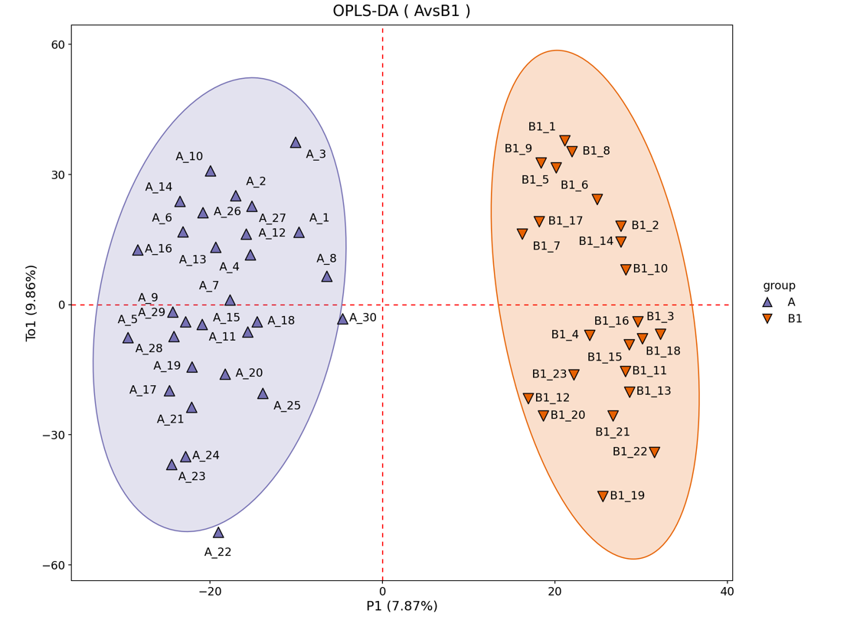
·Figure S1-Ai. OPLS-DA score plot (A vs B1)
(R²Y=0.940 Q²=0.825)
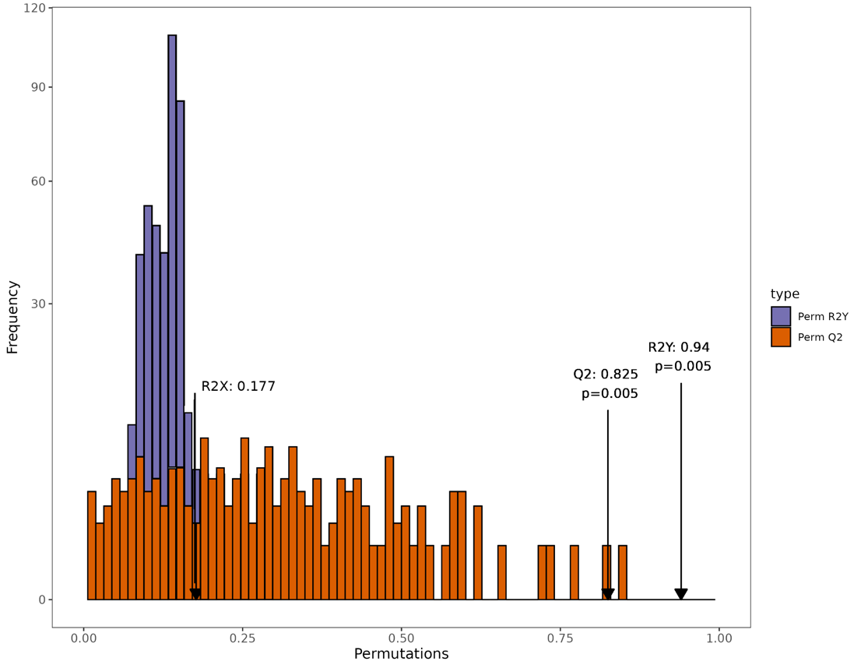
·Figure S1-Aii. Permutation test plot (A vs B1)
Figure S1-B. OPLS-DA and permutation test for the comparison A vs B2.
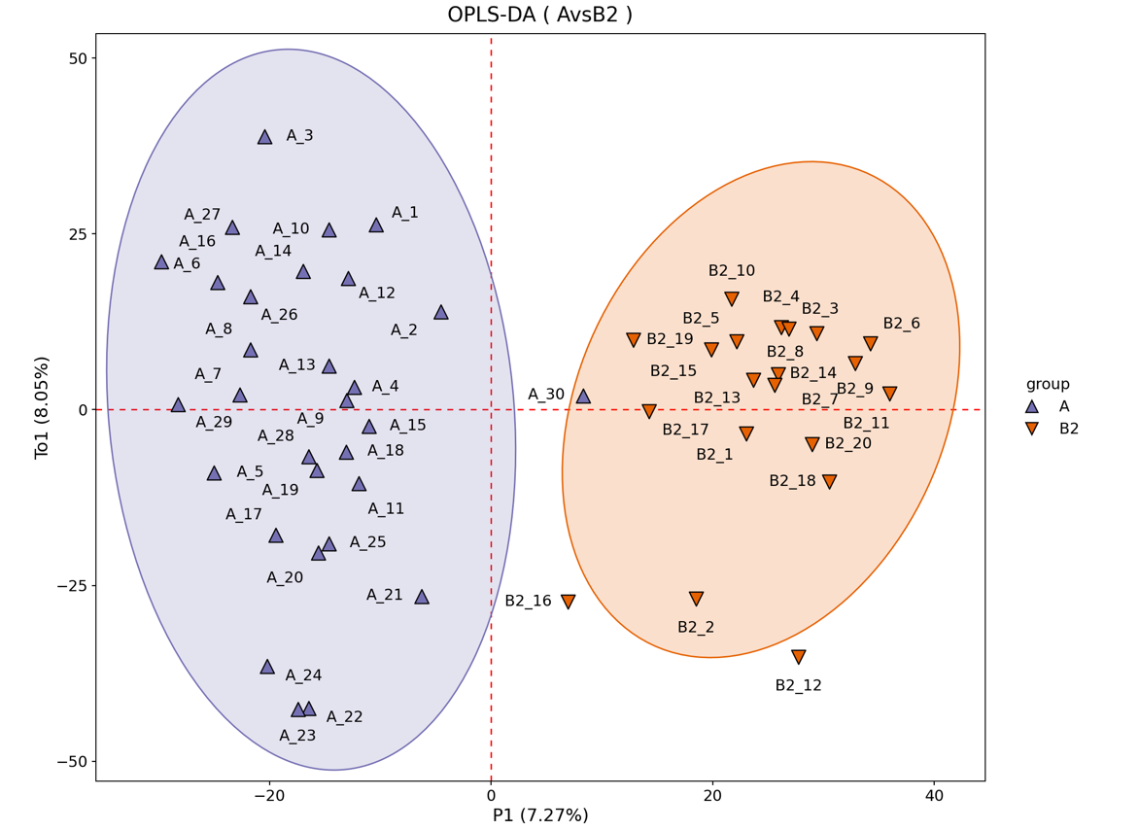
·Figure S1-Bi. OPLS-DA score plot (A vs B2)
(R²Y=0.881 Q²=0.626)
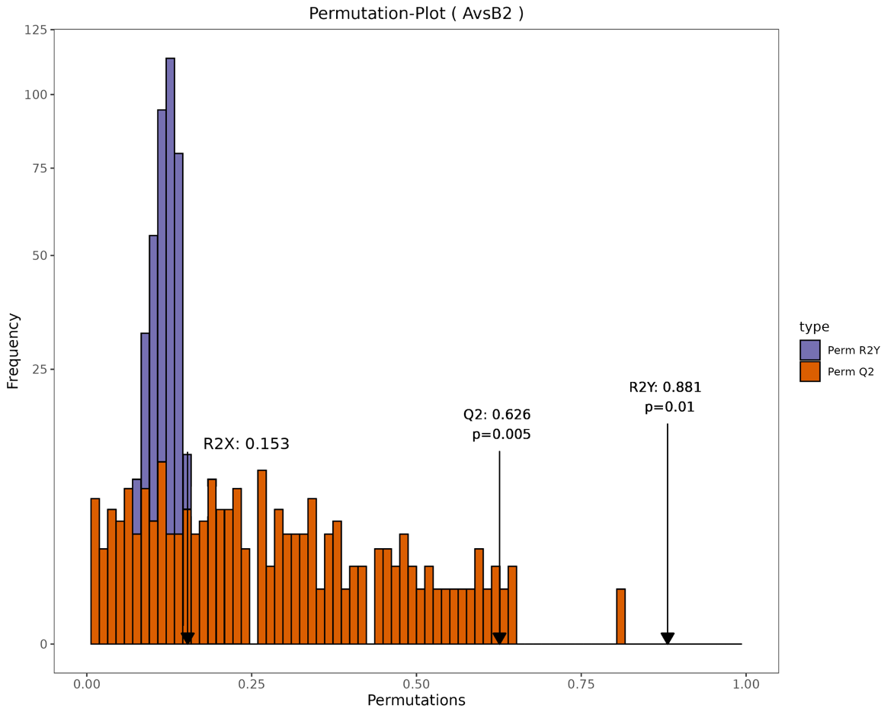
·Figure S1-Bii. Permutation test plot (A vs B2)
Figure S1-C. OPLS-DA and permutation test for the comparison A vs B3.
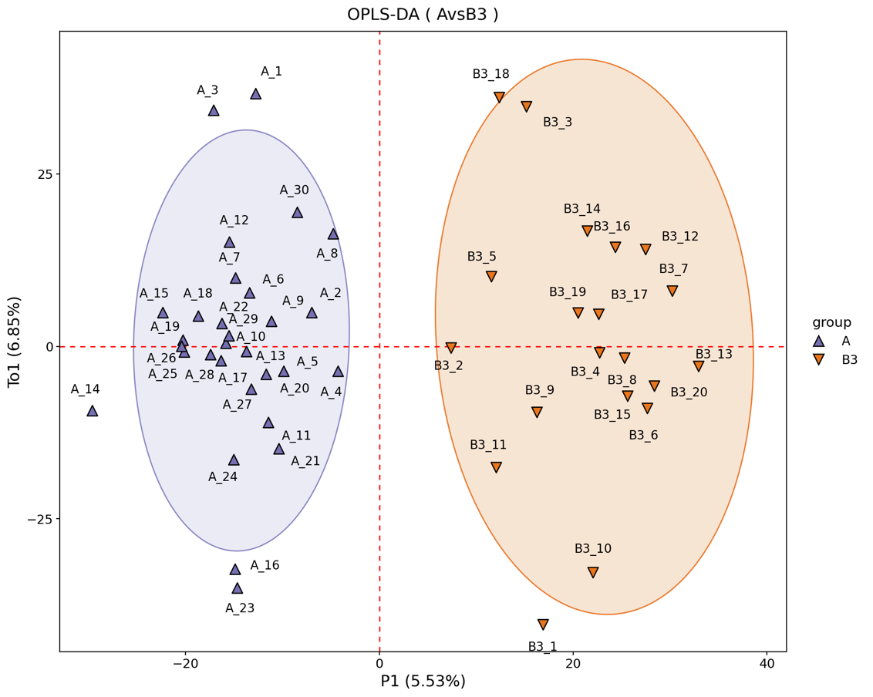
·Figure S1-Ci. OPLS-DA score plot (A vs B3)
(R²Y =0.898 Q²=0.603)
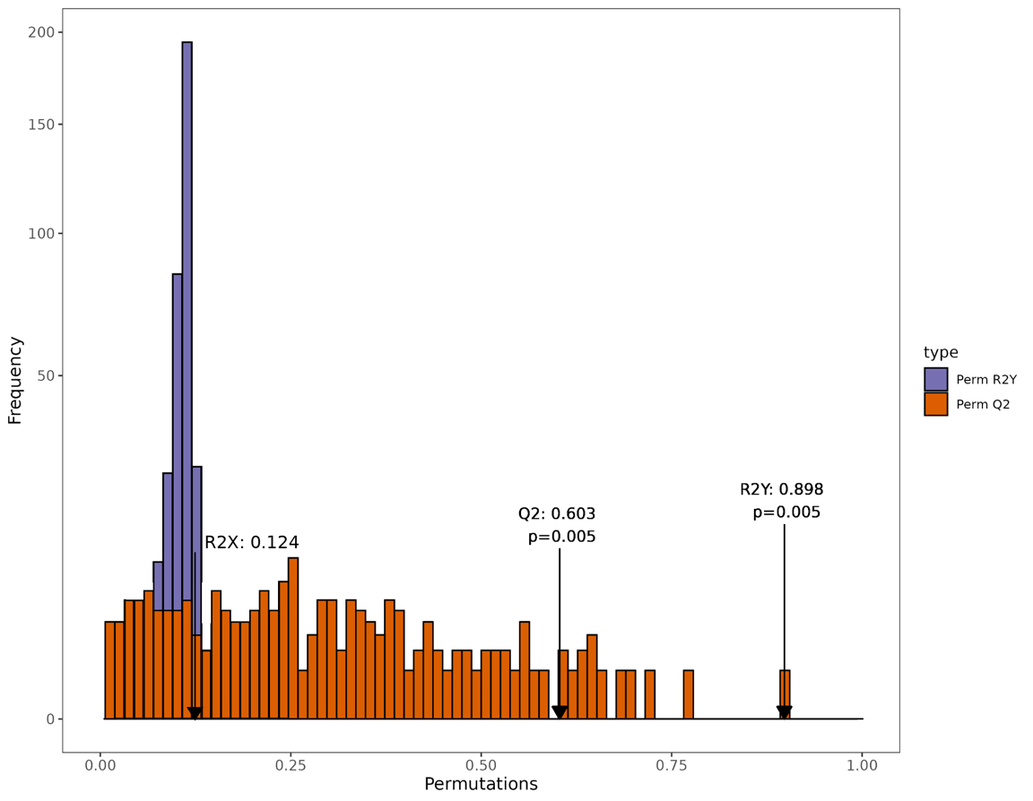
·Figure S1-Cii. Permutation test plot (A vs B3)
Figure S1-D. OPLS-DA and permutation test for the comparison B1 vs C.
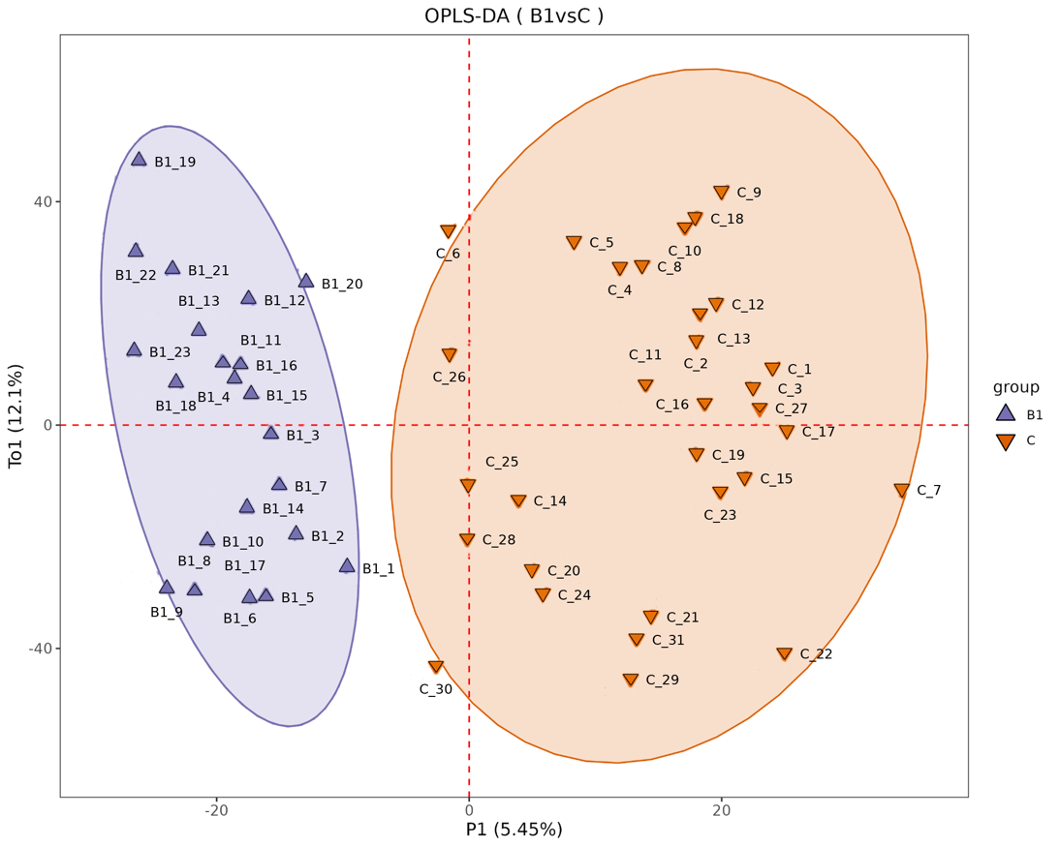
·Figure S1-Di. OPLS-DA score plot (B1 vs C)
(R²Y=0.828 Q²=0.498)
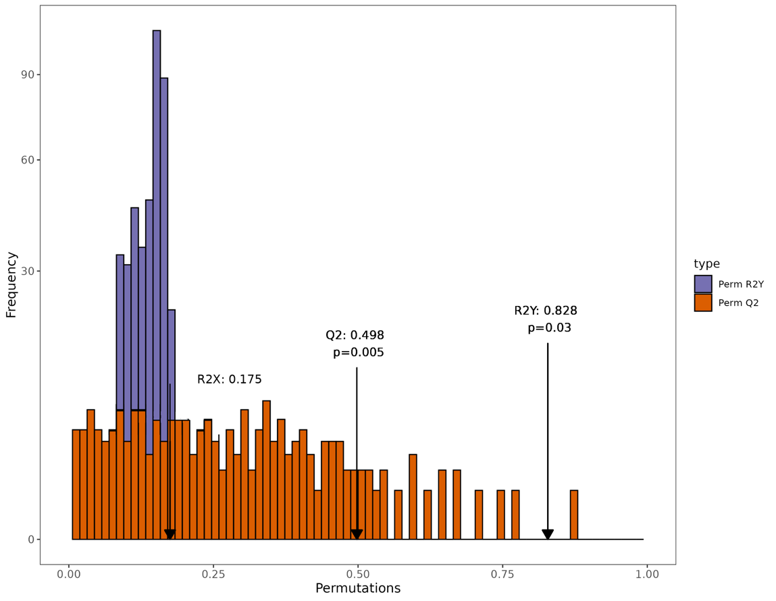
·Figure S1-Dii. Permutation test plot (B1 vs C)
Figure S1-E. OPLS-DA and permutation test for the comparison B2 vs C.
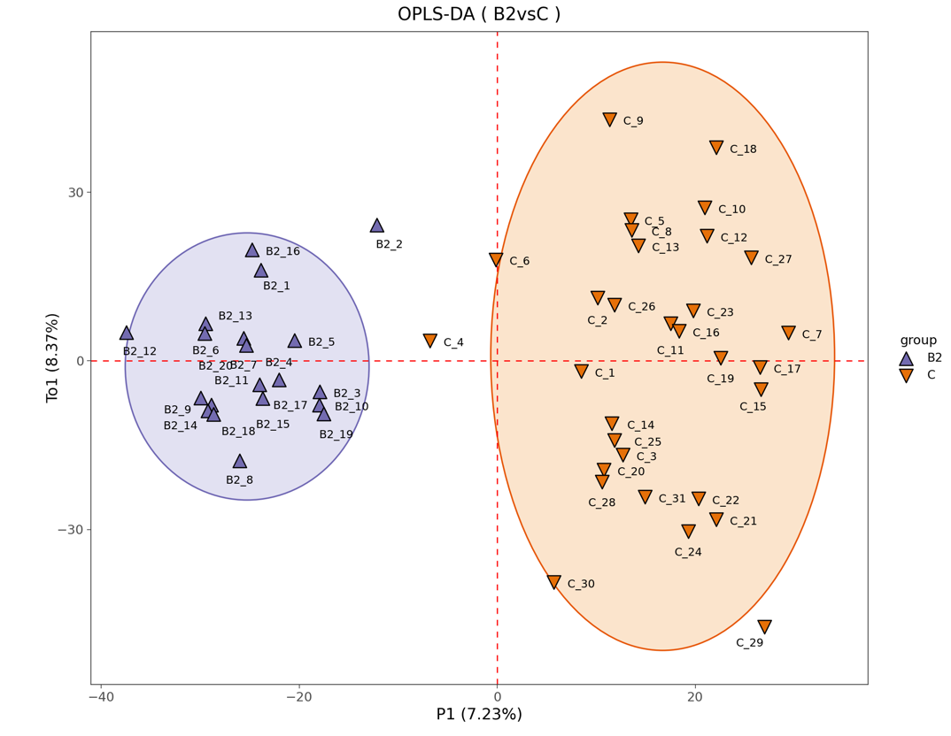
·Figure S1-Ei. OPLS-DA score plot (B2 vs C)
(R²Y=0.886 Q²=0.641)
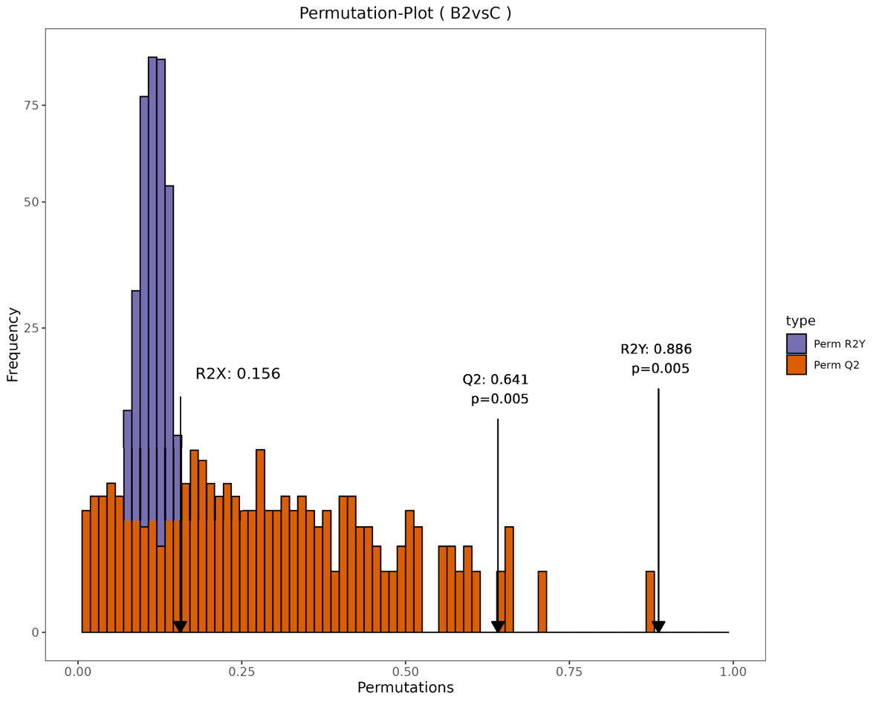
·Figure S1-Eii. Permutation test plot (B2 vs C)
Figure S1-F. OPLS-DA and permutation test for the comparison B3 vs C.
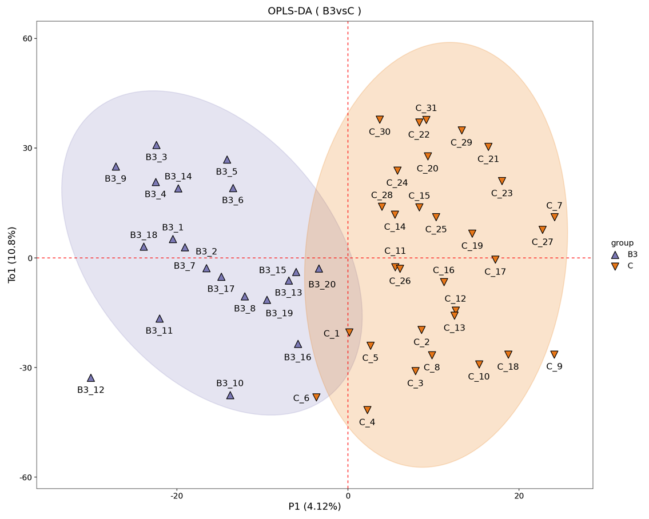
·Figure S1-Fi. OPLS-DA score plot (B3 vs C)
(R²Y=0.777 Q²=0.129)
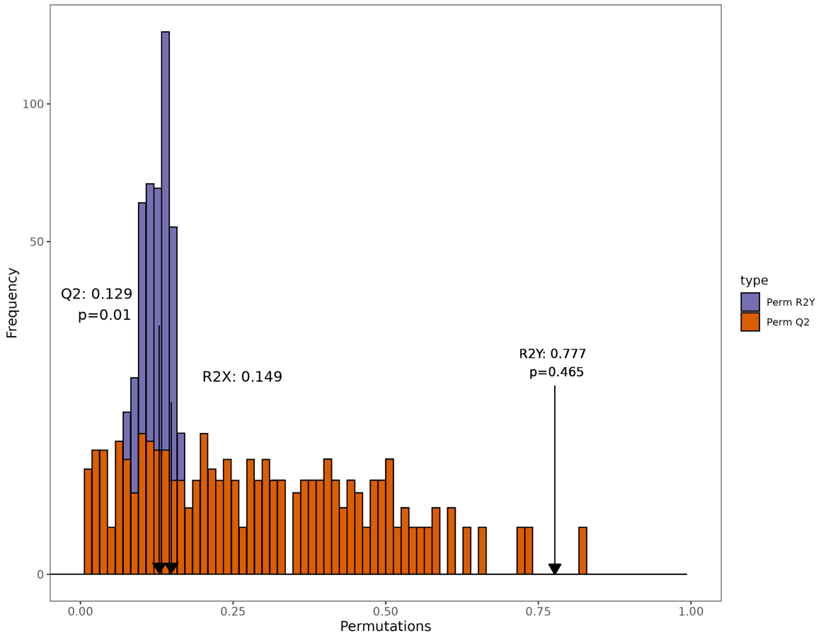
·Figure S1-Fii. Permutation test plot (B3 vs C)
Figure S1-G. OPLS-DA and permutation test for the comparison A vs C.
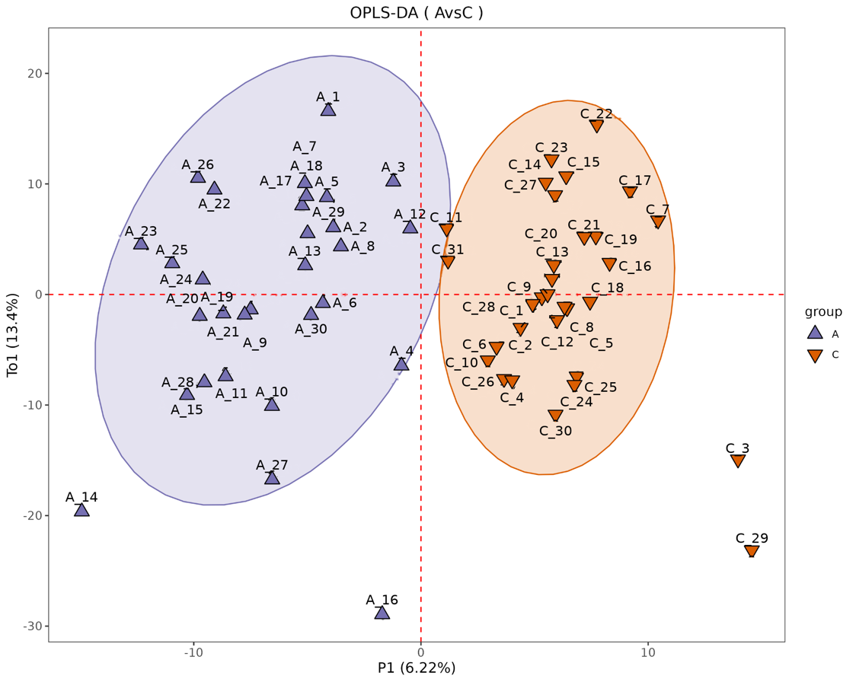
·Figure S1-Gi. OPLS-DA score plot (A vs C)
(R²Y=0.804 Q²=0.598)
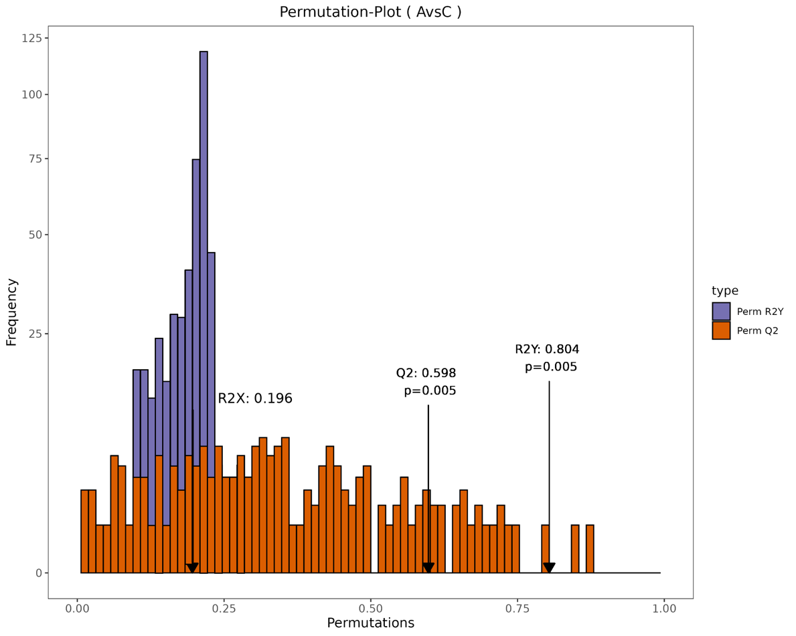
·Figure S1-Gii. Permutation test plot (A vs C)

Supplementary Figure S2. Feature selection stability across 5-fold cross-validation for the combined model
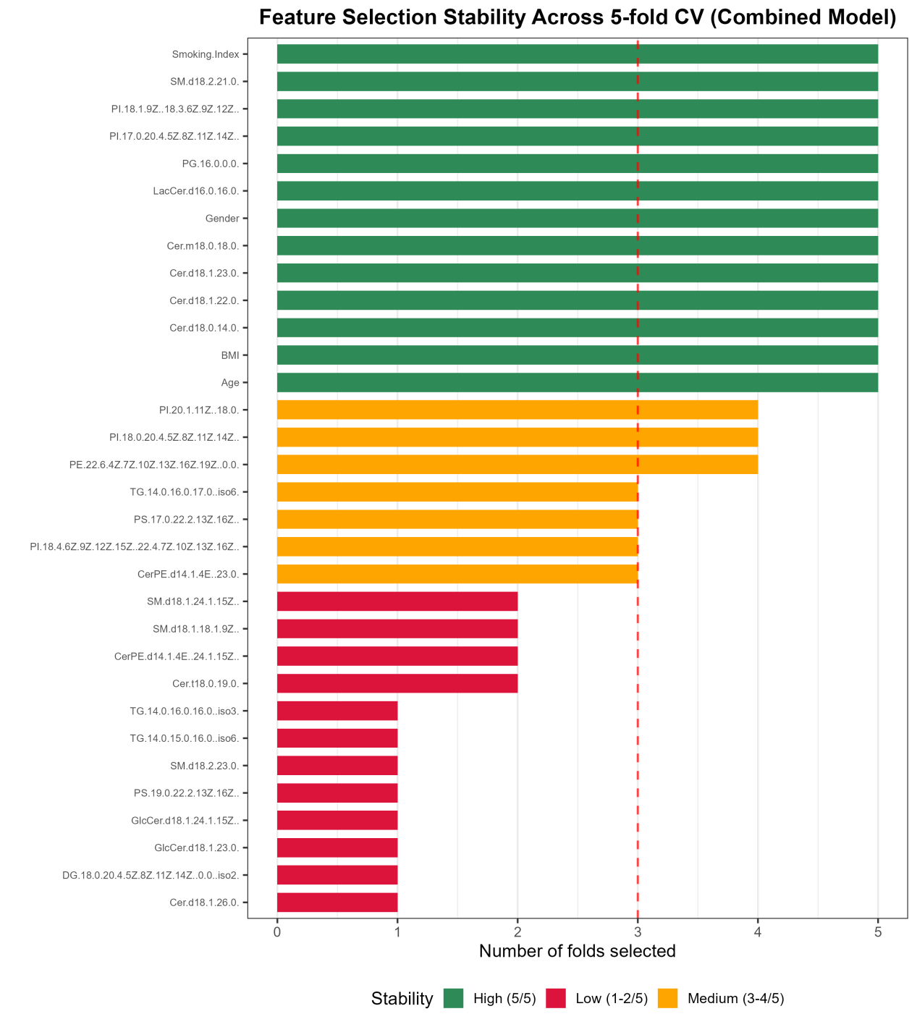
Figure S2-A. Feature stability in the B combined model across 5-fold CV

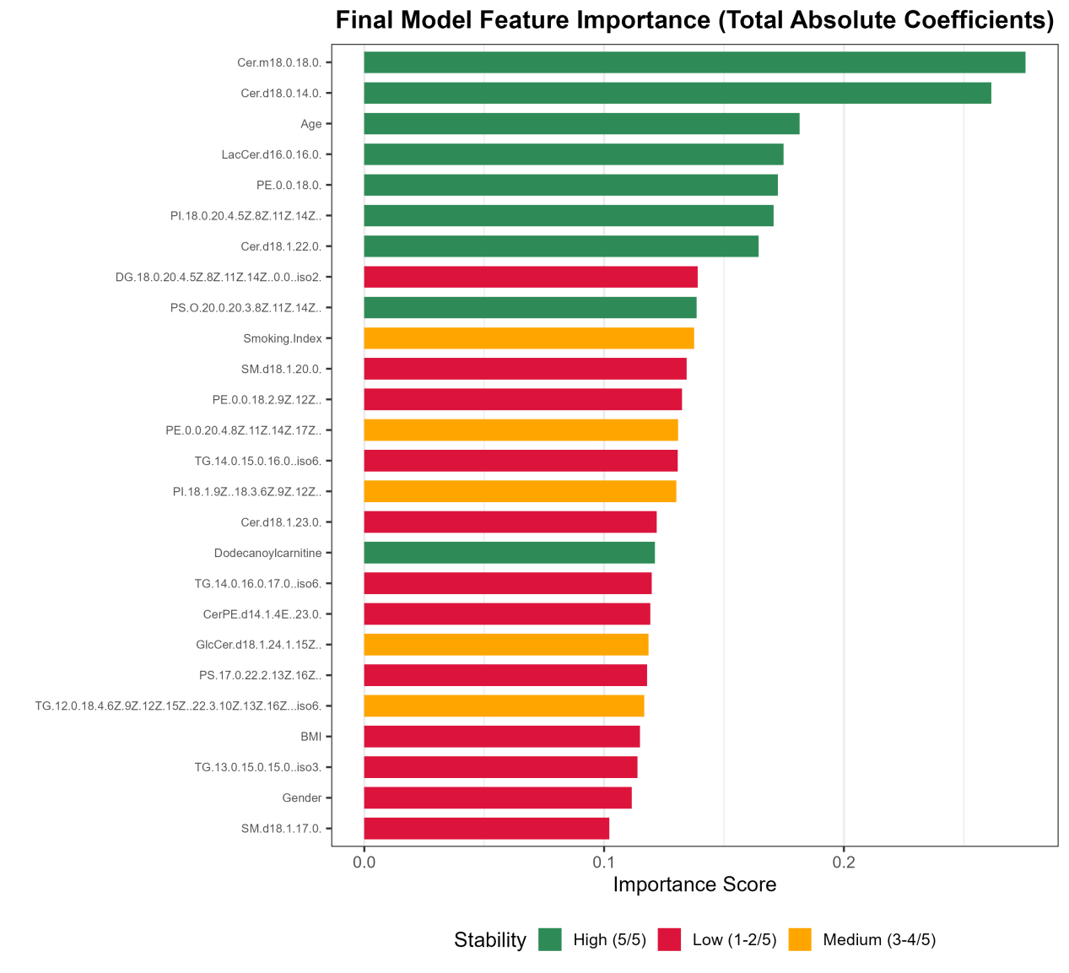
Figure S2-B. Feature stability in the B1 combined model across 5-fold CV

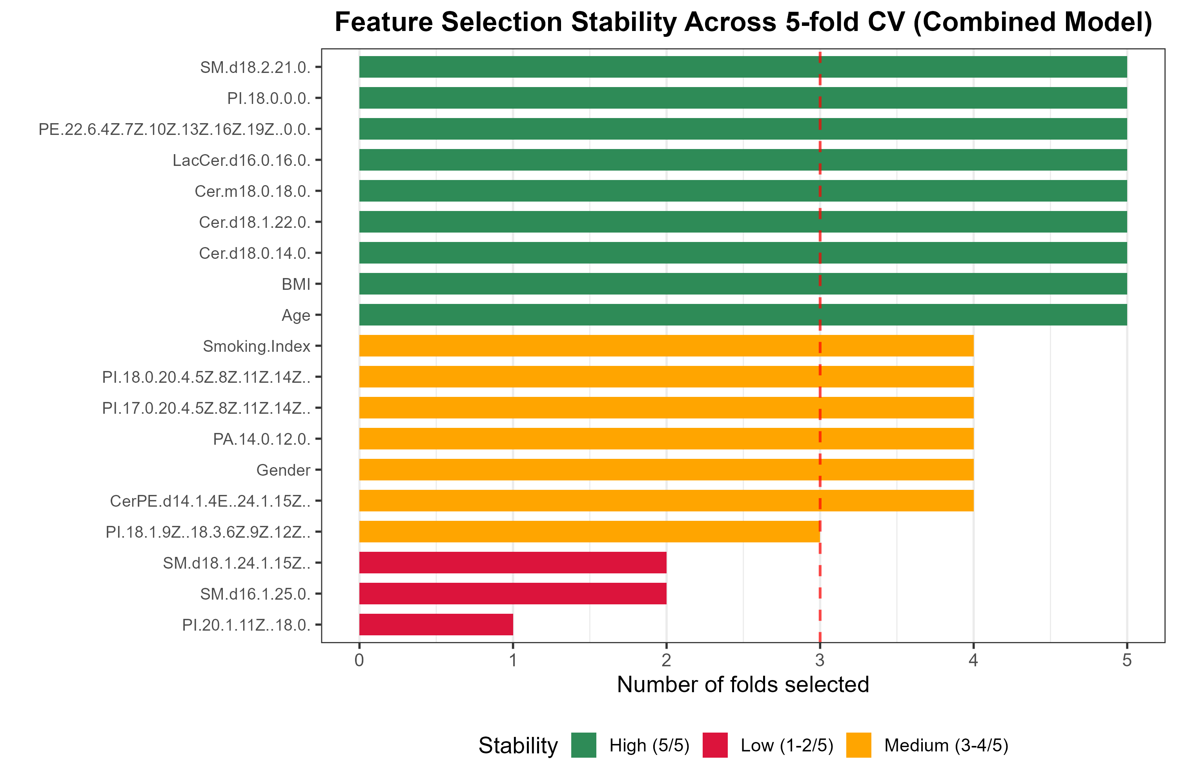
Figure S2-C. Feature stability in the B2 combined model across 5-fold CV

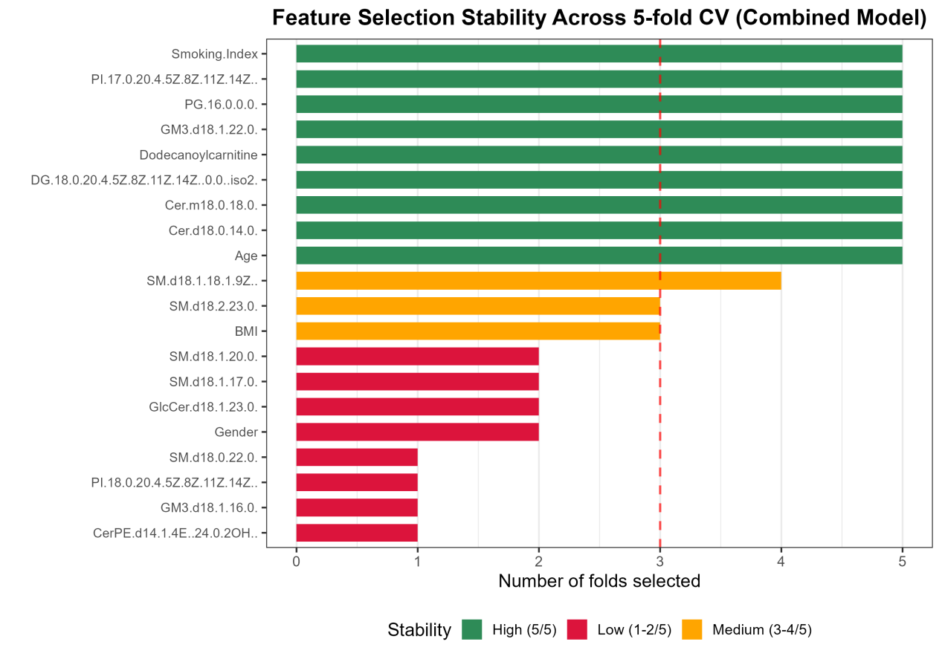
Figure S2-D. Feature stability in the B3 combined model across 5-fold CV

Supplementary Figure S3. Training and test accuracy across the five outer folds of nested cross-validation for the combined model
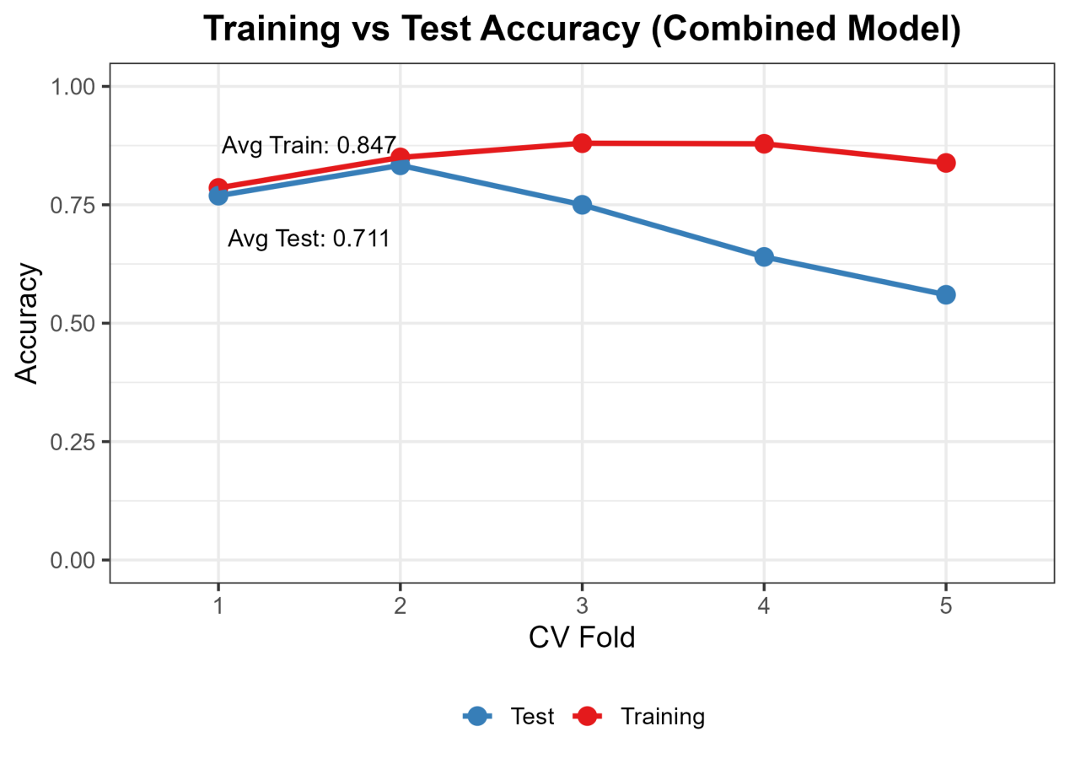
Figure S3-A. Training vs. test accuracy for the B combined model

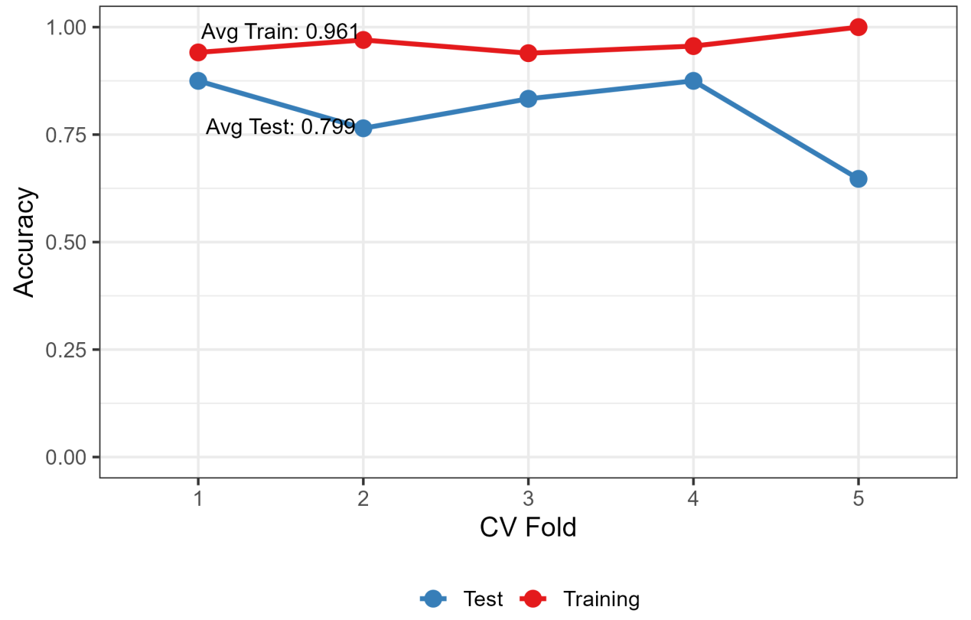
Figure S3-B. Training vs. test accuracy for the B1 combined model.

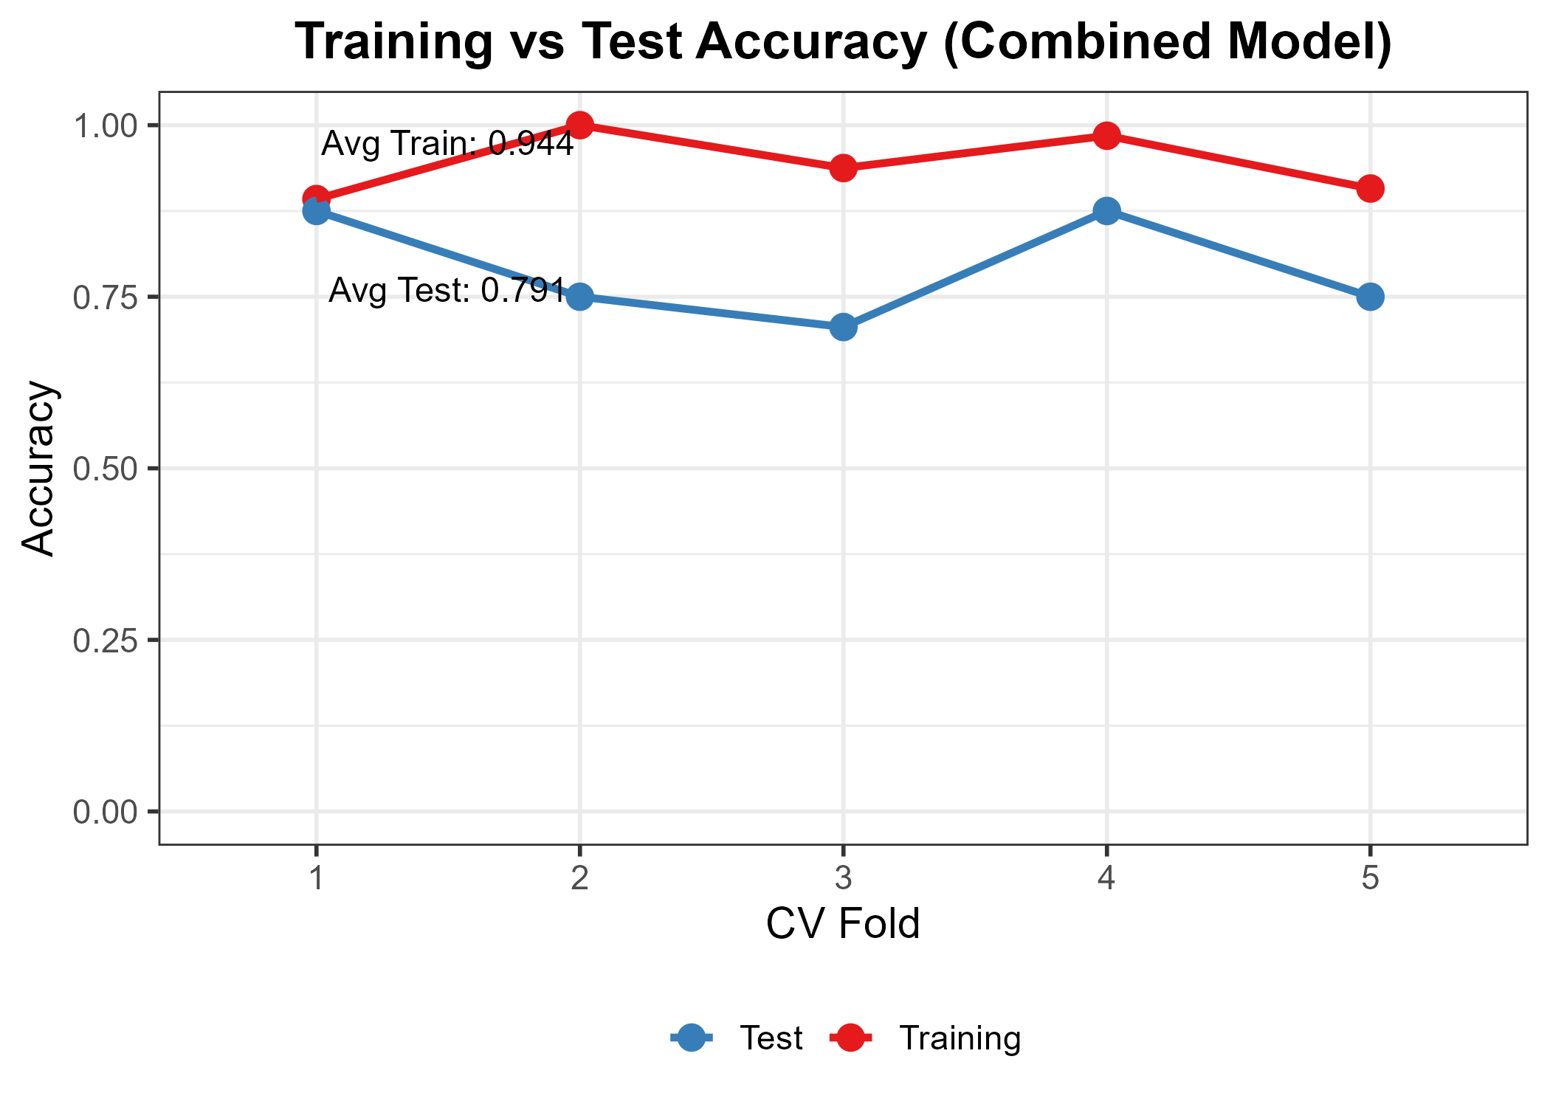Figure S3-C. Training vs. test accuracy for the B2 combined model.

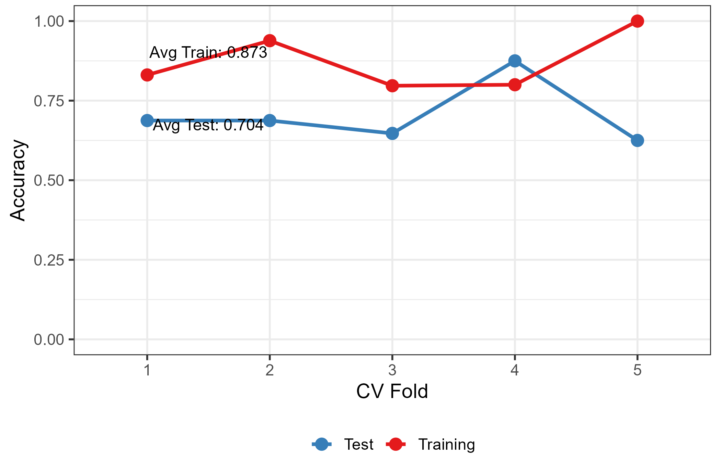
Figure S3-D. Training vs. test accuracy for the B3 combined model.

Supplementary Figure S4. Confusion matrix of the combined model evaluated by nested cross-validation
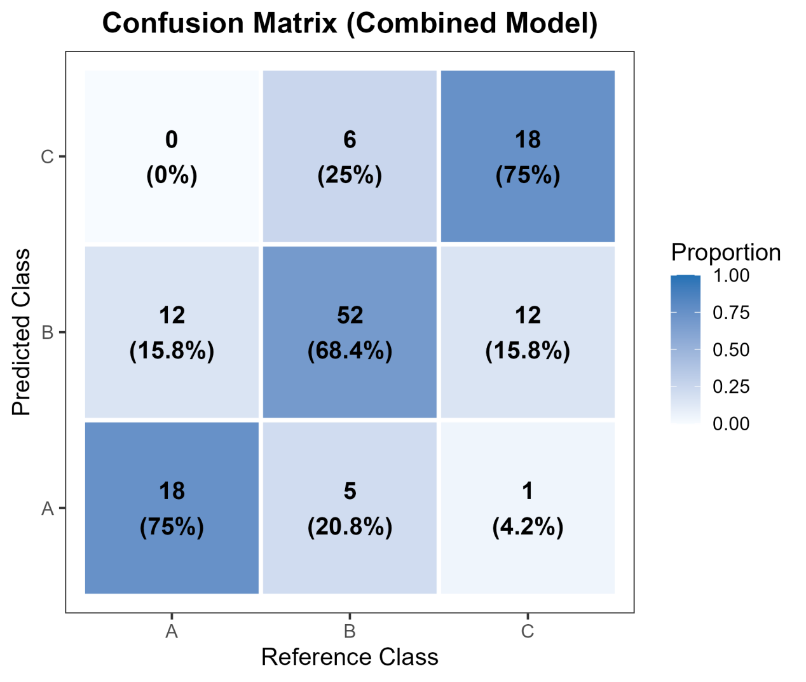
Figure S4-A. Confusion matrix for the B combined model

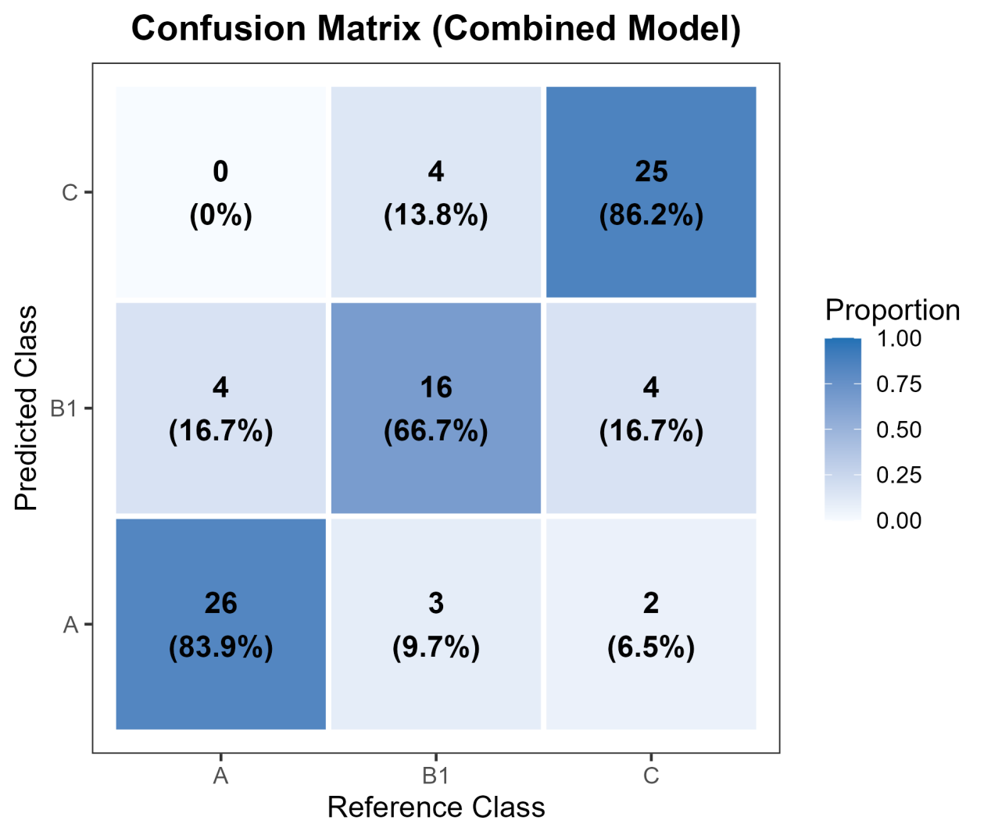
Figure S4-B. Confusion matrix for the B1 combined model

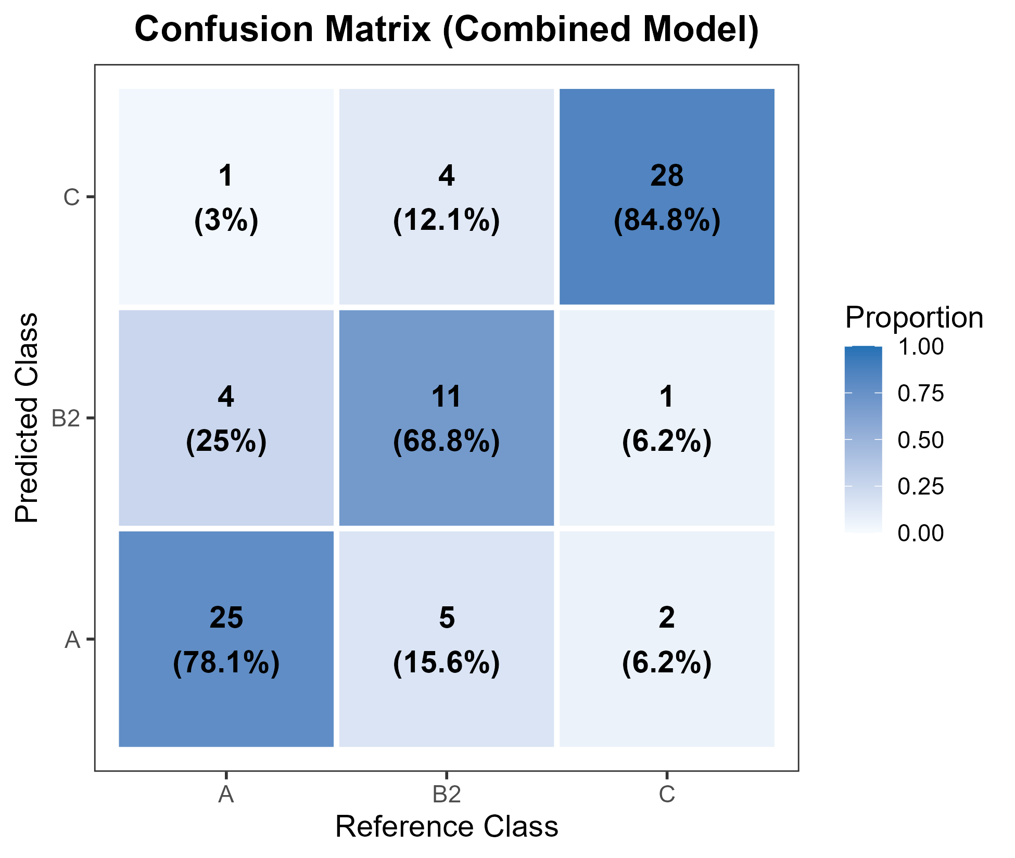
Figure S4-C. Confusion matrix for the B2 combined model

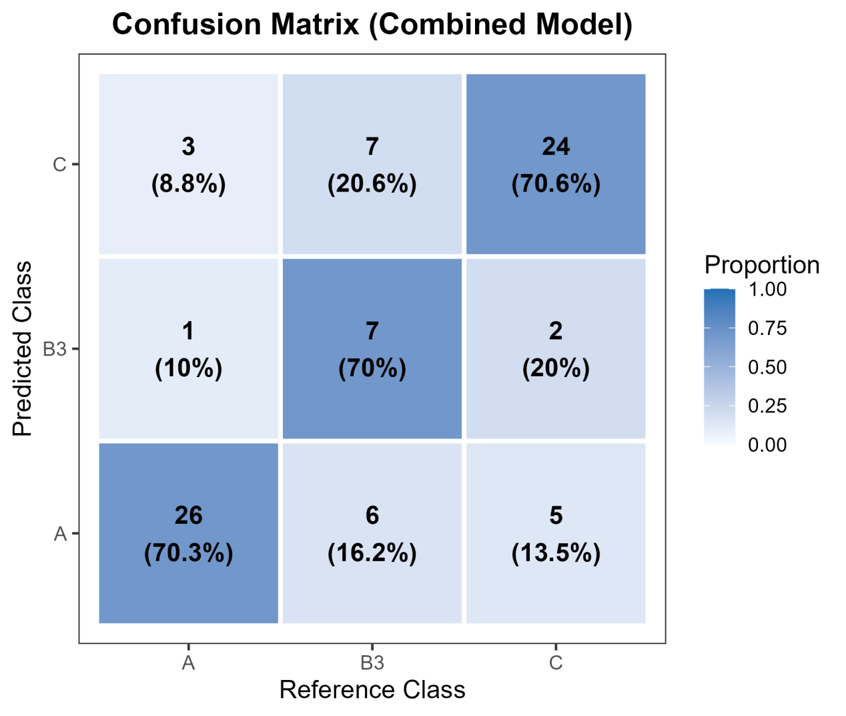
Figure S4-D. Confusion matrix for the B3 combined model.

Supplementary Figure S5. Calibration curves of the combined model (with Brier scores)
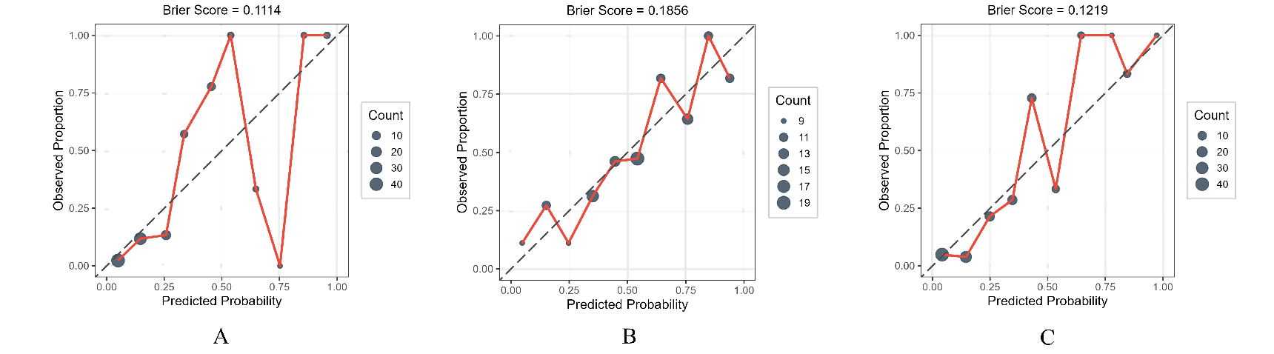
Figure S5-A. Calibration curves for the B combined model.Panels A, B, and C represent the calibration curves for the healthy, Pre-COPD, and COPD groups, respectively. The x-axis shows predicted probability and the y-axis observed proportion. The diagonal dashed line indicates perfect calibration. Curves deviating from the diagonal suggest miscalibration. Brier scores are shown directly above the figure.
Figure S5-B. Calibration curves for the B1 combined model.Panels A, B, and C represent the calibration curves for the healthy, SAD, and COPD groups, respectively. The x-axis shows predicted probability and the y-axis observed proportion. The diagonal dashed line indicates perfect calibration. Curves deviating from the diagonal suggest miscalibration. Brier scores are shown directly above the figure.

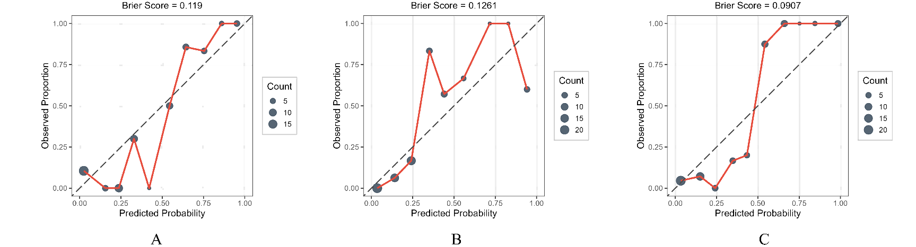
Figure S5-C. Calibration curves for the B2 combined model.Panels A, B, and C represent the calibration curves for the healthy, Emphysema, and COPD groups, respectively. The x-axis shows predicted probability and the y-axis observed proportion. The diagonal dashed line indicates perfect calibration. Curves deviating from the diagonal suggest miscalibration. Brier scores are shown directly above the figure.
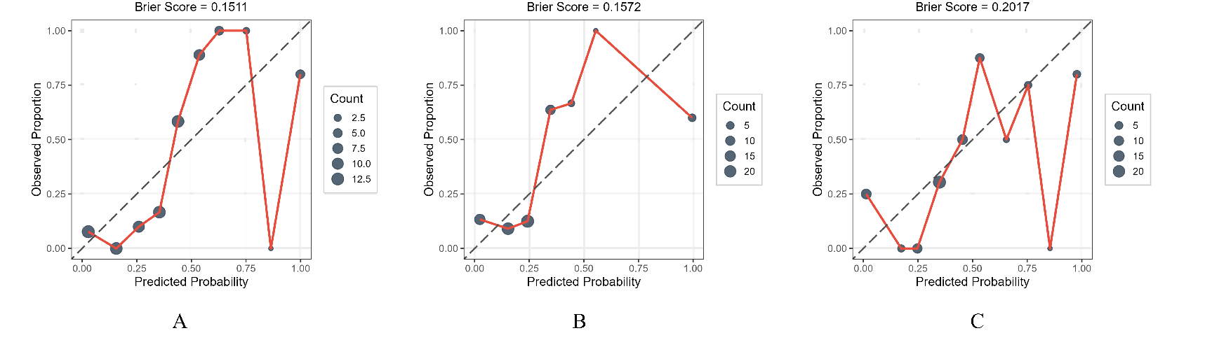
Figure S5-D. Calibration curves for the B3 combined model.Panels A, B, and C represent the calibration curves for the healthy, PRISm, and COPD groups, respectively. The x-axis shows predicted probability and the y-axis observed proportion. The diagonal dashed line indicates perfect calibration. Curves deviating from the diagonal suggest miscalibration. Brier scores are shown directly above the figure.

