Supplementary Materials

Supplementary Table 1 Myeloid immunophenotyping panel (flow cytometry)
Antibody | Fluorochrome | Catalog | Company | Concentration  (mg/mL) | Volume per 100 μL  (μL)
CD45 | APC-Cy7 | 557659 | BD Pharmingen | 0.2 | 1
CD11b | BV605 | 563015 | BD Pharmingen | 0.2 | 1
F4/80 | BV 421 | 123132 | Biolegend | 0.2 | 1
CCR2 | APC | 150628 | Biolegend | 0.2 | 1
TIMD4 | PE | 129905 | Biolegend | 0.2 | 1
MHCII | BV 785 | 107645 | Biolegend | 0.2 | 1
Ly-6C | PE-Cy7 | 128018 | Biolegend | 0.2 | 1
Ly-6G | BV 711 | 127643 | Biolegend | 0.2 | 1
CD11c | PerCP-Cy5.5 | 117328 | Biolegend | 0.2 | 1

Supplementary Table 2 Lymphoid immunophenotyping panel (flow cytometry)
Antibody | Fluorochrome | Catalog | Company | Concentration  (mg/mL) | Volume per 100 μL  (μL)
CD45 | APC-Cy7 | 557659 | BD Pharmingen | 0.2 | 1
CD11b | BV605 | 563015 | BD Pharmingen | 0.2 | 1
CD19 | BV421 | 562701 | BD Pharmingen | 0.2 | 1
CD3 | PE-CF594 | 562286 | BD Pharmingen | 0.2 | 1
NK1.1 | APC | 156506 | Biolegend | 0.2 | 1

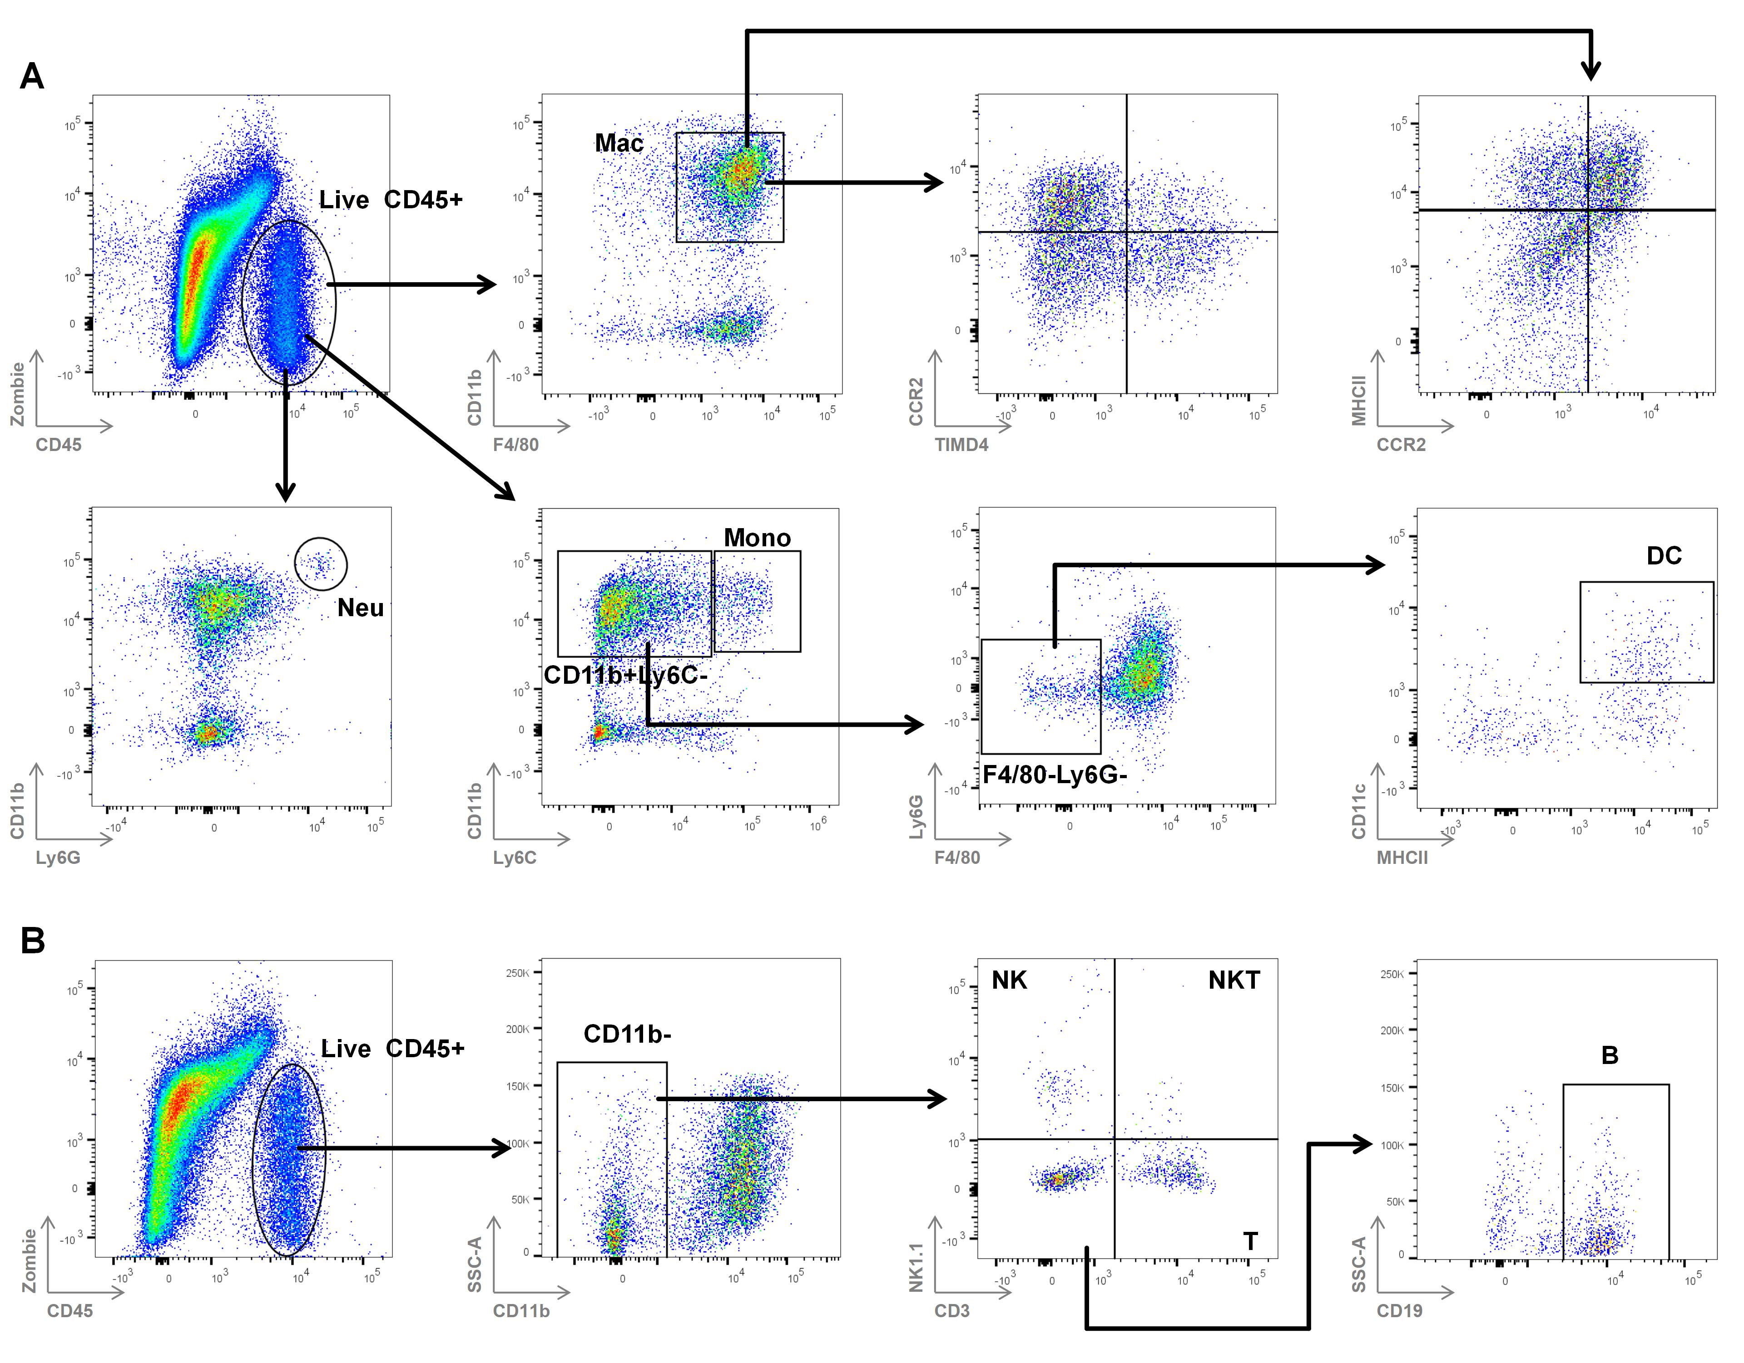
Supplementary Figure 1 Gating strategy for flow cytometry analysis. (A) Gating strategy for myeloid cells. (B) Gating strategy for lymphoid cells.
Note: Proportions of immune cell subsets were calculated from all acquired events per sample for statistical analysis. Since the proportion of live CD45⁺ immune cells among non-cardiomyocytes showed no significant difference between ND and early DCM groups (Figure 3), when subsequently presenting the flow cytometry plots, we used FlowJo's DownSampleV3 plugin to randomly extract an equal number of cells from both groups for visualization. This ensured comparable dot density, facilitating a direct visual comparison of subset proportions. It must be stressed that this downsampling process was used exclusively for illustrative purposes in the figures and played no role in the quantitative calculation of cell ratios or statistical analyses. Consequently, this approach does not compromise the veracity of the data or the robustness of the statistical findings.

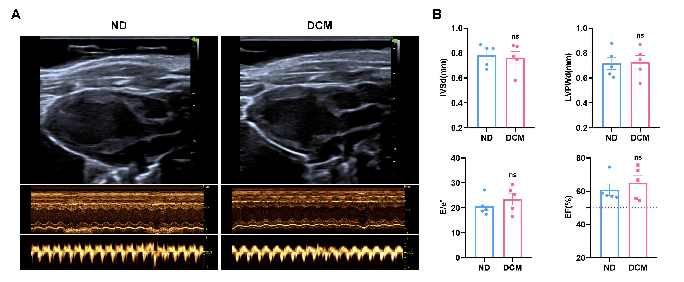
Supplementary Figure 2 Echocardiographic assessment of cardiac structure and function in mice. (A) Representative echocardiograms from ND and model group mice. From top to bottom: (1) Two-dimensional echocardiography in the left ventricular long-axis view; (2) M-mode echocardiography for measurement of left ventricular dimensions; (3) Tissue Doppler imaging for assessment of mitral annular motion velocity. (B) Quantitative statistical results: interventricular septal thickness at end-diastole (IVSd), left ventricular posterior wall thickness at end-diastole (LVPWd), the ratio of early diastolic mitral inflow velocity to early diastolic mitral annular velocity (E/e'), and left ventricular ejection fraction (EF). n = 5. ns, not significant vs. the ND group.

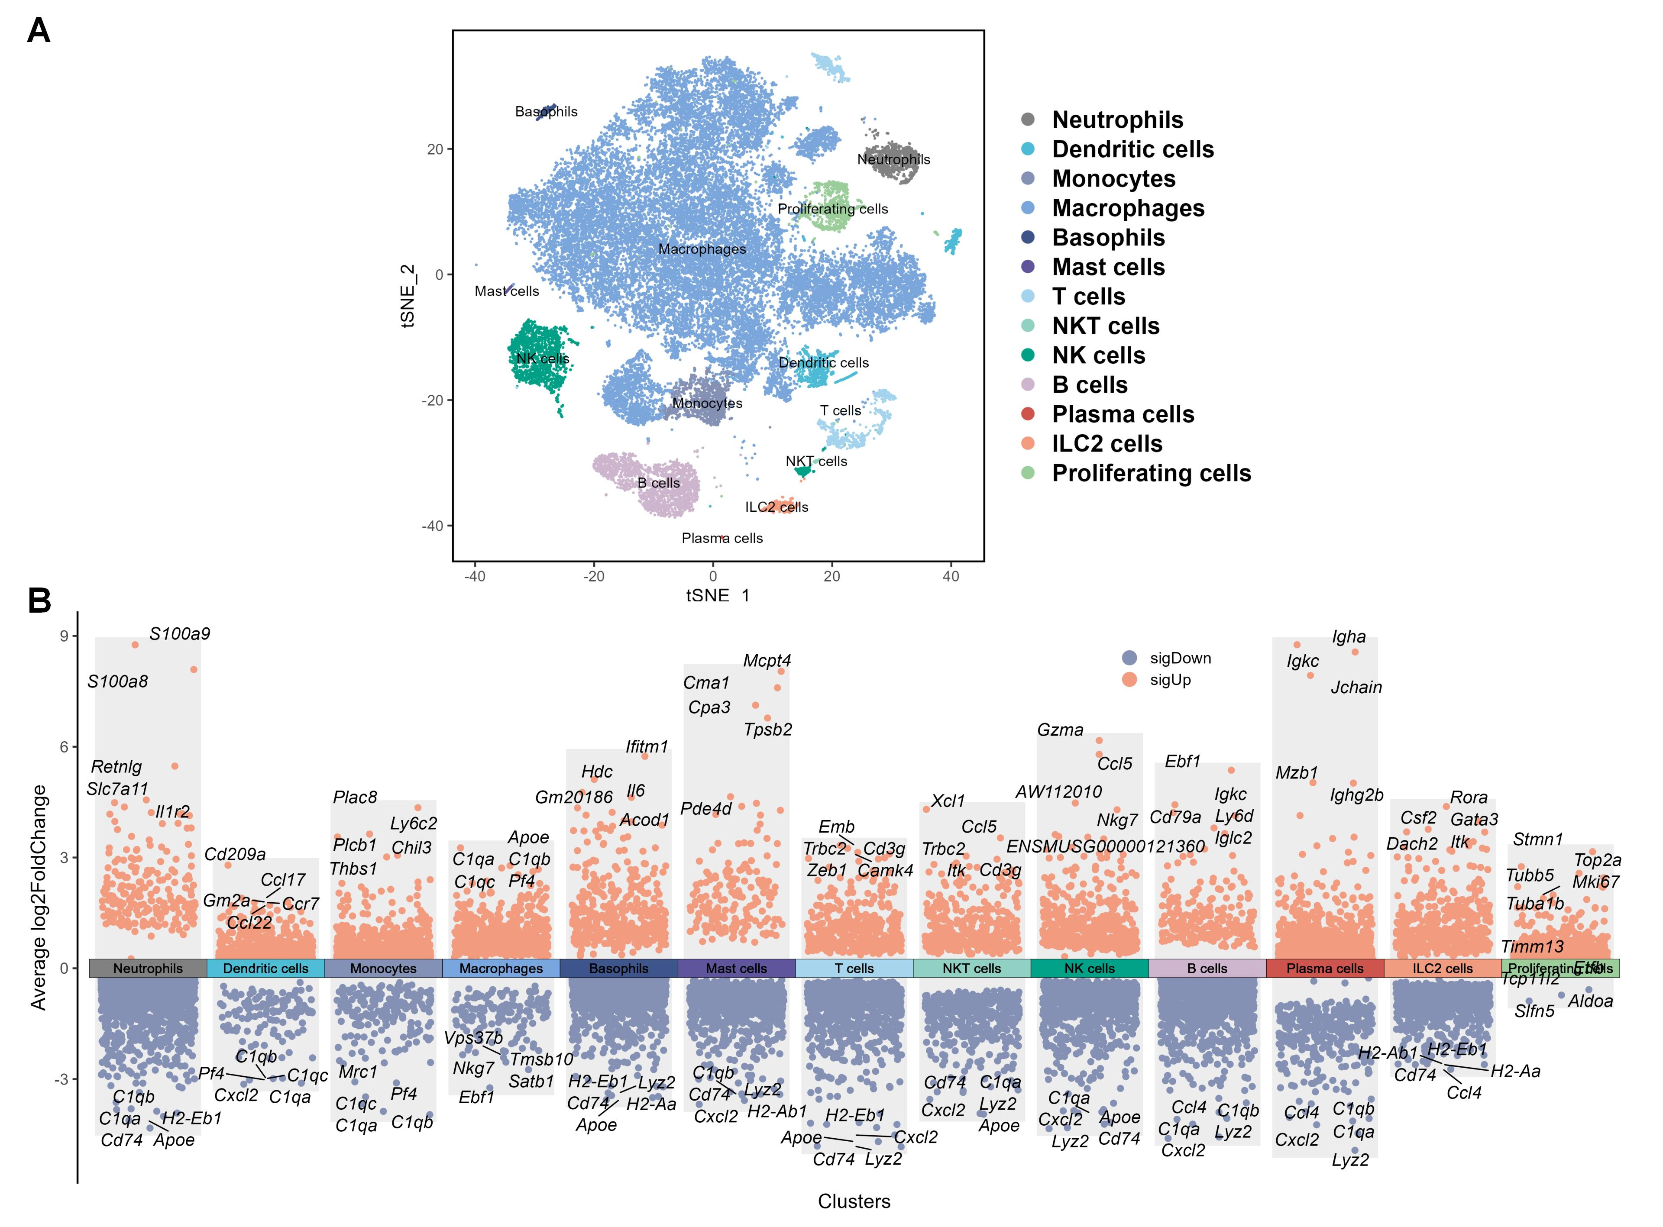
Supplementary Figure 3 Cardiac immune cell clustering and differential gene expression analysis. (A) t-SNE visualization of cardiac immune cells. Based on unsupervised clustering analysis, high-dimensional data were projected onto a two-dimensional plane using the t-SNE nonlinear dimensionality reduction algorithm. Each dot represents a single cell, and different colors indicate distinct cell subsets. (B) Volcano plots of differentially expressed genes in each immune cell subset. For each of the 13 identified cardiac immune cell populations, genes exhibiting differential expression relative to all other cell types are displayed. Significantly upregulated genes (log₂FC > 0.25, adjusted P < 0.05) are marked in orange, while significantly downregulated genes (log₂FC < -0.25, adjusted P < 0.05) are marked in blue. The top 5 upregulated and top 5 downregulated genes with the most pronounced differences (ranked by |log₂FC|) are annotated for each subset.

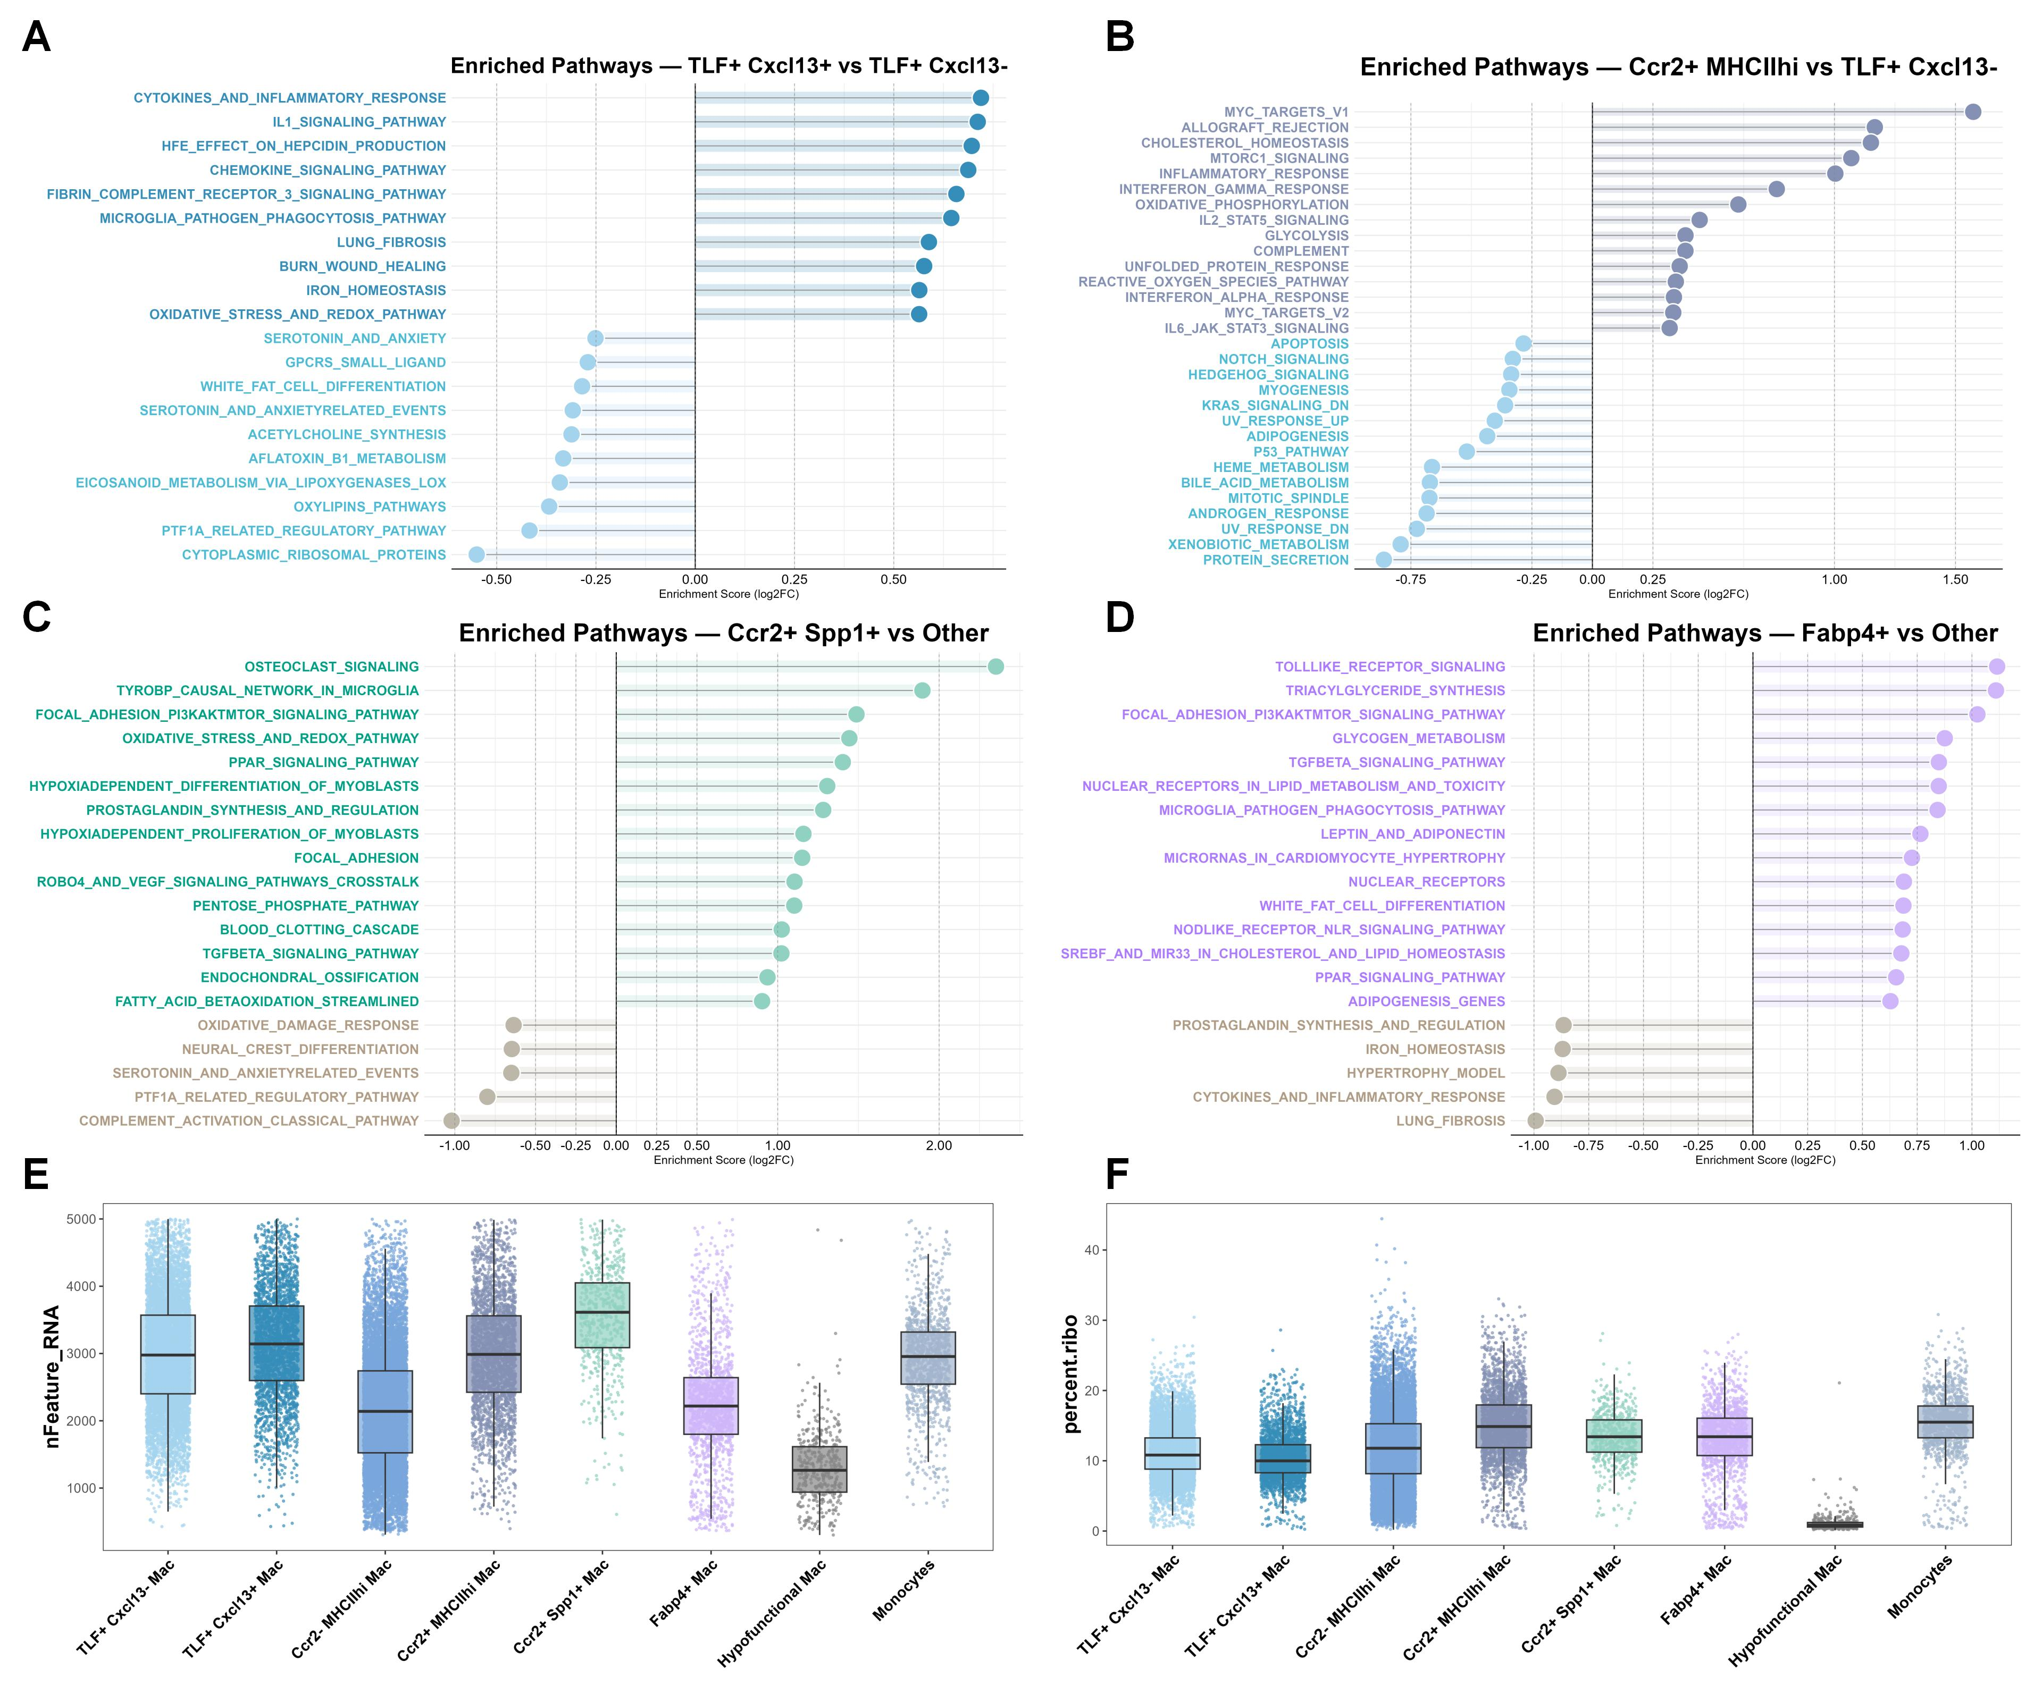
Supplementary Figure 4 Heterogeneity analysis of macrophage function. (A-D) GSVA enrichment analysis results based on the MSigDB database (Hallmark and WikiPathways gene sets), comparing pathway activity changes between four paired subsets. The vertical axis shows significantly enriched pathways (|log₂FC| > 0.25, adjusted P < 0.05). The comparisons are: (A) TLF⁺Cxcl13⁺ Mac vs. TLF⁺Cxcl13⁻ Mac; (B) Ccr2⁺MHCII^{hi} Mac vs. TLF⁺Cxcl13⁻ Mac; (C) Ccr2⁺Spp1⁺ Mac vs. other monocyte/macrophage subsets; (D) Fabp4⁺ Mac vs. other monocyte/macrophage subsets. (E) Boxplot showing the distribution of gene counts (nFeature_RNA) across cardiac monocyte/macrophage subsets. (F) Boxplot showing the distribution of ribosomal gene proportions (percent.ribo) across cardiac monocyte/macrophage subsets.

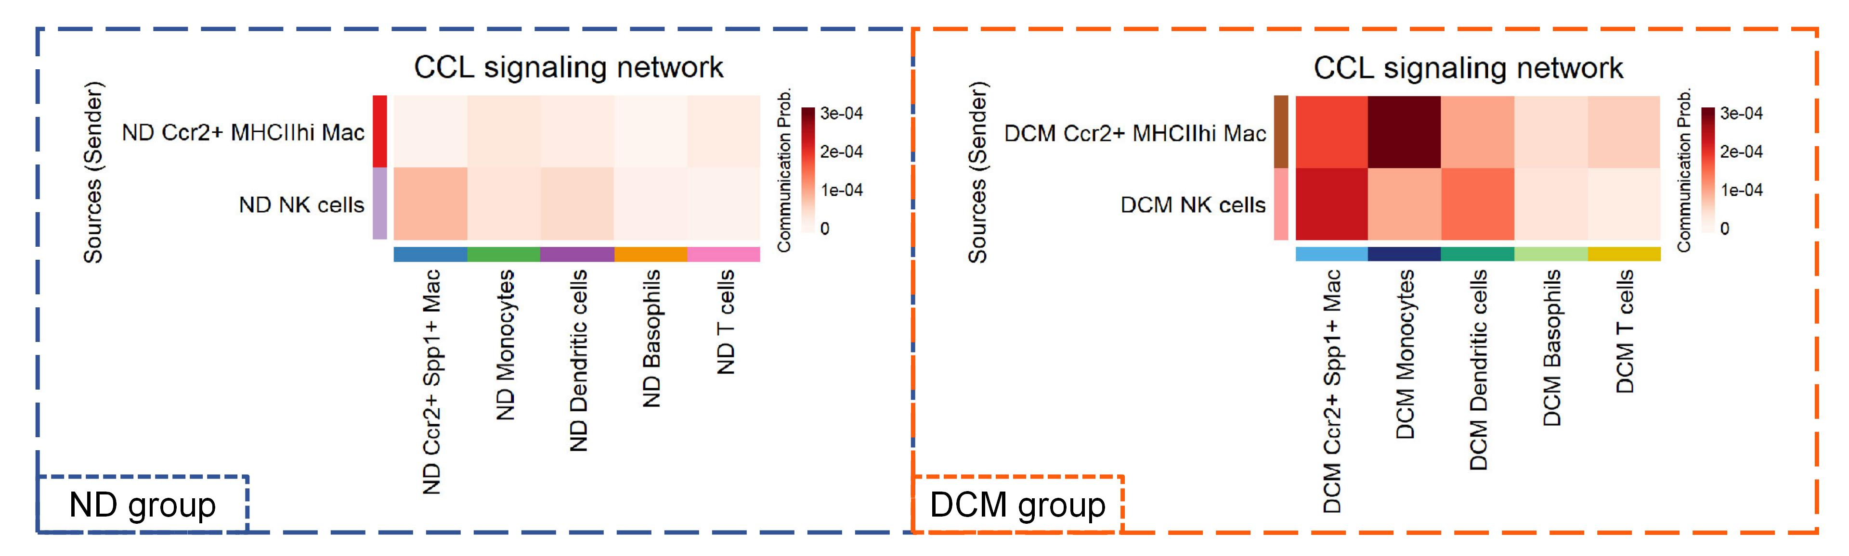
Supplementary Figure 5 Communication heatmap of the CCL signaling pathway.
To compare differences in intercellular communication between the two experimental groups, Ccr2⁺MHCII^{hi} macrophages and NK cells were defined as the source populations for CCL signals, while Ccr2⁺Spp1⁺ macrophages, monocytes, dendritic cells, basophils, and T cells were defined as the receiver populations. The heatmap visualizes the inferred communication probabilities: the left panel represents the ND group, and the right panel represents the DCM group. A darker color intensity corresponds to a higher likelihood of intercellular communication.

Supplementary Table 3 The top 20 upregulated differentially expressed genes in each cardiac immune cell subpopulation.
Cluster | Gene | log₂FC | Adjusted P-values
Neutrophils | S100a9 | 8.759627282 | 0
Neutrophils | S100a8 | 8.090086667 | 0
Neutrophils | Retnlg | 5.475299975 | 0
Neutrophils | Slc7a11 | 4.560376217 | 0
Neutrophils | Il1r2 | 4.484760431 | 0
Neutrophils | Slpi | 4.367376518 | 0
Neutrophils | Hdc | 4.218116851 | 0
Neutrophils | Mxd1 | 4.187451241 | 0
Neutrophils | Csf3r | 4.173990684 | 0
Neutrophils | G0s2 | 4.170652577 | 0
Neutrophils | Acod1 | 4.135227442 | 0
Neutrophils | S100a11 | 3.976242122 | 0
Neutrophils | Msrb1 | 3.925081054 | 0
Neutrophils | Lyst | 3.91641998 | 0
Neutrophils | Sorl1 | 3.799253604 | 0
Neutrophils | Sgms2 | 3.795623148 | 0
Neutrophils | Clec4d | 3.756971599 | 0
Neutrophils | Lmnb1 | 3.572891564 | 0
Neutrophils | Ankrd33b | 3.47544273 | 0
Neutrophils | Hcar2 | 3.355989773 | 0
Dendritic cells | Cd209a | 2.79091245 | 0
Dendritic cells | Ccl17 | 1.900259281 | 0
Dendritic cells | Gm2a | 1.793736969 | 0
Dendritic cells | Ccr7 | 1.783722306 | 8.2493E-189
Dendritic cells | Ccl22 | 1.708739796 | 0
Dendritic cells | Tmtc2 | 1.695910573 | 0
Dendritic cells | Tmsb10 | 1.671493843 | 6.5783E-271
Dendritic cells | Tnip3 | 1.65085485 | 7.3936E-237
Dendritic cells | Phlpp1 | 1.615745335 | 3.6474E-237
Dendritic cells | S100a4 | 1.571802521 | 1.9218E-179
Dendritic cells | Tbc1d8 | 1.545974875 | 6.021E-303
Dendritic cells | Cytip | 1.534466344 | 0
Dendritic cells | Ifi30 | 1.531126055 | 1.1142E-223
Dendritic cells | Lsp1 | 1.527758783 | 0
Dendritic cells | Napsa | 1.510834653 | 0
Dendritic cells | Gng10 | 1.449745134 | 0
Dendritic cells | S100a11 | 1.410255923 | 0
Dendritic cells | Jak2 | 1.406938076 | 4.4161E-302
Dendritic cells | Plbd1 | 1.377551021 | 2.8741E-270
Dendritic cells | Etv6 | 1.370002266 | 3.1563E-217
Monocytes | Plac8 | 4.349561923 | 0
Monocytes | Ly6c2 | 3.634578162 | 0
Monocytes | Plcb1 | 3.558674328 | 0
Monocytes | Chil3 | 3.059914441 | 0
Monocytes | Thbs1 | 3.015456322 | 0
Monocytes | S100a4 | 2.398532686 | 0
Monocytes | Ifitm6 | 2.336241386 | 0
Monocytes | Hp | 2.302327823 | 0
Monocytes | Ms4a4c | 2.203835888 | 0
Monocytes | Tmsb10 | 2.182508089 | 0
Monocytes | Prdx5 | 2.138098518 | 0
Monocytes | Fn1 | 2.097417087 | 0
Monocytes | Ly6a2 | 2.089059445 | 0
Monocytes | Mgst1 | 2.037481999 | 0
Monocytes | Gpr141 | 1.989442827 | 0
Monocytes | Msrb1 | 1.979531651 | 0
Monocytes | Gsr | 1.966654308 | 0
Monocytes | Gda | 1.93377613 | 0
Monocytes | Vcan | 1.881205455 | 0
Monocytes | S100a6 | 1.852891528 | 0
Macrophages | Apoe | 3.261694291 | 0
Macrophages | C1qa | 2.779323458 | 0
Macrophages | C1qb | 2.715605216 | 0
Macrophages | C1qc | 2.681124744 | 0
Macrophages | Pf4 | 2.618073606 | 0
Macrophages | Selenop | 2.53231429 | 0
Macrophages | Mrc1 | 2.363453447 | 0
Macrophages | Hspa1a | 2.30328161 | 0
Macrophages | F13a1 | 2.298043932 | 0
Macrophages | Mt1 | 2.237646027 | 0
Macrophages | Mafb | 2.169193783 | 0
Macrophages | Cxcl2 | 2.09458876 | 0
Macrophages | Dab2 | 2.09221244 | 0
Macrophages | Ctsb | 2.070279809 | 0
Macrophages | Hspa1b | 2.047828834 | 0
Macrophages | Ccl2 | 2.038202917 | 0
Macrophages | Ccl7 | 1.996553502 | 0
Macrophages | Hmox1 | 1.986064733 | 0
Macrophages | Lyve1 | 1.984777513 | 0
Macrophages | Folr2 | 1.972916789 | 0
Basophils | Ifitm1 | 5.73792596 | 0
Basophils | Hdc | 5.114473886 | 0
Basophils | Il6 | 4.763139381 | 0
Basophils | Gm20186 | 4.627707621 | 5.4196E-126
Basophils | Acod1 | 4.342589034 | 0
Basophils | Cyp11a1 | 4.222708688 | 0
Basophils | Slc24a3 | 4.147731389 | 0
Basophils | Gm12840 | 3.999917146 | 8.6639E-137
Basophils | Gzmb | 3.966170244 | 7.8668E-288
Basophils | Osm | 3.894151823 | 9.06E-214
Basophils | Hgf | 3.877343335 | 0
Basophils | Myo1d | 3.847809331 | 0
Basophils | Ccl3 | 3.799925034 | 6.9787E-119
Basophils | Itk | 3.79211981 | 0
Basophils | Gata2 | 3.734166711 | 0
Basophils | Furin | 3.729805208 | 2.2836E-136
Basophils | Csf2rb | 3.718515114 | 8.1154E-189
Basophils | Cd200r3 | 3.71538392 | 0
Basophils | Cd9 | 3.561919567 | 5.2122E-141
Basophils | Cks2 | 3.560687609 | 1.2264E-93
Mast cells | Mcpt4 | 8.039824944 | 0
Mast cells | Cma1 | 7.596173784 | 0
Mast cells | Cpa3 | 7.123848633 | 0
Mast cells | Tpsb2 | 6.776996025 | 0
Mast cells | Pde4d | 4.645629427 | 3.76794E-62
Mast cells | Serpinb1a | 4.468049912 | 8.6115E-225
Mast cells | Rab27b | 4.385888045 | 0
Mast cells | Hdc | 4.277161746 | 3.7467E-288
Mast cells | Hs6st2 | 4.164855375 | 0
Mast cells | Kit | 4.147080482 | 0
Mast cells | Mrgprb1 | 3.904208029 | 0
Mast cells | Il1rl1 | 3.739164655 | 9.3255E-126
Mast cells | Fcer1a | 3.516552171 | 0
Mast cells | Lsamp | 3.396818159 | 0
Mast cells | Sgcd | 3.385096676 | 0
Mast cells | Adamts9 | 3.380756848 | 0
Mast cells | Pakap.1 | 3.37629739 | 0
Mast cells | St6galnac3 | 3.375381865 | 8.6449E-172
Mast cells | Nwd1 | 3.207363812 | 2.0137E-211
Mast cells | Abr | 3.043736007 | 6.2672E-34
T cells | Emb | 3.332407824 | 0
T cells | Cd3g | 3.248445344 | 0
T cells | Trbc2 | 3.139115924 | 0
T cells | Camk4 | 3.093769937 | 0
T cells | Zeb1 | 2.991890449 | 0
T cells | Itk | 2.97320697 | 0
T cells | Grap2 | 2.959425963 | 0
T cells | Trdc | 2.89941165 | 0
T cells | Cd3d | 2.73908971 | 0
T cells | Il7r | 2.64226697 | 0
T cells | Gramd3 | 2.590689413 | 0
T cells | Cd3e | 2.557279605 | 0
T cells | Skap1 | 2.501040749 | 0
T cells | Lef1 | 2.45397752 | 0
T cells | Rora | 2.449849435 | 0
T cells | Ms4a4b | 2.409730864 | 0
T cells | Icos | 2.391253012 | 0
T cells | Scart1 | 2.381601108 | 0
T cells | Ikzf3 | 2.355952207 | 0
T cells | Vps37b | 2.341026458 | 0
NKT cells | Xcl1 | 4.304451835 | 0
NKT cells | Ccl5 | 3.530850729 | 1.01021E-68
NKT cells | Trbc2 | 3.03807037 | 2.6614E-172
NKT cells | Cd3g | 2.954004749 | 9.2685E-296
NKT cells | Itk | 2.852535786 | 7.0157E-123
NKT cells | Ikzf2 | 2.812462868 | 1.56256E-96
NKT cells | Nkg7 | 2.787448422 | 2.6496E-158
NKT cells | Klra1 | 2.756719907 | 0
NKT cells | Ctla2a | 2.733277908 | 1.52991E-70
NKT cells | Gzmb | 2.654698708 | 1.57084E-99
NKT cells | Gem | 2.608089286 | 8.50632E-91
NKT cells | Cd3d | 2.595576917 | 8.5914E-280
NKT cells | Ptpn22 | 2.575054656 | 2.28573E-59
NKT cells | Cd7 | 2.555443578 | 9.0518E-276
NKT cells | Ifng | 2.520333165 | 2.8569E-202
NKT cells | Ly6c2 | 2.461424413 | 2.78472E-60
NKT cells | Klrk1 | 2.457979642 | 3.74604E-85
NKT cells | AW112010 | 2.400407071 | 6.2856E-38
NKT cells | Hcst | 2.391920406 | 1.53096E-37
NKT cells | Il2rb | 2.337474637 | 5.7347E-116
NK cells | Gzma | 6.168651589 | 0
NK cells | Ccl5 | 5.793275777 | 0
NK cells | AW112010 | 4.4763663 | 0
NK cells | Nkg7 | 4.292451452 | 0
NK cells | ENSMUSG00000121360 | 3.620442803 | 0
NK cells | Gm2682 | 3.570039184 | 0
NK cells | Il2rb | 3.550652999 | 0
NK cells | Gzmb | 3.503982395 | 0
NK cells | Il12rb2 | 3.277438427 | 0
NK cells | Klra8 | 3.221543634 | 0
NK cells | Klre1 | 3.144383742 | 0
NK cells | Klra4 | 3.104535835 | 0
NK cells | Txk | 3.078574457 | 0
NK cells | Serpinb9 | 3.033748659 | 0
NK cells | Irf8 | 3.002352554 | 0
NK cells | Prf1 | 2.999675834 | 0
NK cells | Serpinb6b | 2.995420514 | 0
NK cells | Bcl2 | 2.984875477 | 0
NK cells | Xcl1 | 2.981045487 | 0
NK cells | Setbp1 | 2.909365991 | 0
B cells | Ebf1 | 5.36314047 | 0
B cells | Igkc | 4.429005538 | 0
B cells | Cd79a | 4.218139745 | 0
B cells | Ly6d | 4.131018396 | 0
B cells | Iglc2 | 3.799610922 | 0
B cells | Ighm | 3.648811581 | 0
B cells | Aff3 | 3.230830781 | 0
B cells | Cd79b | 3.076411905 | 0
B cells | Iglc1 | 3.053965868 | 0
B cells | Satb1 | 3.027191556 | 0
B cells | Bach2 | 2.872516264 | 0
B cells | Bank1 | 2.854722144 | 0
B cells | Dmxl1 | 2.773309565 | 0
B cells | Ms4a1 | 2.6324893 | 0
B cells | Pax5 | 2.465745121 | 0
B cells | Ppp1r16b | 2.436943446 | 0
B cells | Iglc3 | 2.411621518 | 0
B cells | Scd1 | 2.36555989 | 0
B cells | Ralgps2 | 2.339903351 | 0
B cells | Fcmr | 2.337636482 | 0
Plasma cells | Igha | 8.76113768 | 0
Plasma cells | Igkc | 8.564090432 | 1.09297E-71
Plasma cells | Jchain | 7.930036954 | 0
Plasma cells | Mzb1 | 5.027323818 | 2.1216E-262
Plasma cells | Ighg2b | 5.014337635 | 0
Plasma cells | Iglc1 | 4.136362165 | 9.42063E-37
Plasma cells | Iglv1 | 3.552266557 | 0
Plasma cells | Iglc3 | 3.512901407 | 4.8452E-164
Plasma cells | Pycard | 3.3178962 | 1.63822E-19
Plasma cells | Txndc5 | 3.143510434 | 9.68869E-57
Plasma cells | Eaf2 | 3.086013885 | 2.04209E-92
Plasma cells | Gm30211 | 3.054984606 | 1.04E-242
Plasma cells | Trp53inp1 | 2.892804393 | 5.2061E-52
Plasma cells | Sec11c | 2.858683269 | 1.25441E-21
Plasma cells | Sec61b | 2.652311093 | 1.22867E-19
Plasma cells | Xbp1 | 2.616066182 | 1.86804E-22
Plasma cells | Tnfrsf17 | 2.502062206 | 2.68528E-88
Plasma cells | Rexo2 | 2.426842461 | 1.03121E-23
Plasma cells | Spcs2 | 2.3813485 | 2.40113E-21
Plasma cells | Ssr4 | 2.310251223 | 1.83077E-20
ILC2 cells | Rora | 4.382008477 | 0
ILC2 cells | Csf2 | 3.977598406 | 0
ILC2 cells | Gata3 | 3.764684082 | 0
ILC2 cells | Itk | 3.692872617 | 0
ILC2 cells | Dach2 | 3.688470443 | 0
ILC2 cells | Hilpda | 3.443731811 | 7.7129E-247
ILC2 cells | Pard3 | 3.427889146 | 0
ILC2 cells | Camk4 | 3.315608356 | 0
ILC2 cells | Il1rl1 | 3.275189535 | 0
ILC2 cells | Inpp4b | 3.253176224 | 4.211E-249
ILC2 cells | Lmo4 | 3.220385105 | 2.5279E-254
ILC2 cells | Nrip1 | 3.20670639 | 1.3174E-237
ILC2 cells | Kcnq5 | 3.169464558 | 0
ILC2 cells | Il2ra | 3.015729721 | 0
ILC2 cells | Ikzf3 | 2.995101832 | 0
ILC2 cells | Gm20186 | 2.970082132 | 6.4419E-166
ILC2 cells | Ar | 2.895524166 | 0
ILC2 cells | Ptpn13 | 2.777655708 | 0
ILC2 cells | Areg | 2.755847852 | 1.1854E-300
ILC2 cells | Ern1 | 2.754711053 | 4.121E-174
Proliferating cells | Stmn1 | 3.156766986 | 0
Proliferating cells | Top2a | 2.752789142 | 0
Proliferating cells | Tubb5 | 2.573912535 | 0
Proliferating cells | Mki67 | 2.452328617 | 0
Proliferating cells | Tuba1b | 2.234006995 | 0
Proliferating cells | Hmgb2 | 2.217954591 | 0
Proliferating cells | Ube2c | 2.210946953 | 0
Proliferating cells | Birc5 | 2.195208195 | 0
Proliferating cells | H1f5 | 1.986233709 | 0
Proliferating cells | Pclaf | 1.890675401 | 0
Proliferating cells | D17H6S56E-5 | 1.86333148 | 0
Proliferating cells | H2ac8 | 1.820461798 | 0
Proliferating cells | Sdk1 | 1.770324503 | 0
Proliferating cells | Diaph3 | 1.653487865 | 0
Proliferating cells | Tmpo | 1.646579081 | 0
Proliferating cells | Cenpf | 1.646171565 | 0
Proliferating cells | Hmgn2 | 1.642254918 | 0
Proliferating cells | Nusap1 | 1.637284794 | 0
Proliferating cells | H2az2 | 1.627009661 | 0
Proliferating cells | Smc4 | 1.613956945 | 0

