TABLES
Supplementary material 1

Table S1. Characteristics of participants N-55
Characteristic | n (%)
Age groups
<35 | 1(1.82)
36-45 | 2(3.63)
46-55 | 17(30.91)
56-65 | 14(25.45)
66-75 | 14(25.45)
76-85 | 6(10.91)
>85 | 1(1.82)
Female | 24(43.64)
Male | 31(56.36)
African | 37(67.27)
Caucasian | 9(16.36)
Asian | 5(9.09)
Coloured* | 4(7.27)
T1DM** | 13(23.63)
T2DM*** | 42(76.36)
HbA1c (%) ****
≤7.7 | 33(60)
>7.7 | 22(40)

*Coloured = participants of mixed race, **T1DM = type 1 diabetes
mellitus,***T2DM = type 2 diabetes, ****HbA1c = glycated haemoglobin

Supplementary material 2

Table S2. Linear Regression Coefficients at 3 Months and 6 Months
Treatment Interval | Unstandardized Coefficients |  | Standardized Coefficients | t | Sig. | 95.0% Confidence Interval for B
Treatment Interval | B | Std. Error | Beta | t | Sig. | Lower Bound | Upper Bound
(Constant)  MONTH 3 CFT  MONTH 3 SPFT  MONTH 3 IPFT  MONTH 3 NPFT  MONTH 3 TPFT | -.497 | .237 |  | -2.102 | .041 | -.973 | -.022
 | .003 | .001 | .661 | 4.334 | <.001 | .001 | .004
 | .000 | .001 | .086 | .439 | .663 | -.002 | .003
 | .000 | .001 | .078 | .434 | .666 | -.002 | .003
 | .002 | .002 | .245 | 1.067 | .291 | -.001 | .005
 | -.002 | .001 | -.354 | -1.766 | .084 | -.004 | .000
(Constant)  MONTH 6 CFT  MONTH 6 SPFT  MONTH 6 IPFT  MONTH 6 NPFT | -.471 | .190 |  | -2.476 | .017 | -.853 | -.089
 | .001 | .001 | .405 | 2.291 | .026 | .000 | .003
 | -.001 | .001 | -.227 | -1.324 | .192 | -.003 | .001
 | .001 | .001 | .230 | 1.211 | .232 | -.001 | .003
 | .002 | .001 | .437 | 2.309 | .025 | .000 | .004
MONTH 6 TPFT | .000 | .001 | -.053 | -.213 | .832 | -.003 | .002

FIGURES
Supplementary material 1

Figure S1. Effect of Avastin on visual acuity at baseline, 3 and 6 months
LogMAR =logarithmic minimum angle of resolution; VA = visual acuity; BLPH VA = Baseline pinhole visual acuity

Supplementary material 2
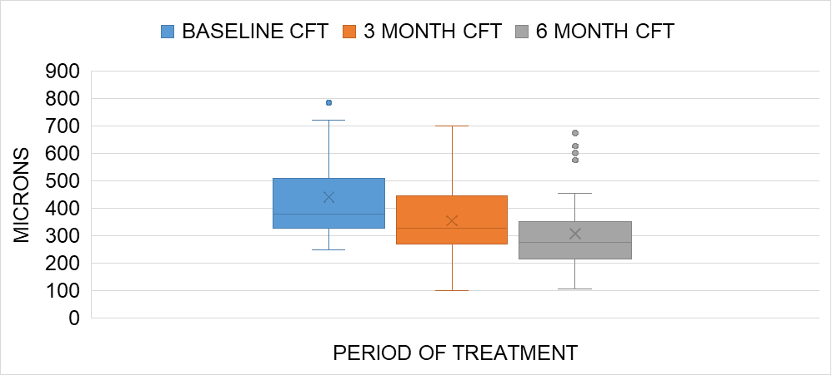
Figure S2. Effect of Avastin in improving the central foveal thickness from baseline to 3 and 6 months
CFT = central foveal thickness; BL = baseline measurement

Supplementary material 3

Figure S3. Effect of Avastin in reducing the superior parafoveal thickness from baseline to 3 and 6 months
PFT = parafoveal thickness; BL = baseline measurement

