Supplementary Figures

Supplementary Figure 1：Panel-specific confusion matrices for MET amplification detection by tissue NGS in the training cohort. Panels A–E correspond to the five participating NGS panels evaluated in this study. For each of the five tissue NGS panels, MET amplification status was classified using MET GCN cut-off values of 6.55 and compared with FISH-defined MET amplification. This figure provides panel-level detail underlying the integrated performance results shown in the main text.

.

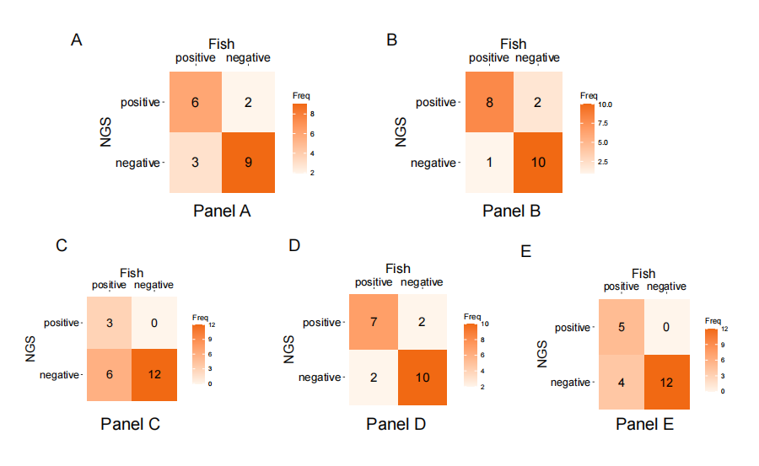

Supplementary Figure 2：The identification and performance of optimal cut-off value of MET GCN by tissue NGS (FISH-MET GCN of 10 as reference)

Supplementary Figure 3: The survival benefit analysis of MET-directed therapy under FISH testing (A), with cut-off value of 5 in MET GCN under NGS (B) and with cut-off value of 10 under NGS (C).
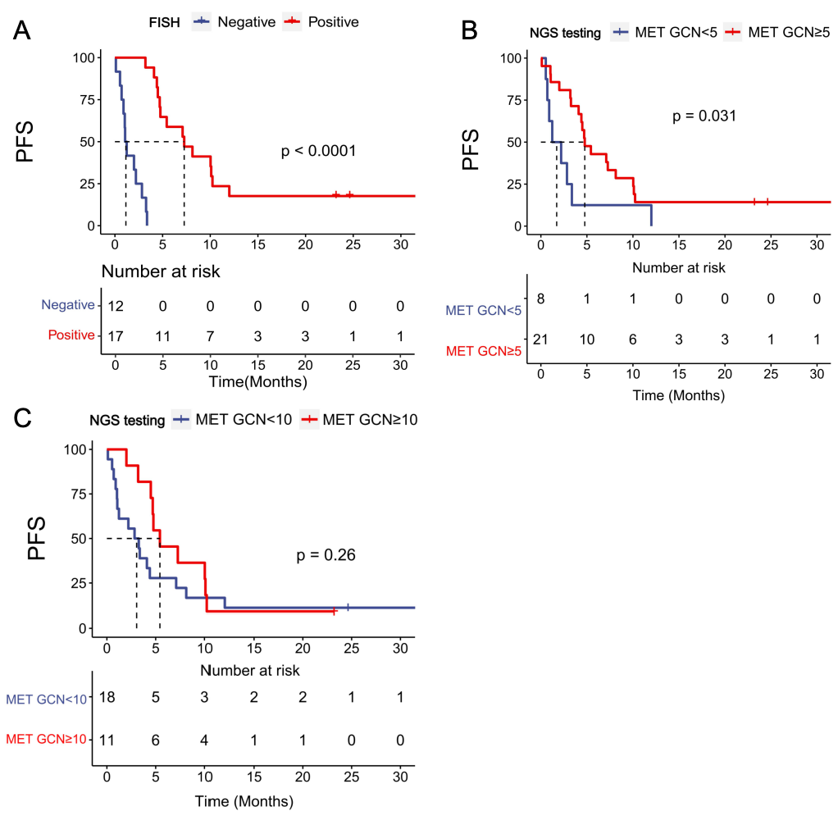

Supplementary Tables

Supplementary Table 1：Performance with different cut-off value of MET GCN for MET amplification detection by integrating with five tissue NGS panels in the training cohort.
Cut off | Specificity | Sensitivity | Accuracy | Npv | Ppv | Precision | Recall | Youden
--- | 0 | 1.00 | 0.43 | --- | 0.43 | 0.43 | 1.00 | 0.00
2.08 | 0.08 | 1.00 | 0.48 | 1.00 | 0.45 | 0.45 | 1.00 | 0.08
2.20 | 0.17 | 1.00 | 0.52 | 1.00 | 0.47 | 0.47 | 1.00 | 0.17
2.40 | 0.25 | 1.00 | 0.57 | 1.00 | 0.50 | 0.50 | 1.00 | 0.25
2.54 | 0.33 | 1.00 | 0.62 | 1.00 | 0.53 | 0.53 | 1.00 | 0.33
2.71 | 0.42 | 1.00 | 0.67 | 1.00 | 0.56 | 0.56 | 1.00 | 0.47
2.95 | 0.50 | 1.00 | 0.71 | 1.00 | 0.60 | 0.60 | 1.00 | 0.50
3.08 | 0.58 | 1.00 | 0.76 | 1.00 | 0.64 | 0.64 | 1.00 | 0.58
3.82 | 0.67 | 1.00 | 0.81 | 1.00 | 0.69 | 0.69 | 1.00 | 0.67
4.94 | 0.75 | 1.00 | 0.86 | 1.00 | 0.75 | 0.75 | 1.00 | 0.75
5.47 | 0.75 | 0.89 | 0.81 | 0.90 | 0.73 | 0.73 | 0.89 | 0.64
5.73 | 0.83 | 0.89 | 0.86 | 0.91 | 0.80 | 0.80 | 0.89 | 0.72
5.87 | 0.83 | 0.78 | 0.81 | 0.83 | 0.78 | 0.78 | 0.78 | 0.61
5.92 | 0.83 | 0.67 | 0.77 | 0.77 | 0.75 | 0.75 | 0.67 | 0.50
6.04 | 0.92 | 0.67 | 0.81 | 0.79 | 0.86 | 0.86 | 0.67 | 0.58
6.55 | 1.00 | 0.67 | 0.86 | 0.80 | 1.00 | 1.00 | 0.67 | 0.67
7.38 | 1.00 | 0.56 | 0.81 | 0.75 | 1.00 | 1.00 | 0.56 | 0.56
7.97 | 1.00 | 0.44 | 0.77 | 0.71 | 1.00 | 1.00 | 0.44 | 0.44
8.63 | 1.00 | 0.33 | 0.71 | 0.67 | 1.00 | 1.00 | 0.33 | 0.33
12.59 | 1.00 | 0.22 | 0.67 | 0.64 | 1.00 | 1.00 | 0.22 | 0.22
19.86 | 1.00 | 0.11 | 0.62 | 0.60 | 1.00 | 1.00 | 0.11 | 0.11
--- | 1.00 | 0.00 | 0.57 | 0.57 | --- | --- | 0.00 | 0.00
Npv: negative predictive value; ppv: positive predictive value.

Supplementary Table 2. The performance of MET amplification detection by five tissue NGS panels between MET GCN of 5 and 6.55 by NGS
 | Cut-off = 5 |  |  | Cut-off = 6.55
Panels | Sensitivity | Specificity | Accuracy | Sensitivity | Specificity | Accuracy
A | 100.0% | 63.3% | 80.0% | 66.7% | 81.8% | 75.0%
B | 100.0% | 75.0% | 85.7% | 88.9% | 83.3% | 85.7%
C | 55.6% | 83.3% | 71.4% | 33.3% | 100.0% | 71.4%
D | 88.9% | 75.0% | 81.0% | 77.8% | 83.3% | 81.0%
E | 100.0% | 75.0% | 85.7% | 55.6% | 100.0% | 81.0%

Supplementary Table 3：Performance with different cut-off value of MET GCN for FISH-MET of 10 by integrating with five tissue NGS panels in the training cohort.
Cut off | Specificity | Sensitivity | Accuracy | Npv | Ppv | Precision | Recall | Youden
--- | 0.00 | 1.00 | 0.24 | --- | 0.24 | 0.24 | 1.00 | 0.00
2.08 | 0.06 | 1.00 | 0.29 | 1.00 | 0.25 | 0.25 | 1.00 | 0.06
2.208 | 0.12 | 1.00 | 0.33 | 1.00 | 0.26 | 0.27 | 1.00 | 0.12
2.40 | 0.19 | 1.00 | 0.38 | 1.00 | 0.28 | 0.28 | 1.00 | 0.19
2.54 | 0.25 | 1.00 | 0.43 | 1.00 | 0.29 | 0.29 | 1.00 | 0.25
2.71 | 0.31 | 1.00 | 0.48 | 1.00 | 0.31 | 0.31 | 1.00 | 0.31
2.95 | 0.38 | 1.00 | 0.52 | 1.00 | 0.33 | 0.33 | 1.00 | 0.38
3.08 | 0.44 | 1.00 | 0.57 | 1.00 | 0.36 | 0.36 | 1.00 | 0.44
3.82 | 0.50 | 1.00 | 0.62 | 1.00 | 0.38 | 0.38 | 1.00 | 0.50
4.94 | 0.56 | 1.00 | 0.67 | 1.00 | 0.42 | 0.42 | 1.00 | 0.56
5.47 | 0.56 | 0.80 | 0.62 | 0.90 | 0.36 | 0.36 | 0.80 | 0.36
5.73 | 0.63 | 0.80 | 0.67 | 0.91 | 0.40 | 0.40 | 0.8 | 0.43
5.87 | 0.69 | 0.80 | 0.71 | 0.92 | 0.44 | 0.44 | 0.8 | 0.49
5.92 | 0.75 | 0.80 | 0.76 | 0.92 | 0.50 | 0.50 | 0.8 | 0.55
6.03 | 0.81 | 0.80 | 0.81 | 0.93 | 0.57 | 0.57 | 0.8 | 0.61
6.55 | 0.88 | 0.80 | 0.86 | 0.93 | 0.67 | 0.67 | 0.8 | 0.68
7.38 | 0.88 | 0.60 | 0.81 | 0.88 | 0.60 | 0.60 | 0.6 | 0.48
7.97 | 0.94 | 0.60 | 0.86 | 0.88 | 0.75 | 0.75 | 0.6 | 0.54
8.63 | 1.00 | 0.60 | 0.91 | 0.89 | 1.00 | 1.00 | 0.6 | 0.60
12.59 | 1.00 | 0.40 | 0.86 | 0.84 | 1.00 | 1.00 | 0.4 | 0.40
19.86 | 1.00 | 0.20 | 0.81 | 0.80 | 1.00 | 1.00 | 0.2 | 0.20
--- | 1.00 | 0.00 | 0.77 | 0.76 | --- | --- | 0.00 | 0.00
Npv: negative predictive value; ppv: positive predictive value.

