Exploratory analyses of additional frequency bands
To examine whether the reported time-frequency effects were specific to frontal theta activity, additional exploratory analyses were conducted for the alpha and beta bands using the same frontal/fronto-central electrode cluster (F1, Fz, F2, FC1, FCz, FC2). For the alpha band (10-13 Hz), mean power was extracted from the 300-550 ms time window. No significant main effects or interactions were observed (all ps > .05). For the beta band (18-22 Hz), mean power was extracted from the 250-500 ms time window. A significant main effect of Electrode was observed, F _{(5, 735)} = 66.304, p < .001, $η_{p}^{2}$=.312, but no significant main effects of Group or Task Type, and no significant interactions involving these factors, were found (all ps > .05). These exploratory results suggest that the critical time-frequency effect reported in the main text was not paralleled in the examined alpha or beta bands.
Supplementary Figure S1
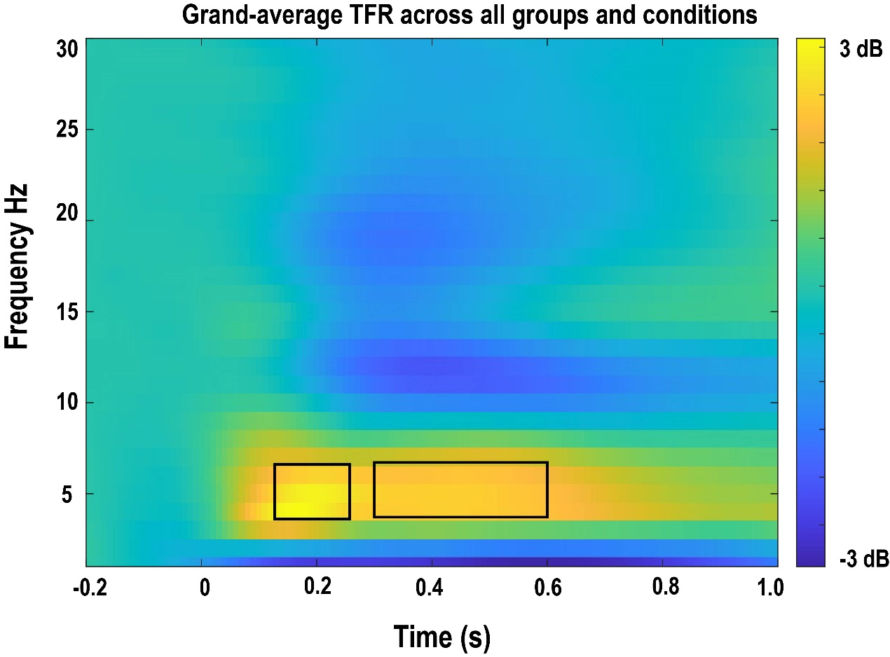
Supplementary Figure S1. Grand-average time-frequency representation across all groups and conditions at the frontal/fronto-central electrode cluster (F1, Fz, F2, FC1, FCz, FC2), used to guide the selection of the theta-band time windows. Grand-average time-frequency representation across all groups and conditions at the frontal/fronto-central electrode cluster (F1, Fz, F2, FC1, FCz, FC2). Visual inspection of this grand-average plot was used to guide the selection of the theta-band time windows (130-260 ms and 300-600 ms).

