Supplementary Materials
Supplementary Methods
S1. Study design and experimental unit
This study used a parallel-group design. Male C57BL/6J mice underwent 1-week acclimatisation and were then fed a high-fat diet (60% kcal from fat) for 4 weeks. Mice were subsequently randomised to receive TAC (26-gauge needle) or sham surgery (thoracotomy and aortic dissection without constriction), and HFD feeding was continued for an additional 4 weeks before endpoint phenotyping and tissue collection. Phenotyping was conducted at predefined time points: echocardiography and tail-cuff measurements were performed after acclimatisation, followed by terminal tissue harvest at the study endpoint. The experimental unit was the individual mouse for all in vivo readouts; RNA sequencing was performed on BAT collected from individual mice.
S2. Inclusion and exclusion criteria. Inclusion criteria were successful completion of the assigned procedures and availability of analyzable data. Exclusion criteria were defined a priori and included perioperative death, unsuccessful TAC (insufficient evidence of constriction), and inadequate sample quality for RNA sequencing. Any exclusions and the exact n for each analysis and group are reported in the figure legends.
S3. Randomisation and minimisation of confounders. Mice were allocated to sham and HFpEF groups using simple randomisation with a computer-generated random sequence (Excel RAND) by an investigator not involved in outcome assessment. Animals were housed 2-3 per cage under identical husbandry conditions. To minimise potential confounding due to cage location, cages were rotated across rack positions weekly. Outcome measurements were performed in a randomised order across animals, and investigators performing echocardiography and histological quantification were blinded to group allocation.
S4. Sample size and exclusions. No a priori sample size calculation was performed because the animal experiments were exploratory and mechanistic in nature. Sample sizes were determined based on prior experience and published studies using comparable HFD plus TAC HFpEF models. For BAT RNA sequencing, five biological replicates per group were analysed (n = 5 per group). The exact n for each outcome and analysis is provided in the corresponding figure legends.
S5. Functional enrichment analysis
Functional enrichment analyses were performed using the Enrichr platform. Gene Ontology (GO) terms, including biological processes (BP), molecular functions (MF), and cellular components (CC), as well as Kyoto Encyclopedia of Genes and Genomes (KEGG) pathways, were interrogated to characterize the functional landscape of the input gene set. Additional pathway annotations were assessed using WikiPathways, Reactome and BioCarta with KEGG. Significance was evaluated using adjusted P values, with a false discovery rate (FDR) < 0.05 considered statistically significant.
S6. Protein-Protein interaction analysis and network construction
Protein-protein interaction (PPI) networks were performed using STRING with a minimum required interaction score of 0.4. To constrain network complexity, the maximum number of first-shell interactors was set to 50, and disconnected nodes were excluded. The resulting networks were imported into Cytoscape (V3.9.1) for visualization and analysis. Hub proteins were identified using the degree centrality method implemented in the cytoHubba plugin.
S7. TF-gene interactions analysis
Transcription factors (TFs) were analyzed using NetworkAnalyst 3.0. TF-gene interaction data were retrieved from the ENCODE ChIP-seq. The hub genes were uploaded to NetworkAnalyst with Homo sapiens specified as the organism and Official Gene Symbol selected as the identifier type. TF-gene interactions were configured to the ENCODE option, and filters were applied as follows: peak intensity signal < 500, predicted regulatory potential score < 1 (BETA subtraction algorithm), and node degree > 1. The resulting TF-gene regulatory network was exported and visualized in Cytoscape.
S8. TF-miRNA coregulatory network analysis
MicroRNAs (miRNAs) are endogenous short non-coding RNAs that post-transcriptionally regulate gene expression by promoting mRNA degradation or inhibiting translation. To construct a TF-miRNA coregulatory network, the shared genes were analyzed in NetworkAnalyst 3.0 using a degree filter of >1. Regulatory interaction information was obtained from RegNetwork20, and the network was visualized in Cytoscape.
S9. Transthoracic echocardiography
Transthoracic echocardiography was performed using a VINNO 6 LAB system (VINNO Technology Co., Ltd., Suzhou, China) equipped with a high-frequency linear probe. Mice were lightly anesthetized with isoflurane, and M-mode and pulsed Doppler images were acquired at the level of the papillary muscles and mitral inflow, respectively. Left ventricular ejection fraction (EF), early diastolic mitral inflow velocity (E), and early diastolic mitral annular velocity (E′) were measured, and the E/E′ ratio was calculated as an index of diastolic function. All measurements were averaged over at least three consecutive cardiac cycles and analyzed by an investigator blinded to group allocation.
At the end of the experiment, mice were euthanized under deep anesthesia. Hearts were excised, washed in cold saline, weighed, and fixed in 4% paraformaldehyde for hematoxylin-eosin (H&E) and Masson trichrome staining.
S10. Blood pressure measurement and exercise capacity test
Systolic and diastolic blood pressure and heart rate were measured in conscious mice using a noninvasive tail-cuff system (BP2006A, Softron, Beijing, China) after at least 3 days of acclimatization. For each mouse, at least five consecutive measurements with stable waveforms were averaged. Exercise capacity was assessed on a motorized treadmill (XR-PT-10B, Xinruan, Shanghai, China) using an incremental workload protocol. The test was initiated at a speed of 10 m/min at a 0。 incline. Every 5 minutes, the workload was increased by raising the running speed by 2 m/min, followed by an increase in incline of 5。 at subsequent stages, and running was continued until the mice reached exhaustion, defined as the inability to maintain pace with the belt despite gentle encouragement. At the point of exhaustion, the maximal running speed and total running distance were recorded for each mouse.
S11. Organ weight indices and lung wet-to-dry ratio
At sacrifice, hearts and tibias were excised and weighed to calculate the heart weight-to-tibia length ratio. Lungs were weighed immediately (wet weight), then dried at 60 ℃ for 48 h to obtain dry weight, and the wet-to-dry ratio was calculated as an index of pulmonary congestion.
S12. BAT collection and RNA sequencing
Interscapular brown adipose tissue (BAT) was rapidly dissected from control and HFpEF-like mice immediately after euthanasia, snap-frozen in liquid nitrogen, and stored at −80℃ until RNA extraction. Total RNA was extracted using TRIzol reagent (Invitrogen, CA, USA) according to the manufacturer’s instructions. RNA purity and concentration were assessed with a NanoDrop 2000 spectrophotometer (Thermo Scientific, USA), and RNA integrity was evaluated using an Agilent 2100 Bioanalyzer (Agilent Technologies, Santa Clara, CA, USA). RNA-seq libraries were prepared using the VAHTS Universal V10 RNA-seq Library Prep Kit (Premixed Version) following the manufacturer's protocol. Transcriptome sequencing and primary data processing were performed by OE Biotech Co., Ltd. (Shanghai, China).
The libraries were sequenced on an Illumina NovaSeq X Plus platform to generate 150 bp paired-end reads. Raw reads in FASTQ format were first processed with fastp to remove adapter sequences and low-quality bases, yielding high-quality clean reads for downstream analysis. Clean reads were aligned to the mouse reference genome using HISAT2, and gene-level expression was quantified as fragments per kilobase of transcript per million mapped reads (FPKM). Read counts for each gene were obtained using HTSeq-count. Principal component analysis (PCA) and hierarchical clustering were performed in R to evaluate sample similarity and overall expression patterns.
Differential expression analysis between control and HFpEF groups was conducted using the DESeq2 package. Genes with an adjusted Q value < 0.05 and a fold change > 2 were defined as differentially expressed genes (DEGs). Gene Ontology (GO) and Kyoto Encyclopedia of Genes and Genomes (KEGG) pathway enrichment analyses of DEGs were performed in R based on the hypergeometric distribution. When appropriate, Reactome and WikiPathways enrichment analyses were also carried out to further characterize significantly enriched functional categories.

Supplementary Table S1. Diagnostic criteria for metabolic syndrome
Diagnostic criteria for MetS
(1) obesity, defined as body mass index (BMI) > 25 kg/m²;
(2) elevated triglycerides (TG) > 1.7 mmol/L;
(3) reduced high-density lipoprotein cholesterol (HDL-C) < 1.04 mmol/L;
(4) hypertension, defined as blood pressure > 130/85 mmHg or current anti-hypertensive treatment in those with previously diagnosed hypertension;
(5) elevated fasting plasma glucose, indicated by levels ≥ 6.0 mmol/L or
ongoing treatment for previously diagnosed diabetes.
Note: MetS was defined as the presence of at least three of the following five components.

Supplementary Table S2. Association between RIR and HF-risk phenotype
Model | Outcome | Exposure | OR (95% CI) | P
Model 1 | HF-risk | HCRP_high | 1.70 (1.15–2.51) | 0.0078
Model 2 | HF-risk | HCRP_high | 1.59 (1.06–2.37) | 0.024

Supplementary Table S3. Sensitivity analysis
Model | Outcome | Exposure | OR (95% CI) | P
Model 1 | HF-risk | HCRP_high | 1.78(1.37–2.32) | <0.001
Model 2 | HF-risk | HCRP_high | 1.55(1.14–2.10) | 0.005
model 1: unadjusted.
Model 2: adjusted for age, sex, BMI, SBP, glucose, HDL-C.
OR, odds ratio; CI, confidence interval.
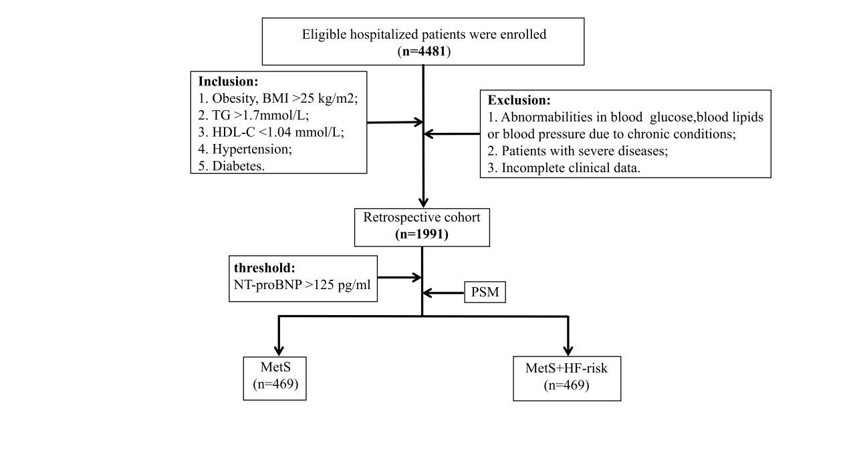
Fig. S1. Flow chart of patient screening, eligibility assessment, and propensity score matching.
Hospitalized individuals were screened for inclusion in the MetS cohort. Patients meeting eligibility criteria were stratified according to the presence or absence of a higher biomarker-defined HF-risk phenotype based on NT-proBNP, followed by propensity score matching. MetS, metabolic syndrome; HF, heart failure; NT-proBNP, N-terminal pro-B-type natriuretic peptide.
Fig. S2. Gene Ontology cellular component enrichment analysis of the six shared MetS-HF genes. The top enriched cellular component terms included the sarcoplasmic reticulum, extracellular matrix, and secretory granule-related compartments.
Fig. S3. Gene Ontology molecular function enrichment analysis of the six shared MetS-HF genes.
The top enriched molecular function terms included chemokine activity, cytokine activity, and growth factor binding.
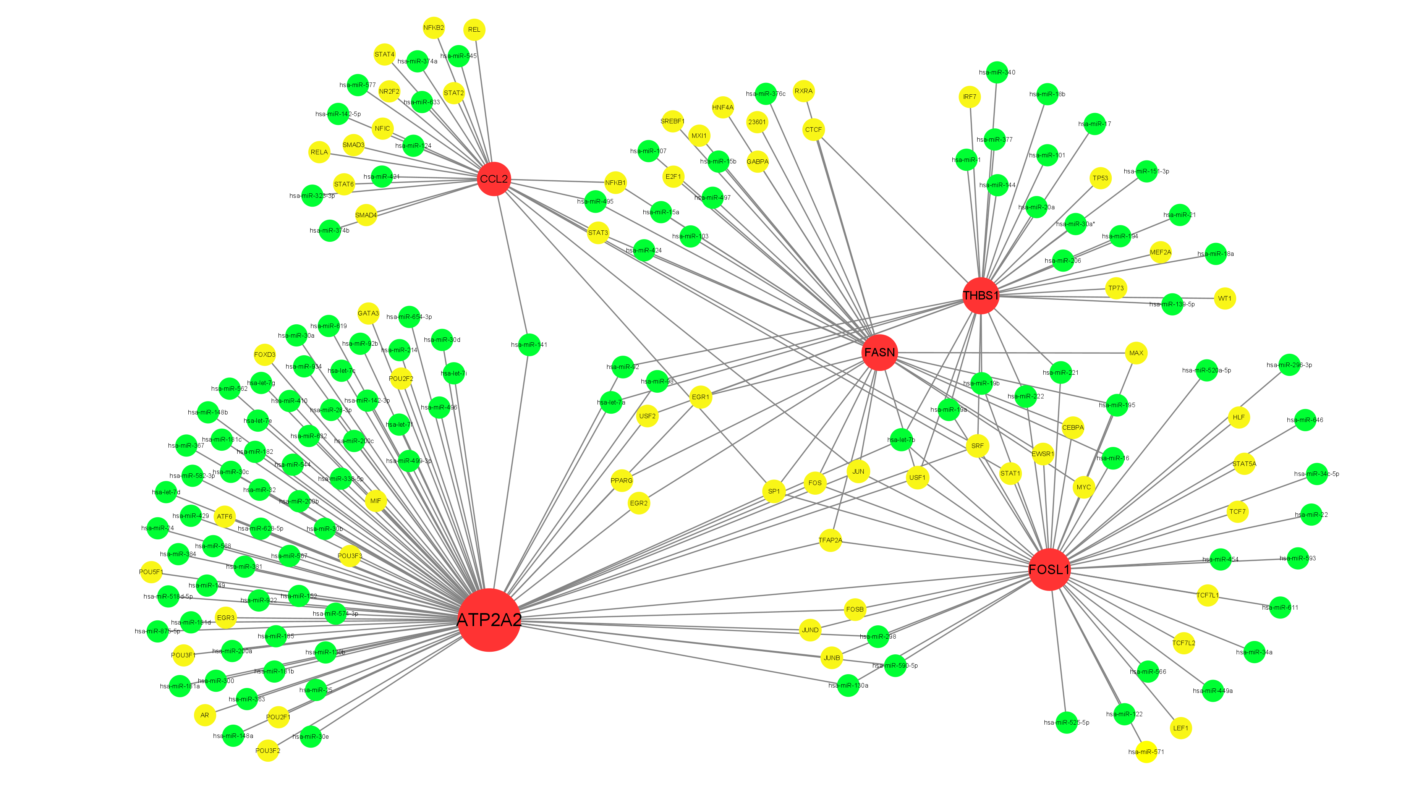
Fig. S4. TF-miRNA co-regulatory network of the shared MetS-HF signature.
The network integrates transcription factors and microRNAs predicted to regulate the shared-gene signature, highlighting multilayer regulatory architecture across five of the six shared genes.
Fig. S5. Echocardiographic, hemodynamic, and metabolic features of the HFpEF model. (a) Left ventricular mass. (b) Left ventricular posterior wall thickness at end-diastole. (c) Fasting glucose. (d) Systolic blood pressure. (e) Diastolic blood pressure. (f) Heart rate. (g) Triglycerides. (h) Low-density lipoprotein cholesterol. (i) High-density lipoprotein cholesterol. Each dot represents one mouse (n = 10 per group). Statistical comparisons were performed using an unpaired two-tailed Student’s t test or Mann-Whitney U test, as appropriate. *P < 0.05, **P < 0.01, ***P < 0.001, ****P < 0.0001 vs sham.
Fig. S6. Morphometric and functional indices in the HFpEF model. (a) Heart weight-to-tibia length ratio. (b) Lung wet-to-dry weight ratio. (c) Exercise capacity, Each dot represents one mouse (n = 10 per group). Statistical comparisons were performed using an unpaired two-tailed Student’s t test or Mann-Whitney U test, as appropriate. *P < 0.05, ****P < 0.0001 vs sham.
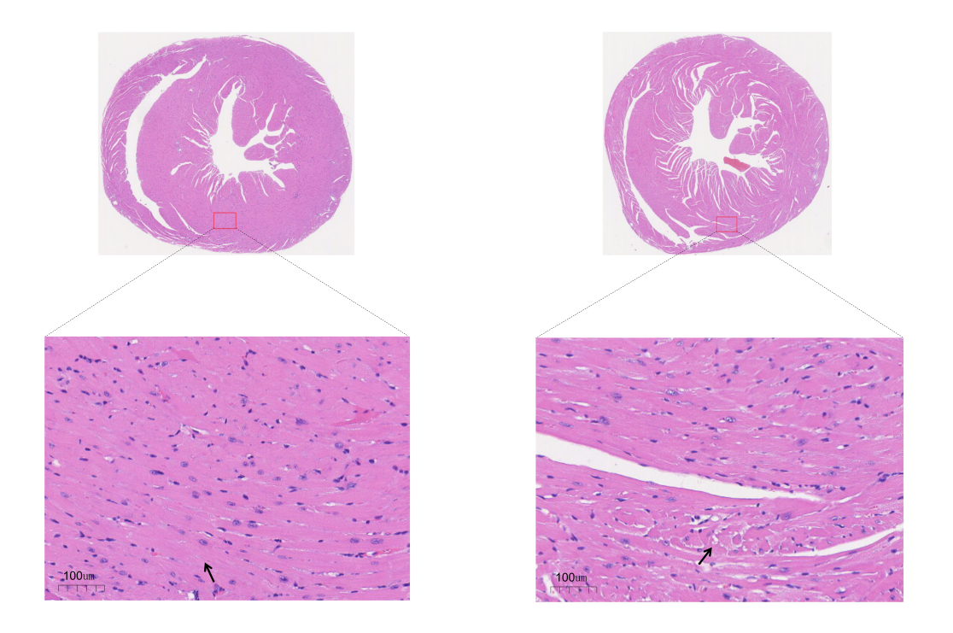
Fig. S7. H&E staining of myocardial sections from sham and HFpEF mice. Representative images show enlarged and disorganized cardiomyocytes in the HFpEF group compared with the sham group. Black arrows indicate representative abnormal cardiomyocytes. Boxed areas indicate representative regions of interest. Scale bars = 100μm.
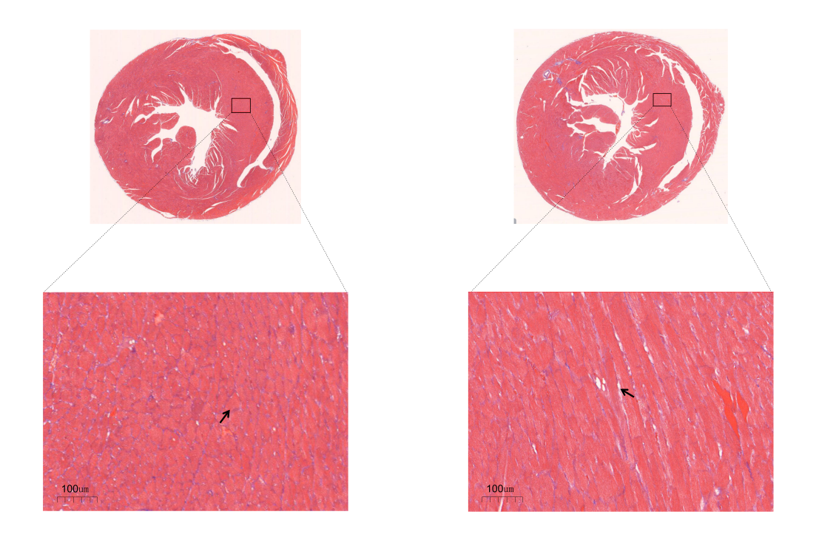
Fig. S8. Masson trichrome staining of myocardial sections from sham and HFpEF mice. Representative images show increased interstitial and perivascular fibrosis in the HFpEF group compared with the sham group. Arrows indicate representative abnormal interstitial changes. Scale bars = 100 μm.

