CONTENTS.
Figure S1 Canonical architecture of an individual deep learning submodel used for property prediction. Each submodel consists of three fully connected hidden layers with 2,048, 1,024, and 128 units, respectively, employing ReLU activation functions. The network is trained independently for each property to enable modular construction of the 33-dimensional drug-likeness spectrum.
Table S1 Composition of the 33 property datasets and overview of the corresponding predictive submodels. The table summarizes the classification of properties into physicochemical properties, pharmacokinetics, efficacy, safety, and stability, along with the associated training datasets and model configurations.
Table S2 Predictive performance of the 33 property-specific deep learning submodels on independent test sets. Performance metrics for each submodel are reported to assess predictive reliability across the individual property domains.
Table S3 Molecular docking scores of the reference drugs and the top fifteen candidate molecules. The table lists the lowest predicted binding energies (kcal/mol) within the primary binding cavity of PBP2, providing quantitative support for the docking analysis discussed in the main text.

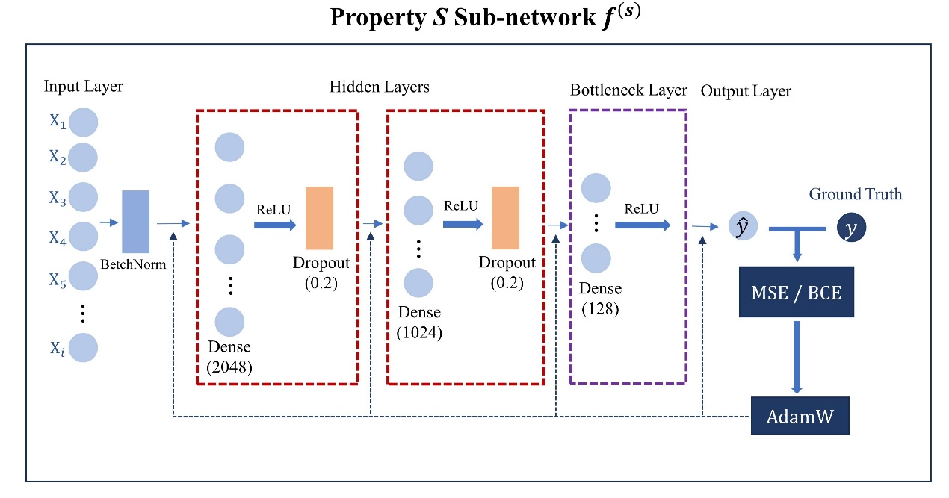
Figure S1 Canonical architecture of an individual deep learning submodel used for property prediction. Each submodel consists of three fully connected hidden layers with 2,048, 1,024, and 128 units, respectively, employing ReLU activation functions. The network is trained independently for each property to enable modular construction of the 33-dimensional drug-likeness spectrum.

Table S1 Composition of the 33 property datasets and overview of the corresponding predictive submodels
No. | Name | Class | Training set | Validation set | Testing set
S1 | Aqueous solubility (LogS) | C1 | 251267 | 53847 | 53851
S2 | Octanol–water partition coefficient (log P) | C1 | 286544 | 61254 | 61263
S3 | Melting point | C1 | 130559 | 27972 | 27984
S4 | Boiling point | C1 | 125784 | 26958 | 26962
S5 | Surface tension | C1 | 59168 | 12679 | 12697
S6 | Density | C1 | 167325 | 35846 | 35869
S7 | Viscosity | C1 | 109081 | 23374 | 23392
S8 | Flash point | C1 | 161846 | 34675 | 34683
S9 | Vapor pressure | C1 | 137928 | 29558 | 29564
S10 | Dissociation constant | C1 | 257753 | 55163 | 55319
S11 | Hydrolysis (half-life value) | C1 | 117046 | 25098 | 25183
S12 | Bioavailability | C2 | 39298 | 8417 | 8461
S13 | Plasma protein binding rate | C2 | 77264 | 16547 | 16583
S14 | Maximal rate of metabolism | C2 | 102937 | 22054 | 22068
S15 | Biliary excretion rate | C2 | 44518 | 9539 | 9671
S16 | Urinary excretion rate | C2 | 57047 | 12248 | 12239
S17 | Volume of distribution | C2 | 137489 | 29439 | 29586
S18 | Half-life | C2 | 129632 | 27747 | 27864
S19 | Minimum Inhibitory Concentration (MIC) | C3 | 335587 | 71956 | 71998
S20 | Enzyme inhibition constant（Ki） | C3 | 137418 | 29447 | 29456
S21 | Receptor affinity | C3 | 185813 | 39736 | 39973
S22 | Maximum effect model parameter (Emax) | C3 | 48246 | 10348 | 10369
S23 | 50% effective dose（EC50） | C3 | 161724 | 34648 | 34623
S24 | Median lethal dose (LD50) | C4 | 161591 | 34627 | 34654
S25 | No Observed Adverse Effect Level (NOAEL) | C4 | 206658 | 44246 | 44289
S26 | Tetrahymena pyriformis 50% growth inhibition concentration | C4 | 245736 | 52639 | 52784
S27 | Median lethal concentration (LC50) | C4 | 155369 | 33247 | 33286
S28 | Developmental toxicity | C4 | 257561 | 55142 | 55364
S29 | Ames mutagenicity | C4 | 397734 | 85237 | 85368
S30 | hERG_risk | C4 | 174397 | 37296 | 37412
S31 | Chemical stability | C5 | 249362 | 53447 | 53586
S32 | Thermostability | C5 | 335341 | 71839 | 71964
S33 | Light stability | C5 | 33789 | 7228 | 7243
Notes: The table summarizes the classification of properties (where C1 denotes physicochemical properties, C2 pharmacokinetics, C3 efficacy, C4 safety, and C5 stability) and lists the corresponding training datasets and model configurations.

Table S2 Predictive performance of the 33 property-specific deep learning submodels on independent test sets
Number | Task Type | Evaluation Metric | Performance
S1 | Regression | R² | 0.87
S2 | Regression | R² | 0.89
S3 | Regression | R² | 0.86
S4 | Regression | R² | 0.92
S5 | Regression | R² | 0.94
S6 | Regression | R² | 0.89
S7 | Regression | R² | 0.88
S8 | Regression | R² | 0.91
S9 | Regression | R² | 0.93
S10 | Regression | R² | 0.95
S11 | Regression | R² | 0.92
S12 | Regression | R² | 0.88
S13 | Regression | R² | 0.86
S14 | Regression | R² | 0.87
S15 | Regression | R² | 0.86
S16 | Regression | R² | 0.88
S17 | Regression | R² | 0.89
S18 | Regression | R² | 0.89
S19 | Regression | R² | 0.93
S20 | Regression | R² | 0.95
S21 | Regression | R² | 0.91
S22 | Regression | R² | 0.93
S23 | Regression | R² | 0.92
S24 | Regression | R² | 0.93
S25 | Regression | R² | 0.91
S26 | Regression | R² | 0.92
S27 | Regression | R² | 0.96
S28 | Classification | AUC | 0.93
S29 | Classification | AUC | 0.96
S30 | Classification | AUC | 0.95
S31 | Classification | AUC | 0.96
S32 | Classification | AUC | 0.91
S33 | Classification | AUC | 0.92
Notes: Performance metrics for each submodel are reported to assess predictive reliability across the individual property domains.
Abbreviations: R², coefficient of determination; AUC, area under the receiver operating characteristic curve.

Table S3 Molecular docking scores of the reference drugs and the top fifteen candidate molecules
Cavity Volumes
517 Å³ |  | 549 Å³ |  | 286 Å³ |  | 635 Å³ |  | 510 Å³
Compd. no | kcal/mol | Compd. no | kcal/mol | Compd. no | kcal/mol | Compd. no | kcal/mol | Compd. no | kcal/mol
Cefradine | -7.9 | Cefradine | -7.5 | Cefradine | -6.9 | Cefradine | -6.3 | Cefradine | -6.3
Cefuroxime | -8.5 | Cefuroxime | -7.4 | Cefuroxime | -6.3 | Cefuroxime | -5.9 | Cefuroxime | -6.4
Ceftriaxone | -8.4 | Ceftriaxone | -8.5 | Ceftriaxone | -7.5 | Ceftriaxone | -7.2 | Ceftriaxone | -7.9
M1 | -8.6 | M1 | -7.7 | M1 | -7.3 | M1 | -6.5 | M1 | -6.1
M2 | -8.8 | M2 | -7.8 | M2 | -6.8 | M2 | -6.7 | M2 | -6.4
M3 | -9.3 | M3 | -8.2 | M3 | -7.6 | M3 | -6.6 | M3 | -6.8
M4 | -8.0 | M4 | -7.7 | M4 | -7.2 | M4 | -6.5 | M4 | -5.6
M5 | -8.7 | M5 | -7.8 | M5 | -7.4 | M5 | -6.9 | M5 | -6.4
M6 | -10.2 | M6 | -9.3 | M6 | -7.9 | M6 | -7.8 | M6 | -7.2
M7 | -8.4 | M7 | -8.0 | M7 | -7.2 | M7 | -6.5 | M7 | -6.6
M8 | -8.1 | M8 | -7.6 | M8 | -7.4 | M8 | -6.4 | M8 | -6.3
M9 | -9.9 | M9 | -7.9 | M9 | -7.0 | M9 | -6.4 | M9 | -5.9
M10 | -8.3 | M10 | -8.3 | M10 | -8.2 | M10 | -6.8 | M10 | -7.1
M11 | -7.6 | M11 | -6.5 | M11 | -6.7 | M11 | -5.7 | M11 | -6.0
M12 | -8.2 | M12 | -7.6 | M12 | -7.4 | M12 | -6.6 | M12 | -7.6
M13 | -8.5 | M13 | -7.7 | M13 | -7.3 | M13 | -7.2 | M13 | -6.4
M14 | -8.6 | M14 | -7.7 | M14 | -6.5 | M14 | -7.0 | M14 | -6.8
M15 | -8.4 | M15 | -6.8 | M15 | -6.7 | M15 | -6.0 | M15 | -6.5
Notes: The table lists the predicted binding energies (kcal/mol) of the reference drugs and candidate molecules in each of the five CB-Dock2-predicted ligand-accessible cavities of PBP2.

